P4P / COMPSYS 770 A/B

Research Compendium
Project Overview & Evidence Index
Architectural Exploration and Voltage–Frequency
Characterisation of a Capsule Neural Network
on the ZCU102 FPGA
2026 • Department of Electrical, Computer, and Software Engineering
The University of Auckland, New Zealand
AUTHORS & RESEARCH TEAM | GUIDANCE
Tonny Chen | Student  Beren Eskildsen | Project partner  Josiah Sterling | Research partner | Maryam Hemmati | Supervisor  Morteza Biglari-Abhari | Co-supervisor

Document role
This document explains the project, identifies evidence and artefacts, and directs future researchers to the accompanying setup, source-code, experimental-procedure and raw-data materials.

How to use this compendium
Start here if you are an examiner reviewing the evidence, a student rebuilding the accelerator, or a researcher extending the voltage–frequency study. The archive is organised by task: navigation and context live in this document; detailed procedures and primary evidence live in separate directories.

Reader pathways
Your goal | Start here | Then consult
Understand the study | 01_Main_Compendium/Research_Compendium.pdf | Final reports and 03_System_Architecture/
Build and run CapsNet | 02_Software_Setup_Guide/Software_Setup_Guide.pdf | 04_Source_Code/ and the board deployment artefacts
Repeat a measurement | 05_Experimental_Procedures/ | 06_Experimental_Data/ and 07_Verification_and_Results/
Audit a plotted result | Evidence traceability table in this document | Raw data, analysis scripts, generated figure
Continue the research | 10_Future_Development/ | Design source, experiment logs, known limitations

Document map
Document / material | Purpose
Research Compendium (this document) | A navigable overview, reproduction route, study results and evidence crosswalk.
Software Setup Guide | Fresh Ubuntu installation through first successful board inference.
Experimental Procedures | Exact stimulus, voltage sweep, measurements, tests, acceptance criteria.
Source Code and Build Scripts | Original model, V1/V2/V3, DPU/HLS integrations, host applications.
Experimental Data and Verification | Raw logs, board records, build reports, analysis scripts and figure outputs.

1 Project overview

1.1 Research question and contributions
This study examines how architectural specialisation of functionally equivalent DigitCaps accelerators changes nominal performance, FPGA resource utilisation, and the experimentally observed voltage–frequency reliability and energy characteristics on the ZCU102. The underlying routing-by-agreement workload is retained while memory organisation, parallelism, arithmetic precision and reduction structure are varied.
- Three DigitCaps HLS accelerators (V1–V3) were developed and compared under consistent implementation and validation conditions.
- Two ZCU102 boards were used for real-silicon voltage–frequency characterisation of the standalone accelerator builds.
- The joint architecture and operating-point comparison identifies the lowest measured energy configuration within the evaluated design space.

1.2 Quantitative research snapshot
Metric | Finding | Measurement context
V1 → V3 kernel latency | 28.490 → 6.333 ms | DigitCaps, 150 MHz; integrated CapsNet configuration
Software baseline kernel latency | 20.872 ms | Cortex-A53 @ 1.2 GHz
V3 full-network latency | 10.749 ms at 150 MHz; 7.599 ms at 300 MHz | Integrated CapsNet configuration
Reference / V3 MNIST accuracy | 99.66% / 98.88% | 10,000-image test set
Lowest observed energy | 9.76 mJ/inference | V3 standalone @ 300 MHz, 0.61 V; seven-rail boundary
Minimum tested supply | 0.55 V | Experimental floor, not necessarily physical Vmin

1.3 Scientific scope and interpretation
The principal contribution is a controlled comparison across three differently specialised implementations of the same DigitCaps operator. The work does not claim to introduce a new dynamic-routing algorithm, nor a novel automatic runtime DVFS controller. Energy values measure a defined seven-rail board-level boundary rather than isolated DigitCaps core energy. Voltage limits are observed under the stated workload and test floor, not certified across all boards or environmental conditions .

2 System design and deployment

2.1 Hardware–software partitioning
The deployed CapsNet is split into six execution stages. Conv1 and Primary_conv2d run on the DPUCZDX8G via Vitis AI Runtime (VART); Primary_reshape is a data-layout operation; Primary_squash, DigitCaps and CapsNet_length are custom HLS accelerators invoked through XRT/ZOCL. DigitCaps transforms 1,152 eight-dimensional primary capsules into ten 16-dimensional output capsules using three routing iterations.
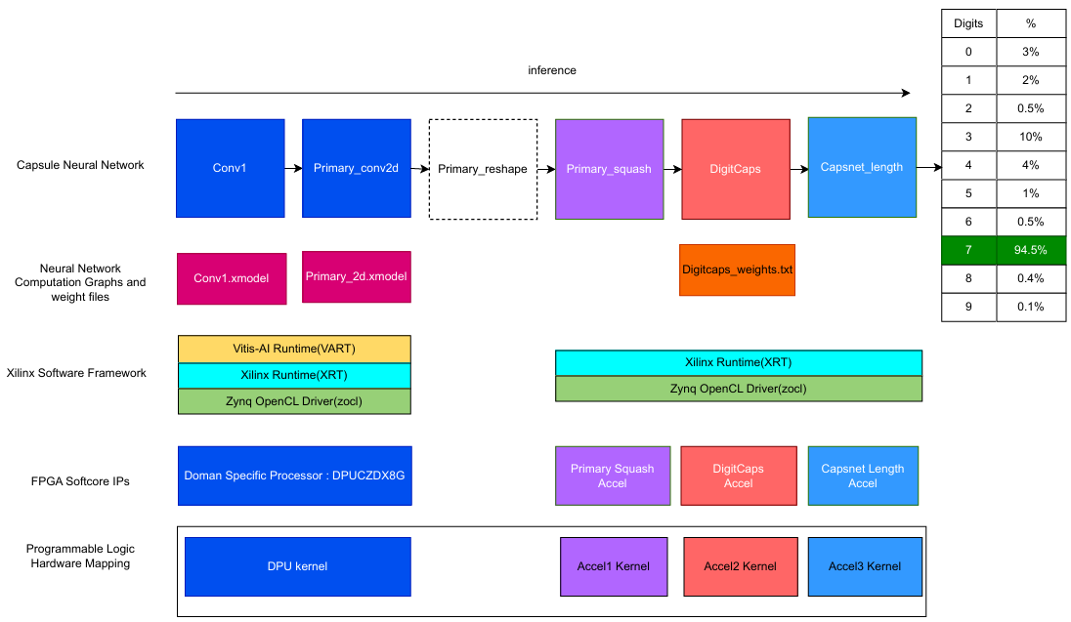
Figure 1. Runtime CapsNet partitioning (reproduced from the supplied Final Report, Fig. 1, p. 7).

2.2 Build and board deployment
The project uses parallel model and accelerator compilation paths. The convolutional portion is extracted from CapsNet.h5, quantised with Vitis AI 2.5 and compiled into XMODEL. The capsule-specific C++ implementations are synthesised with Vitis HLS 2022.1 into XO kernels; the DPU is packaged separately; v++ 2022.1 links the hardware kernels into an XCLBIN. The host application is cross-compiled using the PetaLinux 2022.1 SDK and deployed with the Linux runtime on an SD card.
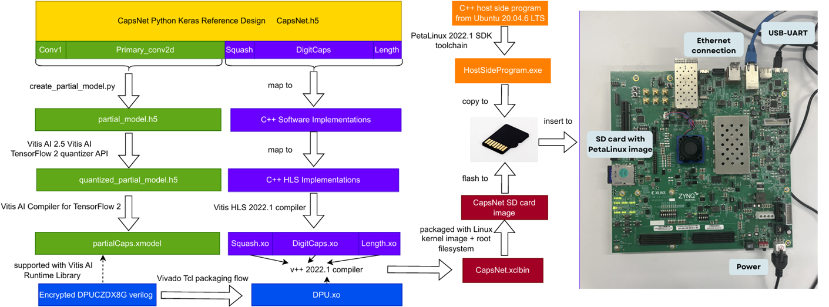
Figure 2. Model-to-board compilation and connection flow (supplied Final Report, Fig. 2, p. 8; board photograph credited there to the 2025 CES82 project).

2.3 Two build contexts must remain separate
Integrated CapsNet build | Standalone DigitCaps build
Contains DPU, Primary_squash, DigitCaps and CapsNet_length acceleration path. | Contains a standalone DigitCaps implementation for isolated measurement.
Use: end-to-end inference, MNIST classification accuracy, host overhead and integrated kernel latency. | Use: architecture resource utilisation, voltage–frequency reliability, energy and power characterisation.
Do not use these results as standalone DigitCaps energy estimates. | Do not claim whole-network inference latency from these measurements.

3 Design archive: V1, V2 and V3
The three implementations preserve the routing-by-agreement computation while changing hardware mapping. The design-history files should explain each major choice alongside the corresponding synthesised source, synthesis settings, logs and representative tests .
Design | Memory and numerical representation | Architectural intent
V1 — baseline | Wide fixed point; weights accessed from PS-side DDR4. | Conservative software-like pipelined baseline; relatively limited parallelism.
V2 — memory / parallelism | INT8 + scale; eight weights per 64-bit word cached in BRAM. | Localise weights, fully unroll prediction MAC, use parallel routing/reductions.
V3 — specialised datapath | 7-bit fixed-point weights (ap_fixed<7,1>), banked BRAM; stage-specific precision. | Two 8-D prediction MAC trees, 16-way squash reduction; first-iteration softmax bypass and reciprocal reuse.

3.1 Physical implementation evidence
Implementation | LUT | FF | BRAM | DSP | Fmax
V1 | 21,702 | 26,200 | 260.5 | 52 | 159.6 MHz
V2 | 64,268 | 57,049 | 495 | 341 | 306.3 MHz
V3 | 33,223 | 26,978 | 417 | 147 | 306.1 MHz
Source: Final Report, Table 4, p. 15. Retain the original post-implementation Vivado/Vitis reports and exact physical-build settings, not only these summary values.

3.2 Functional accuracy and validation
The report gives 99.63%, 99.57%, and 98.88% MNIST test accuracy for V1, V2 and V3 respectively, compared with 99.66% for the reproduced Keras reference Nominal functional validation progressed from Python versus C++ comparison through HLS C/RTL co-simulation, hardware emulation, minimal-kernel board tests and full application checking .
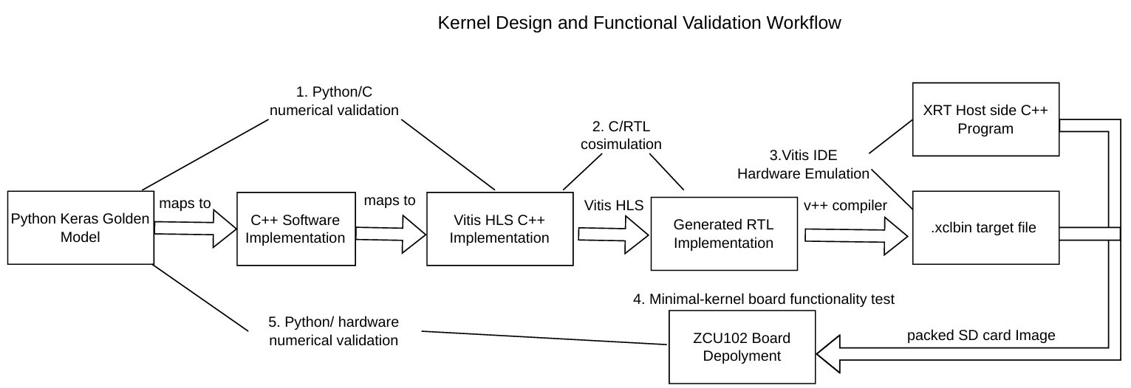
Figure 3. Functional validation chain (supplied Final Report, Fig. 6, p. 13).

4 Experiment design and measurements

4.1 Experimental conditions
Item | Recorded method / scope
Board population | Two ZCU102 boards; identifying serial numbers remain to be inserted in the archive.
Configurations | V1: 50, 100, 150 MHz. V2/V3: 50, 100, 150, 200, 250, 300 MHz.
Voltage sweep | VCCINT 0.85 V nominal down to 0.55 V floor in 0.01 V steps; other rails unchanged.
Input stimulus | First 100 MNIST images; corresponding PrimaryCaps tensors captured from the integrated system and reused for standalone kernels.
Warm-up | 50 images before the main sweep.
Reference output | Each implementation’s own 0.85 V hardware output; 160 DigitCaps values per image.
Reliability pass | All 100 × 160 outputs match the nominal-voltage hardware reference exactly.
Measurements | DigitCaps execution time and seven-rail board monitoring; temperature recorded alongside voltage sweeps.
Source: Final Report, §§5.1–5.2. The automated voltage scripts, timestamps, power sampling details, calibration/verification method and any settling intervals must be checked against the actual 2026 experiment scripts and added to the detailed Experimental Procedures guide.

4.2 Power measurement boundary
The same monitored-rail boundary was used for the standalone hardware and the Cortex-A53 software baseline: VCCINT, VCCBRAM, VCCAUX, VCCPSINTFP, VCCPSINTLP, DDR4_DIMM_VDDQ, and VCCO_PSDDR_504. The energy-per-inference result includes this measured system-level rail set, not just the VCCINT rail (Final Report, §5.2).

4.3 Measurement provenance
Future users must be able to locate the voltage setter and readback, the rail-sampling utility, raw timestamps and measurements, software reference output, board temperature records, input tensor capture and per-configuration binary SHA256 hashes. A record for each experiment should identify date, operator, board, kernel variant, target clock, git revision, XCLBIN, command and outcome.

5 Representative results

5.1 Voltage–frequency reliability
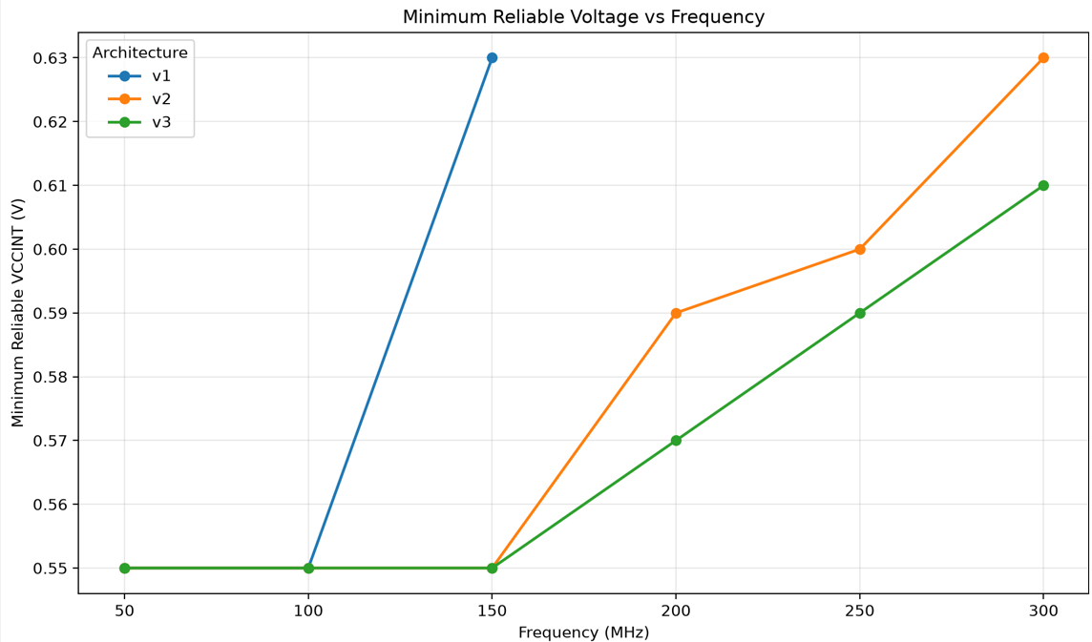
Figure 4. Observed reliable voltage floor by frequency (supplied Final Report, Fig. 8, p. 20). Results at 0.55 V are floor-bounded.
At 150 MHz, V2 and V3 remained reliable at the 0.55 V experimental floor while V1 required 0.63 V. The minimum observed reliable VCCINT for V3 at 300 MHz was 0.61 V (Final Report, §6.2).

5.2 Energy at reliable operating points
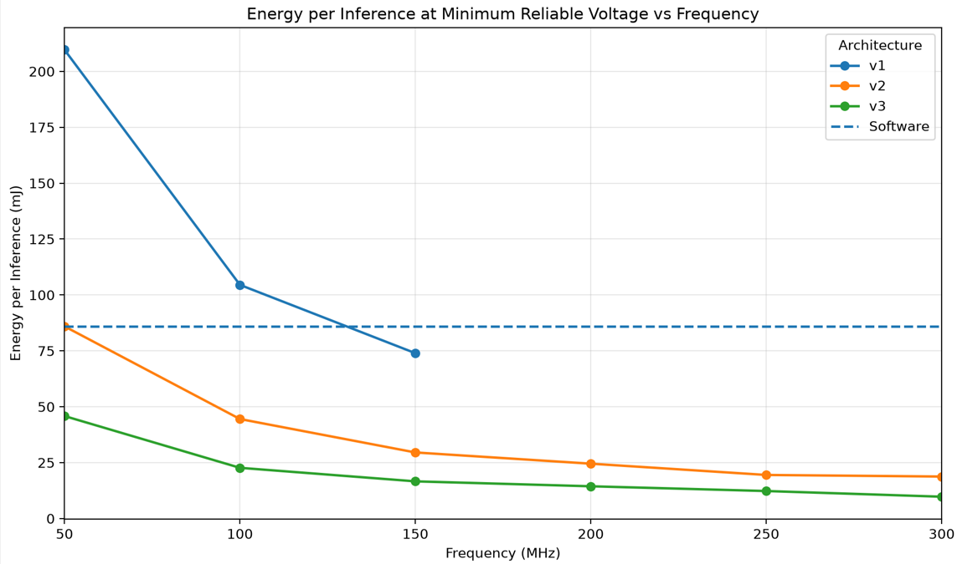
Figure 5. Seven-rail energy per inference at each tested reliable-voltage point (supplied Final Report, Fig. 9, p. 21).
At 150 MHz, the recorded energies were V1 73.96 mJ at 0.63 V, V2 29.55 mJ at 0.55 V and V3 16.62 mJ at 0.55 V. The lowest measured point in the evaluated design space was V3 at 300 MHz and 0.61 V (9.76 mJ/inference), compared with the 85.95 mJ/inference Cortex-A53 baseline (Final Report, §6.3).

6 Reproduction roadmap
The companion Software Setup Guide should provide executable commands and expected outputs. This overview specifies the order and acceptance gates; it deliberately does not invent unverified build commands. Preserve the exact project scripts as the authoritative implementation instructions.
Gate | Work to complete | Evidence of success
G0 — inventory | Confirm board, SD card, UART, Ethernet, host laptop and exact tool versions. | Board/equipment register; installed environment manifest.
G1 — workstation | Prepare Ubuntu 20.04.6 LTS, Vivado/Vitis/Vitis HLS 2022.1, Vitis AI 2.5 and PetaLinux SDK 2022.1. | Version commands, package manifests, toolchain output.
G2 — model | Extract convolutional sub-model; quantise and compile XMODEL against the DPU architecture. | Model and XMODEL artefacts; compilation logs.
G3 — accelerators | Build V1/V2/V3 HLS kernels; run reference and simulation tests. | XO files, C simulation / co-simulation logs.
G4 — integration | Link DPU and three custom kernels with platform and exact directives. | Timing-closed XCLBIN and implementation reports.
G5 — deployment | Cross-compile host application; prepare SD image; connect ZCU102 and boot. | Boot log, network/UART diagnostics, app binaries.
G6 — first inference | Run nominal inference; verify result and numerical output. | Captured terminal log, test stimulus and expected output.
G7 — experiments | Execute and record latency, accuracy, V–f and seven-rail energy experiments. | Raw results, metadata, criteria and reproducible plots.

6.1 Baseline toolchain
Host / target component | Reference identified in the report
Development workstation | Ubuntu 20.04.6 LTS
Vivado / Vitis / Vitis HLS | 2022.1
Vitis AI and TensorFlow 2 flow | Vitis AI 2.5; compile with the TensorFlow 2 compiler
Host cross-compiler | PetaLinux 2022.1 SDK
Target | ZCU102 (XCZU9EG), DPUCZDX8G, XRT/VART runtime
Platform and images | Record the exact ZCU102 .xpfm, common-image/rootfs and XRT build in the setup guide
The report identifies the major tool versions, but not every package checksum, environment variable and command-line dependency. These must be captured in the setup guide/environment manifest; do not infer them from tool version alone.

7 Archive directory and evidence index
The following is the agreed compendium organisation. Relative paths are proposed archive targets: they become verified evidence links only after actual files are copied into the final ZIP and the root README is checked. Maintain the distinction between “planned”, “included” and “independently reproduced”.
Directory | Expected content | Primary user
01_Main_Compendium | This overview; final joint/individual reports; versioned report index. | Examiner / first-time reader
02_Software_Setup_Guide | Fresh-host setup, required packages, Xilinx/PetaLinux/Vitis AI, first inference, screenshots, troubleshooting. | New student / builder
03_System_Architecture | Runtime architecture, build and deployment, DigitCaps datapaths, high-resolution diagrams and hardware/software mapping. | Architect / developer
04_Source_Code | CapsNet model, HLS V1–V3 and testbenches, DPU/FPGA scripts, target applications, inputs/weights and build configuration. | Developer / re-builder
05_Experimental_Procedures | Latency/accuracy, V–f sweep, power/energy and repeatability protocols; stimulus and device records. | Experiment operator
06_Experimental_Data | Unmodified raw logs and samples; processed CSV; analysis and plotting scripts; figure crosswalk. | Data auditor / analyst
07_Verification_and_Results | Numerical reference comparisons, co-sim, timing/resource reports, board checks, calibration/verification and results. | Quality reviewer
08_Project_Records | Meeting/actions, progress logs, design decisions, issue records, project chronology, research notes. | Project reviewer
09_Individual_Submissions | Final Canvas-submitted files for both students with individual manifests. | Examiner / supervisor
10_Future_Development | Known limitations, unresolved questions, extensions and recommended starting points. | Future researcher

7.1 Recommended subfolder conventions
Location | Naming / treatment
04_Source_Code/DigitCaps_V1_V2_V3/ | Separate V1/, V2/, V3/ with source, synthesis settings, tests and README; include a manifest tying each XO/XCLBIN to a commit.
06_Experimental_Data/Raw_Data/ | Create board/variant/frequency/test-run groupings; never edit or overwrite raw files.
06_Experimental_Data/Processed_Data/ | Only script-generated transformation outputs, with clear source filename references.
06_Experimental_Data/Plotting_Scripts/ | Executable scripts and pinned Python dependencies; save regeneration commands.
09_Individual_Submissions/<student>/ | Include exact Canvas versions and an explicit submission_manifest.md.

8 Evidence traceability and handover

8.1 Required experiment record
For each experiment, record a structured run ID and the following: operator, time and timezone, board serial, SD/image identifier, kernel architecture, requested and measured frequency, requested and read-back VCCINT, stimulus/weight versions, input count, command/arguments, reference policy, generated artefacts, pass/fail result, and any exceptions. For energy runs, include timestamps, all seven rail channels, filtering rules and temperature.

8.2 Provenance of prior and collaborative work
The supplied report states that this project builds upon the CSE033 2024 CapsNet-on-ZCU102 deployment, with a 2025 CES82 board image used in the report’s build-flow figure. It credits Beren Eskildsen for automated undervolting scripts and Josiah Sterling for the undervolting infrastructure and support. The submission must retain acknowledgements, identify externally obtained model/DPU components, and distinguish inherited code from 2026 changes (Final Report, §§3.2–3.3 and Acknowledgements).

8.3 Separate individual submissions
The joint compendium must include both students’ Canvas-submitted files, clearly assigned to each individual. Suggested paths: 09_Individual_Submissions/Tonny_Chen/ and 09_Individual_Submissions/Beren_Eskildsen/. Each student folder needs a short manifest listing the exact file, submitted version, submission date, and any shared material.

8.4 Minimum equipment register
Item | Identification to record | Status
ZCU102 board 1 / board 2 | Serial number, FPGA board revision, firmware/boot-switch settings | TO SUPPLY
Host workstation | Model, OS/architecture, tool and installed version manifest | TO SUPPLY
Power monitoring | Rail-to-sensor mapping, source path and calibration/verification method | TO SUPPLY
Cables, SD card and network | Connection and storage details; SD image hash | TO SUPPLY

9 Known limitations and future development

9.1 Interpretation limits
- A voltage point passing 100 images provides an observed workload-dependent boundary, not an exhaustive fault-free guarantee.
- Runs at the 0.55 V test floor are censored by the experiment limit; the true failure threshold may be lower.
- The energy result is a seven-rail measurement and is not equivalent to accelerator-only dynamic power.
- The comparison covers two ZCU102 boards and this DigitCaps workload; wider device and operator generality has not been established.
- V3’s improved latency and resource utilisation are accompanied by lower 10,000-image MNIST classification accuracy.

9.2 Research continuation opportunities
The report proposes extending the study to additional devices, finer and repeated voltage checks near measured boundaries, and a more systematic architecture-aware precision/parallelism/voltage design-space search. Extending the same testing infrastructure to other irregular neural-network operators could test whether architecture-sensitive reliability is a broader phenomenon rather than DigitCaps-specific (Final Report, §8.2).

10 Final archive audit before Canvas submission
Priority | Audit item | Completion
Critical | All ten top-level directories exist and README.md paths match exactly. | ☐
Critical | Software Setup Guide leads from clean workstation to an independently checked first inference. | ☐
Critical | All source, build scripts, DPU architecture configuration, model weights and required binaries are available or retrievable with exact versions. | ☐
Critical | Experiment protocols and raw results substantiate every reported figure/table. | ☐
Critical | Both individual Canvas submission sets are present and attributed. | ☐
Important | Two ZCU102 serials, sensor mapping and measurement verification records are supplied. | ☐
Important | Reproduction output is traceable to Git commit, configuration and SHA256 checksum. | ☐
Important | Included design diagrams have legible source/credit captions. | ☐
Important | ZIP size is below 2 GB or alternative supervisor submission is agreed. | ☐

References and document provenance
Primary source for the numerical claims and technical workflow: Tonny Chen, “Architectural Exploration and Voltage–Frequency Characterisation of a Capsule Neural Network on the ZCU102 FPGA,” uploaded 36-page final-year project report, 2026. Sections, table numbers, and figure numbers in this compendium refer to that supplied report. This overview has been compiled from the report and the agreed archive structure; it does not certify that the separate evidence files have already been added to the archive.
Public project history/repository: https://github.com/wolfuoa/P4P-CapsuleNetworkAccelerator . Preserve a pinned commit and state clearly which 2026 files are newer or different from the historical repository.

