**ЛАБОРАТОРНА РОБОТА №3**

**Тема:** Створення простого застосунку для OS Android

* 1. Загальні відомості та «Hello world»

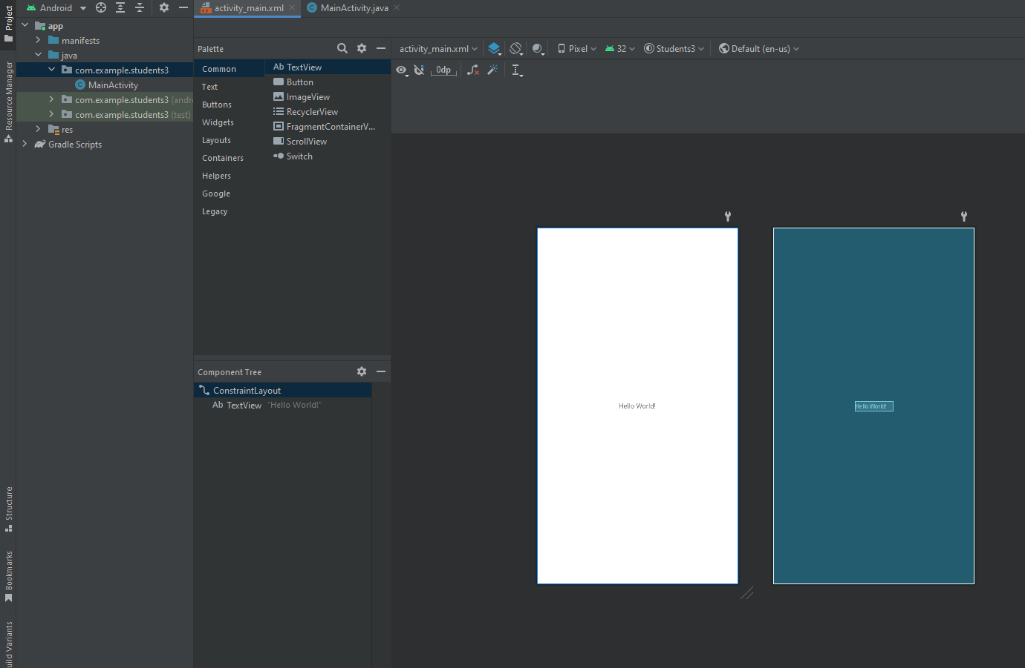

Лістинг програми

MainActivity

package com.example.students3;  
  
import androidx.appcompat.app.AppCompatActivity;  
  
import android.os.Bundle;  
import android.view.View;  
import android.widget.Spinner;  
import android.widget.TextView;  
import android.widget.Toast;  
  
public class MainActivity extends AppCompatActivity {  
  
 @Override  
 protected void onCreate(Bundle savedInstanceState) {  
 super.onCreate(savedInstanceState);  
 setContentView(R.layout.*activity_main*);  
 }  
  
 public void onBtnClick(View view){  
 //CharSequence text = "Ви натиснули кнопку!";  
 //int duration = Toast.LENGTH_LONG;  
 //Toast toast = Toast.makeText(this, text, duration);  
 //toast.show();  
  
 Spinner spinner = (Spinner) findViewById(R.id.*spinner*);  
 String grpNumb = (String) spinner.getSelectedItem();  
  
 String txtStudents = "";  
 for (Student s : Student.*getStudents*(grpNumb)){  
 txtStudents += s.getName() + "\n";  
 }  
  
 TextView textView = (TextView) findViewById(R.id.*text*);  
 textView.setText(txtStudents);  
 }  
}

Student

package com.example.students3;  
  
import java.util.ArrayList;  
import java.util.Arrays;  
  
public class Student {  
 private String name;  
 private String groupNumber;  
  
 public Student(String name, String groupNumber){  
 this.name = name;  
 this.groupNumber = groupNumber;  
 }  
  
 public String getName(){  
 return name;  
 }  
  
 public String getGroupNumber(){  
 return groupNumber;  
 }  
  
 public final static ArrayList<Student> *students* = new ArrayList<>(  
 Arrays.*asList*(  
 new Student("Пупкін Дмитро", "ІПЗ19-1"),  
 new Student("Пупкін Вадим", "ІПЗ19-1"),  
 new Student("Пупкін Петр", "ІПЗ19-2"),  
 new Student("Томазов Олександр", "ІПЗ19-2")  
 )  
 );  
  
 public static ArrayList<Student> getStudents(String groupNumber){  
 ArrayList<Student> stList = new ArrayList<>();  
 for (Student s : *students*){  
 if(s.getGroupNumber().equals(groupNumber)){  
 stList.add(s);  
 }  
 }  
  
 return stList;  
 }  
}

activity_main.xml

<?xml version="1.0" encoding="utf-8"?>  
<LinearLayout  
 xmlns:android="http://schemas.android.com/apk/res/android"  
 xmlns:app="http://schemas.android.com/apk/res-auto"  
 xmlns:tools="http://schemas.android.com/tools"  
 android:layout_width="match_parent"  
 android:layout_height="match_parent"  
 android:padding="16dp"  
 android:orientation="vertical"  
 tools:context=".MainActivity">  
  
 <Spinner  
 android:id="@+id/spinner"  
 android:layout_width="match_parent"  
 android:layout_height="wrap_content"  
 android:layout_marginTop="40dp"  
 android:layout_marginBottom="16dp"  
 android:gravity="center"  
 android:entries="@array/students_groups"/>  
  
 <Button  
 android:id="@+id/button3"  
 android:layout_width="match_parent"  
 android:layout_height="wrap_content"  
 android:text="@string/btn_text"  
 android:layout_marginBottom="16dp"  
 android:onClick="onBtnClick"/>  
  
 <TextView  
 android:id="@+id/text"  
 android:layout_width="wrap_content"  
 android:layout_height="wrap_content"  
 android:text="@string/default_text"  
 android:textSize="18sp"/>  
  
</LinearLayout>

strings.xml

<resources>  
 <string name="app_name">Довідник студентів</string>  
 <string name="btn_text">Показати список</string>  
 <string name="default_text">Список студентів</string>  
  
 <string-array name="students_groups">  
 <item>ІПЗ19-1</item>  
 <item>ІПЗ19-2</item>  
 </string-array>  
</resources>

1.3. Інтенти та передача даних між активностями

Перехід між активностями

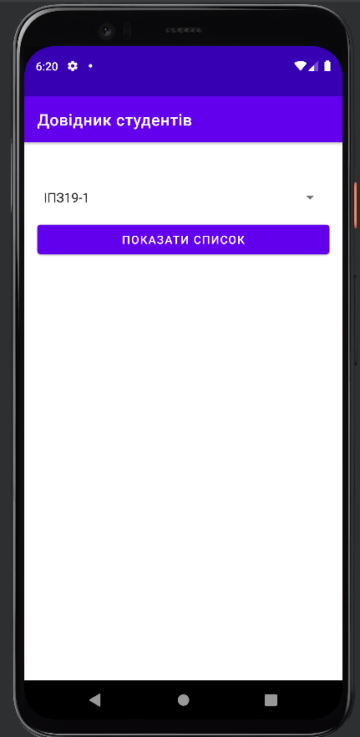

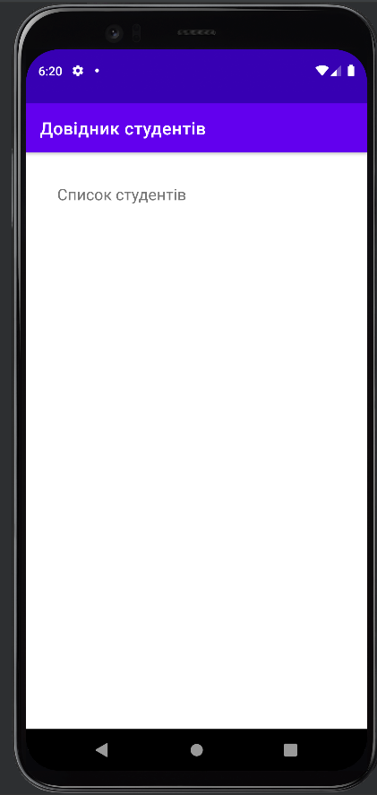

Передача даних у інтент та їх обробка

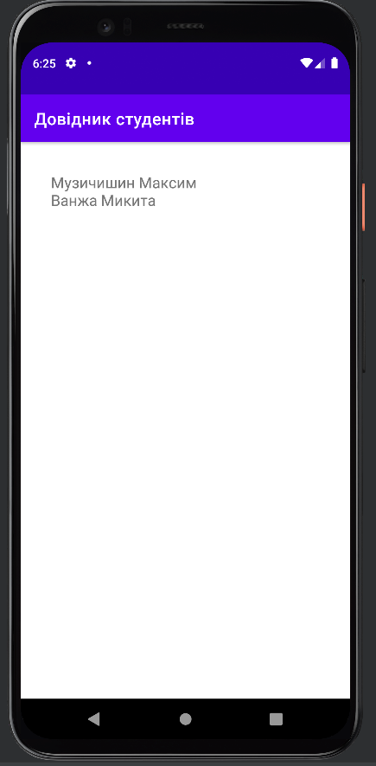

Відправка листа із списком студентів через пошту

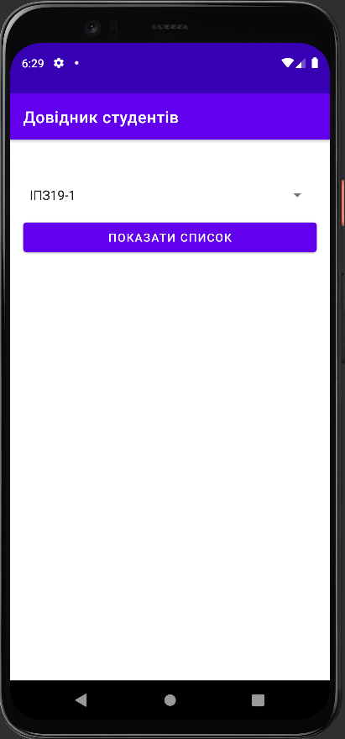

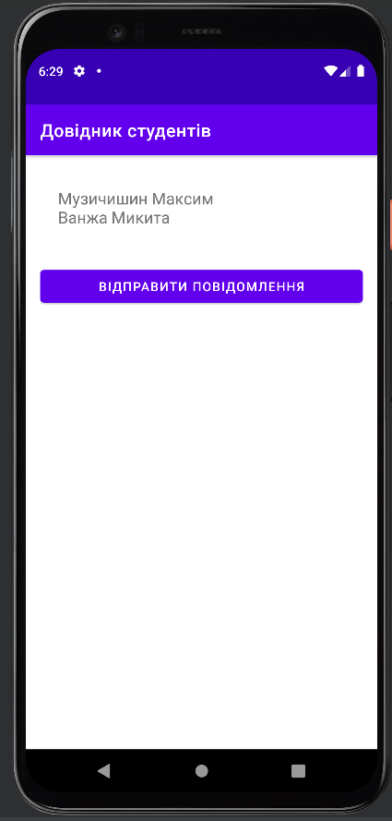

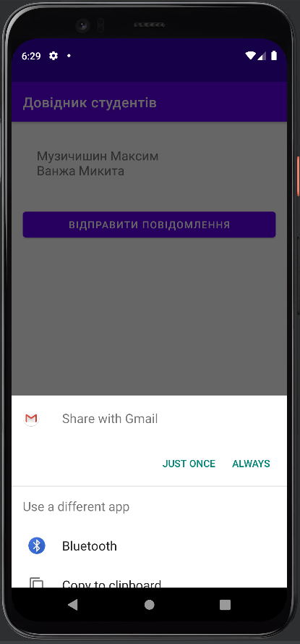

MainActivity

package com.example.students3;  
  
import androidx.appcompat.app.AppCompatActivity;  
  
import android.content.Intent;  
import android.os.Bundle;  
import android.view.View;  
import android.widget.Spinner;  
import android.widget.TextView;  
import android.widget.Toast;  
  
public class MainActivity extends AppCompatActivity {  
  
 @Override  
 protected void onCreate(Bundle savedInstanceState) {  
 super.onCreate(savedInstanceState);  
 setContentView(R.layout.*activity_main*);  
 }  
  
 public void onBtnClick(View view){  
 Spinner spinner = (Spinner) findViewById(R.id.*spinner*);  
 String grpNumb = (String) spinner.getSelectedItem();  
  
 Intent intent = new Intent(this, StudentsListActivity.class);  
 intent.putExtra(StudentsListActivity.*GROUP_NUMBER*, grpNumb);  
 startActivity(intent);  
 }  
}

Student

package com.example.students3;  
  
import java.util.ArrayList;  
import java.util.Arrays;  
  
public class Student {  
 private String name;  
 private String groupNumber;  
  
 public Student(String name, String groupNumber){  
 this.name = name;  
 this.groupNumber = groupNumber;  
 }  
  
 public String getName(){  
 return name;  
 }  
  
 public String getGroupNumber(){  
 return groupNumber;  
 }  
  
 public final static ArrayList<Student> *students* = new ArrayList<>(  
 Arrays.*asList*(  
 new Student("Музичишин Максим", "ІПЗ19-1"),  
 new Student("Ванжа Микита", "ІПЗ19-1"),  
 new Student("Пупкін Петр", "ІПЗ19-2"),  
 new Student("Веделкин Валентин", "ІПЗ19-2")  
 )  
 );  
  
 public static ArrayList<Student> getStudents(String groupNumber){  
 ArrayList<Student> stList = new ArrayList<>();  
 for (Student s : *students*){  
 if(s.getGroupNumber().equals(groupNumber)){  
 stList.add(s);  
 }  
 }  
  
 return stList;  
 }  
}

StudentsListActivity

package com.example.students3;  
  
import androidx.appcompat.app.AppCompatActivity;  
  
import android.content.Intent;  
import android.os.Bundle;  
import android.view.View;  
import android.widget.TextView;  
  
public class StudentsListActivity extends AppCompatActivity {  
  
 public static final String *GROUP_NUMBER* = "groupnumber";  
  
 @Override  
 protected void onCreate(Bundle savedInstanceState) {  
 super.onCreate(savedInstanceState);  
 setContentView(R.layout.*activity_students_list*);  
  
 Intent intent = getIntent();  
 String grpNumber = intent.getStringExtra(*GROUP_NUMBER*);  
  
 String txtStudents = "";  
 for (Student s : Student.*getStudents*(grpNumber)){  
 txtStudents += s.getName() + "\n";  
 }  
  
 TextView textView = (TextView) findViewById(R.id.*text*);  
 textView.setText(txtStudents);  
 }  
  
 public void onSendBtnClick(View view){  
 TextView textView = (TextView) findViewById(R.id.*text*);  
  
 Intent intent = new Intent(Intent.*ACTION_SEND*);  
 intent.setType("text/plain");  
 intent.putExtra(Intent.*EXTRA_TEXT*, textView.getText().toString());  
 intent.putExtra(Intent.*EXTRA_SUBJECT*, "Список студентів");  
 startActivity(intent);  
 }  
}

activity_main.xml

<?xml version="1.0" encoding="utf-8"?>  
<LinearLayout  
 xmlns:android="http://schemas.android.com/apk/res/android"  
 xmlns:app="http://schemas.android.com/apk/res-auto"  
 xmlns:tools="http://schemas.android.com/tools"  
 android:layout_width="match_parent"  
 android:layout_height="match_parent"  
 android:padding="16dp"  
 android:orientation="vertical"  
 tools:context=".MainActivity">  
  
 <Spinner  
 android:id="@+id/spinner"  
 android:layout_width="match_parent"  
 android:layout_height="wrap_content"  
 android:layout_marginTop="40dp"  
 android:layout_marginBottom="16dp"  
 android:gravity="center"  
 android:entries="@array/students_groups"/>  
  
 <Button  
 android:id="@+id/button3"  
 android:layout_width="match_parent"  
 android:layout_height="wrap_content"  
 android:text="@string/btn_text"  
 android:layout_marginBottom="16dp"  
 android:onClick="onBtnClick"/>  
  
</LinearLayout>

activity_students_list.xml

<?xml version="1.0" encoding="utf-8"?>  
<LinearLayout  
 xmlns:android="http://schemas.android.com/apk/res/android"  
 xmlns:app="http://schemas.android.com/apk/res-auto"  
 xmlns:tools="http://schemas.android.com/tools"  
 android:layout_width="match_parent"  
 android:layout_height="match_parent"  
 tools:context=".StudentsListActivity"  
 android:orientation="vertical"  
 android:padding="16dp">  
  
 <TextView  
 android:id="@+id/text"  
 android:layout_width="wrap_content"  
 android:layout_height="wrap_content"  
 android:layout_margin="20dp"  
 android:text="@string/default_text"  
 android:textSize="18sp"/>  
  
 <Button  
 android:id="@+id/sendBtn"  
 android:layout_width="match_parent"  
 android:layout_height="wrap_content"  
 android:text="@string/btn_send"  
 android:layout_marginBottom="16dp"  
 android:onClick="onSendBtnClick"/>  
  
</LinearLayout>

strings.xml

<resources>  
 <string name="app_name">Довідник студентів</string>  
 <string name="btn_text">Показати список</string>  
 <string name="default_text">Список студентів</string>  
  
 <string-array name="students_groups">  
 <item>ІПЗ19-1</item>  
 <item>ІПЗ19-2</item>  
 </string-array>  
  
 <string name="btn_send">Відправити повідомлення</string>  
</resources>

**1.4. Життєвий цикл активності**

Використання кнопки для зміни розміру шрифту

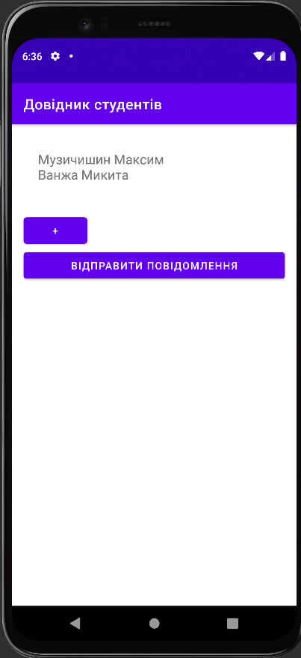

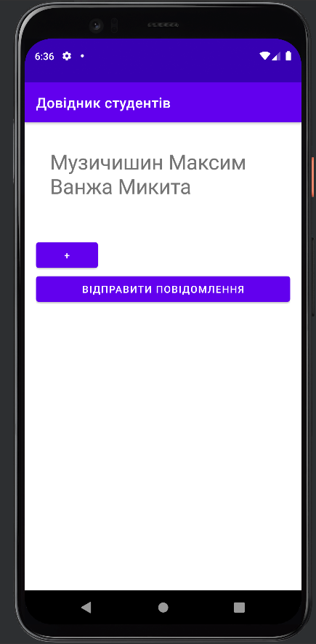

Продовження роботи таймера під час переходу на іншу активність

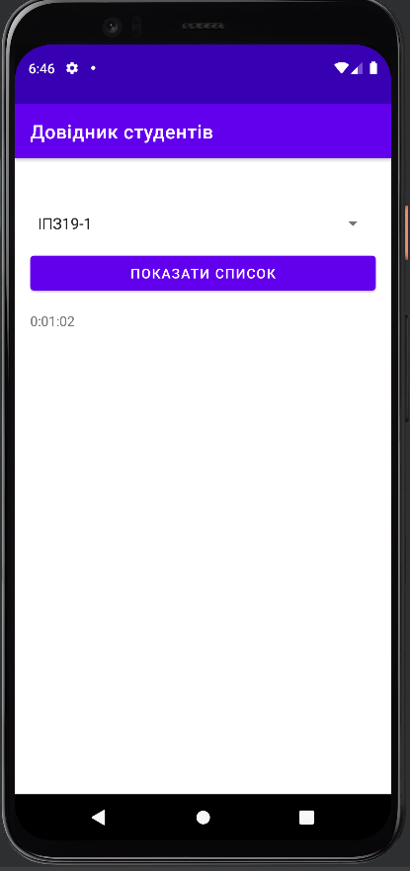

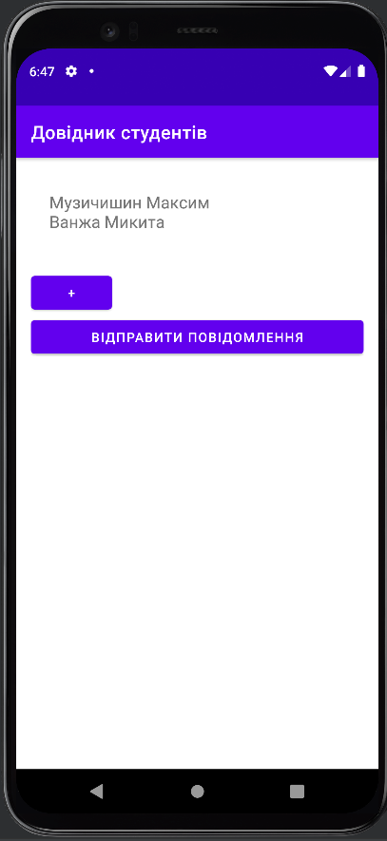

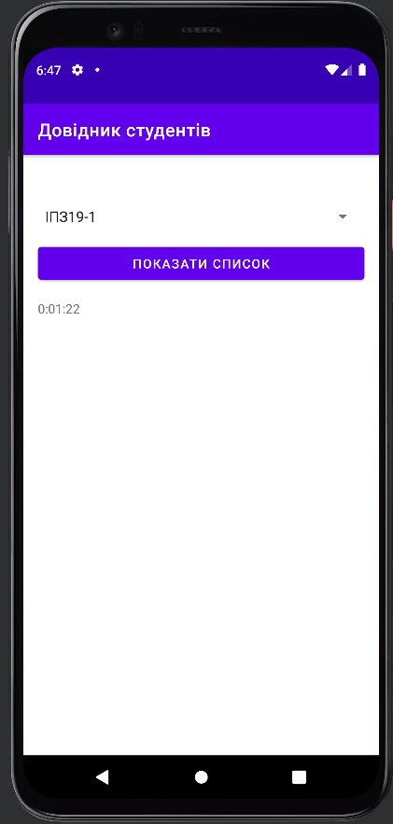

Зупинка таймера при зміні активності

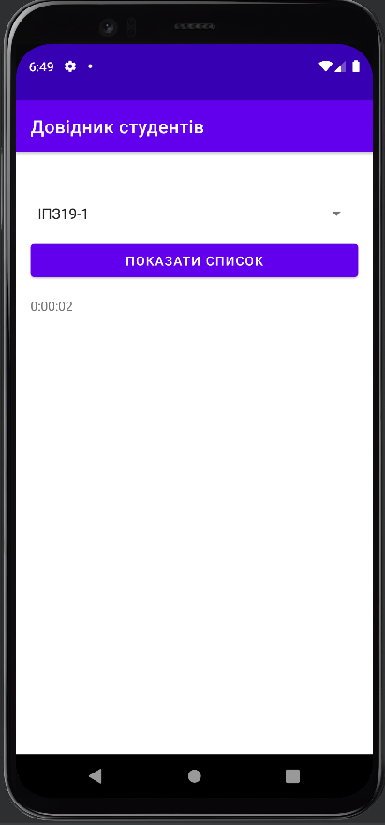

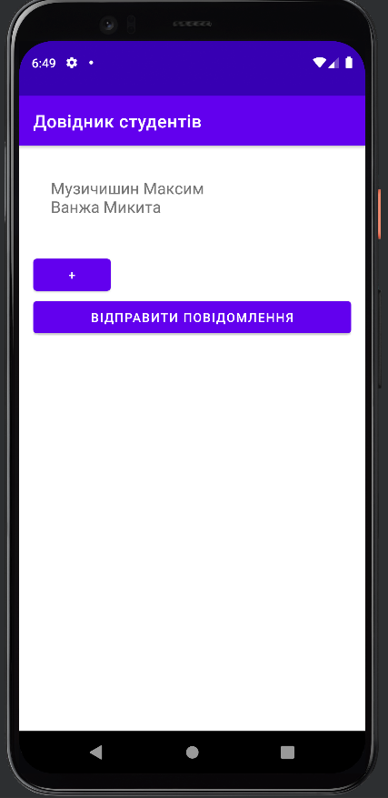



MainActivity

package com.example.students3;  
  
import androidx.appcompat.app.AppCompatActivity;  
  
import android.content.Intent;  
import android.os.Bundle;  
import android.os.Handler;  
import android.view.View;  
import android.widget.Spinner;  
import android.widget.TextView;  
  
import java.util.Locale;  
  
public class MainActivity extends AppCompatActivity {  
  
 private int seconds = 0;  
 private Boolean isRunning = true;  
  
 @Override  
 protected void onCreate(Bundle savedInstanceState) {  
 super.onCreate(savedInstanceState);  
 setContentView(R.layout.*activity_main*);  
  
 if(savedInstanceState != null){  
 seconds = savedInstanceState.getInt("seconds");  
 }  
  
 runTimer();  
 }  
  
 @Override  
 protected void onStart(){  
 super.onStart();  
 isRunning = true;  
 }  
  
 @Override  
 protected void onStop(){  
 super.onStop();  
 isRunning = false;  
 }  
  
 @Override  
 protected void onSaveInstanceState(Bundle outState){  
 super.onSaveInstanceState(outState);  
 outState.putFloat("seconds", seconds);  
 }  
  
 public void onBtnClick(View view){  
 Spinner spinner = (Spinner) findViewById(R.id.*spinner*);  
 String grpNumb = (String) spinner.getSelectedItem();  
  
 Intent intent = new Intent(this, StudentsListActivity.class);  
 intent.putExtra(StudentsListActivity.*GROUP_NUMBER*, grpNumb);  
 startActivity(intent);  
 }  
  
 private void runTimer(){  
 final TextView timeView = (TextView) findViewById(R.id.*textView*);  
 final Handler handler = new Handler();  
  
 handler.post(new Runnable() {  
 @Override  
 public void run() {  
 int hours = seconds/3600;  
 int minutes = (seconds%3600)/60;  
 int secs = seconds%60;  
  
 String time = String.*format*(Locale.*getDefault*(),  
 "%d:%02d:%02d", hours, minutes, secs);  
 timeView.setText(time);  
  
 if(isRunning){  
 seconds++;  
 }  
  
 handler.postDelayed(this, 1000);  
 }  
 });  
 }  
}

Student

package com.example.students3;  
  
import java.util.ArrayList;  
import java.util.Arrays;  
  
public class Student {  
 private String name;  
 private String groupNumber;  
  
 public Student(String name, String groupNumber){  
 this.name = name;  
 this.groupNumber = groupNumber;  
 }  
  
 public String getName(){  
 return name;  
 }  
  
 public String getGroupNumber(){  
 return groupNumber;  
 }  
  
 public final static ArrayList<Student> *students* = new ArrayList<>(  
 Arrays.*asList*(  
 new Student("Музичишин Максим", "ІПЗ19-1"),  
 new Student("Ванжа Микита", "ІПЗ19-1"),  
 new Student("Пупкін Петр", "ІПЗ19-2"),  
 new Student("Веделкин Валентин", "ІПЗ19-2")  
 )  
 );  
  
 public static ArrayList<Student> getStudents(String groupNumber){  
 ArrayList<Student> stList = new ArrayList<>();  
 for (Student s : *students*){  
 if(s.getGroupNumber().equals(groupNumber)){  
 stList.add(s);  
 }  
 }  
  
 return stList;  
 }  
}

StudentsListActivity

package com.example.students3;  
  
import androidx.appcompat.app.AppCompatActivity;  
  
import android.content.Intent;  
import android.os.Bundle;  
import android.util.TypedValue;  
import android.view.View;  
import android.widget.TextView;  
  
public class StudentsListActivity extends AppCompatActivity {  
  
 public static final String GROUP_NUMBER = "groupnumber";  
  
 private float textSize = 0;  
  
 @Override  
 protected void onCreate(Bundle savedInstanceState) {  
 super.onCreate(savedInstanceState);  
 setContentView(R.layout.*activity_students_list*);  
  
 Intent intent = getIntent();  
 String grpNumber = intent.getStringExtra(*GROUP_NUMBER*);  
  
 String txtStudents = "";  
 for (Student s : Student.getStudents(grpNumber)){  
 txtStudents += s.getName() + "\n";  
 }  
  
 TextView textView = (TextView) findViewById(R.id.text);  
 textView.setText(txtStudents);  
  
 textSize = textView.getTextSize();  
 if(savedInstanceState != null){  
 textSize = savedInstanceState.getFloat("textSize");  
 }  
 }  
  
 @Override  
 protected void onSaveInstanceState(Bundle outState){  
 super.onSaveInstanceState(outState);  
 outState.putFloat("textSize", textSize);  
 }  
  
 public void onSendBtnClick(View view){  
 TextView textView = (TextView) findViewById(R.id.text);  
  
 Intent intent = new Intent(Intent.ACTION_SEND);  
 intent.setType("text/plain");  
 intent.putExtra(Intent.EXTRA_TEXT, textView.getText().toString());  
 intent.putExtra(Intent.EXTRA_SUBJECT, "Список студентів");  
 startActivity(intent);  
 }  
  
 public void onPlusBtnClick(View view){  
 textSize = textSize * 1.1f;  
  
 TextView textView = findViewById(R.id.text);  
 textView.setTextSize(TypedValue.COMPLEX_UNIT_PX, textSize);  
 }  
}

activity_main.xml

<?xml version="1.0" encoding="utf-8"?>  
<LinearLayout  
 xmlns:android="http://schemas.android.com/apk/res/android"  
 xmlns:app="http://schemas.android.com/apk/res-auto"  
 xmlns:tools="http://schemas.android.com/tools"  
 android:layout_width="match_parent"  
 android:layout_height="match_parent"  
 android:padding="16dp"  
 android:orientation="vertical"  
 tools:context=".MainActivity">  
  
 <Spinner  
 android:id="@+id/spinner"  
 android:layout_width="match_parent"  
 android:layout_height="wrap_content"  
 android:layout_marginTop="40dp"  
 android:layout_marginBottom="16dp"  
 android:gravity="center"  
 android:entries="@array/students_groups"/>  
  
 <Button  
 android:id="@+id/button3"  
 android:layout_width="match_parent"  
 android:layout_height="wrap_content"  
 android:text="@string/btn_text"  
 android:layout_marginBottom="16dp"  
 android:onClick="onBtnClick"/>  
  
 <TextView  
 android:id="@+id/textView"  
 android:layout_width="match_parent"  
 android:layout_height="wrap_content"  
 android:text="TextView" />  
  
</LinearLayout>

activity_students_list.xml

<?xml version="1.0" encoding="utf-8"?>  
<LinearLayout  
 xmlns:android="http://schemas.android.com/apk/res/android"  
 xmlns:app="http://schemas.android.com/apk/res-auto"  
 xmlns:tools="http://schemas.android.com/tools"  
 android:layout_width="match_parent"  
 android:layout_height="match_parent"  
 tools:context=".StudentsListActivity"  
 android:orientation="vertical"  
 android:padding="16dp">  
  
 <TextView  
 android:id="@+id/text"  
 android:layout_width="wrap_content"  
 android:layout_height="wrap_content"  
 android:layout_margin="20dp"  
 android:text="@string/default_text"  
 android:textSize="18sp"/>  
  
 <Button  
 android:id="@+id/btnPlus"  
 android:layout_width="wrap_content"  
 android:layout_height="wrap_content"  
 android:text="+"  
 android:onClick="onPlusBtnClick"/>  
  
 <Button  
 android:id="@+id/sendBtn"  
 android:layout_width="match_parent"  
 android:layout_height="wrap_content"  
 android:text="@string/btn_send"  
 android:layout_marginBottom="16dp"  
 android:onClick="onSendBtnClick"/>  
  
</LinearLayout>

strings.xml

<resources>  
 <string name="app_name">Довідник студентів</string>  
 <string name="btn_text">Показати список</string>  
 <string name="default_text">Список студентів</string>  
  
 <string-array name="students_groups">  
 <item>ІПЗ19-1</item>  
 <item>ІПЗ19-2</item>  
 </string-array>  
  
 <string name="btn_send">Відправити повідомлення</string>  
</resources>