ЛАБОРАТОРНА РОБОТА №4

Макети та розробка інтерфейсів

Відображення даних по студентській групі

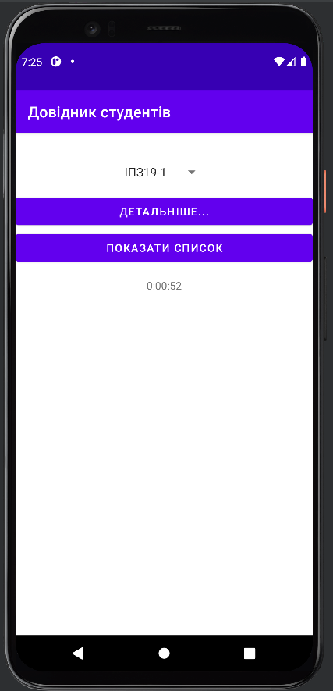

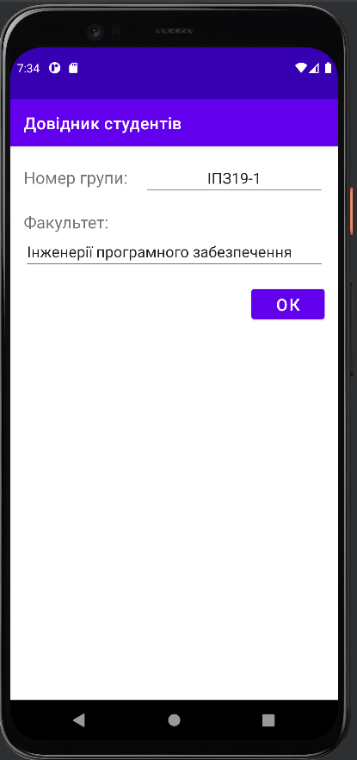

Зовнішній вигляд активності після додавання зображення

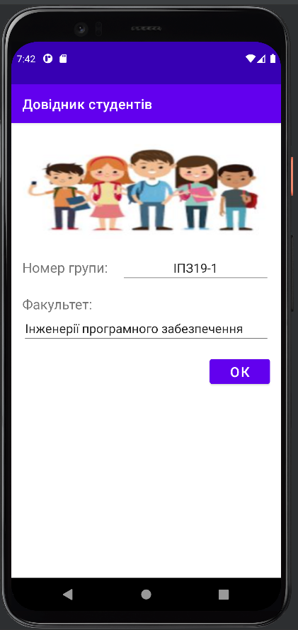

Додавання номеру групи та назви факультету поверх картинки

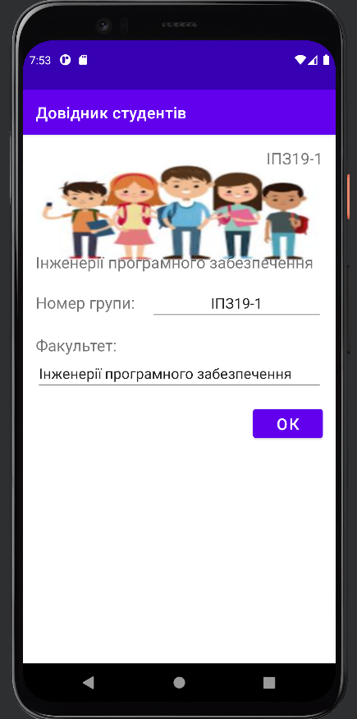

Додаємо рівень освіти та відомості про те, чи є пільговики та контрактники серед студентів групи

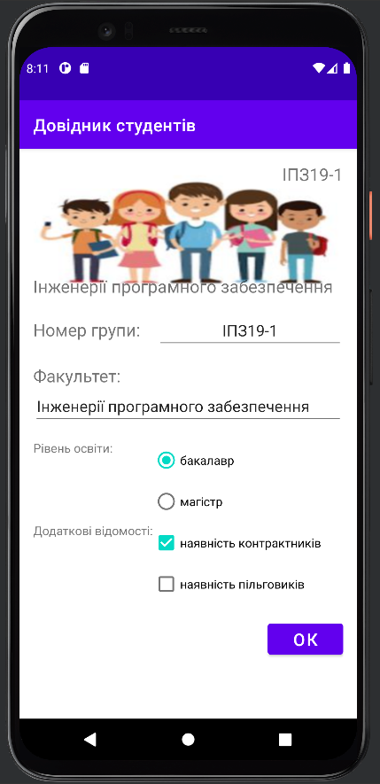

По натисканню на кнопку ОК виводимо повідомлення із значеннями всіх компонентів нашої активності

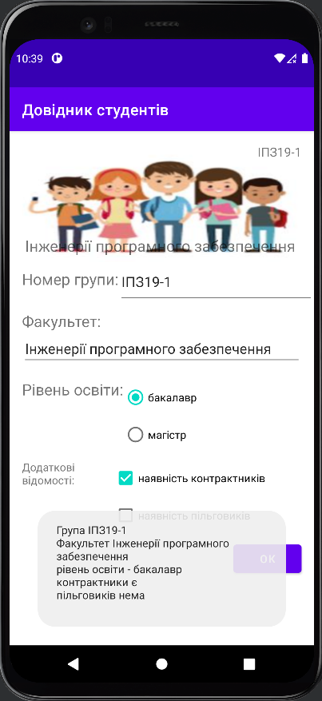

2. Макети з обмеженнями

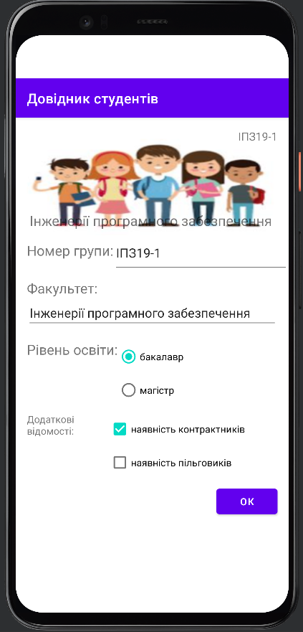

**MainActivity**

package com.example.students;  
  
import androidx.appcompat.app.AppCompatActivity;  
  
import android.content.Intent;  
import android.os.Bundle;  
import android.os.Handler;  
import android.view.View;  
import android.widget.Spinner;  
import android.widget.TextView;  
import android.widget.Toast;  
  
import org.w3c.dom.Text;  
  
import java.util.Locale;  
  
public class MainActivity extends AppCompatActivity {  
  
 private int seconds = 0;  
 private Boolean isRunning = true;  
  
 @Override  
 protected void onCreate(Bundle savedInstanceState) {  
 super.onCreate(savedInstanceState);  
 setContentView(R.layout.*activity_main*);  
  
 if(savedInstanceState != null){  
 seconds = savedInstanceState.getInt("seconds");  
 }  
  
 runTimer();  
 }  
  
 @Override  
 protected void onSaveInstanceState(Bundle outState){  
 super.onSaveInstanceState(outState);  
 outState.putInt("seconds", seconds);  
 }  
  
 @Override  
 protected void onStart(){  
 super.onStart();  
 isRunning = true;  
 }  
  
 @Override  
 protected void onStop(){  
 super.onStop();  
 isRunning = false;  
 }  
  
 public void onBtnClick(View view){  
 Spinner spinner = (Spinner) findViewById(R.id.*spinner*);  
 String grpNumb = (String) spinner.getSelectedItem();  
  
 Intent intent = new Intent(this, StudentsListActivity.class);  
 intent.putExtra(StudentsListActivity.*GROUP_NUMBER*, grpNumb);  
 startActivity(intent);  
 }  
  
 private void runTimer(){  
 final TextView timeView = (TextView) findViewById(R.id.*textView*);  
 final Handler handler = new Handler();  
 handler.post(new Runnable() {  
 @Override  
 public void run() {  
 int hours = seconds / 3600;  
 int minutes = (seconds%3600)/60;  
 int secs = seconds%60;  
 String time = String.*format*(Locale.*getDefault*(), "%d:%02d:%02d", hours, minutes, secs);  
 timeView.setText(time);  
  
 if(isRunning){  
 seconds++;  
 }  
  
 handler.postDelayed(this, 1000);  
 }  
 });  
 }  
  
 public void onGrpBtnClick(View view){  
 Spinner spinner = (Spinner) findViewById(R.id.*spinner*);  
 String grpNumb = (String) spinner.getSelectedItem();  
  
 Intent intent = new Intent(this, StudentsGroupActivity.class);  
 intent.putExtra(StudentsGroupActivity.*GROUP_NUMBER*, grpNumb);  
  
 startActivity(intent);  
 }  
}

**Student**

package com.example.students;  
  
import java.util.ArrayList;  
import java.util.Arrays;  
  
public class Student {  
 private String name;  
 private String groupNumber;  
  
 public Student(String name, String groupNumber){  
 this.name = name;  
 this.groupNumber = groupNumber;  
 }  
  
 public String getName(){  
 return name;  
 }  
  
 public String getGroupNumber(){  
 return groupNumber;  
 }  
  
 private final static ArrayList<Student> *students* = new ArrayList<Student>(  
 Arrays.*asList*(  
 new Student("Музичишин Максим", "ІПЗ19-1"),  
 new Student("Ванжа Микита", "ІПЗ19-1"),  
 new Student("Пупкін Петр", "ІПЗ19-2"),  
 new Student("Свергун Антон", "ІПЗ19-2")  
 )  
 );  
  
 public static ArrayList<Student> getStudents(String groupNumber){  
 ArrayList<Student> stList = new ArrayList<>();  
  
 for (Student s : *students*){  
 if(s.getGroupNumber().equals(groupNumber)){  
 stList.add(s);  
 }  
 }  
  
 return stList;  
 }  
}

**StudentGroup**

package com.example.students;  
  
import java.util.ArrayList;  
import java.util.Arrays;  
  
public class StudentsGroup {  
 private String number;  
 private String facultyName;  
 private int educationLevel;  
 private boolean contractExistsFlg;  
 private boolean privilageExistsFlg;  
  
 public StudentsGroup(String number, String facultyName,  
 int educationLevel, boolean contractExistsFlg, boolean privilageExistsFlg){  
 this.number = number;  
 this.facultyName = facultyName;  
 this.educationLevel = educationLevel;  
 this.contractExistsFlg = contractExistsFlg;  
 this.privilageExistsFlg = privilageExistsFlg;  
 }  
  
 public String getNumber(){  
 return number;  
 }  
  
 public String getFacultyName(){  
 return facultyName;  
 }  
  
 public int getEducationLevel(){  
 return educationLevel;  
 }  
  
 public boolean isContractExistsFlg(){  
 return contractExistsFlg;  
 }  
  
 public boolean isPrivilageExistsFlg(){  
 return privilageExistsFlg;  
 }  
  
 private final static ArrayList<StudentsGroup> *groups* = new ArrayList<StudentsGroup>(  
 Arrays.asList(  
 new StudentsGroup("ІПЗ19-1", "Інженерії програмного забезпечення", 0, true, false),  
 new StudentsGroup("ІПЗ19-2", "Інженерії програмного забезпечення", 0, true, false)  
 )  
 );  
  
 public static StudentsGroup getGroup(String groupNumber){  
 for (StudentsGroup g: groups){  
 if(g.getNumber().equals(groupNumber)){  
 return g;  
 }  
 }  
 return null;  
 }  
}

**StudentGroupActivity**

package com.example.students;  
  
import androidx.appcompat.app.AppCompatActivity;  
  
import android.content.Intent;  
import android.os.Bundle;  
import android.view.Gravity;  
import android.view.View;  
import android.widget.CheckBox;  
import android.widget.EditText;  
import android.widget.RadioButton;  
import android.widget.TextView;  
import android.widget.Toast;  
  
import org.w3c.dom.Text;  
  
public class StudentsGroupActivity extends AppCompatActivity {  
  
 public static final String *GROUP_NUMBER* = "groupnumber";  
  
 @Override  
 protected void onCreate(Bundle savedInstanceState) {  
 super.onCreate(savedInstanceState);  
 setContentView(R.layout.*activity_students_group2*);  
  
 Intent intent = getIntent();  
 String grpNumber = intent.getStringExtra(*GROUP_NUMBER*);  
 StudentsGroup group = StudentsGroup.*getGroup*(grpNumber);  
  
 EditText txtGrpNumber = (EditText) findViewById(R.id.*grpNumberEdit*);  
 txtGrpNumber.setText(group.getNumber());  
  
 EditText txtFacultyName = (EditText) findViewById(R.id.*facultyEdit*);  
 txtFacultyName.setText(group.getFacultyName());  
  
 TextView txtImgGrp = (TextView) findViewById(R.id.*grpNumberImageTxt*);  
 txtImgGrp.setText(group.getNumber());  
  
 TextView txtImgFaculty = (TextView) findViewById(R.id.*facultyNameImageTxt*);  
 txtImgFaculty.setText(group.getFacultyName());  
  
 if(group.getEducationLevel() == 0){  
 ((RadioButton) findViewById(R.id.*edu_level_bachelor*)).setChecked(true);  
 }  
 else{  
 ((RadioButton) findViewById(R.id.*edu_level_master*)).setChecked(true);  
 }  
  
 ((CheckBox) findViewById(R.id.*contract_flg*)).setChecked(group.isContractExistsFlg());  
 ((CheckBox) findViewById(R.id.*privelege_flg*)).setChecked(group.isPrivilageExistsFlg());  
 }  
  
 public void onOkBtnClick(View view){  
 String outString = "Група " + ((TextView) findViewById(R.id.*grpNumberEdit*)).getText() + "\n";  
 outString += "Факультет " + ((TextView) findViewById(R.id.*facultyEdit*)).getText() + "\n";  
  
 if(((RadioButton) findViewById(R.id.*edu_level_master*)).isChecked()){  
 outString += "рівень освіти - " + "магістр\n";  
 }  
 else{  
 outString += "рівень освіти - " + "бакалавр\n";  
 }  
  
 if(((CheckBox) findViewById(R.id.*contract_flg*)).isChecked()){  
 outString += "контрактники є\n";  
 }  
 else{  
 outString += "контрактників нема\n";  
 }  
  
 if(((CheckBox) findViewById(R.id.*privelege_flg*)).isChecked()){  
 outString += "пільговики є\n";  
 }  
 else{  
 outString += "пільговиків нема\n";  
 }  
  
 Toast toast = Toast.*makeText*(getApplicationContext(), outString, Toast.*LENGTH_LONG*);  
 toast.setGravity(Gravity.*CENTER*, 0, 0);  
 toast.show();  
 }  
}

**StudentsListActivity**

package com.example.students;  
  
import androidx.appcompat.app.AppCompatActivity;  
  
import android.content.Intent;  
import android.os.Bundle;  
import android.util.TypedValue;  
import android.view.View;  
import android.widget.TextView;  
  
public class StudentsListActivity extends AppCompatActivity {  
  
 public static final String GROUP_NUMBER = "groupnumber";  
 private float textSize = 0;  
  
 @Override  
 protected void onCreate(Bundle savedInstanceState) {  
 super.onCreate(savedInstanceState);  
 setContentView(R.layout.activity_students_list);  
  
 Intent intent = getIntent();  
 String grpNumb = intent.getStringExtra(GROUP_NUMBER);  
  
 String txtStudents = "";  
 for (Student s : Student.*getStudents*(grpNumb)){  
 txtStudents += s.getName() + "\n";  
 }  
  
 TextView textView = (TextView) findViewById(R.id.*text*);  
 textView.setText(txtStudents);  
  
 textSize = textView.getTextSize();  
 if(savedInstanceState != null){  
 textSize = savedInstanceState.getFloat("textSize");  
 }  
 }  
  
 @Override  
 protected void onSaveInstanceState(Bundle outState){  
 super.onSaveInstanceState(outState);  
 outState.putFloat("textSize", textSize);  
 }  
  
 public void onSendBtnClick(View view){  
 TextView textView = (TextView) findViewById(R.id.text);  
  
 Intent intent = new Intent(Intent.ACTION_SEND);  
 intent.setType("text/plain");  
 intent.putExtra(Intent.EXTRA_TEXT, textView.getText().toString());  
 intent.putExtra(Intent.EXTRA_SUBJECT, "Список студентів");  
 startActivity(intent);  
 }  
  
 public void onPlusBtnClick(View view){  
 textSize = textSize * 1.1f;  
 TextView textView = findViewById(R.id.text);  
 textView.setTextSize(TypedValue.COMPLEX_UNIT_PX, textSize);  
 }  
}

**activity_main.xml**

<?xml version="1.0" encoding="utf-8"?>  
<androidx.constraintlayout.widget.ConstraintLayout xmlns:android="http://schemas.android.com/apk/res/android"  
 xmlns:app="http://schemas.android.com/apk/res-auto"  
 xmlns:tools="http://schemas.android.com/tools"  
 android:layout_width="match_parent"  
 android:layout_height="match_parent"  
 tools:context=".MainActivity">  
  
 <LinearLayout  
 android:layout_width="match_parent"  
 android:layout_height="match_parent"  
 android:orientation="vertical">  
  
 <Spinner  
 android:id="@+id/spinner"  
 android:layout_width="wrap_content"  
 android:layout_height="wrap_content"  
 android:layout_gravity="center"  
 android:layout_marginTop="40dp"  
 android:layout_marginBottom="16dp"  
 android:entries="@array/students_groups"/>  
  
 <Button  
 android:id="@+id/btn_grp_detail"  
 android:layout_width="match_parent"  
 android:layout_height="wrap_content"  
 android:text="@string/btn_grp_detail_text"  
 android:onClick="onGrpBtnClick"/>  
  
 <Button  
 android:id="@+id/button"  
 android:layout_width="match_parent"  
 android:layout_height="wrap_content"  
 android:text="@string/button_text"  
 android:layout_marginBottom="16dp"  
 android:onClick="onBtnClick"/>  
  
 <TextView  
 android:id="@+id/textView"  
 android:layout_width="wrap_content"  
 android:layout_height="wrap_content"  
 android:layout_gravity="center"  
 android:text="00:00:00" />  
  
 </LinearLayout>  
  
</androidx.constraintlayout.widget.ConstraintLayout>

**activity_students_group_xml**

<?xml version="1.0" encoding="utf-8"?>  
<androidx.constraintlayout.widget.ConstraintLayout xmlns:android="http://schemas.android.com/apk/res/android"  
 xmlns:app="http://schemas.android.com/apk/res-auto"  
 xmlns:tools="http://schemas.android.com/tools"  
 android:layout_width="match_parent"  
 android:layout_height="match_parent"  
 tools:context=".StudentsGroupActivity">  
  
 <LinearLayout  
 android:layout_width="match_parent"  
 android:layout_height="match_parent"  
 android:orientation="vertical"  
 android:padding="@dimen/default_padding">  
  
 <FrameLayout  
 android:layout_width="match_parent"  
 android:layout_height="wrap_content">  
  
 <ImageView  
 android:layout_width="match_parent"  
 android:layout_height="wrap_content"  
 android:scaleType="fitXY"  
 android:src="@drawable/group"  
 android:layout_marginBottom="20dp"/>  
  
 <TextView  
 android:id="@+id/grpNumberImageTxt"  
 android:layout_width="wrap_content"  
 android:layout_height="wrap_content"  
 android:text="@string/group_name"  
 android:layout_gravity="top|end"  
 android:textSize="@dimen/default_text_size"/>  
  
 <TextView  
 android:id="@+id/facultyNameImageTxt"  
 android:layout_width="wrap_content"  
 android:layout_height="wrap_content"  
 android:text="@string/faculty_text"  
 android:layout_gravity="bottom|start"  
 android:textSize="@dimen/default_text_size"  
 android:layout_marginBottom="@dimen/default_padding"/>  
  
 </FrameLayout>  
  
 <LinearLayout  
 android:layout_width="match_parent"  
 android:layout_height="wrap_content"  
 android:orientation="horizontal">  
  
 <TextView  
 android:layout_width="0dp"  
 android:layout_height="wrap_content"  
 android:layout_weight="2"  
 android:text="@string/group_number_text"  
 android:textSize="@dimen/default_text_size"/>  
  
 <EditText  
 android:id="@+id/grpNumberEdit"  
 android:layout_width="0dp"  
 android:layout_height="wrap_content"  
 android:layout_weight="3"  
 android:ems="10"  
 android:inputType="textPersonName"  
 android:gravity="center" />  
 </LinearLayout>  
  
 <TextView  
 android:layout_width="match_parent"  
 android:layout_height="wrap_content"  
 android:text="@string/faculty_text"  
 android:textSize="@dimen/default_text_size"  
 android:layout_marginTop="@dimen/default_padding"/>  
  
 <EditText  
 android:id="@+id/facultyEdit"  
 android:layout_width="match_parent"  
 android:layout_height="wrap_content"  
 android:ems="10"  
 android:inputType="textPersonName" />  
  
 <TableLayout  
 android:layout_width="match_parent"  
 android:layout_height="wrap_content">  
  
 <TableRow  
 android:layout_width="match_parent"  
 android:layout_height="wrap_content"  
 android:layout_marginTop="@dimen/default_padding">  
  
 <TextView  
 android:text="@string/edu_level_txt"/>  
 <RadioGroup>  
 <RadioButton  
 android:id="@+id/edu_level_bachelor"  
 android:layout_width="wrap_content"  
 android:layout_height="wrap_content"  
 android:text="@string/edu_level_bachelor_txt"/>  
 <RadioButton  
 android:id="@+id/edu_level_master"  
 android:layout_width="wrap_content"  
 android:layout_height="wrap_content"  
 android:text="@string/edu_level_master_txt"/>  
 </RadioGroup>  
 </TableRow>  
 <TableRow  
 android:layout_width="match_parent"  
 android:layout_height="wrap_content">  
  
 <TextView  
 android:text="@string/additional_flg_txt"/>  
 <LinearLayout  
 android:layout_width="match_parent"  
 android:layout_height="wrap_content"  
 android:orientation="vertical">  
 <CheckBox  
 android:id="@+id/contract_flg"  
 android:layout_width="wrap_content"  
 android:layout_height="wrap_content"  
 android:text="@string/contract_flg_txt"/>  
 <CheckBox  
 android:id="@+id/privelege_flg"  
 android:layout_width="wrap_content"  
 android:layout_height="wrap_content"  
 android:text="@string/privilege_flg_txt"/>  
 </LinearLayout>  
 </TableRow>  
 </TableLayout>  
  
 <Button  
 android:id="@+id/btnOk"  
 android:layout_width="wrap_content"  
 android:layout_height="wrap_content"  
 android:text="@string/btn_ok_text"  
 android:layout_gravity="end"  
 android:layout_marginTop="@dimen/default_padding"  
 android:textSize="@dimen/default_text_size"  
 android:onClick="onOkBtnClick"/>  
 </LinearLayout>  
  
</androidx.constraintlayout.widget.ConstraintLayout>

**activity_students_list.xml**

<?xml version="1.0" encoding="utf-8"?>  
<androidx.constraintlayout.widget.ConstraintLayout xmlns:android="http://schemas.android.com/apk/res/android"  
 xmlns:app="http://schemas.android.com/apk/res-auto"  
 xmlns:tools="http://schemas.android.com/tools"  
 android:layout_width="match_parent"  
 android:layout_height="match_parent"  
 tools:context=".StudentsListActivity">  
  
 <LinearLayout  
 android:layout_width="match_parent"  
 android:layout_height="match_parent"  
 android:orientation="vertical">  
  
 <TextView  
 android:id="@+id/text"  
 android:layout_width="wrap_content"  
 android:layout_height="wrap_content"  
 android:text="@string/default_text"  
 android:textSize="18sp" />  
  
 <Button  
 android:id="@+id/btnPlus"  
 android:layout_width="wrap_content"  
 android:layout_height="wrap_content"  
 android:text="+"  
 android:onClick="onPlusBtnClick"/>  
  
 <Button  
 android:id="@+id/btnSend"  
 android:layout_width="match_parent"  
 android:layout_height="wrap_content"  
 android:text="@string/button_send"  
 android:layout_marginBottom="16dp"  
 android:onClick="onSendBtnClick"/>  
  
 </LinearLayout>  
</androidx.constraintlayout.widget.ConstraintLayout>