ЛАБОРАТОРНА РОБОТА №5

**Тема:** Організація застосунків. Спискові представлення

Активність верхнього рівня та активність категорій

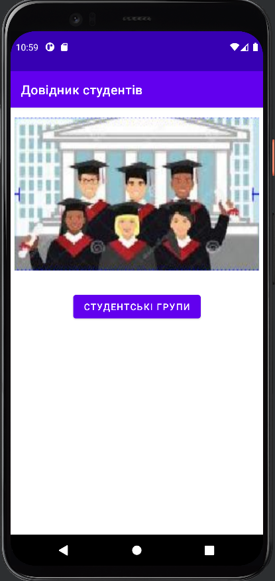

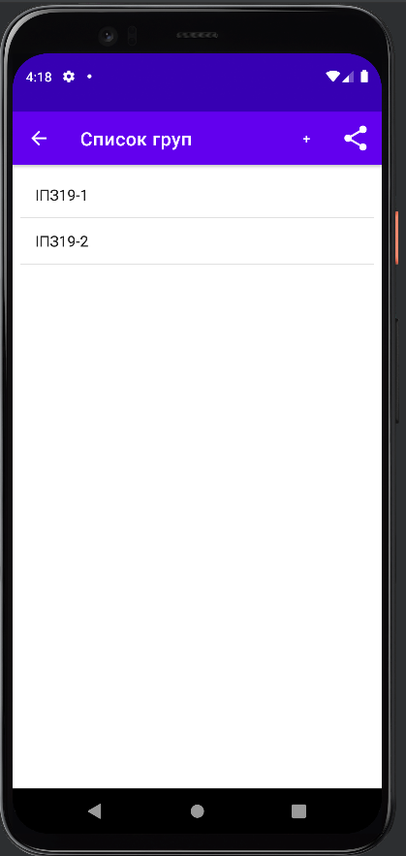

Перевірка події натискання на елементі списку

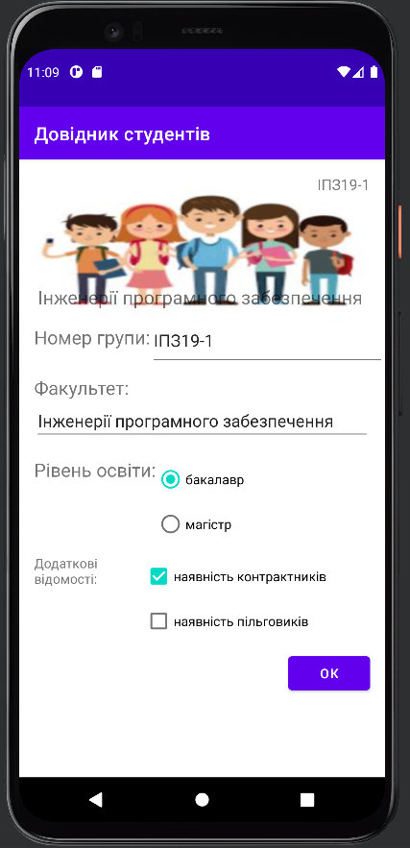

Запуск активності списку студентів із студентської групи

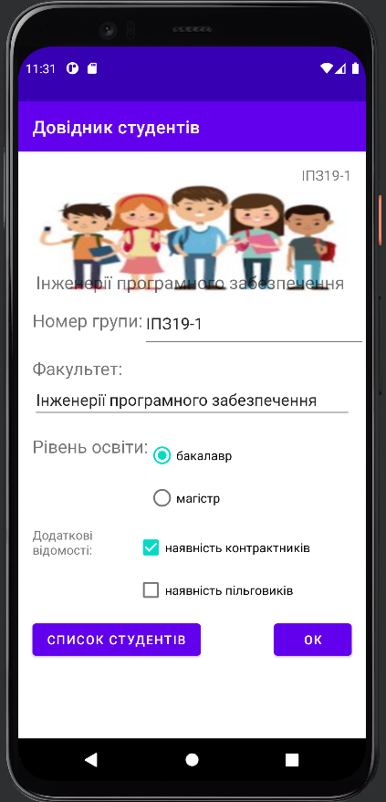

2. Кнопки та панелі інструментів. Провайдер передачі інформації

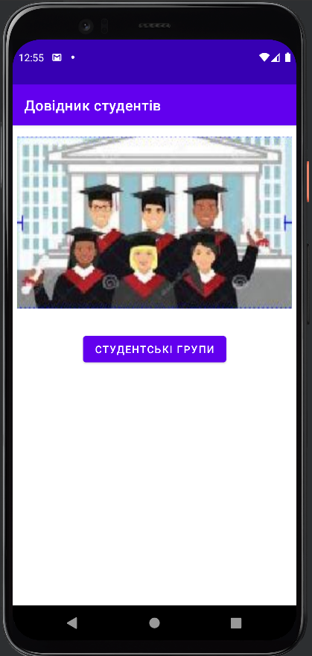

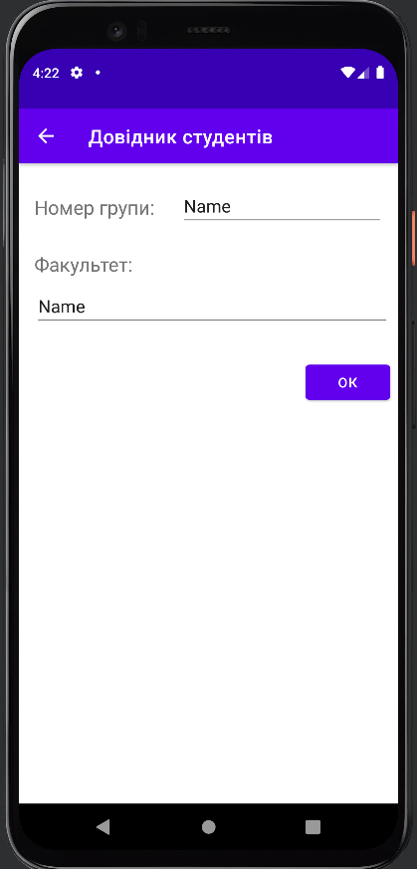

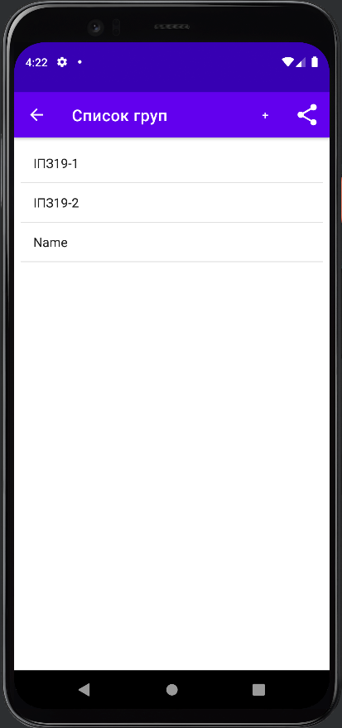

AddStudentsGroupActivity

package com.example.students;  
  
import androidx.appcompat.app.AppCompatActivity;  
import androidx.core.app.NavUtils;  
  
import android.os.Bundle;  
import android.view.View;  
import android.widget.EditText;  
  
public class AddStudentsGroupActivity extends AppCompatActivity {  
  
 @Override  
 protected void onCreate(Bundle savedInstanceState) {  
 super.onCreate(savedInstanceState);  
 setContentView(R.layout.activity_add_students_group);  
 }  
  
 public void onGrpAddClick(View view){  
 EditText number = (EditText) findViewById(R.id.addGroupNumber);  
 EditText faculty = (EditText) findViewById(R.id.addFaculty);  
 StudentsGroup.addGroup(  
 new StudentsGroup(number.getText().toString(),  
 faculty.getText().toString(),  
 0, false, false)  
 );  
 NavUtils.navigateUpFromSameTask(this);  
 }  
}

GroupsListActivity

package com.example.students;  
  
import androidx.annotation.NonNull;  
import androidx.appcompat.app.AppCompatActivity;  
import androidx.appcompat.widget.ShareActionProvider;  
import androidx.core.view.MenuItemCompat;  
  
import android.content.Intent;  
import android.os.Bundle;  
import android.view.Menu;  
import android.view.MenuItem;  
import android.view.View;  
import android.widget.AdapterView;  
import android.widget.ArrayAdapter;  
import android.widget.ListView;  
  
public class GroupsListActivity extends AppCompatActivity {  
  
 @Override  
 protected void onCreate(Bundle savedInstanceState) {  
 super.onCreate(savedInstanceState);  
 setContentView(R.layout.activity_groups_list);  
  
 AdapterView.OnItemClickListener listener = new AdapterView.OnItemClickListener(){  
 @Override  
 public void onItemClick(AdapterView<?> adapterView, View view, int i, long l){  
 String group = ((StudentsGroup) adapterView.getItemAtPosition(i)).toString();  
 Intent intent = new Intent(GroupsListActivity.this, StudentsGroupActivity.class);  
 intent.putExtra(StudentsGroupActivity.*GROUP_NUMBER*, group);  
 startActivity(intent);  
 }  
 };  
  
 ListView listView = (ListView) findViewById(R.id.*groups_list*);  
 listView.setOnItemClickListener(listener);  
 }  
  
 @Override  
 public void onStart(){  
 super.onStart();  
 ListView listView = (ListView) findViewById(R.id.groups_list);  
 ArrayAdapter<StudentsGroup> adapter = new ArrayAdapter<StudentsGroup>(  
 this, android.R.layout.simple_list_item_1,  
 StudentsGroup.getGroups());  
  
 listView.setAdapter(adapter);  
 }  
  
 public void onGrpAddClick(View view){  
 startActivity(  
 new Intent(this, AddStudentsGroupActivity.class)  
 );  
 }  
  
 @Override  
 public boolean onCreateOptionsMenu(Menu menu){  
 getMenuInflater().inflate(R.menu.groups_menu, menu);  
  
 String text = "";  
 for (StudentsGroup group: StudentsGroup.getGroups()){  
 text += group.getNumber() + "\n";  
 }  
  
 MenuItem menuItem = menu.findItem(R.id.action_share);  
 ShareActionProvider shareActionProvider = (ShareActionProvider) MenuItemCompat.getActionProvider(menuItem);  
  
 Intent intent = new Intent(Intent.ACTION_SEND);  
 intent.setType("text/plain");  
 intent.putExtra(Intent.EXTRA_TEXT, text);  
 shareActionProvider.setShareIntent(intent);  
  
 return super.onCreateOptionsMenu(menu);  
 }  
  
 @Override  
 public boolean onOptionsItemSelected(@NonNull MenuItem item){  
 switch (item.getItemId()){  
 case R.id.action_add_group:  
 startActivity(  
 new Intent(this, AddStudentsGroupActivity.class)  
 );  
 default:  
 return super.onOptionsItemSelected(item);  
 }  
 }  
  
}

MainActivity

package com.example.students;  
  
import androidx.appcompat.app.AppCompatActivity;  
  
import android.content.Intent;  
import android.os.Bundle;  
import android.os.Handler;  
import android.view.View;  
import android.widget.Spinner;  
import android.widget.TextView;  
import android.widget.Toast;  
  
import org.w3c.dom.Text;  
  
import java.util.Locale;  
  
public class MainActivity extends AppCompatActivity {  
 @Override  
 protected void onCreate(Bundle savedInstanceState){  
 super.onCreate(savedInstanceState);  
 setContentView(R.layout.*activity_main*);  
 }  
  
 public void onBtnShowGroupsClick(View view){  
 Intent intent = new Intent(this, GroupsListActivity.class);  
 startActivity(intent);  
 }  
}

Student

package com.example.students;  
  
import java.util.ArrayList;  
import java.util.Arrays;  
  
public class Student {  
 private String name;  
 private String groupNumber;  
  
 public Student(String name, String groupNumber){  
 this.name = name;  
 this.groupNumber = groupNumber;  
 }  
  
 public String getName(){  
 return name;  
 }  
  
 public String getGroupNumber(){  
 return groupNumber;  
 }  
  
 private final static ArrayList<Student> *students* = new ArrayList<Student>(  
 Arrays.*asList*(  
 new Student("Музичишин Максим", "ІПЗ19-1"),  
 new Student("Ванжа Микита", "ІПЗ19-1"),  
 new Student("Пупкін Петр", "ІПЗ19-2"),  
 new Student("Веделкин Валентин", "ІПЗ19-2")  
 )  
 );  
  
 public static ArrayList<Student> getStudents(String groupNumber){  
 ArrayList<Student> stList = new ArrayList<>();  
  
 for (Student s : *students*){  
 if(s.getGroupNumber().equals(groupNumber)){  
 stList.add(s);  
 }  
 }  
  
 return stList;  
 }  
  
 @Override  
 public String toString(){  
 return name;  
 }  
}

StudentsGroup

package com.example.students;  
  
import java.util.ArrayList;  
import java.util.Arrays;  
  
public class StudentsGroup {  
 private String number;  
 private String facultyName;  
 private int educationLevel;  
 private boolean contractExistsFlg;  
 private boolean privilageExistsFlg;  
  
 public StudentsGroup(String number, String facultyName,  
 int educationLevel, boolean contractExistsFlg, boolean privilageExistsFlg){  
 this.number = number;  
 this.facultyName = facultyName;  
 this.educationLevel = educationLevel;  
 this.contractExistsFlg = contractExistsFlg;  
 this.privilageExistsFlg = privilageExistsFlg;  
 }  
  
 public String getNumber(){  
 return number;  
 }  
  
 public String getFacultyName(){  
 return facultyName;  
 }  
  
 public int getEducationLevel(){  
 return educationLevel;  
 }  
  
 public boolean isContractExistsFlg(){  
 return contractExistsFlg;  
 }  
  
 public boolean isPrivilageExistsFlg(){  
 return privilageExistsFlg;  
 }  
  
 private static ArrayList<StudentsGroup> *groups* = new ArrayList<StudentsGroup>(  
 Arrays.*asList*(  
 new StudentsGroup("ІПЗ19-1", "Інженерії програмного забезпечення", 0, true, false),  
 new StudentsGroup("ІПЗ19-2", "Інженерії програмного забезпечення", 0, true, false)  
 )  
 );  
  
 public static void addGroup(StudentsGroup group){  
 *groups*.add(group);  
 }  
  
 public static StudentsGroup getGroup(String groupNumber){  
 for (StudentsGroup g: *groups*){  
 if(g.getNumber().equals(groupNumber)){  
 return g;  
 }  
 }  
 return null;  
 }  
  
 public static ArrayList<StudentsGroup> getGroups(){  
 return *groups*;  
 }  
  
 @Override  
 public String toString(){  
 return number;  
 }  
}

StudentsGroupActivity

package com.example.students;  
  
import androidx.appcompat.app.AppCompatActivity;  
  
import android.content.Intent;  
import android.os.Bundle;  
import android.view.Gravity;  
import android.view.View;  
import android.widget.CheckBox;  
import android.widget.EditText;  
import android.widget.RadioButton;  
import android.widget.TextView;  
import android.widget.Toast;  
  
import org.w3c.dom.Text;  
  
public class StudentsGroupActivity extends AppCompatActivity {  
  
 public static final String GROUP_NUMBER = "groupnumber";  
  
 @Override  
 protected void onCreate(Bundle savedInstanceState) {  
 super.onCreate(savedInstanceState);  
 setContentView(R.layout.activity_students_group2);  
  
 Intent intent = getIntent();  
 String grpNumber = intent.getStringExtra(GROUP_NUMBER);  
 StudentsGroup group = StudentsGroup.getGroup(grpNumber);  
  
 EditText txtGrpNumber = (EditText) findViewById(R.id.grpNumberEdit);  
 txtGrpNumber.setText(group.getNumber());  
  
 EditText txtFacultyName = (EditText) findViewById(R.id.facultyEdit);  
 txtFacultyName.setText(group.getFacultyName());  
  
 TextView txtImgGrp = (TextView) findViewById(R.id.grpNumberImageTxt);  
 txtImgGrp.setText(group.getNumber());  
  
 TextView txtImgFaculty = (TextView) findViewById(R.id.facultyNameImageTxt);  
 txtImgFaculty.setText(group.getFacultyName());  
  
 if(group.getEducationLevel() == 0){  
 ((RadioButton) findViewById(R.id.edu_level_bachelor)).setChecked(true);  
 }  
 else{  
 ((RadioButton) findViewById(R.id.edu_level_master)).setChecked(true);  
 }  
  
 ((CheckBox) findViewById(R.id.contract_flg)).setChecked(group.isContractExistsFlg());  
 ((CheckBox) findViewById(R.id.privelege_flg)).setChecked(group.isPrivilageExistsFlg());  
 }  
  
 public void onOkBtnClick(View view){  
 String outString = "Група " + ((TextView) findViewById(R.id.grpNumberEdit)).getText() + "\n";  
 outString += "Факультет " + ((TextView) findViewById(R.id.facultyEdit)).getText() + "\n";  
  
 if(((RadioButton) findViewById(R.id.*edu_level_master*)).isChecked()){  
 outString += "рівень освіти - " + "магістр\n";  
 }  
 else{  
 outString += "рівень освіти - " + "бакалавр\n";  
 }  
  
 if(((CheckBox) findViewById(R.id.*contract_flg*)).isChecked()){  
 outString += "контрактники є\n";  
 }  
 else{  
 outString += "контрактників нема\n";  
 }  
  
 if(((CheckBox) findViewById(R.id.*privelege_flg*)).isChecked()){  
 outString += "пільговики є\n";  
 }  
 else{  
 outString += "пільговиків нема\n";  
 }  
  
 Toast toast = Toast.*makeText*(getApplicationContext(), outString, Toast.*LENGTH_LONG*);  
 toast.setGravity(Gravity.*CENTER*, 0, 0);  
 toast.show();  
 }  
  
 public void onBtnStudListClick(View view){  
 Intent localIntent = getIntent();  
 String group = localIntent.getStringExtra(GROUP_NUMBER);  
  
 Intent newIntent = new Intent(this, StudentsListActivity.class);  
 newIntent.putExtra(StudentsListActivity.GROUP_NUMBER, group);  
 startActivity(newIntent);  
 }  
}

StudentsListActivity

package com.example.students;  
  
import androidx.appcompat.app.AppCompatActivity;  
  
import android.content.Intent;  
import android.os.Bundle;  
import android.util.TypedValue;  
import android.view.View;  
import android.widget.ArrayAdapter;  
import android.widget.ListView;  
import android.widget.TextView;  
  
public class StudentsListActivity extends AppCompatActivity {  
  
 public static final String *GROUP_NUMBER* = "groupnumber";  
  
 @Override  
 protected void onCreate(Bundle savedInstanceState) {  
 super.onCreate(savedInstanceState);  
 setContentView(R.layout.activity_students_list);  
  
 Intent intent = getIntent();  
 String grpNumber = intent.getStringExtra(GROUP_NUMBER);  
  
 ListView listView = (ListView) findViewById(R.id.studentsList);  
 ArrayAdapter<Student> adapter = new ArrayAdapter<Student>(  
 this, android.R.layout.simple_list_item_1,  
 Student.getStudents(grpNumber)  
 );  
 listView.setAdapter(adapter);  
 }  
  
 public void onSendBtnClick(View view){  
 ListView listView = (ListView) findViewById(R.id.studentsList);  
 String text = "";  
  
  
 for (int i = 0; i < listView.getCount(); i++){  
 text += listView.getItemAtPosition(i).toString() + "\n";  
 }  
  
 Intent intent = new Intent(Intent.ACTION_SEND);  
 intent.setType("text/plain");  
 intent.putExtra(Intent.EXTRA_TEXT, text);  
 intent.putExtra(Intent.EXTRA_SUBJECT, "Список студентів");  
 startActivity(intent);  
 }  
  
}