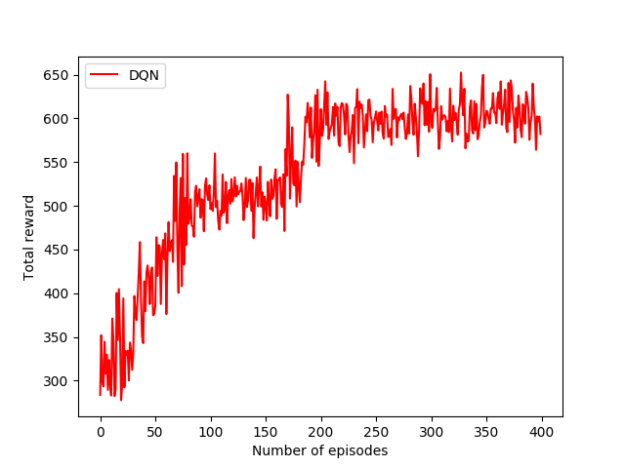
Epsilon varies 0->1; gama = 0.8
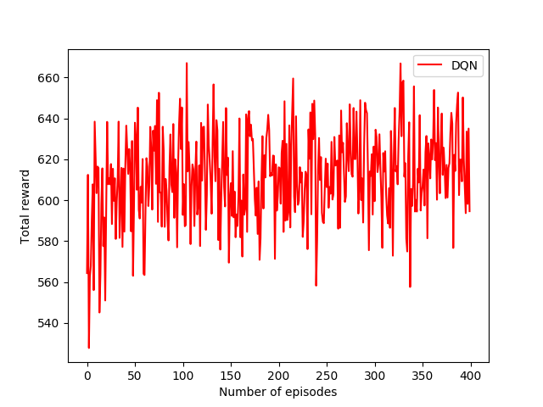
Epsilon = 0.9; gama = 0.8

