**Hong Kong Institute of Vocational Education**

**(Tuen Mun)**

**Department of Information Technology**

**HD in Software Engineering (IT114105)**

**2023/2024**

**(ITP4512) Enterprise Software**

**ABAP Dictionary and ABAP Programming Assignment**

**Date: 20/04/2023**



|  |  |
| --- | --- |
| **Student** | **Signature** |
| Leung Chu Shing | Leung Chu Shing |

We declare that this is a group project and that no part of this submission has been copied from any other student’s work or from any other source except where due acknowledgement is made explicitly in the text, nor has any part been written for us by another perso

Table of content

Part 1: Create table 3

Part 2: Function module to determine earning in HK dollar 5

Part 3: Function module to determine luggage weight in kilograms 15

Part 4: Program to insert into the table ZASG_yournam 19

Go to SE38, create ABAP program 19

Part 5: Program to select records from table ZASG_yourname 32

# Part 1: Create table

**SE11**

**Delivery and Maintenance**

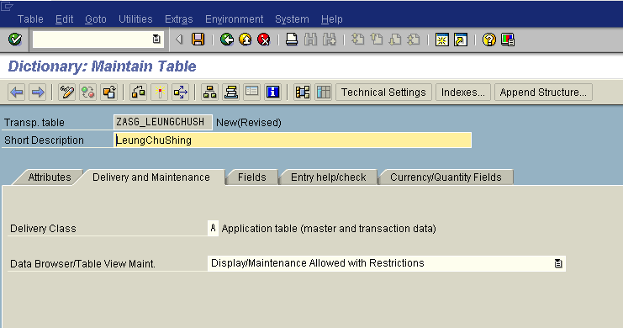

**Fields**

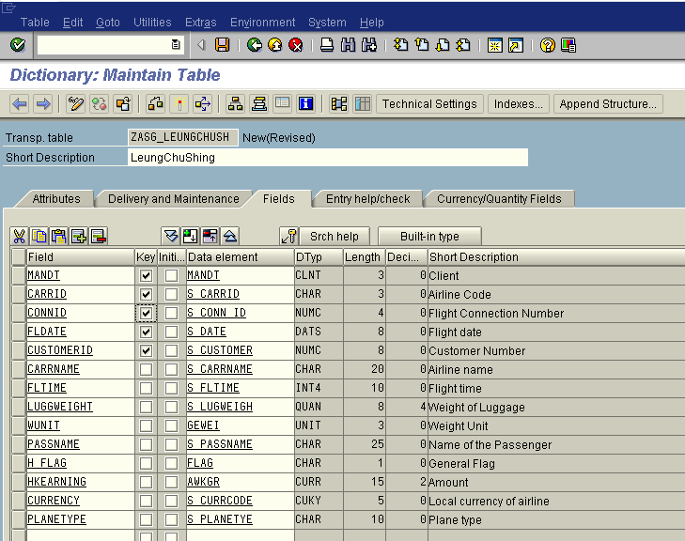

**Currency/Quantity Fields**

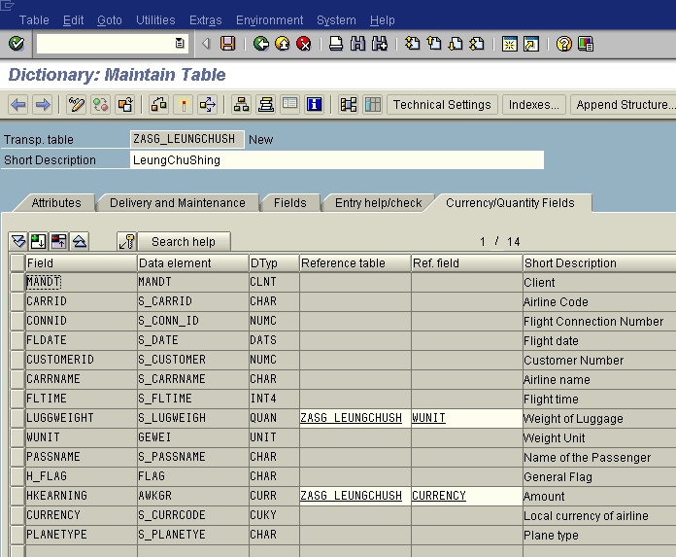

**Technical Settings**

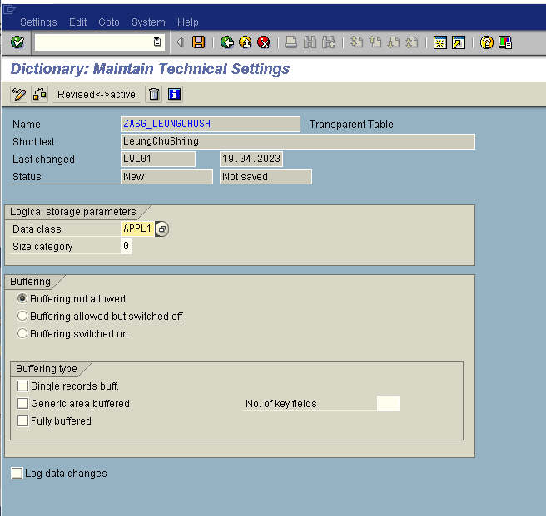

# Part 2: Function module to determine earning in HK dollar

**SE37**

**Create function group**

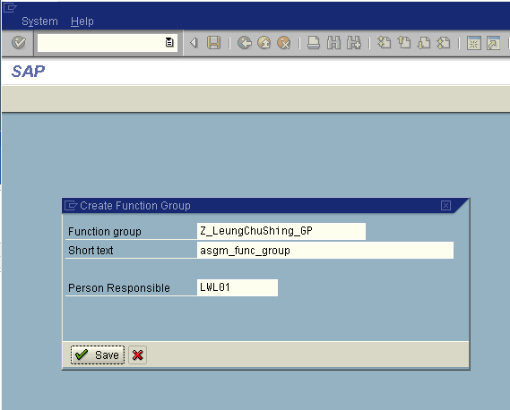

**Create function**

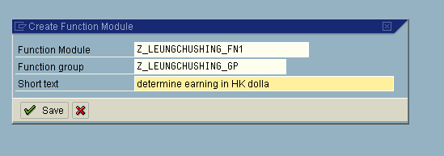

**Import**

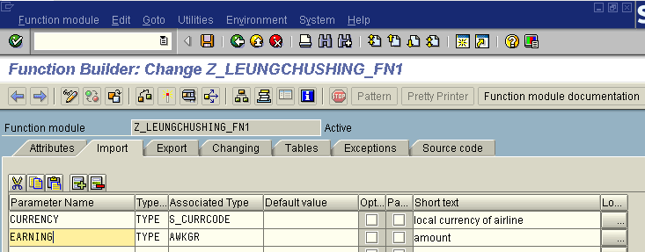

**Export**

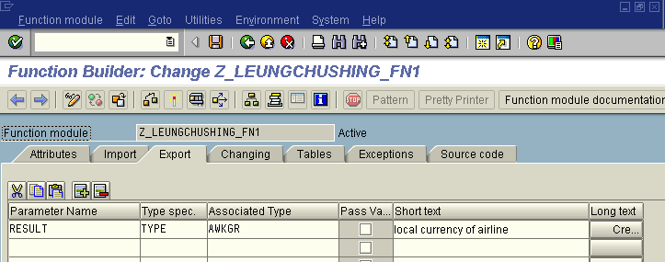

**Exception**

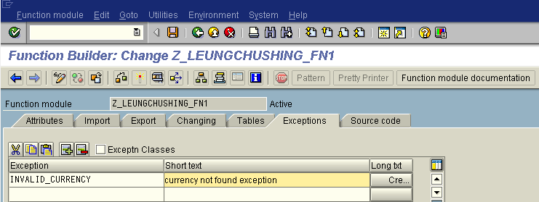

**Source code**

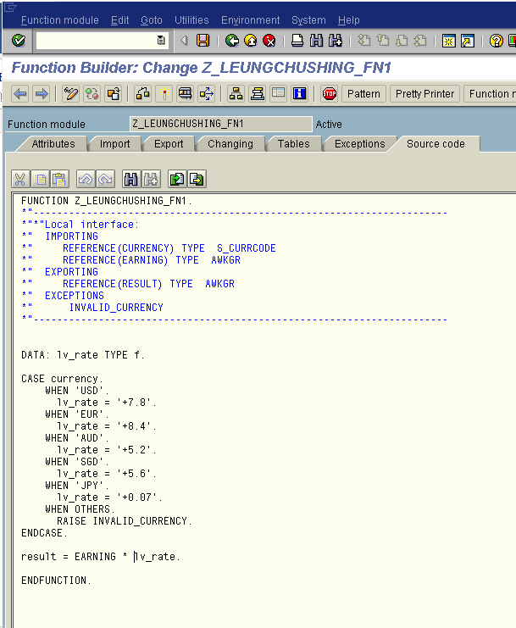

**Testing**

**(input: currency=”USD”, enanign=”100”)**

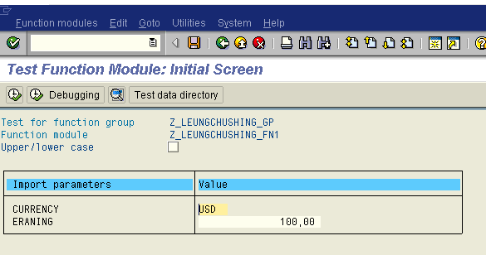

**Result (output: result=”700”)**

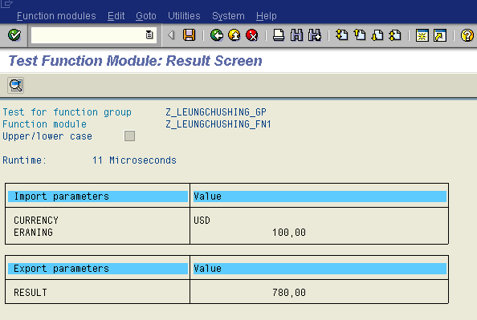

**(input: currency=”JPY”, enanign=”230”)**

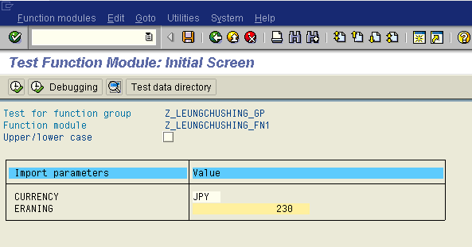

**Result (output: result=”16.1”)**

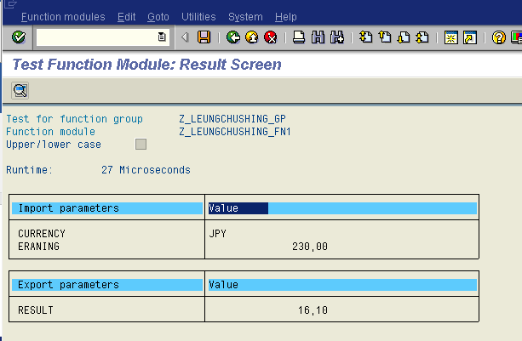

**(input: currency=”EUR”, enanign=”200”)**

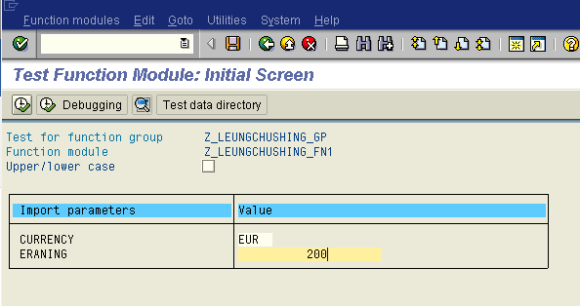

**Result (output: result=”1680”)**

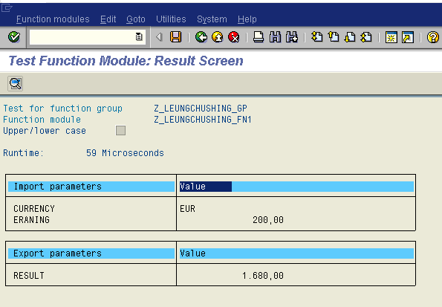

**(input: currency=”AUD”, enanign=”400”)**

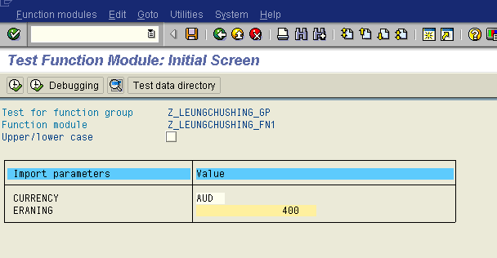

**Result (output: result=”3360”)**

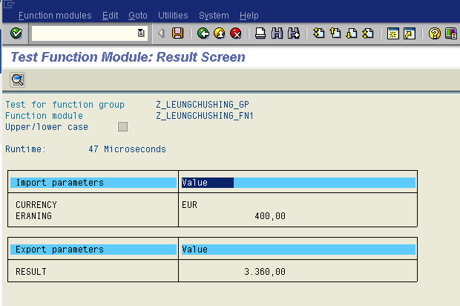

**(input: currency=”SGD”, enanign=”670”)**

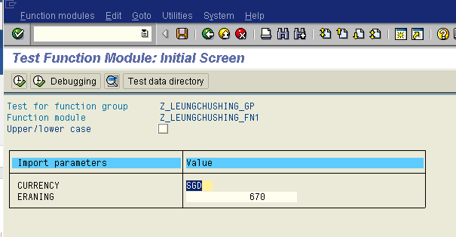

**Result (output: result=”3752”)**

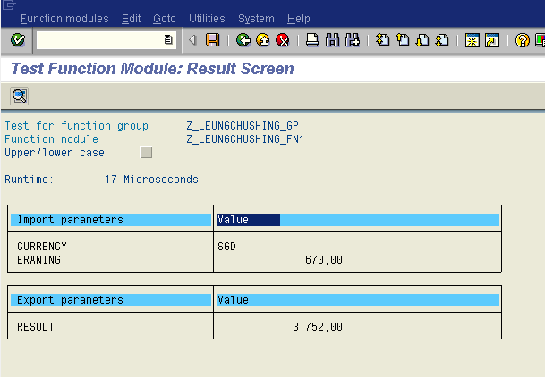

**Exception handle**

**(input: currency=”ERROR”, enanign=”50”)**

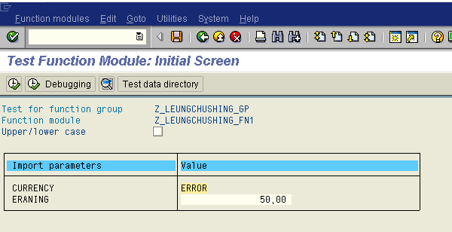

**Result: (throw exception “INVALID_CURRENCY”)**

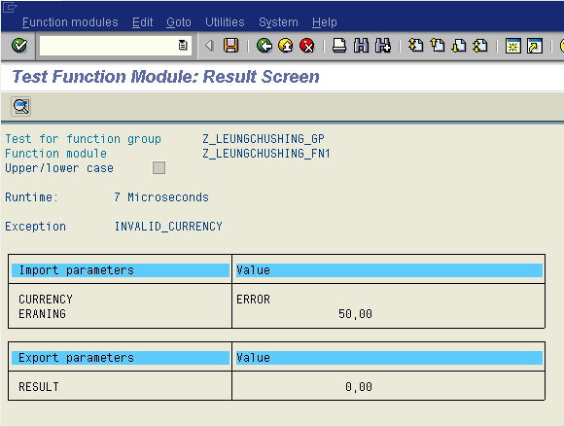

# Part 3: Function module to determine luggage weight in kilograms

**Import**

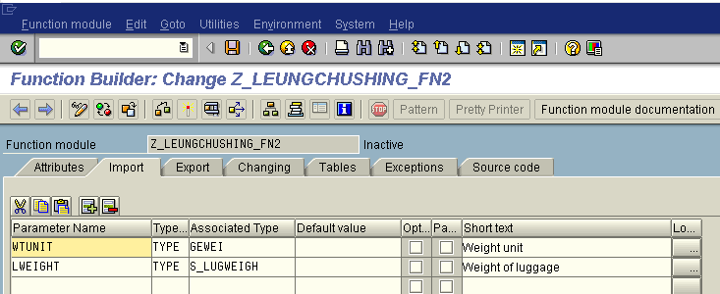

**Export**

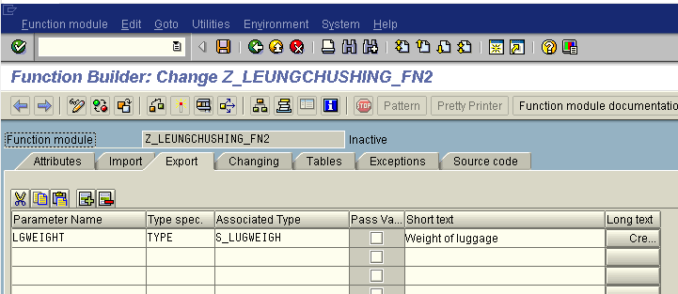

**Source Code**

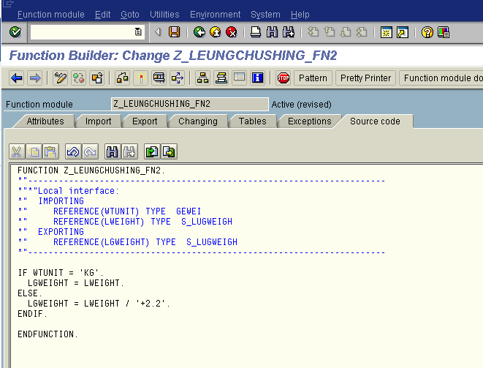

**Input(WTUNUT=”KG”, LWEIGHT=”100”)**

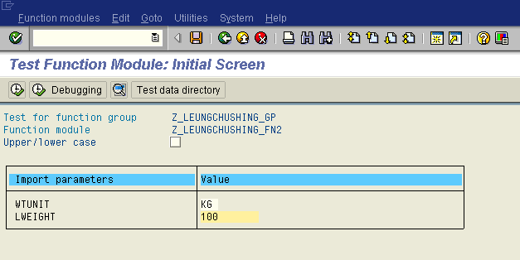

**Result(LGWEIGHT=”100”)**

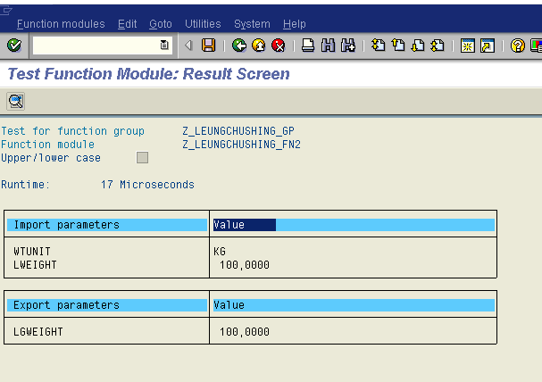

**Input(WTUNUT=”g”, LWEIGHT=”60”)**

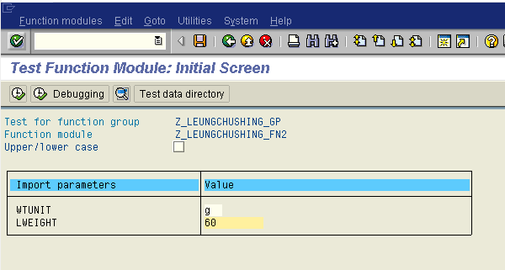

**Result(LGWEIGHT=”27.2727”)**

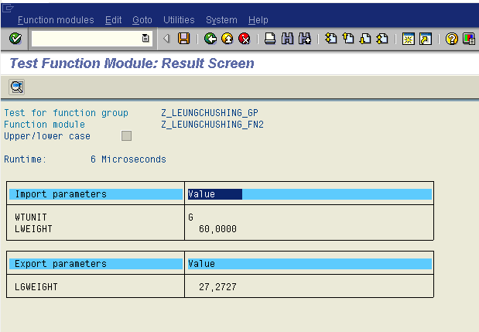

# Part 4: Program to insert into the table ZASG_yournam

# Go to SE38, create ABAP program

**Create program**

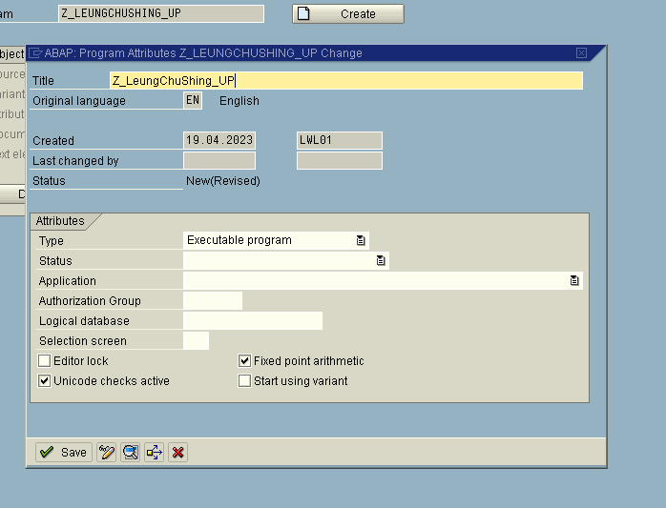

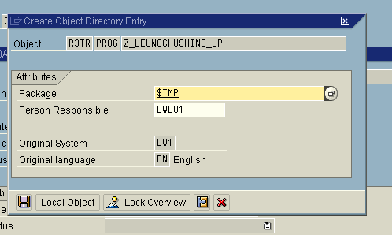

**Source code**

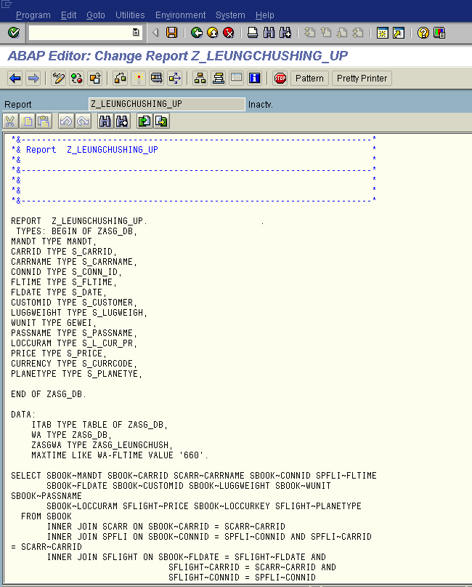 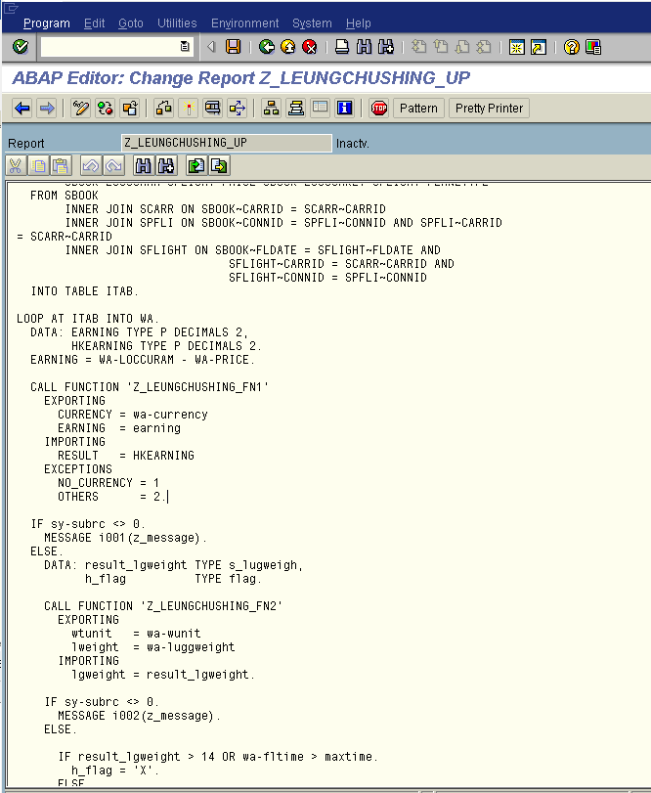

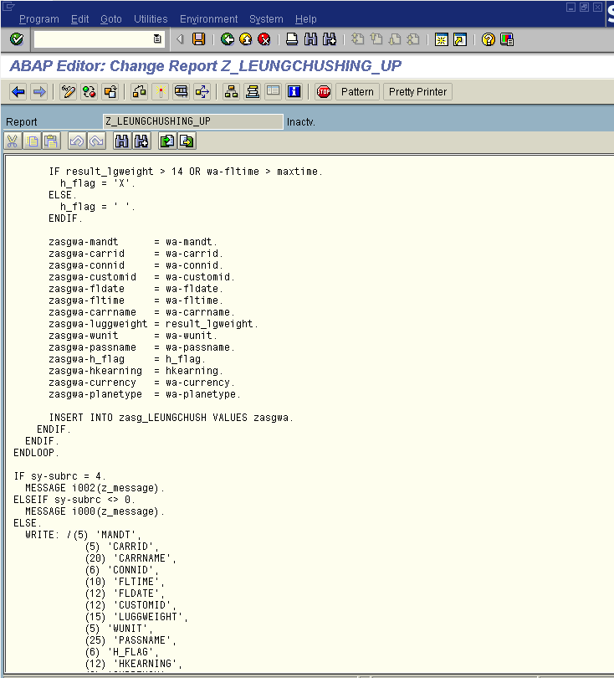

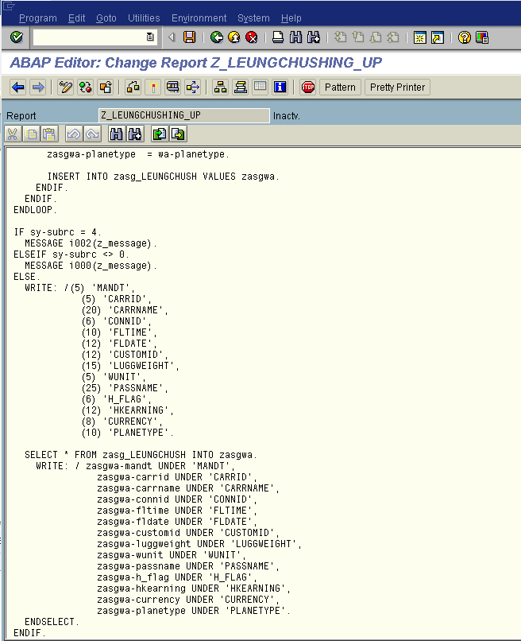

SELECT SBOOK~MANDT SBOOK~CARRID SCARR~CARRNAME SBOOK~CONNID SPFLI~FLTIME

SBOOK~FLDATE SBOOK~CUSTOMID SBOOK~LUGGWEIGHT SBOOK~WUNIT SBOOK~PASSNAME

SBOOK~LOCCURAM SFLIGHT~PRICE SBOOK~LOCCURKEY SFLIGHT~PLANETYPE

FROM SBOOK

INNER JOIN SCARR ON SBOOK~CARRID = SCARR~CARRID

INNER JOIN SPFLI ON SBOOK~CONNID = SPFLI~CONNID AND SPFLI~CARRID = SCARR~CARRID

INNER JOIN SFLIGHT ON SBOOK~FLDATE = SFLIGHT~FLDATE AND

SFLIGHT~CARRID = SCARR~CARRID AND

SFLIGHT~CONNID = SPFLI~CONNID

INTO TABLE ITAB.

* Loop through the ITAB table

LOOP AT ITAB INTO WA.

DATA: EARNING TYPE P DECIMALS 2,

HKEARNING TYPE P DECIMALS 2.

EARNING = WA-LOCCURAM - WA-PRICE.

* Call function module for currency conversion

CALL FUNCTION 'Z_LEUNGCHUSHING_FN1'

EXPORTING

CURRENCY = wa-currency

EARNING = earning

IMPORTING

RESULT = HKEARNING

EXCEPTIONS

NO_CURRENCY = 1

OTHERS = 2.

* Handle exceptions for currency conversion

IF sy-subrc <> 0.

MESSAGE i001(z_message).

ELSE.

DATA: result_lgweight TYPE s_lugweigh,

h_flag TYPE flag.

* Call function module for weight unit conversion

CALL FUNCTION 'Z_LEUNGCHUSHING_FN2'

EXPORTING

wtunit = wa-wunit

lweight = wa-luggweight

IMPORTING

lgweight = result_lgweight.

* Handle exceptions for weight unit conversion

IF sy-subrc <> 0.

MESSAGE i002(z_message).

ELSE.

* Determine flag value based on weight and flight time

IF result_lgweight > 14 OR wa-fltime > maxtime.

h_flag = 'X'.

ELSE.

h_flag = ' '.

ENDIF.

* Assemble and insert data into the custom table

zasgwa-mandt = wa-mandt.

zasgwa-carrid = wa-carrid.

zasgwa-connid = wa-connid.

zasgwa-customid = wa-customid.

zasgwa-fldate = wa-fldate.

zasgwa-fltime = wa-fltime.

zasgwa-carrname = wa-carrname.

zasgwa-luggweight = result_lgweight.

zasgwa-wunit = wa-wunit.

zasgwa-passname = wa-passname.

zasgwa-h_flag = h_flag.

zasgwa-hkearning = hkearning.

zasgwa-currency = wa-currency.

zasgwa-planetype = wa-planetype.

INSERT INTO zasg_LEUNGCHUSH VALUES zasgwa.

ENDIF.

ENDIF.

ENDLOOP.

* Output results

IF sy-subrc = 4.

MESSAGE i002(z_message).

ELSEIF sy-subrc <> 0.

MESSAGE i000(z_message).

ELSE.

WRITE: /(5) 'MANDT',

(5) 'CARRID',

(20) 'CARRNAME',

(6) 'CONNID',

(10) 'FLTIME',

(12) 'FLDATE',

(12) 'CUSTOMID',

(15) 'LUGGWEIGHT',

(5) 'WUNIT',

(25) 'PASSNAME',

(6) 'H_FLAG',

(12) 'HKEARNING',

(8) 'CURRENCY',

(10) 'PLANETYPE'.

SELECT * FROM zasg_LEUNGCHUSH INTO zasgwa.

WRITE: / zasgwa-mandt UNDER 'MANDT',

zasgwa-carrid UNDER 'CARRID',

zasgwa-carrname UNDER 'CARRNAME',

zasgwa-connid UNDER 'CONNID',

zasgwa-fltime UNDER 'FLTIME',

zasgwa-fldate UNDER 'FLDATE',

zasgwa-customid UNDER 'CUSTOMID',

zasgwa-luggweight UNDER 'LUGGWEIGHT',

zasgwa-wunit UNDER 'WUNIT',

zasgwa-passname UNDER 'PASSNAME',

zasgwa-h_flag UNDER 'H_FLAG',

zasgwa-hkearning UNDER 'HKEARNING',

zasgwa-currency UNDER 'CURRENCY',

zasgwa-planetype UNDER 'PLANETYPE'.

ENDSELECT.

ENDIF.

**Demo**

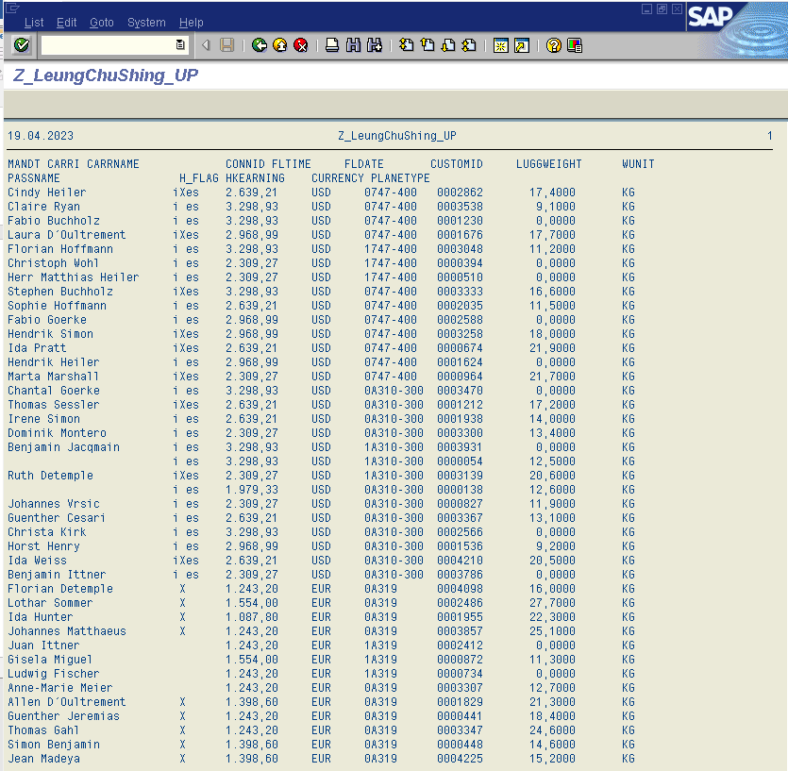

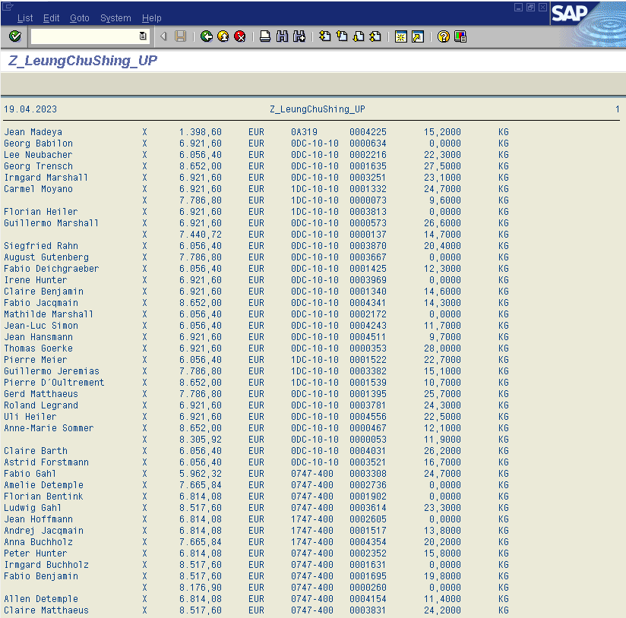

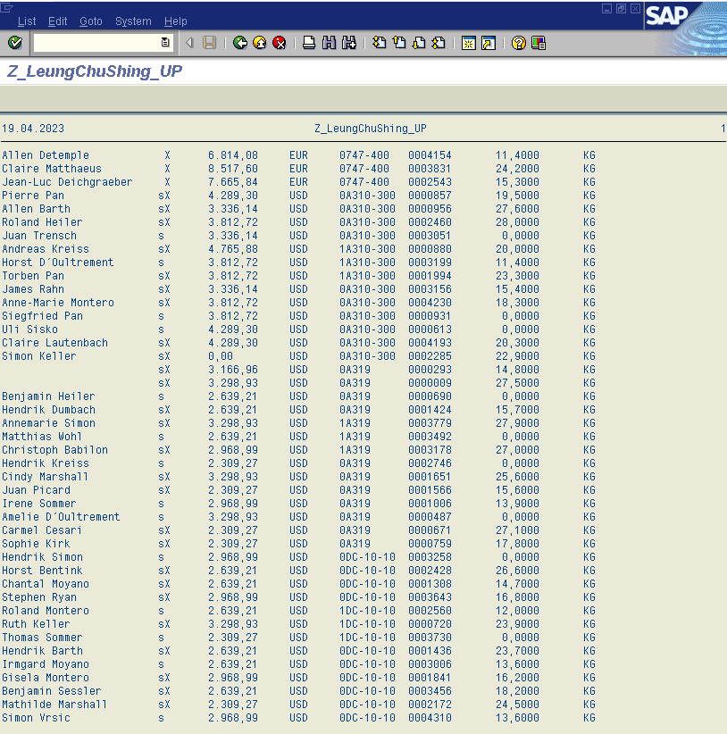

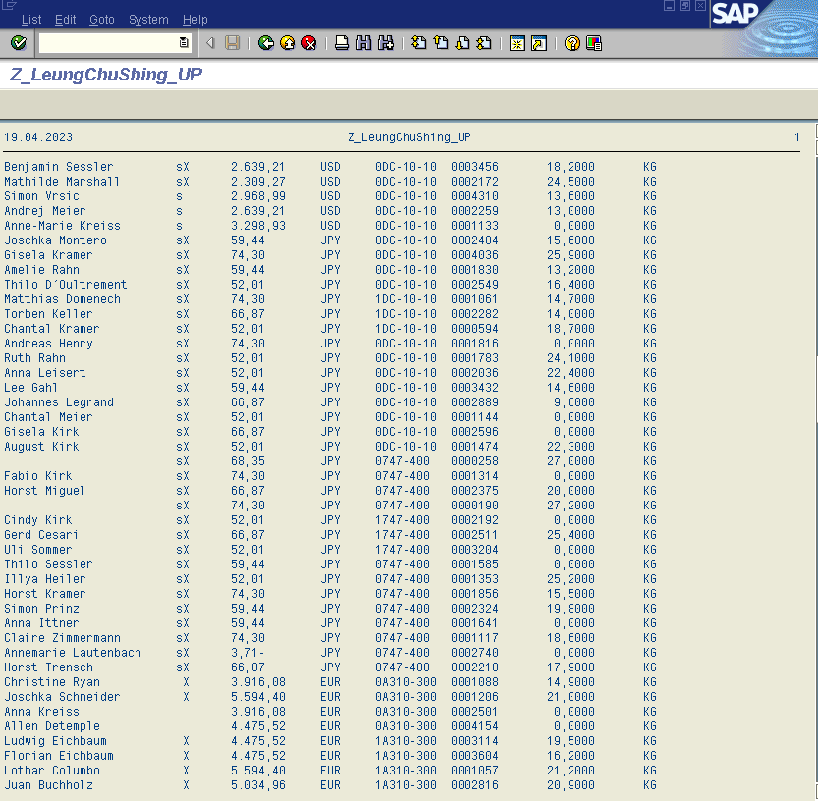

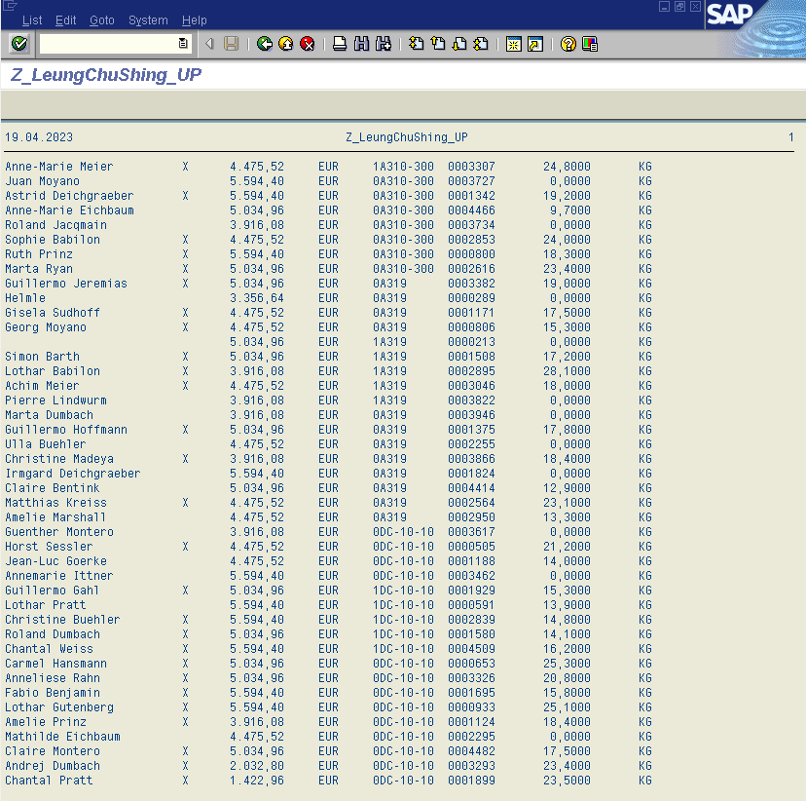

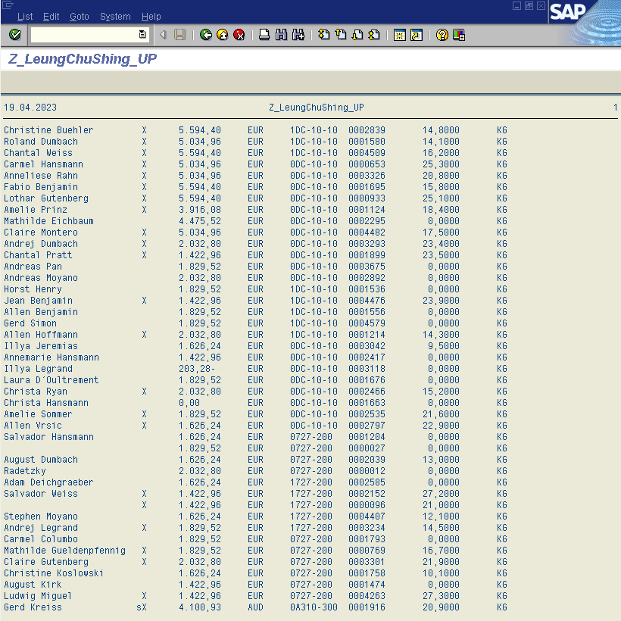

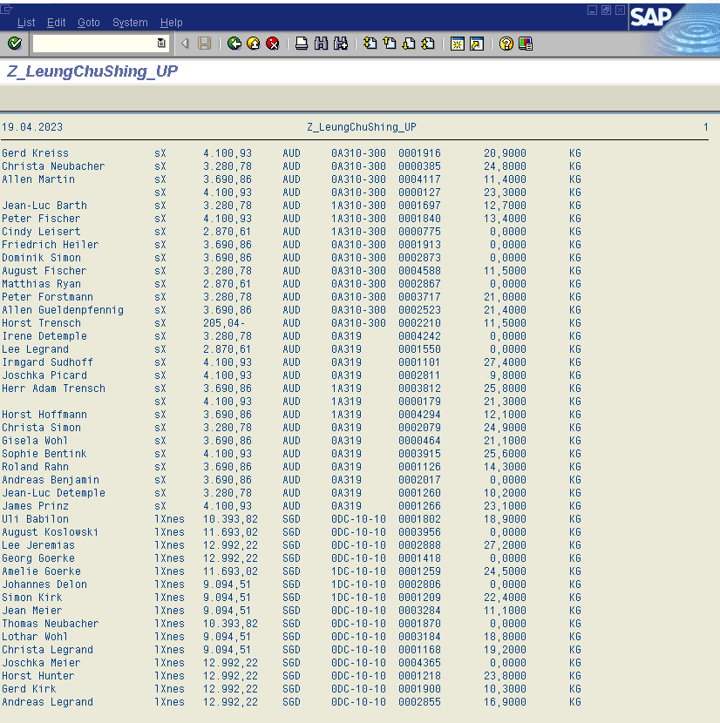

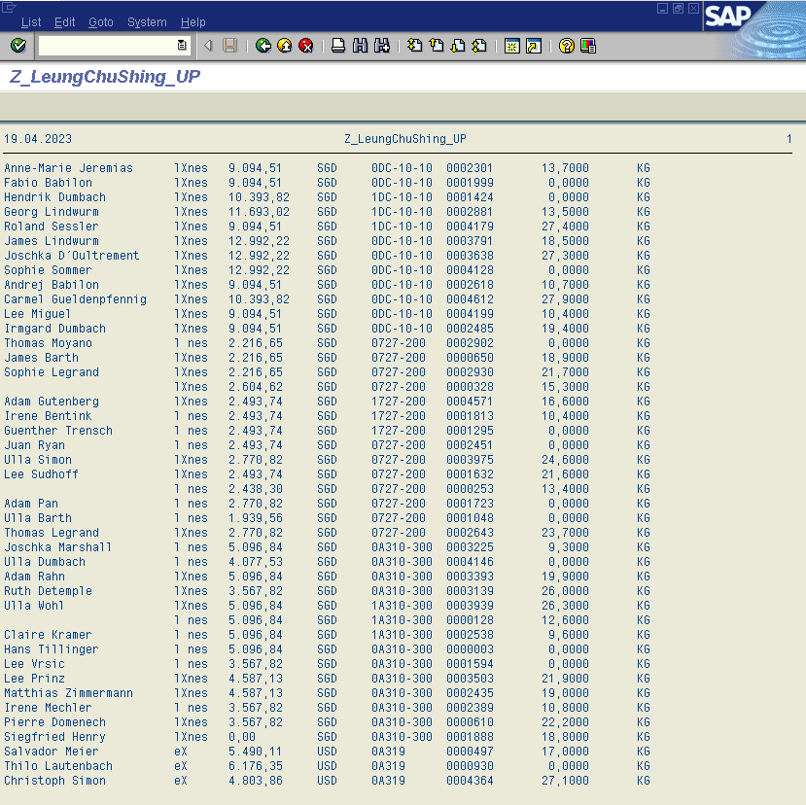

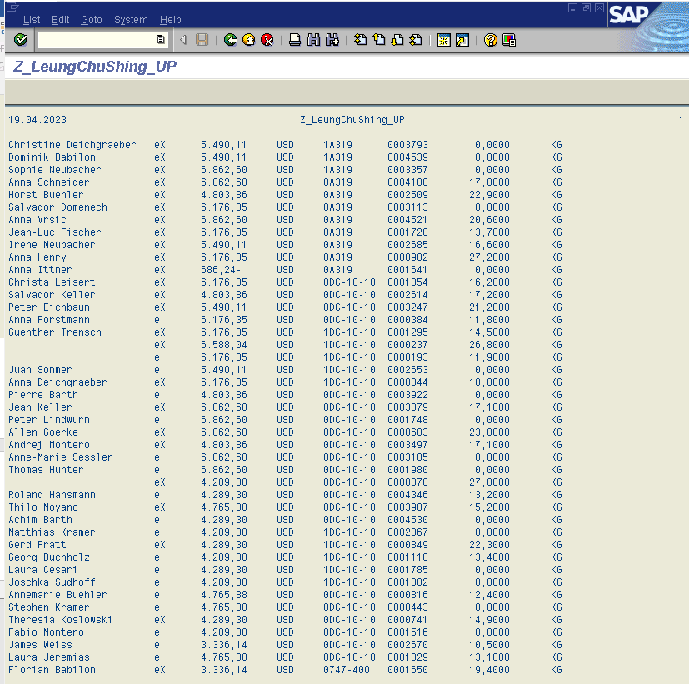

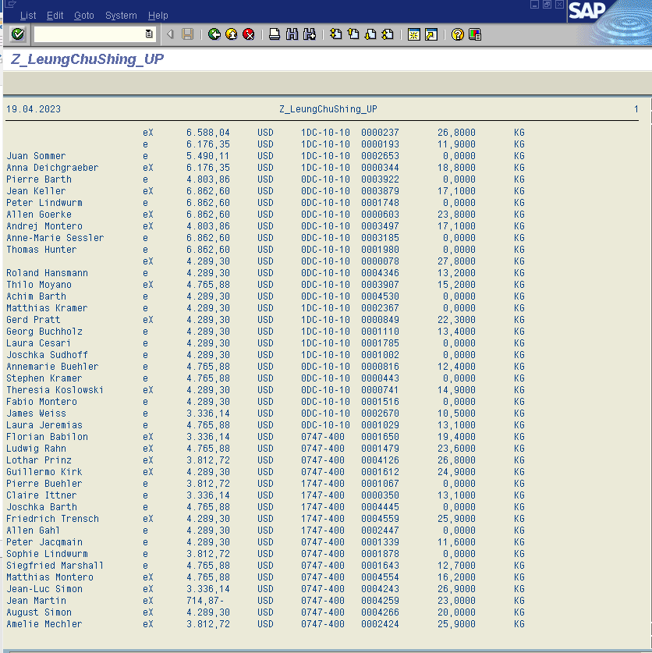

# Part 5: Program to select records from table ZASG_yourname

**Source code :**

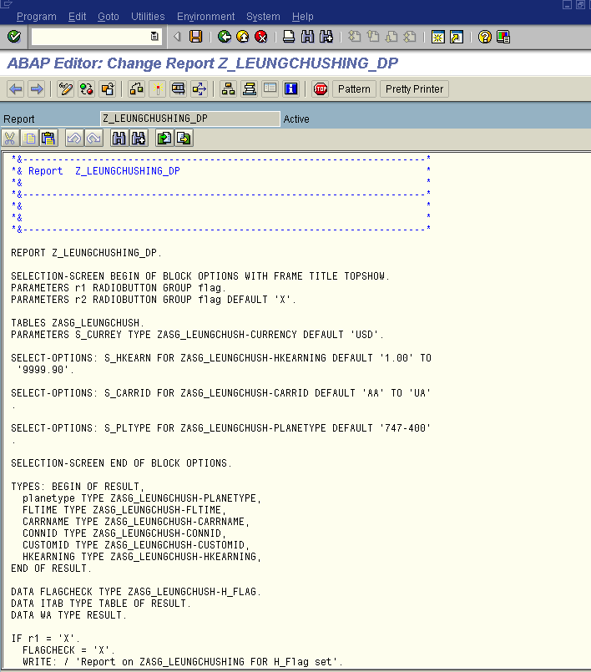

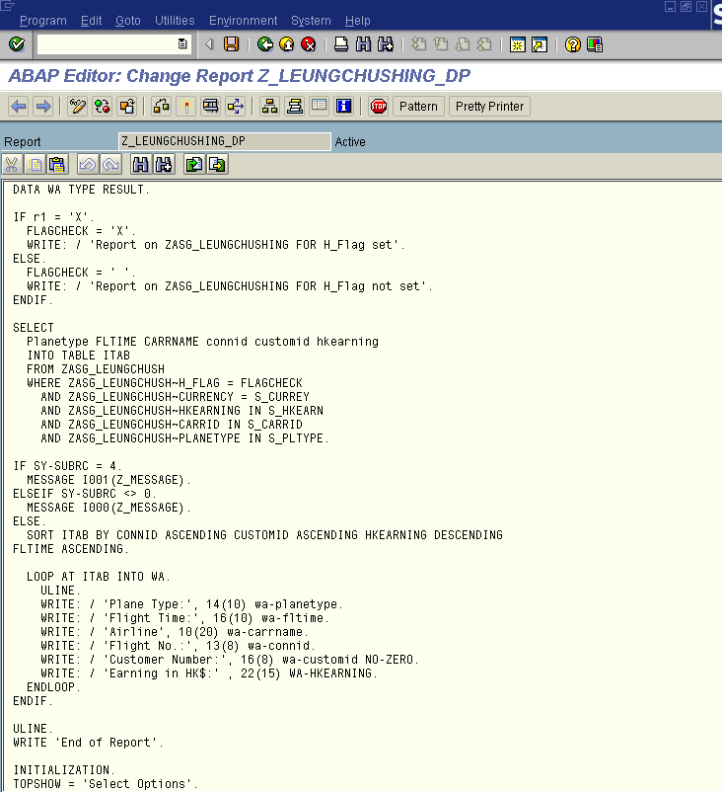

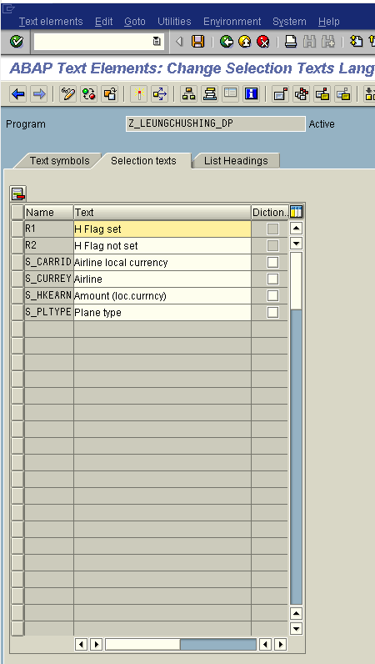

*&---------------------------------------------------------------------*

*& Report Z_LEUNGCHUSHING_DP *

*& *

*&---------------------------------------------------------------------*

*& *

*& *

*&---------------------------------------------------------------------*

REPORT Z_LEUNGCHUSHING_DP.

SELECTION-SCREEN BEGIN OF BLOCK OPTIONS WITH FRAME TITLE TOPSHOW.

PARAMETERS r1 RADIOBUTTON GROUP flag.

PARAMETERS r2 RADIOBUTTON GROUP flag DEFAULT 'X'.

TABLES ZASG_LEUNGCHUSH.

PARAMETERS S_CURREY TYPE ZASG_LEUNGCHUSH-CURRENCY DEFAULT 'USD'.

SELECT-OPTIONS: S_HKEARN FOR ZASG_LEUNGCHUSH-HKEARNING DEFAULT '1.00' TO

'9999.90'.

SELECT-OPTIONS: S_CARRID FOR ZASG_LEUNGCHUSH-CARRID DEFAULT 'AA' TO 'UA'

.

SELECT-OPTIONS: S_PLTYPE FOR ZASG_LEUNGCHUSH-PLANETYPE DEFAULT '747-400'

.

SELECTION-SCREEN END OF BLOCK OPTIONS.

TYPES: BEGIN OF RESULT,

planetype TYPE ZASG_LEUNGCHUSH-PLANETYPE,

FLTIME TYPE ZASG_LEUNGCHUSH-FLTIME,

CARRNAME TYPE ZASG_LEUNGCHUSH-CARRNAME,

CONNID TYPE ZASG_LEUNGCHUSH-CONNID,

CUSTOMID TYPE ZASG_LEUNGCHUSH-CUSTOMID,

HKEARNING TYPE ZASG_LEUNGCHUSH-HKEARNING,

END OF RESULT.

DATA FLAGCHECK TYPE ZASG_LEUNGCHUSH-H_FLAG.

DATA ITAB TYPE TABLE OF RESULT.

DATA WA TYPE RESULT.

IF r1 = 'X'.

FLAGCHECK = 'X'.

WRITE: / 'Report on ZASG_LEUNGCHUSHING FOR H_Flag set'.

ELSE.

FLAGCHECK = ' '.

WRITE: / 'Report on ZASG_LEUNGCHUSHING FOR H_Flag not set'.

ENDIF.

SELECT

Planetype FLTIME CARRNAME connid customid hkearning

INTO TABLE ITAB

FROM ZASG_LEUNGCHUSH

WHERE ZASG_LEUNGCHUSH~H_FLAG = FLAGCHECK

AND ZASG_LEUNGCHUSH~CURRENCY = S_CURREY

AND ZASG_LEUNGCHUSH~HKEARNING IN S_HKEARN

AND ZASG_LEUNGCHUSH~CARRID IN S_CARRID

AND ZASG_LEUNGCHUSH~PLANETYPE IN S_PLTYPE.

IF SY-SUBRC = 4.

MESSAGE I001(Z_MESSAGE).

ELSEIF SY-SUBRC <> 0.

MESSAGE I000(Z_MESSAGE).

ELSE.

SORT ITAB BY CONNID ASCENDING CUSTOMID ASCENDING HKEARNING DESCENDING

FLTIME ASCENDING.

LOOP AT ITAB INTO WA.

ULINE.

WRITE: / 'Plane Type:', 14(10) wa-planetype.

WRITE: / 'Flight Time:', 16(10) wa-fltime.

WRITE: / 'Airline', 10(20) wa-carrname.

WRITE: / 'Flight No.:', 13(8) wa-connid.

WRITE: / 'Customer Number:', 16(8) wa-customid NO-ZERO.

WRITE: / 'Earning in HK$:' , 22(15) WA-HKEARNING.

ENDLOOP.

ENDIF.

ULINE.

WRITE 'End of Report'.

INITIALIZATION.

TOPSHOW = 'Select Options'.

**Demo 1: (H Flag not set)**

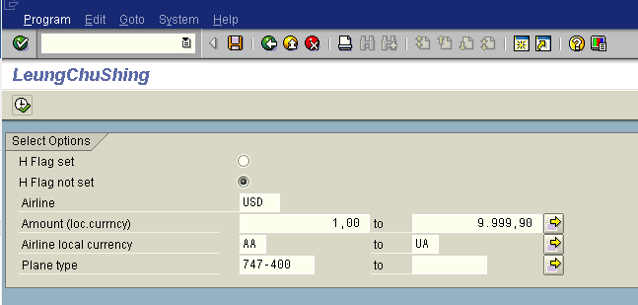

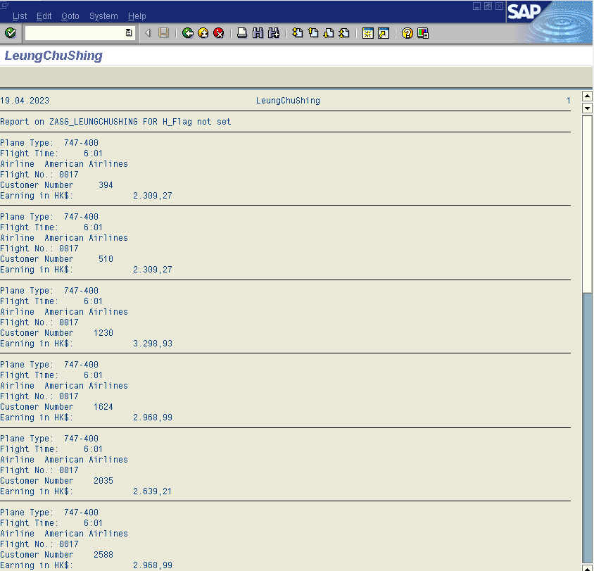

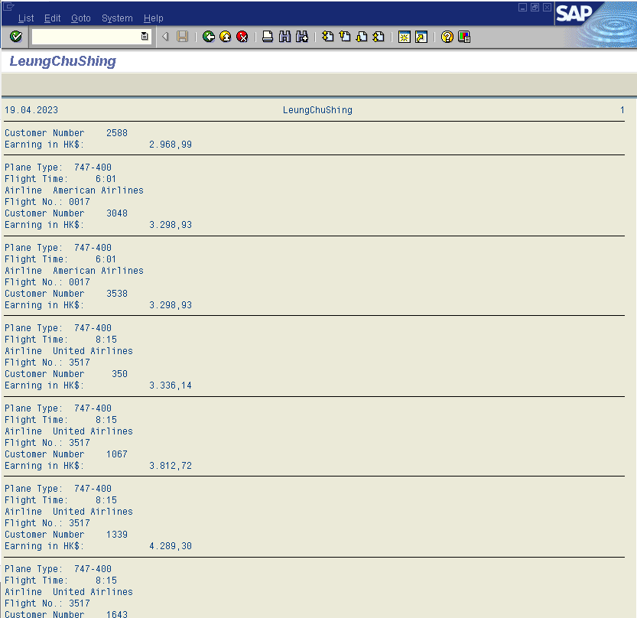

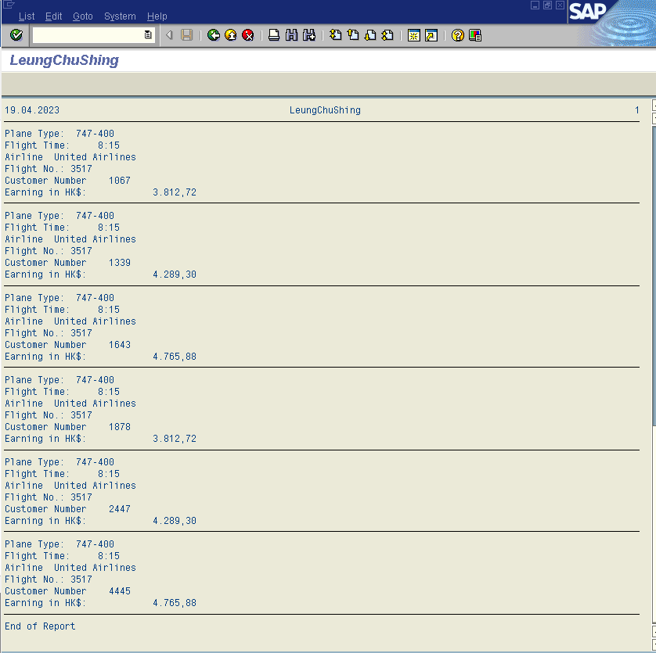

**Demo 2: (H Flag set)**

