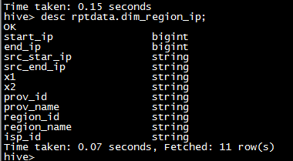

create table intdata.user_visit_daily

(

user_key string,

busi_time string,

serv_number string,

user_id string,

imei string,

cookie string,

tourist_visit_id string,

node_id string,

sup_node_id string,

page_url string,

sup_page_url string,

src_chn_id string,

chn_id string,

chn_99000 string,

chn_reserve1 string,

version_id string,

cp_id string,

content_id string,

node_type string,

net_type_id string,

device_ua string,

**client_ip string,**

session_id string,

refer_page_id string,

client_id string,

server_app_tag string,

app_uid string,

imei_src string,

sales_id string,

program_id string,

is_valid_visit string comment 'Y/N',

is_voms string comment 'Y/N',

city_id string,

phone_city_id string,

term_prod_id string,

sub_busi_id string,

user_type_id string

)

partitioned by(src_file_day string);

两个都是默认分隔符 \x01