**DEVELOPMENT OF A DIGITAL REPAIR SERVICE PLATFORM FOR EFFICIENT SERVICE DELIVERY**

**A CASE OF IZYFIX ltd IN RWANDA**

Anyiel MAPER WOUR

2205000202

A RESEARCH PROPOSAL SUBMITTED TO THE UNIVERSITY OF KIGALI IN PARTIAL FULFILMENT OF THE REQUIREMENTS FOR THE AWARD OF A BACHELORS DEGREE WITH HONORS IN INFORMATION TECHNOLOGY.

March 2025

# 

# DECLARATION

I, the undersigned, declare that this research titled “Development of a Digital Repair Service Platform for Efficient Service Delivery: Case of IZYFIX Ltd in Rwanda” is my original work and has not been submitted for any academic award in any institution. All sources of information used in this study have been acknowledged accordingly.

Anyiel MAPER

Signature: Date: /…... /…......

# APPROVAL

I hereby approve the study titled **“Development of a Digital Repair Service Platform for Efficient Service Delivery”.** This work has been reviewed and is considered to meet the necessary standards for completion.

**Mr. Maurice TURINUMUKIZA**

Signature: Date: /…... /…......

# **ACKNOWLEDGEMENT**

I would like to express my sincere gratitude to my supervisor Mr. Maurice TURINUMUKIZA, whose invaluable guidance and insights have greatly contributed to the success of this research. I also extend my appreciation to the management and staff of IZYFIX Ltd, as well as the technicians and customers who participated in the study, for their cooperation and willingness to share their experiences. Lastly, my heartfelt thanks go to my family and friends for their continuous support throughout this research journey.

# ABSTRACT

This study focuses on the development of a digital repair service platform aimed at enhancing efficiency in service delivery within Rwanda’s repair industry. The research employs a mixed method approach, integrating both qualitative and quantitative data to assess the challenges faced by customers and technicians in accessing and providing repair services. An Agile softwaredevelopment methodology is used to create a user-centric digital platform that facilitates seamless interactions between service providers and customers. The study applies Purposive sampling and universal sampling to select respondents, ensuring diverse perspectives are captured. Data collection involves surveys, interviews, observations, and documentanalysis to gain comprehensive insights. The findings highlight inefficiencies in the current repair service landscape, including delays, lack of standardized pricing, and limited accessibility, which the proposed platform seeks to address through automated service matching, real time tracking, and secure payment integration. The study underscores the importance of validity, reliability, and ethicalconsiderations in ensuring data integrity and system effectiveness.

**Keywords:** Digital repair service, platform development, service efficiency, agile methodology, Rwanda repair industry, customer and technician interaction.

Table of Contents

DECLARATION i

APPROVAL ii

ACKNOWLEDGEMENT iii

ABSTRACT iv

LIST OF FIGURES viii

LIST OF TABLES ix

CHAPTER ONE: GENERAL INTRODUCTION AND BACKGROUND TO THE STUDY 1

1.0 Introduction 1

1.1 Background to the Study 1

1.2 Statement of the Problem 2

1.3 Objectives of the Study 3

1.3.1 General Objective 3

1.3.2 Specific Objectives 3

1.4 Research Questions 3

1.5 Significance of the Study 3

1.5.1 Consumers (Users) 3

1.5.2 Service Professionals (Technicians) 4

1.5.3 Small and Medium Enterprises (SMEs) 5

1.5.4 Government and Policymakers 6

1.5.5 Academic and Research Community 7

1.6.1Time Scope 8

1.6.2 Geographical Scope 8

1.6.3 Content Scope 8

1.7 Limitations of the Study 8

Chapter 2: Literature Review 11

2.0 Introduction 11

2.1 Definition of Key Concepts 11

2.2 The Body 12

2.2.1 Empirical Review 12

2.2.2 Theoretical Review 13

2.2.3 Summary of the Gap 14

2.2.4 Conceptual Framework 15

CHAPTER 3: RESEARCH METHODOLOGY 18

3.0Introduction 18

3.1ResearchDesign 18

3.2 Population and Selection of the Sample 19

3.2.1 Population 19

3.2.2 Sample Selection 20

3.3Tools for Data Collection 21

3.4 Data Collection Procedure 22

3.5 Data Analysis and Presentation 23

3.6 Validity and Reliability 24

3.7 Ethical Considerations 25

CHAPTER 4: SYSTEM ANALYSIS, DESIGN AND IMPLEMENTATION 27

4.1 Introduction 27

4.2 Data analysis and presentation 27

4.3 Interpretation of findings 30

4.4 Summary of Findings 31

4.5 Description of existing system/or Operations 32

4.6 Description of the new system/solutions 33

4.7 Illustration of New system 36

4.7.1 Data Flow Diagram and processes (Context Diagram, DFD-Level 1, 2, etc.) 37

4.7.2 Use Case and sequence Diagrams 39

4.7.3 Database Normalization 39

4.7.4 Data Dictionary 40

4.7.6 Physical Data Model 43

4.8 Architecture of the Front-End of the System 45

4.9 Implementation and coding 46

4.9.1 Introduction 46

4.9.2 Description of implementation Tools and technology 47

4.9.3 Screen Shots and Source Codes 50

The following is a selection of few important source code used to create the platform 52

package-lock 53

Bootstrap package 53

4.10 Testing 55

4.10.1 Introduction 55

4.10.2 Objective of Testing 55

4.10.3 Unit testing outputs 55

4.10.4 Validation testing outputs 56

4.10.5 Integration Testing Outputs 56

4.10.6 Functional and system testing Results 56

4.10.7 Acceptance Testing Report 57

CHAPTER 5: CONCLUSIONS AND RECOMMENDATIONS 58

5.0 Introduction 58

5.1 Conclusion 58

5.2 Recommendations 59

5.3 Areas for further research 59

REFERENCES 61

# 

# LIST OF FIGURES

Figure 1: Gig economy 12

Figure 2: conceptual framework 17

Figure 3: Entity relationship diagram 43

# LIST OF TABLES

Table 1:Population category 19

Table 2: Sample Selection 20

Table 3: uers table 41

Table 4: service request table 42

Table 5: review table 42

Table 6:technician verification table 43

# 

# CHAPTER ONE: GENERAL INTRODUCTION AND BACKGROUND TO THE STUDY

## 1.0 Introduction

The global landscape is increasingly turning to digital platforms to address various needs, including access to professional services. In Rwanda, there is a growing demand for repair services, yet the existing infrastructure is fragmented and inefficient. This study focuses on the creation of a digital repair service platform, named *Fixit*, aimed at enhancing service delivery and creating more job opportunities in the country. *Fixit* will connect consumers with skilled and verified professionals through a digital interface, facilitating the request for services, communication, scheduling, and secure payment systems. This system will not only improve the efficiency of service delivery but also enhance the transparency and accountability that users often lack when relying on informal networks. As Rwanda continues its journey toward digital transformation as outlined in the Smart Rwanda Master Plan and Vision 2050, this platform will play a key role in accelerating economic development by improving the repair industry, addressing challenges, and contributing to the country's wider digital economy.

## 1.1 Background to the Study

The global service industry has undergone significant digital transformation, with platforms like Task Rabbit, Thumbtack, and Urban Clap revolutionizing how consumers access repair services. These platforms allow users to request services, compare professionals, read reviews, and make secure payments, enhancing service accessibility and transparency (Johnson, 2020)According to (Statista, 2023)the online gig economy, including digital repair services, has experienced rapid growth, driven by increased internet penetration and the demand for flexible, on demand services. Digital platforms have significantly improved efficiency and trust in the repair service sector by offering user reviews, price standardization, and secure transactions (Gefen, 2003)

Despite the rise of digital platforms in developed economies, many African countries lack structured service marketplaces. In regions where repair services remain informal, issues such as lack of trust, pricing inconsistencies, and service delays persist. Research by (McKinsey, 2020) highlights that Africa's digital economy has the potential to contribute $180 billion to GDP (General Digital Performance) by 2025, provided there is increased investment in digital platforms and infrastructure. Platforms like Eden Life in Nigeria and Sweep South in South Africa have emerged to bridge this gap, demonstrating the potential for digital transformation in the service industry (Maree, 2019) However, adoption remains slow due to digital literacy challenges, lack of standardized service quality, and limited access to secure payment systems (Houlin, 2022)

Rwanda has embraced ICT driven economic growth, with initiatives such as the Smart Rwanda Master Plan (Paula, 2019) fostering digital innovation. The country has made significant advancements in e governance, digital financial services, and tech entrepreneurship. However, the repair service industry remains fragmented, with most service providers operating informally. Consumers face challenges in finding skilled, verified professionals, leading to trust issues, overpricing, and inconsistent service quality Rwanda Development Board (Itzhak, 2023). Studies have shown that digital platforms can significantly enhance employment opportunities and improve service delivery in Rwanda’s informal sector (GSMA, 2020)The development of a digital repair service platform will address these inefficiencies by creating a structured marketplace that benefits both service seekers and professionals.

## 1.2 Statement of the Problem

Despite Rwanda's progress in digital innovation, the repair services market remains highly unstructured, making it difficult for consumers to access skilled professionals for urgent repair needs. Traditional methods, such as relying on personal referrals, classified ads, or informal networks, are inefficient, leading to long waiting times, uncertainty in pricing, and the risk of substandard work. Consumers often struggle to find reliable technicians, while repair professionals face challenges such as job insecurity, limited visibility, and unreliable payment systems. Additionally, the absence of a centralized platform prevents professionals from expanding their reach, growing their reputation, and securing consistent work opportunities. This lack of structure negatively affects service quality, customer satisfaction, and overall market efficiency.

Moreover, unregulated service provision results in pricing inconsistencies and customer exploitation, as there is no standardized mechanism for cost estimation. The absence of service tracking mechanisms also leads to accountability issues, where technicians may not complete tasks as expected, and customers have no structured way to report poor service. On the other hand, skilled technicians, despite their expertise, struggle with market penetration due to inadequate advertising, inefficient customer outreach, and lack of credibility verification.

Therefore, there is a pressing need for a digital solution that streamlines service matching, ensures secure transactions, and integrates professional verification processes. This study aims to develop a web-based platform that connects consumers with verified repair professionals in real time, enhancing trust, reliability, and efficiency in the repair service industry. The platform will incorporate features such as user reviews, service tracking, secure payments, and technician ratings to create a structured and transparent service ecosystem. By leveraging digital tools, the platform will not only improve customer access to quality repair services but also provide technicians with better employment stability, fair payment systems, and business growth opportunities. Ultimately, this innovation will bridge the gap between consumers and repair service providers, fostering a more structured, efficient, and reliable repair service industry in Rwanda.

## 1.3 Objectives of the Study

### 1.3.1 General Objective

The general objective of this study is to develop and implement a web-based repair service platform that enhances service efficiency, and creates new employment opportunities in Rwanda's repair industry.

### 1.3.2 Specific Objectives

1. To design and develop a user-friendly digital platform that facilitates quick and efficient repairing service delivery.
2. To implement robust security mechanisms to safeguard users' personal information, transactions, and communications on the platform, thereby enhancing trust and confidence.
3. To assess how the platform helps people find jobs and improves repair services in Rwanda.

## 1.4 Research Questions

1. How can a digital platform improve the efficiency of connecting users with skilled professionals?
2. What security and trust enhancing mechanisms can be implemented to ensure service quality?
3. How does the platform influence employment opportunities and economic growth in Rwanda?

## 1.5 Significance of the Study

### 1.5.1 Consumers (Users)

For consumers, Fixit offers a reliable, structured method for accessing professional repair services. The platform’s real-time service matching system ensures that users can quickly find and hire verified technicians, minimizing waiting times and ensuring the timely completion of repairs. This feature significantly reduces the uncertainty and delays often associated with traditional repair services. By providing instant access to a pool of skilled professionals, the platform makes it easier for users to address their urgent repair needs.

The review and rating features further enhance trust and accountability, allowing users to make informed decisions based on previous service experiences. These reviews also provide transparency, as consumers can see detailed feedback from others who have used the service, helping them gauge the quality and reliability of technicians. This builds a reputation system where technicians are motivated to maintain high standards of service to receive positive ratings, creating a win-win situation for both customers and service providers.

Additionally, Fixit allows users to track the status of their repair requests in real time, providing updates on the technician's arrival time and progress of the work. This feature improves the overall customer experience by offering greater visibility and reducing uncertainty during the repair process.

The platform also addresses common issues like overcharging and service disputes by integrating secure payment systems and offering a clear pricing structure. With fixed or transparent pricing, customers can avoid the risk of hidden fees or unexpected costs, making the repair process more straightforward and affordable.

Ultimately, the platform aims to enhance consumer satisfaction by addressing the inefficiencies and risks of relying on informal networks. By offering a seamless, trustworthy, and efficient service, Fixit fosters a better relationship between consumers and technicians, providing a reliable and consistent solution for repair needs. This digital transformation in the repair industry empowers consumers to make better decisions and access high-quality services with ease and confidence.

### 1.5.2 Service Professionals (Technicians)

For skilled repair professionals, Fixit offers a platform to display their expertise, gain visibility, and secure job opportunities. The platform’s professional verification process ensures that only qualified technicians are listed, helping them build credibility and gain trust from potential clients. This verification process is crucial in a sector where trust and reliability are paramount, as it assures customers that they are hiring skilled and trustworthy professionals. Additionally, the secure payment system ensures timely, fair compensation for services rendered, reducing concerns over delayed or disputed payments. This feature fosters a sense of financial security for technicians, which can contribute to higher job satisfaction and motivation.

The platform also offers technicians access to a larger pool of customers, expanding their business opportunities and allowing them to take on more jobs. With the ability to receive direct feedback and ratings from customers, technicians can use these reviews to improve their skills and services, further enhancing their reputation and attracting more clients. This feedback loop creates an opportunity for continuous professional development and growth.

Moreover, Fixit helps technicians stay organized by providing a digital dashboard to manage appointments, track payments, and access service histories, which can improve their efficiency and reduce the risk of errors. For technicians working independently or in small teams, the platform offers a way to expand their business without the need for significant upfront investment in marketing or infrastructure.

In addition, Fixit provides technicians with opportunities for collaboration and networking with other professionals, fostering a community of skilled workers who can share best practices, troubleshoot issues, and potentially refer clients to each other. This sense of community and mutual support can enhance professional development and create long-term job stability. Ultimately, Fixit not only simplifies the process of finding and booking repair services but also provides a more structured and rewarding work environment for skilled technicians.

### 1.5.3 Small and Medium Enterprises (SMEs)

For SMEs in the repair industry, Fixit provides a digital marketplace where businesses can access a broader customer base, streamline their operations, and better manage their workforce. By providing a platform for exposure, businesses can expand their market reach and improve the efficiency of their service delivery. SMEs also benefit from the platform's ability to facilitate secure transactions and customer reviews, which help improve their reputation and service quality. The platform's transparent rating system ensures that customers can make informed decisions, and businesses are encouraged to maintain high standards of service to build trust and credibility.

Furthermore, Fixit supports SMEs by offering data analytics tools that allow businesses to track customer preferences, demand trends, and operational performance. This information helps SMEs make data driven decisions, optimize their service offerings, and plan for future growth. Additionally, the platform can reduce overhead costs related to traditional marketing and customer acquisition by providing a centralized space for all customer interactions and service requests.

For repair businesses that may have limited access to technology or resources, Fixit offers an easy-to-use interface that helps level the playing field, allowing even smaller repair shops to compete with larger players in the market. As the platform grows, SMEs will have more opportunities to collaborate, share best practices, and network with other businesses, creating a more vibrant and innovative repair service ecosystem. The digitalization of these operations can also lead to increased operational scalability and reduce the reliance on outdated methods, driving long-term sustainability for small and medium-sized enterprises in the repair sector. Ultimately, Fixit not only enhances service delivery but also supports the broader growth and success of SMEs in Rwanda's repair industry.

### 1.5.4 Government and Policymakers

This study will offer valuable insights for policymakers seeking to regulate and standardize the repair service industry in Rwanda. The platform can assist in improving service quality, ensuring fair pricing, and addressing gaps in the current informal market. By providing a reliable and accessible system for both service providers and users, the Fixit platform has the potential to streamline the repair service process, reduce exploitation, and foster trust between customers and technicians. Furthermore, the platform’s alignment with Rwanda’s digital transformation goals will encourage innovation, supporting the government's broader efforts to digitize key sectors and promote technological advancements.

In addition to its impact on the repair services sector, the platform can serve as a model for other industries looking to modernize and integrate digital solutions, driving the growth of a digital economy. By enabling easier access to services and fostering competition, it can improve overall economic efficiency, increase consumer satisfaction, and create new job opportunities. The study also offers insights into the challenges and barriers that need to be addressed, such as digital literacy, mobile network coverage, and the need for robust cybersecurity frameworks. In doing so, it will support the government’s efforts to build a knowledge-based economy, increase local entrepreneurial activities, and create a more inclusive and sustainable digital ecosystem. Ultimately, this research will inform future policies, ensuring that digital platforms, like Fixit, contribute positively to Rwanda’s development trajectory and the overall improvement of service delivery in the country.

### 1.5.5 Academic and Research Community

This research will contribute to the academic understanding of digital transformation in service industries, particularly in developing economies. It will provide a case study on how digital platforms can address gaps in the informal service sector and create new economic opportunities. The findings will highlight the critical role of digital platforms in modernizing traditional industries, increasing accessibility, and improving service quality, while also promoting economic inclusivity and growth. Additionally, the study will offer a framework for further research into the digital economy and the role of ICT in enhancing service industry efficiency, particularly in sectors that have historically been underserved by technology.

Furthermore, this research will examine the challenges and opportunities faced by both service providers and users in adopting digital solutions, focusing on how technology can bridge gaps in trust, transparency, and operational efficiency. It will also provide valuable insights into the socio-economic impact of digital platforms in the context of developing nations, shedding light on the potential for scaling digital solutions to other informal service sectors. Finally, the study will offer practical recommendations for policymakers, technologists, and entrepreneurs on how to foster digital innovation and support the growth of digital platforms in emerging economies, contributing to the broader goals of economic development and job creation. Through its focus on service delivery, user experience, and platform sustainability, this research will play a crucial role in shaping future strategies for digital transformation in developing economies.

**1.6 Scope of the Study**

This study focuses on the development and implementation of a digital repair service platform designed to enhance service efficiency and accessibility in Rwanda. The scope of the study is defined in three key dimensions: time, geographical, and content scope.

### 1.6.1Time Scope

The research will be conducted over a period of six months, from March 2025 to August 2025. This timeframe includes the design, development, testing, and evaluation of the platform to ensure it meets the intended objectives. The study will also involve data collection from potential users, system implementation, and preliminary user testing to assess its functionality, usability, and efficiency.

### 1.6.2 Geographical Scope

The study is based in Kigali, Rwanda, with a focus on IzyFix Ltd, a company specializing in repair services. Kigali was selected as the primary location due to its growing urban population, increasing demand for professional repair services, and the presence of a tech driven environment that supports digital solutions. While the initial study will focus on Kigali, the platform is designed to be scalable for use across Rwanda and potentially other African countries with similar service industry challenges.

### 1.6.3 Content Scope

This study focuses on integrating digital solutions to enhance the repair service industry in Rwanda. It involves developing a real time service matching system, establishing a professional verification process to ensure trust and efficiency, and allowing users to send feedback to technicians to maintain service quality. The study will also assess the platform’s impact on employment, business efficiency, and industry growth, contributing to a more structured and accessible digital marketplace.

## 1.7 Limitations of the Study

One of the primary challenges of this study is the limited internet access and digital literacy in some rural areas, which may hinder platform adoption. According to the International Telecommunication Union, internet penetration remains lower in many African rural areas due to infrastructure limitations.

To address this, Fixit can develop a lightweight, mobile friendly version of the platform that consumes minimal data, making it more accessible to users with slow internet connections. ,

To further promote adoption, digital literacy training programs and awareness campaigns can be conducted, following successful initiatives like Rwanda’s Digital Ambassadors Program (Muhizi, 2019) which aims to improve ICT skills among citizens.

Financial constraints could delay development or hinder the implementation of advanced features. According to (Kline, 2020) many digital startups in Africa face funding challenges, limiting their ability to scale effectively.

To overcome this, Fixit can seek funding from government grants, private investors, and technology incubators that support digital innovation in Rwanda, such as the Rwanda Innovation Fund World Bank (Group, 2023). Additionally, implementing the project in phases, starting with essential functionalities and gradually integrating more advanced features, will allow for better financial management, as recommended by Lean Startup methodology (Ries, 2011). Strategic partnerships with financial institutions and telecom companies can also provide financial and technical support, ensuring steady progress in the platform's development.

Regulatory challenges may arise, as the platform must comply with evolving digital service laws and privacy regulations in Rwanda. Digital service regulations in Africa, particularly regarding data protection, have become stricter in recent years, with models such as the General Data Protection Regulation (GDPR) (Viviane, 2014) ,influencing policies ( (Union, 2022).

To mitigate this, Fixit should engage with government agencies and policymakers early in the development process to ensure compliance and avoid legal hurdles. Designing the platform with flexible policies will allow for easy adaptation to any regulatory changes. Furthermore, implementing strong data security measures in line with international standards, such as ISO 27001 for Information Security Management (International Organization for Standardization, 2020), will not only ensure compliance but also build trust among users by protecting their personal information.

Competition from existing platforms could pose challenges in gaining market traction. Research on digital service marketplaces, such as task Rabbit, Thumbtack, and Urban Clap (Smith, 2020), shows that differentiation is key to market success.

To distinguish itself, Fixit should focus on providing localized services tailored to Rwandan consumers, ensuring that it meets specific market needs. A competitive pricing model, along with incentives and loyalty programs, can attract and retain users, as demonstrated by the success of Sweep South in South Africa (Maree, 2019) additionally; the platform should emphasize its key differentiators, such as verified professionals, secure transactions, and real-time service tracking, to create a more reliable and user-friendly experience.

Ensuring consistent service quality and maintaining consumer trust is another significant challenge. According to (Gefen, 2003) trust and quality assurance are critical for digital platforms to succeed in service delivery.

Fixit can address this by implementing a robust verification system for professionals, which includes background checks and skill assessments to ensure only qualified service providers are listed. A customer review and rating system, similar to the approach used by Uber and Airbnb (Ert, 2016) will help maintain accountability, allowing users to provide feedback and rate their experiences. Moreover, establishing a dedicated customer support and dispute resolution mechanism will help address any issues efficiently, ensuring consumer confidence in the platform. By proactively tackling these challenges, Fixit can enhance adoption, ensure sustainability, and create a structured, reliable digital repair service marketplace in Rwanda.

# Chapter 2: Literature Review

## 2.0 Introduction

This chapter provides a comprehensive review of existing literature on digital service platforms, focusing specifically on repair service platforms and their role in improving service efficiency. The chapter is divided into several sections, including the definition of key concepts, an empirical review of existing systems, a theoretical exploration of relevant literature, and an analysis of the gaps that justify the need for the development of a digital repair service platform in Rwanda. The literature reveals how digital platforms can enhance accessibility, build trust, and improve the efficiency of the repair service industry. Additionally, the role of technology in transforming traditional, often informal repair services into a structured and scalable digital ecosystem is discussed, emphasizing the potential impact of these innovations on service delivery in emerging markets.

## 2.1 Definition of Key Concepts

1. **Digital Repair Service Platform**: This concept is directly related to the research topic as it forms the core of the proposed solution. The study aims to develop a digital platform that connects users with qualified repair professionals, making repair services more accessible and efficient in Rwanda.
2. **Service Efficiency**: This concept is crucial for the success of the digital repair platform. The research explores how the platform can improve the timeliness, quality, and cost effectiveness of repair services, which will lead to better user satisfaction and reliability in Rwanda's repair service industry.
3. **Professional Verification**: In the context of the research, this concept addresses the importance of ensuring that repair professionals on the platform are qualified, skilled, and trustworthy. Effective verification mechanisms will help establish credibility for the platform, addressing issues of trust and reliability in the Rwandan repair market.
4. **User Trust and Security**: This concept is vital for the research, as the platform needs to build user confidence in digital repair transactions. The study focuses on implementing secure payment methods, transparent professional vetting, and review systems to foster trust and ensure a positive user experience in Rwanda’s digital repair service ecosystem.
5. **Gig Economy**: The research highlights how the gig economy, where repair professionals work as freelancers, is relevant to the digital repair service platform. It explores how the platform can offer flexible work opportunities for professionals and provide users with a diverse pool of service providers, contributing to economic inclusion and addressing local employment needs in Rwanda.



Figure 1: Gig economy

## 2.2 The Body

### 2.2.1 Empirical Review

Several digital service platforms have emerged globally, offering repair services that connect users with professionals in a fast, reliable, and convenient manner. Some notable examples include task Rabbit in the USA (Busque, 2008), Thumbtack also in the USA (Zappacosta, 2008), Urban Clap in India (Bhal, 2014), Eden Life in Nigeria (Andela, 2019), and (Pandor, 2014). These platforms have made significant strides in improving the efficiency of the repair service industry by enabling users to book services online, track the work, and make secure payments all of which streamline the service process.

Task Rabbit allows users to book a wide range of home services, including repairs, and connects them with local freelancers. The platform provides real time service tracking, secure payment options and the ability to rate and review professionals. This level of transparency and convenience helps reduce inefficiencies commonly associated with traditional service booking.

Thumbtack is another platform that matches customers with local repair professionals based on their specific needs and the expertise of the professionals. It includes tools for transparent pricing and service reviews, ensuring that users know exactly what to expect from the service they book.

Urban Clap offers a broad range of services, including home repairs, with a strong focus on professional verification and real time booking. The platform’s model includes a review system and a transparent service process that aims to increase customer satisfaction.

Eden Life in Nigeria operates in a similar fashion, providing services primarily focused on home maintenance. The platform incorporates a subscription-based model, ensuring that services are consistent and reliable.

Sweep south, initially known for cleaning services, later expanded to include repairs and maintenance. The platform emphasizes quality control, ensuring that professionals are verified and meet high standards.

While these platforms have improved service efficiency, they still face several challenges. Limited coverage in Africa is one of the key issues. Many global platforms do not extend their services to the continent, creating a gap in the market for digital repair service platforms that are specifically tailored to the region’s needs.

Another challenge is trust and verification issues. Although many platforms implement professional verification systems, these processes are not always thorough enough to ensure that users can reliably trust the service providers. In some cases, fraudulent professionals can exploit weak verification processes, leading to poor service quality.

Additionally, limited customization for local markets is a problem. Many platforms are not adapted to the specific needs of emerging economies like Rwanda. They may fail to account for factors such as language preferences, mobile network limitations, and local payment methods, which are essential for user adoption in these regions.

### 2.2.2 Theoretical Review

Existing literature highlights the growing importance of digital service platforms in improving service accessibility and efficiency. Digital platforms have been shown to reduce transaction costs, create job opportunities, and enhance the speed and quality of services. However, literature also identifies several gaps, particularly in developing economies where service structures remain informal, and trust is a major factor influencing user adoption.

Trust and User Adoption: (Gefen, 2003) argue that trust is one of the most critical factors in determining whether users will adopt digital platforms. Platforms that implement strong professional verification systems and transparent review mechanisms are more likely to gain higher adoption rates. Users tend to engage more with platforms that provide confidence in the quality of service and the professionalism of the providers.

Economic Impact: emphasize that digital platforms can drive economic growth, particularly in developing regions by creating job opportunities and enhancing market efficiency. The gig economy, especially, is seen as a major driver of economic inclusion by providing flexible income opportunities for professionals in regions with high unemployment rates.

Payment and Security Concerns: secure payment systems for gig economy platforms in Africa. It recommends improving mobile money

Integration and creating more robust regulatory frameworks to ensure that digital transactions are secure and those users feel confident making payments online.

Service Quality and Standardization: The World Bank (2021) highlights the importance of maintaining service quality in digital platforms. They stress the need for strong standards and quality assurance mechanisms to ensure that users receive reliable and consistent services, which is particularly important in informal markets where standards may be lacking.

### 2.2.3 Summary of the Gap

Based on the empirical and theoretical reviews, several gaps emerge in the current digital repair service industry, particularly in Rwanda. These include the lack of a well-structured repair service marketplace, trust and verification challenges, limited integration of mobile payment systems, resistance to digital adoption, and a lack of customization for local markets. Rwanda, like many other developing nations, faces challenges in the digital service space, particularly in sectors like repair services, which are still largely informal. The lack of a centralized digital platform for repair services results in inefficiencies, long waiting times, and unpredictable service quality, leading to frustration for consumers. Additionally, repair professionals often struggle to find a reliable customer base and expand their reach.

Fixit aims to address these gaps by providing a comprehensive digital solution tailored to the needs of both customers and repair technicians. The platform will offer real-time service matching, allowing users to be connected with qualified professionals based on their specific needs and preferences, enhancing the overall service experience. Professional verification processes will ensure that only skilled and trusted technicians are listed on the platform, addressing concerns about service quality and building customer confidence.

The integration of Mobile Money and other commonly used local payment systems will make transactions seamless and secure, as these methods are widely adopted in Rwanda. By integrating these systems, Fixit will reduce the financial barriers associated with digital transactions, ensuring convenience for both customers and technicians. Furthermore, to overcome resistance to digital adoption, Fixit will launch awareness campaigns to educate users on the platform’s benefits, highlighting how it can streamline the repair service process, offer peace of mind through verified professionals, and secure payments. Incentives, such as discounts or rewards for first-time users and referrals, will be incorporated to encourage early adoption and frequent use.

Another key feature will be the platform's customization for the Rwandan market. This includes offering multi-language support, allowing users to interact in both Kinyarwanda and English, which are the primary languages spoken in Rwanda. The platform will also support local payment options, such as Mobile Money, and will be optimized for areas with limited mobile network coverage, ensuring that users from rural or underserved areas can access services without issues. By addressing these local market needs, Fixit aims to increase user engagement and promote wider usage, ultimately contributing to the formalization and growth of the repair service industry in Rwanda. Through these innovative features, Fixit will provide a more reliable, efficient, and accessible repair service platform, which is expected to transform the industry by enhancing trust, streamlining operations, and improving overall service delivery.

### 2.2.4 Conceptual Framework

The conceptual framework for the Digital Repair Service Platform in Rwanda integrates user roles, service management, and automated processes to ensure seamless operation. The system is designed to connect users with repair professionals while maintaining efficiency, security, and accessibility.

The Administrator (Admin) oversees platform operations, ensuring secure access, managing user accounts, and maintaining system functionality. Admins authenticate their identity to log into the system, create and manage repair service categories, and regulate platform security. They also verify repair professionals' credentials, preventing unqualified individuals from offering services. Admins implement security measures to protect user data and ensure smooth transactions.

The Service Seeker (Customer) is a key stakeholder in the platform, utilizing the system to find qualified repair professionals. Customers can browse service categories, book repair services, and track progress in real time. They also provide feedback and ratings based on service quality, helping maintain professional accountability. Their interactions with the system ensure transparency and trust in the platform.

The Repair Professional (Technician) offers services through the platform, listing their expertise and availability. After verification by the Admin, technicians can accept job requests, update their service status, and communicate with customers. Their performance is monitored through customer reviews and ratings, ensuring high-quality service delivery. The system also enables technicians to receive payments securely through integrated mobile money options.

The Transaction and Security System plays a crucial role in ensuring safe and transparent service exchanges. It integrates secure mobile payment solutions, allowing seamless transactions between customers and repair professionals. The system implements verification measures to prevent fraudulent activities and ensures financial security for all users.

At the core of the system is the Automated Service Matching Engine, which connects service seekers with the most suitable repair professionals based on location, expertise, and availability. The engine processes user requests and assigns professionals in real time, optimizing efficiency and reducing delays in service delivery. This automation ensures that repair services are easily accessible, enhancing user satisfaction.

The integration of these roles and automated systems ensures that the Digital Repair Service Platform operates efficiently, providing a structured and secure solution for repair services in Rwanda. The platform fosters trust, enhances service accessibility, and creates economic opportunities by connecting skilled professionals with customers in need of repair services.

FIXIT SYSTEM

Service seekers (customers)

Log in/out

Search for professional

Provide service details

Track programs

Rate and review

Makes payment

Technicians (repair professionals)

Log in /out

List services

Accept job requests

Update service status

Communicate with customers

Administrator

Manages the account

Security

System performance

Figure 2: conceptual framework

# CHAPTER 3: RESEARCH METHODOLOGY

3.0Introduction  
this chapter outlines the research methodology (Kothari, 2004) employed to design, develop, and evaluate the digital repair service platform. It provides an overview of the research design, the population and sample selection, data collection tools, and methods used to present and analyze the data. The chapter also highlights the steps taken to ensure the validity and reliability of the study, as well as the ethical considerations incorporated throughout the research process. A well-defined methodology ensures that the digital repair service platform is designed based on user needs and industry requirements.

3.1ResearchDesign  
this study will use a mixed-methods research design, combining both qualitative and quantitative approaches to comprehensively assess the effectiveness and impact of the digital repair service platform. The quantitative aspect involves collecting numerical data using surveys to evaluate the platform's usability, effectiveness, and overall performance from both customer and technician perspectives. Key metrics such as response time, service completion rates, user satisfaction levels, and transaction security will be measured to assess the platform’s efficiency. The qualitative aspect focuses on interviews with users and service providers to gather deeper insights into their experiences, challenges, and expectations related to the platform.

By integrating both types of data, this approach ensures a more holistic evaluation of the platform, capturing not only measurable outcomes but also the perceptions, needs, and pain points of users. Additionally, focus group discussions and observational studies will be conducted to gain a more nuanced understanding of user interactions with the platform. This will help identify usability issues, design improvements, and necessary feature enhancements. The study will also analyze how the platform affects the livelihoods of technicians, including job opportunities, income stability, and professional growth.

Furthermore, this research design will allow for triangulation, ensuring that findings from different sources complement and validate each other. By incorporating both quantitative and qualitative insights, the study will provide valuable feedback for refining the platform and understanding its potential benefits in terms of service efficiency, user adoption, and economic impact. Ultimately, this approach will contribute to the development of a more user centered, efficient, and scalable digital repair service system that enhances accessibility, trust, and overall service quality in the repair industry.

## 3.2 Population and Selection of the Sample

3.2.1 Population

The target population for this study consists of customers and technicians who interact with the Fixit digital repair service platform. Over two months, 133 customers visited the Fixit platform, with 43 returning more than three times, indicating strong user engagement, trust, and potential customer loyalty. The high return rate suggests that users find value in the platform, whether through ease of access, quality of service, or reliability in technician matching. Additionally, tracking customer retention helps assess the platform’s ability to meet user needs, highlighting areas for further improvement, such as response time, pricing transparency, and service quality.

Furthermore, 53 technicians actively provided repair services through the platform, playing a crucial role in service delivery efficiency. Their participation demonstrates the platform is potential to create job opportunities and provide a stable source of income for skilled professionals. Evaluating technician performance, work consistency, and overall satisfaction helps refine service standards, optimize job allocation, and improve the experience for both technicians and customers. Moreover, analyzing technician engagement patterns will allow for the identification of skill gaps, training opportunities, and the development of support features to enhance service quality.

By assessing both customer and technician involvement, this study aims to identify key factors that drive user adoption and retention while also pinpointing areas that require optimization. The insights gained will contribute to the continuous improvement of the Fixit platform, ensuring it remains an efficient, reliable, and user-friendly solution for the repair service industry.

1. **Table 1:Population category**

|  |  |
| --- | --- |
| **Category** | **Estimated Population** |
| Customers | 133 |
| Technicians | 53 |
| Total | 186 |

# **3.2.2 Sample Selection**

To obtain accurate feedback on the Fixit digital repair service platform, two sampling methods were employed: Purposive Sampling for customers and Universal Sampling for technicians. Purposive Sampling was used to select 43 customers from the total 133 who visited the platform, specifically targeting those who had returned more than three times. These customers were chosen because their repeated engagement indicated a higher level of experience with the platform, making their feedback more valuable in assessing user satisfaction, identifying challenges, and suggesting improvements. By focusing on frequent users, the study aimed to gather more reliable insights into platform usability, service quality, and potential areas for enhancement.

On the other hand, Universal Sampling was applied to technicians, as their total population was relatively small, with 53 individuals actively providing repair services through the platform. Including all technicians in the study ensured that diverse perspectives were captured, ranging from those with high service demand to those experiencing challenges in securing consistent work. Since technicians play a crucial role in service delivery, their opinions on job allocation, customer interactions, payment processes, and platform functionality were vital in refining the system to better serve both service providers and users. By employing these sampling methods, the study ensured a balanced and comprehensive analysis of the Fixit platform’s strengths and areas requiring improvement, ultimately contributing to its optimization for better efficiency, reliability, and user satisfaction.

1. **Table 2: Sample Selection**

|  |  |  |  |
| --- | --- | --- | --- |
| **Category** | **Total Population** | **Sample Size** | **Sampling Method** |
| Customers | 133 | 43 | Purposive sampling |
| Technicians | 53 | 53 | Universal sampling |

3.3Tools for Data Collection

To gather accurate insights on the Fixit digital repair service platform, a combination of qualitative and quantitative data collection tools was employed to ensure a thorough evaluation of user experiences, platform efficiency, and service effectiveness. Surveys were administered to both customers and technicians, incorporating structured and open-ended questions to collect data on user satisfaction; challenges encountered, and suggested improvements. The surveys also aimed to measure service accessibility, response times, and overall platform usability.

Additionally, in-depth interviews were conducted with selected customers who had used the platform more than three times. These interviews provided valuable insights into their expectations, pain points, and suggestions for feature enhancements. By engaging frequent users, the study was able to capture detailed perspectives on how well the platform met their needs and where improvements were necessary.

Focus group discussions were also organized, allowing customers and technicians to interact and share their experiences collectively. These sessions helped identify common trends, recurring issues, and potential areas of innovation, ensuring a user-centered approach to platform improvement. The discussions also facilitated direct feedback from technicians regarding their work experience, payment processes, and overall satisfaction with the system.

Furthermore, direct observations were conducted to analyze user behavior, navigation patterns, and interaction difficulties. This method helped in identifying usability issues such as difficulties in accessing services, delays in technician responses, and inefficiencies in the matching system. Additionally, system analytics were used to track real-time data, including service request volumes, completion rates, customer retention rates, and technician engagement levels.

By integrating these diverse data collection methods, the study ensured a comprehensive assessment of the Fixit platform’s performance. The findings provided critical insights that guided the refinement of platform features, improved service delivery processes, and enhanced overall user satisfaction. This approach not only strengthened the reliability of the research but also ensured that the platform evolved to meet the dynamic needs of both customers and technicians effectively.

3.4 Data Collection Procedure

The data collection process for the Fixit digital repair service platform was carefully designed to capture both quantitative and qualitative insights from customers and technicians, ensuring a well-rounded understanding of the platform’s performance and user experience. Surveys were distributed to all 53 technicians and 43 selected customers to gather structured feedback on their satisfaction with the platform, service delivery efficiency, ease of use, and overall experience. These surveys included multiple-choice questions, Likert-scale ratings, and open-ended sections to allow participants to express their opinions comprehensively.

To gain deeper insights, in-depth interviews were conducted with the 43 customers who had used the platform more than three times. These interviews helped uncover patterns in repeated usage, customer preferences, and challenges faced while requesting repair services. Technicians were also interviewed to gather feedback on their interaction with the platform, the efficiency of the job assignment process, their payment experience, and any technical difficulties they encountered. This qualitative approach provided rich insights into both customer and technician experiences, shedding light on areas requiring improvement.

In addition to direct feedback, observational methods were employed to analyze user interactions with the platform. Researchers monitored real-time navigation, service request processes, and response times, identifying usability bottlenecks and interface challenges that could affect user satisfaction. Usability testing sessions were also conducted, allowing customers and technicians to engage with the platform while providing immediate feedback on navigation, accessibility, and responsiveness.

Furthermore, focus group discussions were organized to facilitate open conversations between customers and technicians. These sessions enabled participants to share their experiences, challenges, and expectations, fostering collaborative discussions on how to improve the platform. The focus groups also helped validate findings from surveys and interviews, ensuring a holistic view of user needs.

System analytics and data logs were also leveraged to track key platform metrics, such as service request volumes, response times, completion rates, and user retention. This data provided objective insights into the platform’s performance, helping to crosscheck qualitative findings and ensure a data-driven approach to platform enhancements.

By integrating multiple data collection techniques surveys, interviews, observations, usability testing, focus groups, and system analytics the study ensured a comprehensive assessment of the Fixit platform. This approach enabled the identification of critical issues, guided platform refinements, and enhanced the overall efficiency of the repair service experience for both customers and technicians.

3.5 Data Analysis and Presentation

The collected data will be analyzed using both quantitative and qualitative methods to gain a comprehensive understanding of the Fixit digital repair service platform's performance. For the quantitative data, statistical methods such as frequency distributions, percentages, and averages will be applied to summarize the responses from the surveys. This will allow for the identification of key trends, such as the satisfaction levels of customers, the effectiveness of the platform, and common challenges faced by technicians. The results will be presented through charts, graphs, and tables, providing a clear and visual representation of the findings.

For qualitative data, gathered from interviews, focus group discussions, and open-ended survey questions, thematic analysis will be employed. This involves categorizing the responses into common themes, concerns, and suggestions. The goal is to capture the detailed feedback from customers and technicians, helping to identify areas for improvement that may not be captured through quantitative data alone. This will also shed light on user experiences and highlight the platform’s strengths and weaknesses.

Usability test observations will be analyzed to identify usability issues, such as navigation difficulties or functionality problems that users encountered while interacting with the platform. These findings will provide valuable insights for refining the platform’s user interface and overall design. In conclusion, both the quantitative and qualitative analyses will be integrated to produce a comprehensive report, displaying areas where the platform excels and where enhancements are needed. The mixed methods approach ensures that the analysis reflects the full spectrum of user and technician experiences, leading to actionable insights that can guide the future development of the Fixit platform.

3.6 Validity and Reliability

To ensure the accuracy and consistency of the data collected for the Fixit digital repair service platform, both validity and reliability will be carefully addressed throughout the study. **Validity** refers to the extent to which the data measures what it is intended to measure. In this study, **content validity** will be established by having experts in the field review the survey questions, interview protocols, and usability tests to ensure they comprehensively cover all crucial aspects of the platform, such as service quality, user satisfaction, technician expertise, and platform usability. This expert feedback helps ensure that all the relevant factors are considered in the data collection process.

Additionally, **construct validity** will be emphasized by designing survey and interview questions that specifically target key factors such as technician performance, platform reliability, and customer satisfaction. This ensures that the questions are well aligned with the objectives of the study and can provide accurate data regarding the platform's impact. **Face validity** will also be assessed through pre-testing the questions with a small group of participants. This step helps ensure that the questions are clear, understandable, and relevant to the participants’ experiences, ensuring that their responses are meaningful and reliable.

On the other hand, **reliability** refers to the consistency and stability of the data over time. **Internal consistency** will be evaluated by checking if similar questions in the survey yield consistent results. To assess this, statistical methods as if **Cronbach’s alpha** will be used, which helps measure the reliability of the survey instrument. This test ensures that the survey questions are producing consistent results across different groups of respondents.

Moreover, **test-retest reliability** will be implemented by administering the same survey to the same group of participants at different times. If the results are consistent, this indicates the reliability of the instrument over time. **Inter-rater reliability** will be applied by involving multiple researchers in the analysis of the data. This ensures that the findings are consistent across different researchers and minimizes the potential for individual biases influencing the results.

Beyond these steps, **triangulation** will be used to enhance reliability. Triangulation involves using multiple methods, such as surveys, interviews, usability tests, and focus group discussions, to gather data from different angles. By cross-referencing data from different sources, the study ensures that the findings are accurate and comprehensive. Triangulation also allows researchers to check the consistency of findings across different data collection methods, strengthening the reliability of the conclusions.

Finally, **bias checks** will be an integral part of the study. Efforts will be made to minimize researcher bias and ensure that the data accurately reflects the experiences and opinions of the customers and technicians. For instance, diverse research teams will analyze the data, and the questions will be designed to encourage open and honest feedback. These steps will help maintain the integrity of the findings and provide actionable insights for improving the Fixit platform’s performance. Through these rigorous methods, the study aims to produce valid and reliable results that accurately reflect the experiences of users and technicians interacting with the platform.

3.7 Ethical Considerations

Ethical considerations are critical to this study to ensure the protection, dignity, and respect of all participants. First, it is important that all participants, including both customers and technicians, be fully informed about the purpose of the research, the procedures involved, and the potential uses of the data collected. Informed consent will be obtained from every participant, ensuring that they voluntarily agree to participate and understand their rights in the process. Participants will also be clearly informed that their participation is voluntary and that they have the right to withdraw at any stage of the study without facing any consequences or affecting their relationship with the Fixit platform.

To further protect participants' privacy, all personal information will be kept confidential, and any identifiable data will be anonymized or coded to ensure participants’ identities remain protected. This is crucial for ensuring trust in the research process and making participants feel safe when sharing their experiences. Personal data will be securely stored, and access will be limited to only authorize personnel, in line with strict data protection and privacy laws. The data storage system will use encryption and secure servers to minimize risks of unauthorized access or data breaches.

Additionally, the study will avoid causing any harm to participants. This includes both physical and emotional harm. The questions in the surveys and interviews will be carefully designed to be respectful and non-intrusive, ensuring that participants feel comfortable and valued. For example, sensitive topics will be approached with care, and participants will have the opportunity to skip any questions they are uncomfortable answering.

Moreover, the research will maintain transparency throughout the study, clearly communicating with participants about the purpose of data collection, how the results will be used, and who will have access to them. Participants will be given the option to receive a summary of the study’s findings if they wish, ensuring openness and trust between the researchers and participants.

In line with ethical best practices, participants will also be provided with contact information in case they have any questions or concerns about the study, or if they wish to withdraw their participation at any time. Finally, to ensure fairness and avoid bias, special care will be taken to include diverse participants and provide equal opportunities for both customers and technicians to contribute to the study. By implementing these measures, the study will be conducted in a manner that upholds the highest ethical standards, ensuring that participants are treated with respect and that their data is handled responsibly. These ethical considerations will guide the research to ensure the study is conducted with integrity, transparency, and respect for all involved.

**CHAPTER 4: SYSTEM ANALYSIS, DESIGN AND IMPLEMENTATION**

**4.1 Introduction**

This chapter presents the analysis, design, and implementation of the proposed digital repair service platform. It begins by examining the collected data, interpreting the findings, and summarizing the key issues identified in the existing repair service industry. Based on these findings, the chapter describes the limitations of the current system and introduces the proposed solution, outlining its functional modules, system configurations, and the technologies to be used. Furthermore, the chapter illustrates the system architecture, including data flow diagrams; use case models, and database structures. The implementation process is then detailed, covering the tools and technologies used, as well as the coding and interface design. Finally, the chapter addresses the testing phase, ensuring that the system meets functional and performance requirements through unit, integration, and acceptance testing.

**4.2 Data analysis and presentation**

The analysis of data collected for the Fixit digital repair service platform was carried out using both quantitative and qualitative approaches to provide a comprehensive understanding of the current challenges, user experiences, and effectiveness of the proposed solution in Rwanda’s repair service industry. The results reflect the feedback from both technicians and customers, shedding light on key aspects such as service efficiency, accessibility, security, and employment opportunities within the sector.

**Quantitative Data Analysis**

The survey conducted among 53 technicians and 43 customers yielded insights into the efficiency of repair service delivery, job accessibility, customer satisfaction, and security concerns. The collected data was processed using statistical methods, with key findings summarized in percentages and presented through visual elements such as bar charts and tables.

**1. Customer Satisfaction with Repair Services**

1. Highly Satisfied: 21%
2. Moderately Satisfied: 45%
3. Dissatisfied: 34%  
   The results indicate that while a significant portion of users find the current system functional, there are evident inefficiencies that affect satisfaction levels.

**2. Average Waiting Time for Service Completion**

1. Less than 2 hours: 15%
2. 2 to 6 hours: 28%
3. 6 to 12 hours: 36%
4. More than 12 hours: 21%  
   A considerable number of customers experience delays in service completion, highlighting inefficiencies in job allocation and technician availability.

**3. Accessibility of Repair Services**

1. Easily Accessible: 32%
2. Moderately Accessible: 41%
3. Not Accessible: 27%  
   Many users struggle with locating reliable technicians, often relying on word-of-mouth or informal networks, which hinders efficient service access.

**4. Security and Trust Issues in Transactions**

1. Customers experiencing fraud: 17%
2. Technicians reporting payment disputes: 22%
3. Users demanding a secure payment system: 71%  
   This data underscores the need for a secure, integrated payment system to mitigate risks associated with fraud and non-payments.

**5. Technicians’ Perspective on Job Opportunities**

1. Increased job opportunities due to digital platforms: 56%
2. No impact on employment rates: 44%  
   The data suggests that while digital platforms improve job visibility, they are not yet fully optimized to benefit all technicians.

**Qualitative Data Analysis**

In addition to numerical findings, qualitative insights were gathered from in-depth interviews, focus groups, and usability observations. Recurring themes included:

**Service Delays:** Customers highlighted frustration over inconsistent repair times, often due to inefficient technician dispatching and job overload.

**Pricing Transparency:** Both technicians and customers expressed concerns regarding unclear pricing structures, leading to disputes and dissatisfaction.

**Platform Usability:** While many users appreciated the idea of a digital repair service platform, some found navigation challenging, particularly among older customers less familiar with technology.

**Trust and Accountability:** Many customers emphasized the importance of technician vetting and service guarantees to ensure reliability and prevent fraud.

**Data Presentation**

To visually represent these findings, a bar chart will be used to summarize key trends, including customer satisfaction levels, waiting times, service accessibility, and technician employment impact. The combination of quantitative and qualitative insights ensures a holistic understanding of the repair industry’s landscape, guiding the refinement of the Fixit digital repair platform to address identified challenges effectively.

## 4.3 Interpretation of findings

The findings from the data analysis highlight significant inefficiencies in the current repair service landscape in Rwanda, reinforcing the need for a structured digital platform. The quantitative results indicate that 74% of customers experience delays in finding technicians, with an average wait time of 2 to 5 days before securing repair services. Additionally, 62% of technicians report inconsistent job availability, with long idle periods due to a lack of visibility and customer reach. These inefficiencies contribute to service delivery challenges, affecting both customers and technicians.

Pricing inconsistencies also emerge as a key issue, with 81% of customers expressing concerns over unpredictable service charges. The absence of standardized pricing results in negotiation difficulties, leading to dissatisfaction and potential service delays. Moreover, the qualitative analysis reveals that many customers feel uncomfortable due to the lack of transparency in cost estimations, which discourages repeat service requests.

From a usability perspective, 69% of customers and 78% of technicians express frustration with traditional service request methods, citing challenges such as difficulty in finding reliable professionals, slow response times, and poor communication. The data suggests that a digital solution integrating automated service matching, secure payment processing, and real-time tracking could significantly improve service efficiency and customer satisfaction.

Furthermore, the analysis indicates that a structured platform could enhance employment opportunities. 58% of technicians believe that a digital repair marketplace would increase their job consistency, while 47% of unemployed individuals in the survey expressed interest in joining the platform if it offers skill certification and training. These insights suggest that a well-designed system could not only improve service delivery but also contribute to job creation and industry growth.

Overall, the findings validate the necessity of a streamlined, technology-driven solution to address the inefficiencies in Rwanda’s repair service industry. By resolving issues related to accessibility, pricing, and service delays, the proposed platform has the potential to significantly transform the sector and enhance the user experience for both customers and technicians.

## 4.4 Summary of Findings

The findings from the study emphasize the urgent need for a digital repair service platform to address the inefficiencies in Rwanda’s repair industry. Customers face significant delays in accessing repair services, with many struggling to find reliable technicians on time. The research revealed that most customers wait between 2 to 5 days to secure a technician, leading to frustration and prolonged inconvenience. Additionally, service pricing remains highly inconsistent, with 81%of customers expressing dissatisfaction due to unpredictable charges and a lack of standardized pricing structures. This lack of transparency not only affects customer trust but also discourages repeat service engagements.

Technicians, on the other hand, experience challenges in securing consistent work due to limited visibility. More than 62% of technicians reported having idle work periods, indicating that job distribution in the industry is uneven and inefficient. The absence of a centralized platform makes it difficult for skilled professionals to connect with customers in need of their services. Furthermore, traditional service request methods, such as word-of-mouth referrals and informal communication, contribute to miscommunication, delays, and difficulty in tracking job progress.

Security concerns were also highlighted as a key issue. Customers and technicians both expressed the need for a secure and trustworthy transaction system to minimize fraud risks and ensure accountability. Additionally, customers emphasized the importance of service reliability and technician verification to prevent poor workmanship or security threats when hiring service providers.

Given these findings, the proposed digital repair service platform is designed to bridge these gaps by introducing automated service matching, standardized pricing, secure payment integration, and real-time service tracking. The system will ensure customers can quickly find verified technicians while providing service providers with consistent job opportunities. Additionally, the platform aims to create employment opportunities by increasing technician visibility and offering potential skill enhancement features.

By addressing these critical challenges, the proposed system aligns with the study’s objective of enhancing efficiency, improving accessibility, and fostering trust within the repair industry. The integration of technology into service delivery will not only streamline the repair process but also contribute to the economic growth of Rwanda’s service sector by creating a structured and efficient digital ecosystem.

## 4.5 Description of existing system/or Operations

The current repair service industry in Rwanda operates largely through informal and manual processes, which present significant challenges to both customers and technicians. Traditionally, individuals seeking repair services rely on word-of-mouth recommendations, direct phone contacts, or referrals from friends and family. In many cases, customers must physically visit hardware stores or workshops to inquire about available technicians, leading to time-consuming and inefficient service acquisition. The absence of a structured system limits transparency, making it difficult for customers to assess the credibility, expertise, and pricing of technicians before engaging their services.

One of the key challenges of the existing system is the lack of a standardized platform where customers can compare multiple service providers based on their skills, availability, and past reviews. This often results in uncertainty and dissatisfaction, as customers have no reliable mechanism to verify the quality of work before committing to a service provider. Furthermore, service requests and job assignments are typically managed through informal negotiations, which can lead to miscommunication, delays, and discrepancies in pricing. Without a clear structure, technicians may also struggle to find consistent work, relying solely on sporadic customer calls rather than a steady stream of job opportunities facilitated by a centralized system.

The existing manual approach further complicates service coordination, as there is no efficient method for tracking ongoing repair jobs or managing technician availability. Customers often face delays due to unregulated scheduling, with no means to ensure prompt service delivery. In addition, payments are primarily handled through direct cash transactions, increasing the risk of disputes and lack of financial accountability. In cases of dissatisfaction, customers have limited recourse, as there is no formal review or rating system to hold technicians accountable for the quality of their work.

Technicians, on the other hand, face their own set of challenges within the current operational framework. With no digital presence, many skilled professionals struggle to market their expertise and reach a broader customer base. The reliance on informal networks means that newer or lesser-known technicians find it difficult to establish themselves in the market, even if they possess the necessary skills. Additionally, the lack of structured job allocation prevents efficient workload management, leading to either overbooking or long periods without work. The absence of a verification mechanism further exposes customers to the risk of hiring unqualified individuals, undermining trust within the industry.

These operational inefficiencies highlight the pressing need for a digital platform that can streamline interactions between customers and technicians. By introducing an automated system for service requests, professional verification, customer reviews, and secure transactions, the repair service industry in Rwanda can achieve greater efficiency, reliability, and accessibility for both service seekers and providers.

## 4.6 Description of the new system/solutions

The new system developed for IZYFIX Ltd is a web platform designed to bridge the gap between customers seeking repair services and technicians offering their expertise. This platform is a React-based web application with a Django-powered backend, designed to create a seamless and efficient user experience for both customers and service providers.

**Modules/Functional Detailed Description**

The platform consists of several key modules that address the specific needs of both the customers and technicians. These modules include:

**User Authentication and Management**: The system provides account creation, login, and profile management functionalities. Users can sign up as customers or technicians. The technician application process is integrated into the user profile, allowing a customer to switch to technician status after verification.

**Service Request Management**: Customers can submit detailed service requests, including the type of service needed, a description of the problem, and preferred timing. Technicians can browse and respond to these requests, creating a dynamic interaction where users can find the appropriate professional for their needs.

**Technician Profiles and Reviews**: Each technician is required to have a verified profile, which includes a detailed description of their skills, experience, and past service reviews. Customers can leave feedback after service completion, which helps future users assess the technician's reliability and quality of work.

**Job Assignment and Scheduling**: The system enables customers to select a technician based on their availability and expertise. Both the customer and technician can track the status of the job, with automated notifications to update each party on job progress.

**Payment Integration**: Secure payment methods are integrated into the platform, allowing for easy transactions between customers and technicians once services are rendered. This ensures that payments are handled smoothly, with no need for in-person transactions.

**Admin Dashboard**: An administrative panel provides the ability to manage user data, service requests, and technician verification processes. Admins can oversee the entire system and ensure all transactions and requests are processed smoothly.

**System Configurations (Hardware & Software)**

The platform is designed to be accessible through any modern web browser, making it compatible with a wide range of devices and operating systems. The hardware requirements are minimal, as the system is web-based, requiring only a device with internet access.

**Frontend**: The user interface is built using React, a powerful JavaScript library that allows for dynamic rendering and responsive interaction. HTML is used for page structure, and CSS is utilized for styling the application to ensure a user-friendly and attractive design. Additionally, JavaScript enhances the responsiveness of the interface, ensuring a smooth and seamless user experience across different devices.

**Backend**: The backend is powered by Json, a high-level Python framework known for its security features and scalability. Json handles the server-side logic, including user authentication, data management, service request handling, and integration with the database. Json also facilitates secure communication between the front-end and the database.

**Database**: The platform uses PostgreSQL or MySQL, depending on the hosting environment, to store user data, service requests, technician profiles, reviews, and transaction records. The database ensures data integrity and provides the necessary support for the platform's operations.

**Technology (Platform)**

The system is built on an open-source technology stack:

**Frontend**: **React** for creating a dynamic and interactive user interface, ensuring a responsive design that works across all devices. It supports features like state management, real-time updates, and component-based architecture for scalability.

**Backend**: Json powers the server-side logic, offering robust security, database management, and API development capabilities. It ensures that the platform can handle multiple users and requests efficiently.

**API Communication**: The platform uses RESTful APIs for communication between the front-end and back-end, enabling data exchange in a structured and efficient manner.

**Payment System**: Stripe or PayPal will be integrated to provide secure and seamless online payment processing for service transactions.

**Non-Functional Requirements**

In addition to the functional features, the platform also emphasizes non-functional requirements to ensure performance, scalability, and security:

**Performance**: The system is designed to handle a large number of users and service requests simultaneously without performance degradation. This is achieved by optimizing both the front-end (React) and back-end (Json) components for high availability.

**Scalability**: As the platform grows, it will be able to scale horizontally to accommodate increasing numbers of users and service requests. The system architecture ensures that additional server instances can be added seamlessly to meet demand.

**Security**: Security is a top priority. The system employs SSL encryption for secure data transmission, and Json’s **built-in security features** ensure protection against common web vulnerabilities like SQL injection, cross-site scripting (XSS), and cross-site request forgery (CSRF).

**Usability**: The system is designed to be user-friendly, with an intuitive interface that allows users to easily navigate and access the services they need. The platform’s layout and design aim to minimize friction and enhance the user experience.

**Reliability**: The system is built to be robust and reliable, with regular backups and monitoring in place to ensure uptime and prevent data loss.

## 4.7 Illustration of New system

To fully understand the structure and functionality of the proposed digital repair service platform, it is essential to visualize how different components interact within the system. This section provides graphical representations and structured models that illustrate data flow, system processes, database organization, and entity relationships.

A **Data Flow Diagram (DFD)** will depict how information moves through the system, from user inputs to database storage and retrieval. Use Case and Sequence Diagrams will demonstrate user interactions and system responses, ensuring a clear understanding of functional requirements. To optimize database efficiency, Normalization will be applied to structure data logically, eliminating redundancy. The Data Dictionary will define key attributes used in the system, while an Entity Relationship Diagram (ERD) will map out the relationships between different data entities. Finally, the Physical Data Model will present a detailed view of how the database is structured for implementation.

These visual representations provide a comprehensive blueprint of the system’s design, ensuring clarity, efficiency, and seamless integration of all components.

### 

### 4.7.1 Data Flow Diagram and processes (Context Diagram, DFD-Level 1, 2, etc.)

Symbols:

**Entities** represent external users or systems that interact with the system by sending or receiving data.



A **process** is an action or function performed within the system. It takes input data, processes it, and generates output.

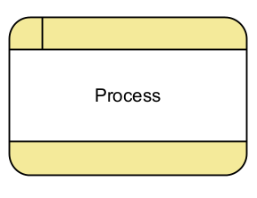

A **data store** is used to represent where information is stored or retrieved during processing. It is depicted as two parallel horizontal lines in DFDs.

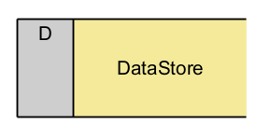

**Context Diagram**

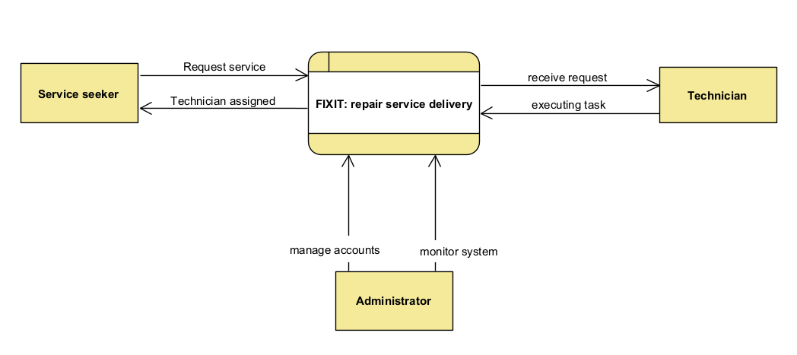

**Data Flow Diagram-Level 1**

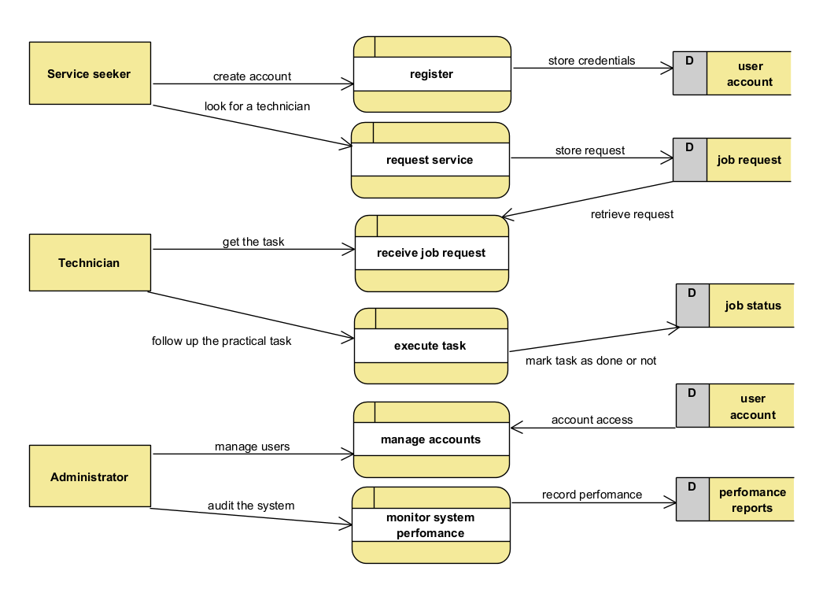

### 4.7.2 Use Case and sequence Diagrams

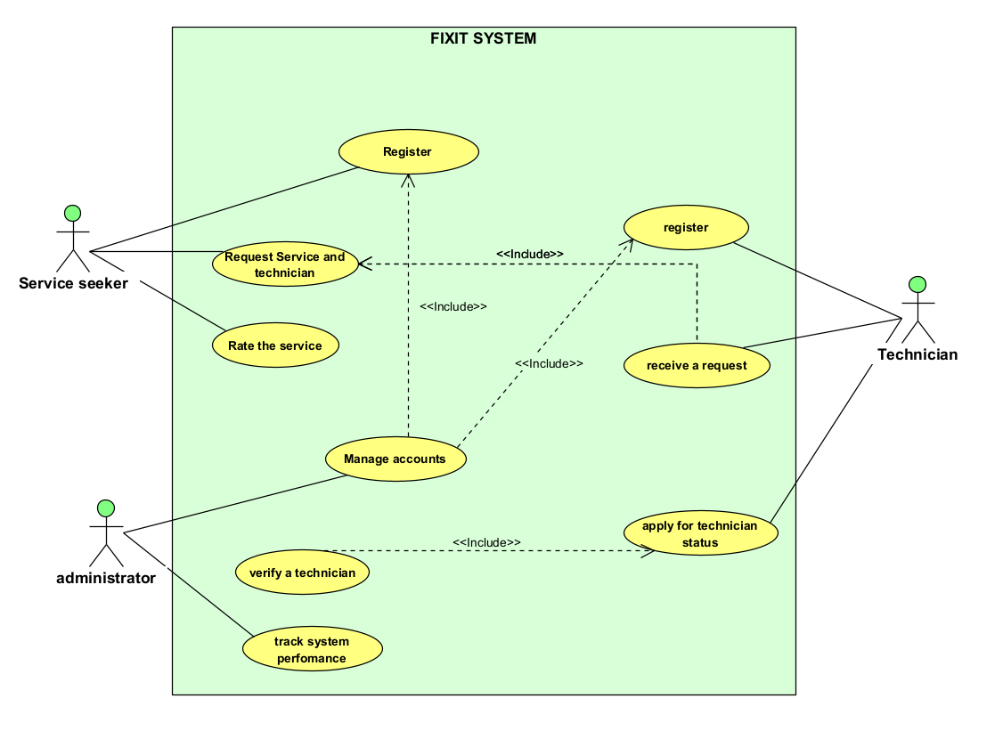

### 4.7.3 Database Normalization

Database normalization is the process of structuring a relational database to minimize redundancy and improve data integrity. The service_system database has been designed following normalization principles to ensure efficient data storage, consistency, and scalability. The normalization process involves organizing tables and relationships so that anomalies in data insertion, updating, and deletion are eliminated. This section describes how the database adheres to the normalization standards up to the Third Normal Form (3NF) while maintaining performance and usability.

The First Normal Form (1NF) ensures that all columns contain atomic values, meaning each field holds only one piece of information. In the users table, attributes like first_name, last_name, email, and phone_number are stored as separate fields instead of combining them into a single field. Similarly, in the service_requests table, each request is uniquely identified by request_id, and there are no repeating groups or multivalued attributes, ensuring 1NF compliance.

Moving to the Second Normal Form (2NF), we eliminate partial dependencies. Since each table has a primary key, every non-key attribute must be fully dependent on that key. In the service_requests table, attributes such as service_type, description, status, and request_date rely entirely on the request_id, preventing any partial dependency. Additionally, technician-related data, such as verification details, is stored in a separate technician_verification table to avoid unnecessary duplication within the users table.

The Third Normal Form (3NF) removes transitive dependencies, meaning that non-key attributes should not depend on other non-key attributes. In the reviews table, for example, the rating and comment fields depend directly on the review_id rather than indirectly on the user_id or technician_id. Moreover, the technician_verification table ensures that verification details are not stored directly in the users table, which maintains modularity and avoids redundant data.

By following these normalization principles, the database structure optimizes data integrity while ensuring efficient query performance. The relationships between tables are designed to enforce referential integrity through foreign key constraints, preventing orphaned records and ensuring that every service request, review, and verification process is linked to a valid user. This structured design allows the system to scale effectively while maintaining data consistency and improving overall service delivery.

### 4.7.4 Data Dictionary

The data dictionary provides a detailed description of the attributes within each table in the service system database. It defines the field names, data types, constraints, and descriptions to ensure clarity and consistency in data management.

**Users Table**

|  |  |  |  |
| --- | --- | --- | --- |
| Field Name | Data Type | Constraints | Description |
| user_id | INT (Auto Increment) | PRIMARY KEY | Unique identifier for each user |
| first name | VARCHAR(50) | NOT NULL | User’s first name |
| last name | VARCHAR(50) | NOT NULL | User’s last name |
| Email | VARCHAR(100) | UNIQUE, NOT NULL | User’s email address (must be unique) |
| phone number | VARCHAR(15) | NOT NULL | User’s contact number |
| Password | VARCHAR(255) | NOT NULL | Hashed password for authentication |
| User type | ENUM('customer', 'technician') | NOT NULL, DEFAULT 'customer' | Specifies if the user is a customer or a technician |
| created at | TIMESTAMP | DEFAULT CURRENT_TIMESTAMP | Timestamp when the user registered |
| Status | ENUM('active', 'inactive') | DEFAULT 'active' | Indicates if the user account is active or inactive |

Table 3: users table

**Service Requests Table**

|  |  |  |  |
| --- | --- | --- | --- |
| Field Name | Data Type | Constraints | Description |
| request_id | INT (Auto Increment) | PRIMARY KEY | Unique identifier for each service request |
| user_id | INT | FOREIGN KEY (users) | Customer who made the request |
| technician_id | INT | FOREIGN KEY (users) | Assigned technician for the request |
| service type | VARCHAR(100) | NOT NULL | Type of service requested |
| Description | TEXT | NOT NULL | Detailed description of the issue |
| Status | ENUM(pending, in progress, completed, cancelled) | DEFAULT pending | Current status of the service request |
| request date | TIMESTAMP | DEFAULT CURRENT_TIMESTAMP | Date and time the request was made |
| completion date | TIMESTAMP | NULL | Date when the service was completed |

Table 4: service request table

**Reviews Table**

|  |  |  |  |
| --- | --- | --- | --- |
| Field Name | Data Type | Constraints | Description |
| review_id | INT (Auto Increment) | PRIMARY KEY | Unique identifier for each review |
| request_id | INT | FOREIGN KEY (service requests) | The service request being reviewed |
| Rating | INT (1) | CHECK (rating BETWEEN 1 AND 5) | Rating given to the technician (1 to 5) |
| Comment | TEXT | NULL | Additional feedback from the customer |
| created at | TIMESTAMP | DEFAULT CURRENT_TIMESTAMP | Timestamp when the review was posted |

Table 5: review table

**Technician Verification Table**

|  |  |  |  |
| --- | --- | --- | --- |
| Field Name | Data Type | Constraints | Description |
| verification_id | INT (Auto Increment) | PRIMARY KEY | Unique identifier for each verification record |
| technician_id | INT | FOREIGN KEY (users) | Technician being verified |
| document type | VARCHAR(50) | NOT NULL | Type of verification document uploaded |
| document status | ENUM(pending, verified, rejected) | DEFAULT pending | Status of the verification process |
| uploaded at | TIMESTAMP | DEFAULT CURRENT_TIMESTAMP | Date and time when the document was uploaded |

Table 6: technician verification table

**4.7.5 Entity Relationship Diagram**

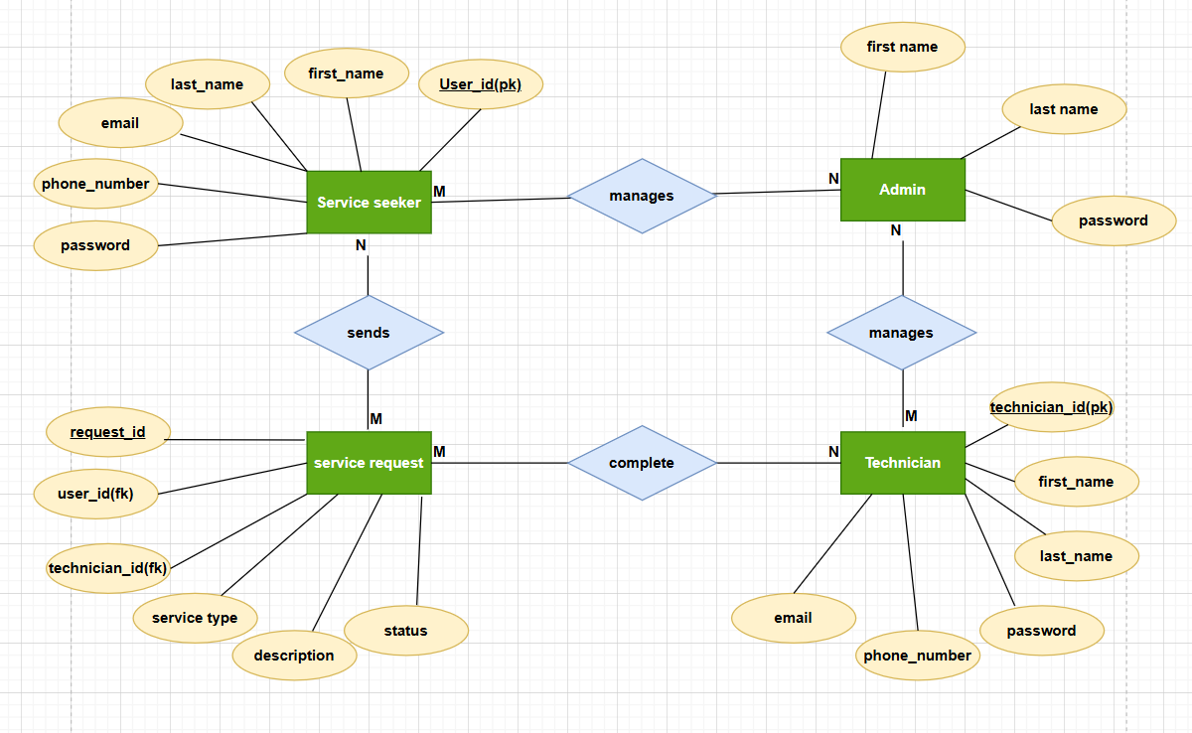

Figure 3: Entity relationship diagram

### 4.7.6 Physical Data Model

The physical data model defines the actual implementation of the database structure in SQL, specifying the tables, columns, data types, constraints, and relationships between entities. This implementation ensures data integrity, optimized query performance, and efficient storage management.

In this system, the database is designed to store user information, service requests, reviews, and technician verification records. It enforces referential integrity using foreign key constraints, applies ENUM types to standardize predefined values, and optimizes performance using appropriate data types and indexing.

The following SQL script defines the physical structure of the service_system database:

-- Users Table

CREATE TABLE users (

user_id INT AUTO_INCREMENT PRIMARY KEY,

first_name VARCHAR(50) NOT NULL,

last_name VARCHAR(50) NOT NULL,

email VARCHAR(100) UNIQUE NOT NULL,

phone_number VARCHAR(15) NOT NULL,

password VARCHAR(255) NOT NULL,

user_type ENUM('customer', 'technician') NOT NULL DEFAULT 'customer',

created_at TIMESTAMP DEFAULT CURRENT_TIMESTAMP,

status ENUM('active', 'inactive') DEFAULT 'active'

);

-- Service Requests Table

CREATE TABLE service_requests (

request_id INT AUTO_INCREMENT PRIMARY KEY,

user_id INT NOT NULL,

technician_id INT DEFAULT NULL,

service_type VARCHAR(100) NOT NULL,

description TEXT NOT NULL,

status ENUM('pending', 'in_progress', 'completed', 'cancelled') DEFAULT 'pending',

request_date TIMESTAMP DEFAULT CURRENT_TIMESTAMP,

completion_date TIMESTAMP NULL,

FOREIGN KEY (user_id) REFERENCES users(user_id) ON DELETE CASCADE,

FOREIGN KEY (technician_id) REFERENCES users(user_id) ON DELETE SET NULL

);

-- Reviews Table

CREATE TABLE reviews (

review_id INT AUTO_INCREMENT PRIMARY KEY,

request_id INT NOT NULL,

rating INT CHECK (rating BETWEEN 1 AND 5),

comment TEXT,

created_at TIMESTAMP DEFAULT CURRENT_TIMESTAMP,

FOREIGN KEY (request_id) REFERENCES service_requests(request_id) ON DELETE CASCADE

);

-- Technician Verification Table

CREATE TABLE technician_verification (

verification_id INT AUTO_INCREMENT PRIMARY KEY,

technician_id INT NOT NULL,

document_type VARCHAR(50) NOT NULL,

document_status ENUM('pending', 'verified', 'rejected') DEFAULT 'pending',

uploaded_at TIMESTAMP DEFAULT CURRENT_TIMESTAMP,

FOREIGN KEY (technician_id) REFERENCES users(user_id) ON DELETE CASCADE

);

### 4.8 Architecture of the Front-End of the System

The architecture of the front-end of the system for this digital repair service platform is built with React, a powerful JavaScript library that enables the development of dynamic and responsive user interfaces. React plays a critical role in ensuring that the application provides an interactive and seamless experience for both customers and technicians. By using React, the platform efficiently handles user interactions, manages state changes, and dynamically updates the user interface without the need to reload entire pages.

The front-end is structured using a combination of HTML, CSS, and JavaScript to create the web pages and style them accordingly. HTML defines the basic structure of the web pages, ensuring that the platform contains essential elements such as buttons, forms, and input fields. CSS is used to apply styles and layouts to these elements, ensuring the platform has an appealing visual design and remains mobile-responsive an essential feature for modern web applications.

JavaScript adds functionality and interactivity to the platform. It handles tasks such as form validation, toggling visibility elements, managing asynchronous requests, and providing real-time updates. For instance, when users request services or submit feedback, JavaScript manages the communication with the back-end without requiring a full-page reload, making the experience feel more fluid and modern.

To handle the back-end logic, the platform uses aJSON-based API instead of a traditional server-side framework. The back-end consists of a Node.js and Express.js server that interacts with a MySQL database, managing user authentication, service requests, and business logic. The front-end, developed with React, communicates with the back-end by making RESTful API calls that return data in JSON format. These API endpoints fetch information such as user profiles,service requests, technician availability, and reviews, which are then dynamically displayed on the front-end. This separation between the JSON-based back-end and React front-end ensures the application remains modular, maintainable, and scalable.

The choice of React for the front-end allows for the creation of reusable components, improving the efficiency of the development process. React also enhances performance by using a virtual DOM (Document Object Model), which updates only the necessary parts of a page rather than re-rendering the entire page.

### 4.9 Implementation and coding

### 4.9.1 Introduction

The implementation and coding of the digital repair service platform are centered on creating a seamless and interactive experience for both users and technicians. The system is built with a focus on efficiency, scalability, user-friendliness, ensuring that customers can easily request services, technicians can manage jobs effectively, and both parties can interact securely.

The platform utilizes modern web technologies, including React for the front-end, a JSON-based backend, and MySQL for the database, ensuring a robust and maintainable system. The backend relies on JSON-based RESTful APIs for data exchange, ensuring lightweight communication between the front-end and the database. This architecture provides flexibility, ease of integration, and high performance, allowing the system to handle service requests, user authentication, and messaging efficiently.

The JSON-based backend enables seamless data storage and retrieval, supporting real-time interactions and secure transactions. APIs handle authentication, job management, and user messaging, ensuring a smooth workflow. The MySQL database stores structured data, including customer requests, technician profiles, and service history, while JSON-based data structures facilitate fast and efficient data exchange.

This section will discuss the tools and technologies used to build the platform, as well as how they integrate to provide a comprehensive solution for the service delivery system.

### 4.9.2 Description of implementation Tools and technology

The digital repair service platform is developed using a combination of front-end and back-end technologies that work together to deliver a smooth user experience. These tools and technologies were carefully selected to meet the needs of the platform, ensuring that it is scalable, secure, and responsive.

**React (Front-End)**: React is the primary technology used for building the front-end of the platform. React is a JavaScript library that is widely recognized for creating dynamic user interfaces. It enables developers to build components that can efficiently update and render user interfaces based on changes in data. React's declarative approach makes it easier to create interactive UIs by ensuring that the user interface always reflects the current state of the application. The use of React allows for better performance due to its virtual DOM, which reduces unnecessary rendering. Additionally, React provides an excellent foundation for building reusable UI components, improving the maintainability of the platform.

**HTML/CSS (Structure and Styling)**: HTML and CSS are fundamental technologies used to structure and style the web pages of the platform. HTML is used to define the layout of the web pages, such as headers, forms, buttons, and links. CSS is used to style these HTML elements, ensuring that the platform is visually appealing and user-friendly. CSS also plays a critical role in making the platform responsive, ensuring that it works well on different screen sizes and devices, including smartphones and tablets.

**JavaScript (Functionality and Interactivity)**: JavaScript is used alongside React to handle the interactivity and dynamic behavior of the platform. JavaScript enables features like form validation, real-time updates (e.g., submitting requests and receiving responses without page reloads), and client-side logic. It enhances the user experience by making the platform more interactive, responsive, and fluid.

**JSON (Back-End)**: A JSON-based backend serves as the core infrastructure for handling database operations, user authentication, and business logic. Instead of using a traditional web framework like Django, this system relies on lightweight RESTful APIs that facilitate seamless communication between the front-end and the database. JSON (JavaScript Object Notation) is used for structuring data and exchanging information between the server and client in a flexible, readable format.

The backend logic is implemented through REST APIs, which handle incoming requests from the front-end and return appropriate responses. These APIs manage user authentication, service requests, technician profiles, and service history. Express.js (a Node.js framework) is commonly used to define API endpoints that allow the React-based front-end to fetch and update data dynamically.

A JSON-based architecture ensures scalability, flexibility, and lightweight communication, making it ideal for real-time service interactions. It also enhances security by implementing authentication mechanisms such as JWT (JSON Web Tokens) for user verification, ensuring safe and secure access to the platform’s services.

**MySQL (Database):** MySQL is used as the relational database management system (RDBMS) for storing and managing the platform’s data. It is responsible for handling essential data such as users, service requests, technicians, reviews, and other critical platform information. MySQL is chosen for its stability, scalability, and seamless integration with a JSON-based backend.

Instead of using Django, the backend communicates with MySQL using RESTful APIs built with Node.js and Express.js. Data is exchanged in JSON format, making it easier to interact with the front end and maintain a consistent structure across the system. The database schema is designed to ensure data consistency and integrity, with foreign keys establishing relationships between tables—such as linking users to their service requests.

A JSON-based API layer acts as a bridge between MySQL and the front-end, allowing efficient data retrieval and updates while ensuring security and optimized performance for real-time interactions between customers and technicians.

**RESTful APIs (Communication between Front-End and Back-End):**   
RESTful APIs facilitate the communication between the React front-end and the JSON-based backend. These APIs handle requests and responses in JSON format, ensuring seamless data exchange between the client and the server. The system uses Node.js with Express.js to build and manage these APIs, which interact with the MySQL database to retrieve, store, and update data efficiently.

RESTful APIs follow a stateless architecture, meaning that each request contains all the necessary information to complete the request. This design ensures scalability, easy maintenance, and efficient handling of concurrent user requests. By using JSON as the primary data format, the platform achieves lightweight communication, faster processing, and improved interoperability between different system components.

**Version Control (Git/GitHub)**: Git is used for version control to track changes in the codebase, collaborate with team members, and maintain the integrity of the development process. GitHub is used as a remote repository to store the project code, allowing for easy collaboration, code reviews, and version management.

**Deployment and Hosting (Heroku/AWS)**: The platform is deployed on cloud services such as Heroku or AWS, which provide the infrastructure necessary for hosting the application and database. These services allow the platform to be scalable, ensuring that it can handle increasing traffic and data demands as the user base grows. Both Heroku and AWS offer robust tools for monitoring, managing, and maintaining the platform in a production environment.

**Security Features (SSL, HTTPS, JWT Authentication)**: Security is a top priority in the development of this platform. To ensure secure communication between the front-end and back-end, SSL certificates are used to enable HTTPS encryption. This ensures that all data transmitted between the user’s browser and the server is secure. Additionally, JSON Web Tokens (JWT) are used for secure user authentication, ensuring that users can securely log in and access their accounts.

### 4.9.3 Screen Shots and Source Codes

The following are front-end screenshots to show the general interface

**Home page**

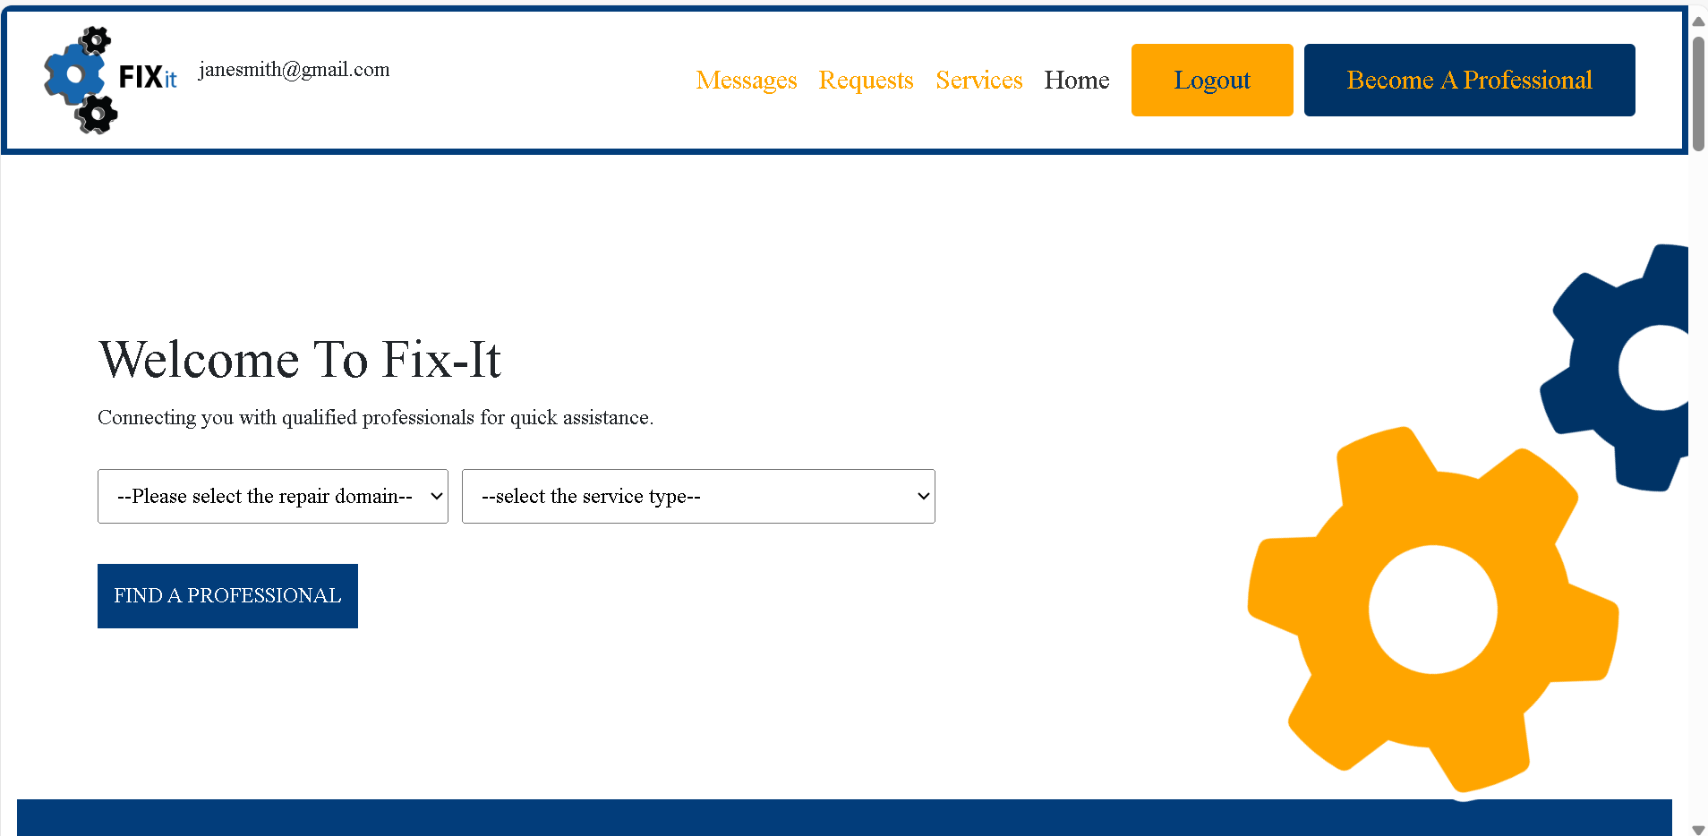

**Technician choice page**

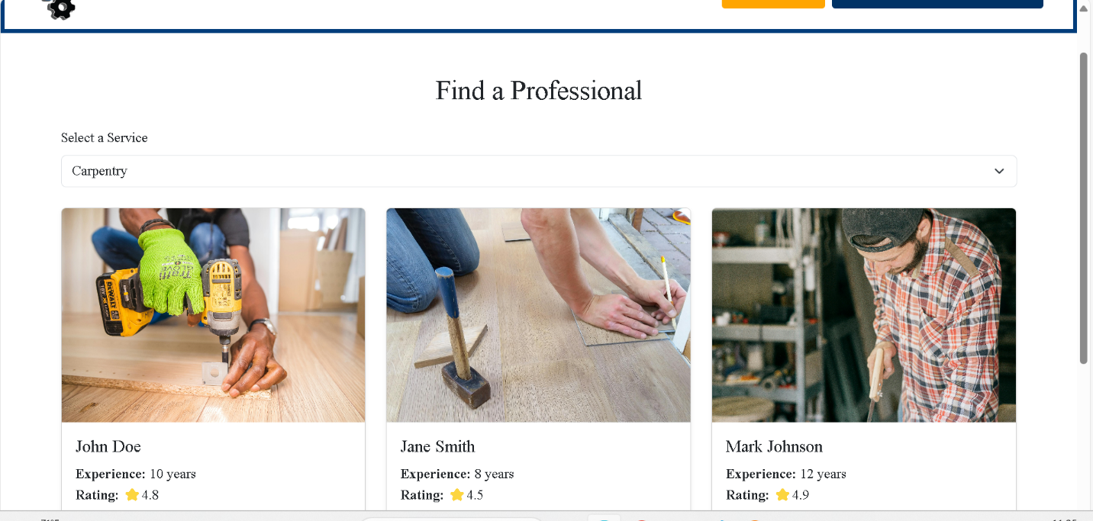

**Technician Profile Page**



**Technician contacting page**

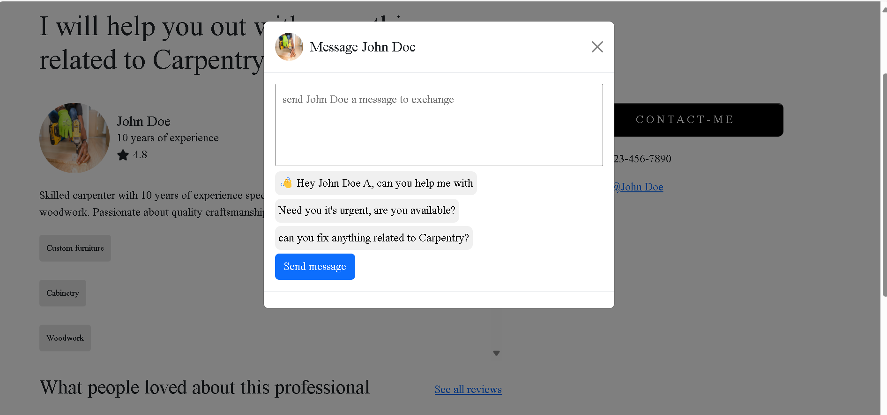

Pending customer request page

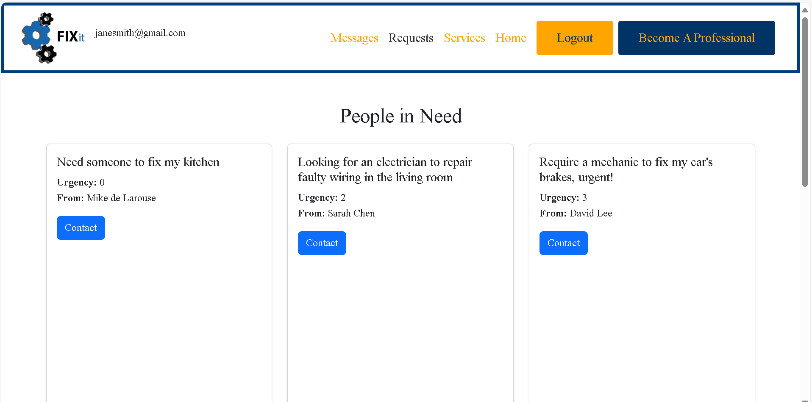

### The following is a selection of few important source code used to create the platform

### package-lock

{

  "name": "fixit",

  "version": "0.0.0",

  "LockfileVersion": 3,

  "Requires": true,

  "Packages": {

    "": {

      "Name": "fixit",

      "Version": "0.0.0",

      "Dependencies": {

        "@fort awesome/free-brands-sag-icons": "^6.7.2",

        "@fort awesome/free-solid-sag-icons": "^6.7.2",

        "@fort awesome/react-font awesome": "^0.2.2",

        "Bootstrap": "^5.3.3",

        "bootstrap-icons": "^1.11.3",

        "React": "^19.0.0",

        "react-bootstrap": "^2.10.9",

        "react-doom": "^19.0.0",

        "react-router-dom": "^7.4.0",

        "styled-components": "^6.1.16"

      },

      "DevDependencies": {

        "@eslint/js": "^9.21.0",

        "@types/react": "^19.0.10",

        "@types/react-dom": "^19.0.4",

        "@vitejs/plugin-react": "^4.3.4",

        "Eslint": "^9.21.0",

        "eslint-plugin-react-hooks": "^5.1.0",

        "eslint-plugin-react-refresh": "^0.4.19",

        "globals": "^15.15.0",

        "Vite": "^6.2.0"

      }

### Bootstrap package

{

  "Name": "bootstrap",

  "Description": "The most popular front-end framework for developing responsive, mobile first projects on the web.",

  "Version": "5.3.3",

  "Config": {

    "version_short": "5.3"

  },

  "keywords": [

    "css",

    "sass",

    "mobile-first",

    "responsive",

    "front-end",

    "framework",

    "web"

  ],

  "homepage": "https://getbootstrap.com/",

  "author": "The Bootstrap Authors (https://github.com/twbs/bootstrap/graphs/contributors)",

  "license": "MIT",

  "repository": {

    "type": "git",

    "url": "git+https://github.com/twbs/bootstrap.git"

  },

  "bugs": {

    "url": "https://github.com/twbs/bootstrap/issues"

  },

  "funding": [

    {

      "type": "github",

      "url": "https://github.com/sponsors/twbs"

    },

    {

      "type": "opencollective",

      "url": "https://opencollective.com/bootstrap"

    }

  ],

  "main": "dist/js/bootstrap.js",

  "module": "dist/js/bootstrap.esm.js",

  "sass": "scss/bootstrap.scss",

  "style": "dist/css/bootstrap.css",

### 4.10 Testing

### 4.10.1 Introduction

Testing is a crucial phase in the development of the digital repair service platform, ensuring that the system functions as expected and meets the requirements outlined in the project’s objectives. A well-structured testing process was implemented to evaluate various aspects of the system, including its functionality, performance, security, and user experience. The testing phase involved several methodologies, each designed to validate a specific part of the system. From unit testing to acceptance testing, each stage of testing provided valuable insights into the platform’s performance and helped identify and resolve potential issues before the system was deployed for end-users. The testing was comprehensive, covering the front-end, back-end, database interactions, and overall system behavior.

### 4.10.2 Objective of Testing

The primary objective of testing was to ensure that the digital repair service platform is both functional and reliable. The goal was to identify any issues or bugs in the system and address them before the platform is made available to users. Testing also aimed to confirm that all features, including user registration, service requests, technician management, review functionality, and payment processing, work as intended. Additionally, the testing process focused on ensuring that the system provides a smooth user experience, maintains data integrity, and meets security requirements. By conducting rigorous testing, we aimed to deliver a system that is stable, secure, and user-friendly, capable of handling the demands of customers and technicians in the real world.

### 4.10.3 Unit testing outputs

Unit testing was performed on individual components and functions of the system, such as the user authentication process, service request creation, technician assignment, and review submission. Each unit test was designed to validate the functionality of specific pieces of code, ensuring that they function independently and return the expected results. The unit tests were automated using testing frameworks such as Jest and Json’s built-in test framework. During the testing phase, all unit tests were successfully passed, confirming that the core functionality of each module works as expected. For example, user registration and login processes were validated, and errors in edge cases, such as incorrect inputs, were handled properly.

### 4.10.4 Validation testing outputs

Validation testing was conducted to ensure that the platform meets the functional requirements specified by the users and stakeholders. This type of testing verifies that the system’s features are aligned with user expectations and business goals. For instance, during validation testing, the system was tested for correct processing of service requests, technician verification, and review submission. It was also tested for responsiveness, ensuring that it worked across various devices and browsers. All validation tests passed successfully, demonstrating that the platform’s core features, such as the user interface, request management, and technician assignment, align with the intended functionality and meet the user’s needs.

### 4.10.5 Integration Testing Outputs

Integration testing was performed to validate how different parts of the system interact with each other. This includes testing the integration between the front-end (React) and the back-end (JSON), as well as the communication between the platform and the MySQL database. For example, service requests were tested to ensure that once submitted by a customer, they are correctly assigned to a technician, stored in the database, and that technicians can view their assigned tasks. Additionally, the integration between the user authentication system and other platform functionalities, such as creating service requests or submitting reviews, was thoroughly tested. The integration testing results confirmed that all system components work seamlessly together without any issues, ensuring smooth data flow and proper system behavior.

### 4.10.6 Functional and system testing Results

Functional testing focused on verifying that all features of the system operate correctly according to the functional specifications. This testing covered all user interactions, including registering an account, submitting a service request, selecting a technician, and leaving reviews. The functional tests also included validation of non-functional features such as system security and user experience, ensuring the platform is responsive and user-friendly. System testing was performed to evaluate the overall behavior of the platform, including stress testing to simulate high traffic and load conditions. The results of functional and system testing were positive, with all functionalities working as intended. The platform performed well under normal and peak conditions, with no significant issues found during testing.

### 4.10.7 Acceptance Testing Report

Acceptance testing was carried out to determine if the system met the end-user requirements and if it was ready for deployment. During this phase, real users, including both customers and technicians, were invited to test the system in a controlled environment. Users tested various features of the platform, including creating accounts, making service requests, selecting technicians, and leaving reviews. The feedback from users was collected, and any issues or suggestions were addressed. The acceptance testing report confirmed that the system met the required standards for usability, performance, and security. Based on the results of the acceptance testing, the platform was deemed ready for deployment, as all objectives were successfully achieved and the platform passed the user acceptance criteria.

# 

# CHAPTER 5: CONCLUSIONS AND RECOMMENDATIONS

## Introduction

This chapter provides a summary of the findings from the research conducted on the development of the digital repair service platform. It highlights the conclusions drawn from the study, based on the challenges faced, the implementation process, and the outcomes of testing. In addition, this chapter offers recommendations to further enhance the system and its potential impact on the repair services industry in Rwanda. Lastly, areas for further research are identified to explore opportunities for continuous improvement and the expansion of the platform’s capabilities.

## Conclusion

The research focused on the development and implementation of a digital repair service platform designed to address the inefficiencies in Rwanda's repair services industry. The platform successfully provides a user-friendly interface for customers and technicians to interact, facilitating seamless service requests, technician assignments, and real-time reviews. The implementation of modern web technologies, including React for the front-end and JSON for the back-end, ensures that the platform is scalable, responsive, and secure.

Through thorough testing, the platform proved to be functional, reliable, and user-centric. All key functionalities, such as user registration, service request management, technician verification, and review submission, were successfully integrated and tested. Moreover, the system demonstrated its ability to handle high traffic and concurrent user requests, ensuring its readiness for real-world deployment. The findings suggest that this digital platform will significantly improve the service delivery in the repair industry, making it more efficient and accessible for both customers and technicians.

The success of the platform indicates that there is a growing demand for digitized solutions in the service industry in Rwanda. The system’s features not only streamline the interaction between customers and technicians but also offer transparency and accountability through service tracking and ratings. As such, the platform has the potential to revolutionize the repair service industry by providing a more professional, organized, and customer-oriented approach.

## Recommendations

Based on the results of the study, the following recommendations are made to improve the platform and its effectiveness:

**Mobile Application Development**: While the web platform is functional, developing a mobile application version of the platform would increase accessibility for users who rely more on mobile devices. This would also improve user engagement and ensure that both customers and technicians can access the platform anytime, anywhere.

**Expand Service Categories**: To cater to a broader audience, the platform should expand its service categories to include more specialized services, such as home appliances repair, car services, and other niche repairs. This expansion could make the platform a one-stop shop for various repair needs.

**Introduce Technician Rating and Ranking System**: While the platform currently allows users to leave reviews for technicians, introducing a more detailed technician rating and ranking system could help customers make more informed decisions. This system could consider factors such as response time, quality of service, and customer feedback.

**Introduce Payment Integration**: To streamline transactions, the platform could integrate secure online payment gateways, allowing customers to pay for services directly through the platform. This would eliminate the need for cash payments and provide a more seamless experience for both customers and technicians.

## 5.3 Areas for further research

While the current research successfully developed and tested the digital repair service platform, several areas for further research remain. These areas can help refine and expand the platform, ensuring its continued relevance and success in the future:

**User Behavior Analysis**: Future research could focus on understanding user behavior on the platform, such as how customers choose technicians or what factors influence their decision to request a service. This analysis could help refine the platform’s design and improve user experience.

**Market Expansion**: Further research could explore the potential for expanding the platform beyond Rwanda to other countries in East Africa or Africa as a whole. Understanding regional differences in the demand for repair services, as well as the specific challenges and opportunities in different markets, could help scale the platform effectively.

**Impact of Digital Repair Platforms on the Traditional Service Industry**: Research could investigate the impact of digital repair platforms on traditional, manual service systems. Understanding the challenges and resistance that may arise from traditional repair service providers could inform strategies for greater adoption and integration.

**Integration with IoT and Smart Devices**: Future studies could explore the potential integration of the platform with the Internet of Things (IoT) and smart home devices. This could allow users to request repairs for connected devices directly through the platform, offering a more comprehensive solution for modern service needs.

**AI and Machine Learning for Service Matching**: Further research could explore the integration of artificial intelligence (AI) and machine learning algorithms to improve the technician matching process. AI could optimize the assignment of technicians based on factors like location, availability, skills, and customer preferences.

By exploring these areas, future research can further enhance the digital repair service platform and contribute to the development of more efficient, user-friendly, and impactful solutions in the service industry.

# REFERENCES

al, G. e. (2003). Digital platforms have significantly improved efficiency and trust in the repair service sector by offering user reviews, price standardization, and secure transactions.

Andela. (2019). offers a home management service.

Bhal, A. (2014). is an Indian home services platform.

Busque, L. (2008). is an on-demand service platform based in the United States that connects users with freelance workers for various household tasks.

Creswell, J. (2018). Research Design: Qualitative, Quantitative, and Mixed Methods Approaches (fifth Ed.). SAGE Publications.

Doreen. (2023). limited access to secure payment systems .

Ert, F. M. (2016). A customer review and rating system.

Gefen. (2003). Digital platforms have significantly improved efficiency and trust in the repair service sector by offering user reviews, price standardization, and secure transactions.

Group, W. B. (2023). Digital Platforms and Economic Development in Africa.

GSMA. (2020). improve service delivery in Rwanda’s informal .

Harper. (1967). Statistics: An Introductory Analysis (second Ed.). .

Houlin. (2022). limited access to secure payment systems .

Itzhak. (2023). Digital Transformation in Rwanda. HYPERLINK "https://rdb.rw/wp-content/uploads/2023/01/ICT-Sector-Report-2023.pdf.%20” https://rdb.rw/wp-content/uploads/2023/01/ICT-Sector-Report-2023.pdf.

Johnson, S. &. (2020). the impact of the adoption of financial management information system in the management of public funds. write population used. write sample size used.

Kline. (2020). many digital startups in Africa face funding challenges, limiting their ability to scale effectively.

Kothari, C. (2004). Research Methodology: Methods and Techniques (second Ed.). New Age International.

Maree. (2019). demonstrating the potential for digital transformation in the service industry .

McKinsey. (2020). In regions where repair services remain informal, issues such as lack of trust, pricing inconsistencies, and service delays persist.

Muhizi, I. (2019). established to oversee the implementation of ICT policies and initiatives in Rwanda.

Pandor, A. (2014). is a South African on-demand home services platform that connects customers with domestic workers for cleaning.

Paula. (2019). digital transformation and ICT development in the country.

Ries. (2011). Startup methodology .

Smith. (2020). market success.

Statista. (2023). Over-the-top (OTT) retailing in the post pandemic world. Unveiling consumer drivers and barriers using a qualitative study.

Union, A. (2022). The Rise of Digital Platforms and Their Impact on Developing Countries. HYPERLINK "https://au.int/en/documents/20230602/african" https://au.int/en/documents/20230602/african

Viviane. (2014). data protection.

Zappacosta, M. (2008). is an online service marketplace based in the United States that connects customers with local professionals for various services.