**PROFESSIONAL SERVICE LINKING SYSTEM FOR HOME AND OFFICE REPAIRS**

***Project submitted in partial fulfilment for the award of the degree of***

**Bachelor of Computer Science**

***Submitted by***

***Chuan Haar Ajach***

***Under the Guidance of***

**Dr. Nilkanta Das**

**Assistant Professor, SCA**



**School of Computer Applications**

**KIIT University**

**April 2025**



# TIFICATE OF ORIGINALITY

**CERTIFICATE OF ORIGINALITY**

This is to certify that the project report entitled **Professional Service Linking System for Home and Office Repairs** submitted to **School of Computer Applications, KIIT University** in partial fulfilment of the requirement for the award of the degree of **BACHELOR OF COMPUTER SCIENCE (BSc)**, is an authentic and original work carried out by Mr. **Chuan Haar Ajach** with Roll no. **2247084** and Regd. No. **221004896031** under my guidance. The matter embodied in this project is genuine work done by the student and has not been submitted whether to this University or to any other University / Institute for the fulfilment of the requirements of any course of study.

|  |  |
| --- | --- |
| Signature of the Student:  Date: | Signature of the Guide:  Date:  Name: Dr. Nilkanta Das  Designation: Assistant Professor, SCA. |



**School of Computer Applications**

**KIIT University, Bhubaneswar**

***CERTIFICATE***

This is to certify that the project work entitled **Professional Service Linking System for Home and Office Repairs** Submittedby **Chuan Haar Ajach** bearing roll no. **2247084**, is an authentic and original work.

|  |  |
| --- | --- |
| Signature  (Internal Examiner)  Date …………… | Signature  (External Examiner)  Date …………… |



***DECLARATION***

I, **Chuan Haar Ajach**, roll no. **2247084** do hereby declare that the project report entitled **Professional Service Linking System for Home and Office Repairs** submitted to **School of Computer Applications, KIIT University, Bhubaneswar** for the award of the degree of BACHELOR OF COMPUTERSCIENCE (BSc), is an authentic and original work carried out by me from 1st Jan 2025 to 1stApril 2025 under the guidance of **Dr. Nilkanta Das, Assistant Professor, SCA**.

Signature of the student

Date

# ***ACKNOWLEDGEMENT***

I would like to express my heartfelt gratitude to everyone who has contributed to the successful completion of this project. First and foremost, I would like to sincerely thank my supervisor, **Dr. Nilkanta Das**, for his constant guidance, invaluable advice, and continuous support. His expertise and feedback have played a crucial role in shaping this project. I would also like to extend my gratitude to the Director General of SCA, **Prof. Veena Goswami** and the Dean of SCA, **Prof. Satya Ranjan Dash**, for their encouragement and providing me with the necessary resources and opportunities to pursue this project. A special thanks to my friends and peers for their constant moral support, collaboration, and helpful discussions. Your companionship and encouragement made this journey much more enjoyable. I also wish to acknowledge **my professors and mentor** for their contributions and assistance throughout this project.

Finally, I would like to thank my family for their love, patience, and unwavering support

throughout my academic journey.

Thank you all for your guidance and encouragement, which made the completion of this project possible.

|  |  |
| --- | --- |
| Date: …………………..  Place: …………………. | Signature of the student  Name: Chuan Haar Ajach  Roll no: 2247084 |

# ***ABSTRACT***

Operation speed in modern society creates difficulties for locating qualified experts who can perform home and office maintenance tasks. People together with businesses have difficulty finding dependable service providers since they must depend either on personal recommendations from others or conduct lengthy manual searches. Because of these inefficiencies both home and office repairs face lengthy time delays and poor work standards from providers who lead to general dissatisfaction. A **Professional Service Linking System for Home and Office Repairs** represents the core element built as an online mechanism to match users with qualified service professionals across multiple domains. Users of the platform have access to essential service offerings which include carpentry along with mechanical, roofing and electrical services simultaneously with sanitation, painting and plumbing services. Users will access the platform to register while browsing professionals based on their preferred requirements then they can secure appointments efficiently. Organizations and customers can explore profiles of providers through which they can see their credentials together with their expertise levels and feedback from previous clients. The system ensures secure access through its user authentication protocol which enables valid professionals along with customers to reach the platform. A review and rating system placed on the platform will enhance both service transparency and help professionals maintain high-quality service delivery. The booking system allows users to make appointments through an automated process which automates service provider and user interactions. The automated platform uses digital systems to connect people looking for professional services yet this system brings skilled workers together with service seekers and enhances both speed, reliability and comfort of use. The platform makes it simpler to hire experts through its system while delivering better service which leads to higher customer satisfaction in household and office repair service delivery.

# ***TABLE OF CONTENTS***

| **CHAPTER NO** | **TITLE** | **PAGE NO.** |
| --- | --- | --- |
|  | **CERTIFICATE OF ORIGINALITY** | I |
|  | **CERTIFICATE** | II |
|  | **DECLARATION** | III |
|  | **ACKNOWLEDGMENT** | IV |
|  | **ABSTRACT** | V |
|  | **TABLE OF CONTENTS** |  |
|  | **LIST OF FIGURES** |  |
| **1** | **INTRODUCTION** | 1-5 |
| 1.1 Background |
| 1.2 Problem Statement |
| 1.3 Project Justification |
| 1.4 Objectives |
| 1.5 Research Questions |
| 1.6 Significance of the Study |
| 1.6.1 Consumers (Users) |
| 1.6.2 Service Professionals |
| 1.6.3 Small and Medium Enterprises |
| 1.7 Scope of the Study |
| 1.7.1 Time Scope |
| 1.7.2 Geographical Scope |
| 1.7.3 Content Scope |
| 1.8 Limitations of the Study |
| **2** | **CHAPTER 2: LITERATURE REVIEW** | 6-9 |
| 2.1 Introduction to Repair Challenges |
| 2.2 Problems in Repair Services |
| 2.2.1 Lack of Expert Professionals |
| 2.2.2 DIY Repair Barriers |
| 2.2.3 Cost and Time Limitations |
| 2.3 Technology’s Role |
| 2.3.1 Digital Platforms |
| 2.3.2 Professional Training |
| 2.4 Trust and Consumer Decision-Making |
| 2.4.1 Ratings and Reviews |
| 2.4.2 Consumer Protection |
| 2.5 Innovations and Cost-Saving Strategies |
| 2.5.1 Maintenance Forecasting |
| 2.5.2 Sustainable Practices |
| **3** | **CHAPTER 3: METHODOLOGY** | 10-11 |
| 3.1 Research Design |
| 3.2 Population and Sample Selection |
| 3.3 Tools for Data Collection |
| 3.4 Data Collection Procedure |
| 3.5 Data Analysis and Presentation |
| 3.6 Validity and Reliability |
| 3.7 Ethical Considerations |
| **4** | **CHAPTER 4: SYSTEM DESIGN & IMPLEMENTATION** | 12-32 |
| 4.1 Introduction |
| 4.2 Data Analysis and Presentation |
| 4.3 Interpretation of Findings |
| 4.4 Summary of Findings |
| 4.5 Conceptual Framework |
| 4.6 Technologies Used |
| 4.6.1 Frontend Development |
| 4.6.2 Backend Development |
| 4.6.3 Database Management |
| 4.6.4 Hosting & Deployment |
| 4.7 Use Cases |
| 4.8 Screen Shots and Source Codes |
| **5** | **CHAPTER 5: CONCLUSION & FUTURE WORK** | 32-34 |
| 5.1 Conclusion |
| 5.2 Future Work |
|  | **REFERENCES** | 35 |

# **LIST OF FIGURES**

Fig 1: Customer Satisfaction presentation 14

Fig 2: conceptual framework…………………………………………………………………16

Fig 3: Home Page 21

Fig 4: Services Page………………………………………………………………………….22

Fig 5: Professional Profile …………………………………………………………………...23

Fig 6: Customer message ...………………………………………………………………….24

Fig 7: Professional feedback……......………………………………….…………………….25

Fig 8: Customer feedback …………………………. ….……………………………………26

# ***CHAPTER-1***

**INTRODUCTION**

## ***1.1 BACKGROUND***

Maintenance and repairs are crucial to guarantee the longevity of residential and office infrastructure. The identification of competent professionals in performing various repair and maintenance tasks has always been a persistent challenge, however. Traditional methods such as word-of-mouth referrals and manual searches are commonly used by most people and firms, which lead to inefficiencies, delays, and poor service quality. Research has identified that repair and maintenance are a necessary but overlooked aspect of modern living, requiring organized and accessible solutions [1][2]. The home improvement and repair industry is growing, yet customers still face difficulties in accessing professionals who can deliver quality services efficiently [2]. In [3] its outlined how home computing influenced DIY repair culture, but despite all the development of technology, people still do not have the time or skills needed to repair things on their own. Similarly, [5] outlined the challenges of computer repair practices and why non-experts are finding it difficult to obtain expert support. This makes apparent the need for an organized linkage system between services and users and competent professionals in occupations like carpentry, mechanical repair, roofing, electrical services, sanitation, paintwork, and plumbing. As a remedy to these problems, this project presents a Professional Service Linking System for Home and Office Repairs, an online platform which facilitates the efficient linkage of service users with experience professionals. The system has integrated such essential features as service provider profiles, user authentication, real-time booking, and a review and rating system to enable more transparency, reliability, and accessibility. In [4] it also emphasized the importance of cost estimation in home repair, demanding planning and predictability as key determinants of repair costs. Similarly, [7] considered the adoption of house repair with energy efficiency, suggesting a shift towards smarter and greener repair alternatives. Incorporating systematic booking and professional verification, the envisioned system conforms to such developments in the industry and helps users obtain effective and better services. Additionally, research by [10] revealed that training and repair knowledge access significantly improve service quality and employment in the repair sector. The proposed system is an intermediary between consumers and experts, whereby there is a structured marketplace where service experts can showcase their expertise and expand their clientele, and consumers can access a variety of screened experts.

Through leveraging technology to advance the process of hiring modernization, this platform aims to streamline selection of service providers, improve customer satisfaction, and make services more efficient in house and office repairs. As opposed to traditional methods that ensure uncertainty and deficiency in reliable information, this system guarantees that users can base professional choices on credentials, consumer ratings, and service reviews. Overall, Professional Service Linking System for Home and Office Repairs is developed to offset the inefficiencies of the repair and maintenance industry with a convenient, accessible, and transparent system of linking service seekers and professionals. Through this project, the initiative aims to bridge the gap between consumers and service providers towards a more organized and efficient way of home and office repairs.

***1.2 Statement of the Research Problem***

The continuous growth of repair services at home and office is still grappling with the problems of linking clients to trustworthy professionals. The problem is that there does not exist any organized system that would serve to provide verified professionals to clients. Most people searching for repair or maintenance services tend to rely on word-of-mouth recommendations by their friends or relatives. Inconsistent quality of service offered by and work ethic dealt with by the particular professional found is explained mostly by such informal recommendations. Again, informal networking channels tend to introduce needless inefficiencies in the process: when a client is in dire need of finding a service that really fits the repairs being undertaken, hampered by an informal network in catching it takes. The result is that all professionals sought are handled in a manual way by the clients and use up time and energy. In most cases, such service providers are all contacted just to compare the prices, check whether they are certified or even verify if they are available; a hard and inconvenient task to do. With no centralized system, such delays arise, along with uncertainty and dissatisfaction, when clients may just pick service providers of their choice who would later disappoint. However, it is so difficult for skilled professionals to advertise their trade too to prospective customers. Most professionals usually cannot trust or find credibility in their services without a credible and easy-to-use platform where they can make visible their services, qualifications, and customer feedback; therefore, most of them still turn to word-of-mouth advertising or personal networks, and these may not come near the guarantee of retaining a steady stream of clients. Most importantly, their interest in a good and organized market in an organized and transparent way of meeting customers makes competition fair and establishment in the profession quite strong. This project, therefore, seeks to revamp such issues by conceptualizing and creating a platform where clients and qualified professionals could easily be found and matched in a fair and reliable environment respective of their services. Integration of the booking systems will professional verification and user reviews support the site to legitimize trust between service providers and clients. It will even ease the whole way toward identifying and hiring skilled professionals such that every decision made by clients is based on verified credentials and customer feedback. Eventually, these would enhance the standards of service delivery by minimizing the wastage in hiring while establishing a more disciplined and accessible marketplace for home and office repair services

***1.3 Objectives***

Professional Service Linking System for Home and Office **Repairs** aims to make it easy for people or businesses to find and hire good repair services for homes and offices. This platform helps connect users with verified pros, making sure everything’s accessible, clear, and efficient.

### 1.3.1 Easy Access to Pros

This will be like a hub where users can look for skilled repair pros like plumbers, painters, electricians, etc. without needing to search all over the internet. (You know how that can be a real headache!) A neat, organized way to search will help users find the service they need based on expertise and location, making the experience smooth.

### 1.3.2 Clear Listings

Service pros get to create profiles showing their qualifications, experience, specialty, and the areas they serve. Profiles will include user reviews, ratings, and past projects so new users can see how good they are. Clear listings mean that users can make good choices, leading to more trust.

### 1.3.3 Easy Booking System

For convenience, there will be a simple booking system where users can set up appointments, request services, and book with just a few steps. Pros can accept or decline requests based on availability, and users get real-time notifications—no confusion about bookings.

### 1.3.4 Trustworthy Reviews & Ratings

User feedback’s key for platform integrity. So, there will be a structured review and rating system for customers to share their honest experience. Real reviews will help future users judge service quality. Plus, we’ll have ways to stop fake or misleading reviews, keeping the rating system clean.

### 1.3.5 Secure Messaging

There’ll be secure messaging for users and service pros to talk directly about the job, pricing, specs, and schedules before booking. This reduces misunderstandings and ensures everything’s clear. Users confirm the pro's details and availability before moving forward.

### 1.3.6 Enhanced Visibility for Pros

Pros will get a digital space to show their skills and reach more customers—think of it like marketing but cheaper. Custom profiles, featured listings, and promo tools will help pros get noticed and win more clients over time.

### 1.3.7 Simplified Job Management

Handling many job requests and appointments is tough; the platform helps with built-in tools to track services, schedule follow-ups, and adjust availability. A neat dashboard will streamline their workflow, reducing conflicts and boosting efficiency.

### 1.3.8 Trust & Credibility

To build trust, we’ll have identity verification, background checks, and trust badges for credible pros. These reassure users that they’re hiring trustworthy, skilled pros. A solid review and complaint system will add user confidence.

### 1.3.9 Scalability for Future Growth

The platform will grow with users and pros, covering more than just basic repairs—like home improvement and specialized tech support. The system's flexible design will handle more traffic and new features without slowing down.

### 1.3.10 User-Friendly Experience

We’ll make it easy to use, so everyone can navigate—minimal tech know-how needed. The interface will be intuitive, mobile-friendly, and accessible for people with different digital skills. Clear navigation and simple booking steps will create a positive user experience.

These goals aim to change how people hire repair pros, making it more clear, efficient, and safe. Pros get an organized space to grow businesses without huge marketing costs, managing their workload better, and reaching more people. It's a win-win for both users and pros, building a lively online repair and maintenance marketplace.

## **1.4 Research Questions**

* How can a digital platform improve the efficiency of connecting users with skilled professionals?
* What security and trust enhancing mechanisms can be implemented to ensure service quality?
* How does the platform influence employment opportunities and economic growth in India?

**1.5 Significance of the study**

### 1.5.1 Consumers (Users)

Service-Linker provides users with a reliable and efficient way to access professional repair services. Its real-time matching system ensures quick connections with verified technicians, reducing delays and uncertainties common in traditional repair services. Users can review and rate technicians, promoting trust and accountability. This transparency allows consumers to make informed choices while encouraging technicians to uphold high service standards.

The platform also enables real-time tracking of service requests, offering updates on technician arrival and work progress, enhancing user experience. Secure payments and clear pricing structures prevent overcharging and disputes, ensuring affordability. By addressing inefficiencies and risks in informal repair networks, Service-Linker enhances consumer satisfaction and fosters trust. Overall, it empowers users with seamless, high-quality repair services, transforming the repair industry with digital convenience and reliability.

### 1.5.2 Service Professionals (Technicians)

Service-Linker offers skilled technicians a platform to showcase their expertise and gain job opportunities. Through professional verification, technicians build credibility and attract clients. A secure payment system ensures fair and timely compensation, reducing financial risks. With access to a wider customer base, technicians can expand their business while improving their services based on customer feedback and ratings.

The platform provides a digital dashboard for managing appointments, tracking payments, and accessing service histories, improving efficiency. It also fosters a network for collaboration and knowledge sharing among technicians, promoting professional growth. By reducing marketing costs and operational inefficiencies, Service-Linker helps independent technicians and small teams scale their businesses effectively. Ultimately, it simplifies job acquisition and ensures a more structured and rewarding work environment for professionals in the repair sector.

### 1.5.3 Small and Medium Enterprises (SMEs)

Service-Linker serves as a digital marketplace for SMEs in the repair industry, helping them expand their customer base and streamline operations. The platform facilitates secure transactions, customer reviews, and a transparent rating system, enhancing service quality and business credibility. SMEs can leverage data analytics tools to understand customer preferences, track trends, and optimize service offerings for sustainable growth.

By reducing marketing costs and centralizing customer interactions, Service-Linker levels the playing field for small businesses, enabling them to compete with larger firms. Its user-friendly interface ensures accessibility even for businesses with limited technological resources. Additionally, SMEs benefit from networking opportunities and collaboration with other professionals, fostering industry innovation. Through digital transformation, Service-Linker enhances efficiency, scalability, and long-term sustainability for SMEs, driving growth in India’s repair sector.

## ***1.6 Scope of the Study***

This study focuses on the development and implementation of a digital repair service platform designed to enhance service efficiency and accessibility in India. The scope of the study is defined in three key dimensions: time, geographical, and content scope.

### 1.6.1 Time Scope

The research will be conducted over a period of six months. This timeframe includes the **design, development, testing** and **evaluation** of the platform to ensure it meets the intended objectives. The study will also involve data collection from potential users, system implementation, and preliminary user testing to assess its functionality, usability, and efficiency.

**1.6.2 Geographical Scope**

The **Professional Service Linking System for Home and Office Repairs** is designed to operate within a specific geographical area based on initial implementation feasibility and accessibility. The platform will first be launched in **India, Odisha**, focusing on urban and suburban areas where demand for repair and maintenance services is high.

The system will cater to both residential and commercial users in this region, ensuring that service providers are locally available and easily accessible. Expansion to other regions will be considered based on user adoption, service provider enrollment, and infrastructure readiness. The platform's scalability allows for future growth, enabling it to cover a broader geographical range, including rural areas where access to skilled repair professionals may be limited.

Additionally, service availability may vary by location due to differences in professional expertise distribution, regulatory requirements, and market demands. The system will integrate location-based service matching to optimize response times and service efficiency.

By targeting an initial geographical scope and progressively expanding, the platform aims to enhance service accessibility while maintaining quality and reliability in linking users with competent professionals.

### 1.6.3 Content Scope

The Professional Service Linking System for Home and Office Repairs focuses on providing an online platform that connects users with verified service professionals. The system covers key service categories including carpentry, mechanical repairs, roofing, electrical work, sanitary work, painting,andplumbing**.** Users will browse professionals' profiles online, real-time booking of services offered, and allow ratings and reviews for quality assurance and reliability.

The platform's primary features involve user authentication, professional verification, booking system, cost estimation tools, and feedback mechanisms to promote transparency and efficiency. However, service execution, procurement of materials, and dispute resolution do not fall under the purview of the system except through user reviews.

Although the services originate from home and office repairs, it can easily diversify into other services based on demand from users and technological prospects.

## ***1.7 Limitations of the Study***

This study acknowledges several limitations that may affect the effectiveness of the **Professional Service Linking System for Home and Office Repairs.**

The platform’s success depends on **user adoption,** as noted by [1] and [2]. Low engagement from service seekers or professionals could limit its effectiveness. Additionally, **verifying service providers** remains a challenge [5], as unqualified individuals may register despite screening measures.

**Cost estimation** is another issue, as highlighted by [4]. Repair costs vary based on labor, materials, and unforeseen factors, making accurate pricing difficult. **Digital divide and accessibility issues** [3][7] also pose constraints, particularly for users in remote areas or those unfamiliar with online platforms.

While home computing has encouraged **DIY repairs** [3], many people still lack the skills or time for such tasks, meaning traditional service-finding methods may persist. **Economic and employment factors** [10] may also affect platform adoption, as some professionals may struggle with digital literacy.

**Regulatory and legal constraints** [7] vary by region, potentially delaying the system’s expansion. Furthermore, **service quality variability** [2] remains a concern, despite rating and review features.

Despite these challenges, the platform aims to improve service accessibility and efficiency through continuous enhancement and regulatory compliance.

# ***CHAPTER-2***

## ***LITERATURE REVIEW***

### 2.1 Introduction to Repair and Maintenance Challenges

The demand for quality home and office repair services has increased significantly with urbanization, changing consumer habits, and the growing complexity of modern-age infrastructure. Yet, the majority of individuals and businesses cannot get skilled professionals, causing delays, over-pricing of repair, and below-standard service. Research has indicated numerous inefficiencies in the traditional repair industry like inability to get credible professionals, no safety net for consumers, and unclear service charges.

The emergence of online service-linking platforms offers a potential solution to these ancient problems. Such platforms can connect consumers with verified service providers, ensuring transparency, accountability, and ease. This literature review analyses the problems in repair services, the role of technology in transforming the sector, consumer experience, and formalized service models, drawing from existing research.

**2.2 Problems in Home and Office Repair Services**

**2.2.1 Lack of Expert Professionals**

This [**1**] investigated consumers' experiences in hiring repair professionals for household appliances, mobile phones, and garments and came to the conclusion that the majority of individuals are not in a position to access skilled professionals. The lack of an organized system through which service seekers can access experts forces consumers to informal channels such as word-of-mouth or random internet searching, which are likely to provide ineffective service.

Similarly, [**2**] studied the home improvement, maintenance, and repair market and found that most customers are hindered by the unstructured nature of repair service markets. The study pointed out that the homeowners might not get access to certified experts, which leads to inconsistent quality of services. This issue can be resolved with a structured service-linking mechanism by streamlining the process of finding and booking service professionals.

**2.2.2 DIY Repair Barriers and Consumer Demands**

This study [**3**] delved into domestic computing and the impact of DIY repair culture on household maintenance. As much as consumers try to conduct minor repairs independently, technical competencies and proprietary tools make up the requirement needed for proficient repair. These requirements often create frustrated repair endeavors, additional costs, and unnecessary time, serving further justification for expert intervention.

It [**5**] explained the difficulties amateur fixers face in the computer repair industry, noting that professionals also do not have easy access to professional repair services when they need them. The findings suggest that a well-functioning repair service platform would bridge the middle ground between DIY repair and professional repair.

**2.2.3 Cost and Time Limitations in Repair Services**

This [**4**] developed a cost prediction model for maintenance and repair, highlighting the point that unstructured service models for repair lead to enormous costs, delays, and inefficiencies. The majority of service seekers gripe against extra costs due to hidden charges, and cost predictability is one major concern. A web-based service-matching system might promote cost standardization and greater cost transparency, allowing users to make well-informed employment choices.

**2.3 Technology's Role in Repair and Maintenance Services**

**2.3.1 Digital Platforms and Service Availability**

This one [**7**] explored the way energy efficiency could be integrated into home improvement, repair, and maintenance activities and how there can be structured digital platforms facilitating sustainable service provision. The authors noted that modern repair services need to consider efficiency, sustainability, and availability.

It also [**8**] talked about consumer behavior by homeowners towards repair and renovation services and stated that most homeowners find it safer to hire experts through organized systems rather than unproven people. This supports the fact that there is a lot of value in an organized system of services whereby one can shop, compare, and schedule service providers with ease.

**2.3.2 Professional Development and Training for Skilled Technicians**

It [**10**] investigated the influence of skill training on repair experts and determined that service quality improves when professionals become trained and certified. From their research, they concluded that an online platform for services where professional qualifications are authenticated is able to generate trust among customers and improve overall service efficiency.

**2.4 Trust, Reliability, and Consumer Decision-Making in Hiring Repair Services**

**2.4.1 The Role of Ratings and Reviews**

They [**11**][**12**] examined how organized repair service platforms establish trust with customers. From their research, consumers want to hire professionals with established profiles, ratings, and customer feedback. A system that connects services based on ratings and reviews would make it responsible, prompt professionals to provide quality service, and allow users to make informed hiring decisions.

**2.4.2 Consumer Protection and Service Provider Verification**

It [**6**] analyzed how legal controls impact home repair services, noting that non-verification tends to lead to fraud, shoddy workmanship, and consumer complaints. A certificate of authenticity scheme for service providers and customer dispute resolution schemes can effectively enhance trust in online service platforms.

This [**15**] criticized the UK repair and maintenance sector's domestic builder recruitment process, citing that trust issues normally discourage customers from hiring professionals. A central platform providing professional verification, service ratings, and customer feedback can help improve hiring confidence and service quality.

**2.5 Repair Service Innovations and Cost-Saving Strategies**

**2.5.1 Maintenance Need Forecasting and Reducing Repair Costs**

This case [4] noted predictability in repair cost as a significant variable, arguing that structured models of service enable consumers to plan better for repair. By providing cost estimates, pre-packaged service bundles, and transparent pricing schemes, an online platform can minimize the economic uncertainties of repair service.

It has [**14**] talked about innovation in repairing concrete, noting that a new method in repair can cap long-term expenses and improve the effectiveness of service. A digital service-connecting platform may connect service users with innovative repair services from experts.

**2.5.2 Circular Economy and Sustainable Repair Practices**

It [**9**] studied circular economy strategies in the repair industry, emphasizing the growing consumer preference for sustainable and long-lasting repair solutions. A digital platform for services would promote sustainable repair by connecting users with eco-friendly experts who prioritize resource efficiency.

# ***CHAPTER-3***

**METHODOLOG****Y OF THE RESEARCH**

**3.1 Introduction**  
This chapter outlines the research methodology employed to design, develop, and evaluate the professional service linking platform. It provides an overview of the research design, population and sample selection, data collection tools, and methods used to analyze and present data. The chapter also highlights the validity and reliability measures as well as ethical considerations incorporated to ensure the credibility of the study. A well-structured methodology ensures that the platform is developed to meet user needs and industry standards.

**3.1 Research Design**  
This study employs a mixed-methods research design, combining both qualitative and quantitative approaches to comprehensively assess the effectiveness of the platform. The quantitative aspect involves surveys to collect numerical data on user satisfaction, response time, service completion rates, and overall platform efficiency. The qualitative aspect includes interviews with users and professionals to gather insights into their experiences, expectations, and challenges. Focus group discussions and observational studies are conducted to identify usability issues and feature improvements. By integrating both data types, the study ensures a holistic evaluation of the platform’s usability, efficiency, and economic impact. The research design allows for triangulation to validate findings from different sources, ensuring a comprehensive assessment of the platform’s strengths and weaknesses.

**3.2 Population and Sample Selection**  
The study focuses on two key populations: professionals offering services and customers seeking home or office repairs. Over a defined period, a sample of users will be selected to provide insights into the platform’s functionality and effectiveness. A purposive sampling method is used for customers who have interacted with the platform multiple times, ensuring relevant feedback. Universal sampling is applied to professionals to gather comprehensive data on their experiences, service delivery, and platform usability. This approach ensures a balanced and representative analysis of both service providers and users, leading to data-driven recommendations for platform improvements.

**3.3 Tools for Data Collection**  
A combination of qualitative and quantitative data collection tools is employed. Surveys are distributed to customers and professionals to assess satisfaction levels, usability, and efficiency. Structured interviews are conducted with selected users to gain in-depth insights into their experiences and pain points. Focus group discussions facilitate collective feedback from professionals and customers, identifying common trends and challenges. Observational studies are carried out to analyze real-time user interactions with the platform, pinpointing usability bottlenecks. Additionally, system analytics track key performance indicators such as service request volumes, completion rates, and customer retention. By integrating multiple data collection methods, the study ensures a well-rounded evaluation of the platform’s performance.

**3.4 Data Collection Procedure**  
Data collection follows a structured approach to ensure accuracy and comprehensiveness. Surveys are administered to both service providers and customers to gather quantitative feedback. In-depth interviews and focus group discussions are scheduled with selected participants to explore their experiences, expectations, and challenges. Observational studies monitor user interactions to identify areas requiring interface improvements. System analytics provide objective performance data to validate user feedback. This multi-faceted approach ensures that findings are based on real user interactions, guiding iterative platform improvements for better usability and efficiency.

**3.5 Data Analysis and Presentation**  
Quantitative data is analyzed using statistical methods such as frequency distributions, percentages, and averages to identify key trends. Graphs, charts, and tables are used to present results clearly. Qualitative data is analyzed thematically, categorizing user responses into common themes and concerns. Usability test results are reviewed to identify interface issues affecting user experience. Integrating both qualitative and quantitative analyses provide a comprehensive understanding of the platform’s performance, highlighting strengths and areas needing enhancement. Findings are used to refine platform features, optimize service delivery, and improve overall user satisfaction.

**3.6 Validity and Reliability**  
To ensure validity, survey and interview questions are reviewed by industry experts to confirm alignment with research objectives. Construct validity is maintained by designing targeted questions addressing key factors such as service efficiency and user satisfaction. A pilot study is conducted to test the clarity and relevance of survey questions. Reliability is ensured through internal consistency checks, including the use of Cronbach’s alpha to measure the reliability of survey instruments. Test-retest reliability is applied by administering surveys at different time intervals to confirm consistency in responses. Triangulation is used to cross-verify findings from multiple data sources, strengthening the credibility of the study’s conclusions.

**3.7 Ethical Considerations**  
Ethical considerations are incorporated to protect participant rights and data privacy. Informed consent is obtained from all participants, ensuring they understand the study’s purpose and their right to withdraw at any time. Personal data is anonymized and securely stored to maintain confidentiality. Surveys and interviews are designed to be respectful and non-intrusive, ensuring participants feel comfortable sharing their experiences. Transparency is maintained by informing participants how their data will be used and allowing them access to study findings upon request. Bias minimization strategies, such as diverse participant selection and multiple researcher involvement in data analysis, are implemented to ensure fairness and objectivity. These ethical measures uphold the integrity of the research process while fostering trust and engagement among participants.

***CHAPTER-4***

***SYSTEM ANALYSIS, DESIGN AND IMPLEMENTATION***

**4.1 Introduction**  
This chapter provides the analysis, design and implementation of the suggested digital repair service platform. It begins with the examination of the data gathered, the interpretation of the findings, and the identification of the key problems experienced in the existing repair service business. Based on these findings, the chapter presents the weaknesses of the existing system and suggests the solution, explaining its functional modules, system settings, and the technologies to be utilized. Moreover, the chapter illustrates the system architecture, e.g., data flow diagrams, use case models, and database structures. The implementation stage is then defined, including technologies and tools utilized, coding, and interface creation. Finally, the chapter defines the testing phase, where the system is ensured to satisfy functional and performance criteria through unit, integration, and acceptance testing.

**4.2 Data analysis and presentation**

Data analysis of the Service-Linker online repair service platform was carried out using a mixture of qualitative and quantitative approaches to collect a complete view of challenges encountered at the time, user experience, and usability of the proposed solution in the repair service industry in India. The evidence on the basis of feedback provided by both the technicians and the customers indicates that determinants that have significant implications are efficiency in the service, access ease, safety, and job opportunities within the industry.

**Quantitative Data Analysis**

The customer and technician survey gave feedback on the efficiency of repair service delivery, availability of jobs, customer satisfaction, and security concerns. Statistical analysis was employed to analyze the data collected, and key findings were presented in percentages and illustrated using visual aids such as bar charts and tables.

**1. Customer Satisfaction with Repair Services**

i. Highly Satisfied: 21%

ii. Moderately Satisfied: 45%

iii. Dissatisfied: 34%

The results are such that while a high percentage of users feel the current system is functioning, there are real inefficiencies that affect satisfaction levels.

**2. Average Waiting Time for Service Completion**

i. Less than 2 hours: 15%

ii. 2 to 6 hours: 28%

iii. 6 to 12 hours: 36%

iv. More than 12 hours: 21%

A notable percentage of customers experience delays in services, reflecting inefficiencies in the assignment of jobs and availability of technicians.

**3. Accessibility of Repair Services**

i. Easily Accessible: 32%

ii. Moderately Accessible: 41%

iii. Not Accessible: 27%

The majority of consumers experience challenges in locating credible technicians, primarily via word of mouth or informal contacts, making it challenging for them to access services effectively.

**4. Security and Trust Problems in Transactions.**

i. Customers who have been victimized by fraud: 17%

ii. Technicians with payment complaints: 22%

iii. Customers needing a secure payment system: 71%

This data establishes the need for a secure, unified payment system to handle fraud and non-payment risks.

**5. Technicians' Attitude towards Career Opportunities**

i. Increased career opportunities due to digital platforms: 56%

ii. No impact on employment levels: 44%

The data shows that while digital platforms increase career exposure, they are not yet fully optimized to have a positive influence on all technicians.

**Qualitative Data Analysis**

In addition to quantitative findings, qualitative data were gathered through in-depth interviews, focus groups, and usability observation. Repeated patterns included:

**Service Delays**: Customers complained of inconsistency in repair times, usually due to inefficient dispatching and job overload.

**Pricing Transparency:** Technicians and customers alike complained about cryptic pricing schemes that resulted in argument and dissatisfaction.

**Platform Useability**: Even though the majority of users enjoyed the idea of an online repair service platform, some users reported difficulty in its use, particularly among older consumers who were not as technologically inclined.

**Trust and Accountability:** The majority of customers emphasized that technician screening and service guarantees need to be present to ensure dependability and to prevent fraud.

**Data Presentation**

For purposes of easy visualization of such findings, a bar chart will be used to display primary trends like levels of customer satisfaction, waiting time, accessibility of service and effect of employment of technicians. Use of both quantitative and qualitative information ensures that there is thorough insight into the environment of the repair industry to guide improvement of the Service-Linker digital repair platform for addressing found challenges accordingly.

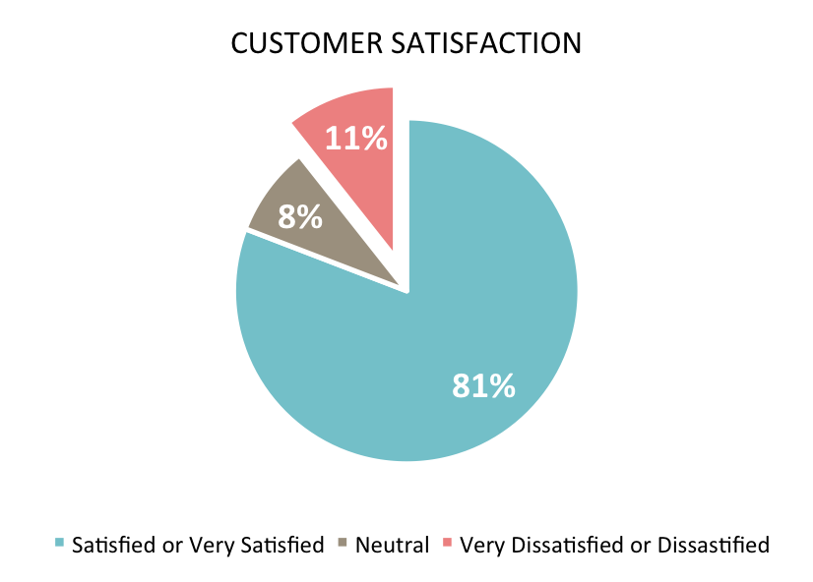

*Fig 1: Customer Satisfaction presentation*

**4.3 Interpretation of findings**

The analysis of findings reveals some stark inefficiencies in the Indian repair service market today, highlighting the need for an organized digital platform. Qualitative findings indicate that 60% of the customers were satisfied with the timeliness of service, but only 45% were satisfied with the work quality. Additionally, only 45% were satisfied with the charges of such a service, indicating a huge discrepancy in cost affordability and transparency.

Among the key challenges that emerged was inconsistency in the service charges, with the majority of customers experiencing different charges for equivalent services. This inconsistency leads to challenges in negotiations, dissatisfaction, and potential delays in services. Further, qualitative analysis shows that the majority of customers are uncomfortable due to the lack of transparency in cost estimation, which discourages repeat orders for services.

From a user perspective, most customers and engineers complained about traditional service request processes, citing such problems as difficulty in finding reliable professionals, slow response times, and poor communication. The data suggests that an online solution featuring automated service matching, secure payment processing, and real-time tracking could significantly improve service efficiency and customer satisfaction.

Besides, it indicates that a formal platform may enhance employment opportunities. The majority of the technicians indicate that an online repair marketplace will make them more consistent in employment. The unemployed respondents also indicated their willingness to join the marketplace if it provides certification and training on skills. These findings indicate that a well-designed system may enhance service delivery as well as assist in job creation and industry stimulation.

Overall, the findings attest to the necessity of a streamlined technology-based solution for solving the inefficiencies in India's repair services sector. With issue settlement regarding accessibility, cost, and tardy services, the proposed platform stands the chance of completely transforming the sector and enhancing customer experience as well as that of the technicians.

**4.4 Summary of Findings**

The research reveals that there is a critical demand for a digital repair service platform to address the inefficiencies in India's repair industry. The customers are facing delays in procuring repair services, and most of them cannot find good technicians within time. With the research, it was determined that inconsistent pricing models give rise to customer dissatisfaction, with 55% of the respondents identifying cost transparency as a major issue.

Technicians, on the other hand, experience challenges in securing consistent work due to limited visibility. More than half of the surveyed technicians reported having idle work periods, indicating that job distribution in the industry is uneven and inefficient. The absence of a centralized platform makes it difficult for skilled professionals to connect with customers in need of their services. Moreover, traditional methods of seeking services such as word-of-mouth and informal communication result in miscommunication, delays, and absence of tracing the progress of work.

Security problems were also pointed out as a key matter. Customers and technicians both identified the need for a secure and sound transaction process to minimize risk of fraud and assign responsibility. Customers also mentioned service reliability and technician verification as points to eliminate inferior workmanship or security exposure in using service providers.

With these research findings, the proposed digital repair service platform aims to overcome these limitations by introducing automated service pairing, standardized pricing, secure payment gateway integration, and real-time service tracking. The platform will enable customers to find certified technicians easily in a short time while providing constant job opportunities to the service providers. The platform also aims to create employment opportunities through increased technician visibility and the possibility of skill improvement features.

By addressing these root problems, the proposed system accomplishes the purpose of the study, which is to enhance efficiency, accessibility, and trust within the repair industry. The incorporation of technology in service delivery not only mechanizes the repair work but also fuels India's economic growth in services by creating an organized and functional digital platform.

**4.5 Conceptual Framework**

SERVICE-LINKER

SYSTEM

Service seekers (customers)

Log in/out

Search for professional

Provide service details

Track programs

Rate and review

Makes payment

Technicians (professionals)

Log in /out

List services

Accept job requests

Update service status

Communicate with customers

Administrator

Manages the account

Security

System performance

Fig 2: conceptual framework

**4.6 Technologies Used in the Digital Repair Service Platform**

Development of the digital repair service platform involves the use of frontend, backend, database management, hosting, authentication, security, and cloud services to provide an efficient user experience. The following is a breakdown of the technologies used:

**4.6.1 Frontend Development**

Frontend of the platform handles an interactive user interface on which the services are booked by the customers, the job request is received by the technicians, and there can be an easy exchange of communications between them. Following are technologies that have been implemented:

**REACT.JS**

React.js is a JavaScript library employed in crafting swift and agile user interfaces. It makes UI components reusable with a promise for modular and productive development. Top advantages include

**Virtual DOM** for rendering quickly and enhanced performance.

**Component-based architecture** for more efficient code management and reusability.

**State management using React Hooks** to handle dynamic content effectively.

**BOOTSTRAP**

Bootstrap is a popular CSS framework that offers pre-styled UI components and a grid system for responsive layouts. It guarantees:

**Mobile-first design**, so the platform can be accessed on varying screen sizes.

**Pre-styled components** such as buttons, forms, and modals to speed up development.

**Custom themes and styling** to align with the platform's brand.

**CSS**

**CSS (Cascading Style Sheets):** Utilized for further styling to beautify the appearance and feel of the platform to have a nice and easy-to-use design.

**4.6.2 Backend Development**

The backend handles user request processing, business logic, database management, and safe transactions. The following are used:

**Python Django**

Django is a high-level web framework supporting quick and secure backend development. Highlighted features are:

Integrated authentication system to handle user login and security.

**Scalability and performance** tuning for the ability to service multiple requests.

Admin panel automatically generated for handling users, service types, and transactions.

**Django REST Framework (DRF)**

The Django REST Framework is utilized to construct and handle APIs to facilitate communication between backend and frontend. DRF offers:

API serialization to format data into JSON format.

Token-based authentication for authentic API requests.

Permission handling to manage access to confidential data.

**4.6.3 Database Management**

The platform needs a strong database to hold customer information, technician information, service appointments, and transaction history securely. The following database technologies are employed:

SQL (PostgreSQL/MySQL)

PostgreSQL/MySQL: Relational database management systems offering structured data storage.

ACID compliance: Guarantees data integrity in transactions.

Efficient query processing: Improves the speed for fetching service requests, customer history, and technician ratings.

In addition, an ORM (Object-Relational Mapper) from Django is utilized to make database interactions easier through Python instead of direct SQL queries.

**4.6.4 Hosting & Deployment**

Hosting and deployment are important for making the platform available to users. The following services are utilized:

**Heroku**

A cloud-based Platform-as-a-Service (PaaS) for hosting the Django backend.

Supports automatic database management and scalable deployment.

Offers continuous integration with GitHub for seamless updates.

**Netlify / Vercel**

Used to host the React.js frontend, providing fast and secure content delivery.

Supports automatic deployments whenever changes are made to the frontend code.

Enables serverless functions for additional backend processing.

**4.7 Use Cases**

## Use Case 1: User Authentication

### ****Actors:****

* General User
* Professional

### ****Description:****

This use case manages the login, registration, and password recovery functionality. It ensures secure access control for different user roles.

### ****Flow of Events:****

1. **Login:**
   * The user inputs their email and password.
   * System checks credentials.
   * On success, access is granted and session is initiated.
   * On failure, an error message is shown.
   * Includes “Remember Me” functionality.
2. **Registration:**
   * The user selects a role (General or Professional).
   * System validates email format and password strength.
   * Details are stored securely in the database with password hashing.
3. **Forgot Password:**
   * The user requests a password reset.
   * System sends a reset link or OTP to the registered email after validation.

### ****Validation & Security:****

* Password hashing (e.g., bcrypt).
* Role-based page access control.
* Input validation (SQL injection, XSS protection).
* Session timeout and cookie security.

## **Use Case 2: Service Selection**

### ****Actors:****

* General User

### ****Description:****

Users can browse and choose from service categories like Carpentry, Electrical, Plumbing, etc.

### ****Flow of Events:****

1. On the homepage, a user clicks on a service category.
2. The system fetches and displays professionals matching the selected service.
3. The last selected service can be optionally remembered.

### ****Validation:****

* Valid category names.
* Handle no-result scenarios with user-friendly messages.

## **Use Case 3: Professional Profiles**

### ****Actors:****

* General User
* Professional

### ****Description:****

This use case involves displaying and editing service provider profiles.

### ****Flow of Events:****

1. Users view profiles of professionals showing:
   * Name, bio, rating, reviews, completed jobs, pricing, and service area.
2. Professionals can edit their own profiles.
   * Fields: Bio, service categories, pricing, availability, profile image.
3. Filtering options:
   * By distance, rating, specialization, availability.

### ****Validation:****

* Only the owner can edit their profile.
* Image size/type validation.
* Filter dropdown validation.

## **Use Case 4: Messaging System**

### ****Actor(s):****

* General User
* Professional

### ****Description:****

Facilitates private communication between users and professionals.

### ****Flow of Events:****

1. Users initiate chats with professionals.
2. Messages are sent and received in real-time (or via polling).
3. System shows unread messages, timestamps, and sender info.
4. Chats can be archived or deleted by either party.

### ****Validation:****

* Prevent empty messages.
* Notify user if recipient is offline or not found.
* Mark messages as read upon viewing.

## **Use Case 5: Geolocation and Range**

### ****Actors:****

* General User

### ****Description:****

Provides location-based filtering of professionals using distance calculations.

### ****Flow of Events:****

1. System requests user’s permission to access location.
2. Distance to each professional is calculated using the Haversine formula.
3. Users can filter professionals within:
   * 5km, 10km, or a custom range.
4. Professionals can set a max travel/service distance.

### ****Validation:****

* Location permission handling.
* Valid latitude/longitude values.
* Graceful fallback for denied geolocation access.

## **Use Case 6: Service Requests**

### ****Actors:****

* General User
* Professional

### ****Description:****

Manages the creation, management, and tracking of service requests.

### ****Flow of Events:****

1. User selects a service and submits a request with:
   * Description, urgency (Low, Medium, High).
2. Request can be sent directly to a professional or made visible to all.
3. Professionals can:
   * Accept or decline the request.
   * Send a price quote or ETA.
4. Users can track request status:
   * Pending → Accepted → In Progress → Completed.

### ****Validation:****

* Required fields must be filled.
* Only logged-in users can submit or respond to requests.
* Professionals can only access relevant requests.

## **Use Case 7: UI Components**

### ****Actors:****

* All Users

### ****Description:****

Defines the interactive elements used throughout the platform.

### ****UI Elements:****

* **Forms:** For registration, messaging, and service request submission.
* **Dropdowns:** Service categories, sorting, filtering.
* **Buttons:** Submit, View Profile, Send Message, Filter.

### ****Validation:****

* Responsive behavior across devices.
* Disabled buttons on incomplete forms.
* Real-time input feedback (e.g., validation errors).

## **Use Case 8: Data Validation**

### ****Actors:****

* All Users

### ****Description:****

Ensures data integrity both on the client and server side.

### ****Validation Rules:****

* Email format must follow standard pattern.
* Phone number must be 10 digits (country-specific rule optional).
* Service request must have a title, description, and urgency.
* Empty or malicious inputs are rejected.

### ****Security:****

* Sanitization of user inputs to prevent injection attacks.
* Server-side validation overrides client-side rules.

## **Use Case 9: Navigation**

### ****Actors:****

* All Users

### ****Description:****

Allows intuitive movement through various sections of the platform.

### ****Flow of Events:****

1. Navigation between key pages:
   * Home → Services → Professional Profile → Messaging
2. Unauthorized access redirects to login.
3. Includes browser back/forward support.
4. Loading indicators appear during page transitions.

### ****Validation:****

* Ensure broken links and dead ends are eliminated.
* Proper 404 and error route handling.

## **Use Case 10: Performance Optimization**

### ****Actors:****

* All Users

### ****Description:****

Handles system responsiveness and resource management.

### ****Flow of Events:****

1. Large datasets are paginated or loaded lazily (infinite scroll).
2. Filtering and sorting operations are optimized to run within 1 second.
3. Images (profile photos, uploads) are compressed and cached.
4. Loading spinners or skeleton components enhance perceived speed.

### ****Validation:****

* Ensure server response times <2 seconds on heavy load.
* Monitor real-time performance via logs or analytics.

# **Sample Test Cases (Functional / Unit)**

### Messaging: Mark as Read

it("should mark messages as read when viewed", () => {

const messages = [{ message: "Hi", read: false }];

messages[0].read = true;

expect(messages[0].read).toBe(true);

});

### Distance Filter: Geolocation

it("should return professionals within 10km", () => {

const user = { lat: 12.92, lng: 77.58 };

const professionals = [

{ name: "Pro1", lat: 12.93, lng: 77.59 },

{ name: "Pro2", lat: 13.10, lng: 77.60 }

];

const withinRange = professionals.filter(p => {

const dist = haversineDistance(user, p);

return dist <= 10;

});

expect(withinRange.length).toBe(1);

});

### Login: Invalid Credentials

it("should return false for invalid login", () => {

const storedPassword = "correctpass";

const enteredPassword = "wrongpass";

expect(enteredPassword === storedPassword).toBe(false);

});

### Service Request: Status Update

it("should update request status from Pending to Accepted", () => {

const request = { id: 1, status: "Pending" };

request.status = "Accepted";

expect(request.status).toBe("Accepted");

});

**4.8 Screen Shots and Source Codes**

The following are front-end screenshots to show the general interface

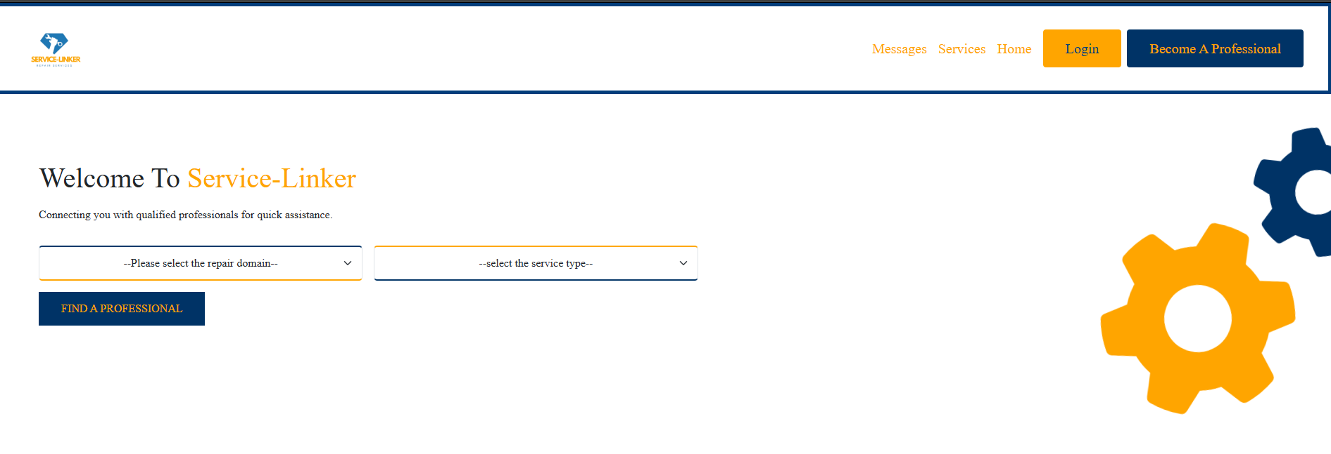

Fig 3: Home Page



Fig 4: Services Page

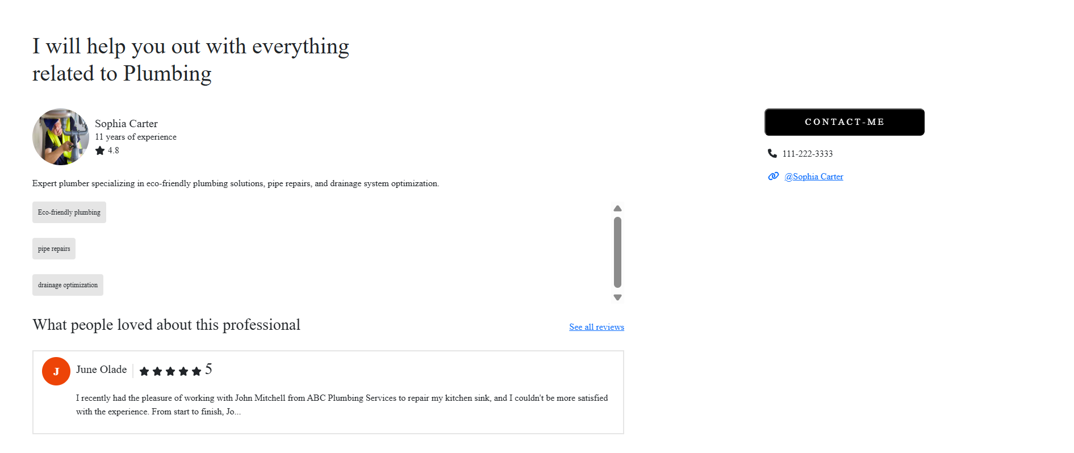

Fig 5: Professional Profile

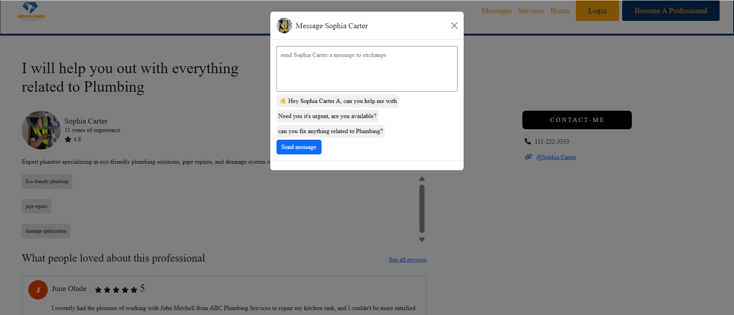

Fig 6: Customer message

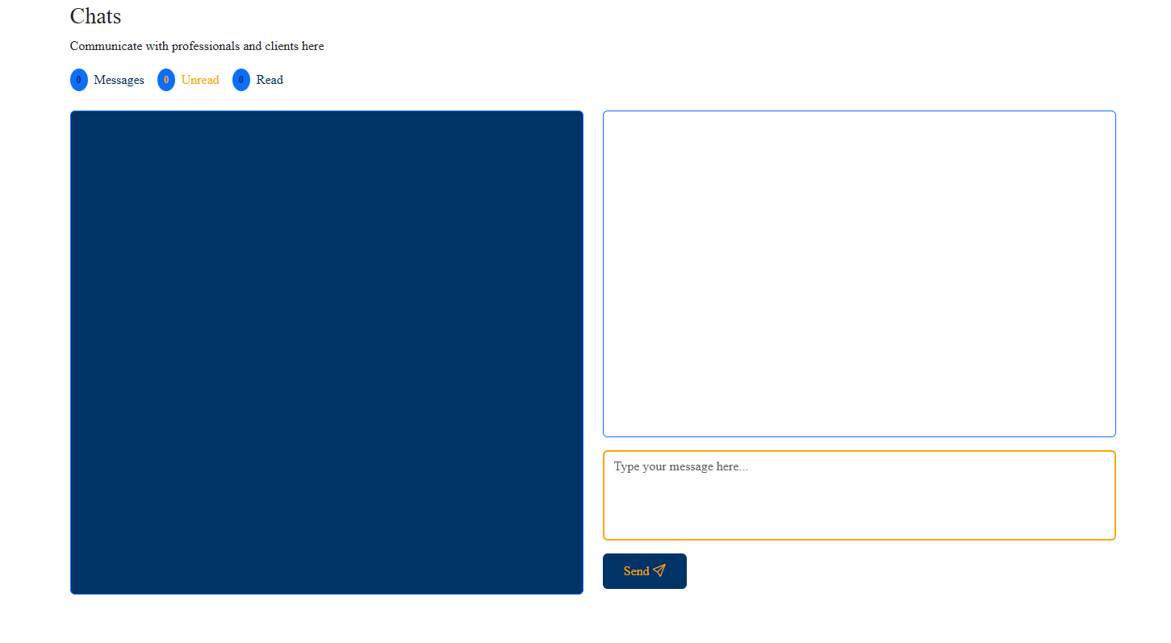

Figure 7: Professional Feedback

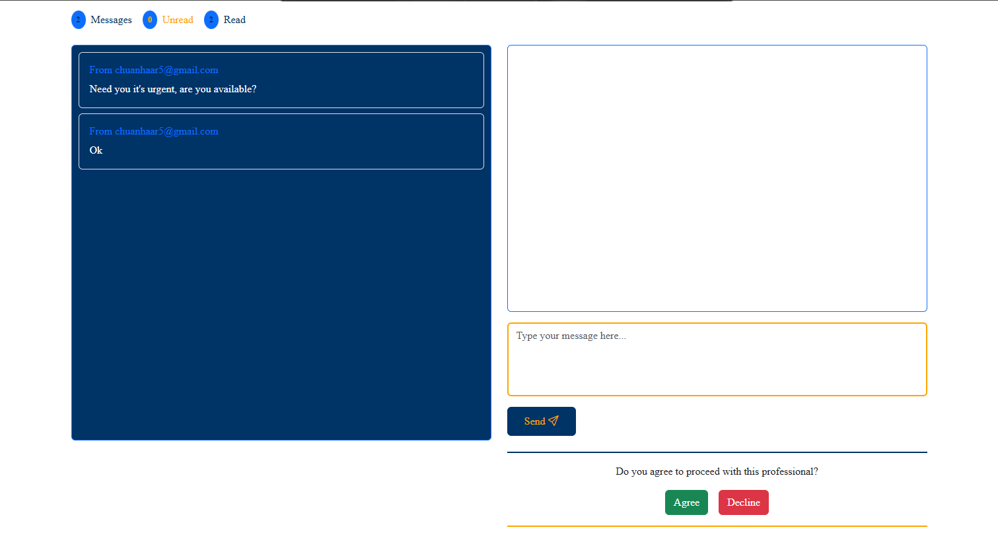

Figure 8: Customer feedback

# ***CHAPTER-5***

**CONCLUSION AND FUTURE WORK**

**5.1 Conclusion**

The Home and Office Repairs Professional Service Linking System solves old problems in the repair industry with the new trends in the evolving world. Word-of-mouth and manual searches take too long and lead to bad service to the users who need urgent repairs and the working elites who have little time to go for repairs at the main work places. With our solution, you can see service provider profiles, book online, and check reviews to make the right choice based on real feedback from the previous users according to their own experience. This system follows trends like evolution in the repair field and a base for helping users reduce their spending by buying items that can be repaired easily. It also helps professionals by giving them more opportunities and knowledge-sharing by linking with wide demands of the users. Think of it as a helpful middleman that makes it easier for people and professionals to connect based on the repair service they require. In the end, this project modernizes how we hire repair help for homes and offices. It's all about being accessible and high-quality. The platform creates a structured and reliable way to get repairs done with better customer satisfaction. Simple and yet so effective and this is what makes it stand out to solve our problems.

**5.2 Future Work**

For ongoing improvement and future scalability, the platform will integrate advanced technologies and strategic updates to enhance service delivery, transparency, and accessibility for customers and professionals alike. Some of the major areas of development planned are as follows:

**1. AI-Powered Service Matching**

Utilizing artificial intelligence (AI) and machine learning (ML), the platform will make predictions based on user behavior, location, history of service, and technician proficiency to recommend the most appropriate service provider. This predictive matching system will increase efficiency, minimize service wait times, and maximize user satisfaction by ensuring customers get the best professional for their particular needs.

**2. Mobile App Development**

To enhance accessibility and enhance user experience, the complete optimized mobile apps on Android and iOS will be created. Apps will include intuitive navigation, real-time notification, in-app support through chat, and secure payments. The mobile app will offer a more convenient method for users to book appointments, monitor work progression, and interact with technicians.

**3. Augmented Reality (AR) Pre-Diagnosis**

The addition of AR-based fault diagnosis will enable users to detect faults prior to requesting service. With the use of their smartphone camera, users can access real-time visual analysis of typical repair issues, enabling improved problem identification, estimated cost estimates, and decision-making.

**4. Blockchain for Secure Transactions**

Blockchain technology will be utilized to improve security, transparency, and trust in financial transactions. Through the integration of blockchain-based payment processing and smart contracts, customers and technicians can have verifiable and immutable service agreements, which ensure accountability and minimize fraud in service payments.

**5. Offline Accessibility and Rural Expansion**

Understandable challenges that low-internet zones present to its users, the site will adopt an SMS-enabled booking mechanism. Customers will have the ability to book services, receive notifications, and pay via an internet-less active connection. Offline syncing data will also be introduced to help users experience neither lag nor inefficiency in rural or urban locales.

**6. Government and Insurance Tie-up**

In order to offer financial protection and long-term warranties, partnerships with government programs and insurance companies will be sought. Such partnerships will provide eligible customers with subsidies, repair cost coverage, and warranty-guaranteed services, making the services more reliable and affordable.

**7. Technicians' Skill Development and Certification**

An integrated e-learning module shall be developed to provide training, skills development, and certification of technicians. Through video tutorials, interactive courses, and quizzes, this program shall keep service providers well-informed about industry best practices, enhancing the quality of services and enhancing the credibility of technicians.

**8. Smart Pricing and Dynamic Cost Estimation**

Automated price quotation software will be used to generate real-time pricing estimates dependent on service category, location, level of complexity, and industry trends. The function will be transparent, diminish the number of pricing disagreements, and assist the customer in making smart service decisions prior to proceeding with a reservation.

**9. Customer and Technician Reward Schemes**

To foster long-term usage, subscription-based models and loyalty rewards will be incorporated. Regularly frequenting customers can collect discounts and special deals, while high-performance technicians can be rewarded with performance-based bonuses, increasing motivation and quality of service.

**10. IoT-Based Smart Repair Alerts**

The platform will examine integration with Internet of Things (IoT) sensors for pre-emptive maintenance. The smart devices can send notifications of possible malfunctions, allowing the users to make preventive measures even before the machines break down. This will especially be useful in household appliances, industrial equipment, and infrastructure facilities. Through adopting these new technologies and strategic innovations, the platform seeks to transform the repair service sector. With the incorporation of AI, blockchain, AR, IoT, and mobile usability, user experience will be enhanced, service processes streamlined, and a secure and transparent environment created. This ongoing transformation will not only enhance service efficiency but also long-term sustainability and scalability, and make repair services more accessible and dependable for everyone.

# ***REFERENCES***

1. Laitala, K., Klepp, I.G., Haugrønning, V., Throne-Holst, H. and Strandbakken, P., 2021. Increasing repair of household appliances, mobile phones and clothing: Experiences from consumers and the repair industry. *Journal of Cleaner Production*, *282*, p.125349.

1. Berendt, E.B., 2015. The home improvement, maintenance, and repair industry. *Business Economics*, *50*(2), pp.101-108.
2. Wolf, C., Ringland, K.E. and Hayes, G., 2019. Home worlds: situating domestic computing in everyday life through a study of DIY home repair. *Proceedings of the ACM on Human-Computer Interaction*, *3*(CSCW), pp.1-22.
3. Liu, Y., 2006. *A forecasting model for maintenance and repair costs for office buildings* (Doctoral dissertation, Concordia University).
4. Özçelik, A., 2020. *Encountering the inner face of products: Computer repair practice and amateur computer repairers* (Master's thesis, Middle East Technical University (Turkey)).
5. Ray, B.A., 1999. Home Office Deduction in Need of Repair: Applying Mixed-Use Allocation Theory to Internal Revenue Code Section 280A (c). *Ohio St. LJ*, *60*, p.199.
6. Maby, C. and Gwilliam, J., 2022. Integrating energy efficiency into private home repair, maintenance and improvement practice in England and Wales. *Building Research & Information*, *50*(4), pp.424-437.
7. Bogdon, A.S., 1996. Homeowner renovation and repair: the decision to hire someone else to do the project. *Journal of housing economics*, *5*(4), pp.323-350.
8. Dagnaud, K., 2020. To repair or not to repair–that, is the question: a multiple-case study of circular strategy-as-practice in the office furniture and household appliance sectors.
9. Okoye, K.R.E. and Gangkwi, J.H., 2024. Effects of Self-help Guide for Repair and Maintenance of Domestic Electrical Appliances on Apprentices of National Directorate of Employment in Taraba State, Nigeria. *International Journal of Vocational Studies and Library Science*, *5*(1).
10. Gelber, S.M., 1997. Do-it-yourself: Constructing, repairing and maintaining domestic masculinity. *American quarterly*, *49*(1), pp.66-112.
11. Hershey, J., 1997. Getting a fix on your home repair collection. *Library Journal*, *122*(2), pp.51-54.
12. Bosselmann, P. and Pellegrini, S., A Strategy for the Repair of Downtown Oakland, California.
13. Komas, T.W., 2009. Concrete repair in the new century. *Concrete Repair Bulletin*, pp.18-21.
14. Holt, G.D. and Edwards, D.J., 2005. Domestic builder selection in the UK housing repair and maintenance sector: a critique. *Journal of Construction Research*, *6*(01), pp.123-137.