Abstract
Labelled financial text is scarce, and models trained on general-domain data may not transfer to financial language. This study investigates how training data choice influences a tweet-adapted RoBERTa model on StockEmotions, using GoEmotions as the general source. General-only, financial-only, mixed and sequential training are compared on a 12-class emotion task and a binary bullish/bearish task. Financial-only fine-tuning achieves the highest core macro-F1 in both tasks (0.365 and 0.804), while general-only training reaches 0.139 and 0.554. TF-IDF baselines with Logistic Regression, SVM and Naive Bayes show the same pattern, with domain-only training best for every algorithm. Dataset weighting and domain tags give small gains to mixed training, and a ten-model ensemble reaches 0.397 macro-F1. Without any training, a structured LLM prompt reaches 0.799 binary macro-F1, close to the best fine-tuned model. The results indicate that in-domain supervision matters most under the tested conditions.

1.0 Introduction and Project Motivation

1.1 Background
Financial emotion and sentiment classification uses natural language processing to identify attitudes expressed in financial text. General sentiment models may struggle when familiar words appear in specialised financial contexts. Ergun and Sefer [1] identify limited labelled data and specialised language as challenges in financial sentiment analysis. Their work investigates transfer learning and financial adaptation of pretrained language models, providing a relevant foundation for this project.
Emotion classification and sentiment classification describe different targets. Emotion classification distinguishes feelings such as anxiety, excitement and anger. Financial sentiment classification identifies a market outlook, such as bullish or bearish. A message can express anxiety while still expecting a stock to rise. This project therefore treats the 12-class emotion task and the binary financial sentiment task separately.

1.2 Real World Motivation
Automated analysis could help researchers organise large collections of investor messages and examine how opinions vary across companies or periods. Financial interpretation depends on context. For example, “The company reduced its losses” contains a negative word but may describe an improvement. Similarly, “This stock could crash, which is worrying” expresses anxiety in a financial setting. These illustrative examples show why recognising isolated sentiment words is insufficient.
The project focuses on classifying text against annotated labels. Its experiments do not establish an ability to predict prices or recommend investments. The practical motivation is to understand when general language knowledge needs additional financial examples to support reliable classification.

1.3 Aim and Objectives
The aim is to investigate how training data choice influences RoBERTa performance on financial text. The study compares general-only, financial-only, mixed and sequential training. Each strategy uses the same pretrained model family and is evaluated on held-out financial examples within its classification task.
The objectives are to describe the source and target datasets, align their labels, compare the training strategies quantitatively, and analyse prediction failures and limitations. A secondary objective is to compare detailed emotion classification with binary financial sentiment classification. These tasks are evaluated separately because they use different target labels and stratified test splits. TF-IDF classifiers provide traditional baselines, and LLM prompting provides a reference that requires no training.

2.0 Research Gap and Research Questions

2.1 Research Problem and Design Rationale
The experimental problem is whether general emotion supervision provides useful knowledge for a financial classification task. A large source dataset offers many labelled examples, but its vocabulary and label meanings may differ from the target dataset. The project examines this source-to-target mismatch using controlled comparisons rather than assuming that additional general data must improve performance.
Shared label names make cross-domain training possible, but they do not guarantee shared meanings. For example, mapping several general positive emotions to financial belief may merge distinct concepts. Training strategy and label alignment must therefore both be considered when interpreting results. The contribution is an empirical comparison on the selected datasets, rather than a claim that financial domain adaptation has not previously been studied.

2.2 Research Questions
Question | Comparison
Q1: How well does general-only emotion training transfer to financial text? | Evaluate Model A on the financial test set.
Q2: How do financial-only, mixed and sequential training affect financial classification performance? | Compare Model B, Model C and sequential transfer within each task.
Q3: How does observed performance differ between the 12-class emotion task and the binary financial sentiment task? | Report the two tasks separately and examine label definitions and data-split differences.

Q1 tests direct cross-domain generalisation. Q2 tests whether source training helps relative to financial-only fine-tuning. Q3 is exploratory because both the target definition and the stratified split change between tasks. Validation data guide model selection, while test data provide the final comparison.

3.0 Related Work

3.1 Financial Transfer Learning and Domain Knowledge
Ergun and Sefer [1] propose FinSentiment models using transfer learning for financial sentiment analysis. They investigate financial adaptation and joint use of general and financial corpora, reporting benefits for finance-specific models across their benchmarks. This work is closely related to the present comparison of source and target training data. However, its results cannot be transferred directly to the present emotion dataset because labels and evaluation conditions differ.
Sun, Yuan and Xu [2] propose EnhancedFinSentiBERT, incorporating financial pretraining, dictionary knowledge and neutral feature extraction. Their approach highlights the importance of domain information and label treatment. The present pipeline does not implement these components. Excluding neutral examples defines the scope of the emotion task and does not establish that neutrality is unimportant.

3.2 Alternative Adaptation Approaches
Wang et al. [3] investigate proxy tuning for financial sentiment analysis. Their method uses differences between model logits to steer a base model with expert knowledge without updating that base model. It provides an alternative for settings with limited training resources. The sequential approach in this project updates model parameters on general examples and then financial examples.
Kirtac and Germano [4] connect financial text analysis with trading strategy development using several language models. Their work supports the practical relevance of financial language analysis, but its market-return and trading outcomes differ from the classification metrics used here. Zhao et al. [5] study source-free adaptation for aspect-based sentiment analysis, transferring model parameters without requiring source data during adaptation. The present project retains both datasets and predicts one label per message, so their setting provides broader adaptation context rather than a directly reproduced method.

3.3 Large Language Model Evaluation
Muhammad et al. [6] benchmark generative language models in zero-shot and few-shot target-based financial sentiment classification. They compare these models with lexicon tools and discriminative Transformers. Their target-specific task accounts for sentiment towards different entities within a text, which differs from the message-level predictions in this project.
Vamvourellis and Mehta [7] examine zero-shot financial sentiment analysis and find that additional reasoning does not improve performance in their tested setting. This finding motivates evaluating prompting choices rather than assuming more elaborate prompts perform better. These studies motivate the prompting experiments in Section 7.5, which compare zero-shot, few-shot and structured prompts on the same financial test messages as the fine-tuned models.

3.4 Literature Comparison
Study | Approach | Connection to this project
[1] Ergun and Sefer | Financial transfer learning | Closest match to general and financial training comparisons.
[2] Sun et al. | Dictionary knowledge and neutral features | Domain knowledge and label-definition choices.
[3] Wang et al. | Proxy tuning | Alternative adaptation with no base-model updates.
[4] Kirtac and Germano | Financial language models and trading | Application motivation; different outcome measures.
[5] Zhao et al. | Source-free aspect-based adaptation | Different source-access and prediction setting.
[6] Muhammad et al. | Target-based LLM benchmarking | Prompt-based alternative; different prediction unit.
[7] Vamvourellis and Mehta | Reasoning and prompting comparison | Evidence for evaluating prompt design empirically.

Together, these studies justify examining financial context, adaptation choices and evaluation design. The present study concentrates on how data selection changes performance with a common RoBERTa model family. Related-work scores are treated as contextual evidence rather than directly comparable benchmarks.

4.0 Data and Preparation

4.1 Source and Target Datasets
The final pipeline reads two cleaned CSV files. The source file, general_clean.csv, contains 53,992 examples with text and a single general emotion label. The source is a cleaned single-label version of GoEmotions [8]. The target file, domain_clean.csv, contains 10,000 financial messages and includes identifiers, dates, stock tickers, emotion labels, bullish or bearish sentiment labels, and text. The target is StockEmotions [9]. The two datasets provide different forms of supervision: general emotional responses and specialised financial attitudes. Exact-text checks find no shared text strings between the supplied files, although this does not exclude near duplicates or other forms of information leakage.
Property | General dataset | Financial dataset
Cleaned examples | 53,992 | 10,000
Role | Source domain | Target domain
Emotion labels | 27 emotions plus neutral | 12 emotions
Binary labels | Derived from selected emotions | 5,474 bullish and 4,526 bearish
Missing values in supplied files | None | None
Exact duplicate text strings | None | None
Both files were produced by a shared cleaning step. GoEmotions annotations marked as very unclear were removed, ratings were aggregated per text, and each text was assigned its rarest emotion that received at least two rater votes, producing a single-label dataset. Text in both datasets was then normalised: HTML entities were unescaped, emojis were converted to descriptive tokens such as [face with tears of joy], URLs and user mentions were removed, the cashtag symbol was stripped from tickers, quotation markers were removed and whitespace was collapsed. Duplicate texts created by normalisation were dropped.

4.2 Aligning the Emotion Labels
For the emotion experiment, the general labels are mapped into the financial dataset’s 12 categories. Neutral is unmapped and removed, leaving 38,042 general examples. The financial emotion labels remain unchanged. An assertion checks that the two datasets contain the same label names after mapping.
Shared label | Original general labels
ambiguous | realization
amusement | amusement
anger | anger, annoyance, disapproval
anxiety | nervousness
belief | admiration, approval, caring, pride, gratitude, love
confusion | confusion, curiosity
depression | sadness, grief, remorse, disappointment, embarrassment
disgust | disgust
excitement | excitement, joy
optimism | optimism, relief, desire
panic | fear
surprise | surprise
This mapping enables a shared classifier, but it is an operational assumption rather than proof of semantic equivalence. Merging distinct emotions may introduce ambiguity. The mapping should therefore be considered a limitation when analysing cross-domain errors.

4.3 Class Distribution and Data Checks
The financial emotion classes are imbalanced. Optimism contains 1,624 examples, excitement 1,386 and anxiety 1,366, whereas depression contains 205 and surprise 244. The largest class is approximately eight times the smallest. This supports reporting macro-F1 alongside accuracy and considering class weights during training. These counts describe the supplied dataset before train, validation and test splitting; they are not prediction results.
Figure 2(a) shows that label distributions also differ between domains after mapping. Belief forms 33.2% of the mapped general data but 9.1% of the financial data, whereas anxiety forms only 0.5% of the mapped general data compared with 13.7% of the financial data. Disgust shows a similar gap (2.6% and 12.8%). Financial posts are also longer, with a median of 16 words compared with 12, and 95% contain 37 words or fewer (Figure 2(b)).
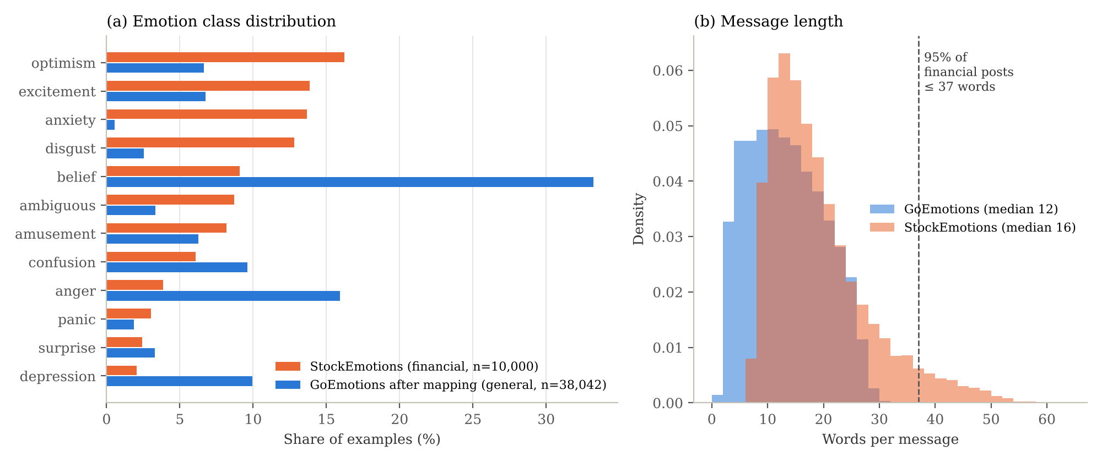
Figure 2 Exploratory data analysis: (a) class shares after label mapping; (b) message length in words.

4.4 Training, Validation and Test Splits
The emotion task uses stratified splitting with random seed 42. The general data are divided into 80% training and 20% validation. Financial data are divided into 70% training, 15% validation and 15% testing. Stratification approximately preserves each dataset’s label proportions.
Dataset for emotion task | Training | Validation | Test
General | 30,433 | 7,609 | Not used
Financial | 7,000 | 1,500 | 1,500

Training examples update the model parameters. Validation examples support learning-rate and checkpoint selection. Each main strategy is evaluated on the same financial test split within the emotion task. General-only training uses general validation for checkpoint selection; the financially trained strategies use financial validation. This distinction affects experimental comparability because checkpoint selection uses different validation distributions.

4.5 Binary Labels and Tokenisation
For the binary extension, 12 general emotions are mapped to positive and 11 to negative. Neutral, confusion, curiosity, realization and surprise are excluded. This produces 31,865 general examples: 20,132 positive and 11,733 negative. Financial bullish and bearish labels are mapped to positive and negative respectively, retaining all 10,000 target examples. General emotional positivity and bullish market outlook are related but not identical concepts.
The binary task creates separate stratified splits using the same 80/20 and 70/15/15 proportions. Financial split sizes remain 7,000, 1,500 and 1,500, but the examples need not match the emotion-task splits because stratification uses different labels. Within each task, the same test examples are used across strategies.
Finally, the RoBERTa tokenizer converts text into token IDs and attention masks. Inputs are truncated to a maximum of 64 tokens, and category names are encoded as numeric label IDs. Truncation may remove information from longer messages, making token length a relevant factor for later error analysis. Because 95% of financial posts contain 37 words or fewer (Figure 2(b)), the 64-token limit truncates few target messages.

5.0 Research Methodology and System Design

5.1 Model Selection and Overall Framework
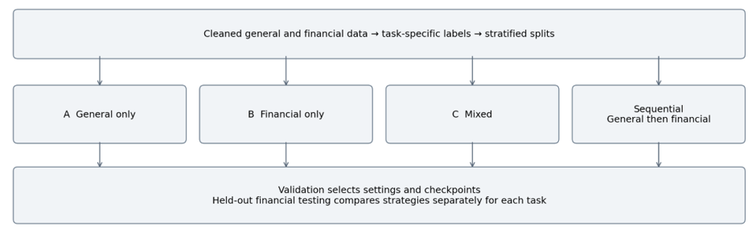
The implementation uses cardiffnlp/twitter-roberta-base, a RoBERTa checkpoint further pretrained on approximately 58 million tweets [10]. Its exposure to informal social media language motivates its selection for financial posts, although similarity in writing style does not establish financial-domain understanding. Each core experiment uses the same base checkpoint and a classification head with either 12 emotion outputs or two sentiment outputs. Architectural extensions are analysed separately from the core data comparisons.

Figure 1 Experimental framework used independently for emotion and binary sentiment classification.

5.2 Training Strategies
Strategy | Training and checkpoint selection
A General only | Fine-tune on general training examples for up to three epochs; select using general validation.
B Financial only | Fine-tune on financial training examples for up to six epochs; select using financial validation.
C Mixed | Combine general and financial training examples and train for up to three epochs; select using financial validation.
Sequential transfer | Save Model A, then continue fine-tuning on financial examples for up to six epochs using financial validation.
Model B still uses a pretrained language model. The distinction is that it receives no supervised general-emotion fine-tuning within this project. In sequential transfer, the shared label space allows the second stage to continue from the first-stage classifier. For 12-class mixed training, 30,433 general and 7,000 financial examples form 37,433 rows, of which 18.7% are financial.

5.3 Adaptation Techniques and Extensions
Beyond sequential transfer, dataset weighting repeats the financial training set twice within the mixed data, increasing its proportion to 31.5%. Domain tags prefix each example with its origin; financial tags are also used for target validation and testing. Both techniques retain the underlying classifier architecture.
Further experiments compare mean pooling, an RCNN classification head inspired by Nguyen et al. [11], and low-rank adaptation, or LoRA [12]. Mean pooling averages non-padding token representations. The RCNN head combines the last four Transformer layers with a bidirectional LSTM, convolution and max pooling. LoRA freezes the base parameters and trains low-rank query/value adapters and the classification head. These experiments investigate alternative representations or parameter updates and are not treated as identical-architecture A/B/C comparisons.

5.4 Baseline and LLM Configurations
Traditional baselines use TF-IDF features with unigrams and bigrams, at most 20,000 features and a minimum document frequency of two. Logistic Regression, linear SVM and multinomial Naive Bayes are each trained as Models A, B and C on the 12-class task. Their main hyperparameter (C, or alpha for Naive Bayes) is selected by stratified five-fold cross-validation on the training data using macro-F1, and Logistic Regression and SVM use balanced class weights. The financial data are split 80/20 with seed 42, giving 8,000 training and 2,000 test messages. This test set differs from the 1,500-message split used for RoBERTa, so baseline and Transformer results are compared by overall pattern rather than exact differences.
The LLM experiments evaluate the binary bullish/bearish task without parameter updates, using the same 1,500 financial test messages as the binary RoBERTa models. Two models are compared: Claude Haiku 5.5 through the Anthropic API, and the locally run Qwen2.5-0.5B-Instruct. The zero-shot prompt lists the two allowed labels. The few-shot prompt adds two labelled examples per class, drawn only from the financial training split. The structured prompt adds label definitions and a rule to judge the stance towards the stock rather than the writer’s mood; for Claude it also requires a one-sentence reason and a label restricted to the two classes through a tool schema. The local model always selects the label with the highest summed token log-probability, so it cannot produce invalid outputs. Unparseable Claude outputs are counted as errors.

6.0 Experimental Design and Implementation

6.1 Training Configuration
A reusable Hugging Face Trainer function manages training, validation and checkpoint restoration. A custom WeightedTrainer computes cross-entropy using the square roots of balanced class weights. This gives rare classes greater influence while moderating the correction. Label smoothing is applied explicitly within the custom loss.
Setting | Configuration
Learning rate | 3 × 10⁻⁵ for core runs, selected on financial validation
Learning-rate sweep | 1 × 10⁻⁵, 2 × 10⁻⁵ and 3 × 10⁻⁵; validation macro-F1 0.319, 0.369 and 0.391
Batch sizes | 32 training; 64 evaluation
Schedule | Cosine decay with 10% warmup
Weight decay | 0.05 for fewer than 10,000 training rows; 0.01 otherwise
Dropout and label smoothing | 0.1 each
Random seed | 42 for core splits and training
Checkpoint selection | Highest validation macro-F1; evaluate after every epoch
Early stopping | Two epochs without validation improvement in core runs
Maximum length | 64 model tokens

The training recipe is largely shared, but epoch budgets, validation domains, effective class weights and weight decay differ between strategies. The selected learning rate also comes from financial validation, including for Model A. The comparison therefore measures these implemented training procedures rather than isolating training data as the only possible cause of performance differences.

6.2 Evaluation and Reproducibility
Macro-F1 is the primary metric because it gives equal importance to each class. Macro-averaged precision and recall are reported alongside it. Accuracy measures the proportion of correctly classified messages. Per-class precision, recall and F1, together with confusion matrices, support error analysis. Each strategy uses the same target test examples within a task; the binary and emotion tasks use different stratified splits.
The research log is bert_experiments.ipynb, while bert_final.ipynb contains the main emotion and binary pipelines. Predictions, logits and summary tables are saved for rescoring and ensemble analysis. Model-only checkpoints reduce storage but do not retain optimizer state for exact training resumption. The recorded environment uses Anaconda and Apple MPS, with memory cleanup between runs. Exact package versions and hardware specifications remain necessary for a complete reproduction record.

7.0 Experimental Results

7.1 Traditional Machine Learning Baselines
Algorithm | Training data | Macro-P | Macro-R | Macro-F1 | Accuracy
Logistic Regression | A General only | 0.16 | 0.16 | 0.138 | 0.147
Logistic Regression | B Financial only | 0.36 | 0.39 | 0.367 | 0.380
Logistic Regression | C Mixed | 0.34 | 0.28 | 0.275 | 0.332
Linear SVM | A General only | 0.15 | 0.18 | 0.144 | 0.149
Linear SVM | B Financial only | 0.36 | 0.39 | 0.365 | 0.384
Linear SVM | C Mixed | 0.35 | 0.30 | 0.298 | 0.346
Naive Bayes | A General only | 0.20 | 0.14 | 0.089 | 0.122
Naive Bayes | B Financial only | 0.47 | 0.24 | 0.244 | 0.328
Naive Bayes | C Mixed | 0.34 | 0.22 | 0.231 | 0.307

Financial-only training gives the strongest baseline for every algorithm. Logistic Regression and SVM reach 0.367 and 0.365 macro-F1, a difference too small to separate them without repeated runs. General-only training falls to 0.089–0.144, showing the same cross-domain gap later observed for RoBERTa. Mixed training lies between the two (0.231–0.298), which suggests that the much larger general set dilutes the financial signal. Naive Bayes is weakest throughout: its financial-only model has high macro-precision (0.47) but low recall (0.24), because it rarely predicts minority classes such as surprise and depression. Macro-precision and recall are taken from the classification reports, which round to two decimals.
The best baselines score similarly to RoBERTa Model B (0.365 macro-F1). Because the baselines use a different test split, this does not show that the two approaches are equivalent, but it indicates that the 12-class task remains difficult for both lexical and contextual models.

7.2 Core Emotion Classification Results
Strategy | Macro-P | Macro-R | Macro-F1 | Accuracy
A General only | 0.165 | 0.179 | 0.139 | 0.168
B Financial only | 0.363 | 0.375 | 0.365 | 0.389
C Mixed | 0.411 | 0.355 | 0.356 | 0.405
Sequential transfer | 0.348 | 0.363 | 0.353 | 0.375

Financial-only training achieves the highest core macro-F1, while mixed training achieves the highest accuracy and macro-precision but the lowest macro-recall among the financially trained strategies. Model A reaches 0.627 macro-F1 on general validation but only 0.139 on financial testing. Its financial anxiety and disgust F1 scores are approximately 0.02 and 0.01, indicating that cross-domain failure affects some classes particularly strongly. General validation and financial testing are different distributions, so their gap is evidence of a transfer difficulty rather than a controlled estimate of one isolated domain effect.
Model B selects epoch four. Sequential and mixed training select their final allowed epochs, suggesting that longer schedules warrant investigation. This observation alone does not establish that additional training would improve held-out performance.

7.3 Adaptation and Extension Results
Experiment on 12-class task | Macro-F1 | Comparison or observation
Financial oversampling | 0.371 | Mixed baseline 0.356
Domain tags | 0.361 | Mixed baseline 0.356
Weighting plus tags plus rank-16 LoRA | 0.353 | No combined benefit in this run
Three-seed ensemble | 0.378 | Individual financial-only runs 0.355–0.365
Mean pooling | 0.366 | Financial-only baseline 0.365
RCNN head | 0.378 | Best single-model score reported
Rank-8 LoRA | 0.365 | Approximately 0.7% of parameters trainable
Four-epoch cap | 0.366 | Overfitting ablation
Select by validation loss | 0.349 | Overfitting ablation
Weight-decay experiment | 0.354 | Configuration not confirmed; excluded from conclusions about regularisation
Ten-model probability ensemble | 0.397 | Accuracy 0.429; prior exponent zero

Oversampling raises mixed-training macro-F1 by approximately 0.015, while tags raise it by 0.005. The combined run performs below either individual technique. LoRA reports similar macro-F1 to full fine-tuning while training approximately 0.9 million of 125.5 million parameters; runtime and energy savings were not measured.
The ten-model ensemble is the ensemble result used in this report. Its members are all 12-class models saved at that stage rather than a subset selected by test score, and the calibration exponent was tuned on financial validation only. Its listed members are S1, S1_long, S1_mean, S1_seed1, S1_seed2, S2, S2a, S3, S3_tagged and S3_weighted, consistent with the earlier notebook output. A later sixteen-model ensemble is separately reported at 0.390; it is not combined with the ten-model result. Validation selects a prior-calibration exponent of zero, leaving ensemble probabilities unadjusted.
The weight-decay experiment reports a macro-F1 of 0.354. However, the available code specifies a weight decay of 0.05 for both the financial-only baseline and the corresponding ablation. This result therefore cannot be interpreted as evidence of the effect of increased regularisation until the executed configuration is confirmed. The planned layer-freezing, higher-dropout and combined ablations are excluded from the comparison because their results are unavailable.

7.4 Binary Financial Sentiment Results
Strategy | Macro-P | Macro-R | Macro-F1 | Accuracy
A General only | 0.574 | 0.563 | 0.554 | 0.581
B Financial only | 0.804 | 0.804 | 0.804 | 0.806
C Mixed | 0.782 | 0.785 | 0.782 | 0.783
Sequential transfer | 0.798 | 0.799 | 0.798 | 0.800

Financial-only training achieves the highest reported binary macro-F1 and accuracy. Its macro-F1 exceeds general-only training by 0.250. Sequential transfer is 0.006 below financial-only training, while mixed training is 0.022 below it. Financial-only training performs best in both tasks, but sequential transfer outperforms mixed training only in the binary task.

7.5 LLM Prompting Results
Model and prompt | Macro-P | Macro-R | Macro-F1 | Accuracy | Invalid
Claude zero-shot | 0.757 | 0.758 | 0.756 | 0.756 | 3
Claude few-shot | 0.755 | 0.753 | 0.752 | 0.751 | 8
Claude structured | 0.799 | 0.799 | 0.799 | 0.801 | 0
Qwen2.5-0.5B zero-shot | 0.604 | 0.603 | 0.597 | 0.597 | 0
Qwen2.5-0.5B few-shot | 0.632 | 0.612 | 0.582 | 0.592 | 0
Qwen2.5-0.5B structured | 0.571 | 0.564 | 0.542 | 0.548 | 0
RoBERTa B (reference) | 0.804 | 0.804 | 0.804 | 0.806 | 0

The structured prompt gives the strongest LLM result: 0.799 macro-F1, 0.005 below RoBERTa Model B and slightly above sequential transfer, without any task-specific training. Zero-shot and few-shot prompting score 0.756 and 0.752. Adding two examples per class therefore did not help and produced more invalid outputs (8 compared with 3). The small local model performs close to RoBERTa Model A (0.542–0.597 macro-F1), so a general 0.5-billion-parameter instruction model provides little financial stance knowledge in this setting.
Claude structured and RoBERTa Model B make a similar number of errors (299 and 291), but only 130 errors are shared (Figure 3). The two approaches therefore fail on partly different messages, which suggests a possible benefit from combining them; this was not tested.
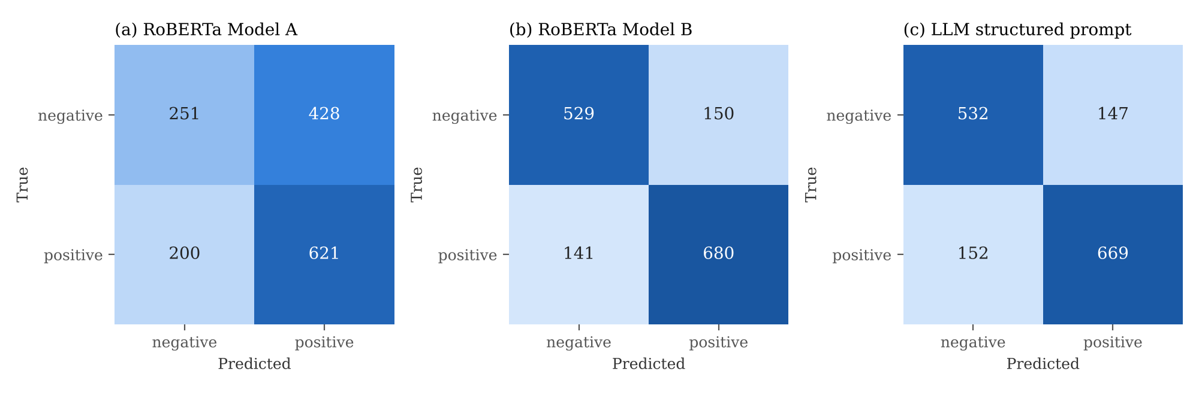
Figure 3 Binary confusion matrices on the 1,500 financial test messages (counts).

7.6 Prediction Errors
The ten-model ensemble reports top-5 emotion accuracy of 0.891, compared with top-1 accuracy of 0.429. The correct label frequently appears among several candidates, but a five-label shortlist is substantially less demanding than a single prediction. It does not demonstrate reliable final classification.
Frequent errors include optimism being predicted as excitement or anxiety, and belief being predicted as excitement. Some pairs are semantically close; optimism and anxiety may instead reflect competing outlooks or mixed attitudes. Establishing the cause of these errors requires examining actual messages and annotation context, rather than relying on label names alone.
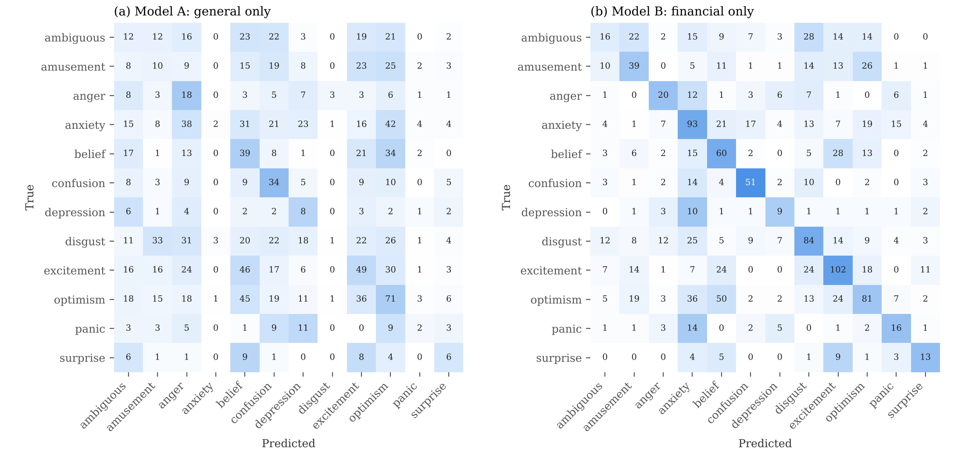
Figure 4 12-class confusion matrices for RoBERTa Models A and B on the financial test set (counts).
Figure 4 shows a label-prior bias inherited from the source domain. Model A predicts anxiety and disgust only six times each in 1,500 messages, matching their scarcity in the mapped general data, and over-predicts anger and belief, which are frequent there. In the binary task (Figure 3(a)), Model A labels 69.9% of messages positive compared with 54.7% in the test set, consistent with the positive skew of its general training data (63.2%). Model B and the structured Claude prompt predict close to the true proportion (55.3% and 54.4% positive), whereas the local Qwen model leans negative in every prompting mode (56.1%–69.9% negative).
Reading misclassified messages shows three recurring error sources. First, trading vocabulary expresses market expectations rather than feelings: phrases such as “dip and then rip”, “pump”, “bag holders”, calls, puts and price targets carry stance that general emotion words do not. For example, Model B labels “Tesla $1,000 by end of week [rocket]” as excitement although its gold label is optimism, illustrating how closely these classes overlap in financial posts. Second, sarcasm reverses surface polarity. “Tesla Down 1.4%. Yeah. Definitely a reason to panic and sell. Bears won. You were right the whole time. [face with rolling eyes]” is labelled bullish, yet both Model B and the structured Claude prompt classify it as bearish. Third, some gold labels are debatable: “Tesla Loading around 300 see you guys there [fire]” is labelled bearish, while both models read it as buying in expectation of a rise. These examples are illustrative and were not counted systematically.

8.0 Discussion and Critical Analysis
How does training data choice influence model performance? In these experiments, training data choice has the largest effect on target performance. Replacing general training data with financial training data raises 12-class macro-F1 from 0.139 to 0.365 and binary macro-F1 from 0.554 to 0.804. Adding general data to financial data, whether mixed or sequential, changes macro-F1 by at most 0.012 in the emotion task and 0.022 in the binary task, comparable to the observed seed variation. Architectural changes (mean pooling, RCNN head, LoRA) change macro-F1 by at most 0.013 relative to financial-only training. Under the tested conditions, whether training data match the target domain matters more than how general data are combined with it or which classification head is used. The TF-IDF baselines show the same ordering, with financial-only training best for all three algorithms.

8.1 General Emotion Knowledge Transfers Unevenly
Q1 asks how well general-only supervision transfers to finance. The 12-class result of 0.139 macro-F1 indicates weak transfer under the implemented mapping. Stronger general-validation performance does not guarantee target-domain success. Financial posts combine specialised expressions, informal language and market expectations, while the source labels were created for general emotional responses. Mapping those labels produces a common output space but may leave important differences in meaning.
General-only binary macro-F1 is higher at 0.554, which is consistent with broad polarity being easier to transfer in this setting. However, this remains a different task with fewer classes, different source filtering and a different target split. The experiment supports a task-specific observation, not a general rule that polarity always transfers successfully.

8.2 Financial Supervision Provides the Strongest Reference
For Q2, financial-only training leads the core macro-F1 comparison in both tasks. The weighted mixed variant (0.371) slightly exceeds financial-only training (0.365) on the emotion task, but this 0.006 difference is within the observed seed variation of approximately 0.010. General supervision therefore provides no reliable improvement over target-only fine-tuning in these runs. This supports prioritising representative financial labels when developing this classifier. It does not establish that source data are universally unhelpful.
The brief anticipates that Model A is general but domain-weak, Model B is domain-aware but unstable, and Model C is the most balanced. The results support the first expectation in both tasks. Model B is domain-aware and achieves the highest core macro-F1; its instability is reflected in a seed range of 0.355–0.365 and in training loss falling well below validation loss. Model C is not the most balanced by macro-F1: it achieves the highest 12-class accuracy but lower macro-F1 than Model B, indicating that its correct predictions are concentrated in more frequent classes. A likely contributor is that financial examples form only 18.7% of the mixed data, and class weights are computed on this mostly general distribution. Raising the financial share to 31.5% increases macro-F1 to 0.371. The TF-IDF baselines show the same ordering of Models A, B and C, so this behaviour is not specific to RoBERTa.
Mixed training exposes the model to substantially more general examples than financial examples. Its improvement under financial oversampling is consistent with target-domain influence being relevant. Nevertheless, oversampling also changes the update count per epoch and the class-weight calculation, so the gain cannot be attributed only to a change in domain proportion. Sequential training may also require different second-stage learning rates or budgets to preserve useful source knowledge while adapting to finance.
Mixed training gives the highest core emotion accuracy but lower macro-F1 than financial-only training. This means the models differ in how their successes are distributed across classes. Macro-F1 gives equal weight to rare emotions, making it suitable for judging coverage across all 12 labels. The binary gap of 0.006 between financial-only and sequential training is small and requires repeated runs before a stable advantage can be claimed.

8.3 Binary Sentiment Is a Different Prediction Target
Q3 compares detailed emotion recognition with binary market sentiment. Financial-only macro-F1 changes from 0.365 to 0.804, indicating that the implemented binary task is more tractable. However, this is not simply a collapse of the same 12 labels. Target supervision changes to independently provided bullish/bearish labels, the general dataset excludes additional emotions, and the financial test membership changes.
The evidence is compatible with fine-grained ambiguity contributing to emotion errors, but it does not prove an intrinsic performance ceiling near 0.40 or rule out model and training improvements. A stronger investigation would compare tasks on matched target examples, audit annotation agreement and test alternative source-to-target mappings.

8.4 Relationship to Previous Work
FinSentiment [1] supports the broader value of financial adaptation, while the present findings show that the benefit of adding general supervision depends on the task and implementation. The domain-knowledge approach in [2] and proxy tuning in [3] suggest alternative directions that were not tested here. Their published scores cannot be ranked directly against these results because datasets, labels and evaluation procedures differ.
Vamvourellis and Mehta [7] report that additional reasoning does not improve zero-shot financial sentiment classification. Here, few-shot examples did not improve on zero-shot prompting, while the structured prompt improved Claude’s macro-F1 from 0.756 to 0.799. Because the structured prompt adds label definitions, a reason and a constrained label at once, this experiment cannot attribute the gain to any one component. The 12-class task was not evaluated with prompts, so no LLM comparison is available for fine-grained emotion.

8.5 Limitations
Most strategy comparisons use a single training seed. Financial-only runs with different seeds vary by approximately 0.010 macro-F1, which is comparable to several differences between strategies. Small performance gaps should therefore be interpreted cautiously until repeated experiments establish their consistency.
Label alignment introduces further uncertainty because general emotions and financial emotions do not necessarily share identical meanings. The binary task also changes the label definition, source-data filtering and financial test membership. Consequently, its higher scores do not isolate the effect of label granularity. In addition, class weights for mixed training are computed on the combined set, which is approximately 81% general data, so they reflect the general rather than the financial class balance.
Random stratified splitting does not establish performance on future messages or previously unseen companies. Exact-text deduplication also does not exclude paraphrases or other related examples. Temporal and ticker-based evaluation would provide stronger evidence of generalisation. In addition, incomplete experiment records and the unverified weight-decay configuration limit reproducibility.
The TF-IDF baselines use an 80/20 financial split with 2,000 test messages, whereas RoBERTa and the LLMs use a 1,500-message split, so baseline and Transformer scores are not directly comparable. LLM results come from a single run of one API model version, which may change over time.

9.0 Future Work
The first priority is to repeat every core strategy across several seeds using matched financial splits and report mean performance with uncertainty estimates. Training budgets, weight decay and learning-rate search effort should be made comparable. Sequential transfer could then be tuned using validation data to determine whether its small binary gap is reproducible.
A second priority is to examine label quality and domain alignment. Reviewing disagreement cases, testing alternative mappings and assessing token-length distributions would help separate annotation difficulty from model limitations. Temporal and ticker holdouts would provide evidence about transfer to new market conditions.
The TF-IDF baselines should be re-run on the same 70/15/15 split used for RoBERTa, and LLM prompting should be extended to the 12-class task. Separating the definitions, reason request and label constraint would show which part of the structured prompt produces its gain. The best configuration should be selected on validation data before one final test evaluation. Experiment manifests, complete result files, package versions and a reproducible input-to-prediction demonstration would support both assessment and later reuse.

10.0 Project Reflection and Team Coordination
The project illustrates that implementing a pretrained classifier is only one part of an experimental study. Label definitions, dataset preparation and validation choices directly affect the interpretation of results. The binary extension also shows why a higher score must be considered alongside changes in the prediction target.
Report preparation was divided between technical documentation and the supporting research discussion. One contributor prepared the Transformer implementation and experimental account, while the other contributors developed the background, related work, interpretation and concluding sections. Coordination required consistent terminology, dataset descriptions and result values across the report.

11.0 Conclusion
This study compares four training strategies for financial emotion and sentiment classification using a tweet-adapted RoBERTa model. Financial-only fine-tuning achieves the highest core macro-F1 on both the 12-class task at 0.365 and the binary task at 0.804. TF-IDF baselines reproduce this ordering, and a structured LLM prompt reaches 0.799 binary macro-F1 without training, close to fine-tuned RoBERTa. General-only emotion training transfers poorly to finance, while mixed and sequential training do not demonstrate a consistent advantage over financial-only training. Oversampling, architectural changes and ensembling provide modest reported improvements on the emotion task, with the ten-model ensemble reaching 0.397 macro-F1. The stronger binary performance supports its practicality for the selected labels, but does not establish that label granularity alone limits emotion classification. The central finding is that financial supervision matters substantially under the tested conditions. Repeated experiments, improved label alignment and more independent evaluation are required before extending this conclusion to broader financial applications.

References
[1] Z. E. Ergun and E. Sefer, “FinSentiment: Predicting financial sentiment through transfer learning,” Intell. Syst. Account. Finance Manag., vol. 32, no. 3, Art. no. e70015, 2025, doi: 10.1002/isaf.70015.
[2] Y. Sun, H. Yuan, and F. Xu, “Financial sentiment analysis for pre-trained language models incorporating dictionary knowledge and neutral features,” Natural Language Processing Journal, vol. 11, Art. no. 100148, Jun. 2025, doi: 10.1016/j.nlp.2025.100148.
[3] Y. Wang, Y. Wang, Y. Liu, R. Bao, K. Harimoto, and X. Sun, “Proxy tuning for financial sentiment analysis: Overcoming data scarcity and computational barriers,” in Proc. Joint Workshop FinNLP, FNP, and LLMFinLegal, Abu Dhabi, UAE, Jan. 2025, pp. 169–174. [Online]. Available: https://aclanthology.org/2025.finnlp-1.16/. Accessed: Aug. 30, 2026.
[4] K. Kirtac and G. Germano, “Enhanced financial sentiment analysis and trading strategy development using large language models,” in Proc. 14th Workshop on Computational Approaches to Subjectivity, Sentiment and Social Media Analysis (WASSA), Bangkok, Thailand, 2024, pp. 1–10, doi: 10.18653/v1/2024.wassa-1.1.
[5] Z. Zhao, Z. Ma, Z. Lin, J. Xie, Y. Li, and Y. Shen, “Source-free domain adaptation for aspect-based sentiment analysis,” in Proc. 2024 Joint International Conference on Computational Linguistics, Language Resources and Evaluation (LREC-COLING 2024), Torino, Italy, May 2024, pp. 15076–15086. [Online]. Available: https://aclanthology.org/2024.lrec-main.1310/. Accessed: Aug. 19, 2026.
[6] I. Muhammad, M. Rospocher, T. Knez, and S. Žitnik, “Benchmarking large language models for target-based financial sentiment analysis,” in Proc. Eleventh Italian Conference on Computational Linguistics (CLiC-it 2025), Cagliari, Italy, CEUR Workshop Proceedings, vol. 4112, pp. 785–795, 2025. [Online]. Available: https://aclanthology.org/2025.clicit-1.74/. Accessed: Aug. 19, 2026.
[7] D. Vamvourellis and D. Mehta, “Reasoning or overthinking: Evaluating large language models on financial sentiment analysis,” in Proc. 6th ACM International Conference on AI in Finance (ICAIF ’25), Singapore, 2025, pp. 299–307, doi: 10.1145/3768292.3770341.
[8] D. Demszky, D. Movshovitz-Attias, J. Ko, A. Cowen, G. Nemade, and S. Ravi, “GoEmotions: A dataset of fine-grained emotions,” in Proc. 58th Annual Meeting of the Association for Computational Linguistics (ACL), 2020, pp. 4040–4054. [Online]. Available: https://aclanthology.org/2020.acl-main.372/. Accessed: Oct. 23, 2026.
[9] J. Lee et al., “StockEmotions: Discover investor emotions for financial sentiment analysis and multivariate time series,” arXiv preprint arXiv:2301.09279, 2023, doi: 10.48550/arXiv.2301.09279.
[10] Cardiff NLP, “Twitter-roBERTa-base,” Hugging Face model card. [Online]. Available: https://huggingface.co/cardiffnlp/twitter-roberta-base. Accessed: Oct. 19, 2026.
[11] Q. T. Nguyen et al., “Fine-tuning BERT for sentiment analysis of Vietnamese reviews,” arXiv preprint arXiv:2011.10426, 2020, doi: 10.48550/arXiv.2011.10426.
[12] E. J. Hu et al., “LoRA: Low-rank adaptation of large language models,” arXiv preprint arXiv:2106.09685, 2021, doi: 10.48550/arXiv.2106.09685.

