AutoCurate: An AI-Native, Self-Verifying Operating Loop for Pretraining-Data Curation
Xiang Tony Cao
Independent Researcher · caoxiang828@gmail.com

Abstract
Pretraining-data curation is usually shipped as a one-shot filter, but in practice it is a standing process: a crawler runs every day, its sources drift, its extractors silently regress, and the curation policy must keep justifying what it keeps. We present autocurate, a small, dependency-free reference implementation that turns a four-direction data-governance theory — traceable sources, assessable quality, graded risk, divisible responsibility — into a runnable, self-verifying, self-improving operating loop. Cheap reference-free extraction gates (HTML / OCR / JSON) auto-decide the easy cases and escalate only an ambiguous middle band to an LLM-as-Judge, reusing the sibling judgecurate package unchanged for semantic adjudication. The scientific core is a mutation-oracle verification harness: it corrupts clean documents with known defects and measures recovery, so every gate, threshold, and capability is scored without human labels; held-out corruption vocabularies force generalization over read-back. A verified hill-climber then improves the gates, adopting a change only if it passes that oracle on disjoint held-out documents without regressing a clean guard set. We do not claim state-of-the-art filtering and we train no language model. Instead, on deterministic, CPU-only synthetic corpora we characterize the mechanism: the two hard reference-free gates (HTML, OCR) reach a 0.85 held-out-floor F1 (0.98 upper bound) at catching injected defects, with a JSON structural gate perfect and reported separately (E1); a cheap router that escalates only the uncertain middle to judgecurate's offline judge recovers ~69% of the judge's macro-F1 gain at half the judge calls (E2); an un-guarded recall objective reward-hacks — destroying 52% of held-out clean data — and the explicit guard clause delivers a hard zero false-positive guarantee that an un-guarded balanced objective cannot promise (E3); a statistical-process-control monitor detects an injected parser regression with zero-day latency across 8 streams (0.13 false alarms/stream) (E4); and, when that regression starts leaking raw HTML tags, a verified hill-climb adapts a blind gate's detection F1 from 0.07 to 0.98 while a naive control over-flags (E6). The gates also beat every external reference-free baseline — Gopher, Alex & Burns, gzip, parse-only — on the same oracle (E7). Every number is reproduced by committed tests, and every equation is bound to a function — an honest, auditable floor that a real LLM judge and a real extractor can only raise.
Keywords: pretraining-data curation; data governance; reference-free quality estimation; verifiable rewards; self-improvement; reward hacking; AI-native.

1. Introduction
The leverage in a modern training pipeline is in the data, and most of the tooling in the data is one-shot: a corpus is filtered once, by a fixed function — Gopher/C4 heuristics, a FineWeb-Edu classifier, a DCLM fastText filter — and then frozen. But a production crawl is not a one-shot object. New shards arrive daily; an upstream HTML extractor ships a regression and starts leaking nav bars; an OCR engine update mangles a font; a partner's JSONL feed begins truncating records. None of this is visible to a static quality classifier, which will happily score the content of a document whose extraction already destroyed it. Curation in the AI-native paradigm is therefore better understood as an operating loop that must continuously (i) trace where data came from, (ii) assess whether it is usable, (iii) grade its risk, and (iv) attribute responsibility for each decision — and, crucially, improve its own capabilities as the corpus shifts.
A recent governance framework names exactly these four directions — traceable sources, assessable quality, graded risk, divisible responsibility — but as theory: it says what a governance regime should guarantee, not how to make those guarantees executable and continuously checked. This paper is the missing operationalization, with one non-negotiable design principle taken from the hard lesson of its predecessor judgecurate: a curation system may only claim what a cheap, reproducible, non-circular oracle can verify. If the thing that scores quality and the thing that is scored share a vocabulary, the benchmark measures memorization, not capability: judgecurate had to hold out 25% of its signal lexicon to escape exactly this tautology.
We make four contributions:
1. Reference-free extraction-quality gates for HTML, OCR, and JSON/JSONL (Section 4) — the upstream defect class no content classifier sees — each a transparent function of cheap structural signals, each exposing a tunable parameter vector.
2. A mutation-oracle verification harness (Section 5) — the scientific core — that injects known corruptions into clean documents and measures recovery, turning every reference-free estimator into a classifier with a known answer key. Held-out corruption vocabularies make the reported numbers a conservative floor, bracketed by an upper bound, exactly as judgecurate brackets its judge.
3. Verifier-gated self-improvement (Section 6): a hill-climber that adopts a capability change only if it improves the verified objective on disjoint held-out documents and does not regress a clean guard set. We demonstrate the failure mode it prevents — an un-guarded recall optimizer that reward-hacks by over-flagging, the data-curation instance of reward overoptimization — and show the guard delivers a hard no-false-positive guarantee that an un-guarded balanced objective, though empirically safer, cannot [1].
4. A harness-agnostic operating loop (Section 8): one Routine.tick(), driven identically by a plain cron, a cloud routine, or any agent runner, that tracks daily throughput and quality with statistical process control, triggers a self-improvement episode on drift, and writes an append-only provenance ledger — the concrete artifacts behind traceable sources and divisible responsibility.
The engine is pure standard library, CPU-only, deterministic, and reuses judgecurate as an optional extra for the expensive judging tier. Everything reported is reproduced by pytest; the committed results/*.json are the contract.

2. Related work
Cheap heuristics in real pipelines. The de-facto reference filters are Gopher's — symbol-to-word ratio, bullet/ellipsis line fractions, a stop-word check, mean word length, duplicate line/paragraph fractions — and C4's hand-built rules [2,3]. RefinedWeb and FineWeb codify extraction (trafilatura) plus Gopher-style filtering plus dedup [4,5]; DCLM establishes curation as a benchmarkable design space and finds model-based filtering the biggest lever [6]. Our profiler (Section 3) reuses these signals, adds a compression-ratio screen, and — the key difference — never freezes them: they are the evolving artifact.
Compression as a quality signal. Compression ability tracks model capability near-linearly [7]. The "entropy law" links corpus compression ratio to training loss and motivates low-redundancy selection [8]. ZIP-FIT selects data by gzip-distance alone [9]. We use gzip ratio as a cheap two-sided redundancy/garble screen.
Reference-free OCR quality. The dictionary/garbage ratio is the workhorse no-reference signal [10]. "Rerunning OCR" predicts OCR accuracy from output-only features such as n-gram statistics and garbage-token detection [11]. A survey of OCR evaluation tools and metrics maps which metrics need ground truth [12]. Our OCR gate (Section 4) is a transparent member of this family.
HTML main-content extraction and its evaluation. Trafilatura is the extractor under RefinedWeb/FineWeb [13]. The standard way to evaluate boilerplate removal is precision/recall/F1 against gold main text, where Trafilatura's mean F1 ≈ 0.94 [14]. Our HTML gate estimates extraction quality reference-free — no gold main text — and the mutation oracle supplies the labels the gold benchmark otherwise would.
Self-improvement and verifiable rewards. STaR keeps only verifiably-correct self-generated rationales [15]. RLVR replaces a learned reward with a deterministic verifier [16]. FunSearch and AlphaEvolve evolve programs under an automated evaluator [17,18]. This accept-rule machinery — propose, verify, keep-if-better — has been aimed at reasoning and code, never at the curation policy itself; we adopt the verifier-gated accept rule, not the open-ended program-discovery capability (our search is a small parameter hill-climb, Section 6). The cautionary result that defines our rule is that optimizing hard against a proxy reward makes the gold reward decline — reward overoptimization / Goodhart [1]. Hence improvement must be scored on a verifier over held-out documents and held-out corruption vocabulary, disjoint from what is optimized.
Data validation and drift. TFDV and Great Expectations encode schema inference, anomaly detection, and drift checks for production ML [19]; we adopt their spirit for the JSON gate and the SPC monitor.
Positioning. Prior curation work treats quality as a fixed, offline-validated function; prior self-improvement work has the verifier-gated loop but points it at models. autocurate sits at the intersection: it treats the curation pipeline as the evolving artifact, scores its improvements with an automated held-out verifier, and is explicit that this is the only safe way to let a curator improve itself [1].

3. From governance theory to an operating loop
Let D = {x_i} be the day's incoming shards, each a raw artifact (HTML markup, an OCR dump, a JSON record) plus the extracted text a model would train on. The loop is a map
(D*, L, R) = AutoCurate(D, Θ, J)
producing a curated subset D*, an append-only provenance ledger L, and a quality report R, under governance parameters Θ and an optional LLM judge J. Each of the four governance directions maps to a concrete module/artifact, as summarized in Table 1.
Table 1. The four governance directions and the concrete autocurate module and artifact (equation → code) that operationalizes each.
Direction | Module | Artifact (eq. → code)
Traceable sources | agentloop.ledger | append-only ProvenanceRecord per doc (source, fetch time, extractor+version)
Assessable quality | profile, extract, judge | heuristic profile + gate quality + cascade Decision
Graded risk | judge (reused risk penalty), report buckets | 5-level risk grade, not a binary flag
Divisible responsibility | Decision.stage, ProvenanceRecord.responsible_stage | every decision names the accountable stage

The governance parameters Θ are collected in one dataclass, AutoCurateConfig: per-gate thresholds, cascade band, robust-z cutoff, SPC limits, and hill-climb budget. One tick() of the loop (Figure 1) is a single Observe→Orient→Decide→Act pass over a day's shards.
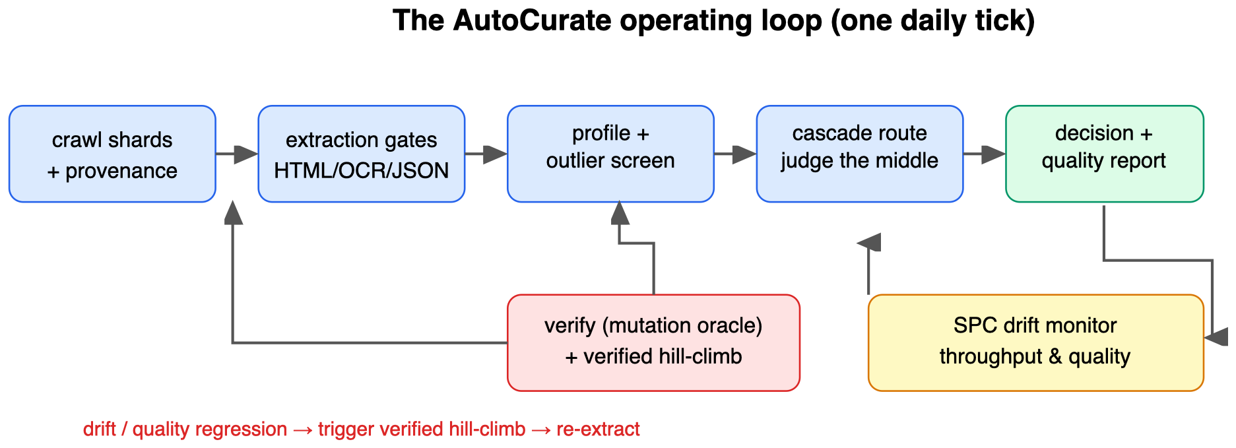
Figure 1. The AutoCurate operating loop: extraction gates → profile/outlier screen → cascade routing (judge the middle) → decision + provenance; a mutation-oracle verifier and a verified hill-climber sit underneath, and an SPC monitor triggers self-improvement on drift.
The cheap profiler (profile/) computes ~20 reference-free text features per document — gzip_ratio (a two-sided redundancy/garble screen), type–token ratio, Gopher-style repetition and symbol signals, character-class fractions, mojibake density — and flags documents in the extreme tail of their source cohort via a robust (median/MAD) z-score, because corpus feature distributions are heavy-tailed and a mean/σ summary is dominated by the junk we are hunting (E5).

4. Reference-free extraction-quality gates
Extraction quality is upstream of content quality: a well-written page is worthless if the HTML→text step leaked the nav bar, the OCR mangled every third character, or the JSON record truncated mid-field — and a content classifier scores it as if the text were intact. Each gate (extract/) estimates extraction fidelity without a gold reference, from cheap defect signals s_k ∈ [0,1] (1 = strong evidence of that defect). Defects are channel-local — a truncated record trips only parse_fail — so a weighted mean would average a single strong defect away. We combine signals as a noisy-AND (independent veto):
quality = Π_k ( 1 − clamp(w_k · s_k) ) (extract.base.Gate._combine)
so any one channel with a strong defect drives quality toward 0 while a clean document (all s_k ≈ 0) scores ≈ 1. The non-negative sensitivities w and the accept threshold are the gate's parameter vector — the knobs the hill-climber (Section 6) optimizes against the verifier (Section 5).
- HTML gate — markup_leak (residual tags/entities/JS-CSS tokens), boilerplate_leak (known nav/legal phrases, train slice only), link_density, nonprose_lines (short, punctuation-less, stop-word-poor lines — a structural fingerprint of nav chrome that generalizes past the phrase list), and stopword_deficit. A one-line tolerance distinguishes a legitimate heading from a wall of boilerplate.
- OCR gate — garbage_rate (implausible tokens: no vowels, extreme vowel ratio, repeated runs), confusion_rate (digit-in-word and isolated 1/0/l/| artifacts), broken_word (hyphenation breaks + word-split fragments), mojibake (structural non-ASCII / replacement-char density — deliberately not a fixed fragment list, so there is nothing to read back), and line_noise — the no-reference OCR-assessment family.
- JSON gate — parse_fail (a near-perfect ground-truth signal), truncated (brace/bracket/quote imbalance), and, against a schema inferred from a clean batch, schema_missing, type_mismatch, empty_value.
Only the gate channels that match a finite natural-language vocabulary — HTML boilerplate_leak (phrases) and OCR confusion_rate (the substitution map) — could in principle memorize the oracle, so those vocabularies are held-out-split; every other channel is a structural class (HTML tags, generic non-ASCII, JSON syntax) with nothing to memorize. A gate that leans on the memorizable channel therefore scores at its conservative held-out floor.

5. The verification harness (the scientific core)
A reference-free quality estimator is normally unfalsifiable — "is this document good?" has no cheap answer, and asking the estimator to grade itself is circular. We invert the trust relationship with a mutation oracle (verify/): take a clean document x, apply a deterministic corruption operator M_t that records (type, params, slice), and ask whether the gate catches M_t(x) while passing x. Because the corruption log is the answer key, the gate's precision / recall / F1 are verifiable.
Corruption operators (verify.corruptions) per modality: HTML (tag_inject, nav_boilerplate, script_style, link_dump), OCR (charsub via a confusion map, wordbreak, mojibake, linenoise), JSON (truncate, schema_break, delimiter). A balanced mutation set pairs each clean document (label 0) with one corrupted copy (label 1); a gate predicts "defect" iff quality < threshold.
De-circularization. Every finite corruption vocabulary is split into a train slice (the only strings a gate may pattern-match) and a 25% held-out slice (lexicons.split_vocab, HELD_OUT_RATE = 0.25, mirroring judgecurate). We report a pair: the held-out floor (score only on held-out-vocabulary mutations — the gate must generalize) and the train upper bound (read-back allowed). The gap is the memorization a gate is not allowed to be rewarded for.
Guard sets and the accept rule. Self-improvement proposes candidate gate configs θ'. Acceptance (verify.accept_candidate) is gated on held-out verified improvement with a clean-guard no-regression clause:
accept(θ') ⇔ LB( F1_eval(θ') − F1_eval(θ) ) > δ AND FPR_guard(θ') − FPR_guard(θ) ≤ ε
where F1_eval is the held-out-vocabulary F1 on a set of disjoint clean documents (a different corpus draw from the ones the climber optimizes on), and LB is its small-sample lower confidence bound over the per-seed improvements (mean − t_{.975,n−1}·sem, e.g. t = 2.78 at n = 5 — the normal z = 1.96 is too optimistic for so few points), with δ = ε = 0.005. The δ margin refuses noise; the FPR clause is the anti-reward-hack lock — a candidate cannot win by flagging everything, because that destroys clean data on the guard set. So "held-out" here is two-fold: held-out corruption vocabulary and held-out documents.

6. Verifier-gated self-improvement
A gate's parameter vector is the evolving artifact. Each round (hillclimb/) a proposer emits population candidates — a deterministic OfflineProposer (bounded Gaussian moves on a random parameter subset; default, runs in CI) or an optional AgenticProposer (an LLM proposes a vector from the current failure cases). The climber optimizes on one document set and is evaluated/guarded on a disjoint one, under one of three regimes:
- verified (proposed): rank by the held-out verified objective; adopt the best only if it passes the Section-5 accept rule.
- naive_recall (ablation): rank by in-sample defect recall on train-vocabulary mutations, with no clean guard, and adopt any improvement — the canonical Goodhart setup: an objective that rewards catching defects but never penalizes destroying clean data.
- naive_f1 (ablation): rank by in-sample balanced F1, still un-guarded — a fairer un-guarded objective, included so the reward-hack is not blamed on a strawman.
A document is flagged when quality < threshold, so an un-guarded recall objective drives the optimizer to raise the threshold until it over-flags. The contrast (E3) is more nuanced than "verification always wins": un-guarded recall reward-hacks catastrophically; un-guarded balanced F1 is empirically much safer (it self-penalizes false positives in-sample) but carries no guarantee; only the explicit guard delivers a provable zero-regression on held-out clean data, at a modest cost in recovered F1. And when the trigger is real drift rather than a hand-degraded start (E6, §9.6), the same verified loop acquires a detection capability the gate lacked — restoring F1 from 0.07 to 0.98 on a newly-appearing defect — which is the self-improvement claim in its strongest, least-constructed form.

7. The cheap → expensive cascade
autocurate does not re-implement semantic judging. A thin adapter (judge.py, the only module importing judgecurate) reuses CurationPipeline and its calibrated, risk-penalized five-attribute decision unchanged. The cascade (pipeline.CurationLoop) routes:
gate fails → FILTER (extraction defect; stage = "gate")
else surface score: ≥ retain_above → RETAIN (stage = "heuristic")
≤ filter_below → FILTER (stage = "heuristic")
middle band → escalate to judgecurate (stage = "judge")
The surface governance score is deliberately weaker than the judge — function-word density, lexical diversity, length, a numbers+entities knowledge proxy, a spam blocklist — so its job is only to route: auto-decide the confident extremes, spend judge calls on the uncertain middle. Without judgecurate installed the band degrades to a conservative "review" stub, so the core still runs offline.

8. The harness-agnostic operating loop
The harness owns scheduling and side-effects; the routine owns logic. One AgentHarness protocol (schedule, run_step, report, now) has three reference adapters: LocalCronHarness (a crontab line + JSONL ledger + stdout, no agent at all), AgentCliHarness (schedule via a cloud routine — the persistent cloud scheduler — and act via a headless agent CLI), and a generic runner. The same CrawlMonitorRoutine runs unchanged under any of them.
tick() curates the day's shards, appends a ProvenanceRecord per document, and updates statistical process control monitors (agentloop.spc) on throughput and mean extraction quality: an EWMA chart (gradual drift) and a CUSUM chart (small sustained shifts), with the baseline estimated robustly (σ = 1.4826·MAD) from a warm-up window. A downward quality alarm triggers the Act — a self-improvement / re-extraction episode (harness.run_step) — and once quality returns in-control the monitor resets, giving a clean detect→fix→clear cycle (E4). Quality is monitored one-sided (degradation) and throughput two-sided (an outage and a spam flood both deserve an alert).

9. Reproducible experiments
What these numbers are. We characterize the mechanism on controlled, deterministic synthetic corpora with held-out corruption vocabularies. They are evidence the engine behaves as designed and an honest floor — not estimates of real-corpus filtering quality, and not a SOTA claim (Section 10). The committed results/*.json are asserted by the test suite, which fails if a number drifts.

9.1 E1 — extraction-gate F1 via the mutation oracle
The per-gate defect-detection scores from the mutation oracle are reported in Table 2 and visualized in Figure 2.
Table 2. Defect-detection F1 (5 corruption seeds, 80 clean docs/modality, on a fixed corpus — the gate is not fit to the documents, so "held-out" here means held-out corruption vocabulary + fresh corruption instances), held-out floor vs. train upper bound, and clean-guard FPR.
Gate | Corruptions | Held-out floor F1 | Upper-bound F1 | Memorization gap | Guard FPR
HTML | boilerplate / markup / links | 0.887 | 0.972 | 0.086 | 0.025
OCR | char-confusion / mojibake / breaks | 0.816 | 0.982 | 0.166 | 0.000
JSON (parse oracle) | truncation / schema-break | 1.000 | 1.000 | 0.000 | 0.000
Hard-gate macro (HTML+OCR) | — | 0.851 | 0.977 | — | —

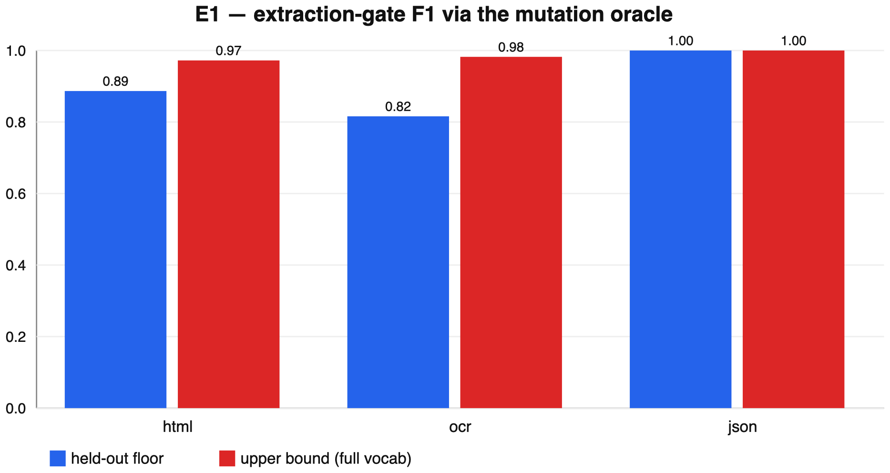
Figure 2. Held-out floor vs. train upper-bound defect-detection F1 per gate (E1), with the clean-guard false-positive rate.
We headline the hard-gate macro of 0.851 (HTML+OCR) rather than the all-three-gate mean (0.901), because the JSON gate is essentially a json.loads + brace-balance oracle: its defects (truncation, delimiter breaks) are structural and caught perfectly, so including it inflates the headline by ~0.05 and is not a reference-free estimation success in the HTML/OCR sense. OCR shows the largest memorization gap (0.166): held-out character confusions that preserve vowels are genuinely hard for a dictionary-free detector, so the floor is honestly conservative — precisely what the held-out slice exposes. The guard FPR stays ≤ 0.025, so the gates do not buy recall with false positives.

9.2 E2 — cascade efficiency
We sweep the fraction of documents escalated to the judge (the most-uncertain middle by surface score) on the judgecurate mini-corpus test split (N = 300). The expensive tier here is judgecurate's offline heuristic judge, not a real LLM (so the whole experiment stays CPU-only and deterministic); the cascade mechanism is identical with a real backend, but the absolute numbers would differ.
Table 3. Quality vs. judge-call budget (E2). e = 0 is heuristic-router-only; e = 1 is judge-everything.
Escalated | Judge calls | Macro-F1 | Agreement
0% | 0 | 0.433 | 0.593
30% | 90 | 0.552 | 0.650
50% | 150 | 0.584 | 0.673
70% | 210 | 0.619 | 0.707
85% | 255 | 0.665 | 0.743
100% | 300 | 0.653 | 0.730

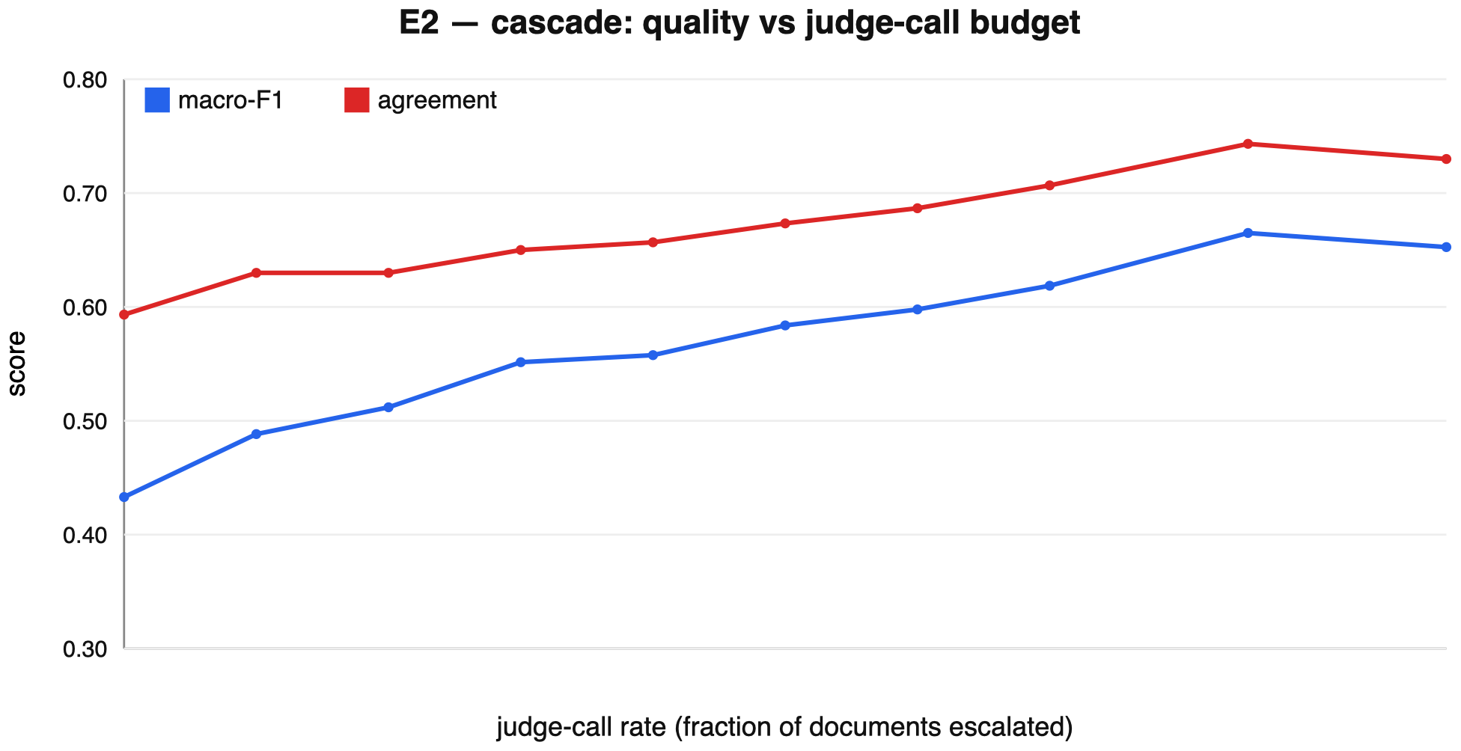
Figure 3. Cascade quality (macro-F1) as a function of the fraction of documents escalated to the judge (E2); the curve is monotone up to the operating point.
As shown in Table 3 and Figure 3, at half the judge calls the cascade recovers ~69% of the judge-everything macro-F1 gain over the cheap router; the curve is monotone and the operating point is tunable — the value is cost: at scale, halving judge calls while keeping most of the quality is the point. Separately, the 85%-escalation row edges judge-everything (0.665 vs. 0.653); we read this as within single-run noise (one deterministic run, no CI, a 0.012 gap), consistent with the cheap tier occasionally getting a confident extreme that the weak judge misses — suggestive, not a "beats the judge" claim.

9.3 E3 — verified vs. naive hill-climbing (reward hacking)
Starting from a deliberately degraded HTML gate (all weights halved), all three regimes hill-climb for 30 rounds (population 10). Crucially, optimization is on one corpus draw (seed 7) and held-out F1 and the clean-guard FPR are measured on a disjoint corpus draw (seed 8), so the numbers below are out-of-sample. All start at recall 0.793 / held-out F1 0.728 / guard FPR 0.000.
The end-state of each regime is reported in Table 4 and Figure 4.
Table 4. End-state after self-improvement (held-out documents), E3.
Regime | In-sample recall | Held-out F1 | Held-out clean-guard FPR
naive_recall (un-guarded recall) | 1.000 | 0.790 | 0.517
naive_f1 (un-guarded balanced F1) | 0.997 | 0.856 | 0.017
verified (held-out + guard) | 0.753 | 0.811 | 0.000

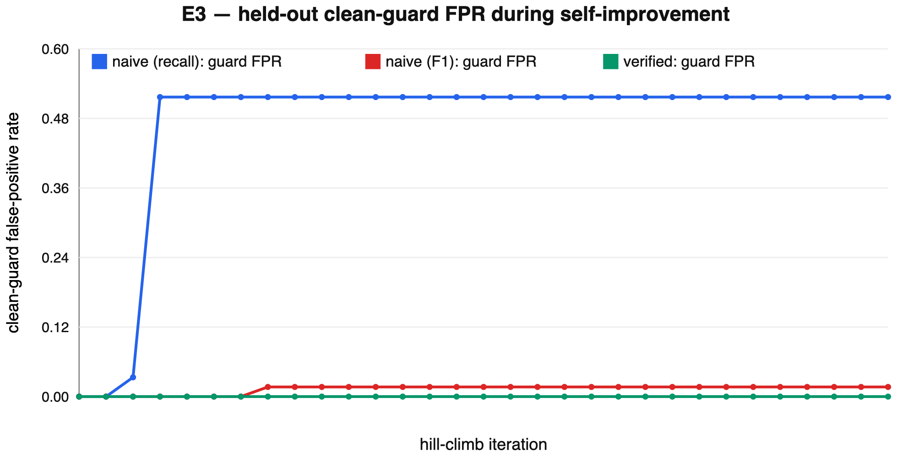
Figure 4. Held-out F1 and clean-guard false-positive rate for the verified vs. naive hill-climbing regimes (E3); the un-guarded recall objective reward-hacks.
The result is sharper and more honest than "verification always wins":
1. An un-guarded recall objective reward-hacks catastrophically. It raises the threshold until in-sample recall hits 1.0, which on the held-out clean set flags 51.7% of good documents as defective — it would silently delete half the corpus. This is the data-curation instance of reward overoptimization.
2. An un-guarded balanced-F1 objective is empirically much safer (guard FPR 0.017) — because F1 already penalizes false positives in-sample, it largely self-guards. So the failure is not an artifact of picking the most degenerate proxy; it is specific to objectives that ignore precision.
3. Only the explicit guard gives a guarantee. The verified regime is the sole one with a held-out clean-guard FPR of exactly 0.000, by construction — at a real cost: it is the most conservative and recovers the least held-out F1 (0.811 vs. naive_f1's 0.856). Verification buys a no-regression guarantee, not the highest score.
The effect requires a genuine clean/defect overlap (a realistic gray zone of headings/lists); for JSON, where clean records are perfectly separable, there is no exploitable gray zone. We therefore present E3 as a constructed worst case that isolates the mechanism, not a claim that the catastrophic hack is generic.

9.4 E4 — drift detection and recovery
8 independent 30-day streams: clean until day 15, then an upstream "parser regression" corrupts half of each day's shards. The routine monitors mean extraction quality with EWMA + CUSUM (warm-up 10 days).
The aggregate drift response is summarized in Table 5, with a representative stream shown in Figure 5.
Table 5. Drift response (mean over 8 streams), E4.
Metric | Value
Streams detected | 8 / 8
Mean / max detection latency after shift | 0.0 / 0 days
False-alarm rate (pre-shift) | 0.125 / stream
Mean quality, pre-shift → on shift | 0.885 → 0.582
Mean recovery latency after re-extraction | 5.5 days

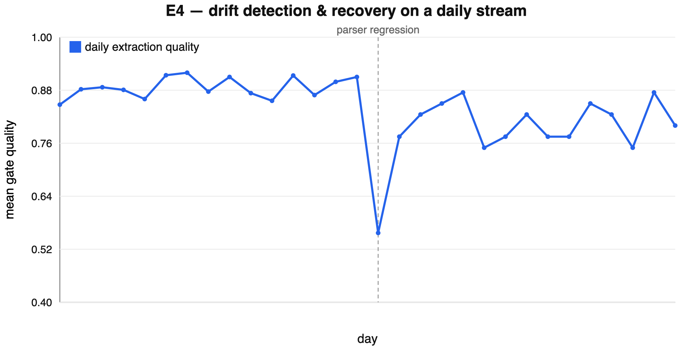
Figure 5. A representative 30-day stream (E4): mean extraction quality with the EWMA/CUSUM control limits, the day-15 parser-regression shift, and the alarms.
The shift is caught the same day it lands in every stream (0-day latency), at a cost of ~1 false alarm per 8 pre-shift stream-windows. Recovery is slower and noisier than a single cherry-picked run suggests: re-extraction restores quality over ~5–6 days, and because the corruption is ongoing the alarm legitimately re-fires on days the residual defect dips quality again (the representative series in the figure alarms on days 15–17, 20–24, 27, 29) before clearing — we report mean latencies rather than a single clean detect→recover arc.

9.5 E5 — outlier detection: robust vs. non-robust
We inject 12% anomalies (truncated, hyper-repetitive, garbled, over-long) into a 400-document corpus and compare a robust (median/MAD) z-score detector against a mean ± kσ detector, sweeping the cutoff.
Anomaly-detection F1 across cutoffs is reported in Table 6 and plotted in Figure 6.
Table 6. Anomaly-detection F1 across cutoffs (E5; headline at z = 3.5: robust P/R/F1 = 0.873/1.000/0.932 vs. mean±kσ 0.800/1.000/0.889).
Cutoff z | Robust-z (MAD) F1 | Mean ± kσ F1
3.0 | 0.873 | 0.881
3.5 | 0.932 | 0.889
4.0 | 0.951 | 0.923
4.5 | 1.000 | 0.923

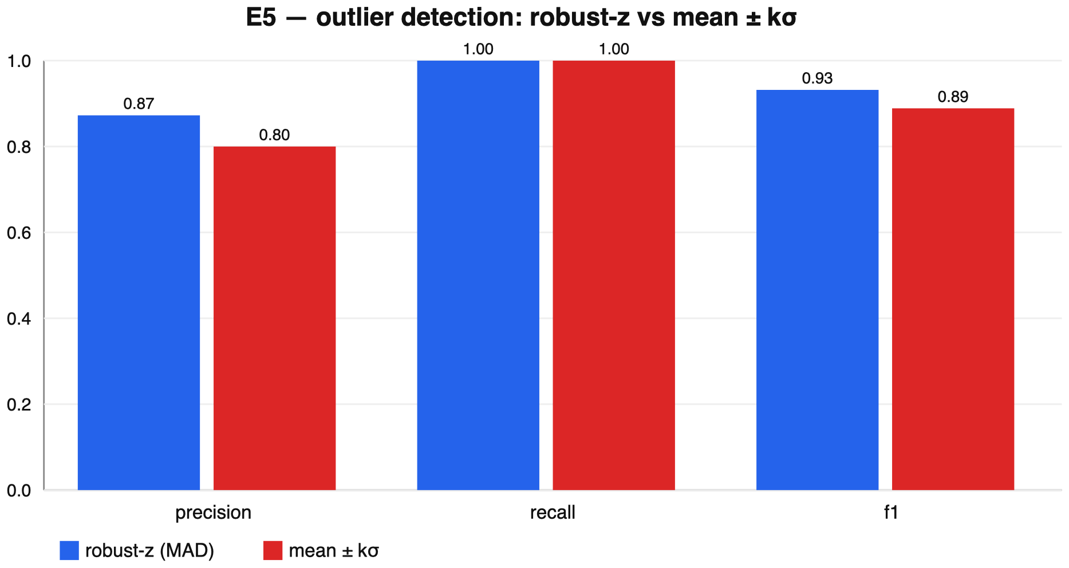
Figure 6. Anomaly-detection F1 vs. cutoff z for the robust (median/MAD) detector against the non-robust mean ± kσ detector (E5).
The MAD scale is not inflated by the very outliers it is hunting, so at stricter cutoffs (3.5–4.5) it flags the same anomalies with fewer false positives; at the loosest cutoff (3.0) the two are within noise (0.873 vs. 0.881). The advantage is real but cutoff-dependent, not universal.

9.6 E6 — drift-triggered self-improvement (adapting to a new defect)
E3 starts from a hand-degraded gate, so a reviewer may fairly call it un-breaking. E6 is the stronger claim: the loop acquires a capability it lacked, in response to drift. A parser regression begins leaking raw HTML tags into the extracted text — a defect type the deployed gate under-weights (it was tuned in a clean-extraction era, so its markup_leak channel is off). The drift monitor (E4) fires; the loop hill-climbs the gate targeting the drifting defect type (operator-restricted mutations), on one corpus draw, evaluated on a disjoint one.
Detection F1 before and after the drift-triggered self-improvement episode is reported in Table 7 and Figure 7.
Table 7. Held-out F1 at detecting the newly-drifting tag-leak defect (E6).
Gate state | Held-out F1 on the drift | markup_leak weight | Clean-guard FPR
Blind (before) | 0.070 | 0.00 | 0.025
Verified hill-climb | 0.983 | 1.02 | 0.000
Naive-recall (control) | 0.889 | — | 0.250

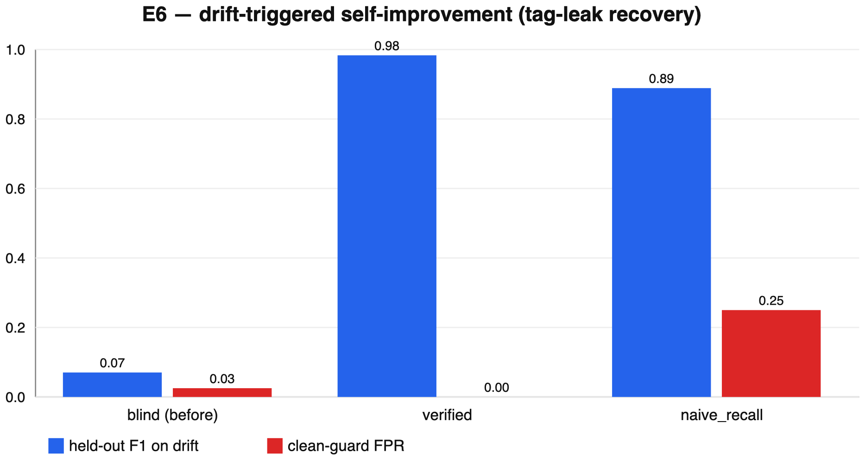
Figure 7. Held-out detection F1 on the newly-appearing tag-leak defect before vs. after the verified hill-climb, against the naive-recall control (E6).
The blind gate misses the new defect almost entirely (F1 0.070). The verified loop restores detection to 0.983 by re-discovering the markup_leak channel (weight 0 → 1.02), with the clean-guard FPR pinned at zero. The naive-recall control "recovers" only to 0.889 and over-flags (FPR 0.25) — so even in the recovery setting, the un-guarded objective reward-hacks, and the guard is what makes self-improvement safe to run unattended in the loop.

9.7 E7 — gates vs. external reference-free baselines
So the gates are not only compared to themselves, we score transparent stand-ins for the prior-art reference-free families on the same held-out mutation oracle (baselines.py): a compression-ratio screen (gzip), the Gopher/C4 stop-word+symbol heuristics (HTML), the Alex & Burns dictionary/garbage ratio (OCR), and a json.loads-only check (JSON).
Table 8 and Figure 8 compare each gate against the best external reference-free baseline for its modality.
Table 8. Held-out defect-detection F1 (5 seeds), E7: AutoCurate gate vs. the best external reference-free baseline per modality.
Modality | AutoCurate gate | Best baseline | Other baselines
HTML | 0.887 | 0.194 (gzip) | Gopher 0.020
OCR | 0.816 | 0.740 (dict/garbage) | gzip 0.077
JSON | 1.000 | 0.815 (parse-only) | gzip 0.070

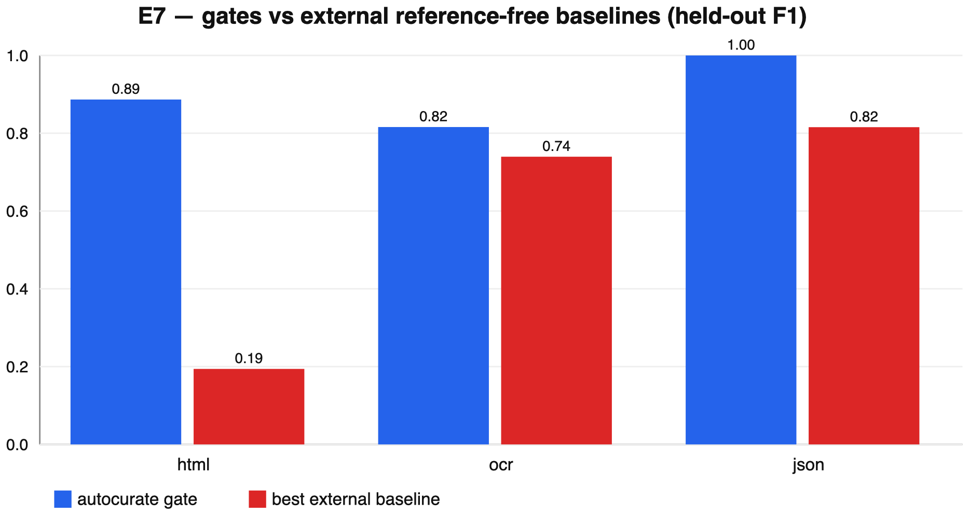
Figure 8. AutoCurate gate vs. the best external reference-free baseline per modality on the same held-out mutation oracle (E7).
The gates beat every baseline on every modality, and the why is mechanistic. Gopher/C4 heuristics target content repetition and symbols, not extraction faithfulness, so they barely register markup leakage (0.020) — exactly the gap extraction gates fill. The Alex & Burns dictionary ratio is the strongest baseline (OCR 0.740) but the multi-signal gate still edges it (0.816). And json.loads-only (0.815) misses every schema-valid-but-wrong record — a deleted or retyped field that still parses — which the schema-aware gate catches, lifting it to 1.000. Compression alone (gzip) is a weak extraction-defect detector across the board.

9.8 Reproducing
pip install -e ".[judge,dev]" # the [judge] extra (judgecurate) is needed for E2
python scripts/run_experiments.py # writes results/*.json (E1-E7, ~45s)
python scripts/make_figures.py # renders the 8 SVG figures
pytest # 31 tests, ~90s; asserts the committed numbers
E1, E3-E7 are pure-stdlib and always reproduce; E2 requires the [judge] extra — without judgecurate installed, e2_cascade returns a skipped marker and its reproduction test skips, so the committed E2 numbers are pinned to judgecurate ≥ 0.3.0.

10. Limitations and honest framing
The experiments characterize a mechanism on synthetic data, not real-corpus filtering quality, and we are deliberate about what each does and does not show:
- Synthetic, transparent generators. Clean corpora and corruptions come from deterministic processes (datagen.py, verify/corruptions.py). Held-out corruption vocabularies make the gate numbers a conservative floor; the OCR gate's dictionary-free garble detector is a weak stand-in for an OCR-aware model (its 0.166 floor↔upper gap is the honest cost).
- E2's "judge" is judgecurate's offline heuristic judge, not an LLM. The cascade mechanism is real, but absolute numbers (and any "near the judge" reading) would change with a real backend; the cheap router is also minimal by design, so the curve is a lower bound on a stronger router (e.g. a distilled judge).
- Self-improvement is a small parameter hill-climb, not program discovery. It searches a 5-scalar gate-weight space; we adopt the verifier-gated accept rule of FunSearch/AlphaEvolve, not their open-ended discovery. E3 starts from a hand-degraded gate (a constructed worst case, and its catastrophic reward-hack is specific to an un-guarded recall objective with a clean/defect gray zone); E6 is the less-constructed version — adapting to a genuinely new defect type under drift — but is still a weight hill-climb. The durable claim is the guard's guarantee, not the search's power.
- Variance is over corruption seeds, not many corpora. E1's intervals resample corruptions of a fixed document set (the gate is not fit to documents, so this is appropriate); E3 uses two disjoint corpus draws; broader corpus-level variance is future work.
- No language model is trained and no downstream accuracy is measured. The loop emits a curated, provenance-tagged corpus ready for that study, and the verified accept rule is what makes any proposer — random walk or frontier LLM — safe to deploy.

11. Conclusion
We turned a four-direction data-governance theory into a small, transparent, tested, fully reproducible operating loop that does what a static filter cannot: it gates extraction quality reference-free, verifies every claim against a mutation oracle it cannot game, improves its own capabilities under a held-out, guard-protected accept rule, and runs as a harness-agnostic daily routine with provenance and drift detection. The headline is methodological: self-improving curation is only safe when the reward is verifiable and held-out — an un-guarded curator reward-hacks by destroying good data, and the guard is cheap. The obvious next step is to run the loop over a real crawl with a real LLM judge and a real extractor, and measure downstream accuracy directly; the floor reported here is the number such a study can only raise.

References
1. Gao, L., Schulman, J. & Hilton, J. Scaling Laws for Reward Model Overoptimization. ICML, 2023. arXiv:2210.10760.
2. Rae, J. et al. Scaling Language Models: Methods, Analysis & Insights from Training Gopher. 2021. arXiv:2112.11446.
3. Raffel, C. et al. Exploring the Limits of Transfer Learning with a Unified Text-to-Text Transformer (T5/C4). JMLR, 2020. arXiv:1910.10683.
4. Penedo, G. et al. The RefinedWeb Dataset for Falcon LLM. NeurIPS Datasets & Benchmarks, 2023. arXiv:2306.01116.
5. Penedo, G. et al. The FineWeb Datasets: Decanting the Web for the Finest Text Data at Scale. NeurIPS Datasets & Benchmarks, 2024. arXiv:2406.17557.
6. Li, J. et al. DataComp-LM: In Search of the Next Generation of Training Sets for Language Models. NeurIPS, 2024. arXiv:2406.11794.
7. Huang, Y. et al. Compression Represents Intelligence Linearly. COLM, 2024. arXiv:2404.09937.
8. Yin, M. et al. Entropy Law: The Story Behind Data Compression and LLM Performance. NeurIPS, 2024. arXiv:2407.06645.
9. Obbad, E. et al. ZIP-FIT: Embedding-Free Data Selection via Compression-Based Alignment. 2024. arXiv:2410.18194.
10. Alex, B. & Burns, J. Estimating and Rating the Quality of Optically Character Recognised Text. DATeCH, 2014.
11. Schneider, P. & Maurer, Y. Rerunning OCR: A Machine Learning Approach to Quality Assessment and Enhancement Prediction. Journal of Data Mining & Digital Humanities, 2021. arXiv:2110.01661.
12. Neudecker, C. et al. A Survey of OCR Evaluation Tools and Metrics. HIP@ICDAR, 2021.
13. Barbaresi, A. Trafilatura: A Web Scraping Library and Command-Line Tool for Text Discovery and Extraction. ACL-IJCNLP System Demos, 2021.
14. Bevendorff, J. et al. An Empirical Comparison of Web Content Extraction Algorithms. SIGIR, 2023.
15. Zelikman, E. et al. STaR: Bootstrapping Reasoning With Reasoning. NeurIPS, 2022. arXiv:2203.14465.
16. Lambert, N. et al. Tülu 3: Pushing Frontiers in Open Language Model Post-Training (RLVR). 2024. arXiv:2411.15124.
17. Romera-Paredes, B. et al. Mathematical Discoveries from Program Search with Large Language Models (FunSearch). Nature 625, 2024.
18. Novikov, A. et al. AlphaEvolve: A Coding Agent for Scientific and Algorithmic Discovery. 2025. arXiv:2506.13131.
19. Caveness, E. et al. TensorFlow Data Validation: Data Analysis and Validation in Continuous ML Pipelines. SIGMOD, 2020.

