VOLTIKA Platform — General Corrections
Findings from the delivery simulation test

This document lists the bugs and corrections detected during the delivery simulation. Each item describes the current behavior, the expected behavior, and references the screenshot (Figure) that illustrates it.

1. Admin Portal — Origin Checklist

Bug 1.1 — Engine number must be validated against the actual unit
Reference: Figure 1
Current behavior: The Origin Checklist allows entering the engine number without any validation.
Expected behavior: The system must validate that the engine number entered matches the actual engine number of the physical unit.
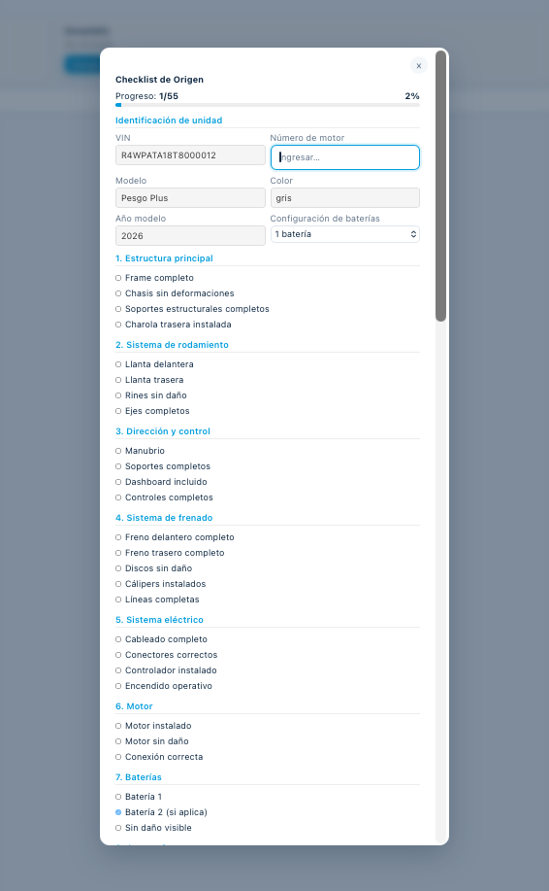
Figure 1 — Origin Checklist screen, identification section. The "Número de motor" field is where the validation must be applied.

Bug 1.2 — Origin Checklist PDF is missing user signature, timestamps, and auto-save
Reference: Figure 2
Current behavior: The generated Origin Checklist PDF does not display the signature of the user who completed it, nor the start/submission times. Progress is not auto-saved.
Expected behavior:
- The PDF must include the signature of the user who filled out the checklist.
- The PDF must show the start time and the submission time.
- Progress must be auto-saved while the checklist is being filled out.
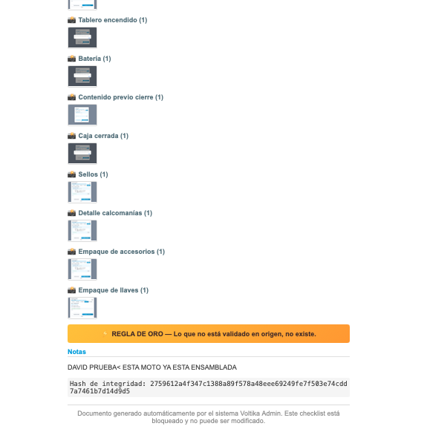
Figure 2 — Lower section of the Origin Checklist (notes / "Regla de Oro" / hash) where the user signature and timestamps must appear in the PDF.

2. Admin Portal — Shipment Screen

Bug 2.1 — Arrival date must not be earlier than shipment date
Reference: Figure 3
Current behavior: The system allows setting an estimated arrival date (ETA) earlier than the shipment date.
Expected behavior: The arrival date must not be allowed to be earlier than the shipment date.

Bug 2.2 — Tracking and Carrier fields are not requested for exhibition shipments
Reference: Figure 3 (same screen)
Current behavior: In this case the unit was being shipped for exhibition purposes, and the system does not allow entering Tracking or Carrier.
Expected behavior: The system must request Tracking and Carrier data for these shipments as well.
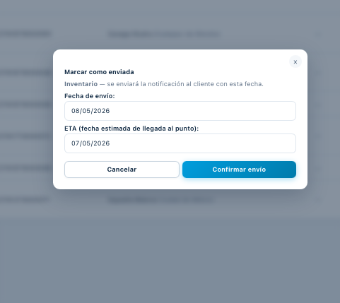
Figure 3 — "Marcar como enviada" (Mark as shipped) screen.

3. Point of Sale Portal — Motorcycle Reception Page
URL: voltika.mx/puntosvoltika

Bug 3.1 — Motorcycle status must be displayed
Reference: Figure 4
Current behavior: The reception page does not display the status of the motorcycle.
Expected behavior: The page must show the status of the motorcycle (e.g., in transit, not shipped, etc.).

Bug 3.2 — More shipment information must be displayed
Reference: Figure 4
Current behavior: The reception page is missing key shipment information.
Expected behavior: The page must display additional shipment data, including:
- Tracking number
- Carrier
- Shipment date
- A verifier confirming that the Origin Checklist has been certified
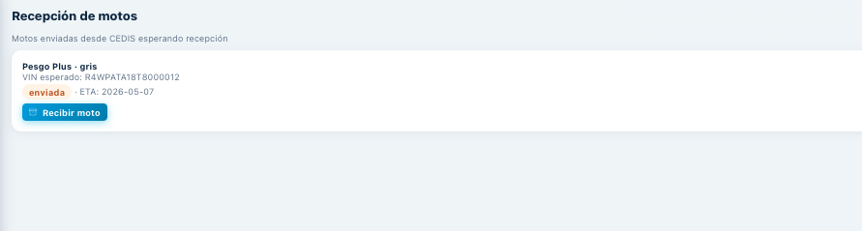
Figure 4 — Current Reception page on the Point of Sale Portal.

Bug 3.3 — Reception checklist must be more detailed and include additional fields
Reference: Figure 5
Current behavior: The current reception checklist is too simple.
Expected behavior: The reception checklist must be more explicit and include the following fields:
Required fields:
- VIN number on the motorcycle box — Text
- Security seal number applied — Text
- Security seal applied and not violated
- Physical condition of the unit OK (no damage or hits)
Required photos for reception:
- Photo of the security seal applied
- Photo of the VIN label
- Photo of the unit reception
Additional fields:
- Observations field — Text
- Reception date — Date
- User who receives — Text
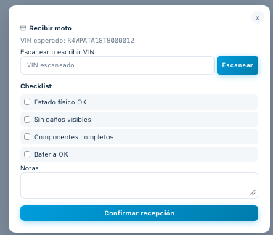
Figure 5 — Current reception checklist (too basic).

Bug 3.4 — Pending assignment must appear in the Reception panel as a pending shipment
Reference: Figures 6 and 7
Current behavior: This point of sale has a motorcycle assignment pending, but it is not reflected in the Reception panel — the Reception panel shows "No hay envíos pendientes" (No pending shipments).
Expected behavior: The pending assignment must appear in the Reception panel as a pending shipment.
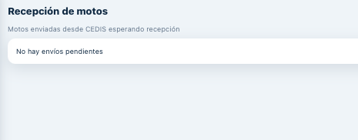
Figure 6 — Reception panel showing "No hay envíos pendientes" (the pending shipment is missing here).
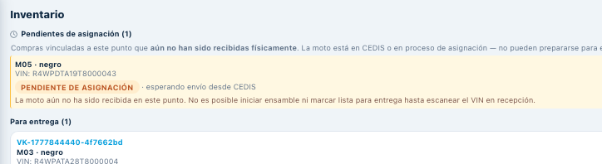
Figure 7 — Inventory section showing the motorcycle as "PENDIENTE DE ASIGNACIÓN" (waiting for shipment from CEDIS) — this is the assignment that should also appear in the Reception panel.

4. Assembly Checklist — Sync Between Portals

Bug 4.1 — Assembly Checklist in the Point of Sale Portal must be the same as in the Admin Portal
Reference: Figures 8 (current) and 9 (correct)
Current behavior: The Assembly Checklist in the Point of Sale Portal (voltika.mx/puntosvoltika) is different from the one in the Admin Portal (voltika.mx/admin) — for example, photo upload sections are missing in the Point of Sale version.
Expected behavior: The Assembly Checklist in the Point of Sale Portal must be identical to the one in the Admin Portal, and both must be synchronized in real time.
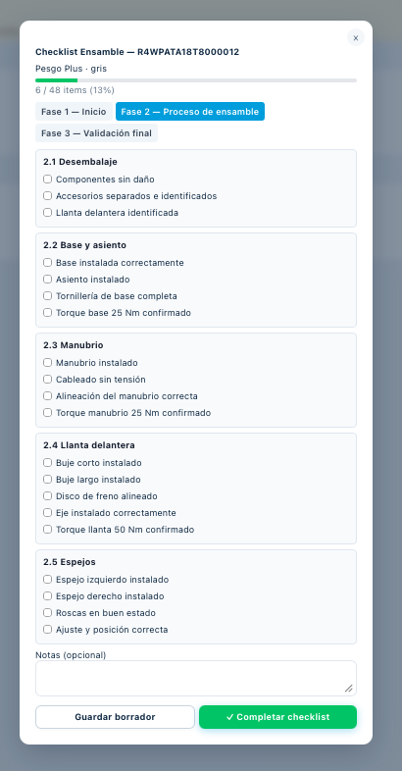
Figure 8 — Current Assembly Checklist on the Point of Sale Portal (voltika.mx/puntosvoltika) — INCORRECT.
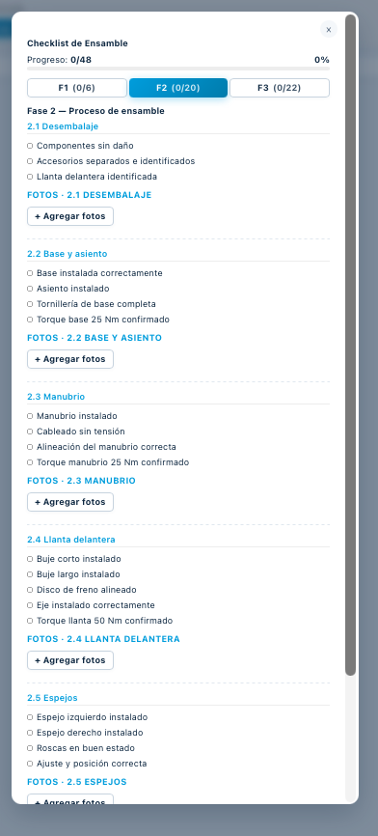
Figure 9 — Correct Assembly Checklist on the Admin Portal (voltika.mx/admin) — this is what the Point of Sale Portal must also show.

5. Delivery Process

Bug 5.1 — Delivery process must auto-save and handle interruptions
Current behavior: We had to repeat the process several times because the window kept closing and the entire process restarted from scratch.
Expected behavior:
- The process must auto-save once started, and only finalize after the customer's signature.
- If the process is started but not completed, an "Unsuccessful delivery" button must be available with an observations field to explain the reason.
- The process must not last longer than 6 hours. If it is started and not completed within that time frame, it must be closed so it can be started again.

Bug 5.2 — OTP is only being sent to email; it must also be sent to the mobile phone
Reference: Figure 10
Current behavior: The OTP that initiates the delivery process is only sent to the customer's email.
Expected behavior: The OTP must be sent to the customer's mobile phone (not to email).
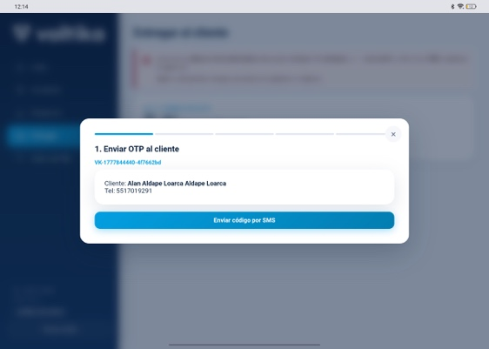
Figure 10 — OTP request screen at the start of the delivery process.

Step 2 — Customer photo and ID photo for comparison

Bug 5.3 — ID photo capture opens file browser instead of camera
Reference: Figure 11
Current behavior: After taking the customer's photo, the ID photo capture does not open the camera — it opens the file browser instead.
Expected behavior: Both options must be enabled: take a photo with the camera AND select a photo from files.

Bug 5.4 — Only one ID side can be uploaded
Reference: Figure 11
Current behavior: There is only one upload field for the ID, allowing only one side to be uploaded.
Expected behavior: A second photo upload field must be enabled to capture the back side of the ID as well.
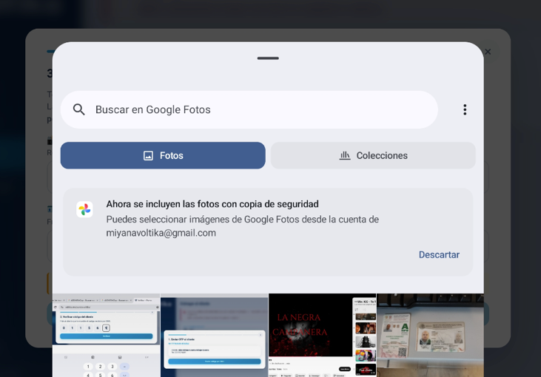
Figure 11 — Step 2 (ID capture) showing the file browser opening instead of the camera, and only one upload slot.

Step 3 — ID Verification

Question 5.5 — What engine/service does the system use to perform this automatically?
Reference: Figure 12
Note: This is a question for the developer to clarify — what engine/service is being used so that this verification step runs automatically?
Status: This step is otherwise working correctly.
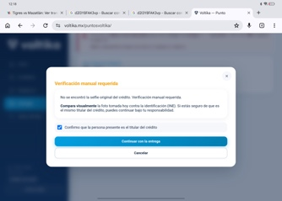
Figure 12 — Step 3 (ID verification). Working correctly.

Step 4 — Motorcycle Delivery Checklist

Bug 5.6 — Wrong (reduced) Delivery Checklist is shown; the full one must be displayed and synchronized
Reference: Figures 13 (currently shown — wrong) and 14 (correct one that must appear)
Current behavior: At this step the Point of Sale Portal shows a reduced version of the Delivery Checklist (Figure 13) instead of the full one.
Expected behavior:
- This checklist must only exist on the Point of Sale Portal (puntosvoltika), and it must be the full checklist, not a reduced one.
- The checklist shown in Figure 14 is the correct one and must appear at this step.
- It must be synchronized with the Admin Portal.
- Regarding the signature: instead of being signed in this panel, the notification must be sent to the Customer Portal so the customer signs there. Only after the customer signs can the delivery be considered completed.
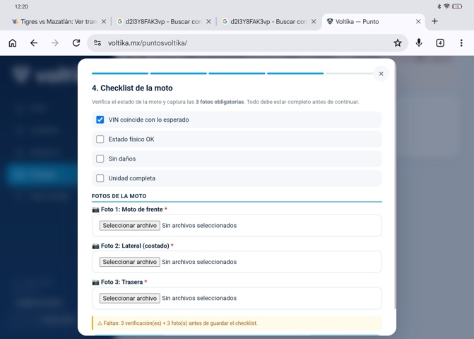
Figure 13 — Reduced Delivery Checklist currently shown in the Point of Sale Portal — INCORRECT.
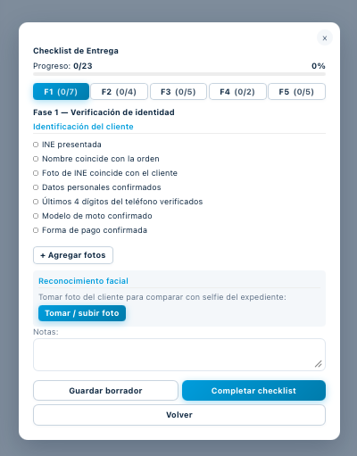
Figure 14 — Correct full Delivery Checklist that must appear at this step.

Step 5 — Customer Signature

Bug 5.7 — CRITICAL: Customer signature is replaced by a checkbox instead of using Cincel signature system
Reference: Figures 15 (Point of Sale Portal sending the request) and 16 (Customer Portal — only a checkbox appeared)
Severity: Critical.
Current behavior: When the signature is requested from the customer, the Customer Portal only shows a checkbox to sign the delivery agreement (acta) — and that checkbox counted as the signature. Only the checkbox was requested, not an actual signature.
Expected behavior: The Customer Portal must request the signature using the Cincel signature system in order to validate the delivery document. The checkbox alone is not a valid signature.
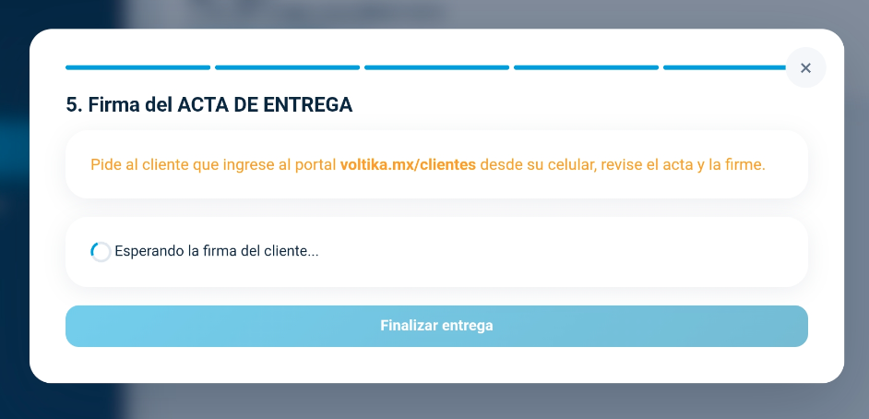
Figure 15 — Point of Sale Portal correctly sending the signature request to the Customer Portal ("Esperando la firma del cliente...").
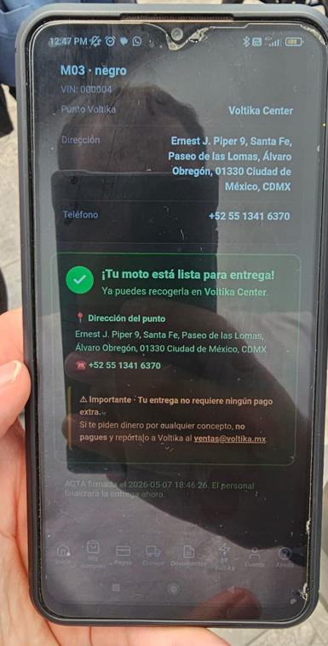
Figure 16 — Customer Portal showing only a checkbox/confirmation instead of the Cincel signature flow.

Step 6 — Customer marks the motorcycle as delivered

Bug 5.8 — "Confirmar recepción" button must not exist on the Customer Portal
Reference: Figure 17
Current behavior: The Customer Portal shows a "Confirmar recepción" button for the customer to mark the motorcycle as delivered.
Expected behavior: This button must not exist. The delivery must be finalized — and reflected in the Customer Portal — when the seller, from their own panel, selects the option to finalize after the customer's Cincel signature.
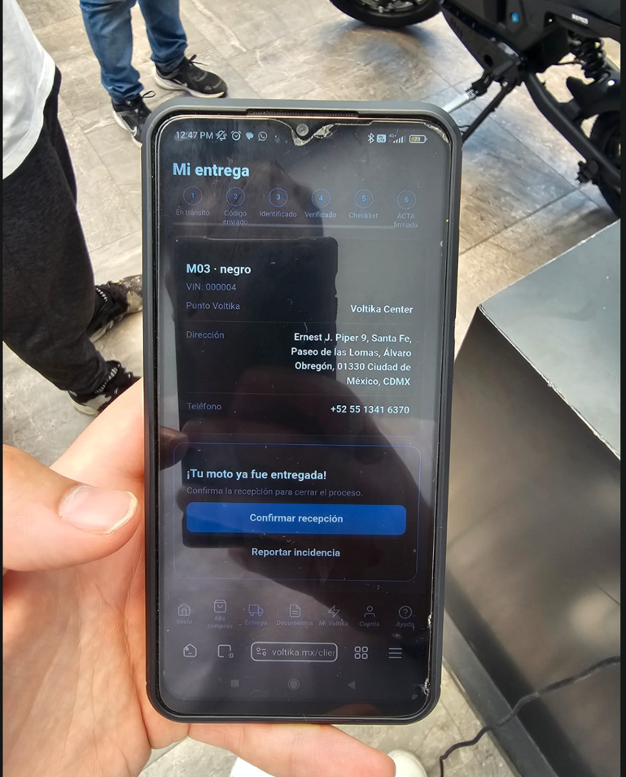
Figure 17 — Customer Portal showing the "Confirmar recepción" button that must be removed.

