Figma - <https://www.figma.com/file/Of7NLRkOHhUEwTkKHWnRV3/Vitalina-Kuzmenko's-team-library?node-id=426%3A60&t=tNHnTtQFhLHrxnIy-1>

**CarbonCheck.com – first page**

*Calculate, report on, and reduce your carbon footprint.*

Our world is in crisis - from climate change to the pollution in our oceans and devastation of our forests. It's up to all of us to fix it. Take your first step with our footprint calculator.

**Button – Start the calculator**

**Second page – calculator**

**Form**

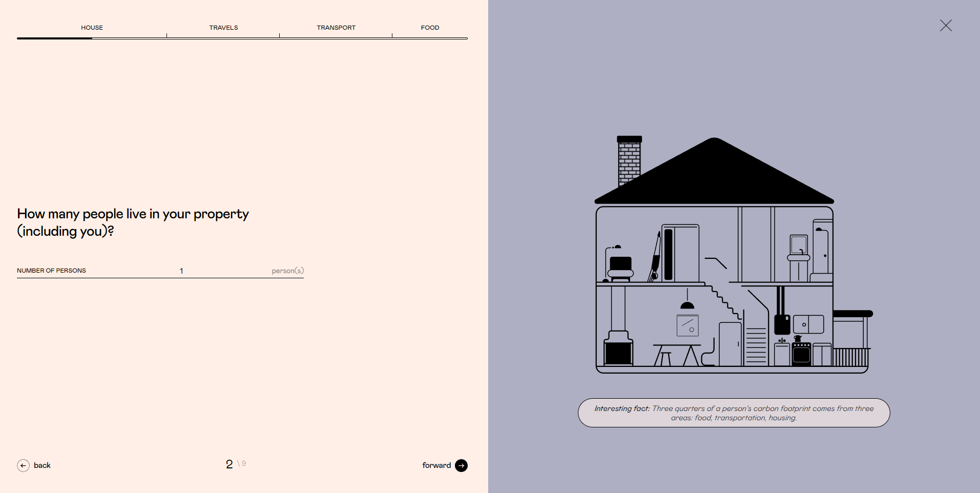

**Result – the same page (ideas below)**

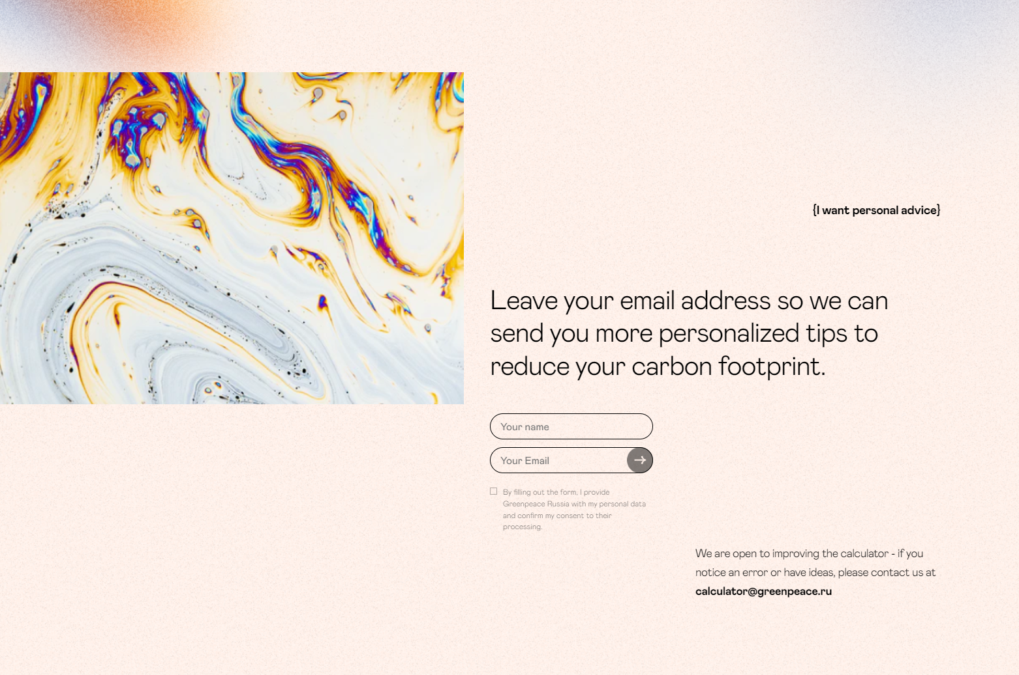

**Third page – Contact**

**Form (for html)**

**Home**

1. How many people are there in your household?

* Input – to write the number

1. How much electricity is used in your household?

* Small house / flat
* Medium
* Large house
* Hall of residence

1. Is heating oil, coal, wood or bottled gas used in your household?

* No
* Yes

If yes:

Enter your use over the last year:  
The number of litres of heating oil:     
The number of kilograms of coal:           
The number of kilograms of wood:           
The number of kilograms of bottled gas:   

**Transport**

1. What are the modes of transport you used last year?

* Car
* Bus
* Train
* Plane

1. Provide 12-month mileage:

* Journeys by car:
* Provide 12-month car mileage: - Input
* Journeys by bus:
* Provide your regular mileage each month: - Input
* Journeys by train:
* Provide your regular mileage in the year: - Input
* Journeys by plane:

Provide hours spent on flights: - input

**Food**

1. How much of the food that you eat is organic?

* None
* Some
* Most
* All

7. How much meat/dairy do you eat personally?

* Above-average meat/dairy
* Average meat/dairy
* Below-average meat/dairy
* Lacto-vegetarian
* Vegan

8. How much of your food is packaged / processed (e.g. 'ready meals', tins)?

* Above average
* Average
* Below average
* Very little

**Recycling**

1. Miscellaneous personal lifestyle choices:

* What is your miscellaneous spending?  
  - Above-average   
  - Average   
  - Below-average   
  - Much below-average
* Do you recycle paper, glass and metal?

- No

- Yes

* Do you recycle plastic apart from bags?

- No

- Yes

**Result**

**Your total is num tonnes C02**

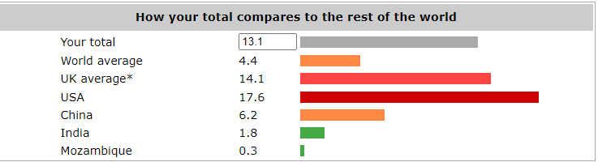

**Form (for JS)**

**Home**

1. How many people are there in your household?

* Input – to write the number (This is needed for sharing out your gas, electricity and car use between the members of your household.)

1. How much electricity is used in your household?

* Small house / flat (0,93)
* Medium (1,48)
* Large house (2.16)
* Hall of residence (0,62)

1. Is heating oil, coal, wood or bottled gas used in your household?

* No (0)
* Yes

If yes:

Enter your use over the last year:  
The number of litres of heating oil:    2.96 kg / litre / 1000  
The number of kilograms of coal:          3.26 kg / kg / 1000  
The number of kilograms of wood:          0.10 kg / kg / 1000  
The number of kilograms of bottled gas:     3.68 kg / kg / 1000

**Transport**

1. What are the modes of transport you used last year? (just checking transport to know what to ask in next question)

* Car
* Bus
* Train
* Plane

1. Provide mileage:

* Journeys by car:

Provide 12-month car mileage: - Input (if num < 1000 = num * 0,03; else if num > 100 = num * 0,31 else num == 0)

* Journeys by bus:

Provide your regular mileage each month: - Input (if num < 100 = num * 0,01; else if num < 1000 = num * 0,12 else num == 0)

* Journeys by train:

  Provide your regular mileage in the year: - Input (if num < 100 = num * 0,01; else if num < 1000 = num * 0,12 else if num > 1000 = num * 1,2 else num == 0)

* Journeys by plane:

Provide hours spent on flights: - input (num = hours * 0,25)

**Food**

1. How much of the food that you eat is organic?

* None (0,7)
* Some (0,5)
* Most (0,2)
* All (0)

7. How much meat/dairy do you eat personally?

* Above-average meat/dairy (0,6)
* Average meat/dairy (0,4)
* Below-average meat/dairy (0,25)
* Lacto-vegetarian (0,1)
* Vegan (0)

8. How much of your food is packaged / processed (e.g. 'ready meals', tins)?

* Above average (0,6)
* Average (0,4)
* Below average (0,2)
* Very little (0,05)

**Recycling**

1. Miscellaneous personal lifestyle choices:

* What is your miscellaneous spending?  
  - Above-average (5)  
  - Average (3,4)  
  - Below-average (2,4)  
  - Much below-average (1,4)
* Do you recycle paper, glass and metal?

- No (0)

- Yes (-0,7)

* Do you recycle plastic apart from bags?

- No (0)

- Yes (-0,14)

Total = sum of every question + 1,1 (health, education, etc).

**Result**

**Your total is Total tonnes C02**



**Design**

We are using for icons in footer – fontsAwesome.

Instagram

<i class="fa-brands fa-instagram"></i>

<i class="fa-brands fa-square-instagram"></i>

Facebook

<i class="fa-brands fa-facebook"></i>

Twitter

<i class="fa-brands fa-twitter"></i>

Arrow

<i class="fa-solid fa-arrow-right"></i>

* **Fonts**

**Manrope**

<link rel="preconnect" href="https://fonts.googleapis.com">  
<link rel="preconnect" href="https://fonts.gstatic.com" crossorigin>  
<link href="https://fonts.googleapis.com/css2?family=**Manrope:wght@200;300;400;500;600;700;800**&display=swap" rel="stylesheet">

font-family: 'Manrope', sans-serif;

**Rubik One**

I think this one is default.

font-family: 'Rubik One';