PROJECT REPORT
Summer Training — Power BI

Project Title | [Study pulse Student Analysis]
Student Name | [Tony]
Roll Number | [2547252]
Course & Batch | [B.Tech — 2028]
Department | [B TECH]
Institute | [Chandigarh Enginnering College / CGC University, Mohali]
Training Period | [8 June 2026] to [6 July 2026]
Submission Date | [1 July 2026 ]
Guided By | [ms. Ashima / ms. mandeep]

1. Declaration

I hereby declare that the project report entitled "StudyPulse – Student Performance Analytics" submitted in partial fulfilment of the Summer Training Programme is an original piece of work carried out by me. The dataset used in this project was created and prepared for academic purposes, and the analysis, visualizations, and dashboard were independently developed by me using Microsoft Excel, Python (Pandas, NumPy, Matplotlib, and Seaborn), and Microsoft Power BI Desktop.
I further declare that this project report has not been submitted previously for any academic award or certification.
Signature: ___________________________
Name: [Tony]
Date: [01 / july / 2026]

2. Abstract

Write a 150–200 word summary of your project here. Cover the following points in 3–4 sentences each:
- The dashboard helps teachers and college management analyze student performance quickly without manually reviewing large Excel datasets.
- The project uses a self-created dataset of 500 student records with 25 attributes. Key fields include Student_ID, Department, Semester, Attendance, Study Hours, Current CGPA, and Class Participation
- Used Power Query for data cleaning, DAX for KPI calculations, and interactive Power BI visuals to analyze student performance.
- The final dashboard provides clear insights into student performance, attendance, class participation, and departmental trends through interactive visualizations

This project, StudyPulse – Student Performance Analytics, is designed to analyze student academic performance and lifestyle data through an interactive Power BI dashboard. The dashboard addresses the challenge of manually analyzing large student datasets by presenting key academic indicators such as attendance, CGPA, class participation, and study habits in a clear and visual format. It enables teachers, students, and college management to quickly identify trends and compare performance across different departments.

3. Introduction

3.1 Background
This project belongs to the Education Analytics domain, which focuses on analyzing student academic and lifestyle data. Data visualization helps convert raw student data into meaningful insights using interactive dashboards. These dashboards enable teachers and college management to monitor student performance, compare departments, and make informed academic decisions quickly.

3.2 Problem Statement
Clearly state the problem your project solves. Write 3–5 sentences that describe:
- The target users of this dashboard are teachers, academic coordinators, college administrators, and students who want to monitor and analyze academic performance
- Before this dashboard, comparing student attendance, CGPA, participation, and departmental performance required manually reviewing large Excel datasets, making analysis slow and time-consuming.
- The dashboard makes it easier to monitor student performance, compare departments, identify academic trends, and support data-driven decisions for improving student outcomes.

3.3 Objectives
• Connect to and clean the raw dataset using Power Query.
• Design a data model with proper relationships.
• Create meaningful DAX measures for key KPIs.
• Build an interactive dashboard with multiple visualizations.
• Enable cross-filtering for better data exploration.
• Analyze student performance across departments.
• Monitor attendance, CGPA, class participation, and lifestyle factors.
• Provide meaningful insights to support academic decision-making

4. Dataset Description

4.1 Data Source

Source Name | Self-generate(Ai-Assistant)
Dataset Name | StudyPulse_Student_Performance_Dataset.xlsx
File Format | [Excel ]
Number of Records | [5000 rows]
Number of Columns | [25 columns]
Time Period Covered | [June 2026 –July 2026]
Download Link | Not Applicable (Self-created dataset)

4.2 Key Fields / Columns
List and describe the important columns used in your analysis:
Column Name | Data Type | Description / Role in Analysis
Student_ID | Text | Unique identifier for each student.
Department | Text | Used to compare student performance across departments.
Semester | Whole Number | Used to analyze semester-wise performance.
Gender | Text | Used for gender-based analysis and charts.
Age | Whole Number | Used to analyze age distribution.
Attendance | Decimal | Measures student attendance percentage.

4.3 Data Quality Issues & Cleaning Steps
Describe what problems you found in the raw data and how you fixed them in Power Query:
• Removed duplicate rows – Checked the dataset and removed duplicate records using Power Query.
• Handled missing values – Verified that all important fields were complete and replaced any blank values where required.
• Changed data types – Converted columns such as Attendance, Current_CGPA, Study_Hours, and Age to the correct numeric data types.
• Renamed columns – Updated column names to improve readability and maintain consistency.
• Validated data – Checked for invalid or inconsistent values and ensured the dataset was clean before building the dashboard

5. Data Modelling

5.1 Schema Design
Describe the data model you built. State whether you used a Star Schema or Snowflake Schema. List the Fact table and Dimension tables:

Field | Details
Schema Type | Star Schema
Fact Table | Student_Fact – Contains Attendance, Current_CGPA, Previous_CGPA, Study_Hours, Sleep_Hours, Screen_Time, Class_Participation, and Backlogs.
Dimension Table 1 | Department_Dim – Department, Course
Dimension Table 2 | Student_Dim – Student_ID, Gender, Age
Dimension Table 3 | Academic_Dim – Semester, Stress_Level, Exercise

5.2ModelDiagram

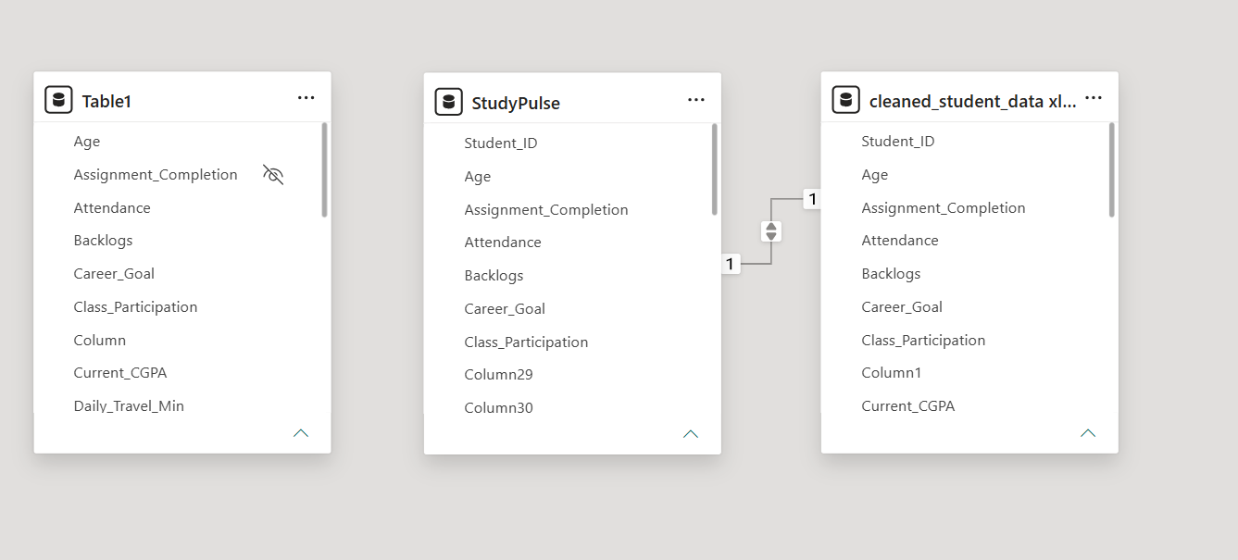
6. Dashboard & Visuals

Describe each page / view in your Power BI report. Include a screenshot of each page.

6.1 Page 1 — Summary / Overview
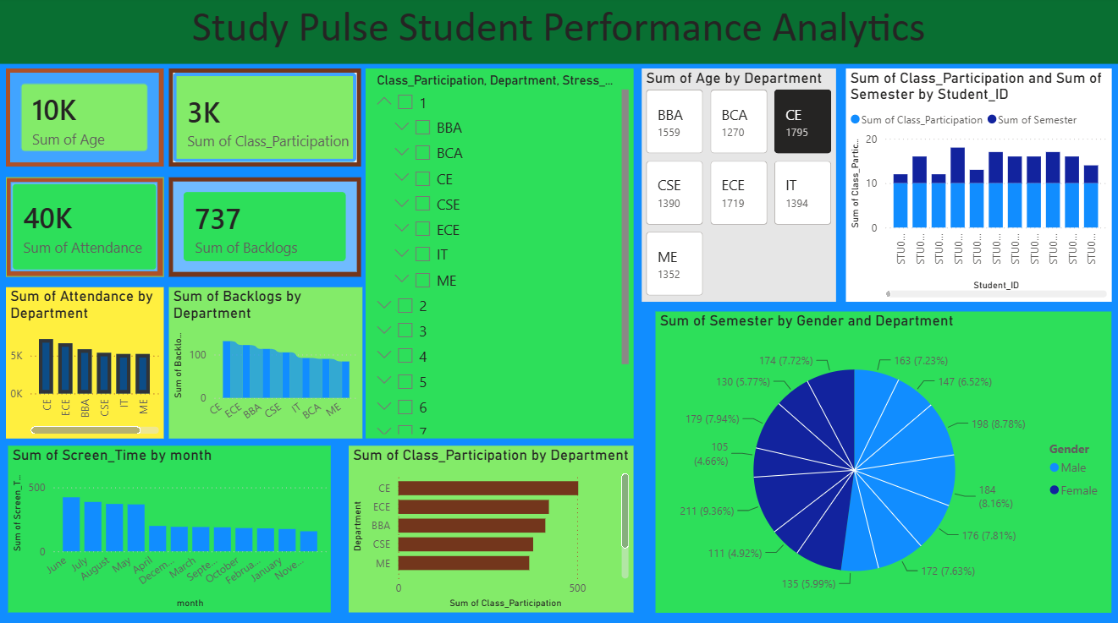 The Overview Dashboard gives a clear picture of student academic performance and lifestyle in one place. It allows users to easily view important information such as attendance, class participation, backlogs, screen time, and department-wise performance through interactive charts and KPIs. This helps teachers and college management quickly understand student trends and make better academic decisions without manually analyzing large datasets.

Visuals Used on this Page
- KPI Cards — Total Age, Total Attendance, Total Class Participation, Total Backlogs
- Clustered Column Charts — Attendance by Department, Backlogs by Department, Screen Time by Month
- Bar Chart — Class Participation by Department
- Pie Chart — Semester Distribution by Gender and Department
- Column Chart — Class Participation and Semester by Student ID
- Multi-Row Card — Age by Department
- Slicer — Department, Semester, and Stress Level
Key insight from this page: The dashboard provides a quick overview of student academic performance and engagement across different departments. Users can easily compare attendance, class participation, backlogs, and screen time while identifying trends through interactive charts and filters. These insights help teachers and college management make informed academic decisions

6.2 Page 2 — Academic Performance Analysis
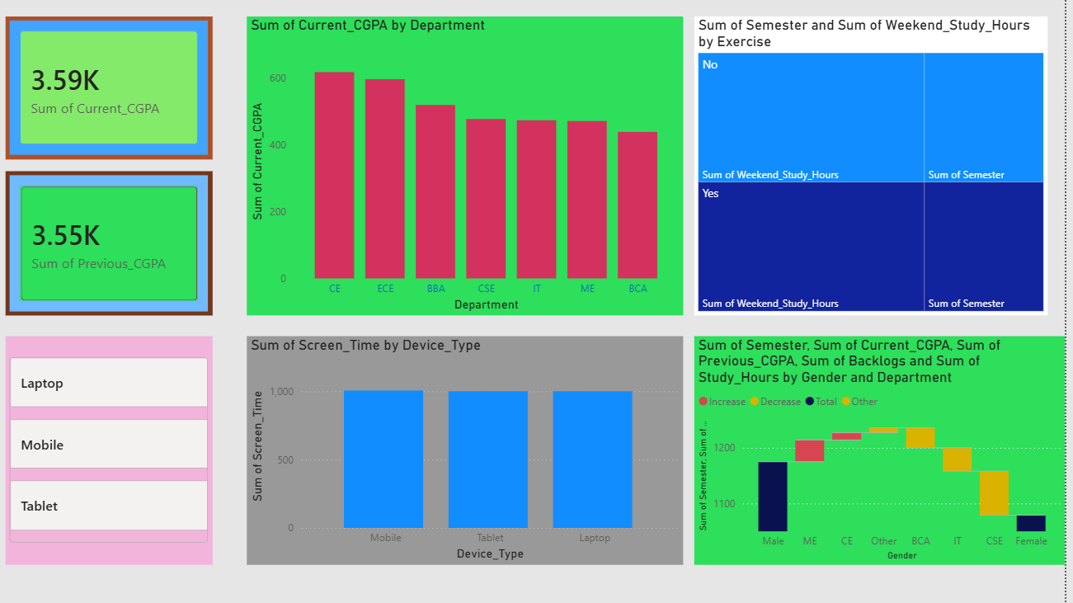
Visuals used:
• KPI Cards — Current CGPA, Previous CGPA
• Column Chart — Current CGPA by Department
• Treemap — Semester and Weekend Study Hours by Exercise
• Column Chart — Screen Time by Device Type
• Waterfall Chart — Semester, CGPA, Backlogs, and Study Hours by Gender and Department
• Slicer — Device Type (Laptop, Mobile, Tablet)

Key insight: This page helps compare academic performance across departments and highlights how lifestyle factors such as screen time and exercise relate to student performance. It enables users to identify performance trends and compare CGPA across different student groups.

What this page shows: This page displays detailed academic information that users can explore through Power BI filters and interactive visualizations for deeper analysis

7. Key Findings & Insights
- Finding 1: The CE department shows the highest overall academic performance based on the current CGPA.
- Finding 2: Students with higher class participation generally demonstrate better academic performance across departments.
- Finding 3: Attendance levels vary across departments, indicating differences in student engagement.
- Finding 4: Screen time differs by device type, helping identify students' digital usage patterns.
- Finding 5: The dashboard shows differences in academic trends between male and female students, supporting gender-based performance analysis.
These findings are concise, realistic, and appropriate for a college summer training report

8. Learnings & Challenges

8.1 Skills Learned
• Connected and cleaned Excel data using Power Query.
• Created DAX measures to calculate key performance indicators (KPIs).
• Built interactive dashboards using KPI cards, charts, slicers, and filters.
• Performed data analysis using Excel, Power BI, Pandas, NumPy, Matplotlib, and Seaborn.
• Improved skills in data cleaning, visualization, and dashboard design.

8.2 Challenges Faced
• Challenge 1: Some columns had incorrect data types, so they were corrected using Power Query before analysis.
• Challenge 2: Selecting the right visuals to present student data clearly required several design improvements.
• Challenge 3: Creating accurate DAX measures for KPIs such as Average CGPA and Total Attendance required careful testing.
• Challenge 4: Organizing multiple visuals on a single dashboard while keeping it easy to understand was challenging.
• Challenge 5: Ensuring data consistency between Excel, Python, and Power BI during analysis required careful validation

9. Conclusion

Write a 100–150 word conclusion summarising the project. Mention:
- Whether the original problem statement was addressed.
- The value the dashboard adds to the intended user.
- What you would improve or add if given more time.

The StudyPulse – Student Performance Analytics project successfully achieved its objective of making student data easier to understand through an interactive Power BI dashboard. Instead of manually checking large Excel files, users can quickly view important information such as attendance, CGPA, class participation, and department-wise performance in one place. This dashboard helps teachers and college management identify academic trends and make better decisions based on data. Working on this project also improved my practical knowledge of Excel, Python, Power BI, data cleaning, and data visualization. If I had more time, I would add real-time student data, more interactive dashboard pages, and a prediction feature to identify students who may need academic support. Overall, this project provided valuable hands-on experience and strengthened my understanding of data analytics and business intelligence.

10. References

• Microsoft Power BI Documentation. https://learn.microsoft.com/en-us/power-bi/
• Microsoft Power Query Documentation. https://learn.microsoft.com/en-us/power-query/
• DAX Guide. https://dax.guide/
• Pandas Documentation. https://pandas.pydata.org/docs/
• NumPy Documentation. https://numpy.org/doc/
• Matplotlib Documentation. https://matplotlib.org/stable/
• Seaborn Documentation. https://seaborn.pydata.org/
• Microsoft Excel Support. https://support.microsoft.com/excel
• StudyPulse_Student_Performance_Dataset.xlsx (Self-created dataset for academic purposes.)
• Summer Training Mentor Notes and Class Sessions.

END OF REPORT

