Recommendations for the excel file

1. No blank line at the end
2. The data stored in same sheet should be the same kind and of the same unit
3. Avoid double/triple headings

Example for An ideal format

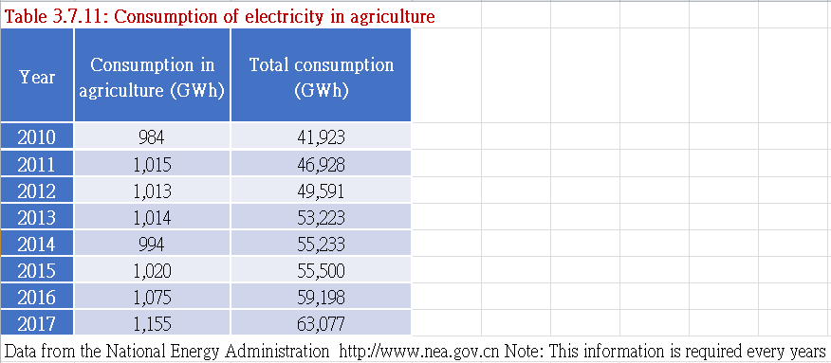If you want to update the data of a new year of one sheet, just add one row before above the “Data from the National ….”

If you want to add a new sheet in the excel file, you have to strictly follow the format. For example, Table x.x.xx : “title”. The “:” is important. The last row “Data from the National ….” matters too.

If the new sheet is of double headers or three headers, you have to specify it inside the app.py file.

To start the application locally, install python 3.7.

Open terminal in the same directory of app.py run

pip install pandas

pip install dash

pip install xlsxwriter

python app.py

The app would be running on <http://127.0.0.1:8050/>

To host the app temporarily, I recommend pythonanywhere.com.