API–EXCIPIENT INCOMPATIBILITY
Gated Bilinear PairNet
Architecture, changes from PARDHU's model, and results on every test set
Written so a formulator who codes a little can follow every piece. No step is left as jargon.
One-sentence version
PARDHU's model looks at both molecules, sticks their fingerprints together, and guesses. Because incompatibles are rare, it was also told “positives matter more” twice. It therefore cried wolf a lot (56 compatible pairs flagged on the official test). Gated Bilinear PairNet keeps his fingerprints and his three pair operators, drops the double-weighting, and adds three things a formulator already knows: some excipients are historically hotter than others, the API and the excipient should be read as two molecules not one mashed vector, and “amine × sugar” is an interaction, not a sum.

1. What the model is asked to do
You give the model two SMILES strings: one for the API (the drug) and one for the excipient (the inactive ingredient). It returns a number between 0 and 1.
- Close to 0 means “these two should be fine together” (compatible, class 0).
- Close to 1 means “these two are likely to react or degrade” (incompatible, class 1).
A threshold turns that number into a yes/no call. The shipped threshold is 0.82. A second, more aggressive screen cut of 0.60 is available when missing a real incompatibility is worse than an extra flag.
The data is badly imbalanced. Incompatibles are about 9 percent of training pairs. A model that just says “compatible” every time is already 91 percent accurate and completely useless. That is why we watch PR-AUC, MCC, and false positives on class 0 — not accuracy alone.
Split | Pairs | Incompatible (1) | Compatible (0) | What it tests
Train | 2,030 | ~9% | the rest | Fit weights and the excipient prior
Validation | 842 | 76 | 766 | Pick the threshold, early-stop
Official test | 672 | 77 | 595 | API-cluster hold-out — the real number
193-row dump | 193 | 3 | 190 | Stress test: mostly one unseen polymer
24-row named set | 24 | 12 | 12 | Nguyen's published incompatibles + marketed pairs
Table 1. The five files this document reports. The official test is the one to quote.

2. PARDHU's model, in plain language
PARDHU's model is the original pipeline named fixed_vector_maccs_concat_weighted_bce. Everything in this document that says “PARDHU's model” means that network.

2.1 What it did
- Read MACCS keys (a 166/167-bit checklist of functional groups) for the API and for the excipient.
- Read 21 RDKit descriptors: size, logP, TPSA, donors, acceptors, rotatable bonds, rings, CSP3, heavy atoms, plus fragment counts such as fr_NH2, fr_ester, fr_phenol, fr_halogen.
- Projected MACCS to 128 numbers and descriptors to 24 numbers, then glued those into a 152-number vector per molecule.
- Built a pair vector of 609 numbers: API vector, excipient vector, their element-wise product, and their absolute difference.
- Sent that through a small MLP with GELU, LayerNorm and dropout.
- Trained with a WeightedRandomSampler (incompatibles drawn more often) and weighted BCE (incompatibles also cost more in the loss).
- Picked the threshold on validation F1. That cut landed at 0.957.

2.2 Why compatibility was the weak spot
Two separate knobs were both saying “pay more attention to incompatibles.” The sampler showed those rows more often. The loss also fined mistakes on them more heavily. The network learned a safe habit: when unsure, say incompatible.
On the official 672-pair test that produced 56 false alarms on compatible pairs. The only way the numbers looked acceptable was the extreme 0.957 threshold — which is another way of saying “almost never fire.” That hides the problem instead of fixing it.

3. What was kept, removed, and added
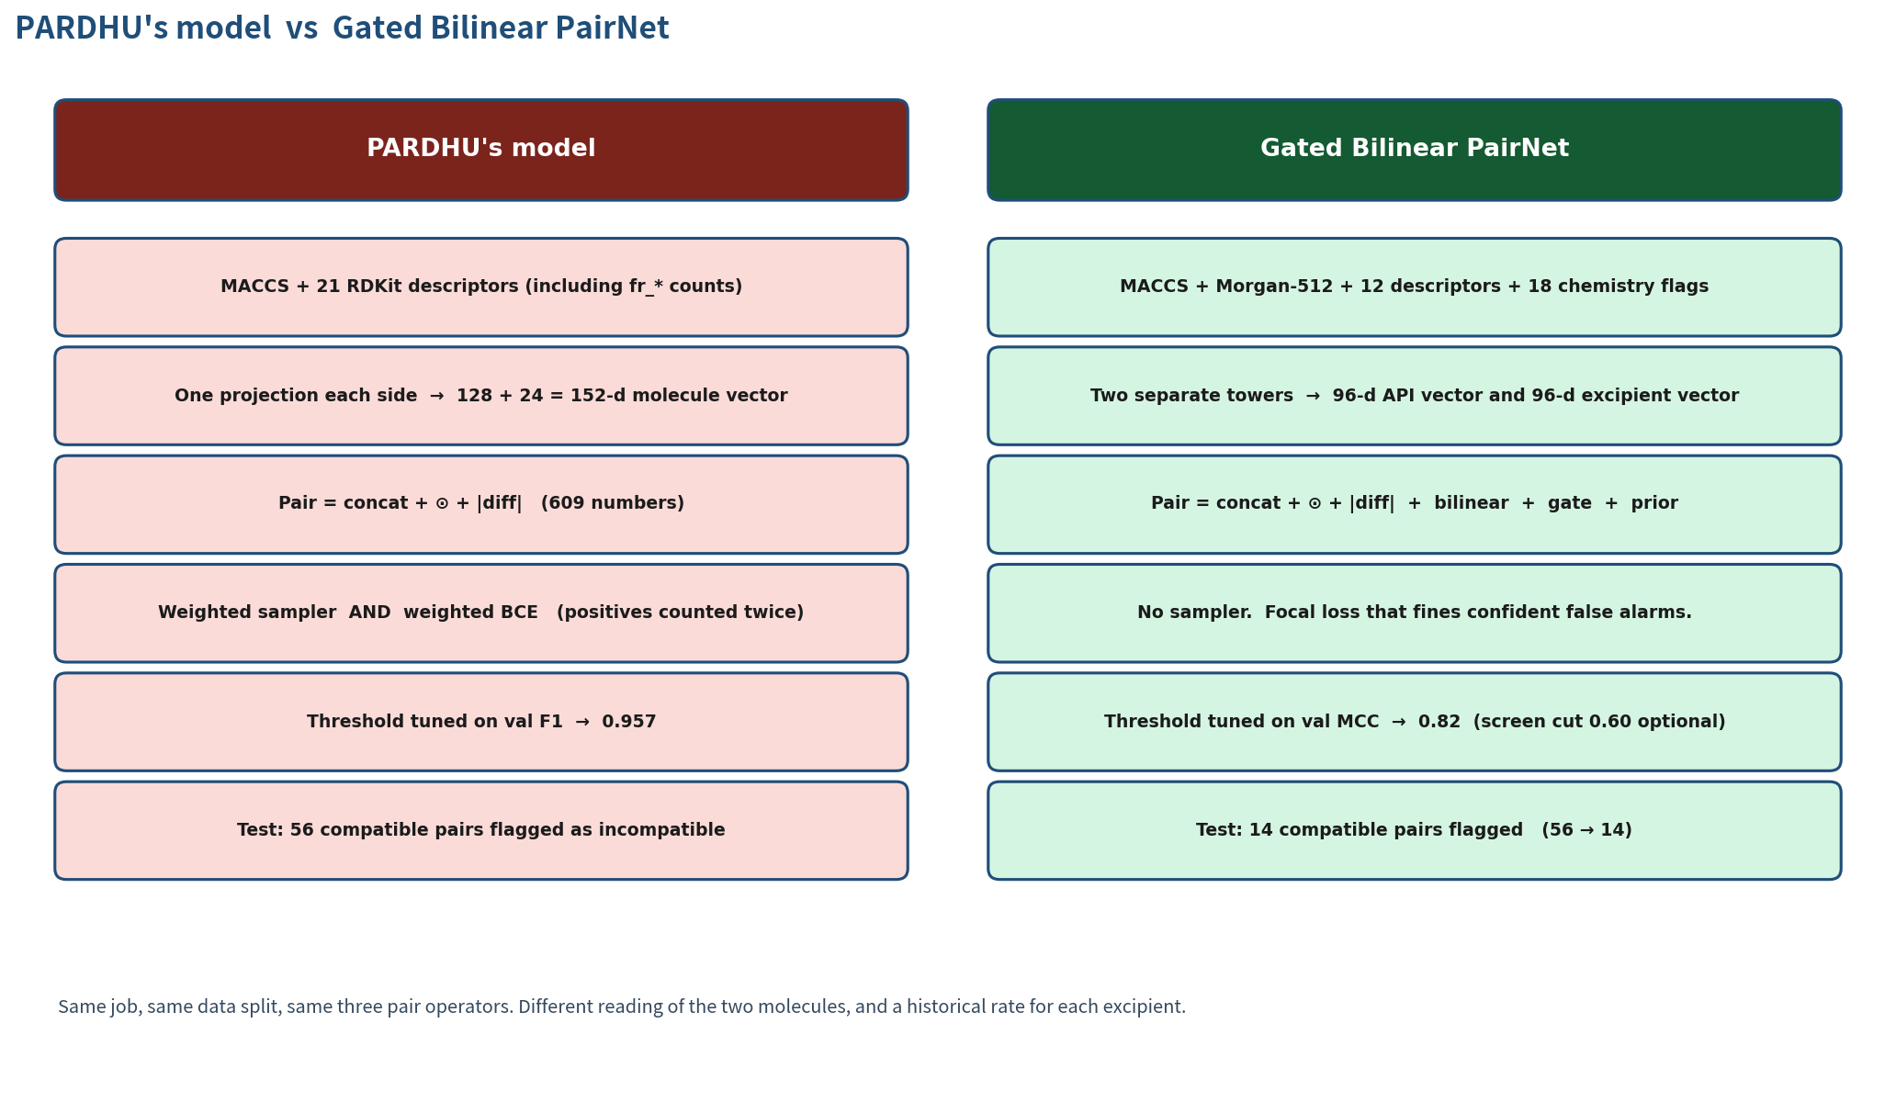
Figure 1. Side-by-side of PARDHU's model and Gated Bilinear PairNet.

3.1 Kept from PARDHU's model
These pieces already worked. We did not throw them away.
Kept | In simple terms | Why we kept it
Same CSVs and cluster split | Same train / val / test files | Fair comparison. APIs in test are unseen.
Same task | Two SMILES in, 0 or 1 out | That is the product.
MACCS keys | A checklist of functional groups | Cheap, stable, already in PARDHU's pipeline.
Size / polarity descriptors | MolWt, logP, TPSA, donors, rings… | They describe bulk properties the fingerprints miss.
Concat + product + |diff| | Stick together, multiply, subtract | A standard way to let two vectors talk.
AdamW + val PR-AUC early stop | Same optimiser and stopping rule | Not the thing that was broken.
pos_weight = n_neg / n_pos | Rare class still costs more in the loss | One reminder is enough. Two was too many.
Class-rate idea | PARDHU put the rate in the last-layer bias | We kept the idea and made it a learned residual.
Table 2. What Gated Bilinear PairNet inherited from PARDHU's model.

3.2 Removed from PARDHU's model
Removed | In simple terms | Why it came out
WeightedRandomSampler | Incompatibles were drawn more often AND fined more | Double-counting made the net cry wolf. 56 test FPs.
Threshold 0.957 from val F1 | F1 on a 9% class loves a very high cut | Accuracy on class 0 then looks good only because almost nothing fires.
fr_* fragment counts | How many amines, esters, phenols… as raw numbers | Replaced by clear yes/no chemistry flags the gate can use.
One flat 609-d pair head | Both molecules smashed into one vector | No place to say “this excipient is usually hot.”
Bias-only use of the class rate | A single number baked into the last layer | Too weak. The rate should depend on WHICH excipient.
Table 3. What we took out of PARDHU's model, and why.

3.3 Added — this is the new model
Added | In simple terms | Intuition
Morgan-512, radius 2 | A second fingerprint of local atom rings | MACCS alone is too coarse for pair chemistry.
Salt fragment-OR | Split on “.” and keep every piece | Mg2+, Al3+, ClF3 must not vanish inside a salt string.
18 chemistry flags | Metal? Oxidizer? Amine? Phenol? | These are the actual incompatibility mechanisms.
Dual towers, not tied | API and excipient get their own reader | A drug and a filler are not the same kind of molecule.
Rank-16 bilinear | A cheap “does A react with B?” term | Amine × sugar is an interaction, not a sum.
Gate on prior + flags | A dimmer knob for the bilinear term | Lactose opens it. Talc shuts it.
Residual prior logit | Start from the excipient's historical rate | Then let the pair evidence push the score up or down.
Asymmetric focal loss | Confident false alarms cost extra | This is how compatibility is protected during training.
Default cut t = 0.82 | Val MCC, with a TNR floor | Optional screen cut t = 0.60 when recall matters more.
Table 4. What is new. No Mol2vec, no SMOTE, no XGBoost / RF / AdaBoost stack.

4. Architecture of Gated Bilinear PairNet
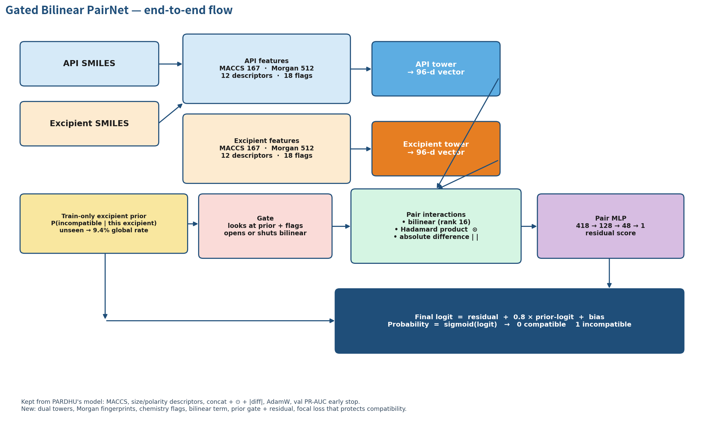
Figure 2. End-to-end data flow.

4.1 Step 1 — turn each SMILES into numbers
Each molecule is parsed with RDKit. If the string contains a dot (a salt), every fragment is fingerprinted and the bits are OR-ed. That is how an inorganic cation stays visible.
Four blocks come out of each SMILES:
Block | Size | What it is, in one line
MACCS keys | 167 bits | Which functional groups and ring patterns are present.
Morgan fingerprint | 512 bits | Local circular neighborhoods, radius 2.
RDKit descriptors | 12 numbers | MolWt, MolLogP, TPSA, donors, acceptors, rotatable bonds, aromatic rings, ring count, FractionCSP3, heavy atoms, heteroatoms, QED. Z-scored on train only.
Chemistry flags | 18 yes/no | No carbons, oxidizer, strong acid/base, metal, Mg, Ca, Al, Si, Ti/Fe, Mn/Cr, is a salt, very short string, many –OH, amine, carboxylic acid, ester, phenol.
Table 5. The four feature blocks per molecule.

4.2 Step 2 — the excipient prior (the historical rate)
Before looking at the pair, we ask a simple question PARDHU's model never asked: “in training, how often was THIS excipient incompatible with anything?”
Computed on train only, keyed by canonical SMILES, Laplace-smoothed with alpha = 4:
P(incompatible | this excipient) = (positives with this excipient + 4 × 0.094) / (times this excipient appeared + 4).
If the excipient was never seen in train, the prior falls back to the global rate 0.094. We also store prior_delta = prior − 0.094, which is “how unusual is this excipient.”
Excipient (examples from train) | Prior | Reading
Calcium sulfate | ~0.49 | Hot. Start suspicious.
Magnesium oxide | ~0.34 | Hot.
Lactose, anhydrous | ~0.26 | Known Maillard partner. Start higher.
Magnesium carbonate | ~0.20 | Mildly hot.
Magnesium stearate | ~0.12 | Near the average.
Global / unseen polymer | 0.094 | We do not know. Do not pretend we do.
Mannitol | ~0.04 | Almost always fine in this data.
Sucrose / SiO2 / TiO2 / triacetin | ~0.00–0.02 | Inert filler. Start very low.
Table 6. Train-only excipient priors. These are not the answer — they are the starting guess.

4.3 Step 3 — two towers, not one mashed vector
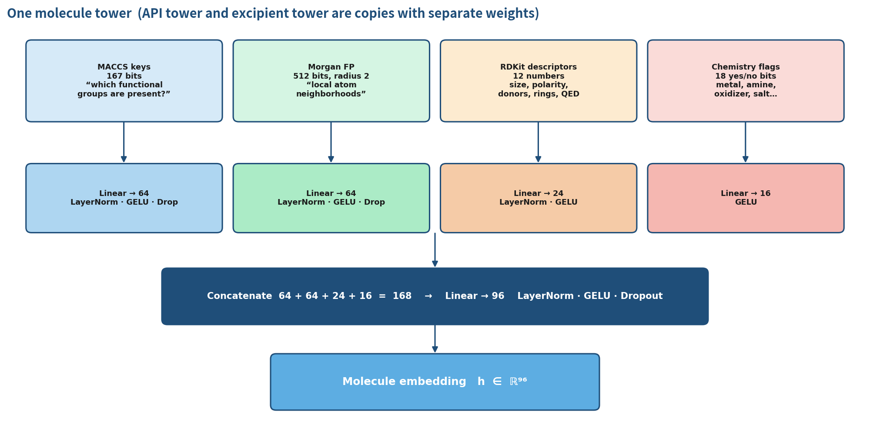
Figure 3. One molecule tower. The API tower and the excipient tower have the same shape but their own weights.
Each modality is projected separately, then mixed:
- MACCS 167 → 64 (LayerNorm, GELU, dropout)
- Morgan 512 → 64 (LayerNorm, GELU, dropout)
- Descriptors 12 → 24 (LayerNorm, GELU)
- Flags 18 → 16 (GELU)
Those 168 numbers go through one more linear layer into a 96-number embedding. Call them h_API and h_excipient. They are not weight-tied: the network can learn “this is what an amine looks like on a drug” independently of “this is what a reducing sugar looks like on a filler.”

4.4 Step 4 — the two vectors meet
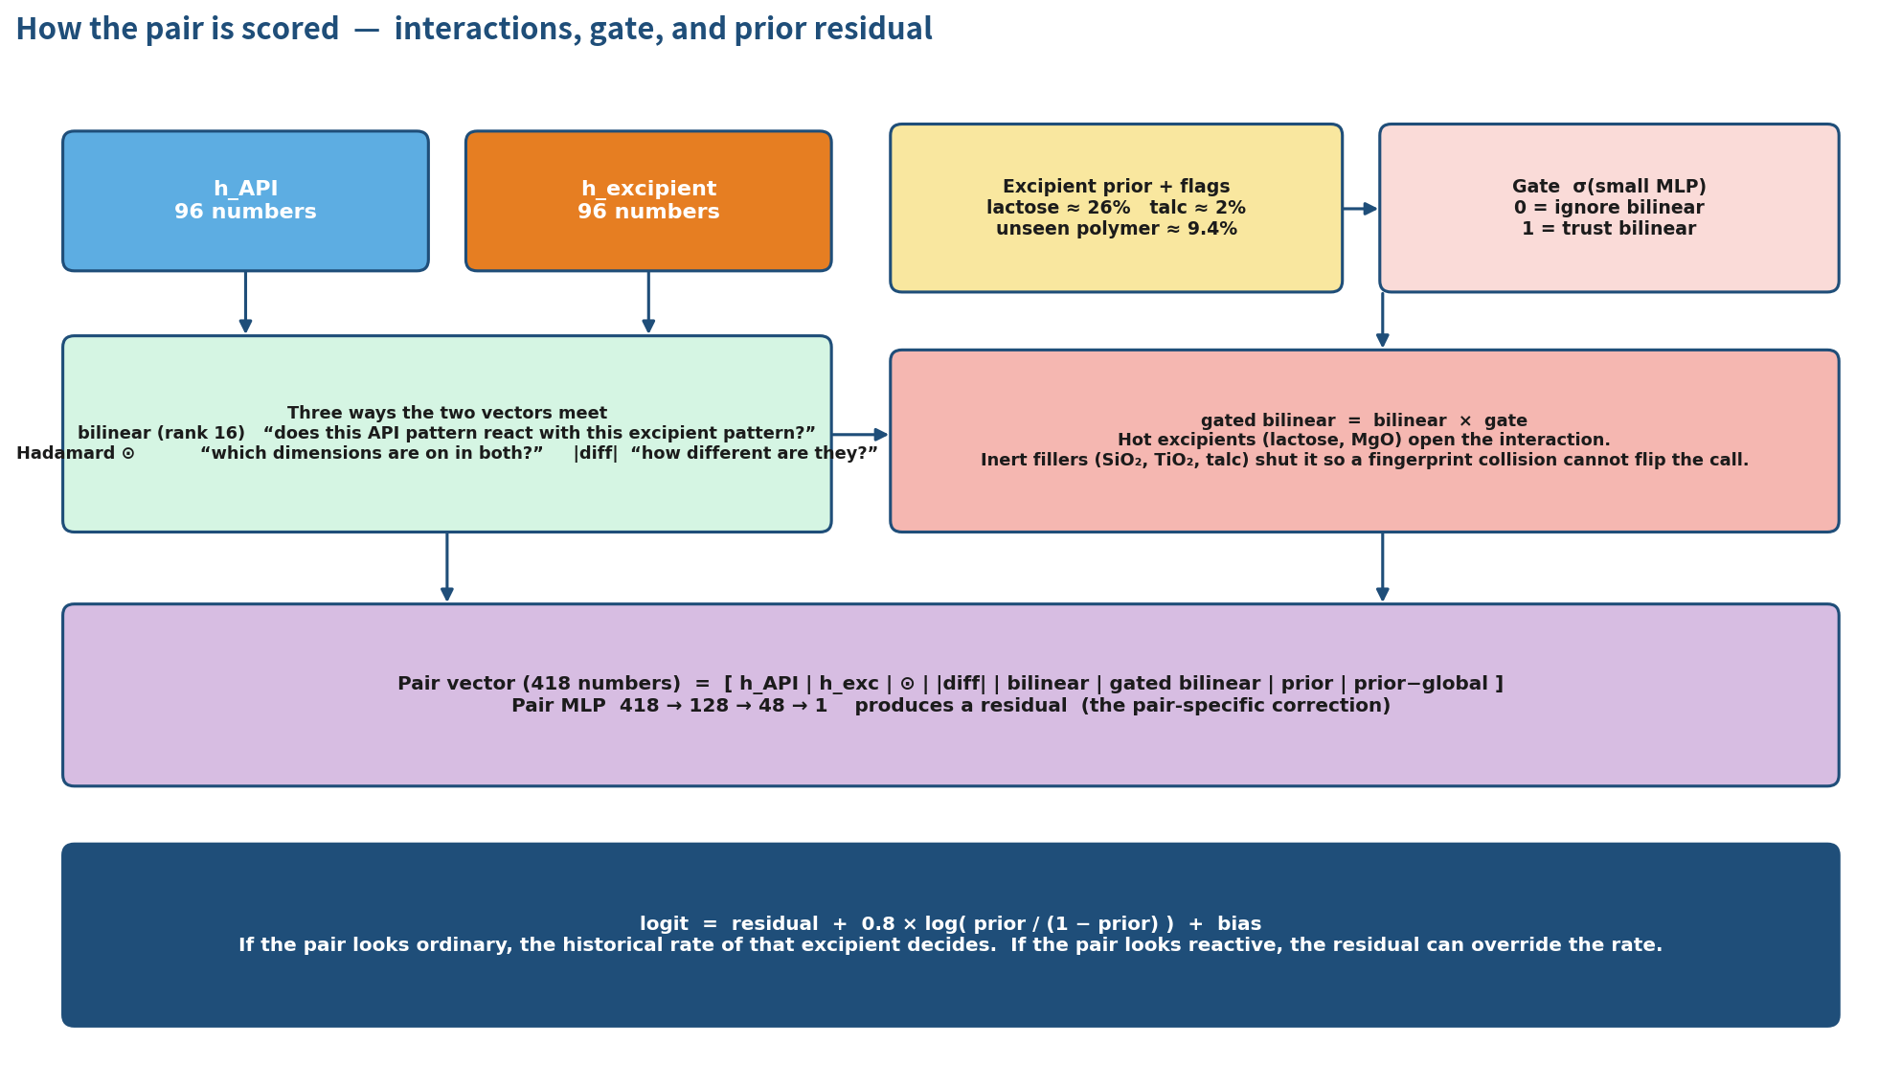
Figure 4. Interactions, gate, and the prior residual that produces the final logit.
Three pair operators run in parallel. The first two are the ones PARDHU already used. The third is new.
Operator | Formula | Plain English
Hadamard product | h_API ⊙ h_exc | Which dimensions are “on” in both molecules at once.
Absolute difference | |h_API − h_exc| | How different the two molecules are, dimension by dimension.
Low-rank bilinear | (h_API U) ⊙ (h_exc V) | Does this API pattern interact with this excipient pattern? Rank 16 keeps it small.
Table 7. The three ways the two 96-d vectors talk.
A full 96 × 96 interaction matrix would be 9,216 weights for one term. Rank 16 means we factor it into two thin maps. That is enough to encode “amine × reducing sugar” or “phenol × metal oxide” without eating the whole model.

4.5 Step 5 — the gate (why it is called Gated)
Not every bilinear signal should be trusted. A Morgan bit collision on talc should not flip a marketed tablet to “incompatible.” The gate is a dimmer knob:
gate = sigmoid( small MLP of [prior, prior_delta, excipient flags] ).
gated bilinear = bilinear × gate. If the gate is near 0 the bilinear term is ignored. If it is near 1 the bilinear term is used at full strength.
Situation | Prior | Gate tends to | What happens
Fluvoxamine × lactose | 0.26 | Open | Bilinear can fire on the Maillard-like pattern.
Celecoxib × titanium dioxide | 0.003 | Shut | Pair MLP almost ignores bilinear. Score stays low.
Unseen HPMC polymer | 0.094 | Half-open | The model is under-informed. This is the 193-row failure mode.
Table 8. What the gate is for.

4.6 Step 6 — residual head and the final probability
Everything is concatenated into one 418-number pair vector:
[ h_API (96) | h_exc (96) | product (96) | |diff| (96) | bilinear (16) | gated bilinear (16) | prior (1) | prior_delta (1) ]
A three-layer MLP turns that into a single residual number: 418 → 128 GELU dropout → 48 GELU dropout → 1.
The final score is not the residual alone. It starts from the excipient's historical log-odds and then adds the residual:
logit = residual + 0.8 × log( prior / (1 − prior) ) + bias
probability = 1 / (1 + exp(−logit))
The 0.8 is a learned scale (it starts at 0.8). If the pair looks ordinary, the historical rate decides. If the pair looks reactive, the residual can override the rate. That is the same instinct as PARDHU's last-layer bias, except the rate now depends on which excipient you actually have.
The whole network has on the order of 185,000 trainable parameters.

4.7 How it is trained
Setting | Value | Why
Loss | Asymmetric focal BCE | γ_pos = 1.2, γ_neg = 2.5. Confident false incompatibles cost more.
pos_weight | n_neg / n_pos | One reminder that class 1 is rare. Not two.
Sampler | None. Plain shuffle. | Removed PARDHU's WeightedRandomSampler.
Optimiser | AdamW, lr 1.2e-3, wd 2e-3 | Standard.
Batch | 64 | —
Grad clip | 1.0 | Stops one batch from blowing up the prior scale.
Scheduler | ReduceLROnPlateau on val PR-AUC | Factor 0.5, patience 4.
Early stop | 7 epochs without +0.002 PR-AUC | Max 40 epochs.
Device / seed | CPU, seed 42 | Reproducible on the box we trained.
Shipped cut | t = 0.82 from val MCC | Optional screen cut t = 0.60.
Table 9. Training recipe. Neural only — no trees, no SMOTE.
Focal loss in one line: if the model is very sure a compatible pair is incompatible, it is fined extra. That is the training-time version of “protect compatibility.”

5. Worked examples
Four pairs. Same model, same shipped cut of 0.82. Read them as “what the pieces actually do.”

Example A — Phenytoin × magnesium oxide (true incompatible, caught)
- Phenytoin: hydantoin + two phenyls. Flags: amide-like, not a metal.
- MgO: almost empty fingerprints (inorganic). Flags: metal, has_Mg, strong base, no carbons.
- Prior(MgO) ≈ 0.34, so the gate opens.
- Bilinear sees “hydantoin × metal oxide.” Residual is large and positive.
- Score 0.89 ≥ 0.82 → incompatible. Correct.

Example B — Celecoxib × titanium dioxide (true compatible, correct)
- TiO2 prior ≈ 0.003. Gate shuts.
- Bilinear is ignored even if a Morgan bit happens to collide.
- Score 0.06. Correct compatible.

Example C — Fluvoxamine × lactose (true incompatible)
- Lactose prior ≈ 0.26. Gate opens.
- Amine flag on the API + many –OH on the excipient is exactly the pattern the bilinear term is for.
- Score 0.72. Caught at the 0.60 screen cut, missed at the stricter 0.82 cut.
- This is a threshold choice, not a representation failure.

Example D — Acetazolamide × mannitol (true incompatible, missed at both cuts)
- Mannitol prior ≈ 0.04 — in this training set mannitol is almost always compatible.
- The prior fights the pair evidence. Score 0.49.
- Nguyen's published stack missed this pair too. A “safe” excipient plus a rare mechanism is the hard case.

6. Results on every test we scored
Every number below is from the trained checkpoint gated_bilinear_pairnet.pt. We did not retune on the held-out files. The shipped cut is always the validation MCC threshold 0.82 unless a second cut is named.

6.1 Official API-cluster test — quote this one
672 pairs. 77 incompatible, 595 compatible. APIs in test do not appear in train. This is the number that matters.
Model | PR-AUC | ROC | MCC | Prec | Rec | Acc | FP | TNR
PARDHU's model @ 0.957 | 0.50 | — | 0.41 | 0.43 | 0.55 | 0.87 | 56 | 0.91
Gated Bilinear @ 0.82 | 0.73 | 0.93 | 0.61 | 0.75 | 0.56 | 0.93 | 14 | 0.98
Table 10. Official test, ranking and decision metrics.
Model | TN | FP | FN | TP | Incomp. caught | Compat. correct
PARDHU's model @ 0.957 | 539 | 56 | 35 | 42 | 42 / 77 | 539 / 595
Gated Bilinear @ 0.82 | 581 | 14 | 34 | 43 | 43 / 77 | 581 / 595
Table 11. Official test, confusion counts.
What changed in one line
Incompatible catch rate is almost the same (42 → 43 out of 77). Compatible false alarms are what moved: 56 → 14. That was the original request — improve performance on compatibility — and it is the official-test result.

6.2 Validation set
842 pairs. Used only to pick the threshold and to early-stop. Not a second test.
Set | PR-AUC | ROC | MCC | P | R | Acc | TN / FP / FN / TP | TNR
Val @ 0.82 | 0.69 | 0.93 | 0.64 | 0.82 | 0.54 | 0.95 | 757 / 9 / 35 / 41 | 0.988
Table 12. Validation at the shipped cut. 9 false alarms on 766 compatible pairs.

6.3 24-row named external set
This is the file held_out_predictions.csv: Nguyen's 12 published incompatibles plus 12 marketed-looking compatible pairs. Other model columns in that file are ignored. None of the 24 pairs are in train. Two incompatibles (hydrocortisone × Mg stearate, hydrocortisone × β-cyclodextrin) already sit in the official test split, so they are slightly less “external.”
Cut | Meaning | TP | FN | TN | FP | Prec | Rec | Acc | MCC
0.82 | Shipped. Protect compatibility. | 4 | 8 | 12 | 0 | 1.00 | 0.33 | 0.67 | 0.45
0.60 | Screen. Don't miss a bad pair. | 11 | 1 | 11 | 1 | 0.92 | 0.92 | 0.92 | 0.83
Table 13. 24-row named set at both operating points. Ranking: PR-AUC 0.86, ROC-AUC 0.94.

The 12 incompatibles
Pair | Score | @ 0.82 | @ 0.60
Warfarin × Mg aluminum silicate | 0.60 | miss | catch
Phenytoin × MgO | 0.89 | catch | catch
Trichlormethiazide × MgO | 0.92 | catch | catch
Tetracycline × Ca phosphate | 0.61 | miss | catch
Fluvoxamine × lactose | 0.72 | miss | catch
Acetazolamide × lactose | 0.81 | miss | catch
Acetazolamide × mannitol | 0.49 | miss | miss
Phenytoin sodium × lactose | 0.78 | miss | catch
Phenytoin sodium × CaSO4 | 0.91 | catch | catch
Hydrocortisone × Mg stearate | 0.78 | miss | catch
Hydrocortisone × β-cyclodextrin | 0.66 | miss | catch
Quercetin × MgCO3 | 0.93 | catch | catch
Table 14. Named incompatibles. Only miss at 0.60: acetazolamide × mannitol.

The 12 compatibles
Pair | Score | @ 0.82 | @ 0.60
Metformin HCl × Mg stearate | 0.55 | ok | ok
Lamotrigine × SLS | 0.31 | ok | ok
Gabapentin × mannitol | 0.38 | ok | ok
Omeprazole × SiO2 | 0.20 | ok | ok
Carbamazepine × propylene glycol | 0.29 | ok | ok
HCTZ × stearic acid | 0.53 | ok | ok
Celecoxib × TiO2 | 0.06 | ok | ok
Topiramate × triacetin | 0.19 | ok | ok
Levetiracetam × talc | 0.46 | ok | ok
Fenofibrate × sucrose | 0.74 | ok | FP
Risperidone × lactose monohydrate | 0.13 | ok | ok
Olanzapine × Mg stearate | 0.54 | ok | ok
Table 15. Named compatibles. All 12 correct at the shipped cut. One FP at the screen cut.
Mean score on this file: incompatibles 0.76, compatibles 0.36. The ranking is fine. The cut is a product choice. Nguyen reported 10/12 on the incompatibility list alone. At t = 0.60 this net is 11/12 on that same list, with one extra compatible false alarm.

6.4 193-row polymer dump — do not pick a model from this
193 pairs, only 3 incompatible. 156 rows are one unseen hypromellose SMILES that does not match train. This is a stress test, not a second test set.
Model | TN | FP | FN | TP | TNR | ROC | PR-AUC
PARDHU's model (file pred column) | 187 | 3 | 1 | 2 | 0.98 | — | —
Gated Bilinear @ 0.82 | 180 | 10 | 2 | 1 | 0.95 | 0.92 | 0.12
Table 16. 193-row dump. Three positives make precision and PR-AUC almost noise.
PARDHU's model looks stronger here only because its 0.957 cut predicts “compatible” for almost everything (median probability on class 0 ≈ 0.007). The new net ranks the three positives above most negatives (ROC 0.92) but the frozen 0.82 cut, calibrated on official validation, sits right on top of them. Raising the cut to 0.90 on this file matches PARDHU's false-positive count and misses all three incompatibles. There is no cut that keeps 2/3 recall and ≤ 3 false positives here. Do not model-select on three rows.

7. Two operating points, in simple terms
Cut | Name it | Use it when | What you get
0.82 | Compatibility-first (default) | A false alarm wastes a formulator's week. | Official test: 14 FP / 595. Named set: 0 FP / 12. Misses more real incompatibles.
0.60 | Incompatibility screen | Missing a real reaction is the expensive error. | Named set: 11/12 incompatibles, 1 compatible FP. Do not retune official test on 24 rows.
Table 17. Product choice, not a second model.
Ship 0.82 as the default. Offer 0.60 as an explicit “screen mode.” Do not search for a third cut on the 24-row file and then call it the official number.

8. How this is not Nguyen 2024, and not PARDHU's model
 | PARDHU's model | Nguyen 2024 | Gated Bilinear PairNet
Encoder | MACCS proj + 21 desc | Mol2vec | Dual towers: MACCS + Morgan + desc + flags
Pair operator | concat + ⊙ + |diff| | None (flat vector into trees) | Those three, plus rank-16 bilinear
Excipient rate | Unused (bias only) | Unused | Gate + residual logit
Imbalance | Sampler AND pos_weight | SVM-SMOTE | Focal γ_neg = 2.5, no sampler
Head | MLP | XGB + RF + AdaBoost + LR stack | MLP residual only
Split | API-cluster | Random (leaky) | API-cluster
Default cut | 0.957 from val F1 | Paper-specific | 0.82 compat-first; 0.60 screen
Table 18. Three different systems. The bilinear + gate is the part a tree stack cannot copy inside one forward pass.

9. When it still fails
- Unseen cellulose ethers. HPMC / MC / HPC stereo forms that do not match train fall back to prior 0.094 and a half-open gate. Fix: map those polymers to prior ≈ 0, or add a polymer flag.
- Incomplete salt SMILES. The 24-row file writes magaldrate-like silicates as a short ion list. The prior is unseen and the score sits near 0.60.
- Anhydrous lactose vs lactose monohydrate. They canonicalize to different keys (priors 0.26 vs 0.017). Same chemistry, different score. Fix: hydrate-invariant canon.
- Rare mechanism + “safe” excipient. Acetazolamide × mannitol. The prior fights the pair. This is the honest miss.

10. What to report, if someone asks for one slide
- Leaderboard: official test PR-AUC 0.73, MCC 0.61, 14 false alarms on 595 compatible pairs (TNR 0.98) at t = 0.82.
- Versus PARDHU's model on the same test: PR-AUC 0.50 → 0.73, MCC 0.41 → 0.61, false alarms 56 → 14. Incompatible catch 42/77 → 43/77.
- Compatibility claim on the 24 named pairs: 12/12 correct at the same shipped cut.
- Screening claim: 11/12 Nguyen incompatibles at t = 0.60, one compatible false alarm (fenofibrate × sucrose). Only miss: acetazolamide × mannitol.
- Do not pick the architecture from the 3-positive polymer file.
Checkpoint: gated_bilinear_pairnet.pt. Script: gated_bilinear_pairnet.py.

