[409856043@gms.tku.edu.tw](mailto:409856043@gms.tku.edu.tw)

y53637133!A

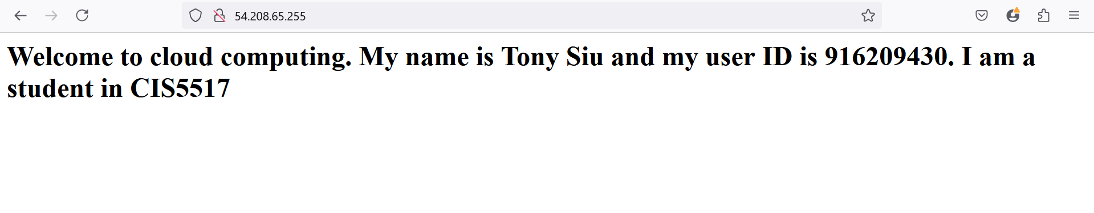

*1) Submit a screenshot of your EC2 instance summary and a screenshot of your message when you access your web server from a browser.*

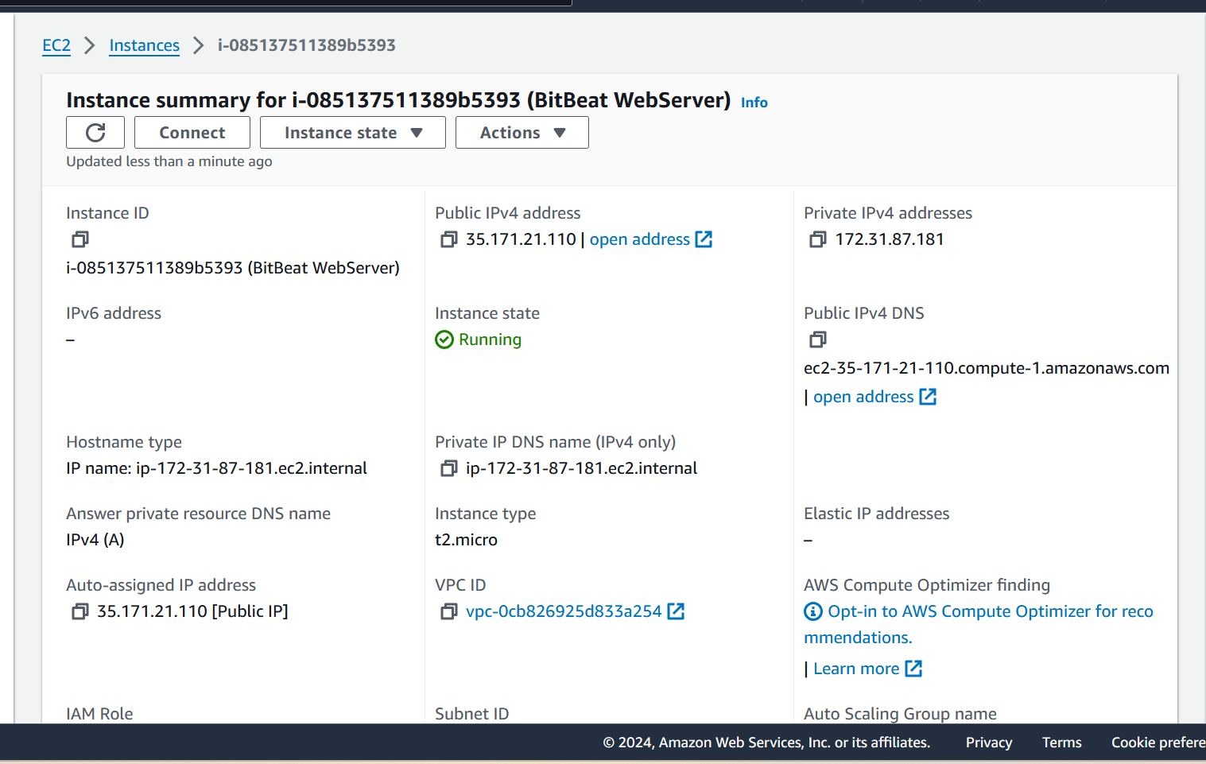

1. *What is the purpose of EC2?*

Amazon EC2 **allows you to select a configuration of memory, CPU, instance storage, and the boot partition size that is optimal for your choice of operating system and application**. For example, choice of operating systems includes numerous Linux distributions and Microsoft Windows Server.

1. *Which zone is your EC2 instance located?*

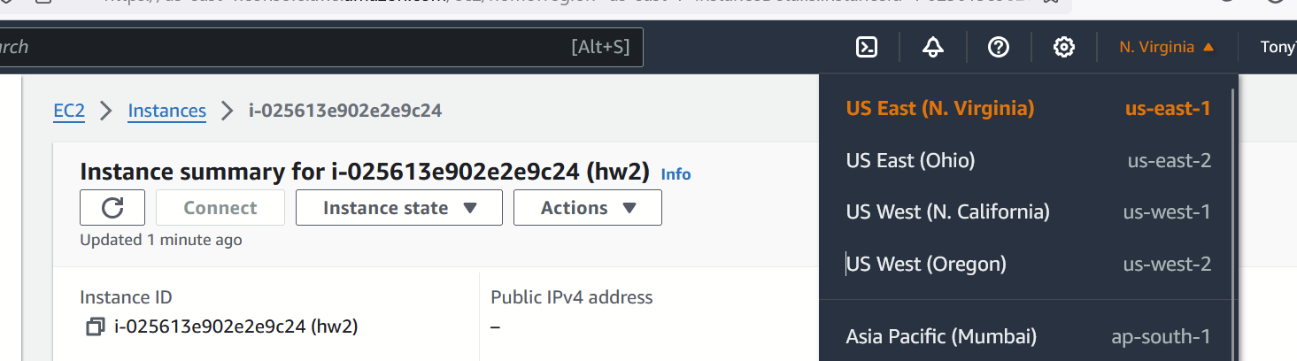

US East N. Virginia

1. *What is the purpose of an Amazon Machine Image (AMI)?*

An Amazon Machine Image (AMI) is an image that provides the software that is required to set up and boot an Amazon EC2 instance. Each AMI also contains a block device mapping that specifies the block devices to attach to the instances that you launch.

1. *Why did we select the t2.micro AMI?*

The t2.micro instance is in the general purpose family with 1 vCPUs, 1.0 GiB of memory and low to moderate network performance starting at $0.0116 per hour. For us, it is a free tier AMI that is configured to be a web server

*2. (For CIS5517 students only, 50 points) Using your above EC2 instance, write a code to test whether a number N is a prime number or not. Monitor the time to run that code remotely on the cloud with the following N: 43112609 and 9246736. Submit screenshots as well.*

