1.

<?xml version="1.0" encoding="iso-8859-1"?>

<!DOCTYPE flightlist [

<!ELEMENT flightlist (flight+)>

<!ELEMENT flight (passengers+)>

<!ATTLIST flight

number #PCDATA

origin ( "BOS" | "SJU" | "SFO" | "JFK" | "DCA" | "MAD" )

dest ( "BOS" | "SJU" | "SFO" | "JFK" | "DCA" | "MAD" )>

<!ELEMENT passengers (passenger+)>

<!ATTLIST passengers

date #PCDATA>

<!ELEMENT passenger EMPTY>

<!ATTLIST passenger

name #PCDATA

seat #PCDATA>

]>

<flightlist>

<flight number="AA101" origin="BOS" dest="SJU">

<passengers date="2024-09-30">

<passenger name="John Doe" seat="12A" />

<passenger name="Jane Smith" seat="12B" />

</passengers>

</flight>

<flight number="UA202" origin="JFK" dest="DCA">

<passengers date="2024-09-30">

<passenger name="Alice Johnson" seat="3C" />

</passengers>

</flight>

<flight number="DL303" origin="MAD" dest="SFO">

<passengers date="2024-09-30">

<passenger name="Bob Brown" seat="22F" />

<passenger name="Clara White" seat="22E" />

<passenger name="David Black" seat="23A" />

</passengers>

</flight>

</flightlist>

2.

1. { "name": "CS 125", "enrollment": 500, "averageGrade": 3.9 }
2. { "name": "CS 125", "enrollment": 600, "averageGrade": 3.8 }

3.

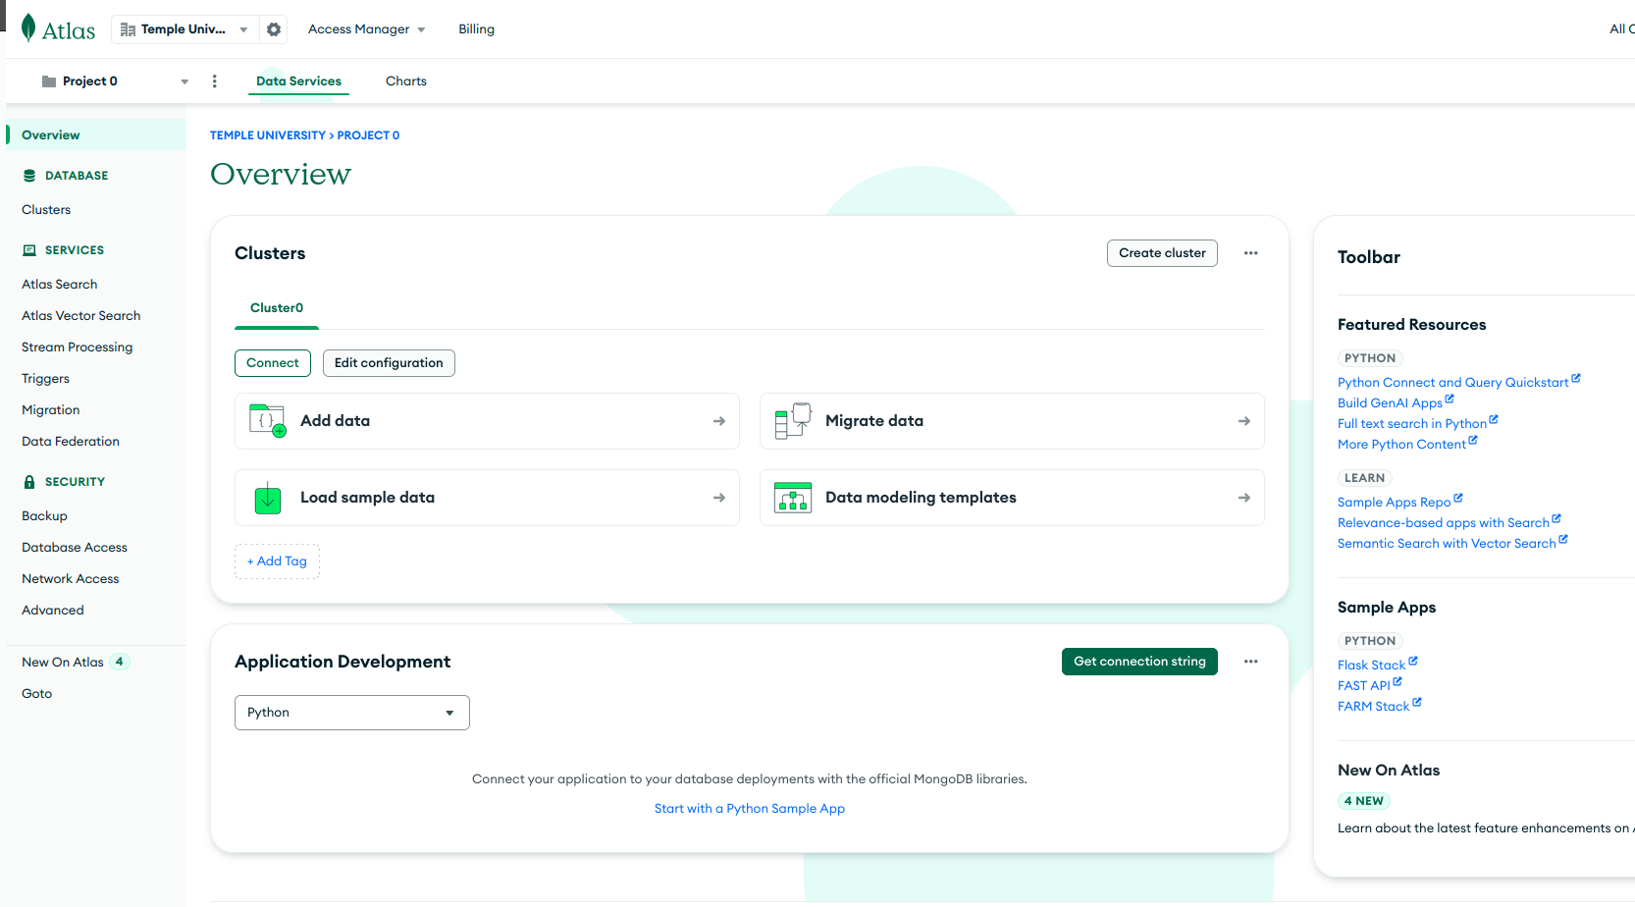

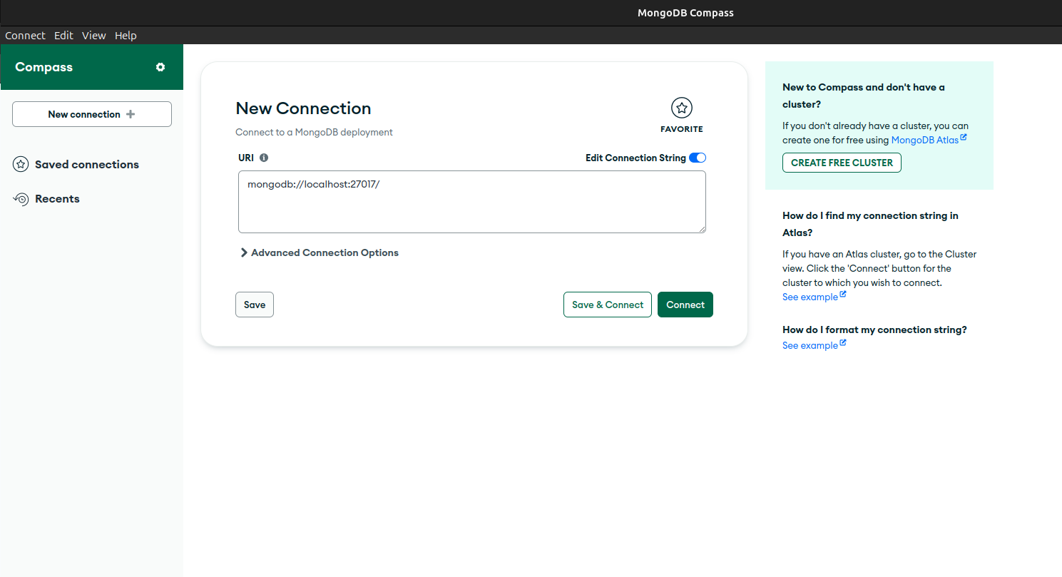

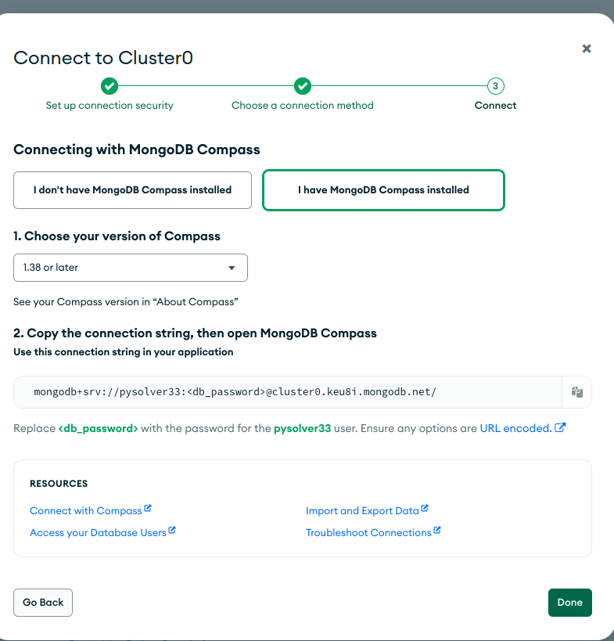

Play with the data:

i. Select all entries in the database WHERE the cuisine is Pizza.

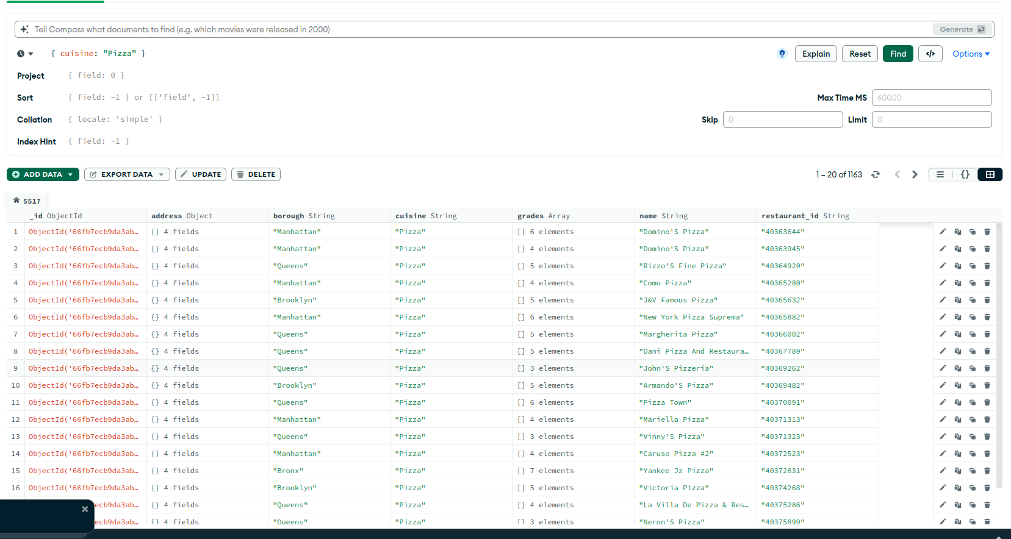

ii. Select only the boroughs and name of the restaurant where the cuisine is Pizza.

Study how you can avoid displaying the id.

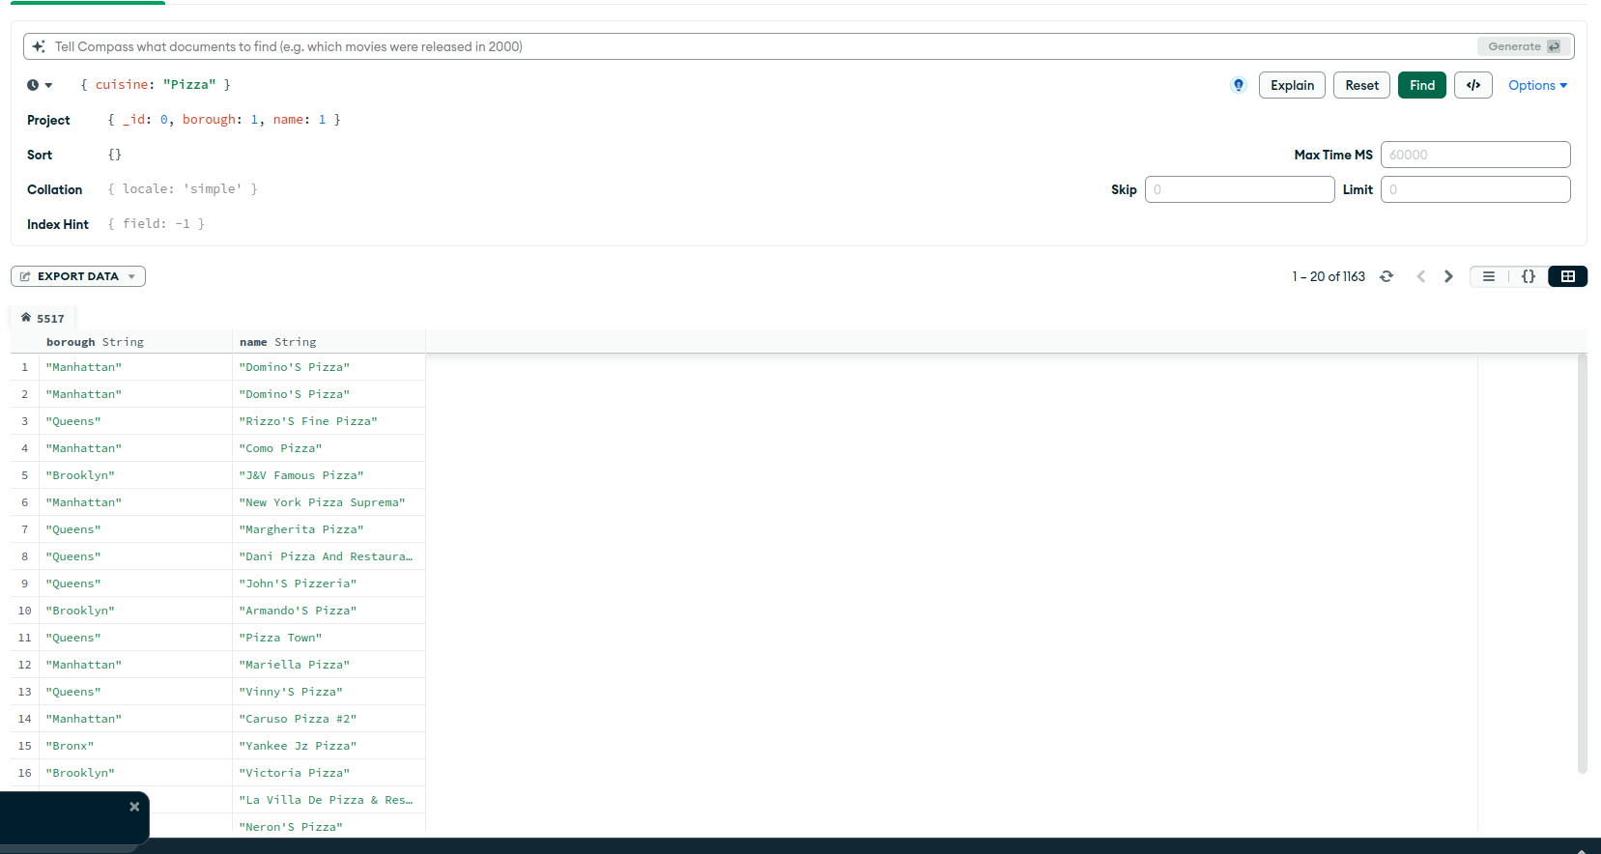

iii. Insert a new restaurant with an address in Philly and cuisine French.

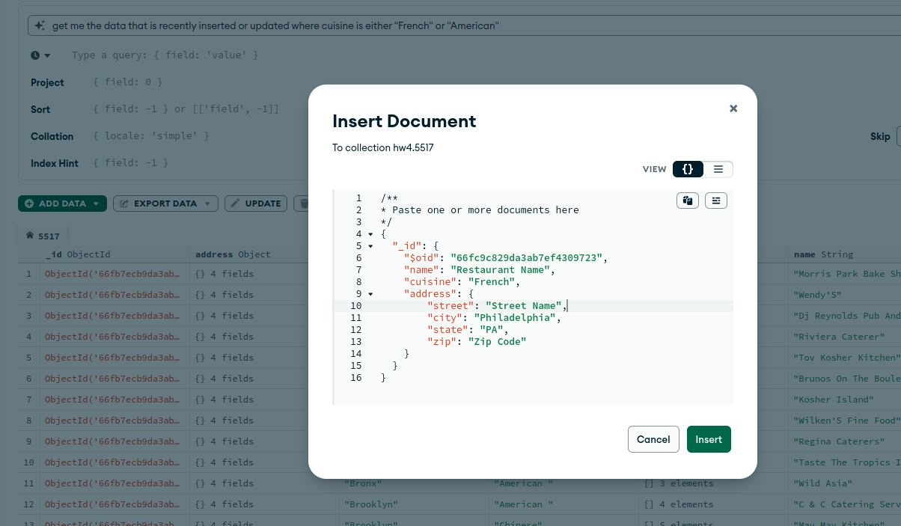

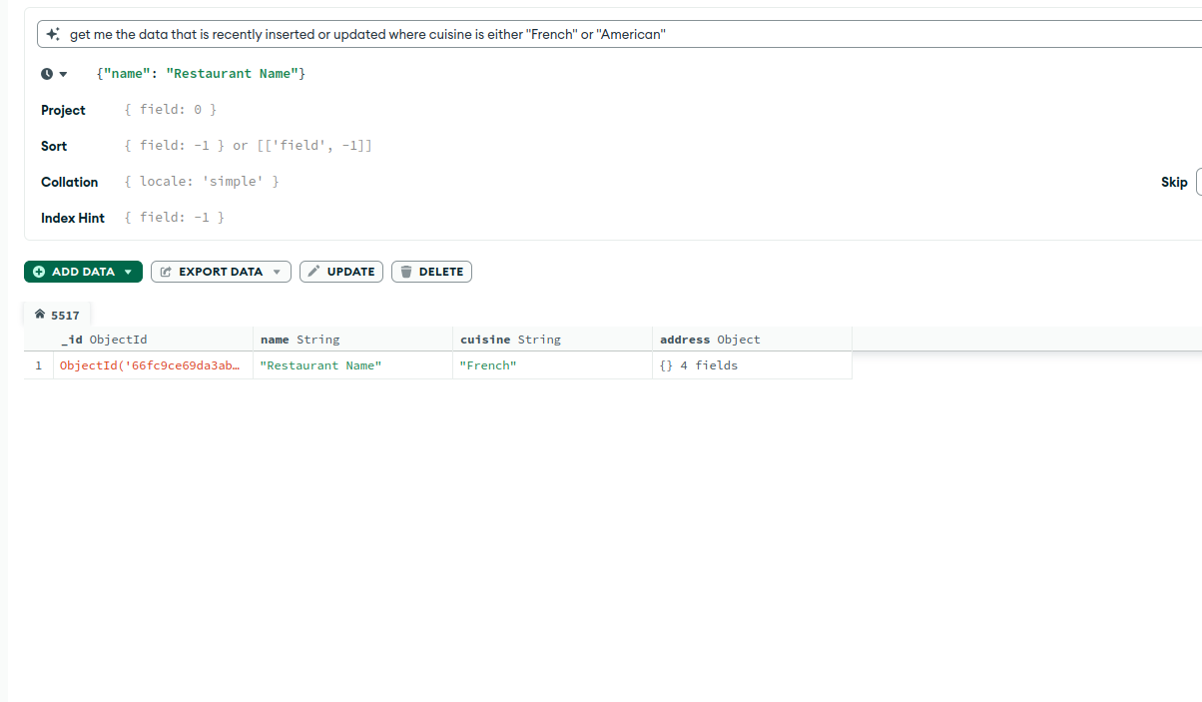

iv. Update your new restaurant just inserted. Set the cuisine to "American."

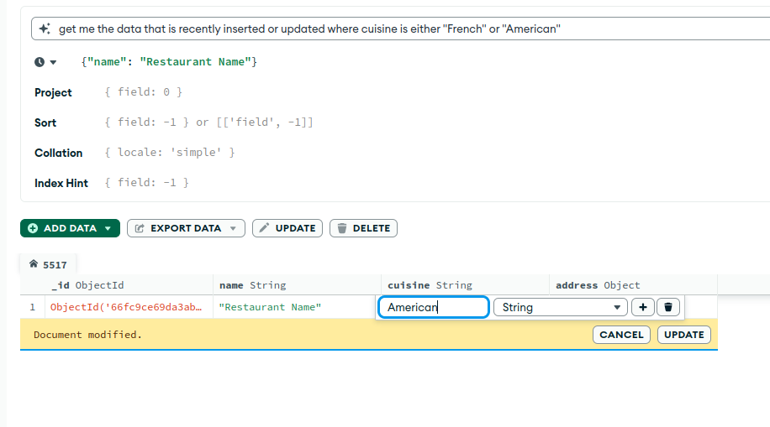

v. Select all the details for only the new record you created and updated.

vi. Remove the restaurant you created

