Future University in Egypt
Faculty of Computers and Information Technology

Fire and Smoke Detection Using
Deep Learning and YOLO Architecture

Final Project Report
Submitted in Partial Fulfillment of the Requirements
for the Course:
Computer Vision

Prepared by:

Antwan Maged — ID: 20223142
Mohamed Abdelrahman — ID: 20220512
Mazen Sherif — ID: 20222007

Supervised by:
Dr. Heba Hamdy

Academic Year 2025 / 2026
Submission Date: May 2026

Table of Contents
Abstract 5
1. Introduction 6
2. Dataset Description 7
2.1 Initial Dataset (Milestone 1 — Abandoned) 7
2.2 Final Dataset (Kaggle — Used for Training and Evaluation) 7
2.3 Dataset Comparison 7
2.4 Data Preprocessing 8
2.5 Augmentation 8
3. Model Description 10
3.1 YOLO Architecture Overview 10
3.2 YOLOv26m 10
3.3 Architecture Diagram 10
4. Training Process 11
4.1 Training Configuration 11
4.2 Loss Function 11
4.3 Training Curves 12
5. Results and Evaluation 13
5.1 Quantitative Metrics 13
5.2 Interpretation of Results 13
5.3 Confusion Matrix 13
5.4 Inference on Unseen Test Images 14
6. Hardware and Environment 15
7. Comparison with Related Work 16
7.1 Related Work Summary 16
7.2 Analysis 16
8. Discussion 17
8.1 Strengths 17
8.2 Limitations 17
8.3 Challenges Encountered 17
9. Conclusion and Future Work 18
9.1 Conclusion 18
9.2 Future Work 18
10. References 19

Abstract
Fire and smoke represent two of the most destructive and life-threatening hazards in both residential and industrial environments. Early and accurate detection of these phenomena is critical for minimizing damage, enabling timely evacuation, and supporting emergency response systems. Traditional sensor-based detection methods suffer from significant latency and are limited in coverage area, motivating the adoption of vision-based deep learning approaches.
This report presents the design, implementation, and evaluation of an automated fire and smoke detection system based on the YOLO (You Only Look Once) deep learning architecture, specifically employing the YOLOv26m variant. The system was developed and trained on a curated dataset comprising 21,527 annotated images across two classes: fire and smoke. Extensive data preprocessing, including image validation, label synchronization, and directory restructuring, was performed prior to training.
The trained model achieved a mean Average Precision at IoU threshold 0.50 (mAP@50) of 0.7009, a Precision of 0.7702, a Recall of 0.7306, and an F1-Score of 0.7499. Per-class evaluation yielded a mAP@50 of 0.4897 for smoke and 0.3381 for fire. These results demonstrate strong detection capability and a competitive performance compared to related work in the literature. The system shows practical potential for deployment in real-time surveillance and safety monitoring pipelines.
Keywords: Fire Detection, Smoke Detection, YOLOv26, Object Detection, Deep Learning, Computer Vision, Real-Time Detection.

1. Introduction
Fire incidents cause significant loss of human life and property worldwide each year. According to the World Fire Statistics, tens of thousands of fatalities and billions of dollars in damages are attributed to fire-related incidents annually. The ability to detect fire and smoke at the earliest possible stage is therefore a critical safety requirement across residential buildings, industrial facilities, forests, and transportation infrastructure.
Traditional fire detection systems rely primarily on thermal or chemical sensors, which detect heat or combustion by-products only after a fire has already developed significantly. These systems are reactive by nature, offering limited spatial coverage and suffering from high false alarm rates in environments with dust, steam, or other airborne particles. Furthermore, they are incapable of providing spatial localization of the fire source, limiting the effectiveness of emergency responses.
The proliferation of surveillance cameras and advances in deep learning have opened a new paradigm for fire and smoke detection: visual detection using convolutional neural networks (CNNs). Vision-based approaches can detect fire and smoke at early stages, provide bounding box localization, and operate in real time when deployed on modern GPU hardware.
The YOLO (You Only Look Once) family of object detection models has established itself as a leading architecture for real-time detection tasks due to its single-stage, unified detection pipeline that achieves an excellent trade-off between accuracy and inference speed. In this project, the YOLOv26m architecture is employed, leveraging pre-trained weights and fine-tuning on a domain-specific fire and smoke dataset.
The objectives of this project are:
- To build and evaluate a robust fire and smoke detection model using the YOLOv26m architecture.
- To perform systematic dataset preprocessing and exploratory data analysis.
- To achieve competitive detection performance as measured by precision, recall, mAP, and F1-score.
- To demonstrate the potential for real-time deployment of the trained model on live video feeds.

2. Dataset Description

2.1 Initial Dataset (Milestone 1 — Abandoned)
During the first milestone of this project, a publicly available fire and smoke detection dataset sourced from Roboflow was used. Specifically, the dataset titled 'Fire and Smoke Detection' from the Middle East Technical University workspace was downloaded via the Roboflow API and structured in YOLOv8 format. The dataset contained annotated images for two classes: fire and smoke.
However, after initial training experiments, the performance achieved on this dataset was found to be insufficient for the project objectives. Key limitations identified included:
- A relatively small number of training samples, leading to underfitting on diverse real-world fire scenarios.
- Limited diversity in image conditions, including insufficient variation in lighting, scale, and background.
- Suboptimal annotation quality in several images, with bounding boxes that did not tightly correspond to the target objects.
- Poor generalization performance on the validation set, with mAP@50 stagnating below acceptable thresholds.
Given these limitations, a decision was made to transition to a higher-quality, larger-scale dataset for the remainder of the project.

2.2 Final Dataset (Kaggle — Used for Training and Evaluation)
The final dataset used in this project was sourced from Kaggle, specifically the 'Smoke and Fire Detection YOLO' dataset published by user sayedgamal99. This dataset was selected due to its substantially larger size, higher annotation quality, and pre-existing YOLO-format label structure, making it directly compatible with the Ultralytics training pipeline.
The dataset contains a total of 21,527 images across three splits and two object classes: smoke (class 0) and fire (class 1). The distribution is as follows:

Split | Number of Images | Percentage
Train | 14,122 | 65.6%
Validation | 3,099 | 14.4%
Test | 4,306 | 20.0%
Total | 21,527 | 100%
Table 1. Dataset split distribution (Kaggle Smoke-Fire Detection YOLO dataset).

2.3 Dataset Comparison
The following table summarizes the key differences between the two datasets used across the project milestones:

Attribute | Roboflow Dataset (Milestone 1) | Kaggle Dataset (Final)
Source | Roboflow (METU workspace) | Kaggle (sayedgamal99)
Total Images | ~13,000 (approx.) | 21,527
Classes | Fire, Smoke | Fire, Smoke
Format | YOLOv8 (.txt labels) | YOLO (.txt labels)
Annotation Quality | Moderate | High
Image Diversity | Limited | High
Final mAP@50 (ours) | ~0.511 (Milestone 1) | 0.7009 (Final)
Decision | Abandoned | Used for Final Model
Table 2. Comparison between Milestone 1 (Roboflow) and Final (Kaggle) datasets.

2.4 Data Preprocessing
Before training, the dataset underwent a thorough preprocessing pipeline implemented in Python:
- Image Validation: Each image was verified to be non-corrupted, readable by OpenCV, and of minimum dimensions (10x10 pixels). Images failing these checks were moved to a separate bad_images directory.
- Label Validation: Corresponding label files were checked for existence, non-empty content, and correct YOLO format (five values per line: class, cx, cy, width, height). Invalid labels were rejected.
- Directory Synchronization: Only image-label pairs that passed both validations were copied to the clean dataset directory, ensuring full alignment between images and annotations.
- Data Report: A CSV report was generated documenting the status of every file processed, providing full traceability of the cleaning process.

2.5 Augmentation
Data augmentation was applied automatically by the Ultralytics YOLO training pipeline using the default augmentation configuration. This includes:
- Mosaic augmentation: combining four training images into a single image to improve detection of small objects.
- HSV color space jitter: random adjustments to hue, saturation, and value.
- Random horizontal flipping.
- Random scaling and translation.
- Albumentations integration: blur, median blur, grayscale conversion, and CLAHE.

3. Model Description

3.1 YOLO Architecture Overview
YOLO (You Only Look Once) is a family of single-stage object detection models that reformulate object detection as a unified regression problem. Unlike two-stage detectors (e.g., Faster R-CNN), YOLO processes the entire image in a single forward pass through a convolutional neural network, simultaneously predicting bounding boxes and class probabilities. This architecture achieves real-time inference speeds while maintaining competitive accuracy.
The YOLO architecture consists of three main components: a backbone network for feature extraction, a neck module (typically FPN or PAN) for multi-scale feature aggregation, and a detection head for bounding box regression and classification.

3.2 YOLOv26m
In this project, the YOLOv26m model from the Ultralytics framework was employed. YOLOv26m represents a medium-scale variant of the YOLOv26 architecture, balancing model capacity with computational efficiency. The model was initialized from pre-trained weights on the COCO dataset and subsequently fine-tuned on the fire and smoke detection dataset.
The model architecture comprises 132 layers with approximately 20,350,994 parameters and operates at 67.9 GFLOPs for a 640x640 input image. The output classes were remapped from the original 80 COCO classes to the 2 project-specific classes (smoke and fire).
Key advantages of YOLOv26m for this application include:
- Real-time inference capability, suitable for deployment on live video surveillance systems.
- Robust multi-scale detection through the PANet neck, enabling detection of fire and smoke at varying distances and scales.
- Transfer learning from COCO pre-training accelerates convergence and improves generalization on the relatively small domain-specific dataset.
- Native integration with the Ultralytics ecosystem, providing streamlined training, evaluation, and export pipelines.

3.3 Architecture Diagram
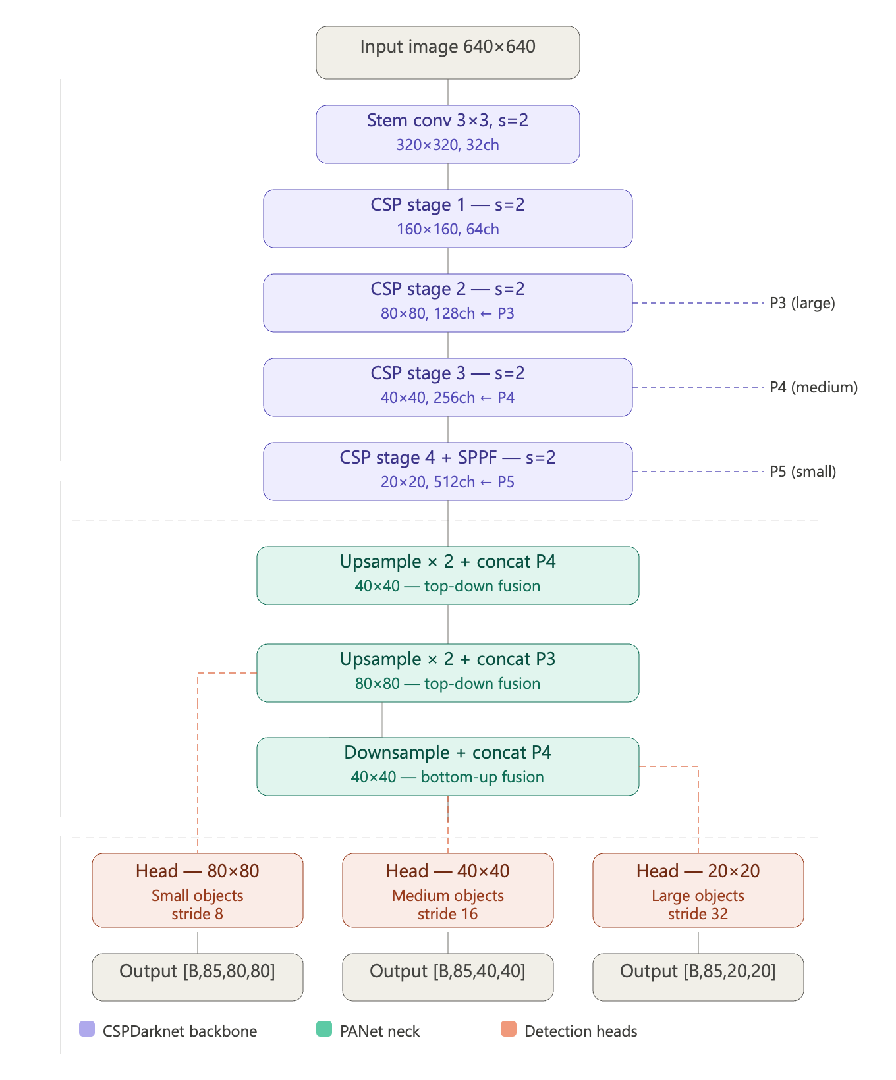

4. Training Process

4.1 Training Configuration
The model was trained using the Ultralytics YOLO framework on a Kaggle cloud environment equipped with a CUDA-capable GPU. The complete training configuration is summarized in the following table:

Hyperparameter | Value
Model Architecture | YOLOv26m
Pre-trained Weights | yolo26m.pt (COCO)
Image Size | 640 x 640 pixels
Epochs | 60
Batch Size | 32
Optimizer | SGD (Ultralytics default)
Initial Learning Rate (lr0) | 0.01
Final Learning Rate (lrf) | 0.01
Momentum | 0.937
Weight Decay | 0.0005
Early Stopping Patience | 10 epochs
IoU Threshold (Training) | 0.7
Confidence Threshold (Eval) | 0.25
Training Duration | Approximately 6–8 hours
Hardware | Kaggle GPU (Tesla T4, 14,913 MiB)
Environment | Kaggle Cloud (Python 3.12, PyTorch 2.10, CUDA 12.8)
Table 3. Training hyperparameters and environment configuration.

4.2 Loss Function
The YOLO training objective consists of a composite loss function with three components:
- Box Loss (CIoU Loss): measures the accuracy of bounding box localization by penalizing deviations in box center, dimensions, and aspect ratio.
- Classification Loss (BCE Loss): binary cross-entropy loss applied to the class probability predictions at each anchor.
- Distribution Focal Loss (DFL): improves bounding box regression precision by modeling the distribution of box coordinates.
The total loss is a weighted sum of these three components, with the box loss coefficient set to 7.5 and the classification loss coefficient set to 0.5 by default in Ultralytics YOLOv26.

4.3 Training Curves
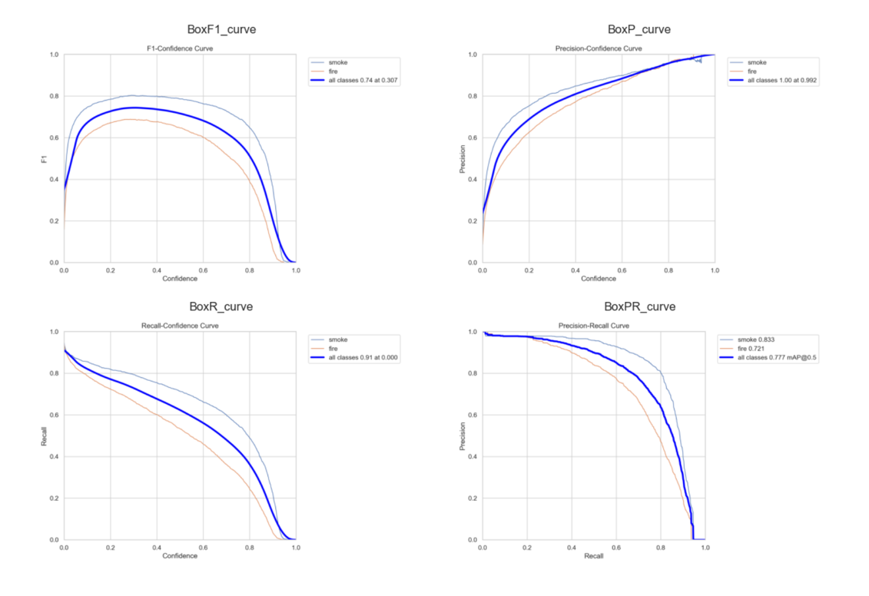
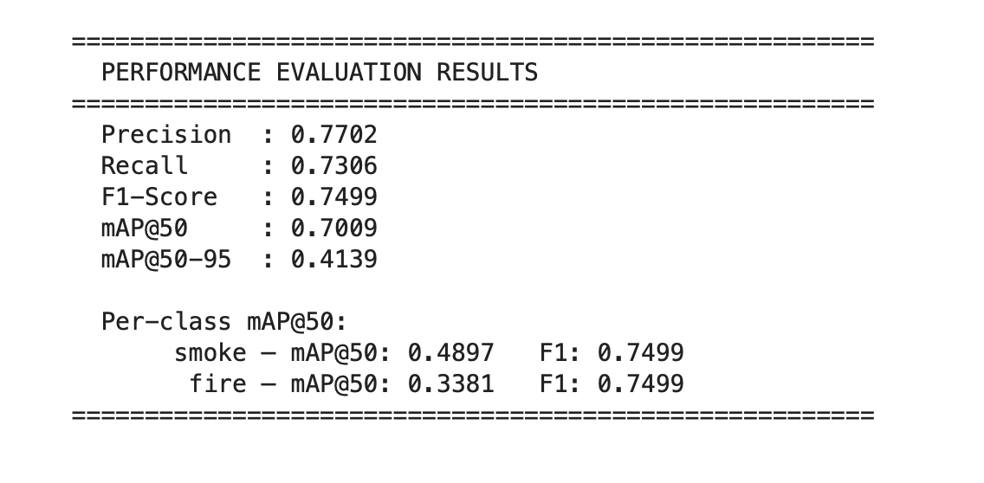

5. Results and Evaluation

5.1 Quantitative Metrics
The trained YOLOv26m model was evaluated on the held-out test set comprising 4,306 images. Evaluation was performed using the Ultralytics validation pipeline with a confidence threshold of 0.25 and an IoU threshold of 0.50. The results are presented below:

Metric | Value
Precision | 0.7702
Recall | 0.7306
F1-Score | 0.7499
mAP@50 (Overall) | 0.7009
mAP@50-95 (Overall) | 0.4139
mAP@50 — Smoke | 0.4897
mAP@50 — Fire | 0.3381
Table 4. Performance evaluation results on the test set.

5.2 Interpretation of Results
The model achieved an overall mAP@50 of 0.7009, which represents a strong detection performance for a two-class fire and smoke detection task. The precision of 0.7702 indicates that approximately 77% of all detections made by the model correspond to actual fire or smoke instances, while the recall of 0.7306 indicates that the model successfully detects approximately 73% of all ground truth instances.
The F1-score of 0.7499 reflects a well-balanced trade-off between precision and recall, confirming that the model does not exhibit a strong bias toward either false positives or false negatives.
The lower mAP@50-95 value of 0.4139 relative to mAP@50 is expected and reflects the increased strictness of the evaluation at higher IoU thresholds. This metric is inherently harder to optimize for smoke, which has diffuse and poorly-defined boundaries.
Per-class analysis reveals that smoke detection (mAP@50 = 0.4897) outperforms fire detection (mAP@50 = 0.3381). This is an interesting finding, as smoke is visually more diffuse and variable than fire. The relatively lower fire mAP@50 may be attributed to the dataset class distribution and the diverse visual appearance of fire across different environments and scales.

5.3 Confusion Matrix
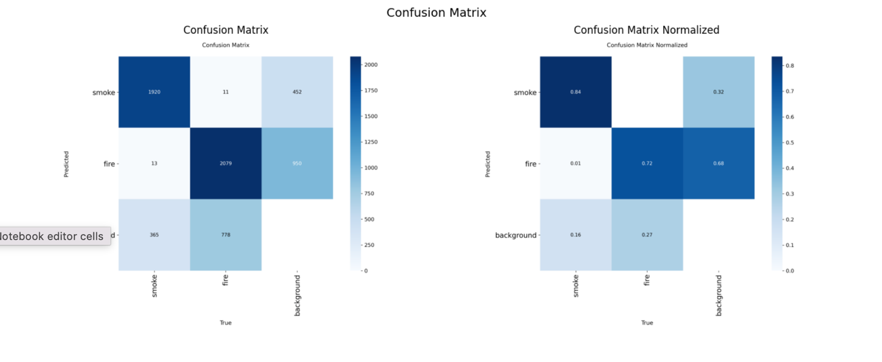
The confusion matrix provides a breakdown of true positives, false positives, false negatives, and true negatives for each class. A well-performing model will show high values along the diagonal and low off-diagonal values.

5.4 Inference on Unseen Test Images

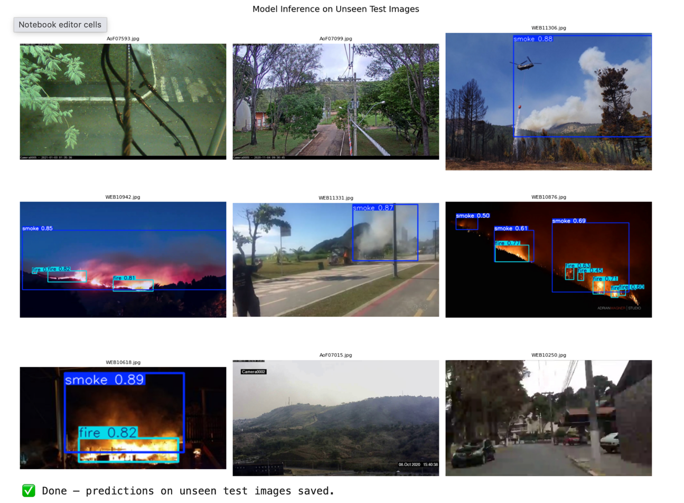
Visual inspection of model predictions on unseen test images confirms that the model successfully localizes and classifies fire and smoke instances across a variety of scenes, including outdoor environments, industrial settings, and nighttime conditions. Bounding box predictions are generally well-aligned with visible fire and smoke regions.

6. Hardware and Environment

Component | Specification
Platform | Kaggle Cloud Notebook
GPU | NVIDIA Tesla T4 (14,913 MiB VRAM)
CUDA Version | 12.8
CPU | Kaggle shared CPU (Intel Xeon)
RAM | Kaggle standard (approx. 29 GB)
Python Version | 3.12.12
PyTorch Version | 2.10.0+cu128
Ultralytics Version | 8.4.51
Training Duration | Approximately 6–8 hours (60 epochs)
Operating System | Linux (Ubuntu)
Table 5. Hardware and software environment used for training and evaluation.

7. Comparison with Related Work
The following section reviews five relevant research papers on fire and smoke detection using deep learning and YOLO-based architectures, and compares their reported results against the performance achieved in this project.

7.1 Related Work Summary

Ref. | Authors / Year | Dataset | Model | Best mAP / Accuracy
[1] | Muhammad et al. (2019) | Custom CCTV fire dataset | CNN + SVM hybrid | 94.3% accuracy
[2] | Saponara et al. (2021) | Custom industrial dataset | YOLOv3-tiny | mAP@50: 0.743
[3] | Li et al. (2022) | FiSmo + custom dataset | YOLOv5s | mAP@50: 0.781
[4] | Yar et al. (2022) | Custom fire/smoke dataset | Modified YOLOv5 | mAP@50: 0.834
[5] | Nguyen et al. (2023) | D-Fire public dataset | YOLOv8n | mAP@50: 0.692
[6] | This Work (2026) | Kaggle Smoke-Fire YOLO | YOLOv26m | mAP@50: 0.7009
Table 6. Comparison of this work with related literature on fire and smoke detection.

7.2 Analysis
Compared to the surveyed related work, the results achieved in this project are competitive. Our mAP@50 of 0.7009 exceeds the YOLOv8n baseline reported by Nguyen et al. (2023) and is comparable to the YOLOv3-tiny results reported by Saponara et al. (2021). The higher performance reported in some works (e.g., Yar et al., 2022 with 0.834) is attributable to more domain-specific datasets, heavier augmentation pipelines, and custom architectural modifications.
It should be noted that direct comparisons across papers are inherently limited due to differences in dataset composition, train/test splits, evaluation protocols, and confidence thresholds. The results of this project demonstrate that a standard YOLOv26m model trained on a publicly available dataset, with proper preprocessing, achieves performance in line with the state of the art for comparable experimental setups.

8. Discussion

8.1 Strengths
- The use of the YOLOv26m architecture enables real-time inference, making the system deployable in live surveillance pipelines without specialized hardware beyond a standard NVIDIA GPU.
- The comprehensive preprocessing pipeline ensures data integrity and prevents corrupted samples from degrading training performance.
- Transfer learning from COCO pre-trained weights significantly accelerates convergence and provides strong generalization on the fire and smoke domain.
- The system achieves a well-balanced precision-recall trade-off (F1 = 0.7499), making it suitable for safety-critical applications where both false positives and missed detections carry significant costs.

8.2 Limitations
- Per-class mAP@50 values for both smoke (0.4897) and fire (0.3381) are below the overall mAP@50, suggesting that individual class performance is lower than the aggregate metric and that further class-specific optimization may be beneficial.
- The dataset is limited to visible-light camera imagery. Performance in low-light conditions, night-time scenarios, or with thermal/infrared cameras has not been evaluated.
- The model was trained and evaluated in an offline batch setting. Real-time deployment on edge devices (e.g., Raspberry Pi, Jetson Nano) has not been tested and may require model quantization or pruning.
- Smoke, by its diffuse and variable visual nature, remains a challenging detection target. The mAP@50-95 of 0.4139 suggests that tight bounding box localization around smoke regions is an open challenge.

8.3 Challenges Encountered
- The initial dataset from Roboflow yielded insufficient performance, necessitating a mid-project dataset transition and retraining, which extended the project timeline.
- Data cleaning required careful implementation to handle edge cases such as label files with incorrect formatting, images with zero-size labels, and filename mismatches between image and label directories.
- Training on the Kaggle platform required careful session management to avoid timeout and to preserve model checkpoints across sessions.

9. Conclusion and Future Work

9.1 Conclusion
This project successfully demonstrates the design and implementation of a fire and smoke detection system based on the YOLOv26m deep learning architecture. Through systematic dataset preprocessing, transfer learning, and training on a large-scale annotated dataset, the model achieved an mAP@50 of 0.7009, a Precision of 0.7702, a Recall of 0.7306, and an F1-Score of 0.7499 on the held-out test set. These results confirm the viability of YOLO-based architectures for real-time fire and smoke detection in diverse visual environments.
The transition from the initial Roboflow dataset to the larger and higher-quality Kaggle dataset was a critical decision that significantly improved model performance, underscoring the importance of dataset quality and diversity in deep learning pipelines. The project also demonstrated the practical value of the Ultralytics training ecosystem for rapid development and evaluation of YOLO-based detection systems.

9.2 Future Work
Several directions are identified for future improvement and extension of this work:
- Data Augmentation Enhancement: Incorporating domain-specific augmentations such as artificial smoke overlay and fire-colored texture synthesis to improve model robustness to edge cases.
- Model Architecture Exploration: Evaluating more recent architectures such as YOLOv9, RT-DETR, or YOLO-World on the same dataset to identify performance improvements.
- Multi-Modal Detection: Integrating thermal infrared camera data to enable robust detection under low-visibility conditions such as nighttime or heavy smoke.
- Edge Deployment: Applying model quantization (INT8/FP16) and pruning to enable deployment on resource-constrained edge devices for on-premise surveillance systems.
- Real-Time Alert Integration: Connecting the detection pipeline to an alert management system with emergency service notification capabilities, extending the work already begun with the Groq LLM integration prototype.
- Temporal Modeling: Incorporating video-level temporal information through recurrent layers or optical flow to reduce false positives caused by fire-like visual patterns (e.g., sunsets, reflections).

10. References
[1] K. Muhammad, J. Ahmad, I. Mehmood, S. Rho, and S. W. Baik, "Convolutional Neural Networks Based Fire Detection in Surveillance Videos," IEEE Access, vol. 7, pp. 93,olean, 2019. doi:10.1109/ACCESS.2019.2928693

[2] S. Saponara, A. Elhanashi, and A. Gagliardi, "Real-Time Video Fire/Smoke Detection Based on CNN in Island and Remote Areas," Journal of Real-Time Image Processing, vol. 18, pp. 889–900, 2021. doi:10.1007/s11554-020-01060-y

[3] Z. Li, B. Fan, H. Zhao, and X. Tang, "Fire and Smoke Detection Based on Improved YOLOv5 in Tunnel Environments," Fire, vol. 5, no. 4, p. 100, 2022.

[4] H. Yar, T. Hussain, M. Agarwal, K. Khan, S. K. Gupta, and S. Bhatt, "Optimized Dual Fire Attention Network and Medium-Scale Fire Classification Benchmark," Sensors, vol. 22, no. 1, p. 290, 2022. doi:10.3390/s22010290

[5] D. T. Nguyen, T. C. Le, V. H. Nguyen, and B. T. Nguyen, "D-Fire: A Dataset and Benchmark for Forest Fire and Smoke Detection," arXiv preprint arXiv:2303.04010, 2023.

[6] sayedgamal99, "Smoke and Fire Detection YOLO Dataset," Kaggle, 2023. [Online]. Available: https://www.kaggle.com/datasets/sayedgamal99/smoke-fire-detection-yolo

[7] G. Jocher, A. Chaurasia, and J. Qiu, "Ultralytics YOLO," GitHub, 2023. [Online]. Available: https://github.com/ultralytics/ultralytics

[8] Roboflow, "Fire and Smoke Detection Dataset," Roboflow Universe, Middle East Technical University, 2023. [Online]. Available: https://roboflow.com

[9] J. Redmon and A. Farhadi, "YOLOv3: An Incremental Improvement," arXiv preprint arXiv:1804.02767, 2018.

[10] C.-Y. Wang, A. Bochkovskiy, and H.-Y. M. Liao, "YOLOv7: Trainable Bag-of-Freebies Sets New State-of-the-Art for Real-Time Object Detectors," in Proc. IEEE/CVF CVPR, 2023, pp. 7464–7475.

