**PROJECT DOCUMENTATION**

Project Title: Predicting the Energy Output of Wind Turbine Based on Weather Conditions Watson Auto AI

|  |  |  |
| --- | --- | --- |
| Internship Title | : | RSIP Career Basic ML 062 |
| Project ID | : | SPS_PRO_298 |

Name: Komati hariharan

E-mail: kh7477@bennett.edu.in

**INTRODUCTION:**

As we all know that wind energy plays an increasing role in the supply of energy world-wide. Hence this project predicts the energy of the wind generated. The project is done with the help of IBM cloud. It consists of Watson studio Auto AI experiment which uses different pipelines and uses the best one. The prediction of the project is shown using Node Red App.

Auto AI feature of IBM cloud thus helps us to find the best result and when we give the column name that we need to find out the output it will go through the best suitable algorithm and gives us the result. Purpose: As we all know that the Wind energy plays an increasing role in the supply of energy world-wide.

The energy output of a wind farm is highly dependent on the weather conditions present at its site. If the output can be predicted more accurately, energy suppliers can coordinate the collaborative production of different energy sources more efficiently to avoid costly overproduction.

So, with the help of machine learning algorithm we can predict energy prediction based on weather data and analyse the important parameters as well as their correlation on the energy output.

Most manufacturers rate their turbines by the amount of power they can safely produce at a wind speed. A wind turbine manufacturer can help us estimate the energy production you can expect.

They will use a calculation based on the particular wind turbine power curve, the average annual wind speed at your site, the height of the tower that you plan to use, and the frequency distribution of the wind–an estimate of the number of hours that the wind will blow at each speed during an average year.

If the wind speed decreases by half, power production decreases by a factor of eight. On average, therefore, wind turbines do not generate near their capacity that is why we need to predict the energy on different weather conditions so that it will help to boost the amount of energy.

So, to solve this problem Our aim is to map weather data to energy production. We wish to show that even data that is publicly available for weather stations close to wind farms can be used to give a good prediction of the energy output.

Furthermore, we examine the impact of different weather conditions on the energy output of wind farms. We are building an IBM Watson AutoAI Machine Learning technique to predict the energy output of wind turbine.

The model is deployed on IBM cloud to get scoring end point which can be used as API in mobile app or web app building. We are developing a web application which is built using node red service. We make use of the scoring end point to give user input values to the deployed model.

The model prediction is then showcased on User Interface to predict the energy output of wind turbine.

Ranking by root mean square method:

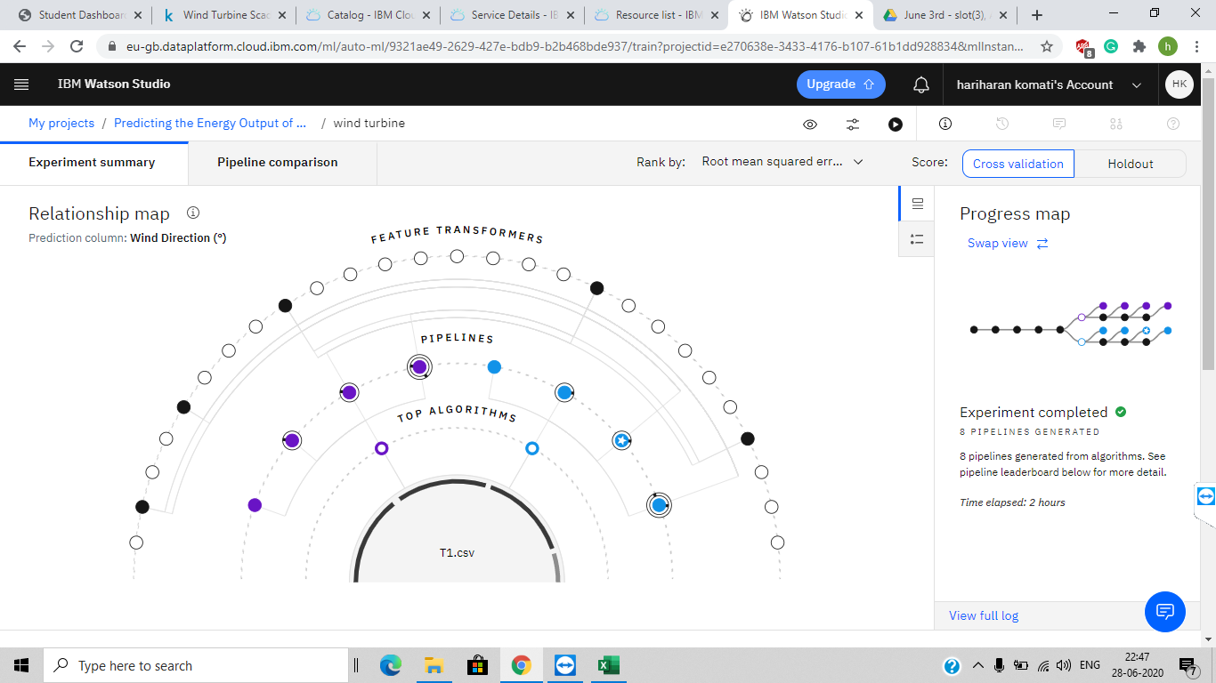

Flow of node red:

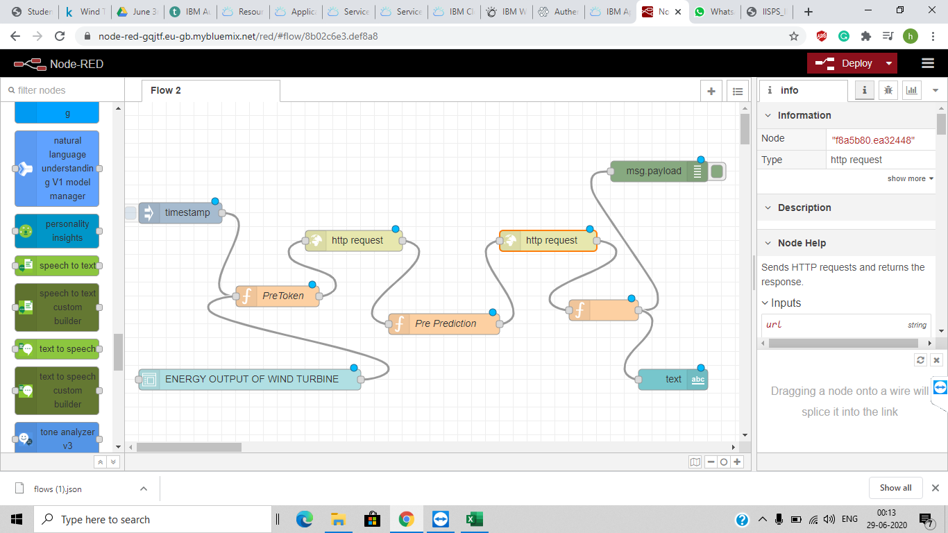

**RESULT: After** successfully done the deployment in the Watson studio we have to present the project. So, with the help of Node red app in the IBM cloud we did the steps as per required and the ui was hence generated. The Node Red UI provide us simple way to get the result of Auto AI Experiment. In this we need to give the inputs like date/time to predict the output. When you click on submit button it will give you the desired result.

**Proposed solution:**

We have examined the impact of different weather conditions on the energy output of wind farms through the dataset given. We have built an IBM Watson AutoAI Machine Learning technique to predict the energy output of wind turbine. Using the Auto AI Experiment, we can build and deploy a machine learning model with sophisticated training features and no coding. The tool does most of the work for you. In this project, the UI model building can help students a lot. With this feature our project is demonstrated in a better way. The predictions can be used in the impact of different weather conditions on the energy output of wind farms. The model is deployed on IBM cloud to get scoring end point which can be used as API in mobile app or web app building. We are developing a web application which is built using node red service which is available to use on other applications.

Reference of dataset in project:

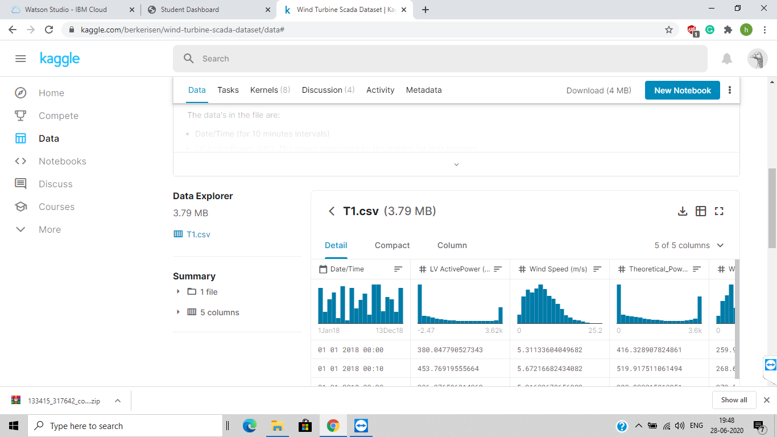

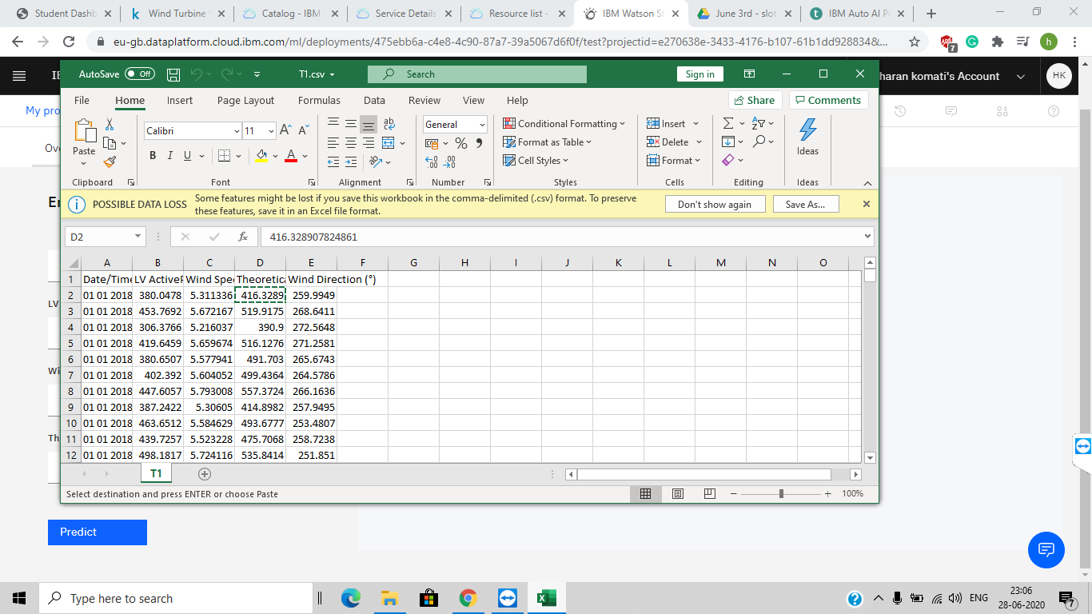

Which we taken directly downloaded from Kaggle .

Thank you.