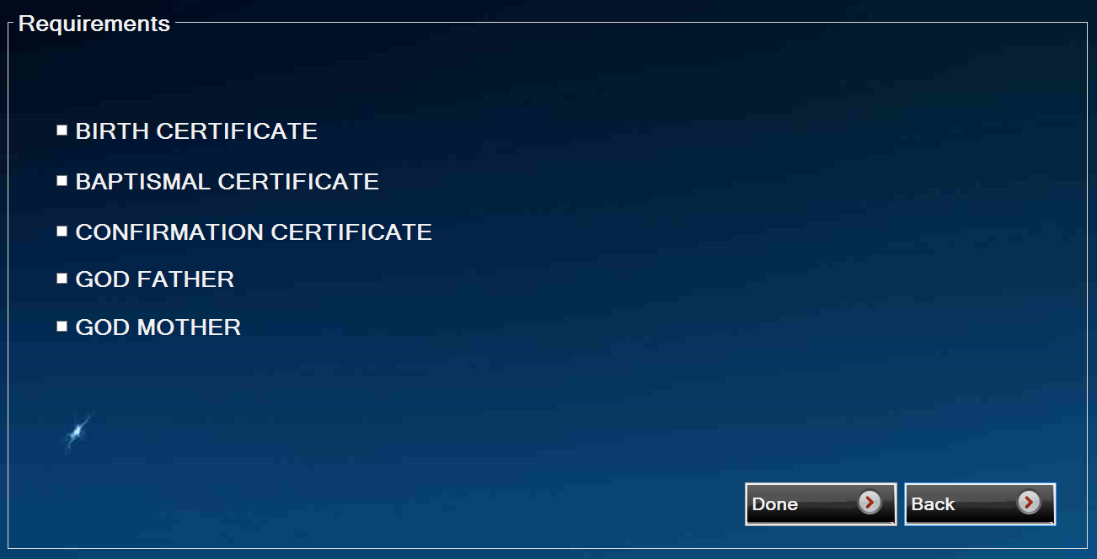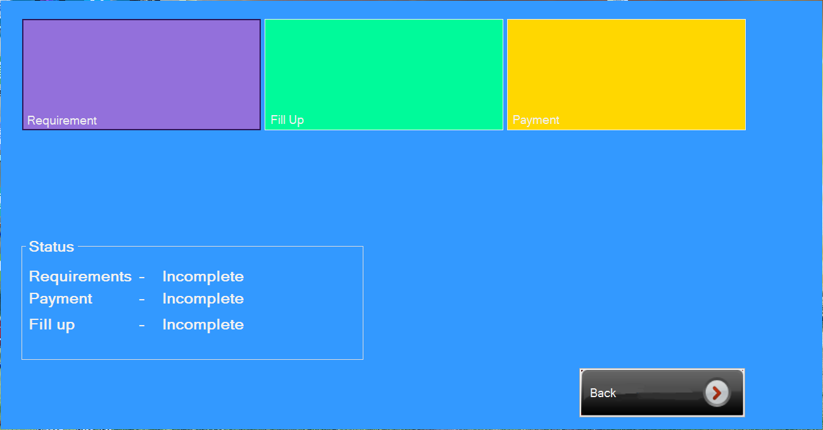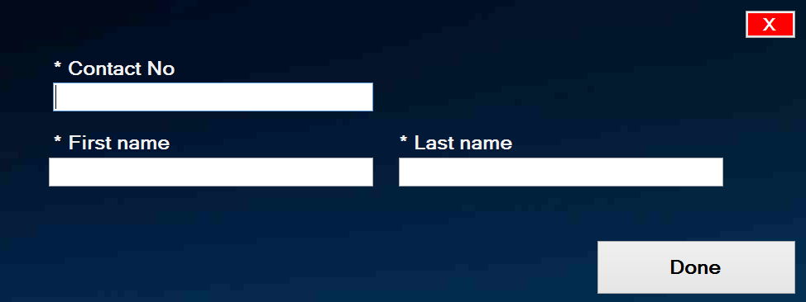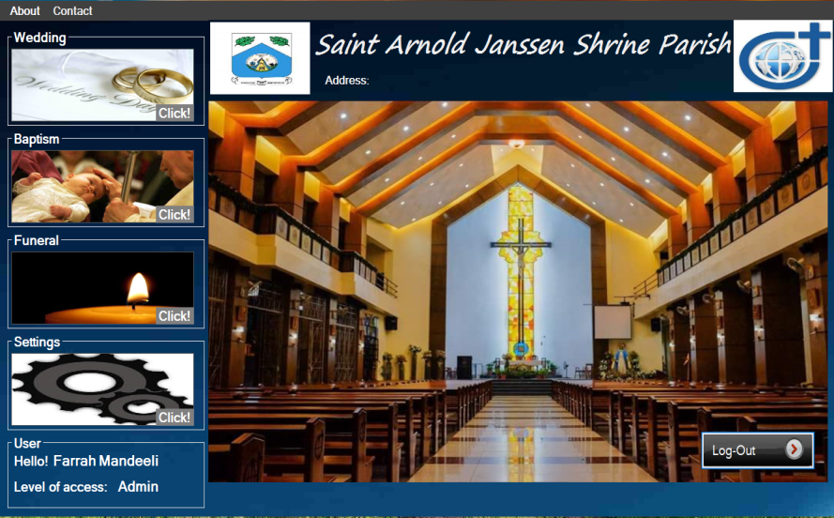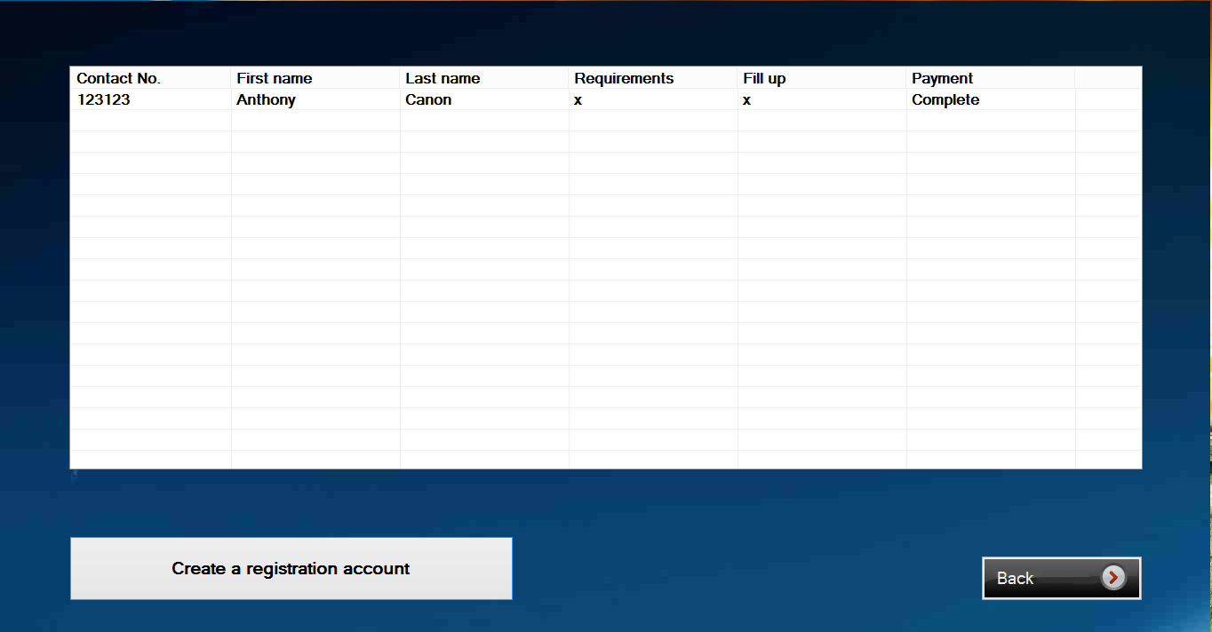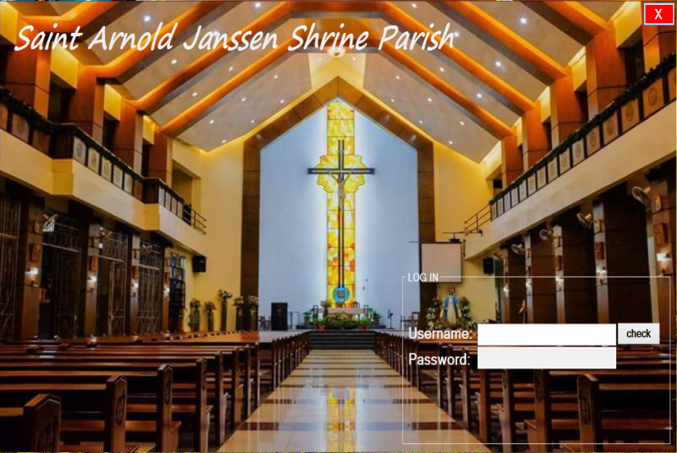Log-in Form Main Form   
  
Registration Form Creating Registration Account   
  
  
  
Wedding Form Wedding Requirements Form

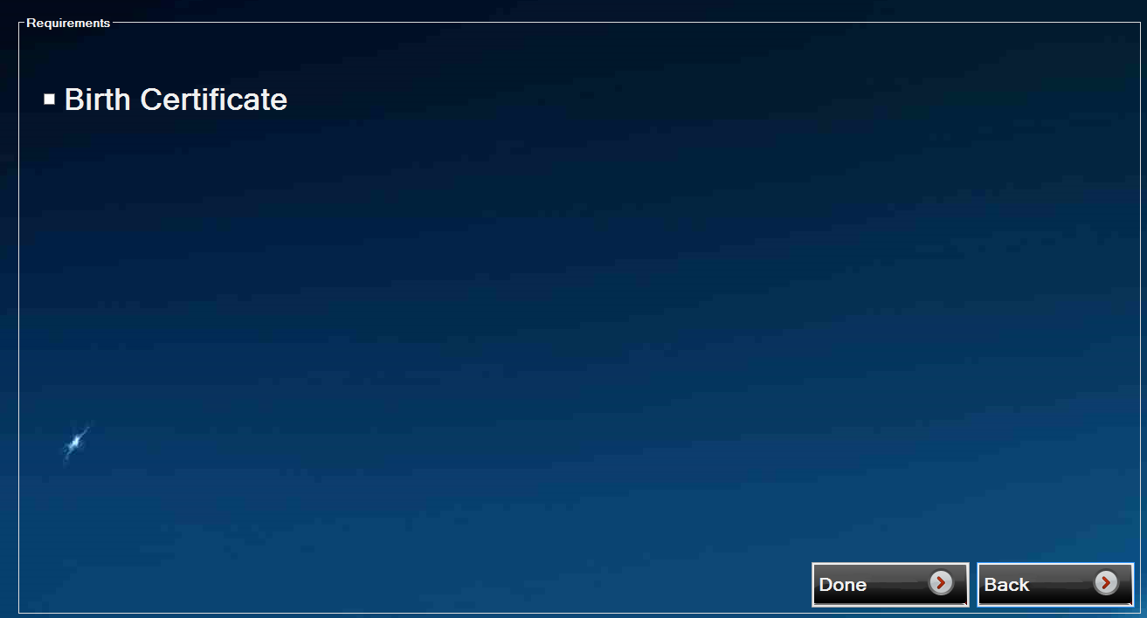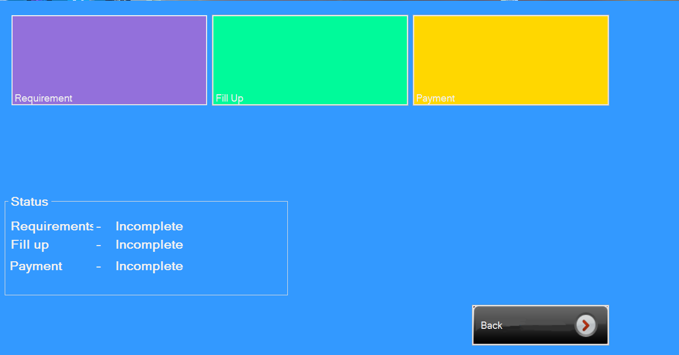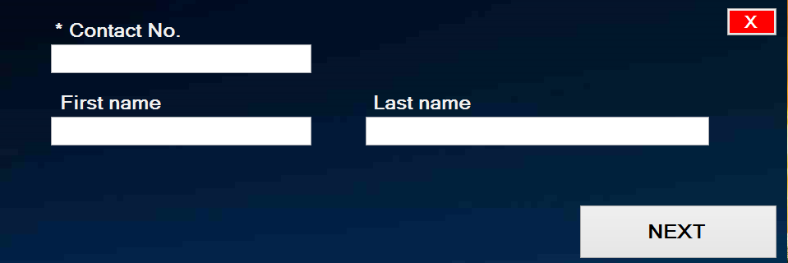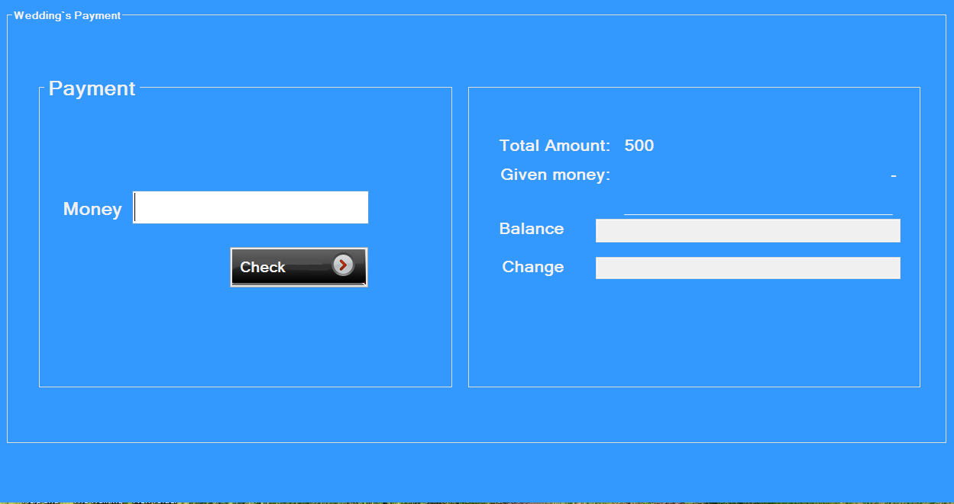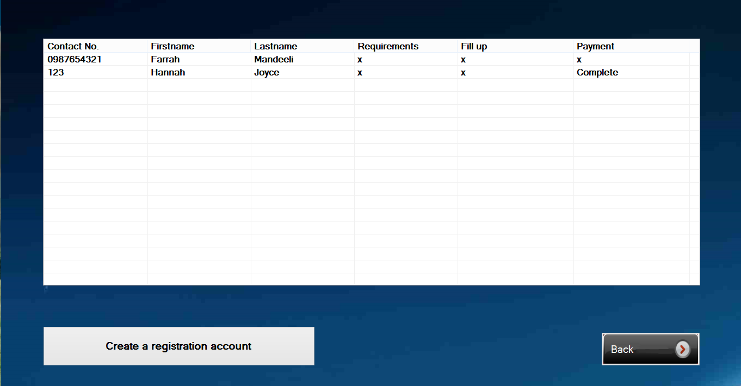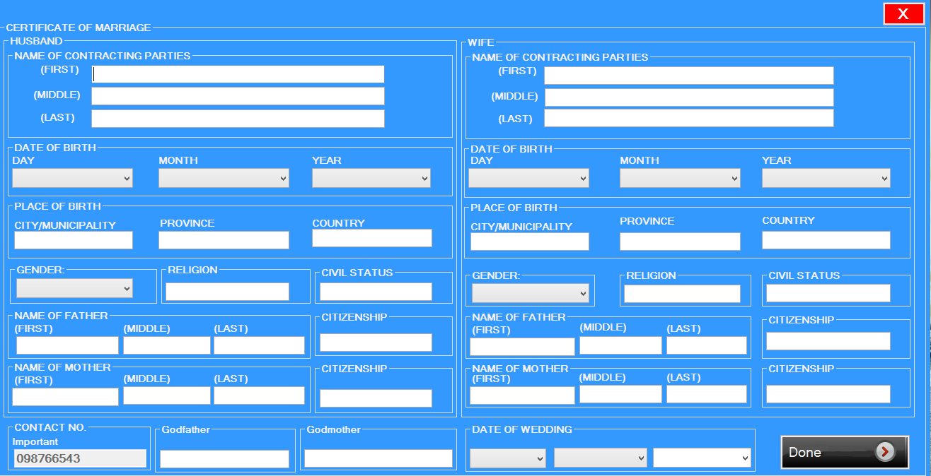Wedding Fillup Form Wedding Payment Form  
  
Registration Form Baptist Registration Creating Account  
  
Baptist Form Baptist Requirements  
  
  
  
  
  
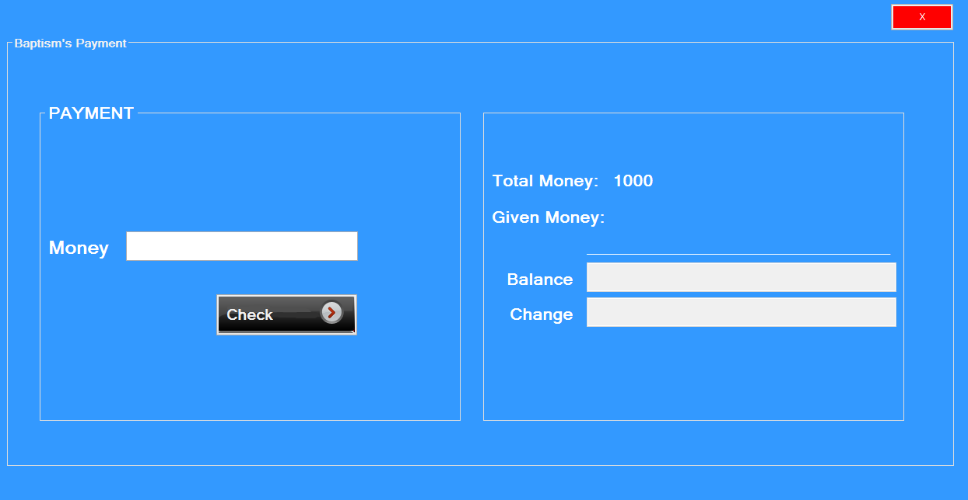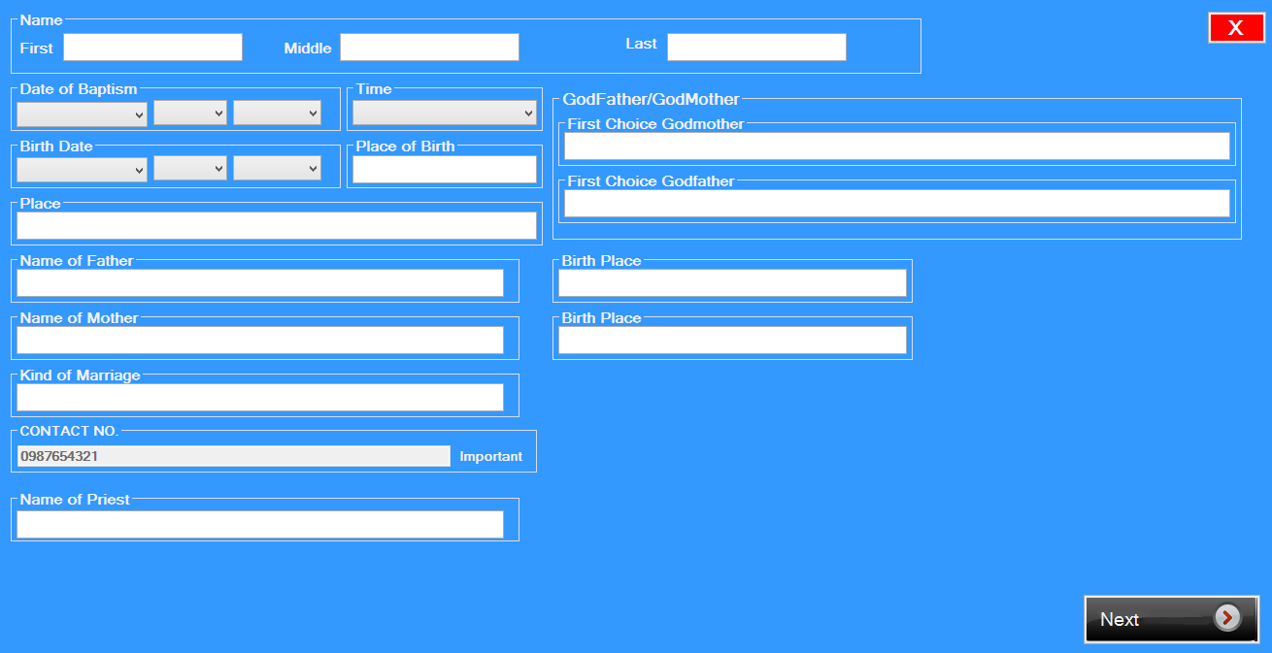Baptist Fill-up Form Baptist Payment Form  
  
Registration Form Funeral Registration Creating Account   
  
  
  
  
  
  
  
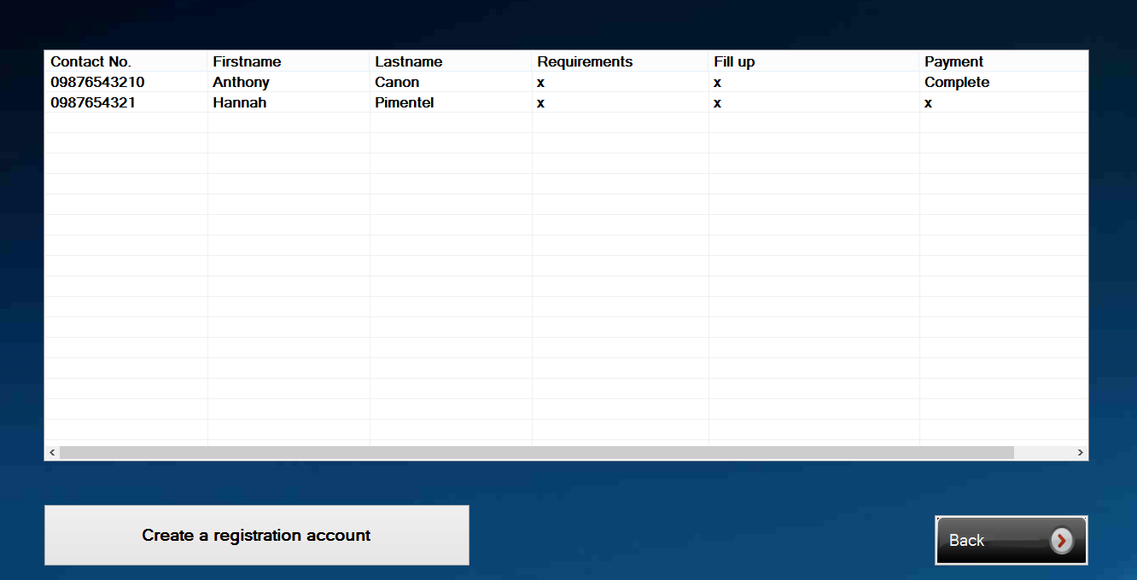  
  
  
  
  
  
  
  
  
  
  
  
Funeral Form Funeral Requirements  
  
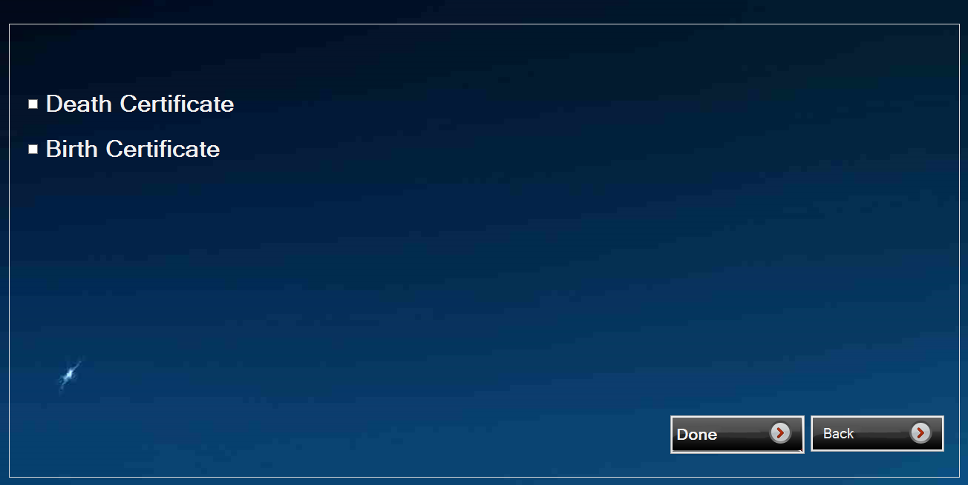



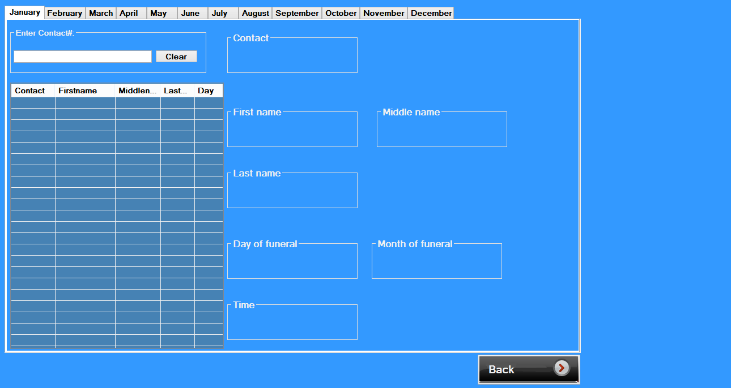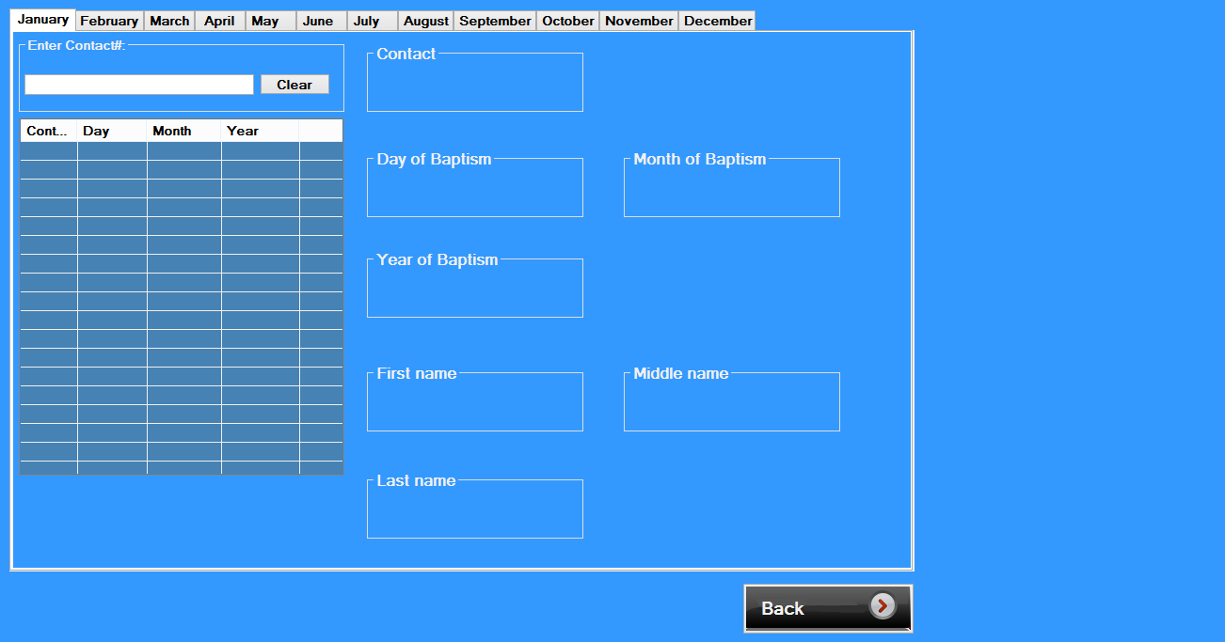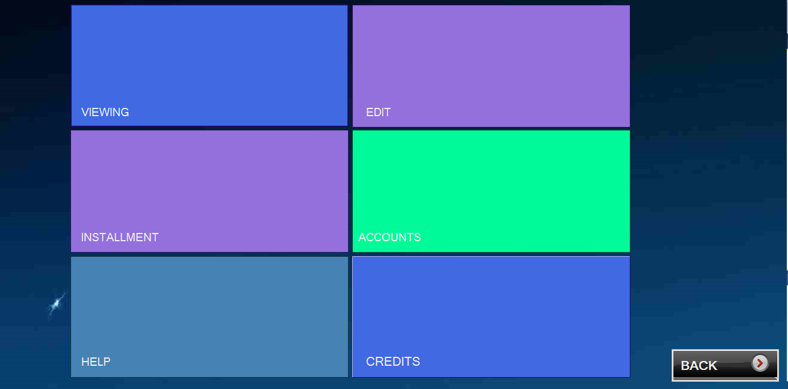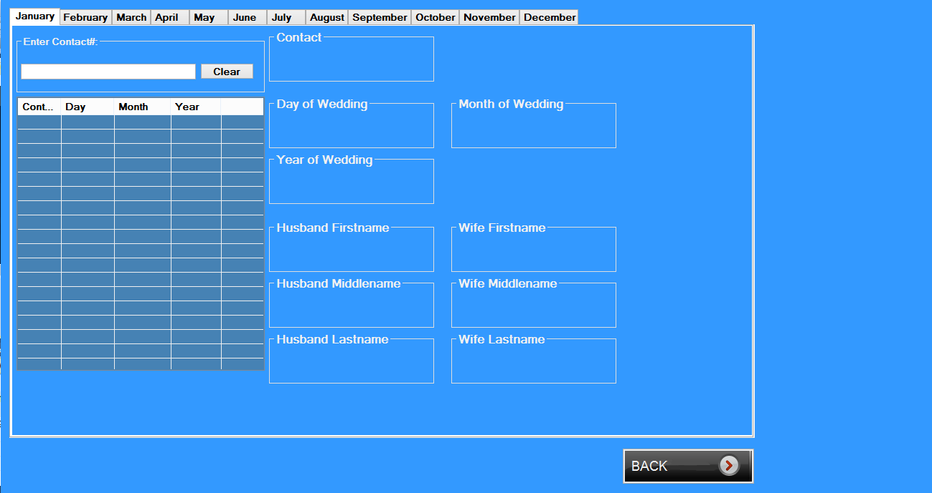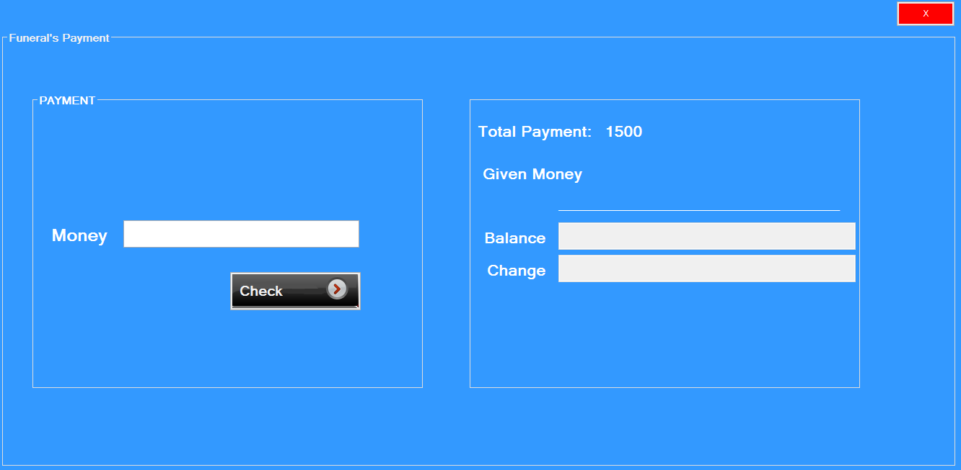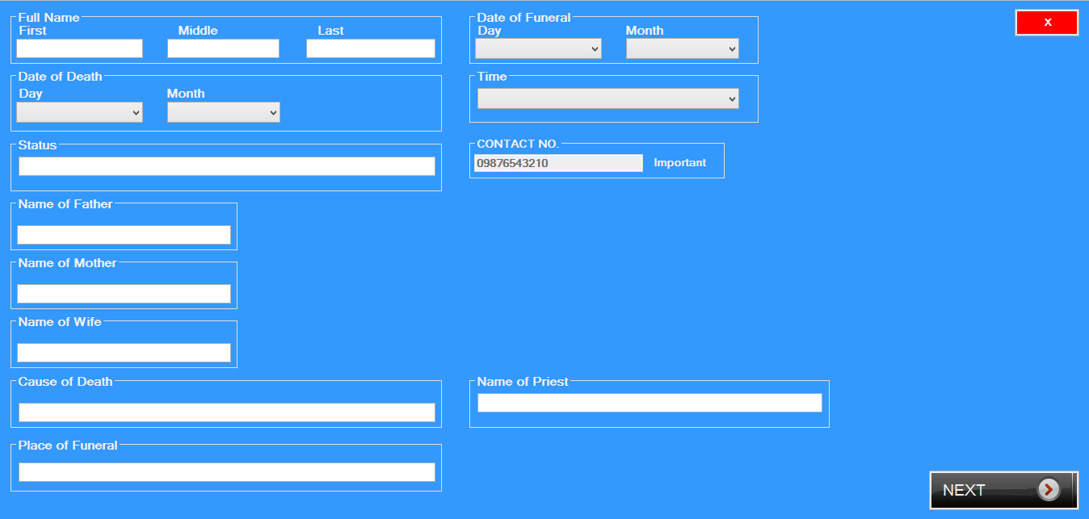Funeral Fillup Form Funeral Payment Form  
  
  
  
  
  
  
  
  
  
  
  
  
  
  
Setting Form Wedding Viewing  
  
  
  
  
  
  
  
  
  
  
  
  
  
Baptist Viewing Funeral Viewing  
  
  
  
  
  
  
  
  
  
  
  
  
  
  
  
  
Wedding Edit Baptist Edit  
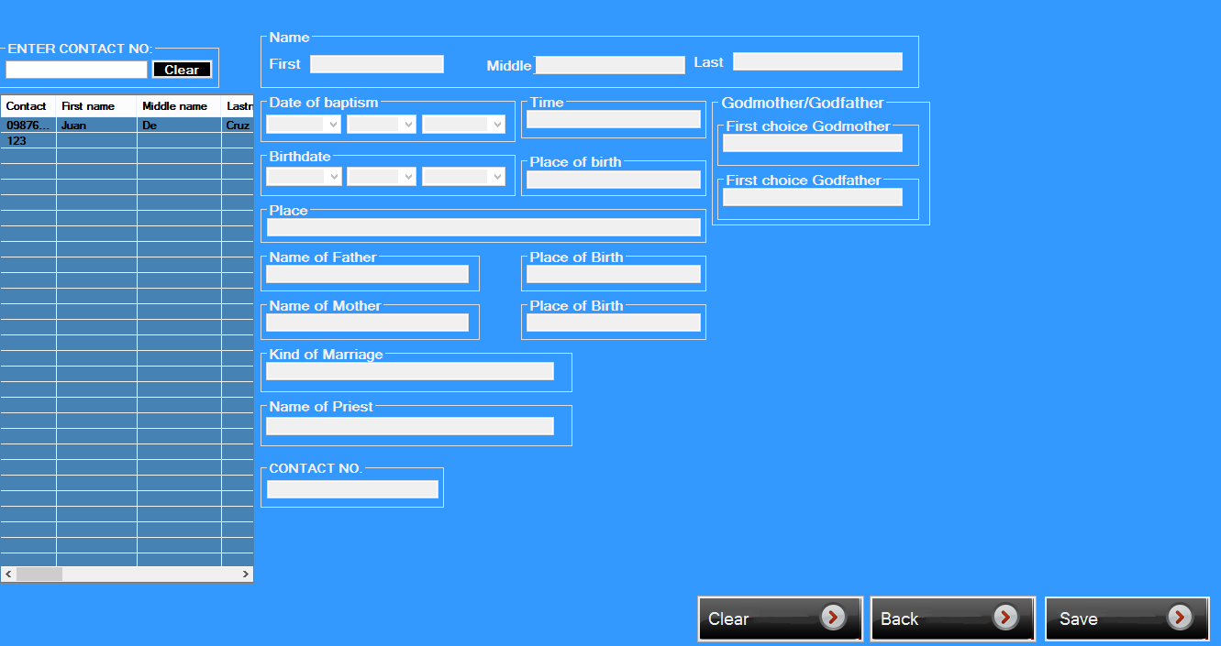  
  
  
  
  
  
  
  
  
  
  
  
  
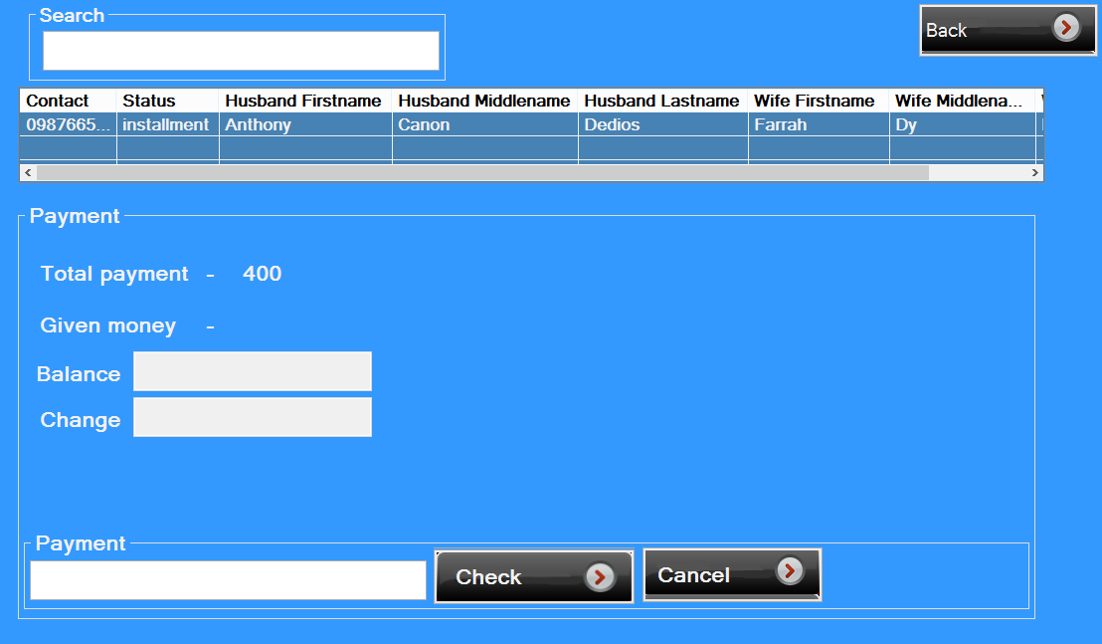Funeral Edit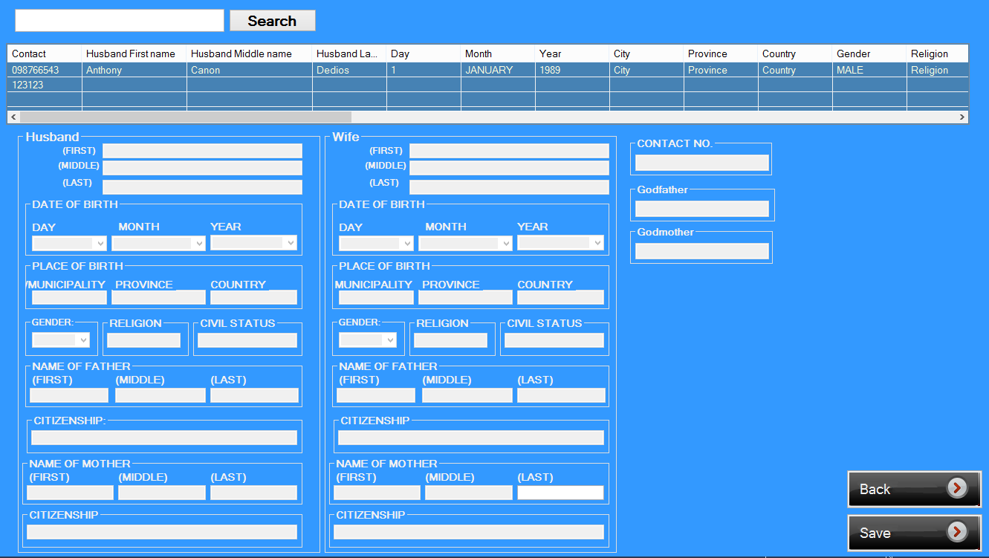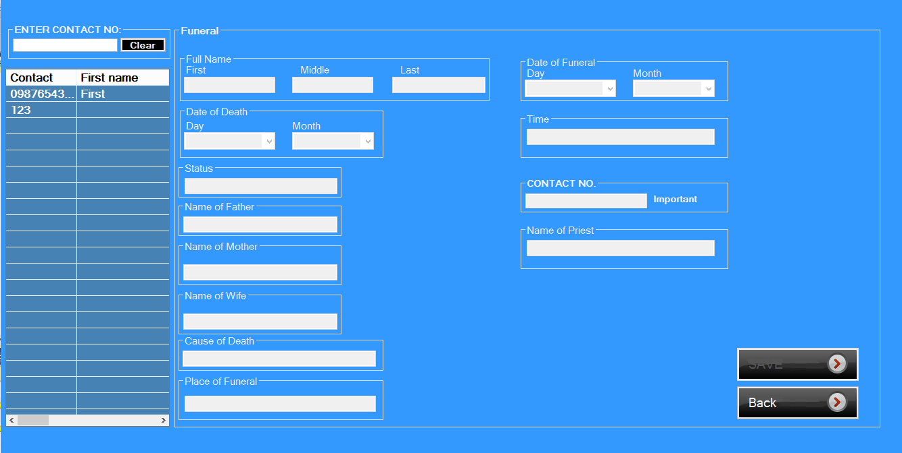 Wedding Installment  
  
Baptist Installment Funeral Installment  
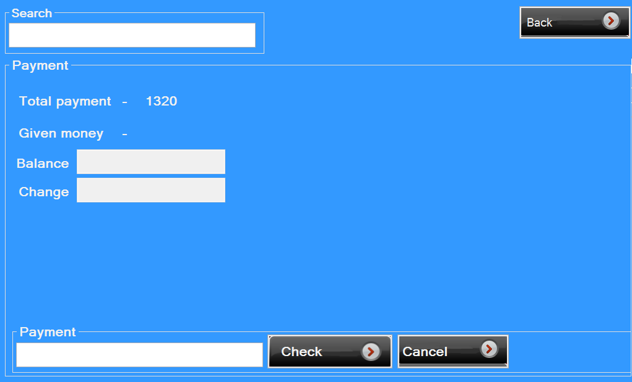

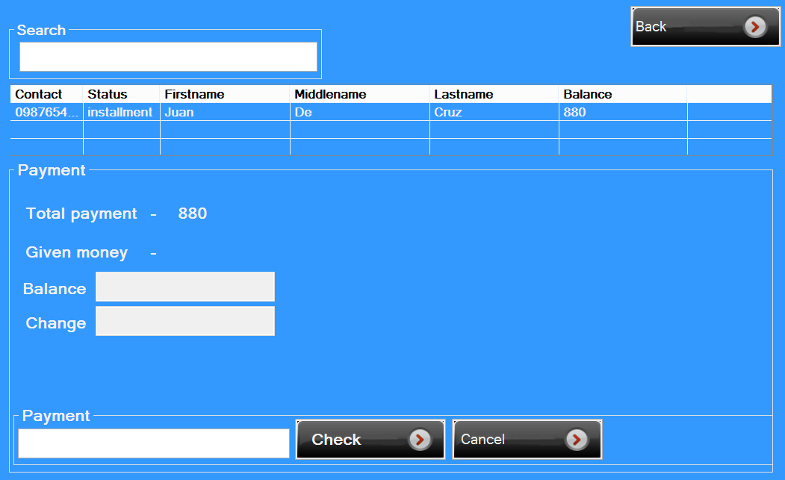

Account Setting  
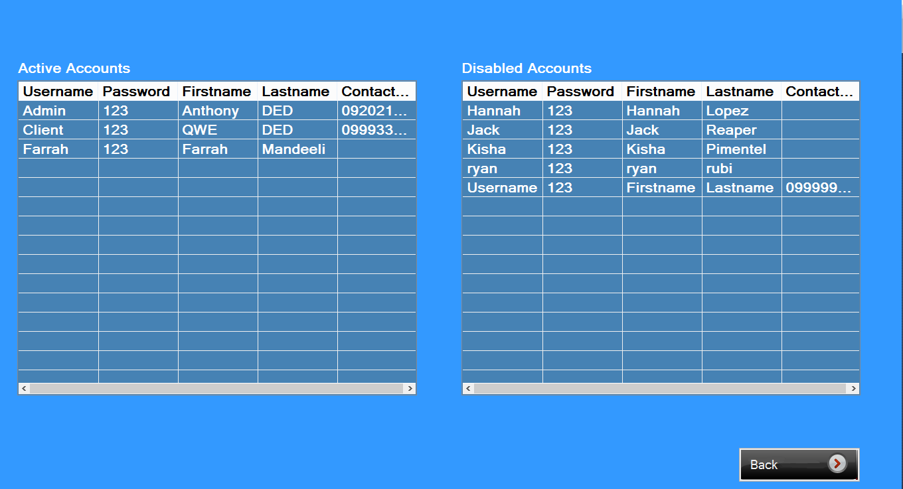  
Creating Account  
