**Result on different datasets**

**How to run the program**

*python preprocess.py -i data/iris.csv -o data/iris_processed.csv*

*python NeuralNet.py -i data/iris_processed.csv -p 0.8 -m 200 -d 4 -n 4*

**1. Car Evaluation Dataset**

training percent=80%, maximum_iterations=200

hidden layers=2, neurons in each hidden layer=2

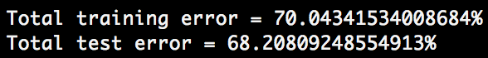

hidden layers=3, neurons in each hidden layer=3

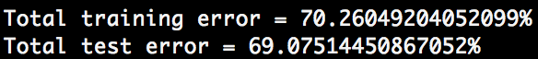

hidden layers=4, neurons in each hidden layer=4

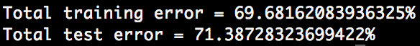

Tried different combination of hidden layer parameters, the result does not differ a lot. We can just set the number of hidden layer to be 2, and number of neurons in each hidden layer to be 2 also to keep the network simple. All the weights are the following:

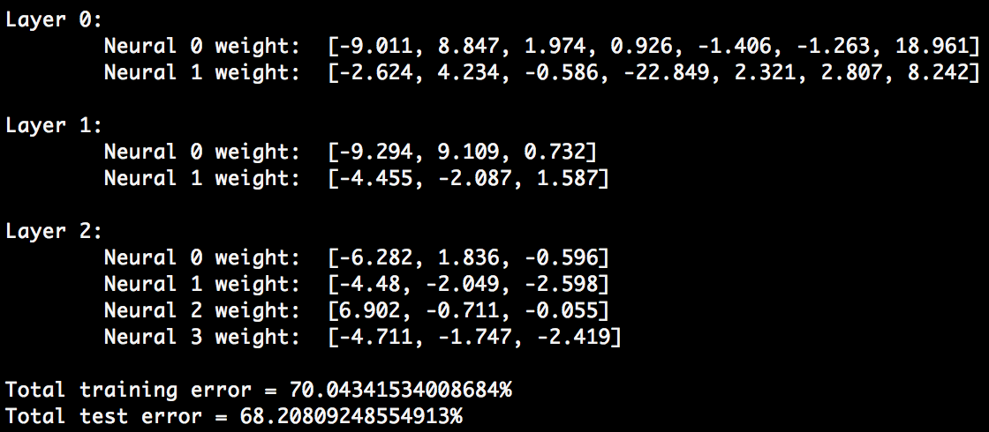

**2. Iris dataset**

training percent=80%, maximum_iterations=200

hidden layers=1, neurons in each hidden layer=2

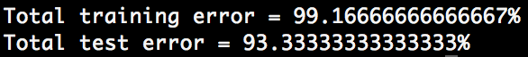

hidden layers=2, neurons in each hidden layer=2

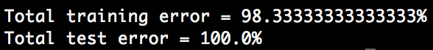

Tried different combination of hidden layer parameters, the result does not differ a lot. We can just set the number of hidden layer to be 2, and number of neurons in each hidden layer to be 2 also to keep the network simple. All the weights are the following:

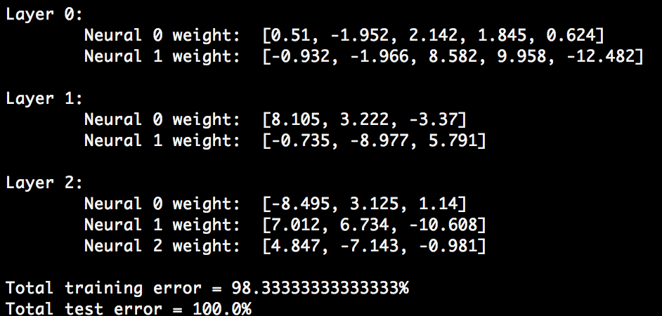

**3. Adult Census Income dataset**

training percent=80%, maximum_iterations=200

hidden layers=2, neurons in each hidden layer=2

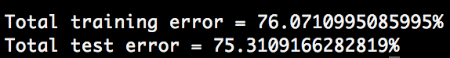

hidden layers=3, neurons in each hidden layer=3

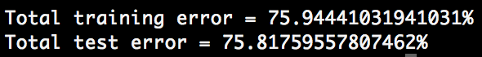

Tried different combination of hidden layer parameters, the result does not differ a lot. We can just set the number of hidden layer to be 2, and number of neurons in each hidden layer to be 2 also to keep the network simple. All the weights are the following:

