**Datanet Customer Order CMS System Deploy Handbook V1.0**

**By**

**Shinetechchina Team**

**April 20, 2017**

Contents

1. Source code 3

2. Deploy database 3

3. Modify configuration files 7

4. Add directory permission 8

5. Create IIS directory 11

### Source code

We will provide contents as follows:

Source code: DatanetCMS.Client and DatanetCMS.WebApi

Database file: DatanetCMSClient.bacpac and DatanetCMSWeb.dacpac

Deploy file

### Deploy database

1. Right click “Databases” in Microsoft SQL Server Manangerment Studio, choose “Import Data-tier Application..” for DatanetCMSClient.bacpac

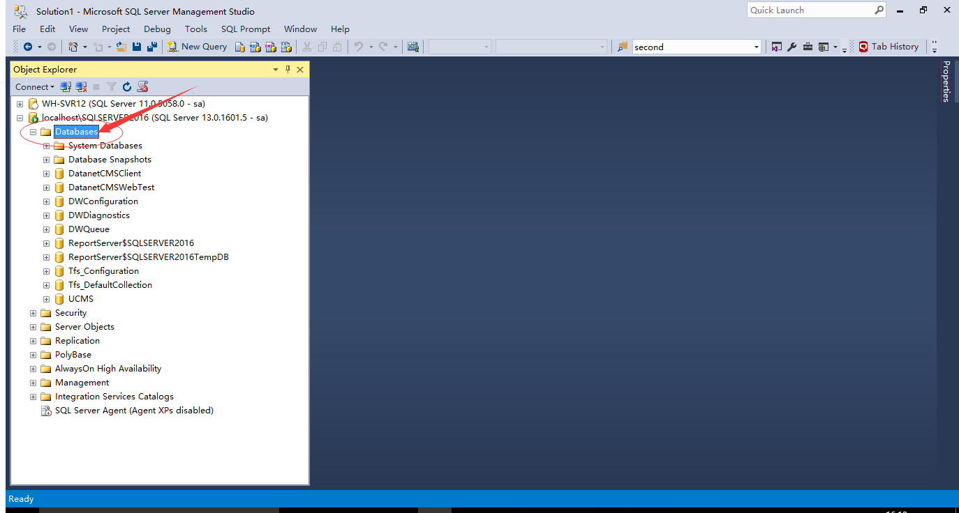

Follow view page is the first page when choose “Import Data-tier Application..”

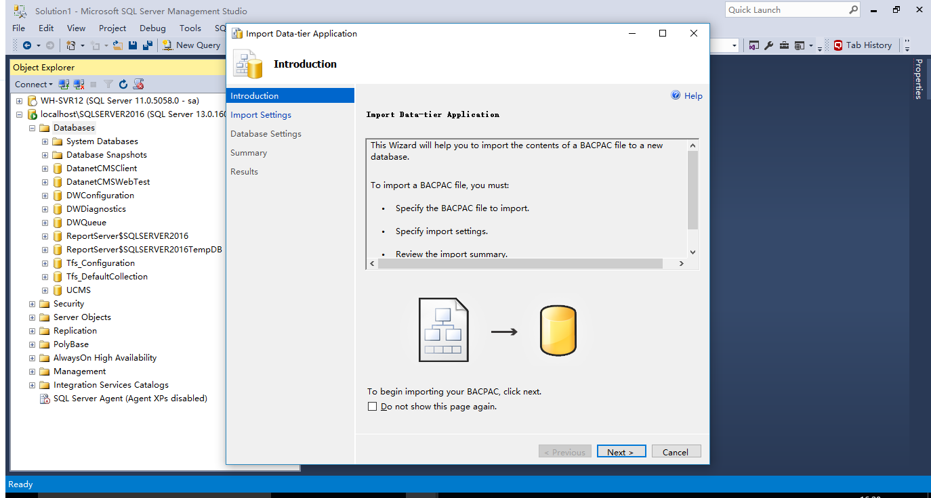

Click “Next”, and import “DatanetCMSClient.bacpac” file

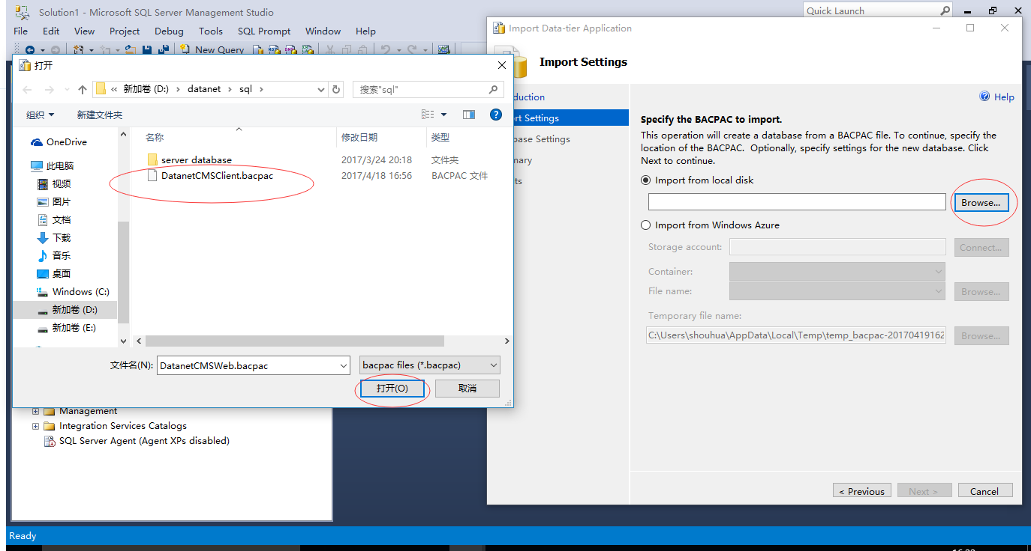

You can modify default “New database name” field and next done it.

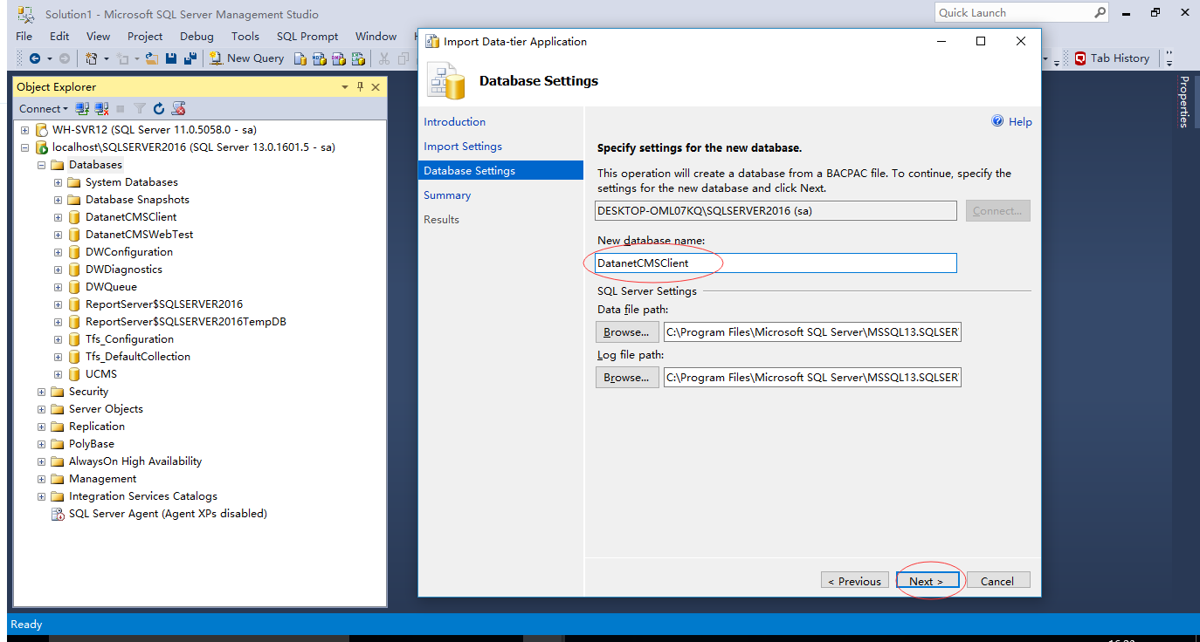

1. choose “Deploy Data-tier Application” for DatanetCMSWeb.dacpac



Right click “Databases”, and choose “Deploy Data-tier Application..”

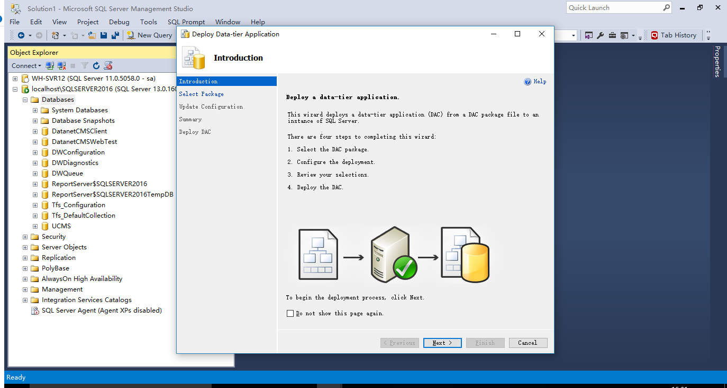

Click “Next” and Click “Browser”, and select “DatanetCMSWeb.dacpac”

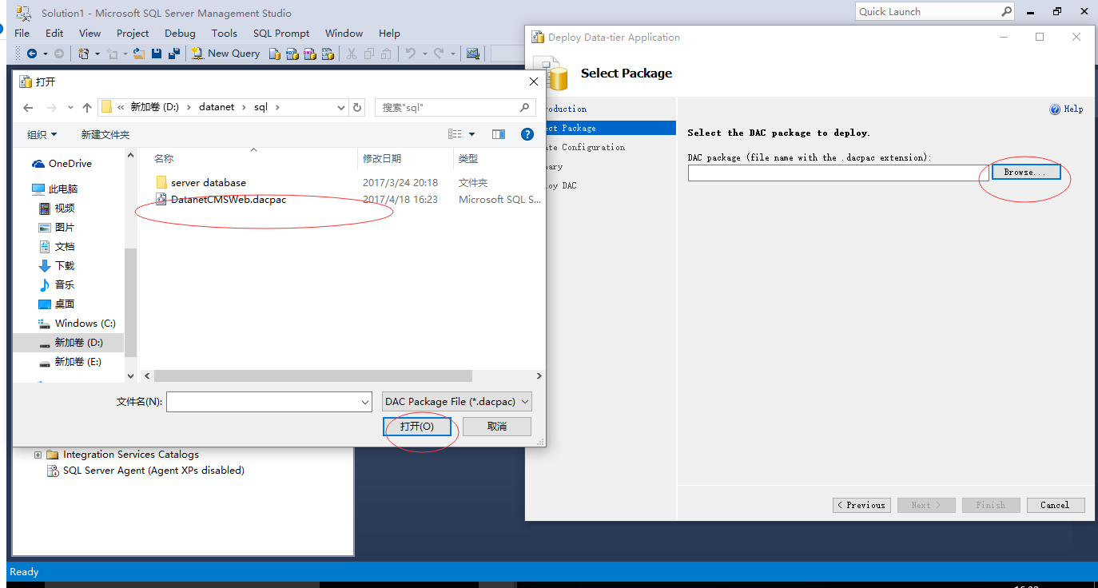

You can modify default database name and next to done it

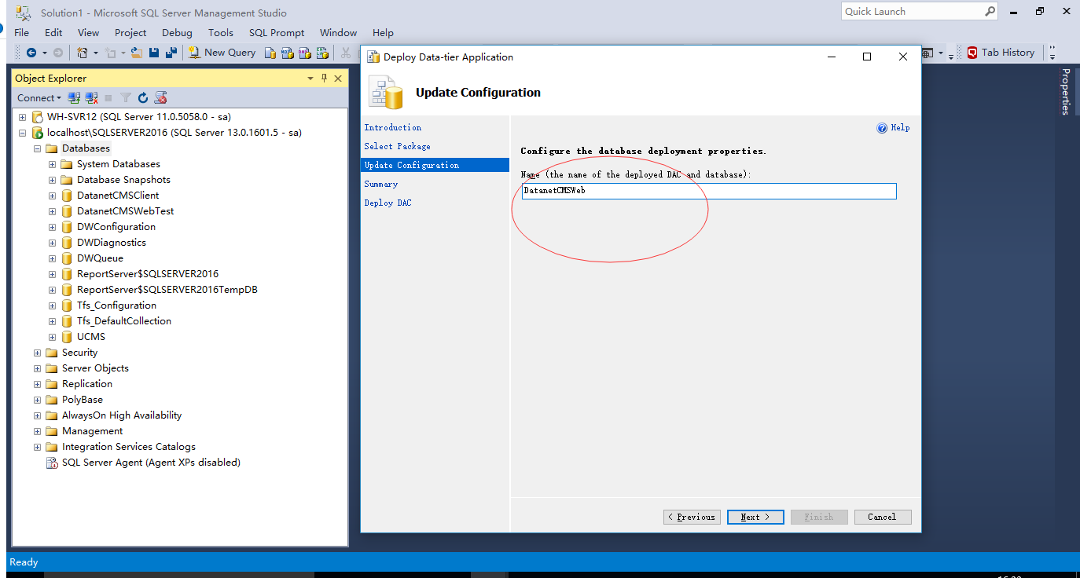

### Modify configuration files

1. Modify connection string in file “Web.config” of the DatanetCMS.Client and the DatanetCMS.WebApi project
2. Line 59 in Web.config (DatanetCMS.Client->Web.config)
3. Line 44 in Web.config (DatanetCMS.WebApi->Web.config)
4. Line 119 in Web.config (DatanetCMS.WebApi->Web.config)
5. Modify mail server configuration information in “appSettings” node of the file “Web.config”, line 21 to 26
6. Modify data.json in DatanetCMS.Client -> Scripts -> Config as follows:
7. Change baseUrl from <http://116.211.6.94:9101/api/> to <http://yourapidomain:apiport/api/>
8. Change clientBaseUrl from <http://116.211.6.94:9100> to <http://yourclientdomain:clientport>
9. Change fileUrl from  [http://116.211.6.94:9101/files/podoc/](http://localhost:57001/files/podoc/) to <http://yourapidomain:apiport/files/podoc>

### Add directory permission

1. Add “IIS_IUSRS” user for DatanetCMS.WebApi directory:

Right click “DatanetCMS.WebApi” directory, select “Properties”, choose “Security” tab, click “edit...” button, click “add..” button, input “IIS_IUSRS” for the field “Enter the object names to select”, then click “Check Names”, then ok, and check the user “IIS_IUSRS” ‘s modify and write permission, then “Apply”-> “OK” and done it!

.

Right click directory “DatanetCMS.WebApi” and then choose “Porperty”

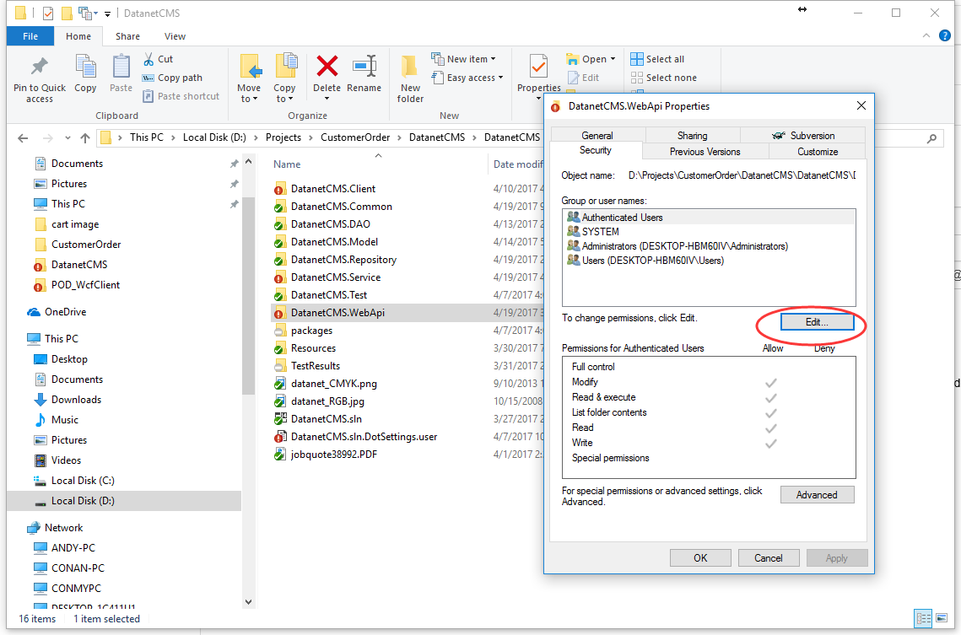

Click “Edit”

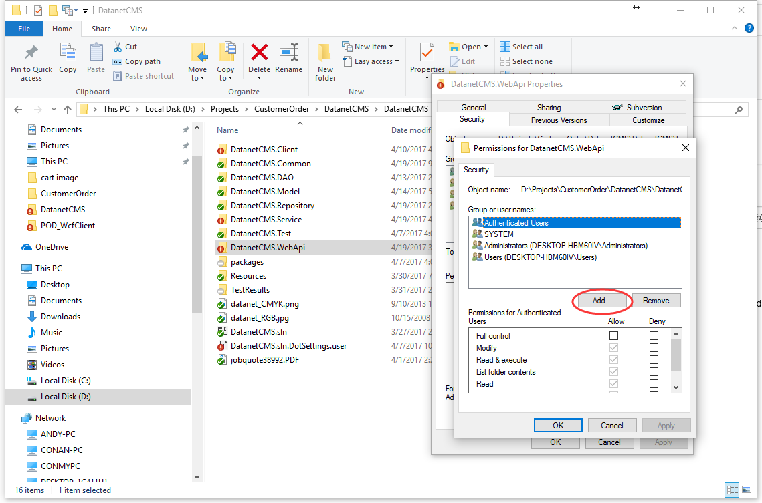

Click “Add..” directly

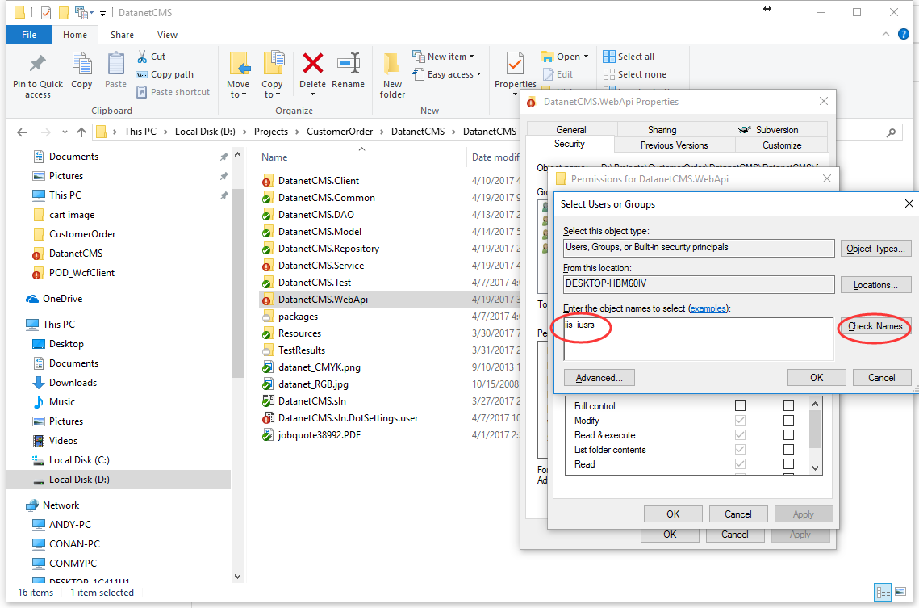

Input “iis_iusrs” and then click “Check Names” and will display like follow screenshot

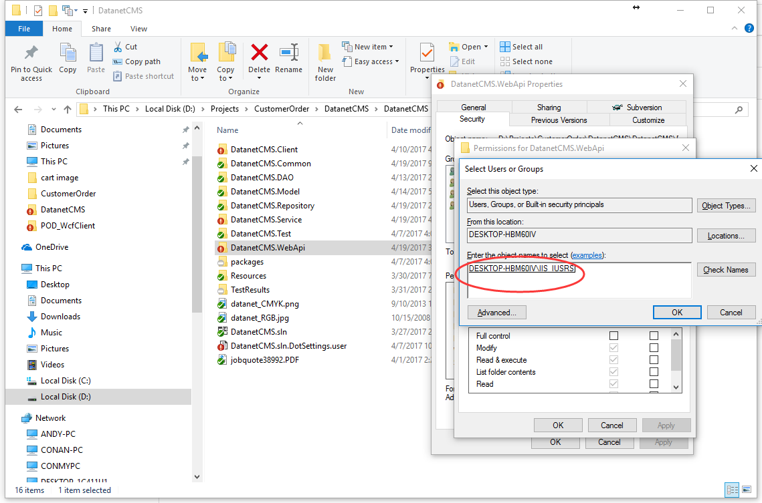

Then “OK”, Choose ”IIS_IUSRS” and check “Modify” and “Write” permission then “Apply”-> “OK” and done it!

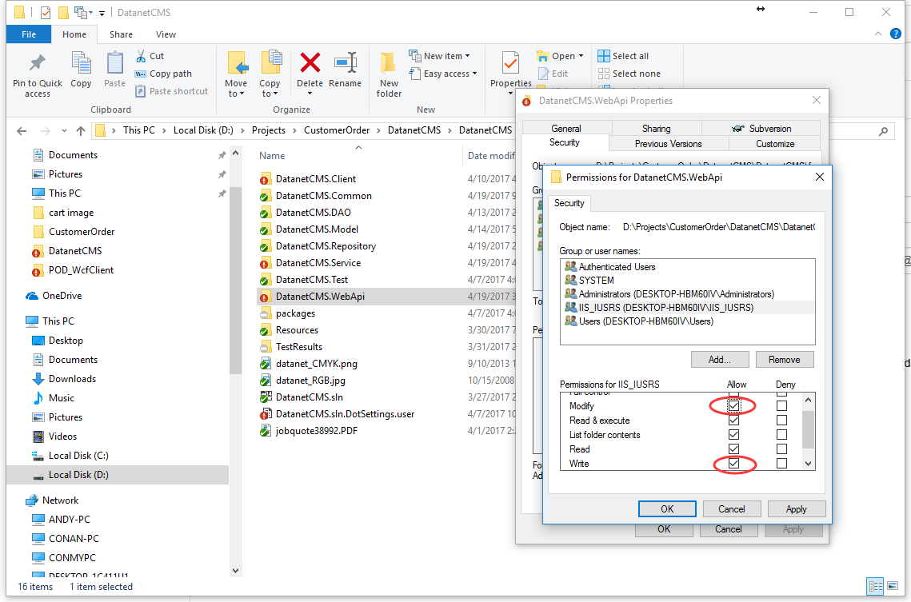

### Create IIS directory

You should create web site in IIS and add map between IIS site with related source code directory. After that your can enter <http://apidomain:apiport/api/test/test> in your browser, the backend API service deploy success when display view page as follow:

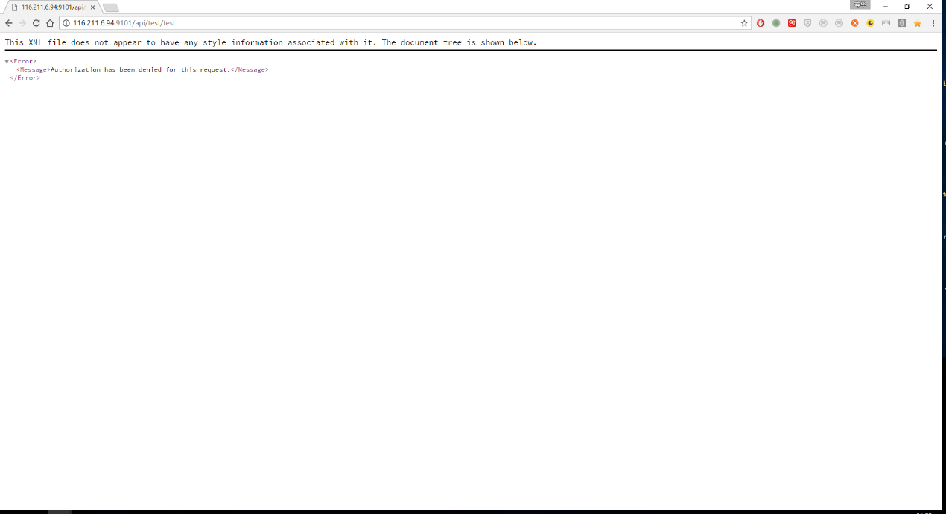

For customer portal test, your can directly enter: <http://clientdomain:clientport> in your browser, the browser will show you the login view page directly.

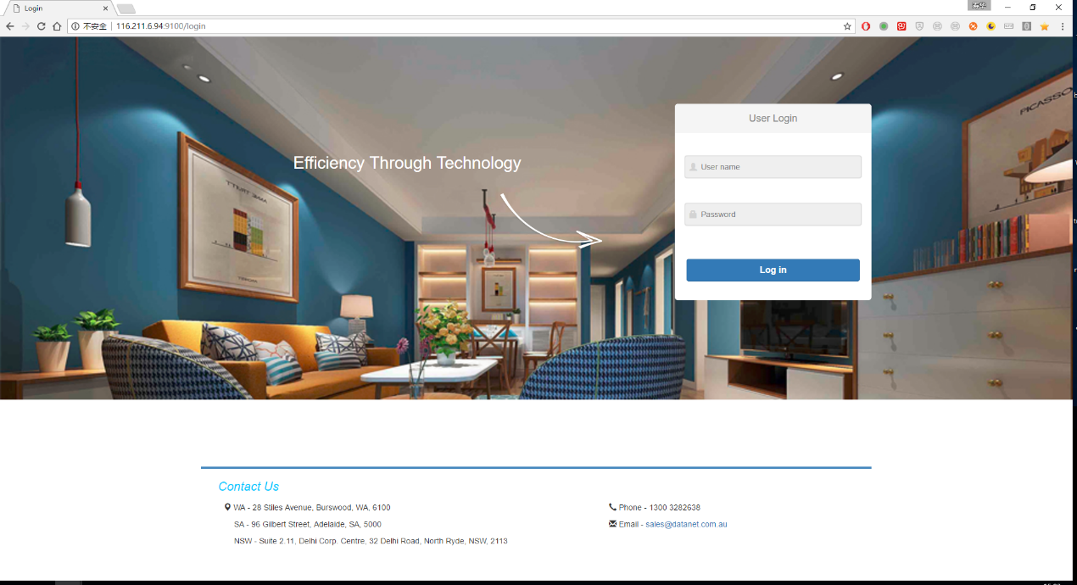

NOTE: there will a default administration account for the admin portal is:

Login Id: admin

Password: admin