Tony Hong
1005109482
Oct. 28, 2020

CSC258 Prelab (Lab 6)
Part 1: Sequence Recognizer
- Given the starter circuit, the reset signal is an asynchronous reset that is active high. During tests, the reset should be used when we want to test a new sequence of 4 numbers without influence from the previous inputs.
- Below is the state table and assigned flip flop values for each state
Input State | F2 | F1 | F0 | W (Input) | F2 | F1 | F0 | Output State
A | 0 | 0 | 0 | 0 | 0 | 0 | 0 | A
A | 0 | 0 | 0 | 1 | 0 | 1 | 0 | B
B | 0 | 1 | 0 | 0 | 0 | 0 | 0 | A
B | 0 | 1 | 0 | 1 | 1 | 1 | 0 | C
C | 1 | 1 | 0 | 0 | 1 | 0 | 1 | E
C | 1 | 1 | 0 | 1 | 1 | 1 | 1 | D
D | 1 | 1 | 1 | 0 | 1 | 0 | 1 | E
D | 1 | 1 | 1 | 1 | 1 | 0 | 0 | F
E | 1 | 0 | 1 | 0 | 0 | 0 | 0 | A
E | 1 | 0 | 1 | 1 | 0 | 0 | 1 | G
F | 1 | 0 | 0 | 0 | 1 | 0 | 1 | E
F | 1 | 0 | 0 | 1 | 1 | 0 | 0 | F
G | 0 | 0 | 1 | 0 | 0 | 0 | 0 | A
G | 0 | 0 | 1 | 1 | 1 | 1 | 0 | C

Note, that some of the transitions change more than 1 bit. It is impossible to design a state table for this FSM where each transition changes a maximum of 1 bit because there are 5 different states that either transition to or transition from E.
Below are the K-maps to determine the circuits that will implement the logic from the state table.
5. Below outlines a test plan for this FSM.
Prep: set clock tick to 1Hz, Async Reset the state and finally, turn on the Enable for the state.
Test 1: Turn W to 1 and watch 4 clock cycles pass and check if Z becomes 1. Let some more clock cycles pass and check if Z maintains its value of 1.
This test shows that the FSM detects the pattern 1111
Test2: Reset the state and turn W to 1 for 3 clock cycles. Turn W to 0 for the next clock cycle and turn W to 1 for the clock cycle after. Check to see that Z is 1 for that clock cycle
This test shows that the FSM detects the pattern 1101
Below are screen shots showing parts of Test 1.
Cycle 1:
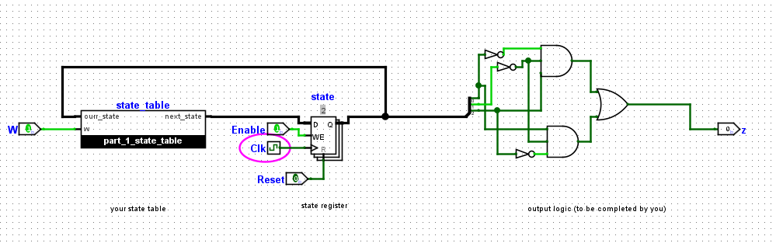
Cycle 2:
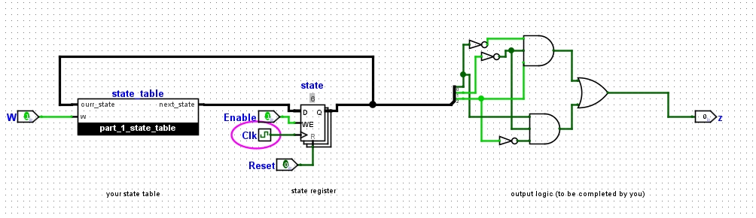
Cycle 3:
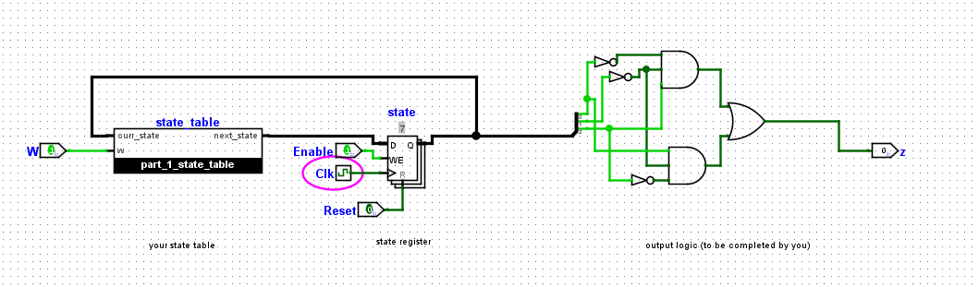
Cycle 4:
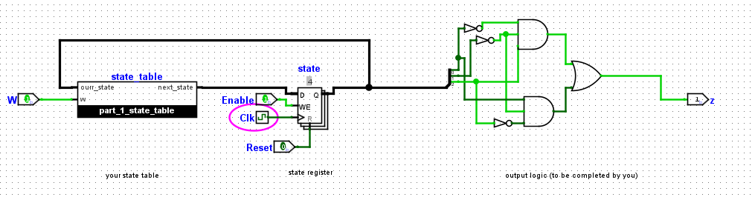
Part 2: FSM For CX² + Bx + A
Below is a plan to complete the required computation along with 4-bit state representations for each step.
Below is a state table for all states of my controller and the signals for each ALU component
State | ld_a | ld_b | ld_c | ld_x | alu_select_a | alu_select_b | ld_alu_out | alu_op | ld_r | next_state
0000 | 0 | 0 | 1 | 0 | 00 | 00 | 0 | 0 | 0 | 0001
0001 | 0 | 0 | 0 | 1 | 00 | 00 | 0 | 0 | 0 | 0011
0011 | 1 | 0 | 0 | 0 | 00 | 00 | 0 | 0 | 0 | 0010
0010 | 0 | 1 | 0 | 0 | 00 | 00 | 0 | 0 | 0 | 0110
0110 | 0 | 1 | 0 | 0 | 01 | 11 | 1 | 1 | 0 | 0111
0111 | 0 | 1 | 0 | 0 | 01 | 00 | 1 | 0 | 0 | 0101
0101 | 1 | 0 | 0 | 0 | 11 | 11 | 1 | 1 | 0 | 0100
0100 | 1 | 0 | 0 | 0 | 00 | 10 | 1 | 1 | 0 | 1100
1100 | 0 | 0 | 0 | 0 | 00 | 01 | 0 | 0 | 1 | 1100

Test and Screenshots: C=4, X=3, B=6, A=2 Expected Output: 56
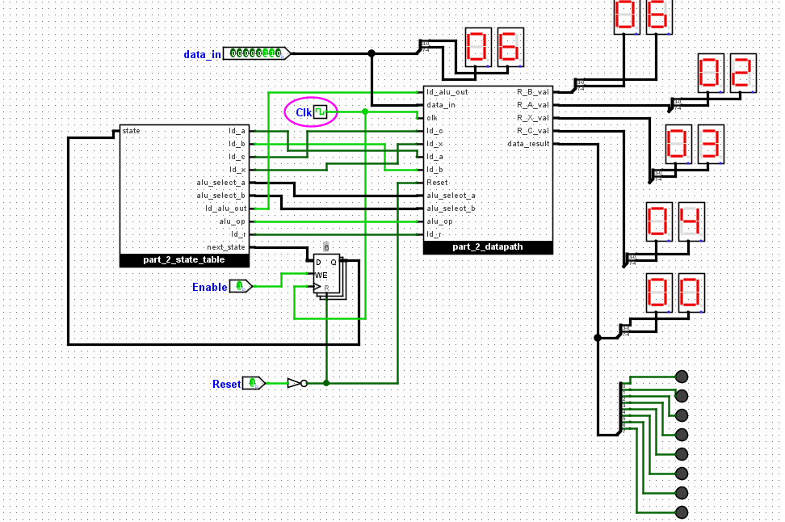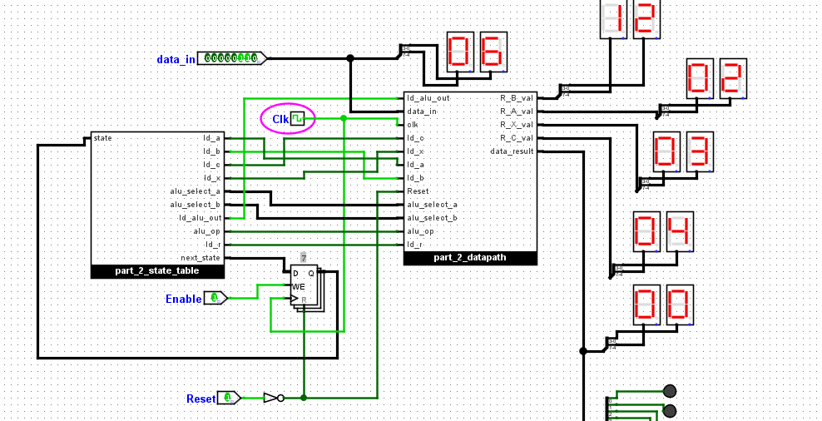
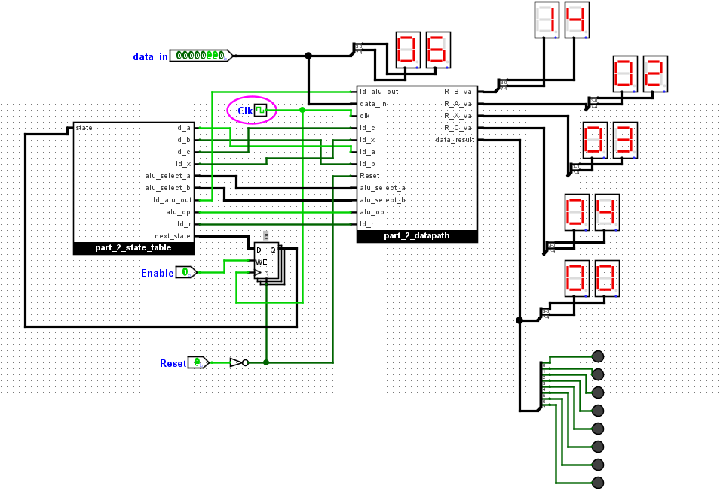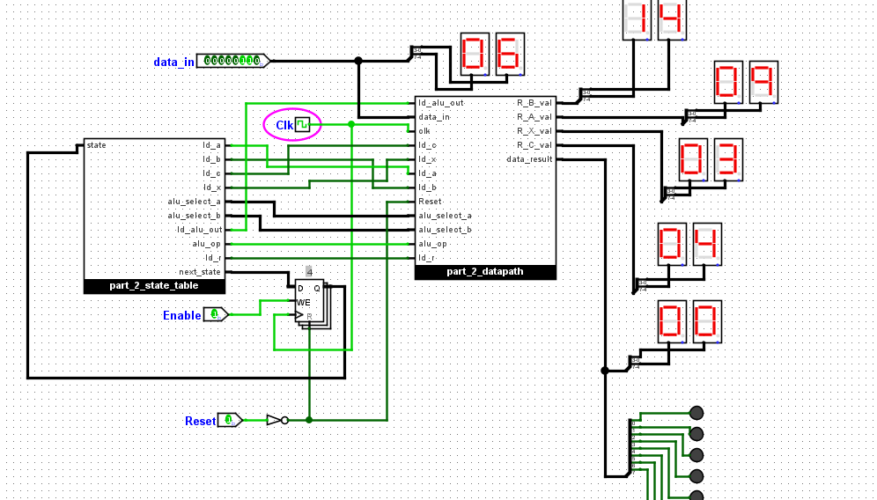

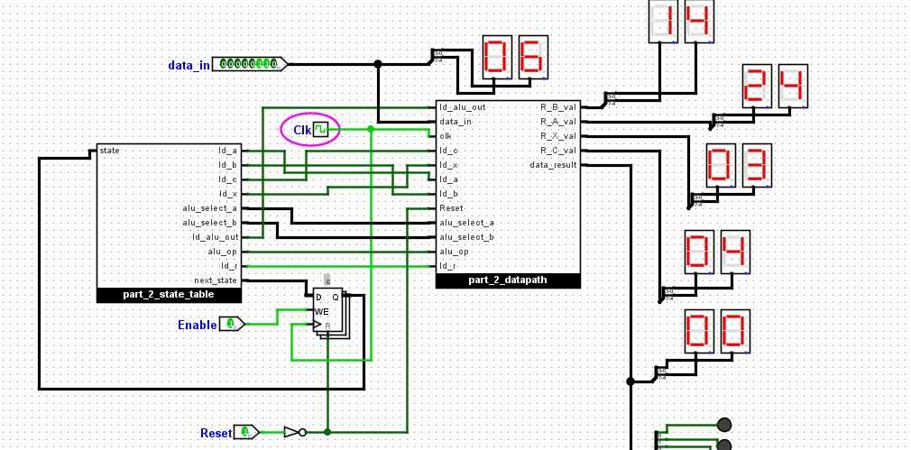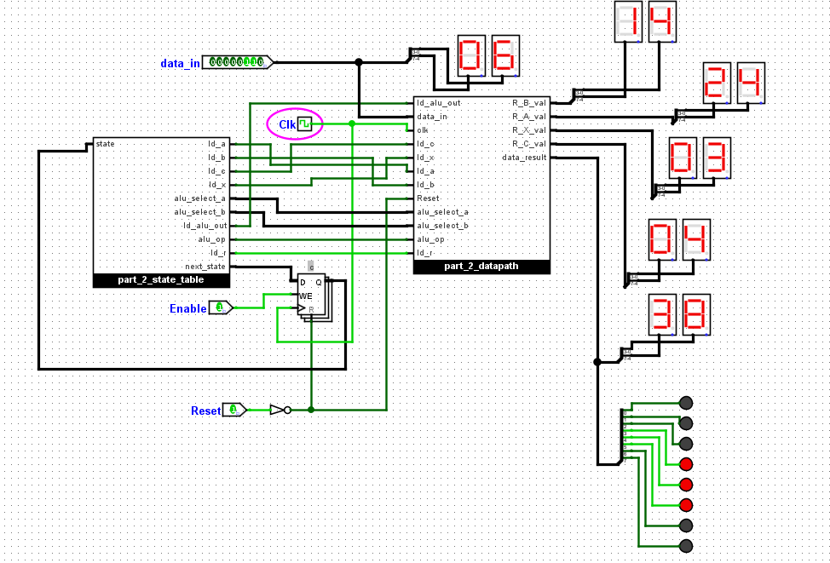
As seen in the final screenshot, the Output is indeed 56. (3*16 + 8)

