**UNIVERSITY OF VAASA**

**FACULTY OF BUSINESS STUDIES**

**DEPARTMENT OF ACCOUNTING AND FINANCE**

Lauri Tšili, v99327

Emma Kontsas, w101398

Topi Huhta-Halkkola, v99178

Tony Hurmalainen, w101368

**CORPORATE FINANCE CASE STUDY: PONSSE**

Lask3048

Corporate finance case study

**VAASA 2016**

Sisällysluettelo

1. INTRODUCTION 3

2. PONSSE OYJ 4

3. WEIGHTED AVERAGE COST OF CAPITAL 5

3.1 General Assumptions 5

3.2 Market Beta 6

3.3 Cost of Equity 6

3.4 Cost of Debt 7

4. DISCOUNTED FREE CASH FLOW (DCF) BASED VALUATION 8

5. DIVIDEND DISCOUNT MODEL 10

6. PEER GROUP VALUATION 11

7. SUMMARY 12

REFERENCES 13

# 1. INTRODUCTION

This paper is a case study on Ponsse Plc’s situation in terms of selling the company. We began by describing the current market situation of Ponsse Plc and its current ownership base. The following parts examine the calculations for Weighted Average Cost of Capital (WACC), Discounted Free Cash Flow based valuation, Dividend Discount Model Valuation and Peer Group Valuation. The last part summarizes the results of these calculations, and a suitable price range for selling the company is presented.

Ponsse Oyj manufactures forest machines designed for the cut-to-length method and offers also the related services and information systems. In Cut-to-length method the trunks are cut to required lengths in the forest and the end user receives the information of the trunks types and quantities in real time. This increases the value for the customer as the logs can be transported directly to production plants and the production plants are aware of what types of logs they are receiving beforehand. (Ponsse Plc 2016.)

Ponsse’s shares are quoted on the NASDAQ OMX Nordic List and it is currently valued at 623,28 million euros (29.11.2016) based on its stock price. (Kauppalehti 2016.) The current situation of the company is very stable both financially and on the ownership basis. The share of the company has been in steady rise for the last 5 years and holding period return has been over 200 %.

# 2. PONSSE PLC

Ponsse Oyj’s main competitors are John Deere and Caterpillar Inc. However, they produce mainly track harvesters, which are less friendly to forests. Ponsse Plc has performed very well in recent years. Its revenue grew 15 % from 2014 to 2015 and the net profit grew 12 % from 2014 to 2015 (Ponsse Plc annual report 2015). During the same period John Deere´s Construction and Forestry sales dropped 9 %, due to lower shipment volume and unfavourable exchange rates (John Deere annual report 2015), and Caterpillar’s all other segments revenue dropped 2 % (Caterpillar annual report 2015). Ponsse´s performance has been outstanding relative to its competitors during a time when economic growth has been very modest.

Ponsse has almost 100 professionals focusing solely on technological research and development. In 2015 Ponsse launched a new innovative model line, which will provide growth in revenue for forthcoming years. Their maintenance sales have grown steadily and produces 18 % of total revenue. However, it is expected to grow significantly. Ponsse’s manufacturing capabilities are in exceptional shape because of their Vieremäki factory and their R&D is in the same location. Ponsse´s customer driven approach has been core for their success ever since Einari Vidgren established the company. (Ponsse Plc annual report 2015.)

Currently about 50 % of the worlds harvested wood is harvested manually with a chainsaw or some other similar method. The rest is harvested mechanically. Cut-to-length method accounts about 40 % of the mechanical harvesting and 60 % is harvested with the less advanced tree-length method. The cut-to-length method harvesting has grown steadily and it should affect positively to Ponsse’s sales. Cut-to-length method is also more friendly to environment. (Ponsse 2016.)

Freedonia Group expects the world forestry equipment demand to increase by 4,5 % annually to 9,3 billion in 2019. Sales are forecasted to grow partly because of the mechanization of harvesting in developing regions and partly because of low demand after the recession. Additionally, new regulations are likely to increase the sales of highly technological forestry equipment that meet the new requirements. Freedonia expects the US market to make the highest increases in sales but also Finland, Brazil and Poland are expected to grow more than average. (Freedonia Group 2015.) Ponsse has a strong footing in Finland and US and we expect it to benefit strongly from the general increase in demand.

Ownership base of Ponsse is heavily distributed in Vidgren family. Juha, Jukka, Janne and Jarmo Videgren’s own approximately 63 % of the company. This makes the company rather illiquid and on the possible sale scenario Vidgrens play a major part. In the other hand, as the Vidgren’s own most of the company the selling negotiations are likely to be faster.

# 3. WEIGHTED AVERAGE COST OF CAPITAL

The weighted average cost of capital we have calculated for Ponsse Plc is 6.00 %. In this calculation we have used the calculated costs for equity and debt. The values for these are 6.37 % and 2.89 % respectably. In the weighted average cost of capital calculation we have used the tax rate of 20 %. The shares of capital by market value for Ponsse Plc are 9.00 % for debt and 91.00 % for equity. The formula we have used for the average cost of capital is the following:



Where,

WACC = The weighted average cost of capital for Ponsse Plc for the next five years,  
MVe = The market value of equity of Ponsse Plc,  
MVd = The market value of debt of Ponsse Plc,  
Re = The five year estimated cost of equity of Ponsse Plc,  
Rd = The five year estimated cost of debt of Ponsse Plc,  
Rt = The tax rate.

## 3.1 General Assumptions

*Risk-free rate*

The risk-free rate used in WACC-calculations is assumed zero. This is based on Finnish 5-year government bond rate of -0.45 %, Finnish 10-year government bond rate of 0.42 % and Euribor-12 rate of -0.079 %. (Bank of Finland 2016)

*Liquidity Premium*

Liquidity premium of 3.2 % is used in Ponsse Plc’s WACC-calculations. This premium is equal to PwC’s 2015 research on equity market risk premium in Finland, where the average illiquidity premium is 3.2 %. Ponsse Plc is considered illiquid since the average trading volume of its stock is 10 689. (PwC 2015; Yahoo Finance 2016)

*Market Risk Premium*

Market risk premium of 5.8 % is used in Ponsse Plc’s WACC-calculations. This premium is equal to PwC’s 2015 research on equity market risk premium in Finland, where the average expectation of market risk premium is 5.8 %. (PwC 2015)

## 3.2 Market Beta

The market beta we have used in our calculations is the five year estimated beta of Ponsse Plc. The value of this beta is 0.55. In our calculations we have agreed to use a five year investment horizon resulting in the use of the five year beta. Other estimated beta calculations are available from the appendix. In the calculations we have used the OMXHCAPPI as the market index. The formula for our beta calculations is as follows:

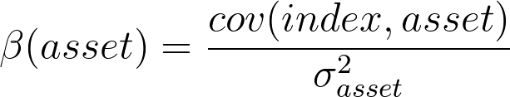Where,

β(asset) = The market beta of Ponsse Plc,  
cov(index,asset) = The Covariance between Ponsse Plc and the market index OMXHCAPPI, $σ_{asset}^{2}$ 
 = The variance of Ponsse Plc.

## 3.3 Cost of Equity

The rate for the cost of equity used in our calculations is 6.37 %. This rate has been calculated by using the capital asset pricing model adjusted with an added liquidity premium. The liquidity premium used in our calculations is 3.2 %. We calculated several possible values for beta, which is apparent from the appendix. The beta we have decided to use is the estimated five year beta for Ponsse in comparison to the OMXHCAPPI index. The value of the beta is 0.55. The market risk we have estimated to be 5.8 %. From these values, we arrive at the following formula:

https://raw.githubusercontent.com/tsili/cf-case-ponsse/master/cost-of-equity/cost-of-equity.png

Where,

= the mean risk of Ponsse Plc for the next five years,  
*rf*  = the risk free rate,  
βponsse = the estimated five year beta of Ponsse Plc, ${\overline{r}}_{market}$ 
 = the mean market risk,  
*rl* = the liquidity premium.

## 3.4 Cost of Debt

The 2015 cost of debt is 2.89 %. The cost of debt used in WACC-calculations is based on the financial liabilities and interest expenses in 2015. Ponsse Plc’s cost of debt has been stable for the last five years and it is assumed to remain stable. Ponsse Plc’s long-term liabilities were 39 346 000 €, short-term liabilities were 23 056 000 €, interest in financial loans were 804 000 € and other financial expenses were 998 000 €. The calculation is based on the following equation:

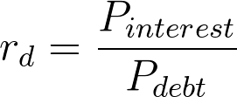

Where *rd* = cost of debt,   
*Pinterest* = interest in financial loans + other financial expenses  
*Pdebt* = long-term liabilities + short-term liabilities.

# 4. DISCOUNTED FREE CASH FLOW (DCF) BASED VALUATION

In discounted free cash flow valuation method four different cases are presented. Firstly, base case which is the most probable case which is discounted at estimated WACC of 6 %. Secondly, a case where WACC of 7 % is used for the same forecasts to show how the value is dependent on the discount rate. Lastly, cases of positive and negative scenarios in economy are presented.

In positive case Ponsse Plc is able grow at faster rate than expected due to exceptionally good performance in service sales and increase in general demand in the important markets. Russian market is thriving when sanctions are pulled out, U.S. economy is growing under the impact of Donald Trump’s recovery policy and Europe overcomes its crisis and starts growing. Ponsse’s products are well accepted in the markets and new line PONSSE2015 is grabbing market share from competitors.

In negative case there is a decrease in sales in all major markets due to depression and high competition. Russian and European markets have not started growing, instead they are in steady decline and Ponsse Plc is suffering in the U.S. markets because of the severe competition. Service sales is also lagging severely.

Free cash flow and changes in working capital calculations are presented in the appendix. Table 1 below describes the results of DCF analysis in all scenarios.

**Table 1** DCF analysis results

Chart 1 shows the market value of equities in all scenarios.

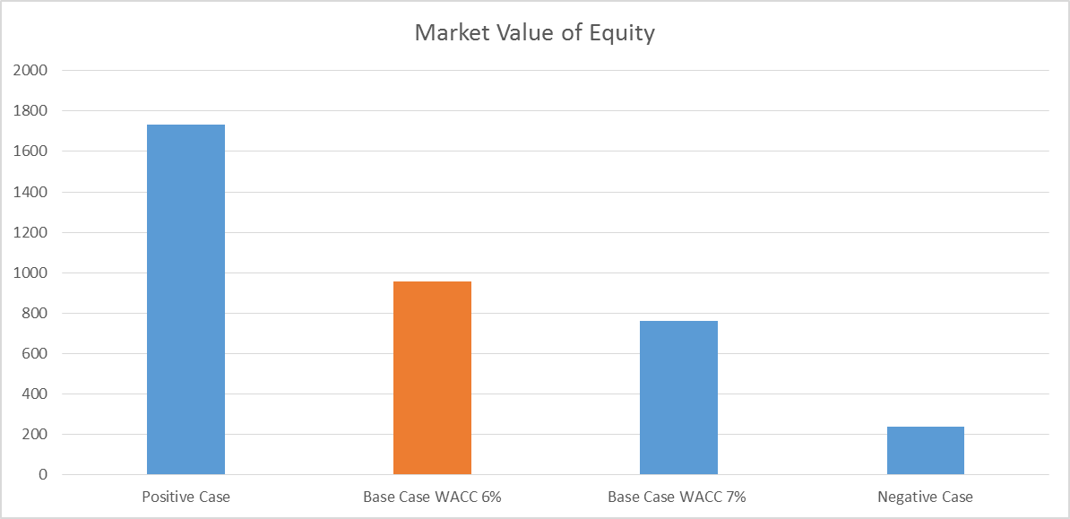

**Chart 1** Market Value of Equity

# 5. DIVIDEND DISCOUNT MODEL

Ponsse Plc does not state any official dividend policy. Hence, the dividends are likely to fluctuate depending on the yearly earnings. Ponsse Plc has increased their dividends from 0.10 € in 2008 to 0.55 € in 2015 and they have paid dividends every year. Even in year 2009 when their earnings per share were -0.72 €. Hence, Ponsse seems to pursue somewhat stable dividend growth but they have left room for dividend changes. Ponsse’s dividends have increased on average 35.28 % between 2008 and 2015.

We estimate that Ponsse will not be able to maintain its dividend growth rate at previous year’s rate as the year 2015 was extremely good and Ponsse has forecasted that their operating profit from 2016 will be on par with year 2015. Also, capital is required for future investment projects. Therefore, in year 2016 we expect dividends to increase by 20 % and steadily continue to rise but with lower growth rate. From year 2021 to perpetuity we estimate Ponsse to grow its dividends by 2% annually. We discount our forecasted dividends with 6.00%, as calculated before, and our estimated share value is 26.42 €. Hence, Ponsse Plc is valued at 738.8 million euros. The calculations for the model are presented below in Table 2.

|  |  |  |  |  |  |  |  |  |  |
| --- | --- | --- | --- | --- | --- | --- | --- | --- | --- |
|  | 2014 | 2015 | 2016e | 2017e | 2018e | 2019e | 2020e | 2021e | perpetuity value (2%) |
| Nominal dividends / share | 0,45 | 0,55 | 0,66 | 0,78 | 0,90 | 1,00 | 1,10 | 1,16 | 28,96 |
| Growth % | 50,00 % | 22,22 % | 20,00 % | 18,00 % | 15,00 % | 12,00 % | 10,00 % | 5,00 % | 2,00 % |
| Discounted dividends / share |  |  | 0,66 | 0,73 | 0,80 | 0,84 | 0,87 | 0,87 | 21,64 |
| WACC | 0,06 |  |  |  |  |  |  |  |  |
| Estimated share value | 26,42 |  |  |  |  |  |  |  |  |

**Table 2** Dividend discount model

# 6. PEER GROUP VALUATION

There is big differential in values when valuing Ponsse based on peer group multiples lowest value being 373 M€ and highest being 663 M€. We believe that Ponsse is in better condition than its peers and it will be able to grow at higher rate and because of this Ponsse´s value would be higher than the one derived from peer group valuation. Especially price to sales is a bad ratio comparing different companies given that Ponsse is very profitable. P/E and P/EBITDA are better in valuing Ponsse but even those don’t take into account Ponsse´s sustaining growth. Values based on peer group multiples are presented below on Chart 2. The calculations are presented in Appendix.

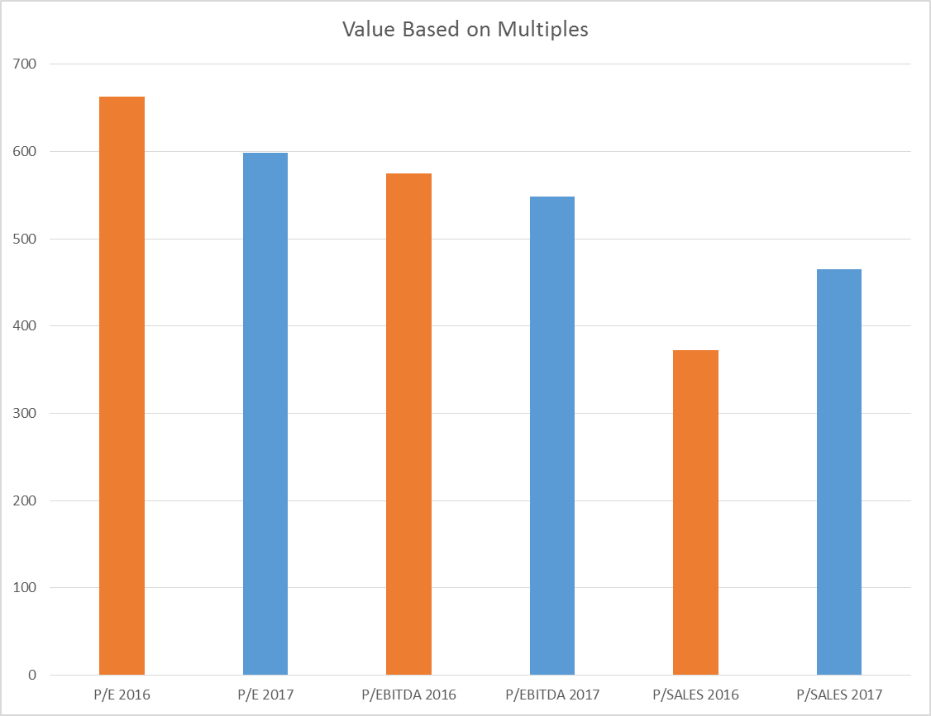

**Chart 2** Value Based on Multiples

# 7. SUMMARY

The results of different methods differ significantly. The DCF model values Ponsse Plc at 955 million euros, dividend discount model at 739 million and peer group valuation between 373–663 million. The variation is high but we believe that Ponsse Plc’s actual value is in the high end.

Currently Ponsse’s share price is 22.26 €. Based on our calculations we believe the true price is between 26.42 and 34.11 €. This converts to total market value of 740–955 million euros.

Our valuation is above the current market price of 623 million (28.11.2016). For some reason Ponsse is conservatively valued. It has a P/E –ratio of 13.01 which is extremely low for a growing company like Ponsse. The market might also consider Ponsse to be extremely illiquid and use higher illiquidity premiums. Small size and family ownership can be off-putting for large investors. We believe that Ponsse Plc would be an exceptionally good fit for a bigger forest machinery company and that it will strongly benefit from the general increase in forestry markets.

# REFERENCES

Freedonia Group (2015). *World Forestry Equipment.* [online] [cited 29.11.2016].

Available online: <URL:http://www.freedoniagroup.com/industry-study/3270/world-forestry-equipment.htm>

Kauppalehti (2016). *Ponsse Oyj (PON).* [cited] [online 29.11.2016]. Available Online:

<URL:http://www.kauppalehti.fi/5/i/porssi/porssikurssit/osake/?klid=1046>

Ponsse (2016). [online] [cited 29.11.2016]. Available online:

<URL:www.ponsse.fi>

PWC (2015). *Markkinariskipreemio Suomen Osakemarkkinoilla*. [online] [cited

29.11.2016]. Available online: <URL:https://www.pwc.fi/fi/julkaisut/tiedostot/markkinariskipreemio-2015.pdf>

Suomen Pankki (2016). *Suomen valtion viitelainojen korot*. [online] [cited 29.11.2016].

Available online:

<URL:http://www.suomenpankki.fi/fi/tilastot/korot/pages/tilastot_arvopaperimarkkinat_velkapaperit_viitelainojen_korot_fi.aspx>

Suomen Pankki (2016). *Euriborkorot päivittäin*. [online] [cited 29.11.2019].

<URL:http://www.suomenpankki.fi/fi/tilastot/korot/pages/tilastot_markkina-_ja_hallinnolliset_korot_euriborkorot_pv_chrt_fi.aspx>

Yahoo Finance (2016). *Ponsse Plcj (PON1V.HE).* [online] [cited 29.11.2016]. Available

online: <URL:https://finance.yahoo.com/quote/PON1V.HE?ltr=1>