PM Accelerator – AI Engineer Tech Assessment (Full Stack)
System Analysis Documentation
Tony Wang
July 11th, 2026

Weather App
Content:
- Project Description
- Use Case Diagram
- Entity-Relationship Diagrams (ERD) & Data Dictionary
- Activity Diagram
- System Sequence Diagram (SSD)
- Frontend-Backend Function Mapping
- Resources and References Used

1. Project Description
2. Use Case Diagram
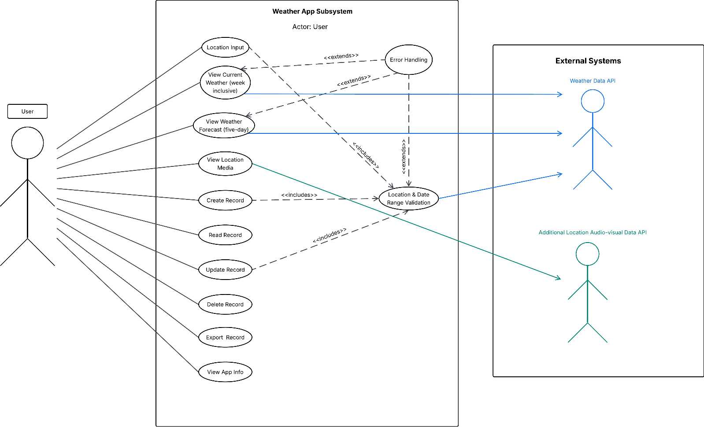

3. Entity-Relationship Diagrams (ERD) & Data Dictionary
3.1 ERD
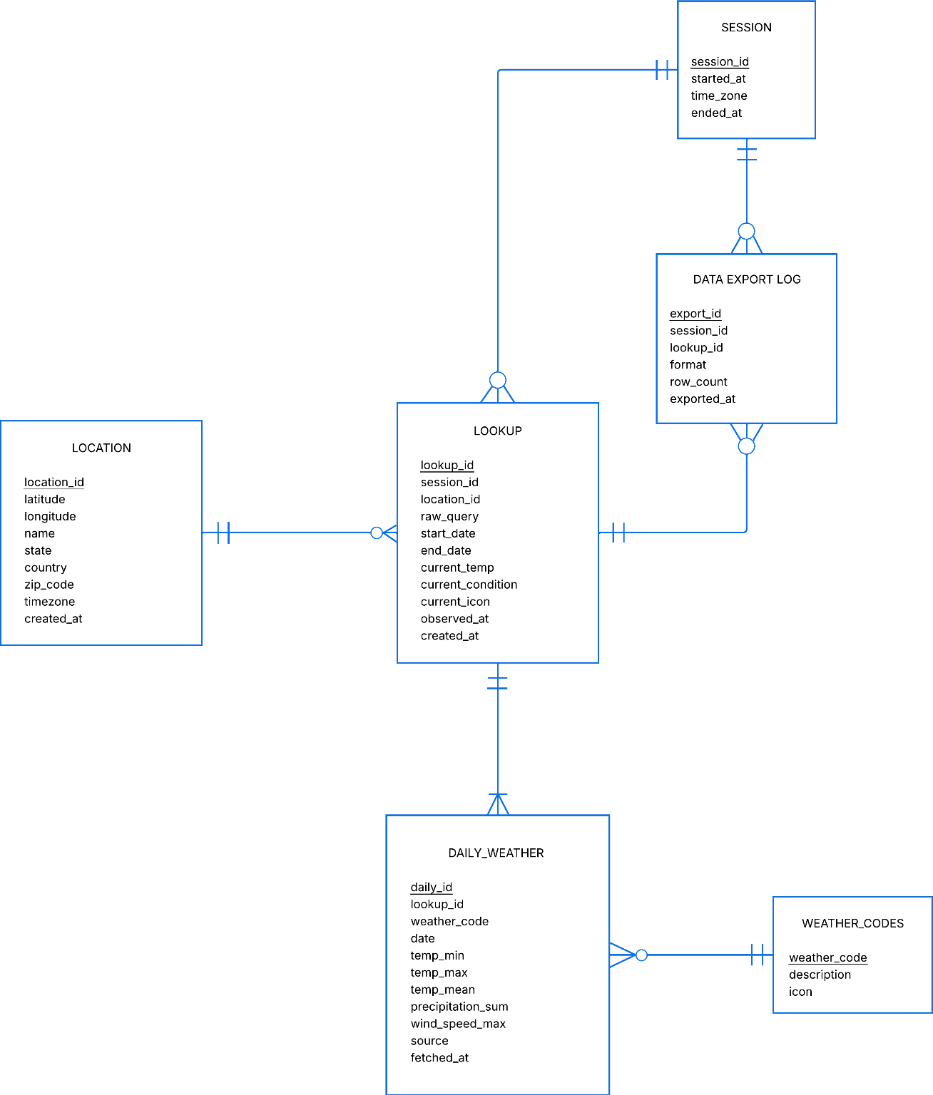

3.2 Relations Diagram
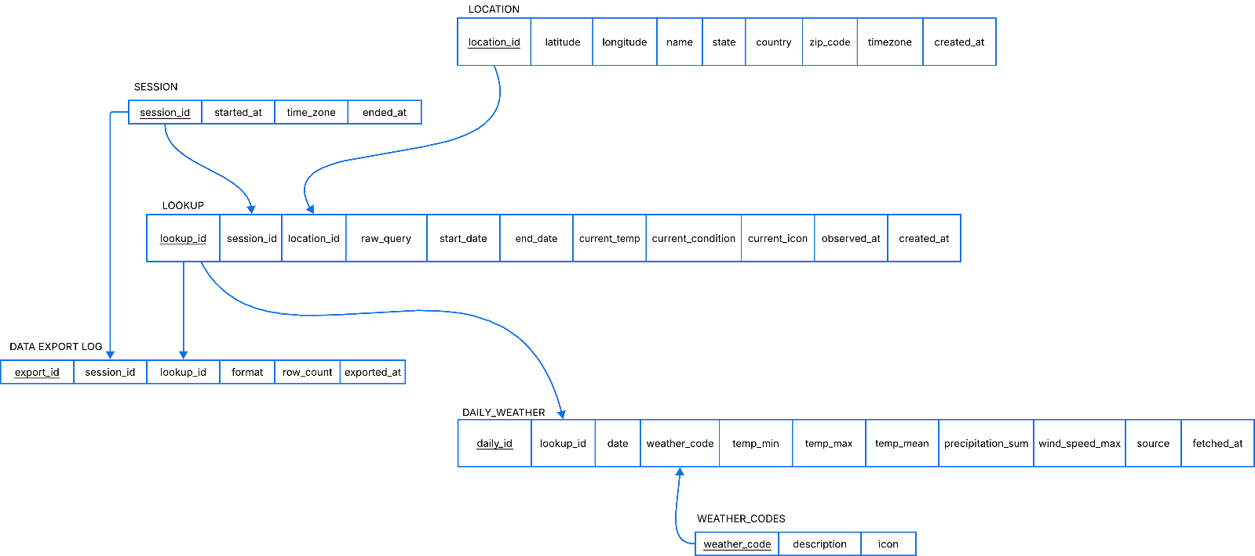

3.3 Data Dictionary
SESSION
data_name | data_type | data_description
session_id | INT | PK, unique ID for each visit
started_at | TXT | when the visit began (UTC, ISO 8601)
time_zone | TXT | the user's local timezone during the visit
ended_at | TXT | when the visit ended

LOCATION
data_name | data_type | data_description
location_id | INT | PK, unique ID for each place
latitude | REAL | how far north/south
longitude | REAL | how far east/west
name | TXT | the place’s name
state | TXT | State or region
country | TXT | ISO country code
zip_code | TXT | Postal Code
timezone | TXT | IANA Timezon
created_at | TXT | when was this place first time to be saved to the local DB

LOOKUP
data_name | data_type | data_description
lookup_id | INT | PK. Unique ID for one search
session_id | INT | FK → SESSION. Which visit this search happened in
location_id | INT | FK → LOCATION. Which place was searched
raw_query | TXT | Exactly what the user typed — "bronx ny"
start_date | TXT | First day of the range requested
end_date | TXT | Last day of the range requested
current_temp | REAL | Temperature at that place at search time (°C)
current_condition | TXT | Plain-txt condition then — "light rain"
current_icon | TXT | OpenWeather icon code — "10d"
observed_at | TXT | When the weather station took that reading
created_at | TXT | When the user submitted the search

DAILY_WEATHER
data_name | data_type | data_description
daily_id | INT | PK. Unique ID for one day of weather
lookup_id | INT | FK → LOOKUP. Which search produced this day
weather_code | INT | FK → WEATHER_CODES. WMO code for the day's  dominant condition
date | TXT | The calendar day this row describes (local to the place)
temp_min | REAL | Coldest temperature that day (°C)
temp_max | REAL | Warmest temperature that day (°C)
temp_mean | REAL | Average temperature that day (°C)
precipitation_sum | REAL | Total rain + snow that day (mm)
wind_speed_max | REAL | Strongest wind that day (km/h)
source | TXT | Which API supplied this row — "open-meteo"
fetched_at | TXT | When this row was pulled from the API — tells you how stale a forecast is

DATA EXPORT LOG
data_name | data_type | data_description
export_id | INT | PK. Unique ID for one export
session_id | INT | FK → SESSION. Which visit the export happened in
lookup_id | INT | FK → LOOKUP. Whose data was exported
format | TXT | File format chosen — csv / json / xml / pdf / md
row_count | INT | How many day-rows were written to the file
exported_at | TXT | When the export happened
export_id | INT | PK. Unique ID for one export
session_id | INT | FK → SESSION. Which visit the export happened in

WEATHER_CODES
data_name | data_type | data_description
weather_code | INT | PK. WMO code, 0–99
description | TXT | Human-readable meaning — "Rain: slight"
icon | TXT | Icon name you map to this condition

4. Activity Diagram
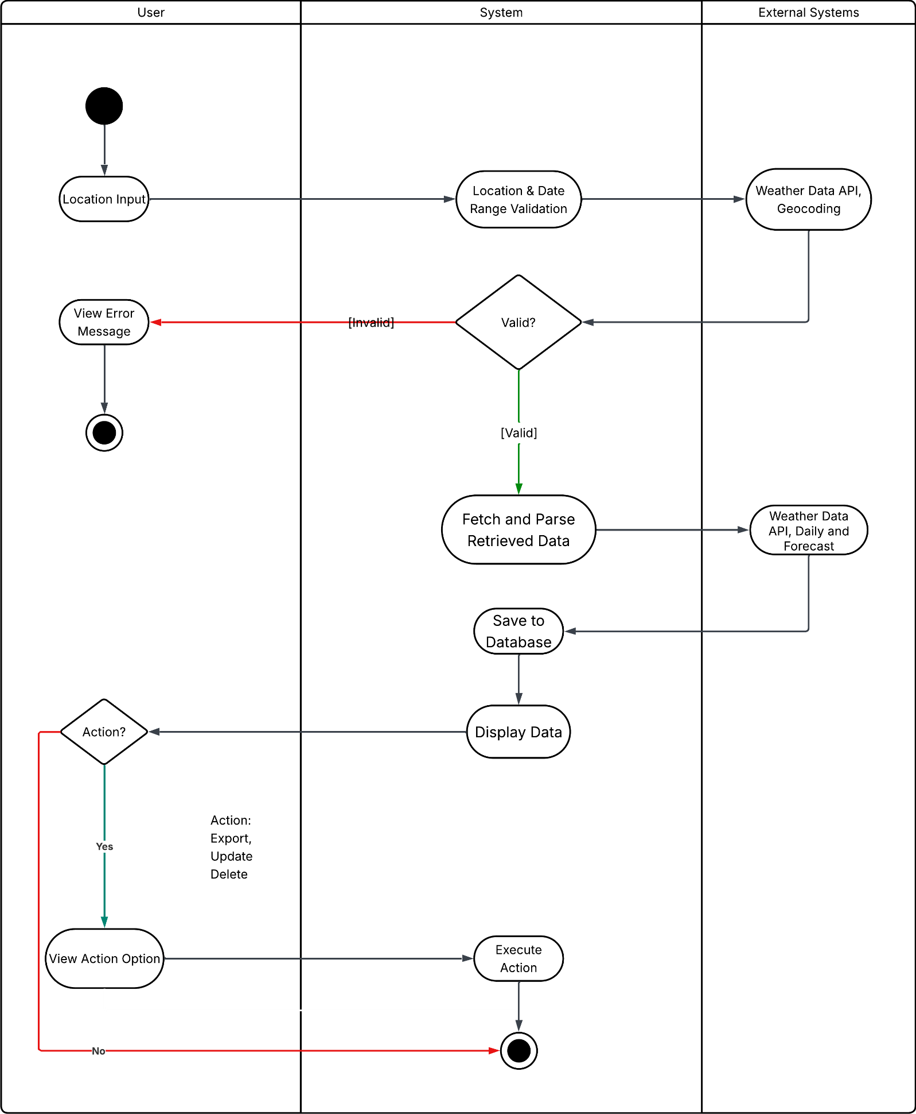

5. System Sequence Diagram
