Local Deployment Architecture (Development)
Goal: Run the entire infrastructure on your laptop with one command.
In this setup, you simulate the cloud using Docker Compose. This ensures that what you build locally works exactly the same way when you push it to Azure.
The Stack:
- Flutter App: Runs on your Emulator/Device (connects to localhost).
- API Gateway (Backend): Python (FastAPI). Handles Auth, Orders, and logic.
- Database: PostgreSQL (with PostGIS extension for map tracking).
- AI Service: A separate Python container (running PyTorch/TensorFlow/OpenCV) for image analysis.
- Realtime Engine: Redis (for tracking driver location).
- Storage: MinIO (simulates Azure Blob Storage locally).

Data Flow:
- User uploads a photo in Flutter -> Sent to FastAPI -> Saved to MinIO.
- FastAPI places a "Scan Job" in Redis.
- AI Worker picks up the job -> Analyzes photo -> Updates PostgreSQL with volume/price.
- Flutter listens to a WebSocket (via FastAPI) and updates the UI instantly.
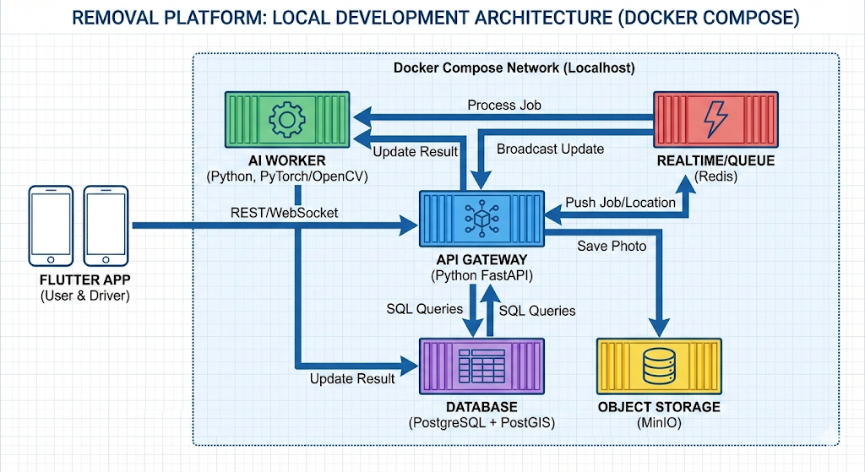
Removal service platform
Technical task
These must be 2 separate mobile apps for Android and iOS.
  - Service requestor (individual or business)
  - Service provider (business)
Service requestor application description:
User Login: with email for both platforms. Gmail account for Android and Apple ID for iOS
User registration : can register with email.
When user logins, for the first time, must enter personal data. Full Name, E-mail, Mobile Phone number.
User has to have an option to edit personal details in User’s profile.
User is redirected to Request a Removal service screen.
If user’s profile is already filled with data, the user is redirected directly to the Request Removal Service screen.
User has to choose a removal date.

Origin address
Please provide details of the shipper, being the person or company responsible for the shipment at the origin address.
Shipper:
Full name and surname
Contact phone number
Please include country code
Email
Email address
Origin Country
Origin City
Street name
House/Apartment number
Postal code
Floor
For ground floor please enter "0"
Is there an elevator?
Yes, available and operational
No elevator / not operational
I don’t know
Parking permit required?
Yes
No
I don’t know
Hand carry distance from truck parking to entrance (meters) *
30
Hand carry distance (approximate)
Additional information about access or property
Narrow stairs, long corridor, restricted access, time limitations, etc.

Furniture disassembly *
Required
Not required
Disassembly of furniture
Lamp dismantling *
Required
Not required
Dismantling of lamps or light fixtures to ensure safe packing and transportation.
Export packing *
Required
Not required
Professional export-grade packing suitable for international transportation and long-distance moves.
Wrapping *
Required
Not required
Protective wrapping of furniture and items using moving blankets, stretch film, or similar materials.
Wooden crates *
Required
Not required
Custom-built wooden crates for fragile, high-value, or sensitive items requiring additional protection.
Special packing *
Required
Not required
Packing of items requiring special care due to fragility, value, shape, or material.
Piano handling *
Required
Not required
Specialized handling and preparation of pianos or similar musical instruments.
Heavy handling (items over 30 kg) *
Required
Not required
Manual or mechanical handling of items exceeding 30 kg, requiring additional manpower or equipment.
Washing machine lock *
Required
Not required
Securing the washing machine drum with transport bolts to prevent damage during transportation.
External lift *
Required
Not required
Use of an external lifting device for moving items through windows or balconies when stair or elevator access is not suitable.
Loading *
Driver assistance only
Full loading by ELP Moving crew
Client loads items independently
Please indicate who will be responsible for loading activities at the origin address.
Additional information about items or special handling requirements
Fragile lamps, heavy boxes, oversized items, access limitations, etc.
Please provide details of the recipient, being the person or company responsible for the shipment at the destination address.
Recipient’s full name
Recipient’s contact phone number
Recipient's Country
Recipient's City
Street name
House/Apartment number
Postal code
Floor
Is there an elevator?
Yes, working
No or not working
Don’t know
Not applicable — unloading at ground level
Parking permit required?
Yes
No
I don’t know
Distance from truck to door
30
Any additional comments about access or property

Services required at the destination address
Please indicate which services are required at the destination. The information provided below will be used for operational planning, equipment allocation, and cost calculation. If you are unsure about any item, please select Required and add a short note in the comments field below.
Furniture assembly *
Required
Not required
Assembly of furniture items following delivery, including beds, wardrobes, tables, and similar items.
Lamp mounting *
Required
Not required
Installation or reinstallation of lamps or light fixtures after delivery.
Unpacking work *
Required
Not required
Unpacking of boxes and items after delivery, including removal of packing materials.
Disposal: *
Required
Not required
Removal and disposal of packing materials or unwanted items, subject to local regulations.
External lift *
Required
Not required
Use of an external lifting device for moving items through windows or balconies when stair or elevator access is not suitable.
Uncrating *
Required
Not required
Removal of items from wooden crates following delivery, including basic disposal of crate materials where permitted.
Unloading *
Driver assistance only
Full unloading by ELP Moving crew
Client unloads items independently
Unloading to ground level only (for palletised shipments)
Please indicate who will be responsible for unloading activities at the destination address. The selected unloading method will determine the scope of services provided at the destination address and may affect pricing and manpower requirements.
Additional information about items or special handling requirements
Fragile lamps, oversized items, unusually heavy items, access limitations, or any other relevant details.

