**ARTIFICIAL INTELLIGENCE LAB PROGRAMS**

**OUTPUT**

Tony J Mathew

1BM17CS119

1. **Implementation of Tic-Tac-Toe game**

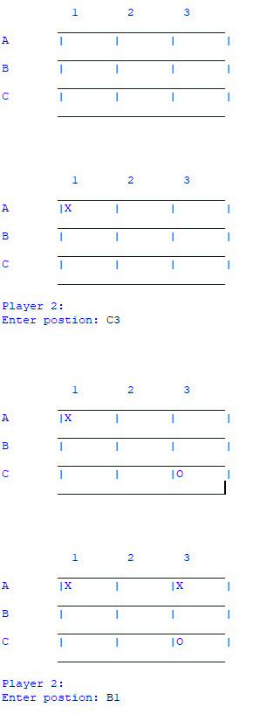

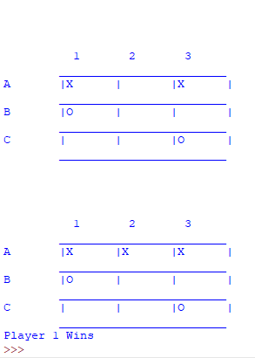

1. **Solving 8 puzzle problem**



1. **Implementation of vacuum cleaner agent**

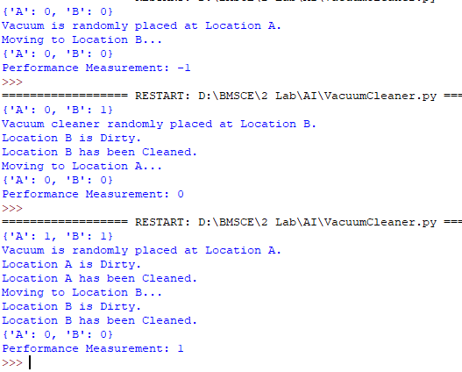

1. **Implementation of A* search algorithm**

 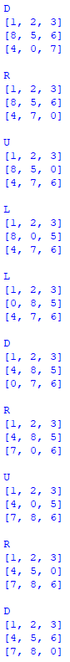

1. **Implementing iterative deepening search to solve 8 puzzle problem**

Screenshots not taken for middle part

Beginning Ending

 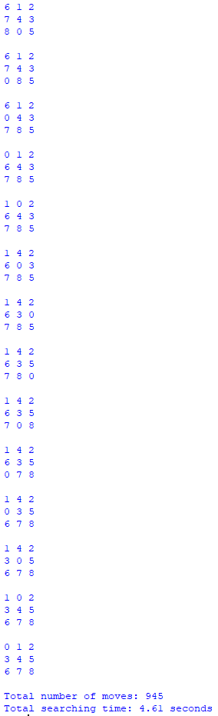

1. **Create a knowledge base using prepositional logic and show that the given query entails the knowledge base or not**

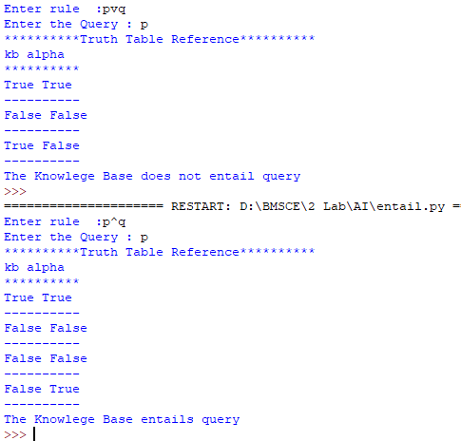

1. **Convert the given first order logic statement into conjunctive normal form (CNF)**

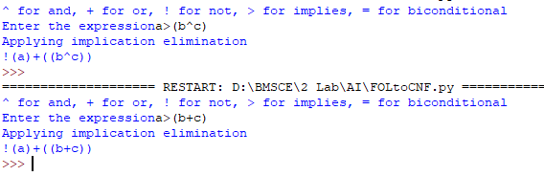

1. **Implementation of unification in first order logic**

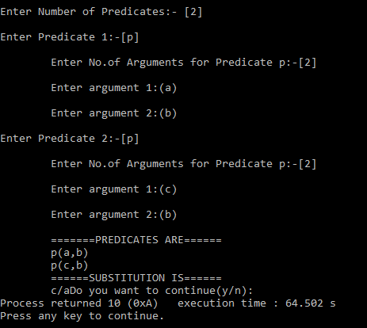

1. **Create a knowledge base consisting of first order logic statements and prove the query using forward reasoning**

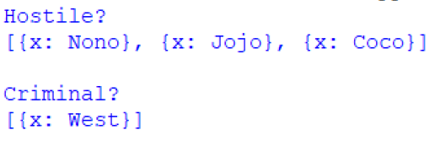

1. **Demonstrate decision tree learning for a given set of**

**training examples and test data**

