**B.M.S. COLLEGE OF ENGINEERING BENGALURU**

Autonomous Institute, Affiliated to VTU



Lab Record

**Object Oriented Analysis and Design**

*Submitted in partial fulfillment for the 6th Semester Laboratory*

Bachelor of Technology

in

Computer Science and Engineering

*Submitted by:*

**TONY J MATHEW**

1BM17CS119

Department of Computer Science and Engineering

B.M.S. College of Engineering

Bull Temple Road, Basavanagudi, Bangalore 560 019

Jan-May 2019

**B.M.S. College of EngineerinG**

**DEPARTMENT OF COMPUTER SCIENCE AND ENGINEERING**



***CERTIFICATE***

This is to certify that the Object-Oriented Analysis and Design(16CS6DCOOM) laboratory has been carried out by TONY J MATHEW (1BM17CS119) during the 6th Semester Jan-May-2019.

Signature of the Faculty Incharge:

NAME OF THE FACULTY:

Department of Computer Science and Engineering

B.M.S. College of Engineering, Bangalore

Table of Contents

|  |
| --- |
| 1.College Information System |
| 2.Hostel Management System |
| 3.Stock Maintenance System |
| 4.Coffee Vending Machine |
| 5.Online Shopping System |
| 6.Railway reservation system |
| 7.Graphics Editor |

**1. College Information System**

**Problem Statement:**

To design a College Information System to simplify the process of course registration. The system will allow students to register their courses online. The information is directly relayed to the college database and eliminates unnecessary paperwork, travelling and time consumption.

**SRS:**

Purpose:

The College Management System is an online system. The system is developed to facilitate more streamlined course registration process. The system allows students to register their courses online. The information is directly relayed to the college database and reduces paperwork, travelling and time consumption. Details of courses such as syllabus, credits and prescribed learning material can also be checked.

Requirements:

Functional Requirements:

* Provide Student Login:

Students can login and register for courses within prescribed time limits.

* Provide Course Information:

Course Details can be checked before and after registration. Data such as syllabus, credits and learning material are available for viewing.

* Provide Admin Login:

Admin login is required to update available courses as well as course details.

* GUI:

An interface is developed for above mentioned functional requirements.

Non-Functional Requirements:

* Cost:

The software should be cheap and within budget.

* Time:

The software product should be completed within deadlines

* Security:

The data should be secure

**Class Diagram:**

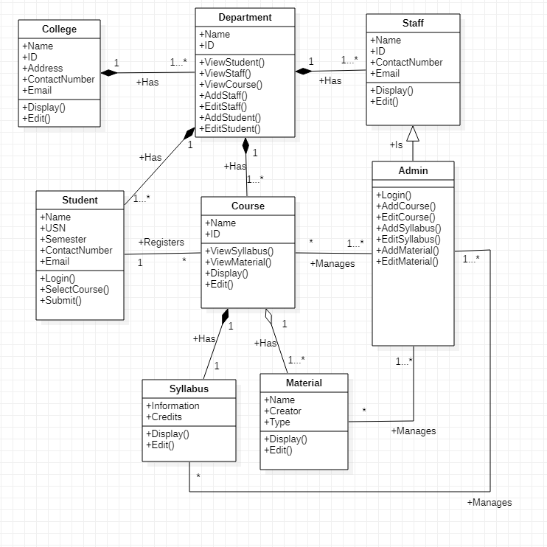

**State Diagram:**

