**B.M.S. COLLEGE OF ENGINEERING BENGALURU**

Autonomous Institute, Affiliated to VTU

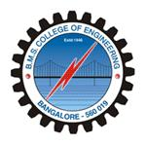

Lab Record

**Object Oriented Analysis and Design**

*Submitted in partial fulfillment for the 6th Semester Laboratory*

Bachelor of Technology

in

Computer Science and Engineering

*Submitted by:*

**TONY J MATHEW**

1BM17CS119

Department of Computer Science and Engineering

B.M.S. College of Engineering

Bull Temple Road, Basavanagudi, Bangalore 560 019

Jan-May 2019

**B.M.S. College of EngineerinG**

**DEPARTMENT OF COMPUTER SCIENCE AND ENGINEERING**

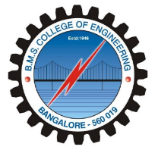

***CERTIFICATE***

This is to certify that the Object-Oriented Analysis and Design(16CS6DCOOM) laboratory has been carried out by TONY J MATHEW (1BM17CS119) during the 6th Semester Jan-May-2019.

Signature of the Faculty Incharge:

NAME OF THE FACULTY:

Department of Computer Science and Engineering

B.M.S. College of Engineering, Bangalore

Table of Contents

|  |
| --- |
| 1.College Information System |
| 2.Hostel Management System |
| 3.Stock Maintenance System |
| 4.Coffee Vending Machine |
| 5.Online Shopping System |
| 6.Railway reservation system |
| 7.Graphics Editor |

**1. College Information System**

**Sequence Diagrams:** 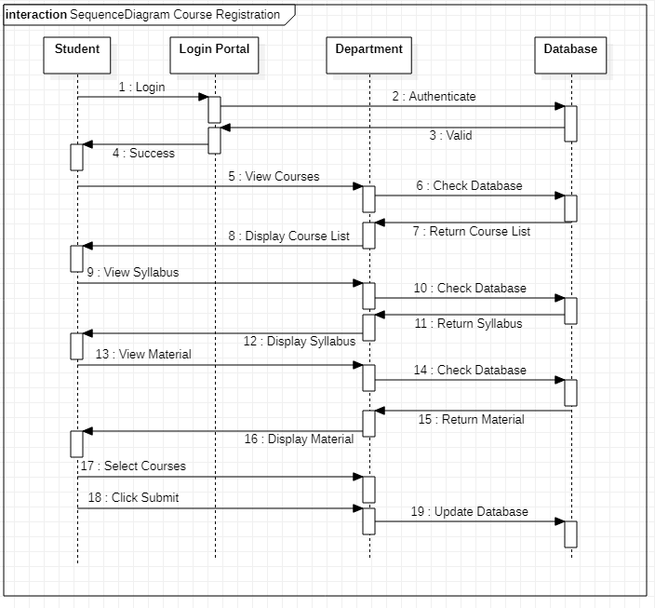

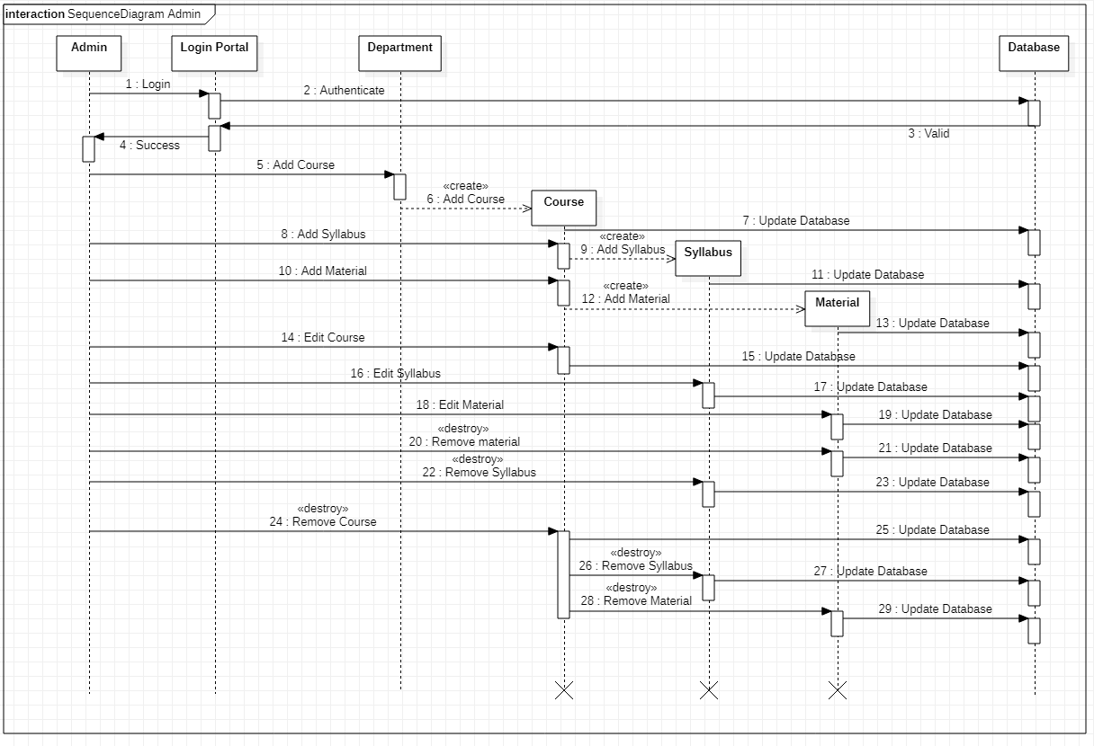

**2. Hostel Management System**

**Sequence Diagrams:** 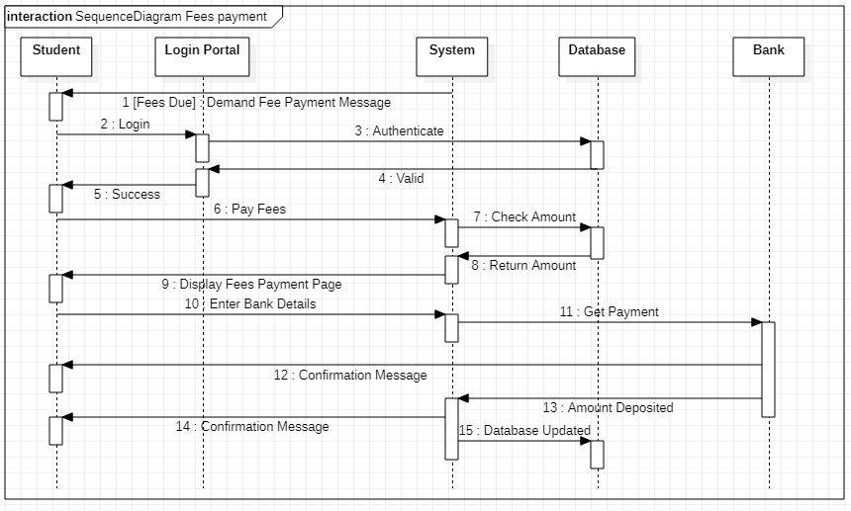

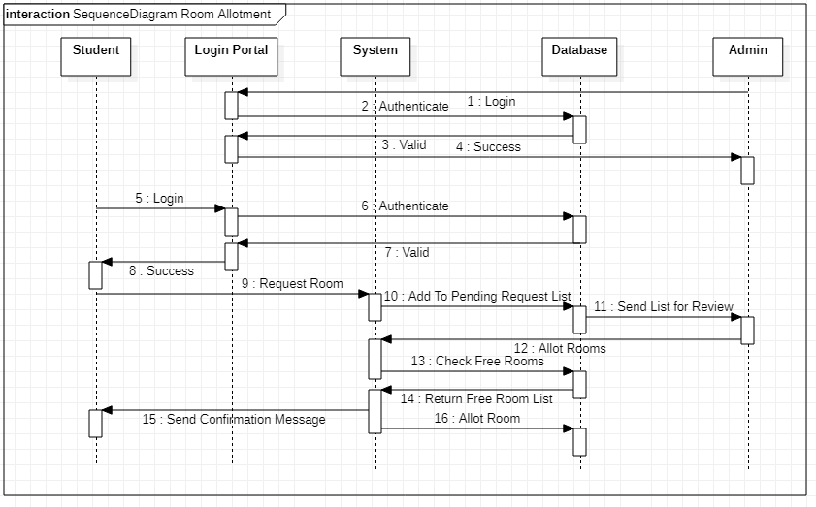

**3. Stock Maintenance System**

**Sequence Diagrams:**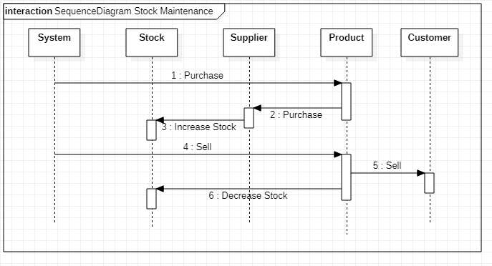

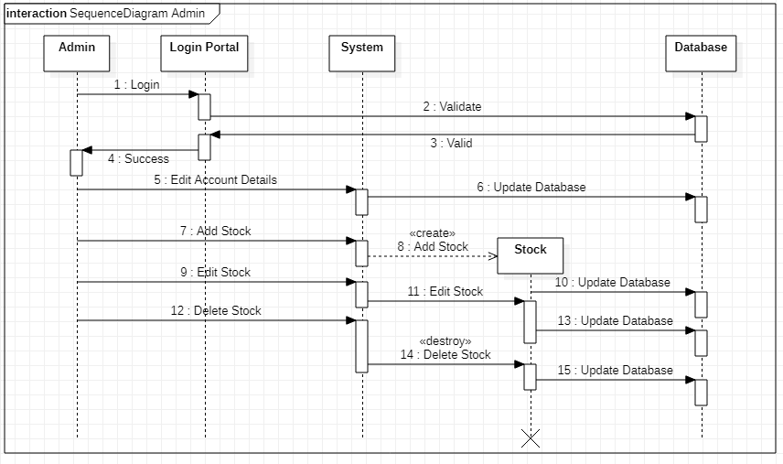

**4. Coffee Vending Machine**

**Sequence Diagrams:**

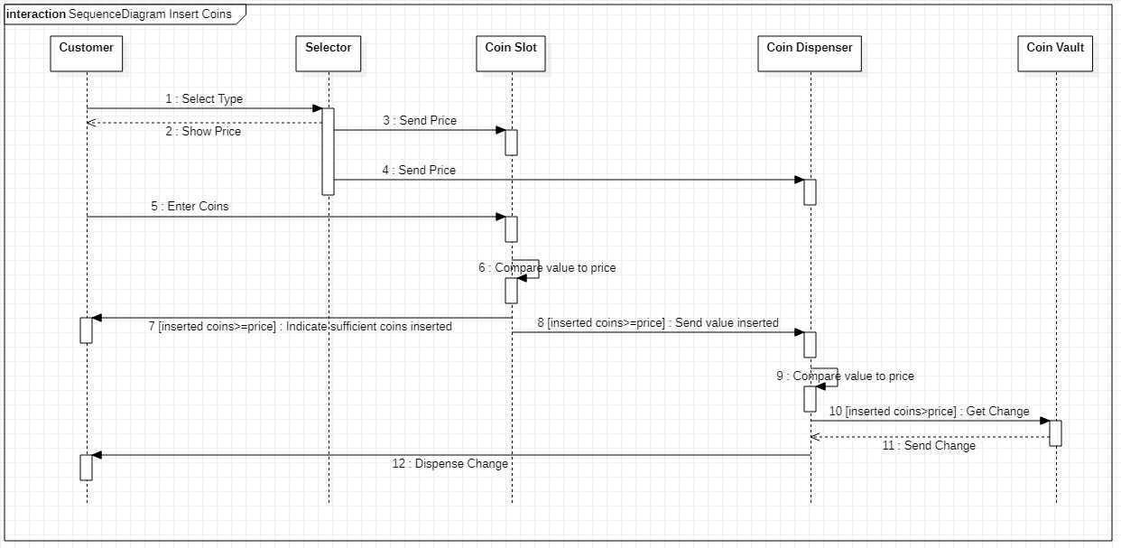

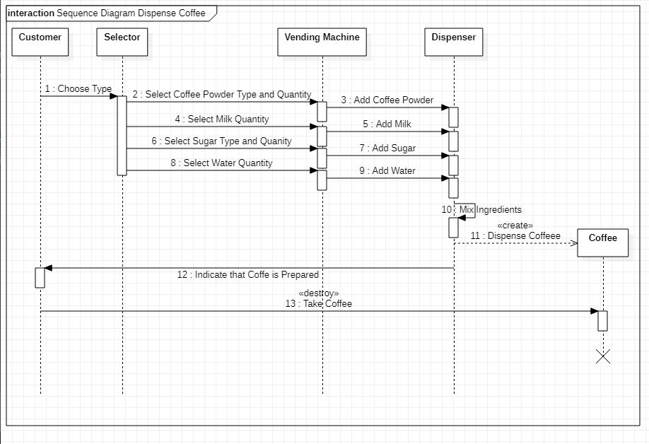

**5. Online Shopping System**

**Sequence Diagrams:**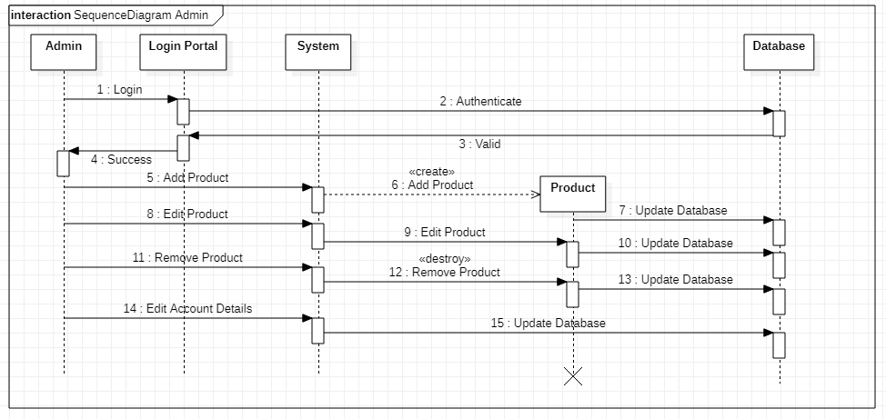

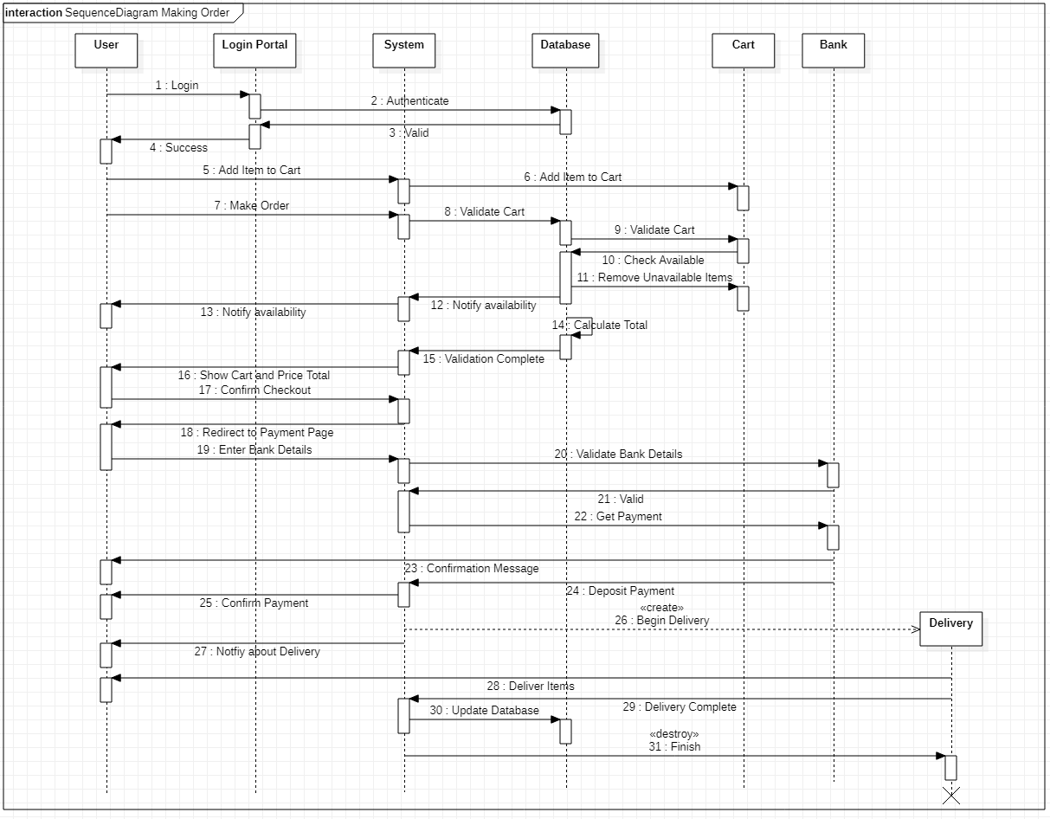

**6. Railway Reservation System**

**Sequence Diagrams:**

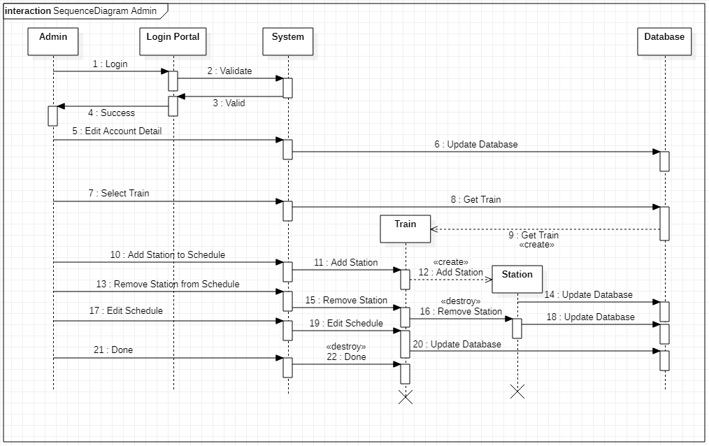

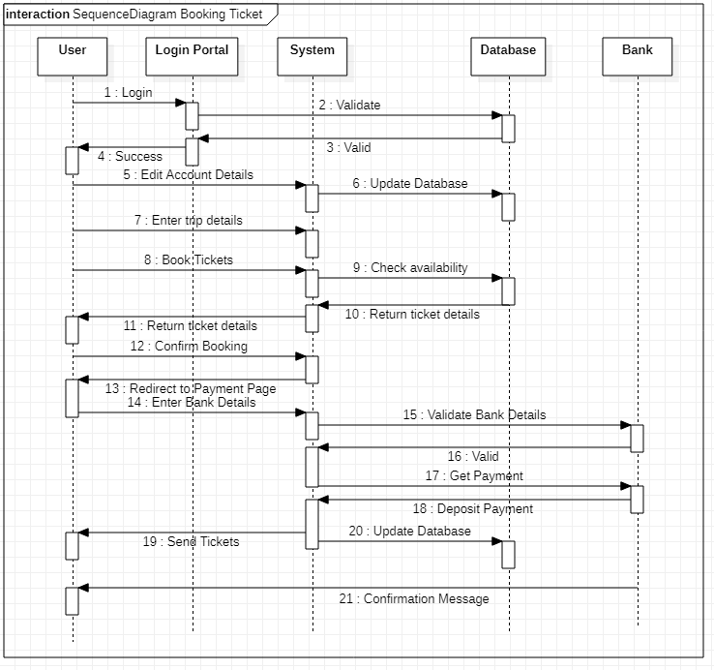

**7. Graphics Editor**

**Sequence Diagrams:**

