**B.M.S. COLLEGE OF ENGINEERING BENGALURU**

Autonomous Institute, Affiliated to VTU



Lab Record

**Object Oriented Analysis and Design**

*Submitted in partial fulfillment for the 6th Semester Laboratory*

Bachelor of Technology

in

Computer Science and Engineering

*Submitted by:*

**TONY J MATHEW**

1BM17CS119

Department of Computer Science and Engineering

B.M.S. College of Engineering

Bull Temple Road, Basavanagudi, Bangalore 560 019

Jan-May 2019

**B.M.S. College of EngineerinG**

**DEPARTMENT OF COMPUTER SCIENCE AND ENGINEERING**



***CERTIFICATE***

This is to certify that the Object-Oriented Analysis and Design(16CS6DCOOM) laboratory has been carried out by TONY J MATHEW (1BM17CS119) during the 6th Semester Jan-May-2019.

Signature of the Faculty Incharge:

NAME OF THE FACULTY:

Department of Computer Science and Engineering

B.M.S. College of Engineering, Bangalore

Table of Contents

|  |
| --- |
| 1.College Information System |
| 2.Hostel Management System |
| 3.Stock Maintenance System |
| 4.Coffee Vending Machine |
| 5.Online Shopping System |
| 6.Railway reservation system |
| 7.Graphics Editor |

**1. College Information System**

**Use Case Diagrams:**

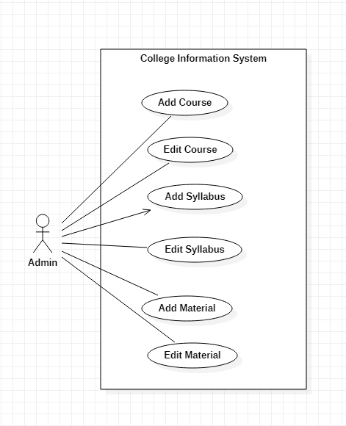

There is one actor:

* **Admin:** Person who manages the available courses

There are six use cases:

* **Add Course:** Add courses that can be chosen
* **Edit Course:** Edit courses that can be chosen
* **Add Syllabus:** Add syllabus to course
* **Edit Syllabus:** Edit syllabus of course
* **Add Material:** Add material to course
* **Edit Material:** Edit material of course

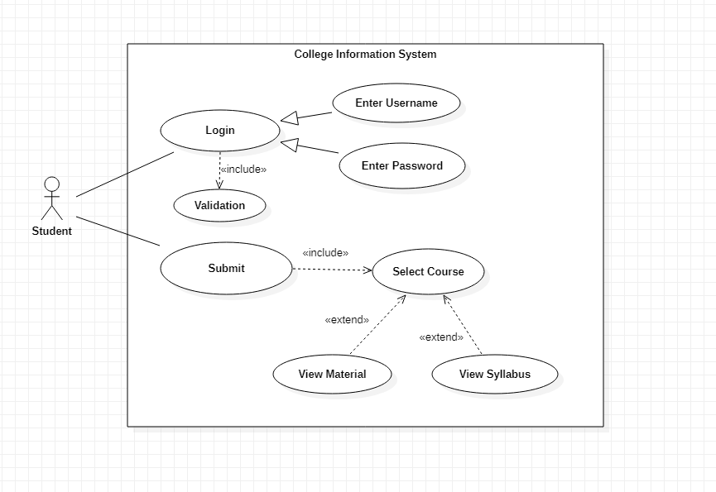

There is one actor:

* **Student:** Person who registers for courses

There are eight use cases:

* **Login:** Login to course registration website
* **Enter Username:** Enter username to login
* **Enter Password:** Enter password to login
* **Validation:** Validate login credentials and allow login
* **Submit:** Submit selected courses to college database
* **Select Course:** Select course from available courses
* **View Syllabus:** View syllabus of course
* **View Material:** View material of course

**2. Hostel Management System**

**Use Case Diagrams:**

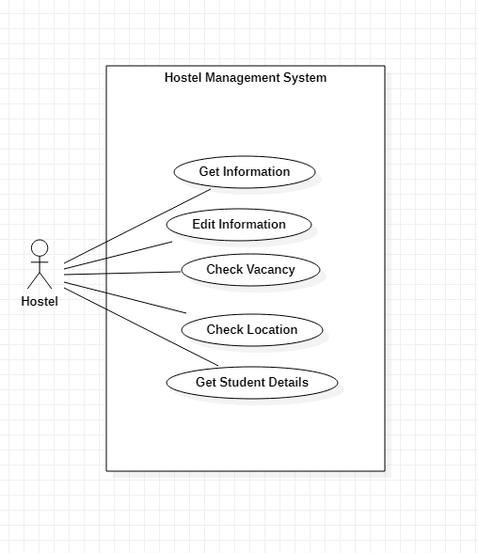

There is one actor:

* **Hostel:** The area where students are allowed to live

There are five use cases:

* **Get Information:** Get information about hostel
* **Edit Information:** Edit information about hostel
* **Check Vacancy:** Check for vacant rooms
* **Check Location:** Query location of vacant rooms
* **Get Student Details:** Get information about students residing in hostel

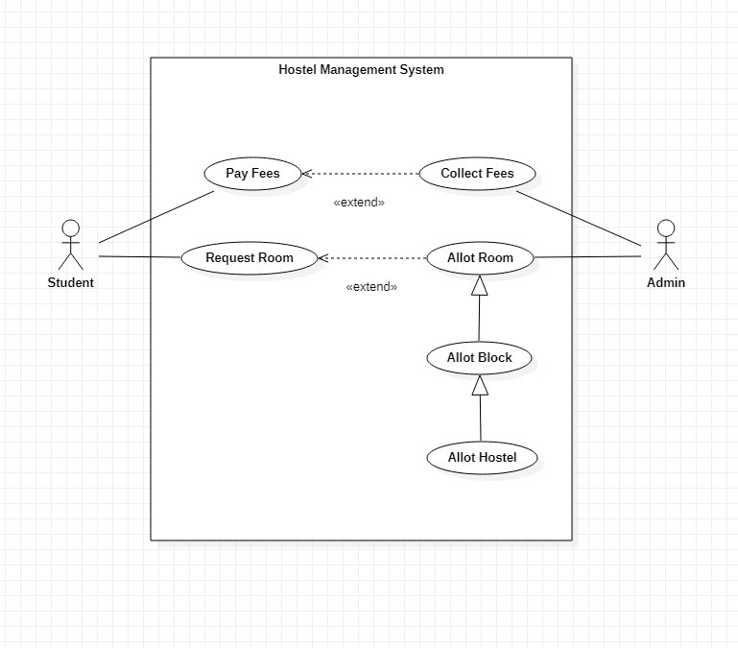

There are two actors:

* **Student:** Person who requests a room
* **Admin:** Person who allots rooms and collects fees

There are six use cases:

* **Pay Fees:** Pay fees for staying at hostel
* **Request Room:** Request hostel room
* **Collect Fees:** Collect fees for staying at hostel
* **Allot Room:** Allot room for student
* **Allot Block:** Allot block for student
* **Allot Hostel:** Allot hostel for student

**3. Stock Maintenance System**

**Use Case Diagrams:**

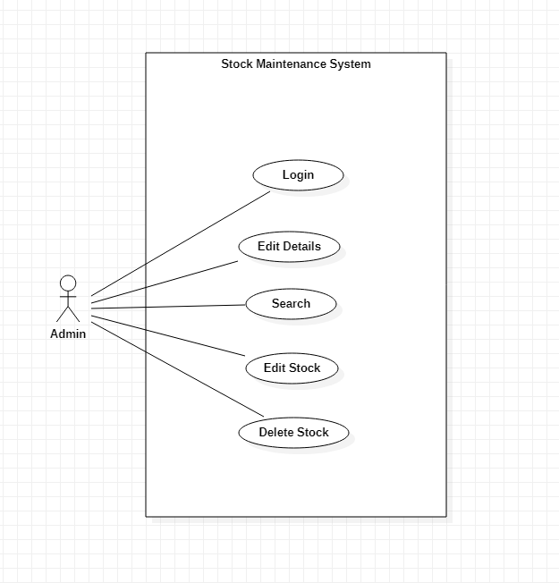

There is one actor:

* **Admin:** Person who manages the stock

There are five use cases:

* **Login:** Login to Stock Management Database
* **Edit Details:** Edit account details
* **Search:** Search for products
* **Edit Stock:** Edit Stock details
* **Delete Stock:** Delete stock from database

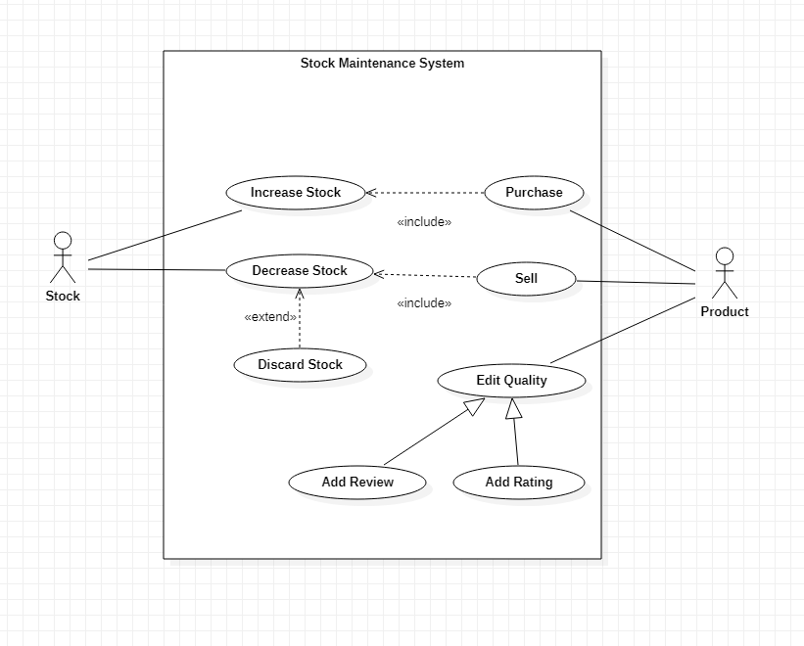

There are two actors:

* **Stock:** The place where merchandise is kept
* **Product:** The merchandise that is being stocked

There are eight use cases:

* **Increase Stock:** Increase stock of products
* **Decrease Stock:** Decrease stock of products
* **Discard Stock:** Discard faulty products
* **Purchase:** Purchase product from supplier
* **Sell:** Sell product to customer
* **Edit Quality:** Edit quality of product
* **Add Review:** Add product review
* **Add Rating:** Add product rating

**4. Coffee Vending Machine**

**Use Case Diagrams:**

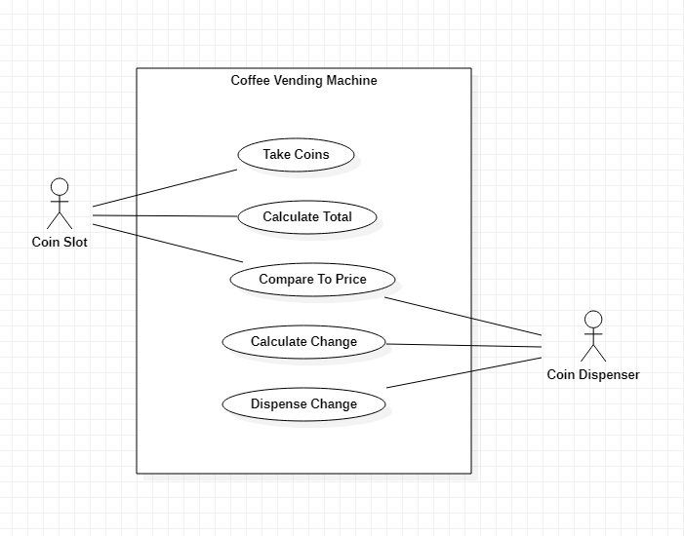

There are two actors:

* **Coin Slot:** The slot in which coins are inserted
* **Coin Dispense:** The dispenser that returns change

There are five use cases:

* **Take Coins:** Take coins from user
* **Calculate Total:** Calculate total value of inserted coins
* **Compare To Price:** Compare value inserted to price of coffee
* **Calculate Change:** Calculate change to return
* **Dispense Change:** Return change to user

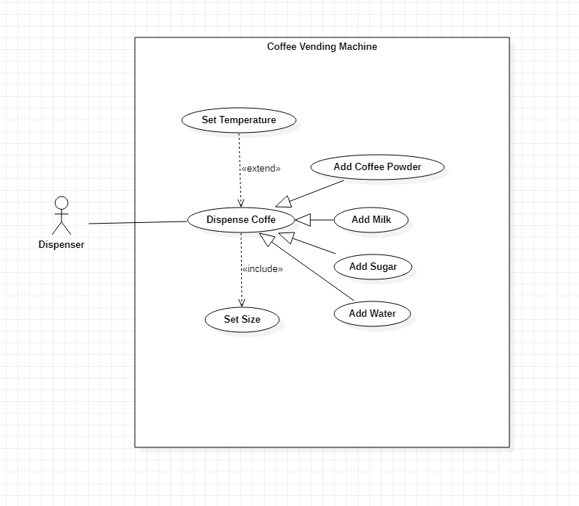

There is one actor:

* **Dispenser:** The equipment that mixes and dispenses coffee

There are seven use cases:

* **Dispense Coffee:** Dispense coffee as selected
* **Add Coffee Powder:** Add coffee powder to mix
* **Add Milk:** Add milk to mix
* **Add Sugar:** Add sugar to mix
* **Add Water:** Add water to mix
* **Set Size:** Set size of coffee desired
* **Set Temperature:** Set desired temperature for coffee

**5. Online Shopping System**

**Use Case Diagrams:**

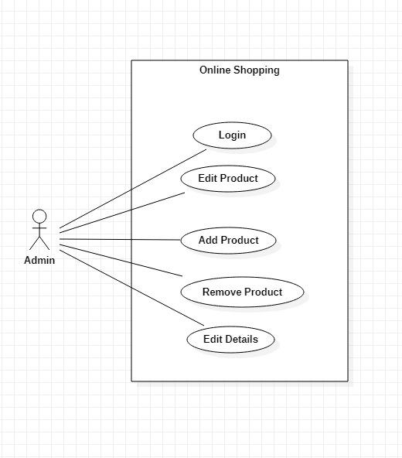

There is one actor:

* **Admin:** Person who manages products for sale

There are five use cases:

* **Login:** Login to online shopping website
* **Edit Product:** Edit Product details
* **Add Product:** Add product to store
* **Remove Product:** Remove product from store
* **Edit Details:** Edit account details

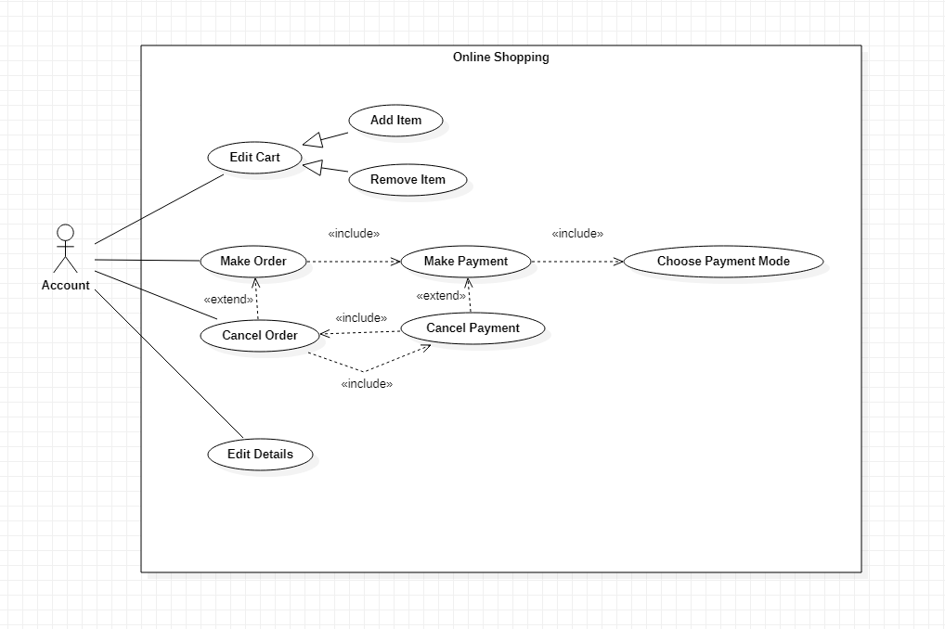

There is one actor:

* **Account:** Created by user to make transactions

There are nine use cases:

* **Edit Cart:** Edit shopping cart
* **Add Item:** Add items to shopping cart
* **Remove Item:** Remove items from shopping cart
* **Make Order:** Confirm order for items from cart
* **Make Payment:** Make payment for order
* **Cancel Order:** Cancel order before delivery
* **Cancel Payment:** Cancel payment for an order
* **Choose Payment Mode:** Choose payment mode for order
* **Edit Details:** Edit account details

**6. Railway Reservation System**

**Use Case Diagrams:**

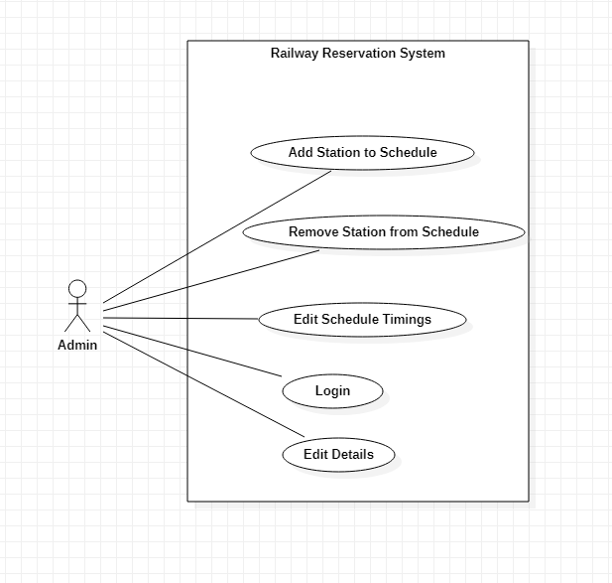

There is one actor:

* **Admin:** Person who manages train schedules

There are five use cases:

* **Add Station to Schedule:** Add station to schedule of train
* **Remove Station from Schedule:** Remove station from schedule of train
* **Edit Schedule Timings:** Edit timings in schedule of train
* **Login:** Login to railway reservation database
* **Edit Details:** Edit account details

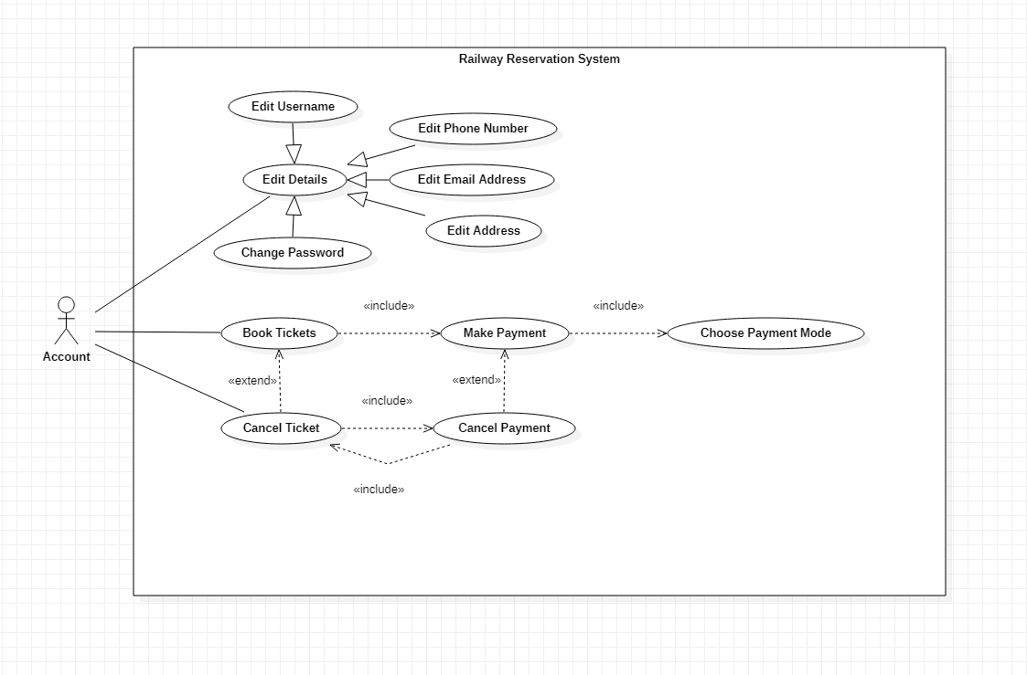

There is one actor:

* **Account:** Created by user to book tickets

There are eleven use cases:

* **Edit Details:** Edit account details
* **Edit Username:** Edit account username
* **Edit Phone Number:** Edit account phone number
* **Edit Email Address:** Edit account email address
* **Edit Address:** Edit account address
* **Change Password:** Change password for account
* **Book tickets:** Confirm booking of tickets
* **Make Payment:** Make payment for tickets
* **Cancel Ticket:** Cancel booked tickets
* **Cancel Payment:** Cancel payment for tickets
* **Choose Payment Mode:** Choose payment mode for booking

**7. Graphics Editor**

**Use Case Diagrams:**

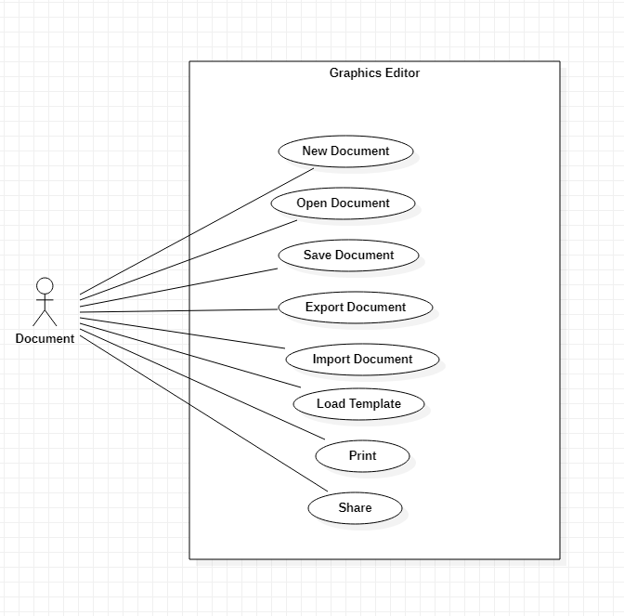

There is one actor:

* **Document:** File that stores changes made by user

There are eight use cases:

* **New Document:** Create a new document
* **Open Document:** Open am existing document
* **Save Document:** Save document on computer
* **Export Document:** Export document to other file formats
* **Import Document:** Import document from other file formats
* **Load Template:** Load template for document
* **Print :** Print document
* **Share:** Share document with others

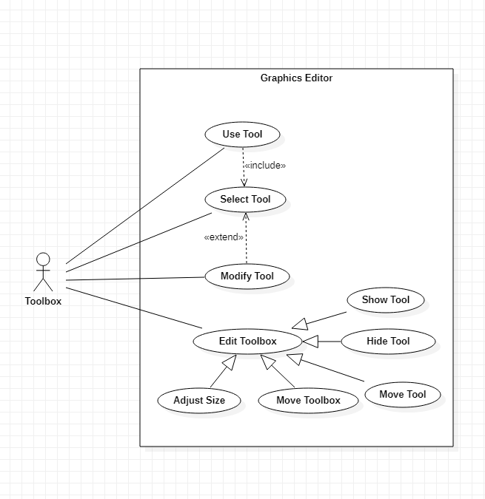

There is one actor:

* **Toolbox:** UI interface that provides options for user to modify document.

There are nine use cases:

* **Use Tool:** Use selected tool
* **Select Tool:** Select tool from toolbox
* **Modify Tool:** Modify selected tool settings
* **Edit Toolbox:** Edit toolbox UI
* **Show Tool:** Show tool in toolbox
* **Hide Tool:** Hide tool in toolbox
* **Move Tool:** Move tool in toolbox
* **Move Toolbox:** Move toolbox on screen
* **Adjust Size:** Adjust size of toolbox