Some Things are in multiple categories so we have to decide where to put it.

**Title**

**Introduction**

**Software Requirement Specification** [6] <PDF Chapter no.>

**User Requirements**

1. The user should be automatically allowed entry into parking lot and payment must be handles without user input.

**System Requirements**

1. The user should have a parking card and it must be pasted inside front window of car.
2. User must link digital wallet to the system.
3. User receives mail containing details of transaction.
4. User must have specified minimum balance in wallet.

**Functional Requirements**

1. Every user receives a card with a unique ID.
2. The user’s digital wallet is linked to the system and can be identified using card ID.
3. When user is allowed entry into parking lot, the time is registered.
4. When user exits parking lot, time is registered and payment is made.
5. If payment is insufficient, user is informed to refill wallet.
6. System contains information regarding which parking spaces are currently occupied.
7. New users are given location of available parking spots. If no parking spots are available, they are informed.

**Non-Functional Requirements:**

**-Product Requirements**

**-Organizational Requirements**

**-External Requirements**

1. The system shall not disclose personal information about customer apart from name and reference ID to system operators. Account details must be secure so as to prevent misuse.

**Domain Requirements**

**Form Based Specification**

**Sequence Diagram**

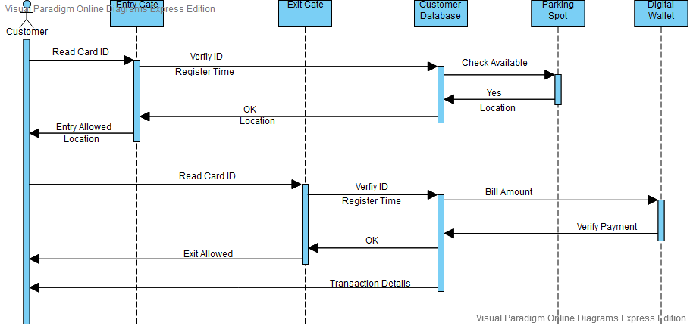

**Use Case Diagram**

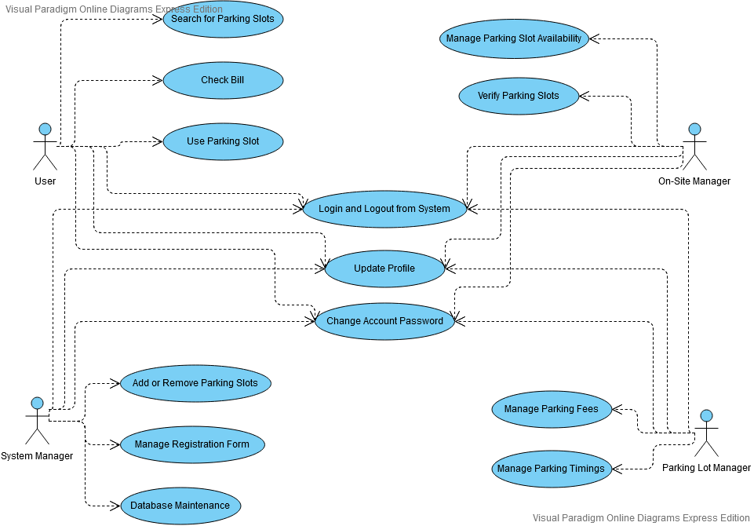

* Feasibility Study? [7]

* Viewpoint? [7]

* Use Cases [7]

* Validation? [7]

**Design Models** [8]

* Context Model

* Process Model

* Data Flow Model

* Behavioural Model

* State Machine Model

* Object Model

**Detailed Description of Models**

Explain above models

**Architectural Design** [11]

* Box and Line Diagram

* Object Model

* Function Oriented Models

* Control Style (Event Driven)

**Detailed Design** [14]

*System Context and Model of use

* Use Case Models

*Use Case Description

*Subsystem Model

* Sequence Model

* State Charts

**Estimation and Schedule** [26,27]

https://www.tutorialspoint.com/estimation_techniques/estimation_techniques_overview.htm

https://www.geeksforgeeks.org/software-engineering-project-size-estimation-techniques/

**Test Cases**

https://wiki.openoffice.org/wiki/QA/Testcase/How_to_write_test_case

https://www.tutorialspoint.com/software_testing_dictionary/test_case.htm

**Conclusion**