Some Things are in multiple categories so we have to decide where to put it.

**Title**

**Introduction**

**Software Requirement Specification** [6] <PDF Chapter no.>

**User Requirements**

1. The user should be automatically allowed entry into parking lot and payment must be handles without user input.

**System Requirements**

1. The user should have a parking card and it must be pasted inside front window of car.
2. User must link digital wallet to the system.
3. User receives mail containing details of transaction.
4. User must have specified minimum balance in wallet.

**Functional Requirements**

1. Every user receives a card with a unique ID.
2. The user’s digital wallet is linked to the system and can be identified using card ID.
3. When user is allowed entry into parking lot, the time is registered.
4. When user exits parking lot, time is registered and payment is made.
5. If payment is insufficient, user is informed to refill wallet.
6. System contains information regarding which parking spaces are currently occupied.
7. New users are given location of available parking spots. If no parking spots are available, they are informed.

**Non-Functional Requirements:**

**-Product Requirements**

**-Organizational Requirements**

**-External Requirements**

1. The system shall not disclose personal information about customer apart from name and reference ID to system operators. Account details must be secure so as to prevent misuse.

**Domain Requirements**

**Form Based Specification**

|  |  |
| --- | --- |
| **Automatic Parking System** | |
| **Function** | Automatic Entry and Exit to and from parking lot. Automatic parking fee payment. |
| **Description** | I allows automatic entry and exit to and from parking lot. The parking fee to be charged is calculated and automatically deducted from linked account. |
| **Inputs** | User Id, Time of Entry, Time of Exit, Parking Slot Availability |
| **Source** | FASTag Reader at Entry and Exit Gate, Parking Slot Load Cell |
| **Outputs** | Open Gate, Deduct calculated bill amount from linked account, Location of available parking slot |
| **Destination** | Customer Database, Main Control Loop |
| **Action** | FASTag Reader reads card ID of entering and exiting vehicles. The card ID is verified with the customer database. Load cells are present at all parking slots to check if it is occupied. If ID is valid and parking slot is available (entry only), the gate opens and the time of entry and exit are registered at respective gates. User is given the location of an available parking slot which is displayed on an LCD screen above gate. The bill is calculated on exit based on entry and exit times. The bill amount is then charged from the linked user account. Bill details are sent to user. |
| **Requires** | Card ID to verify with customer database. Load cell sensor data to check parking slot availability. Entry and Exit timings to calculate bill. |
| **Pre-Condition** | User must have Parking Service Card. Linked account must have minimum fare amount. |
| **Post-Condition** | If linked account has insufficient balance, user must be informed to add money to linked account. Pending fees stored in Customer Database. |
| **Side Effects** | None. |

* Feasibility Study? [7]

* Viewpoint? [7]

* Validation? [7]

**Design Models** [8]

* Context Model

* Process Model

* Data Flow Model

* Behavioural Model

* State Machine Model

* Object Model

**Detailed Description of Models**

Explain above models

**Architectural Design** [11]

* Box and Line Diagram

* Object Model

* Function Oriented Models

* Control Style (Event Driven)

**Detailed Design** [14]

**Use Case Diagram**

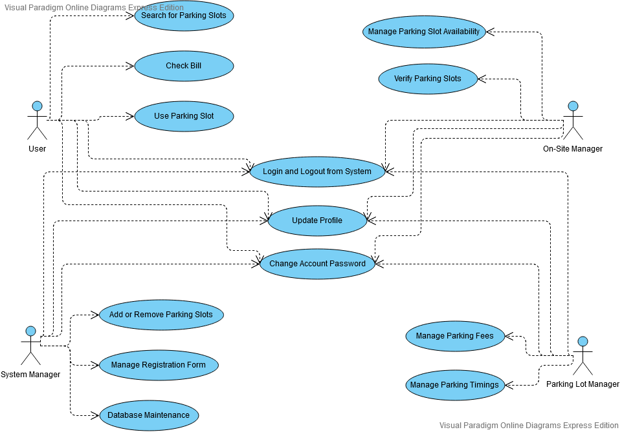

**Sequence Diagram**

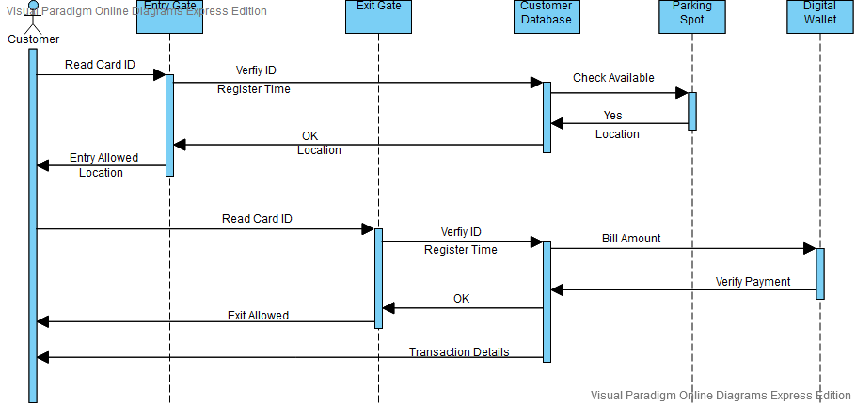

*System Context and Model of use

* Use Case Models

*Use Case Description

*Subsystem Model

* State Charts

**Estimation and Schedule** [26,27]

https://www.tutorialspoint.com/estimation_techniques/estimation_techniques_overview.htm

https://www.geeksforgeeks.org/software-engineering-project-size-estimation-techniques/

**Test Cases**

**Title:** Parking Lot – Entry

**Description:** A registered user should be able to allowed entry to parking lot.

**Precondition:** The user must already be registered to the service with an email address and password.

**Assumption:** The user has membership card stuck inside front window of car.

**Test Steps:**

1. Drive car to entry gate.
2. Card is scanned by FASTag Reader.

**Expected Result:** Entry gate opens if space is available in parking lot. Location of free parking spot is displayed on screen. Time of entry is registered into customer database.

**Title:** Parking Lot – Parking Spot Availability

**Description:** System should know if parking spot is available and location of available parking spots.

**Precondition:** Load Cell at every parking spot.

**Assumption:** Free parking spot available.

**Test Steps:**

1. Check for available parking spots in database.
2. Drive car to parking spot.
3. Check database.
4. Drive car out of parking spot.
5. Check database.

**Expected Result:** If car is parked in a parking spot, the location should be updated in database and marked as unavailable. If car leaves parking spot, it should be marked as available.

**Title:** Parking Lot – Exit

**Description:** A registered user should be able to allowed exit from parking lot and payment automatically deducted from linked account.

**Precondition:** The user must already be registered to the service with an email address and password.

**Assumption:** The user has membership card stuck inside front window of car.

**Test Steps:**

1. Drive car to exit gate.
2. Card is scanned by FASTag Reader.

**Expected Result:** Exit gate opens if sufficient balance is present in linked account. Bill payment carried out automatically. Mail is sent to user giving details of transaction.

**Conclusion**