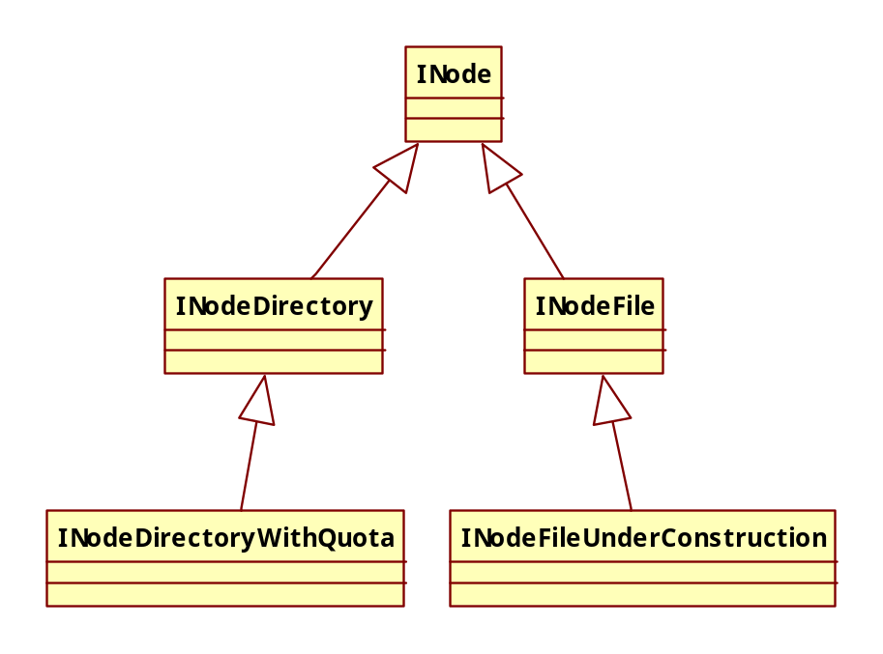

INode
抽象类，实现了Comparable<byte[]>。表示file和directory的inode信息

属性：
- protected byte[] name;
- protected INodeDirectory parent;
- protected long modificationTime;
最近修改时间
- protected long accessTime;
最近访问时间
- private long permission;
权限信息，只能被updatePermissionStatus修改

permission共分为三段，分别对应PermissionStatusFormat中的三个部分，每次调用updatePermissionStatus方法时，会根据传入的PermissionStatusFormat类型进行设置，保证只设置permission中对应的那一段数据。（共64位，差分为3个部分）

方法：
- boolean isRoot()
判断是否为root的inode，返回name.length == 0;
- protected void setPermissionStatus(PermissionStatus ps)
分别调用setUser，setGroup和setPermission，设置为ps对应的属性
- protected PermissionStatus getPermissionStatus()
使用getUserName，getGroupName和getFsPermission构造PermissionStatus
- private synchronized void updatePermissionStatus(PermissionStatusFormat f, long n)
设置permission = f.combine(n, permission);
- public String getUserName()
  - 获取int n = (int)PermissionStatusFormat.USER.retrieve(permission);
  - 返回SerialNumberManager.INSTANCE.getUser(n);
- protected void setUser(String user)
  - 获取int n = SerialNumberManager.INSTANCE.getUserSerialNumber(user);
  - 设置updatePermissionStatus(PermissionStatusFormat.USER, n);
- public String getGroupName()
同5
- protected void setGroup(String group)
同6
- public FsPermission getFsPermission()
使用PermissionStatusFormat.MODE.retrieve(permission)的返回值新建FsPermission
- protected short getFsPermissionShort()
直接返回PermissionStatusFormat.MODE.retrieve(permission)
- protected void setPermission(FsPermission permission)
调用updatePermissionStatus(PermissionStatusFormat.MODE, permission.toShort());
- public final ContentSummary computeContentSummary()
  - 调用long[] a = computeContentSummary(new long[]{0,0,0,0});
  - 使用a新建ContentSummary并返回
- long getNsQuota()
-1
- long getDsQuota()
-1
- boolean isQuotaSet()
返回getNsQuota() >= 0 || getDsQuota() >= 0;
- String getLocalName()
返回DFSUtil.bytes2String(name);
- void setLocalName(String name)
设置name = DFSUtil.string2Bytes(name);
- void setModificationTime(long modtime)
  - 保证isDirectory();
  - 如果modificationTime <= modtime，则设置modificationTime = modtime
- void setModificationTimeForce(long modtime)
  - 保证!isDirectory();
  - 设置modificationTime = modtime;
- boolean isUnderConstruction()
false
- static byte[][] getPathComponents(String[] strings)
把传入的strings转化成字节数组
- static String[] getPathNames(String path)
保证path以Path.SEPARATOR开头（即”/”），返回path.split(Path.SEPARATOR);
- boolean removeNode()
  - 如果parent为空，则直接返回false
  - 否则，调用parent.removeChild(this);，然后设置parent = null;并返回true
- public int compareTo(byte[] o)
返回compareBytes(name, o);
- public boolean equals(Object o)
只比较name
- static int compareBytes(byte[] a1, byte[] a2)
依次比较每个字节
- LocatedBlocks createLocatedBlocks(List<LocatedBlock> blocks)
返回new LocatedBlocks(computeContentSummary().getLength(), blocks, isUnderConstruction());

抽象方法:
- public abstract boolean isDirectory();
- abstract int collectSubtreeBlocksAndClear(List<Block> v);
- abstract long[] computeContentSummary(long[] summary);
- abstract DirCounts spaceConsumedInTree(DirCounts counts);

DirCounts
简单的包装nsCount (namespace consumed) and dsCount (diskspace consumed)

PermissionStatusFormat
枚举，封装了权限信息

- MODE(0, 16),
- GROUP(MODE.OFFSET + MODE.LENGTH, 25),
- USER(GROUP.OFFSET + GROUP.LENGTH, 23);

属性：
- final int OFFSET;
- final int LENGTH; //bit length
- final long MASK;

构造函数：
PermissionStatusFormat(int offset, int length)：
- 设置OFFSET = offset;
- 设置LENGTH = length;
- 设置MASK = ((-1L) >>> (64 - LENGTH)) << OFFSET;

方法：
- long retrieve(long record)
返回(record & MASK) >>> OFFSET;
- long combine(long bits, long record)
返回(record & ~MASK) | (bits << OFFSET);

INodeDirectory
继承自INode，表示目录的inode

属性：
- protected static final int DEFAULT_FILES_PER_DIRECTORY = 5;
- final static String ROOT_NAME = "";
- private List<INode> children;

方法：
- public boolean isDirectory()
true
- INode removeChild(INode node)
使用二分查找Collections.binarySearch(children, node.name);，如果找到则从children中删除
- void replaceChild(INode newChild)
同2使用二分查找，找到后设置为newChild
- private INode getChildINode(byte[] name)
同2使用二分查找
- private INode getNode(byte[][] components)
调用getExistingPathINodes
- INode getNode(String path)
返回getNode(getPathComponents(path));
- int getExistingPathINodes(byte[][] components, INode[] existing)
  - assert compareBytes(this.name, components[0]) == 0（此处components[0]应该是root，为空才对？可能是调用这个方法的，必须是root？）
  - 设置INode curNode = this;
  - 因为只能盛放满existing，所以首先计算components的起始index，从这个index向后获取，填充existing（细节见方法说明）
  - 遍历components，对父节点调用getChildINode查找，直到components中最后一个节点或者已经查找到文件尾部，即不可能再往下遍历（文件不能有子文件）
  - 返回查找到的个数，可见existing不应定会填满，没填充的位置则留为null
- INode[] getExistingPathINodes(String path)
  - 调用byte[][] components = getPathComponents(path);
  - 初始化INode[] inodes = new INode[components.length];
  - 调用getExistingPathINodes(components, inodes);
  - 返回inodes
- <T extends INode> T addChild(final T node, boolean inheritPermission)
  - 如果inheritPermission为true，则继承父目录的权限：
    - 获取FsPermission p = getFsPermission();
    - 如果当前用户没有WRITE_EXECUTE的权限，则要加上
    - 设置权限node.setPermission(p);
  - 如果children为null，则初始化children = new ArrayList<INode>(DEFAULT_FILES_PER_DIRECTORY);
  - 在children使用二分查找node，如果找到，则返回null，因为不能覆盖
  - 设置node.parent = this;
  - 添加children.add(-low - 1, node);其中low为二分查找的返回值
  - 更新父目录的访问时间setModificationTime(node.getModificationTime());
  - 如果node.getGroupName() == null，即没有群组信息，则设置node.setGroup(getGroupName());
  - 返回node
- int nextChild(byte[] name)
查找给定name的下一个节点位置
  - 二分查找：int nextPos = Collections.binarySearch(children, name) + 1;
  - 如果nextPos >= 0则返回nextPos
  - 否则返回-nextPos
- <T extends INode> T addNode(String path, T newNode, boolean inheritPermission )
调用addToParent(path, newNode, null, inheritPermission)，如这个方法返回null，则直接返回null，否则返回newNode
- <T extends INode> INodeDirectory addToParent(String path, T newNode, INodeDirectory parent, boolean inheritPermission )
  - 获取byte[][] pathComponents = getPathComponents(path);，确保返回的pathComponents不为空
  - 如果pathLen < 2，则表示root，不可行，返回null
  - 如果parent == null：
    - 新建INode[] inodes = new INode[2];并调用getExistingPathINodes(pathComponents, inodes);（获取父目录和节点自身）
    - 获取INode inode = inodes[0];（即父目录），如果indoe为null，则抛出FileNotFoundException说明父目录不存在
    - 如果inode不是目录，则抛出FileNotFoundException
    - 设置parent = (INodeDirectory)inode;
  - 设置newNode.name = pathComponents[pathLen-1];，即文件名
  - 调用parent.addChild(newNode, inheritPermission)插入到父目录的children列表，如果返回null，则表示插入不成功，返回null
  - 否则返回parent
- DirCounts spaceConsumedInTree(DirCounts counts)
  - 设置counts.nsCount += 1;
  - 遍历children，对每个INode child，调用child.spaceConsumedInTree(counts);
  - 返回counts
- long[] computeContentSummary(long[] summary)
返回一个数组：0: length, 1: file count, 2: directory count 3: disk space
- 确保4 == summary.length;
- 初始化long[] subtreeSummary = new long[]{0,0,0,0};
- 遍历children，对每个INode child调用child.computeContentSummary(subtreeSummary);
- 如果this是INodeDirectoryWithQuota类型：
- 强转INodeDirectoryWithQuota node = (INodeDirectoryWithQuota)this;
- 获取long space = node.diskspaceConsumed();
- 调用assert -1 == node.getDsQuota() || space == subtreeSummary[3];，如果不满足，则要打印出警告Inconsistent diskspace for directory
- 把subtreeSummary加到summary
- 调用summary[2]++;
- 返回summary
- int collectSubtreeBlocksAndClear(List<Block> v)
Collect all the blocks in all children of this INode.
- 设置int total = 1;
- 对每个child调用collectSubtreeBlocksAndClear(v);，结果加到total
- 设置parent和children为null
- 返回total

InodeDirectoryWithQuota
继承自INodeDirectory，提供了quota限制

属性：
- private long nsQuota; /// NameSpace quota
- private long nsCount;
- private long dsQuota; /// disk space quota
- private long diskspace;

构造函数：
INodeDirectoryWithQuota(long nsQuota, long dsQuota, INodeDirectory other)
把other转化为带有quota限制的INodeDirectoryWithQuota：
- 调用super(other);
- 新建INode.DirCounts counts = new INode.DirCounts();并计算other.spaceConsumedInTree(counts);
- 设置this.nsCount= counts.getNsCount();和this.diskspace = counts.getDsCount();
- 调用setQuota(nsQuota, dsQuota);

方法：
- DirCounts spaceConsumedInTree(DirCounts counts)
设置counts.nsCount += nsCount;和counts.dsCount += diskspace;，返回counts
- void updateNumItemsInTree(long nsDelta, long dsDelta)
设置nsCount += nsDelta;和diskspace += dsDelta;
- void setSpaceConsumed(long namespace, long diskspace)
设置this.nsCount = namespace;和this.diskspace = diskspace;
- void verifyQuota(long nsDelta, long dsDelta)
验证是否满足quota的限制：
- 计算long newCount = nsCount + nsDelta;和long newDiskspace = diskspace + dsDelta;
- 如果nsQuota < newCount，则抛出NSQuotaExceededException
- 如果dsQuota < newDiskspace，则抛出DSQuotaExceededException

INodeFile
继承自INode，表示文件的inode

属性：
- static final FsPermission UMASK = FsPermission.createImmutable((short)0111);
- static final short BLOCKBITS = 48; //Number of bits for Block size
- static final long HEADERMASK = 0xffffL << BLOCKBITS;
64位的header mask，格式为[16 bits for replication][48 bits for PreferredBlockSize]
- protected long header;、
- protected BlockInfo blocks[] = null;

方法：
- protected void setPermission(FsPermission permission)
调用super.setPermission(permission.applyUMask(UMASK));，因为不可能存在文件的执行权限，所以设置了Mask
- public boolean isDirectory()
false
- public short getReplication()
返回((header & HEADERMASK) >> BLOCKBITS)，见HEADERMASK解释
- public void setReplication(short replication)
设置header = ((long)replication << BLOCKBITS) | (header & ~HEADERMASK);
- public long getPreferredBlockSize()
返回header & ~HEADERMASK;
- public void setPreferredBlockSize(long preferredBlkSize)
设置header = (header & HEADERMASK) | (preferredBlkSize & ~HEADERMASK);
- void addBlock(BlockInfo newblock)
添加newblock到blocks，因为是静态数组，所以只能重建数组
- void setBlock(int idx, BlockInfo blk)
设置this.blocks[idx] = blk;
- int collectSubtreeBlocksAndClear(List<Block> v)
  - 设置parent = null;
  - 遍历blocks，添加到v中
  - 设置blocks为null
  - 返回1
- long[] computeContentSummary(long[] summary)
  - 遍历blocks，对每个Block，计算bytes += blk.getNumBytes();
  - 设置summary[0] += bytes;
  - 设置summary[1]++;
  - 设置summary[3] += diskspaceConsumed();
  - 返回summary
- DirCounts spaceConsumedInTree(DirCounts counts)
  - 设置counts.nsCount += 1;
  - 设置counts.dsCount += diskspaceConsumed();
  - 返回counts
- long diskspaceConsumed(Block[] blkArr)
  - 遍历blkArr，对每个Block，计算size += blk.getNumBytes();
  - 如果最后一个block还在写入（即isUnderConstruction()为true），则要重新计算这个block占用的空间size += getPreferredBlockSize() - blocks[blocks.length-1].getNumBytes();
  - 返回size * getReplication();（这里计算的是总的空间占用，会算上副本数量）
- Block getPenultimateBlock()
获取倒数第二个block，如果没有则返回null
- INodeFileUnderConstruction toINodeFileUnderConstruction(String clientName, String clientMachine, DatanodeDescriptor clientNode)
  - 如果isUnderConstruction()为true，则直接强转后返回(INodeFileUnderConstruction)this;
  - 否则，新建一个INodeFileUnderConstruction返回
- Block getLastBlock()
返回最后一个block

INodeFileUnderConstruction
继承自INodeFile，表示正在构建的file

属性：
- String clientName; // lease holder
- private final String clientMachine;
- private final DatanodeDescriptor clientNode; // if client is a cluster node too.
- private int primaryNodeIndex = -1; //the node working on lease recovery
- private DatanodeDescriptor[] targets = null; //locations for last block
- private long lastRecoveryTime = 0;

方法：
- boolean isUnderConstruction()
true
- void setTargets(DatanodeDescriptor[] targets)
设置this.targets = targets;和this.primaryNodeIndex = -1;
- void addTarget(DatanodeDescriptor node)
如果node没在targets中，则新建添加到targets中，因为targets是数组，所以要重建一个数组
- INodeFile convertToInodeFile()
使用相关属性新建一个INodeFile
- void removeBlock(Block oldblock)
删除block，要求这个block必须是列表中的最后一个：
- 从blocks中删除最后一个block，因为是数组，所以要重建数组
- 设置targets = null;，即删除最后一个block的block locations
- synchronized void setLastBlock(BlockInfo newblock, DatanodeDescriptor[] newtargets )
  - 获取原来的最后一个block：BlockInfo oldLast = blocks[blocks.length - 1];
  - 如果BlockInfo oldLast = blocks[blocks.length - 1];则打印出error并抛出IOException
  - 如果oldLast.getGenerationStamp() > newblock.getGenerationStamp()，则要打印出warn
  - 设置blocks[blocks.length - 1] = newblock;
  - 调用setTargets(newtargets);
  - 设置lastRecoveryTime = 0;
- void assignPrimaryDatanode()
初始化lease recovery：
- 如果targets.length == 0，则打印出warn
- 设置int previous = primaryNodeIndex;
- 遍历targets：
  - 如果targets[j].isAlive，则获取DatanodeDescriptor primary = targets[primaryNodeIndex = j];
  - 调用primary.addBlockToBeRecovered(blocks[blocks.length - 1], targets);
- synchronized boolean setLastRecoveryTime(long now)
如果now - lastRecoveryTime > NameNode.LEASE_RECOVER_PERIOD;（10s）则设置lastRecoveryTime = now;

ContentSummary
存储目录或文件的summary信息

- private long length;
- private long fileCount;
- private long directoryCount;
- private long quota;
- private long spaceConsumed;
- private long spaceQuota;

