设备运行信息周报表

中国气象局卫星中心
报表生成时间：2012-06-05
报表统计时间：2012-06-03 00:00:00~2012-06-09 23:59:59

1 设备事件统计
1.1 设备故障告警统计
事件总数6909次,其中:普通告警0次,严重告警4856次,紧急告警2053次.
1.2 设备告警明细

服务器 | IP地址 | 设备名称 | 操作系统 | 事件总数 | 普通 | 严重 | 紧急 | 连通率事件 | 内存事件 | 磁盘事件 | CPU事件
1 | 10.24.130.104 | 网管服务器2 | Windows Professional/XP | 1 | 0 | 0 | 1 | 1 | 0 | 0 | 0
2 | 10.24.254.1 | SOCC1 | IBM AIX 服务器 | 1393 | 0 | 697 | 696 | 696 | 0 | 697 | 0
3 | 10.24.254.2 | SOCC2 | IBM AIX 服务器 | 1357 | 0 | 679 | 678 | 678 | 0 | 679 | 0

网络设备 | IP地址 | 设备名称 | 操作系统 | 事件总数 | 普通 | 严重 | 紧急 | 连通率事件 | 内存事件 | 磁盘事件 | CPU事件
1 | 10.24.63.17 | nsmc-dmz-sw | null | 678 | 0 | 0 | 678 | 678 | 0 | 0 | 0

1.3 事件告警趋势

类别 | 提示 | 普通 | 严重 | 紧急
网络告警 | 0 | 0 | 0 | 678
设备告警 | 0 | 0 | 0 | 0
服务器告警 | 0 | 0 | 1376 | 1375
数据库告警 | 0 | 0 | 3480 | 0
中间件告警 | 0 | 0 | 0 | 0
应用告警 | 0 | 0 | 0 | 0
存储告警 | 0 | 0 | 0 | 0
业务告警 | 0 | 0 | 0 | 0
安全告警 | 0 | 0 | 0 | 0

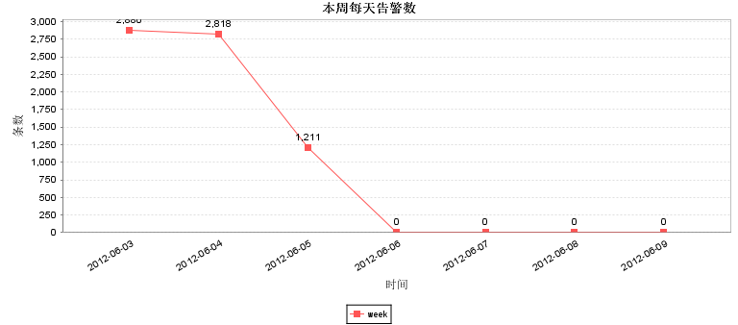

2 设备TOP分析
2.1 服务器Top分析
2.1.1 服务器CPU Top

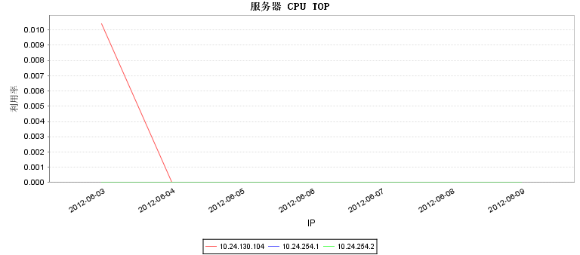

IP | 2012-06-03 | 2012-06-04 | 2012-06-05 | 2012-06-06 | 2012-06-07 | 2012-06-08 | 2012-06-09
10.24.130.104 | 0.0104166666666667 | 0.0 | 0.0 | 0.0 | 0.0 | 0.0 | 0.0
10.24.254.1 | 0.0 | 0.0 | 0.0 | 0.0 | 0.0 | 0.0 | 0.0
10.24.254.2 | 0.0 | 0.0 | 0.0 | 0.0 | 0.0 | 0.0 | 0.0

2.1.2 服务器内存 Top

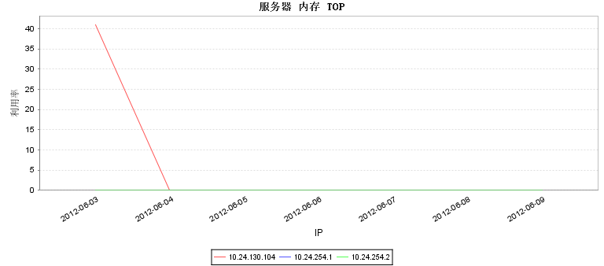

IP | 2012-06-03 | 2012-06-04 | 2012-06-05 | 2012-06-06 | 2012-06-07 | 2012-06-08 | 2012-06-09
10.24.130.104 | 40.9689338235294 | 0.0 | 0.0 | 0.0 | 0.0 | 0.0 | 0.0
10.24.254.1 | 0.0 | 0.0 | 0.0 | 0.0 | 0.0 | 0.0 | 0.0
10.24.254.2 | 0.0 | 0.0 | 0.0 | 0.0 | 0.0 | 0.0 | 0.0

2.1.3 服务器连通性 Top

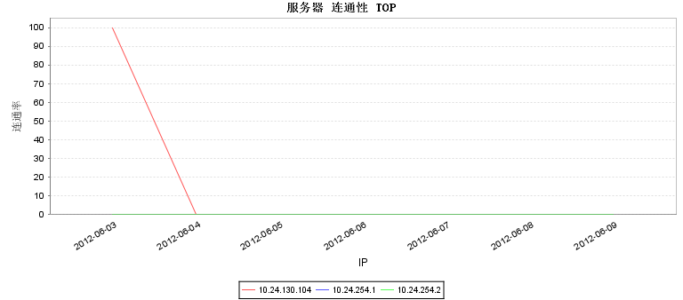

IP | 2012-06-03 | 2012-06-04 | 2012-06-05 | 2012-06-06 | 2012-06-07 | 2012-06-08 | 2012-06-09
10.24.130.104 | 99.8819444444444 | 0.0 | 0.0 | 0.0 | 0.0 | 0.0 | 0.0
10.24.254.1 | 0.0 | 0.0 | 0.0 | 0.0 | 0.0 | 0.0 | 0.0
10.24.254.2 | 0.0 | 0.0 | 0.0 | 0.0 | 0.0 | 0.0 | 0.0

2.1.4 服务器响应度 Top

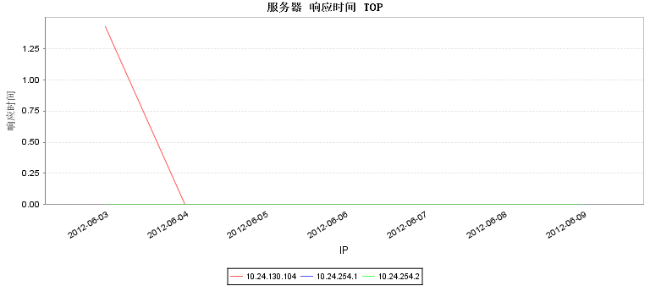

IP | 2012-06-03 | 2012-06-04 | 2012-06-05 | 2012-06-06 | 2012-06-07 | 2012-06-08 | 2012-06-09
10.24.130.104 | 1.42708333333333 | 0.0 | 0.0 | 0.0 | 0.0 | 0.0 | 0.0
10.24.254.1 | 0.0 | 0.0 | 0.0 | 0.0 | 0.0 | 0.0 | 0.0
10.24.254.2 | 0.0 | 0.0 | 0.0 | 0.0 | 0.0 | 0.0 | 0.0

2.1.5 服务器磁盘 Top

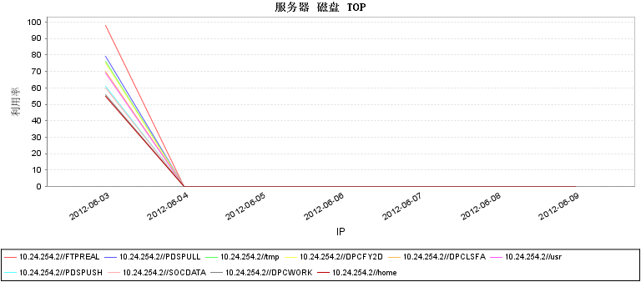

IP | 2012-06-03 | 2012-06-04 | 2012-06-05 | 2012-06-06 | 2012-06-07 | 2012-06-08 | 2012-06-09
10.24.254.2//FTPREAL | 98.0 | 0.0 | 0.0 | 0.0 | 0.0 | 0.0 | 0.0
10.24.254.2//PDSPULL | 79.0 | 0.0 | 0.0 | 0.0 | 0.0 | 0.0 | 0.0
10.24.254.2//tmp | 76.0 | 0.0 | 0.0 | 0.0 | 0.0 | 0.0 | 0.0
10.24.254.2//DPCFY2D | 75.0 | 0.0 | 0.0 | 0.0 | 0.0 | 0.0 | 0.0
10.24.254.2//DPCLSFA | 70.0 | 0.0 | 0.0 | 0.0 | 0.0 | 0.0 | 0.0
10.24.254.2//usr | 69.0 | 0.0 | 0.0 | 0.0 | 0.0 | 0.0 | 0.0
10.24.254.2//PDSPUSH | 61.0 | 0.0 | 0.0 | 0.0 | 0.0 | 0.0 | 0.0
10.24.254.2//SOCDATA | 60.0 | 0.0 | 0.0 | 0.0 | 0.0 | 0.0 | 0.0
10.24.254.2//DPCWORK | 56.0 | 0.0 | 0.0 | 0.0 | 0.0 | 0.0 | 0.0
10.24.254.2//home | 55.0 | 0.0 | 0.0 | 0.0 | 0.0 | 0.0 | 0.0

2.2 网络Top分析
2.2.1 网络设备CPU Top

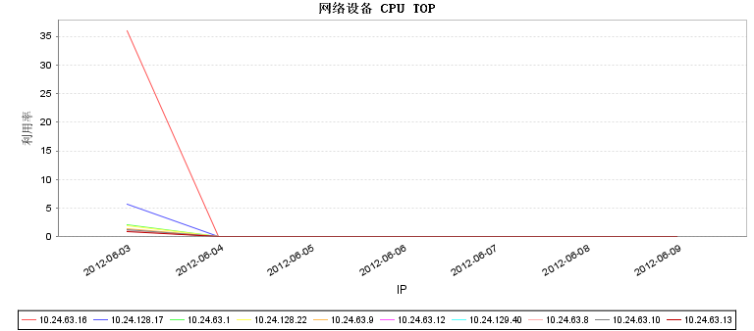

IP | 2012-06-03 | 2012-06-04 | 2012-06-05 | 2012-06-06 | 2012-06-07 | 2012-06-08 | 2012-06-09
10.24.63.16 | 36.0104166666667 | 0.0 | 0.0 | 0.0 | 0.0 | 0.0 | 0.0
10.24.128.17 | 5.65972222222222 | 0.0 | 0.0 | 0.0 | 0.0 | 0.0 | 0.0
10.24.63.1 | 2.04166666666667 | 0.0 | 0.0 | 0.0 | 0.0 | 0.0 | 0.0
10.24.128.22 | 2.00347222222222 | 0.0 | 0.0 | 0.0 | 0.0 | 0.0 | 0.0
10.24.63.9 | 1.46715328467153 | 0.0 | 0.0 | 0.0 | 0.0 | 0.0 | 0.0
10.24.63.12 | 1.03819444444444 | 0.0 | 0.0 | 0.0 | 0.0 | 0.0 | 0.0
10.24.129.40 | 1.13541666666667 | 0.0 | 0.0 | 0.0 | 0.0 | 0.0 | 0.0
10.24.63.8 | 1.07986111111111 | 0.0 | 0.0 | 0.0 | 0.0 | 0.0 | 0.0
10.24.63.10 | 1.17482517482517 | 0.0 | 0.0 | 0.0 | 0.0 | 0.0 | 0.0
10.24.63.13 | 0.996527777777778 | 0.0 | 0.0 | 0.0 | 0.0 | 0.0 | 0.0

2.2.2 网络设备内存 Top

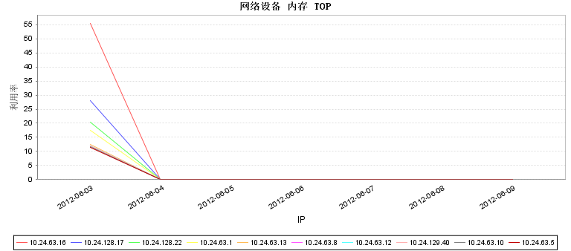

IP | 2012-06-03 | 2012-06-04 | 2012-06-05 | 2012-06-06 | 2012-06-07 | 2012-06-08 | 2012-06-09
10.24.63.16 | 55.5 | 0.0 | 0.0 | 0.0 | 0.0 | 0.0 | 0.0
10.24.128.17 | 28.0 | 0.0 | 0.0 | 0.0 | 0.0 | 0.0 | 0.0
10.24.128.22 | 20.5 | 0.0 | 0.0 | 0.0 | 0.0 | 0.0 | 0.0
10.24.63.1 | 17.5 | 0.0 | 0.0 | 0.0 | 0.0 | 0.0 | 0.0
10.24.63.13 | 12.5 | 0.0 | 0.0 | 0.0 | 0.0 | 0.0 | 0.0
10.24.63.8 | 12.0104166666667 | 0.0 | 0.0 | 0.0 | 0.0 | 0.0 | 0.0
10.24.63.12 | 12.0 | 0.0 | 0.0 | 0.0 | 0.0 | 0.0 | 0.0
10.24.129.40 | 12.0 | 0.0 | 0.0 | 0.0 | 0.0 | 0.0 | 0.0
10.24.63.10 | 11.6666666666667 | 0.0 | 0.0 | 0.0 | 0.0 | 0.0 | 0.0
10.24.63.5 | 11.5 | 0.0 | 0.0 | 0.0 | 0.0 | 0.0 | 0.0

2.2.3 网络设备连通性 Top

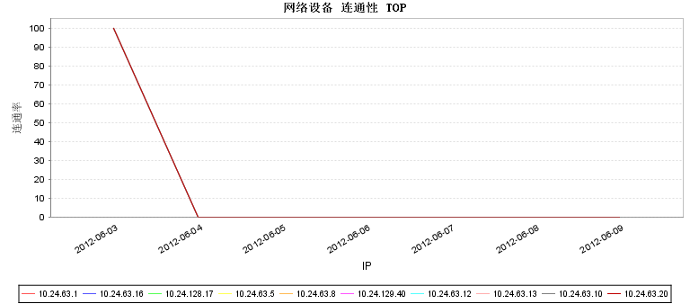

IP | 2012-06-03 | 2012-06-04 | 2012-06-05 | 2012-06-06 | 2012-06-07 | 2012-06-08 | 2012-06-09
10.24.63.1 | 100.0 | 0.0 | 0.0 | 0.0 | 0.0 | 0.0 | 0.0
10.24.63.16 | 100.0 | 0.0 | 0.0 | 0.0 | 0.0 | 0.0 | 0.0
10.24.128.17 | 100.0 | 0.0 | 0.0 | 0.0 | 0.0 | 0.0 | 0.0
10.24.63.5 | 100.0 | 0.0 | 0.0 | 0.0 | 0.0 | 0.0 | 0.0
10.24.63.8 | 100.0 | 0.0 | 0.0 | 0.0 | 0.0 | 0.0 | 0.0
10.24.129.40 | 100.0 | 0.0 | 0.0 | 0.0 | 0.0 | 0.0 | 0.0
10.24.63.12 | 99.8819444444444 | 0.0 | 0.0 | 0.0 | 0.0 | 0.0 | 0.0
10.24.63.13 | 99.8815331010453 | 0.0 | 0.0 | 0.0 | 0.0 | 0.0 | 0.0
10.24.63.10 | 99.8776978417266 | 0.0 | 0.0 | 0.0 | 0.0 | 0.0 | 0.0
10.24.63.20 | 100.0 | 0.0 | 0.0 | 0.0 | 0.0 | 0.0 | 0.0

2.2.4 网络设备响应度 Top

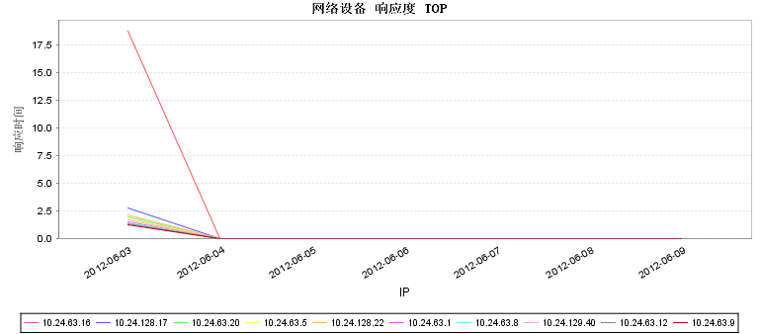

IP | 2012-06-03 | 2012-06-04 | 2012-06-05 | 2012-06-06 | 2012-06-07 | 2012-06-08 | 2012-06-09
10.24.63.16 | 18.7916666666667 | 0.0 | 0.0 | 0.0 | 0.0 | 0.0 | 0.0
10.24.128.17 | 2.80208333333333 | 0.0 | 0.0 | 0.0 | 0.0 | 0.0 | 0.0
10.24.63.20 | 2.03472222222222 | 0.0 | 0.0 | 0.0 | 0.0 | 0.0 | 0.0
10.24.63.5 | 1.84027777777778 | 0.0 | 0.0 | 0.0 | 0.0 | 0.0 | 0.0
10.24.128.22 | 2.15277777777778 | 0.0 | 0.0 | 0.0 | 0.0 | 0.0 | 0.0
10.24.63.1 | 1.56597222222222 | 0.0 | 0.0 | 0.0 | 0.0 | 0.0 | 0.0
10.24.63.8 | 1.46875 | 0.0 | 0.0 | 0.0 | 0.0 | 0.0 | 0.0
10.24.129.40 | 1.73263888888889 | 0.0 | 0.0 | 0.0 | 0.0 | 0.0 | 0.0
10.24.63.12 | 1.38888888888889 | 0.0 | 0.0 | 0.0 | 0.0 | 0.0 | 0.0
10.24.63.9 | 1.31944444444444 | 0.0 | 0.0 | 0.0 | 0.0 | 0.0 | 0.0

2.2.5 网络设备入口流速 Top

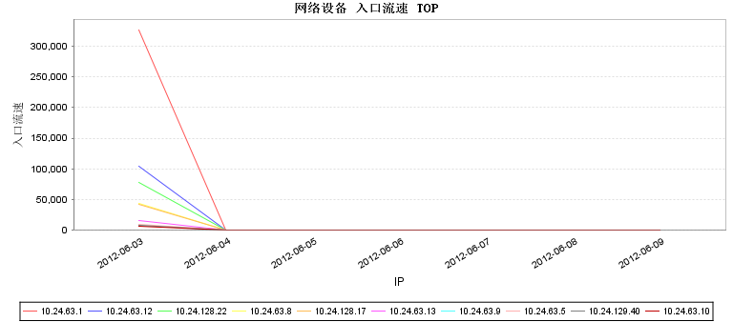

IP | 2012-06-03 | 2012-06-04 | 2012-06-05 | 2012-06-06 | 2012-06-07 | 2012-06-08 | 2012-06-09
10.24.63.1 | 326663.0 | 0.0 | 0.0 | 0.0 | 0.0 | 0.0 | 0.0
10.24.63.12 | 104857.25 | 0.0 | 0.0 | 0.0 | 0.0 | 0.0 | 0.0
10.24.128.22 | 77385.8056 | 0.0 | 0.0 | 0.0 | 0.0 | 0.0 | 0.0
10.24.63.8 | 44659.7222 | 0.0 | 0.0 | 0.0 | 0.0 | 0.0 | 0.0
10.24.128.17 | 42657.3056 | 0.0 | 0.0 | 0.0 | 0.0 | 0.0 | 0.0
10.24.63.13 | 16050.5556 | 0.0 | 0.0 | 0.0 | 0.0 | 0.0 | 0.0
10.24.63.9 | 8157.9155 | 0.0 | 0.0 | 0.0 | 0.0 | 0.0 | 0.0
10.24.63.5 | 9829.3889 | 0.0 | 0.0 | 0.0 | 0.0 | 0.0 | 0.0
10.24.129.40 | 8610.1111 | 0.0 | 0.0 | 0.0 | 0.0 | 0.0 | 0.0
10.24.63.10 | 7174.8333 | 0.0 | 0.0 | 0.0 | 0.0 | 0.0 | 0.0

2.2.6 网络设备出口流速 Top

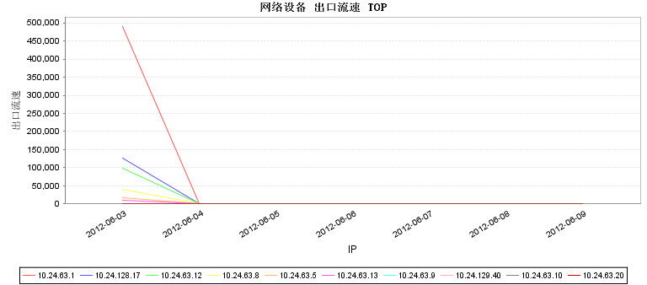

IP | 2012-06-03 | 2012-06-04 | 2012-06-05 | 2012-06-06 | 2012-06-07 | 2012-06-08 | 2012-06-09
10.24.63.1 | 490230.7778 | 0.0 | 0.0 | 0.0 | 0.0 | 0.0 | 0.0
10.24.128.17 | 127129.25 | 0.0 | 0.0 | 0.0 | 0.0 | 0.0 | 0.0
10.24.63.12 | 98064.0 | 0.0 | 0.0 | 0.0 | 0.0 | 0.0 | 0.0
10.24.63.8 | 39553.4444 | 0.0 | 0.0 | 0.0 | 0.0 | 0.0 | 0.0
10.24.63.5 | 16611.4167 | 0.0 | 0.0 | 0.0 | 0.0 | 0.0 | 0.0
10.24.63.13 | 9281.75 | 0.0 | 0.0 | 0.0 | 0.0 | 0.0 | 0.0
10.24.63.9 | 1377.4366 | 0.0 | 0.0 | 0.0 | 0.0 | 0.0 | 0.0
10.24.129.40 | 1812.5 | 0.0 | 0.0 | 0.0 | 0.0 | 0.0 | 0.0
10.24.63.10 | 381.5603 | 0.0 | 0.0 | 0.0 | 0.0 | 0.0 | 0.0
10.24.63.20 | 551.6389 | 0.0 | 0.0 | 0.0 | 0.0 | 0.0 | 0.0

