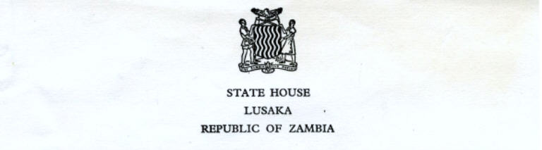

SH.2/6 6th October, 1969

Dear Mr. Lewis,

I am directed by His Excellency the President to thank you most sincerely for your letter dated 19th September, 1969, in which you kindly say that His Excellency the President's appearance on the B.B.C. Television was very successful and that the objective was indeed very effective.
I would like you to know that it is very relieving to receive a letter like yours from a person so many hundreds of miles away from Zambia to give us the moral support which we need so much. This is very encouraging.

No doubt Zambia, as a young nation, can hope to succeed in nation building with the help of people both from within and outside. Your message therefore carries weight and has come at the right time.

I recall that you once lived in Zambia for a considerable period during which time you held a prominent and high position in the Government. I am sure that you have a fair knowledge, if not fully conversant with our problems. Every country has her problems especially in the early stages of developments. However for Zambia these are but temporary.

Your last paragraph has been noted. Indeed Zambia is counting on willing hands for their services should need arise.

Once again, thank you for remembering us.

Yours sincerely,

Private Secretary

D.J. Lewis Esq.,
Director General
Keep Britain Tidy Group,
27 Queen Anne's Gate,
London, S.W.1.

