

CLARENCE HOUSE S.W1
29th December 1981

I write at the bidding of Queen Elizabeth The Queen Mother to thank you for your telegram of good wishes for Christmas and the Hew Year which you sent on behalf of the Keep Britain Tidy Group.
Your kind thought was greatly appreciated by Her Majesty.
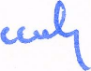
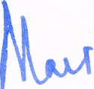
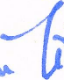
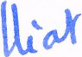

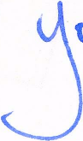
David J. Lewis, Esq.

