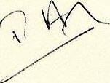
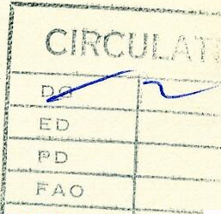

SECRETARY OF STATE FOR ENERGYO

THAMES HOUSE SOUTH MILLBANK LONDON SW1P 4QJ
01 211 6402

David Lewis Esq
September 1984
Director General
The Keep Britain Tidy Group
Bostel House
37 West Street
BRIGHTON
BN1 2RE
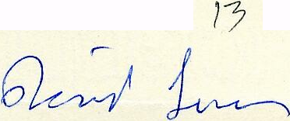
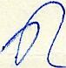

Thank you very much for your letter of
10 September and the very interesting annual
report.
Naturally I am delighted at the progress you continuously achieve and the impact you make in the country. As always there is still much more to be done, but I am sure that you will do it..
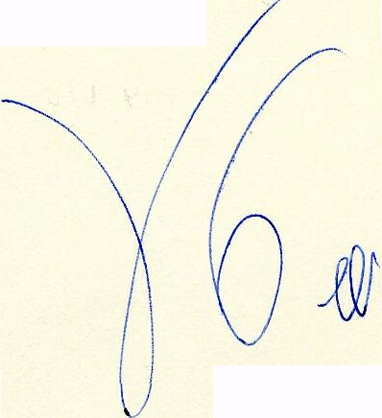
PETER WALKER

