18th May 1981

DJ Lewis Esq.
Keep Britain Tidy Group
Bostel House
Charter Medical Corporation

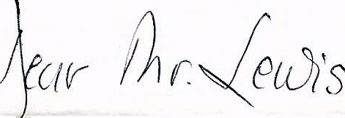
-We are delighted to have the opportunity to host a reception for Sir Derek Ezra, Chairman of the Keep Britain Tidy Group.
Our company is relatively new in the United Kingdom, but we are anxious to do our part to become a good corporate citizen here. Since my wife and I have always supported activities to beautify the United States, particularly through the Keep America Beautiful programme, it seemed only right that we should support a parallel British cause.
The reception will be held at Claridges on Monday, 15th June, and I very much hope you and your wife will find it possible to accept the enclosed invitation and be able to join us on this occasion.
During the reception, Sir Derek will have the opportunity to explain his ideas and plans for the Keep Britain Tidy Group and, hopefully, will encourage you to think about helping this extremely worthwhile cause. Sincerely,

William A. Fickling, Jr., Chairman and Chief Executive.

For the sake of convenience it would be appreciated if you would please reply to the address given on the invitation card:-The Organising Secretary, Charter Clinic, 1-5 Radnor Walk, Box 323, LONDON SW3 4PB.
P. 0. BOX 209 • 577 MULBERRY STREET • MACON, GEORGIA 31298 • (912) 742-1161

