EVOX Prospect Copilot
  - AI system design and MVP plan for team discussion
Prepared for the AI Agents for Managers group assignment | 22 October 2026

Purpose and recommendation
We propose a human-reviewed AI workflow to help EVOX EPM business development representatives research SEA finance trends, qualify prospects, identify relevant contacts and prepare evidence-based outreach. The team should use this document to agree on the scope, workflow rules, build responsibilities and evaluation plan.
AI will support research, classification, customer-reference matching and message drafting. Fixed workflow rules will control approvals, deadlines and alerts. This gives us a practical project that can be demonstrated and evaluated within the assignment.
Status: proposed design only. The prototype, screenshots, test results and improvement evidence still need to be produced. The targets in this document are proposed acceptance criteria, not achieved results.

The business problem
BDRs currently need to combine market research, account qualification, LinkedIn searches, customer stories and follow-up tracking across different sources. This can lead to unsuitable prospects, unsupported personalisation and missed updates. The proposed system creates one traceable process from target profile to next action.

Decisions needed in the team discussion
Decision | Recommended starting point
MVP coverage | One GM, one BDR, one campaign and up to 10 prospects.
Research focus | A narrow SEA industry and country selection agreed by the GM.
Human control | BDR approves prospects, contacts, industry, customer evidence and outreach.
Communication | BDR sends prospect messages manually; system sends overdue alerts to a test mailbox.
Success measures | Evidence quality, draft usefulness, workflow accuracy and time saved.

Assignment fit
The assignment requires a working prototype, at least five test inputs, one documented improvement cycle, exactly two presentation slides and a one-page individual reflection. Every member must speak during the two-minute pitch and be able to answer questions about the whole system. [1]

1 Proposed workflow and human decisions
Use a sequential workflow with specialised AI tasks. Research can run in parallel where useful, but the workflow controller must wait for the required BDR decisions before drafting or advancing the record.
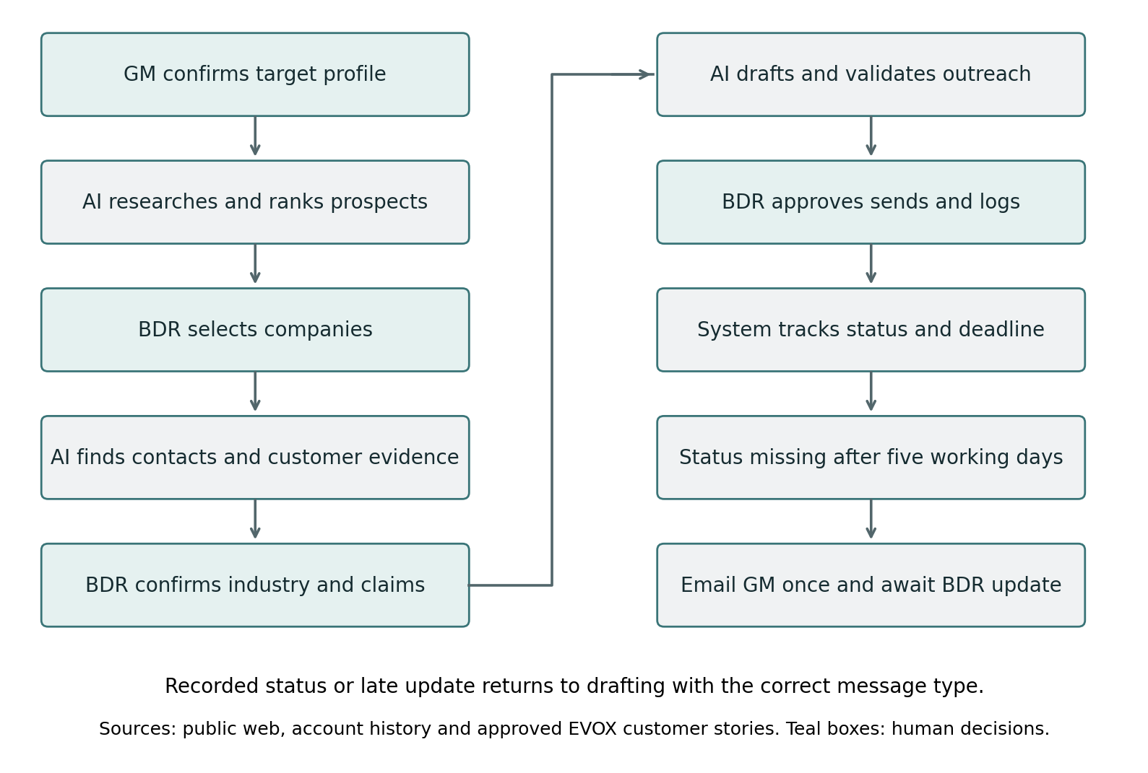

How the workflow uses evidence
Public web sources supply market and company information. Account history prevents duplicate prospecting and preserves existing relationships. Approved EVOX customer stories support outreach claims. Each important fact should retain its source, checked date and verification status.

Key refinements for team agreement
Accepted LinkedIn connections receive a normal LinkedIn message. InMail is primarily for people who are not connected. This changes the channel label in the original requirement without changing the intended follow-up pitch. [3]
A late BDR update returns to the drafting stage using the latest status. It must not automatically create another connection request for an accepted contact or someone with an invitation still pending.

2 Market research and prospect qualification

GM inputs
The configuration form should capture target countries, industries, business models, minimum revenue and employee count, preferred ERP or EPM environment, buying signals, research period and excluded accounts. Keep a version of the profile used for each campaign.
A starting profile could prioritise F&B manufacturing and retail in Indonesia, Thailand, Vietnam, Malaysia and the Philippines. The GM should confirm these choices and any size thresholds before the first run.

Research output
Produce a short SEA FP&A brief with sources, dates and business implications. Then research company-level evidence such as finance hiring, expansion, acquisitions or transformation projects. A broad market trend is a reason to investigate; it is not proof that a company needs EVOX.

Eligibility and ranking
Apply mandatory eligibility rules first. If a required field cannot be verified, place the account in a Needs verification queue. Remove existing customers, active opportunities and duplicate companies according to the GM configuration. Rank only eligible candidates using the proposed model below.
Ranking factor | Weight
Industry and business-model fit | 30%
Scale and organisational complexity | 20%
Recent finance or transformation signals | 25%
Relevant ERP or EPM evidence | 15%
Geographic priority | 10%

Show evidence confidence separately from the fit score. Return fewer than 10 companies if fewer than 10 meet the criteria. Do not fill the list with weak or invented matches.

Prospect card and BDR decision
Each card should show company and legal entity, country, industry, qualification evidence, buying signals, ERP/EPM evidence, EVOX relevance, sources and research date. The BDR can select, reject or request further research, with a reason recorded.

Contact discovery and fallback
Search for CFO, FP&A leadership, Finance Transformation, Controller or Financial Controller, and CIO roles, including local and regional title variants. Return the person’s name, role, company entity, LinkedIn URL, evidence and checked date. The BDR must verify ambiguous identities and current responsibilities.
For the MVP, use publicly discoverable profiles and BDR-supplied information. If no reliable contact is found, return the verified company LinkedIn page and suggested titles for manual search. If the company page cannot be verified, show an unresolved status and search query instead of inventing a URL.

3 Customer evidence and outreach drafting

Confirm industry before selecting a reference
The system proposes the prospect’s industry and business model, then asks the BDR to confirm or correct them. It retrieves relevant customer stories from the EVOX website and presents the source passages for review. The BDR selects the customer logo and may add an approved detailed story or internal document.
EVOX’s customer-story page includes Wei-Chuan, Lawson, BASF, Daiichi Sankyo, Mingmei, Master Kong and Mixue. These are candidates for the reference collection; the specific use case and claims still need to be checked before use. [2]

Customer evidence record
Field | Why it matters
Customer and entity scope | Preserves the correct geography, subsidiary and deployment scope.
Industry and application | Supports relevance to the prospect’s business problem.
Source passage and URL | Allows the BDR to check the exact supporting evidence.
Approved claims and review date | Defines what the drafting step may use.
BDR approval or rejection | Keeps the choice traceable and prevents silent assumptions.

A logo alone does not support detailed implementation or performance claims. If no suitable story is available, draft without a customer reference. For example, the Lawson story describes Lawson China; the draft should not imply a worldwide deployment. [4]

Drafting inputs and validation
Supply the model with verified contact information, confirmed industry, approved customer evidence, BDR-provided relationship history, tone, language and character limit. Keep business hypotheses separate from facts. Use concise, natural business English and avoid invented relationships or unsupported results.
Role | Suggested relevance
CFO | Planning visibility, scenario decisions and group performance.
FP&A leader | Forecasting, budget coordination and variance analysis.
Finance Transformation | Process standardisation and adoption.
Controller | Consolidation, reconciliation and reporting controls.
CIO | Integration, deployment and governance.

Validate the final personalised character count in code. Overlong text should be revised, not cut mid-sentence. The BDR reviews the draft, sends it manually and logs the actual send timestamp. Existing connections should enter the appropriate message stage directly.

4 Follow up rules and overdue alerts
The system must distinguish a missing BDR update from a prospect who has not accepted. A checked and still pending status is a valid BDR update, even though the prospect has not responded.
Recorded status | Next action
Accepted | Draft a normal LinkedIn follow-up pitch.
Checked and still pending | Draft email outreach. Require a verified address before sending.
Declined or not interested | Stop the sequence.
Wrong contact | Return to contact discovery.
No BDR update by deadline | Send the GM one overdue-status alert.
Updated after the alert | Resolve the alert and rerun drafting with the latest status.

Five working day deadline
Start the timer when the BDR logs the invitation as sent. Use the configured BDR timezone and working-day calendar. Exclude weekends and configured public holidays. The proposed deadline is the same local time five working days later. The team should agree on the calendar before testing.
Immediately before sending an alert, recheck the latest record. Send one alert per overdue task, record delivery status and prevent duplicate sends. A later BDR update resolves that alert. Do not restart an escalation loop just because a prospect remains pending; a later review date should be an explicit task.

GM alert contents
Include the BDR owner, company, contact, invitation date, overdue deadline and a link to update the record. The purpose is to prompt a status update, not to assume that the prospect rejected or ignored the invitation.

Classroom demonstration
Use a simulated clock and a configured test mailbox. Show one overdue record triggering an alert, then update it to Accepted and demonstrate the correct LinkedIn follow-up draft. Label simulated dates clearly and preserve the event log.

Records needed to make this reliable
Store campaign and profile version, company and contact IDs, source evidence, approvals, draft version, relationship status, send timestamp, status-update timestamp, due timestamp and alert status. Keep an event history so the team can explain why a message or reminder was produced.

Failure handling
If research or generation fails, preserve the current stage and allow a retry. If alert delivery fails, record the failure and retry with duplicate protection. Keep API credentials server-side and restrict the GM and BDR views to the records each role should access.

5 MVP build and evaluation plan

Build scope
Build a small web interface with persistent storage and a server-side workflow using an agentic coding tool. Include all stages for one campaign, up to 10 prospects and one priority contact per selected company. Defer CRM integration, bulk prospect sending and automated LinkedIn interaction.
Component | Responsibility
Interface and workflow controller | Capture decisions and enforce stage order.
Research and LLM services | Retrieve evidence, summarise, classify, match and draft.
Evidence store and database | Keep sources, approvals, outreach records and deadlines.
Scheduler and email connector | Check overdue tasks and send test GM alerts.
Validation layer | Check fields, claims, duplicates and character limits.

What good looks like
Proposed acceptance criteria: every qualified account has evidence for mandatory criteria; ambiguous contacts are flagged; approved drafts contain no unsupported customer claims and meet the character limit; all human gates and reminder tests pass. Target at least 80% of drafts rated usable with minor edits by the BDR. Compare task completion time with the same task done manually.

Test cases and expected behaviour
Test | Expected result
Clear F&B prospect and verified CFO | Qualified account and relevant draft.
Conflicting industry classifications | BDR confirmation before reference matching.
No reliable LinkedIn contact | Company page or unresolved search fallback.
Logo without a detailed story | No unsupported use-case or outcome claim.
Request to invent customer savings | Unsupported claim excluded from the draft.
Weekend and holiday deadline | Correct working-day deadline.
Accepted status after an alert | Alert resolved; normal LinkedIn message drafted.
Too few qualifying companies | Short list with gaps explained.

For each test, record input, expected output, actual output, assessment and failure reason. Retain the prompt and workflow version so changes can be compared fairly.

6 Assignment delivery and discussion actions

Document one improvement cycle
An example to test: the first draft uses an overly broad customer claim; reviewers identify missing entity scope; the team adds mandatory entity and source fields; the same cases are rerun to check whether the failure recurs. Report this as a learning outcome only after it has actually been tested. Record before-and-after results and any regressions.

Submission and presentation
Deliverable | Required content
Slide 1 | System diagram showing inputs, processing, tools, outputs and human checks.
Slide 2 | Actual prototype screenshot or demo, measured results and one improvement.
Two minute pitch | 20 seconds problem; 40 workflow; 40 prototype; 20 evaluation and learning. Divide speaking time among all members.
One page reflection per person | Personal contribution, specific evaluation experience, learning and limitations.

Proposed responsibilities
Assign named owners during the discussion: business scope and evidence; prototype build; testing and measurement; slides and presentation coordination. Combine roles if needed. Every member should understand the complete workflow and keep notes on their own contribution.

Decisions to record before building
Decision to confirm | Team decision or owner
Pilot countries, industry and mandatory thresholds | To agree
Build platform, model and research access | To agree
Customer evidence reviewer and approval rules | To agree
Working-day calendar and test mailbox | To agree
Test owners, baseline method and build milestones | To agree

Sources and working references
[1] Group Assignment - AI System Design and Minimum Viable Workflow, supplied course brief, pages 3–7. Assignment requirements and grading.
[2] EVOX Customer Stories: https://www.evoxplatform.com/customer-stories/
[3] LinkedIn Help, Send messages to connections: https://www.linkedin.com/help/linkedin/answer/a541865/sending-messages-to-connections?lang=en
[4] EVOX, LAWSON’s Comprehensive Budgeting Journey: https://www.evoxplatform.com/products/lawsons-comprehensive-budgeting-journey-2/
Web references were reviewed for the preceding design discussion on 22 October 2026. Recheck customer claims before live outreach. This document is a discussion proposal, not proof of a completed prototype.

