Couple things I noticed right away that I would like changed.

1. There is no way in the admin to addcategories and items, change pricing, etc.

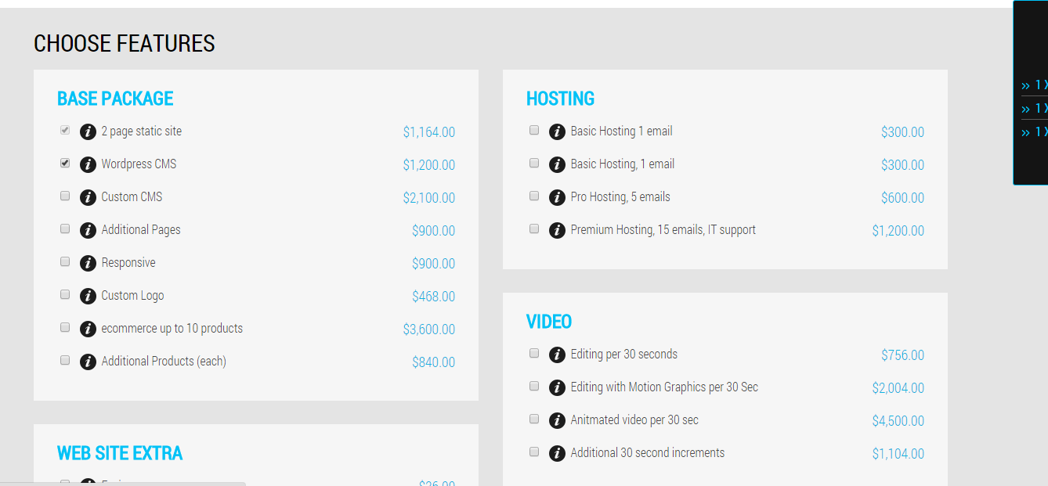

1. These should be balloons that have explanations. I would need that in the admin too.

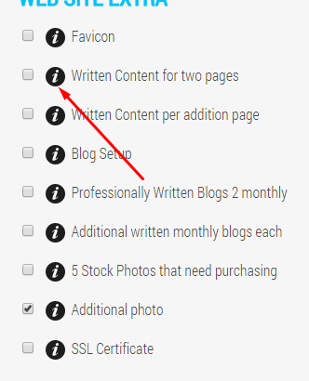

1. The get started buttons on the homepage should go here. I want them to be able to start building a package Before being required to signup.

<http://50.87.144.115/~eswtech/projects/site_builder/subscribe>

1. Switch the position of these fields 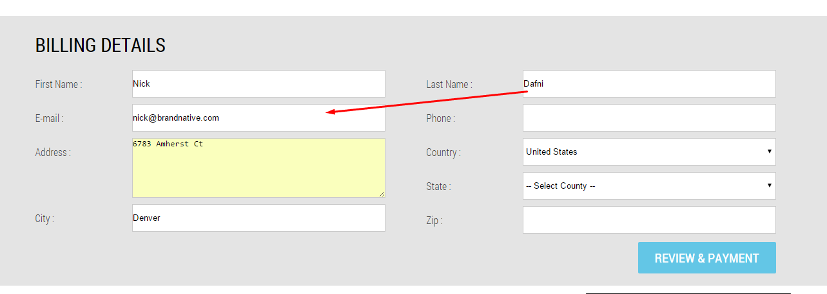
2. Is there a way they can create an account on this page too if they already started to create a package? So maybe there is create an account or login above the billing details. IF they create an account it would still go to the review and payment next but it would create the billing and the account. I don’t want them leaving this page to continue the process. So wheather they signin or create an account they should be able to do so from this page.

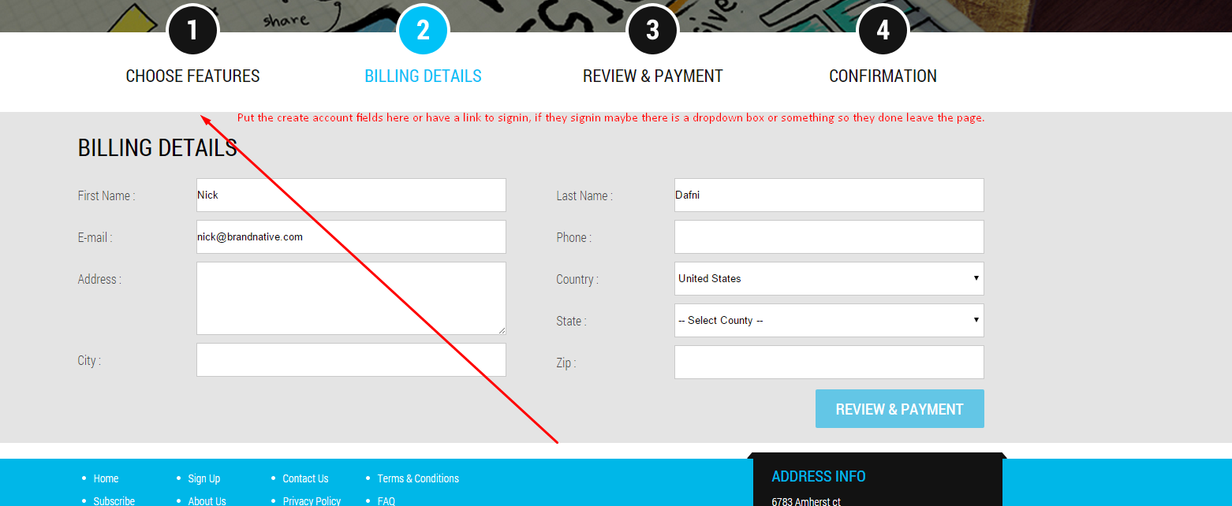

SO these fields would be above the billing details unless they signin You can keep the sign up page too. I just want it to be easy if they build a package to create an account while paying.

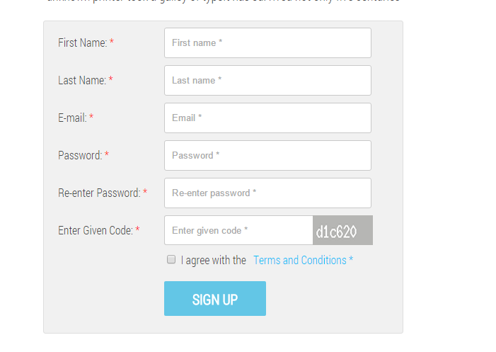

1. Subscribe history should say: You currently do not have a subscription. Then have a button that says: Subscribe.

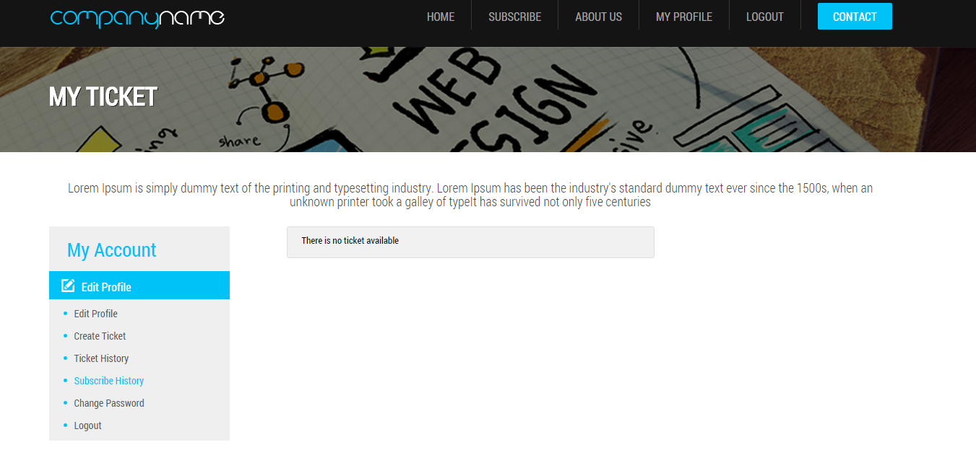

1. Need area in admin to add departments

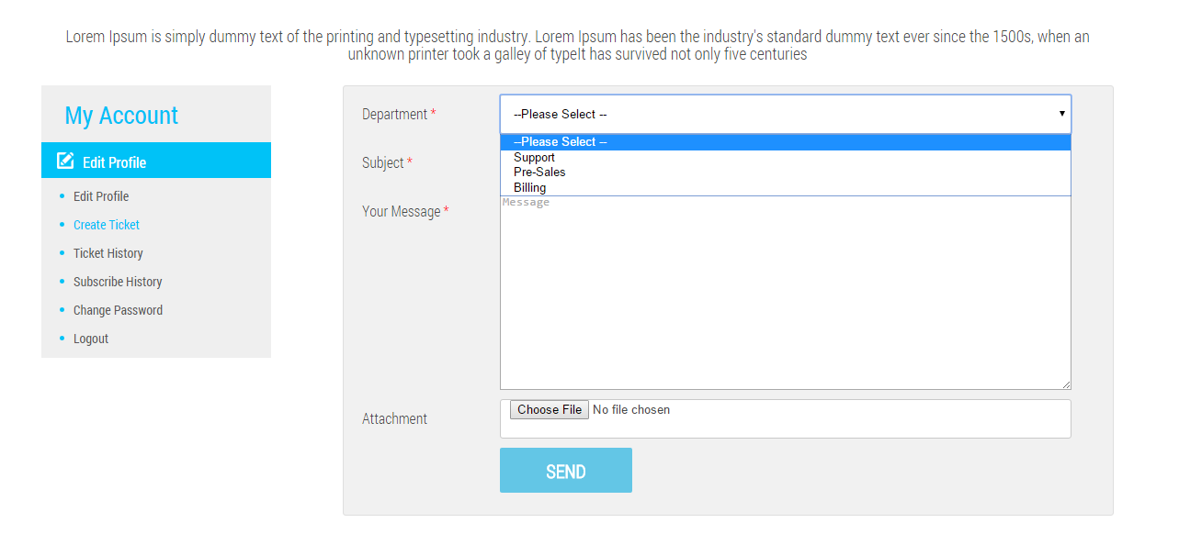

1. I also need the ability in the admin to add and edit their pricing. The ticket system is for them to request new features or changes, get quotes, or change package. Ideally I would like the ability for them to shop for more things directly from the backend. For example, if they wanted to add additional pages and seo then they could just go to a page like this and add on.

<http://50.87.144.115/~eswtech/projects/site_builder/subscribe>

They would need a button from their backend to upgrade their subscription. This would automatically add to the monthly billing once new products are sold. I’m not sure how this would affect the payment gateway. IF they added features it should add to the monthly billing. I also need a way to manually add for custom features. For example, they want to add two new pages, they should be able to order two pages from the cart and it would add to the monthly billing. There would also need to be a notice where they confirm that this will change the price of their monthly billing.

An upgrade button could be added here if they wanted to continue shopping or add to their monthly subscription. The upgrade would then add the features and notify me that the account was upgraded and what was upgraded.

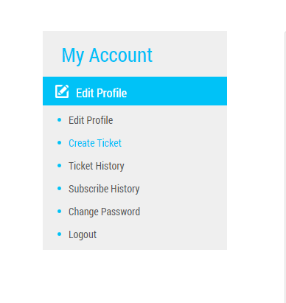

1. On this page I need a section for custom features. This will be a quote that I will have to give manually for features that are not standard. I would then need the ability to add the custom amount to their package from the admin which would automatically update the billing. For example, say they want a customer portal section added. That is a custom quote job. They would then need to get a quote and if approved, I would need to be able to add the dollar amount to their monthly subscription. If they pay for the features up front then I will just charge separately, but I do need the option to add to monthly if they want to break it up.

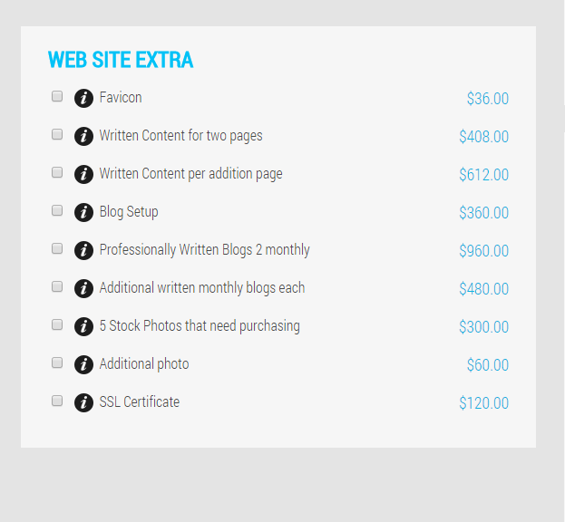

1. Speaking of billing, we have PayPal but can I also add another gateway like authorize.net? Can we add to a recurring monthly payment? I also would like a prepayment option for a year.
2. Need a field for current website URL when they create an account. It should also be in the profile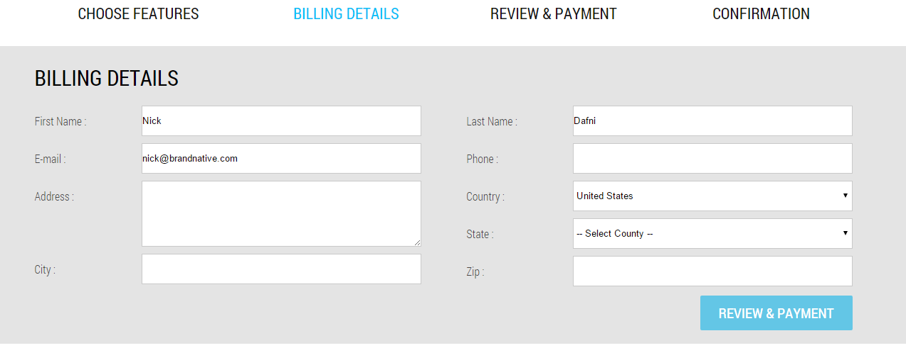

Should be here too. I see a spot in the admin panel for it. Make sure the data fills there as well

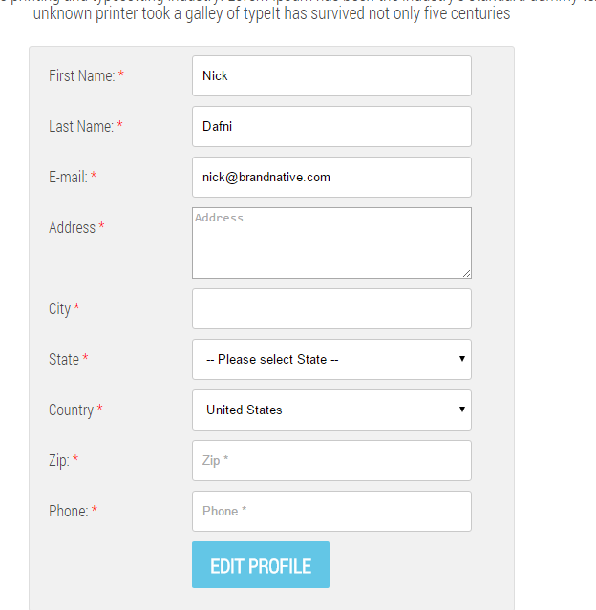

1. I would like to have on the subscribe history page a renewal date. These subscriptions are 12 months minimum, once the time has been fulfilled, a text and button should appear that says You are now eligible for a new facelift for your website, Button would say redeem. That button would then notify me that they want a new website. If redeemed, the time would start over and they would be committed for 12 more months. If they are within the timeframe, it should say you will be eligible for your new facelift on this date which is 12 months from the day they subscribed.

