**计算机与网络安全学院**

**软件工程系**

**项目名称 C++综合程序设计**

**题 目 员工信息管理系统**

**学生学号** 201641404313

**学生姓名**  **吴俊鸿**

**指导教师** **肖捷老师**

**完成时间** 2017 年06 月 01 **日 至** 2017 年 06 月 13 **日**

**项目地址https://github.com/TonyNgcn/WorkerManagement/**

**目 录**

1、系统分析…………………………………………………………………………………………………………

1.1功能需求分析………………………………………………………………………………………………

1.2数据需求分析………………………………………………………………………………………………

2、系统设计…………………………………………………………………………………………………………

2.1系统功能模块设计…………………………………………………………………………………………

2.2类的抽象与类间关系………………………………………………………………………………………

2.3类的设计……………………………………………………………………………………………………

3、系统编码…………………………………………………………………………………………………………

3.1程序文件模块划分…………………………………………………………………………………………

3.2程序代码……………………………………………………………………………………………………

4、系统运行结果…………………………………………………………………………………………

5、总结………………………………………………………………………………………………………………

5.1自我评价及收获……………………………………………………………………………………………

5.2有待解决的问题及进一步完善的思路……………………………………………………………………

1．系统分析

**1．1 功能需要分析**

该软件用于管理某公司的经理、技术员、销售员、销售经理4类人员信息，人员信息包括：工号、姓名、性别、部门、岗位、出生日期、当月工资等，具体功能包括：

1. 添加功能：添加部门和员工信息
2. 查询功能：提供多种组合查询方式，查询各类人员信息和部门信息。
3. 删除功能：删除各类人员信息，以及删除部门信息。
4. 显示功能：显示输出所有人员信息。
5. 修改功能：修改人员信息和部门名称

⑥ 分析功能：分析各项员工工资数据

**1．2 数据需要分析**

该软件用于管理某公司的经理、技术员、销售员、销售经理4类人员信息，人员信息包括：工号、姓名、性别、部门、岗位、出生日期、当月工资等，各数据项含义如下：

⮚ 工号：表示员工的编号。

⮚ 姓名：表示员工的姓名。

⮚ 性别：表示员工的性别。

⮚ 出生日期：表示员工的出生日期，包括年、月、日3个数据分量，它是一个复杂数据项。

⮚ 部门：表示员工的部门。（数字表示）

⮚ 岗位：表示员工的工作岗位。//1-销售员 2-技术员 3-销售经理 4-经理

⮚ 当月工资：表示员工的当月工资。

⮚ 工作时间：表示技术员的工作时间。

⮚ 销售额：表示销售员的销售额。

2．系统设计

**2．1 系统功能模块设计**

**2．类的抽象与类间关系**

“员工信息管理”系统，抽象出几个类——department类、date类、basicInfo类、interFace类，其中：

⮚ department类，部门类，表示一个部门

⮚ interFace类,界面类，包含菜单及数据的处理

⮚ date类：日期类，表示一个日期

⮚ basicInfo类：表示人员类，包括经理、技术员、销售员、销售经理4类人员。

类间关系——组合关系，如下图如下。



**2．3 类设计**

“员工信息管理”系统的类设计。

2.3.1 部门类

class department

{

string depName; //部门名称

int depNo; //部门编号

int count; //部门人数

public:

//函数功能：提取部门名称

string getDepName()const;

//函数功能：提取部门编号

int getDepNo()const;

//函数功能：输出部门名称、编号

void printAllDep()const;

//函数功能：输出该部门名称、编号、人数

void getDepInfo()const;

//函数功能：输入部门编号、名称

void input();

//函数功能：部门人数加一

bool addCount();

//函数功能：提取部门人数

int getCount()const;

//函数功能：构造函数

department();

//函数功能：修改部门名称

bool changeDepName();

//函数功能：部门人数减一

bool reduceCount();

//函数功能：检查部门名称是否重复

bool checkDepName(string toCheck);

//函数功能：检查部门编号是否重复

bool checkDepNo(int toCheck);

//函数功能：计算该部门平均工资

double calAverageSalary();

//函数功能：重载输入运算符

friend istream& operator >>(istream&, department &);

//函数功能：重载输出运算符

friend ostream& operator <<(ostream&, department &);

};

2.3.2日期类

class date

{

int year; //年

int month; //月

int day; //日

public:

//函数功能：构造函数

date(int, int, int);

//函数功能：已存在日期直接录入

void setDate(int, int, int);

//函数功能：重载输入运算符

friend istream& operator >>(istream &, date &);

//函数功能：重载输出运算符

friend ostream& operator <<(ostream &, date &);

//函数功能：输出日期数据

void print()const;

//函数功能：输入日期数据

void input();

};

2.3.3 基本信息类

class basicInfo

{

protected:

int no; //员工工号

string name; //姓名

string sex; //性别

int department;//部门编号

date birthday; //出生日期

double salary; //当月工资

int workPost; //1-销售员 2-技术员 3-销售经理 4-经理

public:

//函数功能：构造函数

basicInfo();

//函数功能：提取工号

int getNo()const;

//函数功能：提取姓名

string getName()const;

//函数功能：提取性别

string getSex()const;

//函数功能：提取部门编号

int getDepartment()const;

//函数功能：提取工作岗位编号

int getWorkPost()const;

//函数功能：输出出生日期

void getDate()const;

//函数功能：提取出生日期

date getBirthday()const;

//函数功能：提取当月工资

double getSalary()const;

//函数功能：虚函数，输入数据

virtual void input();

//函数功能：设置部门编号

void inputDepNo(int depNo);

//函数功能：纯虚函数，输出单个员工信息

virtual void printSingle() = 0;

//函数功能：纯虚函数，输出多个员工信息（无表头）

virtual void printNoHead() = 0;

//函数功能：纯虚函数，计算工资

virtual void calSalary() = 0;

//函数功能：重载输入运算符

friend istream& operator >>(istream&, basicInfo &);

//函数功能：重载输出运算符

friend ostream& operator <<(ostream&, basicInfo &);

//函数功能：重载相等运算符

bool operator ==(basicInfo &a)const;

//函数功能：比较工资多少

static bool bigger(const basicInfo *a,const basicInfo *b);

//函数功能：检查员工号是否重复

bool checkNo(int toCheck)const;

//函数功能：修改姓名

bool changeName();

//函数功能：纯虚函数，修改工作时间

virtual bool changeWorkTime() = 0;

//函数功能：纯虚函数，修改销售额

virtual bool changeSaleAmount() = 0;

//函数功能：修改性别

bool changeSex();

//函数功能：修改出生日期

bool changeBirthday();

//函数功能：修改部门编号

bool changeDep(int depToChange);

//函数功能：检查姓名是否合法

bool checkName(string toCheck)const;

//函数功能：设置已知信息

bool setBasicInfo(int, string, string, int, date);

};

2.3.4 经理类 从基本信息类继承

class manager :public basicInfo

{

public:

//函数功能：构造函数

manager();

//函数功能：输入

void input();

//函数功能：输出一个员工数据

void printSingle();

//函数功能：输出员工员工数据（无表头）

void printNoHead();

//函数功能：计算员工工资

void calSalary();

//函数功能：没有用

bool changeSaleAmount();

//函数功能：没有用

bool changeWorkTime();

//函数功能：重载输入运算符

friend istream& operator >>(istream&, manager &);

//函数功能：重载输出运算符

friend ostream& operator <<(ostream&, manager &);

};

2.3.5 销售员类 从基本信息类继承

class salesman :public basicInfo

{

double saleAmount; //销售额

public:

//函数功能：构造函数

salesman();

//函数功能：提取销售额

double getSaleAmount();

//函数功能：输入数据

void input();

//函数功能：输出一个员工数据

void printSingle();

//函数功能：输出一个员工数据（无表头）

void printNoHead();

//函数功能：计算工资

void calSalary();

//函数功能：更改销售额

bool changeSaleAmount();

//函数功能：没有用

bool changeWorkTime();

//函数功能：重载输入运算符

friend istream& operator >>(istream&, salesman &);

//函数功能：重载输出运算符

friend ostream& operator <<(ostream&, salesman &);

};

2.3.6 销售经理类 从基本信息类继承

class salesmanager :public basicInfo

{

public:

//函数功能：构造函数

salesmanager();

//函数功能：输入数据

void input();

//函数功能：输出一个员工信息

void printSingle();

//函数功能：输出一个员工信息（无表头）

void printNoHead();

//函数功能：计算工资

void calSalary();

//函数功能：没有用

bool changeSaleAmount();

//函数功能：没有用

bool changeWorkTime();

//函数功能：重载输入运算符

friend istream& operator >>(istream&, salesmanager &);

//函数功能：重载输出运算符

friend ostream& operator <<(ostream&, salesmanager &);

};

2.3.7 技术员类 从基本信息类继承

class technician :public basicInfo

{

int workHour; //工作时间

public:

//函数功能：构造函数

technician();

//函数功能：提取工作时间

int getWorkHour();

//函数功能：输入数据

void input();

//函数功能：输出一个员工信息

void printSingle();

//函数功能：输出一个员工信息（无表头）

void printNoHead();

//函数功能：计算工资

void calSalary();

//函数功能：修改工作时间

bool changeWorkTime();

//函数功能：没有用

bool changeSaleAmount();

//函数功能：重载输入运算符

friend istream& operator >>(istream&, technician &);

//函数功能：重载输出运算符

friend ostream& operator <<(ostream&, technician &);

};

2.3.8 界面类

class interFace

{

public:

//部门对象临时变量

department tempDep;

//员工基类指针临时变量

basicInfo *tempPerson;

//储存员工基类指针临时容器

vector<basicInfo*> temp_v;

//保存部门的容器

vector<department> department_v;

//保存经理的容器

vector<manager> manager_v;

//保存销售员的容器

vector<salesman> salesman_v;

//保存销售经理的容器

vector<salesmanager> salesmanager_v;

//保存技术员的容器

vector<technician> technician_v;

//函数功能：主菜单

void mainMenu();

//函数功能：用于增加的菜单

void addMenu();

//函数功能：用于修改的菜单

void changeMenu();

//函数功能：用于查看的菜单

void checkMenu();

//函数功能：用于删除的菜单

void deleteMenu();

//函数功能：用于分析的菜单

void analysisMenu();

//函数功能：修改部门名称

void changeDepName();

//函数功能：修改员工信息

void changePersonInfo();

//函数功能：计算全部工资

void calAllSalary();

//函数功能：计算全体平均工资

double calAverageSalary();

//函数功能：删除部门

bool deleteDep(department);

//函数功能：输出所有部门

void getAllDep()const;

//函数功能：输出制定部门的名称

void getDepName(int)const;

//函数功能：增加部门

void addDep();

//函数功能：增加员工

void addPerson();

//函数功能：增加指定部门的员工数量

void addCountOfDep(int depNo);

//函数功能：判断该部门是否存在

bool checkDepExist(int checkDepID)const;

//函数功能：判断该部门是否存在销售经理

bool checkSalesManager(int checkDepID)const;

//函数功能：根据部门编号查找部门

bool searchDep(int checkDepID);

//函数功能：根据部门名称查找部门

bool searchDep(string checkDepName);

//函数功能：输出找到部门的信息

void checkByDep();

//函数功能：把四种不同岗位的员工放入一个基类指针的容器

void tempAll();

//函数功能：对基类指针的容器进行排序

void sortAll();

//函数功能：根据姓名查找员工

bool searchByName(string checkName);

//函数功能：根据工号查找员工

bool searchByNo(int checkNo);

//函数功能：更改工作岗位

void changeWorkPost();

//函数功能：减少该部门的人数

void reduceDepCount(int depNo);

//函数功能：删除员工

bool deletePerson();

//函数功能：把数据从容器读入文件

bool vectorToFile();

//函数功能：把数据从文件读入容器

bool fileToVector();

//函数功能：分页显示员工信息

void printByPages();

//函数功能：计算销售员平均工资

double calSalesmanAverageSalary();

//函数功能：计算销售经理平均工资

double calSalesmanagerAverageSalary();

//函数功能：计算技术员平均工资

double calTechnicianAverageSalary();

};3．系统编码

**3．1 程序文件模块划分**

员工信息管理”系统的程序文件模块的划分。

⮚ All.h：全部类定义文件，定义全部类的结构。

⮚ main.cpp：主控模块，程序入口，用于调用interface类的相关功能。

⮚ interface.cpp：界面类实现文件，定义interFace类的成员函数的具体实现。

⮚ department.cpp：部门类实现文件，定义department类的成员函数的具体实现。

⮚ person.cpp：基本信息类实现文件，定义date、 basicInfo类的成员函数的具体实现。

⮚ salesman.cpp：销售员类实现文件，定义salesman类的成员函数的具体实现。

⮚ technician.cpp：技术员类实现文件，定义technician类的成员函数的具体实现。

⮚ salesmanager.cpp：销售经理类实现文件，定义salesmanager类的成员函数的具体实现。

⮚ manager.cpp：经理类实现文件，定义manager类的成员函数的具体实现。

**3．2 程序代码**

“员工信息管理”系统的程序代码。

3.2.1 All.h：全部类定义文件，定义全部类的结构。

All.h与2.3中的代码一致。

3.2.2 main.cpp：主控模块，程序入口。

#include "ALL.h"

interFace inter;

int main()

{

inter.fileToVector();

while (1)

inter.mainMenu();

return 0;

}

3.2.3 interface.cpp：界面类实现文件

#include "ALL.h"

void interFace::mainMenu()

{

system("cls");

cout << "员工信息管理系统" << endl

<< "==============================" << endl;

cout << "1.增加部门信息或员工信息" << endl

<< "2.修改部门信息或员工信息" << endl

<< "3.查询部门信息或员工信息" << endl

<< "4.删除部门信息或员工信息" << endl

<< "5.统计分析部门或员工信息" << endl

<< "6.保存信息并退出系统" << endl;

cout << "请输入对应序号（1-6）：";

int choice = 0;

cin >> choice;

cin.clear();

cin.ignore(100, '\n');

while (choice < 1 || choice>6)

{

cout << "输入错误，请重新选择：";

cin >> choice;

cin.clear();

cin.ignore(100, '\n');

}

if (choice == 1)

addMenu();

else if (choice == 2)

changeMenu();

else if (choice == 3)

checkMenu();

else if (choice == 4)

deleteMenu();

else if (choice == 5)

analysisMenu();

else

{

system("cls");

cout << "员工信息管理系统——保存信息并退出系统" << endl

<< "===========================================" << endl;

if (!vectorToFile())

{

cout << "文件保存不成功" << endl;

system("pause");

}

exit(0);

}

}

void interFace::addMenu()

{

while (1)

{

system("cls");

cout << "员工信息管理系统——增加部门信息或员工信息" << endl

<< "===========================================" << endl;

cout << "注意：添加员工前需要先添加部门信息" << endl

<< "1.添加部门信息" << endl

<< "2.添加员工信息" << endl

<< "3.返回上一层菜单" << endl;

cout << "请输入对应序号（1-3）：";

int choice = 0;

cin >> choice;

cin.clear();

cin.ignore(100, '\n');

while (choice < 1 || choice>3)

{

cout << "输入错误，请重新选择：";

cin >> choice;

cin.clear();

cin.ignore(100, '\n');

}

system("cls");

if (choice == 1)

addDep();

else if (choice == 2)

addPerson();

else

return;

}

}

void interFace::changeMenu()

{

while (1)

{

system("cls");

cout << "员工信息管理系统——修改部门信息或员工信息" << endl

<< "===========================================" << endl;

cout << "注意：员工工号和部门编号均不可修改" << endl

<< "1.修改部门名字" << endl

<< "2.修改员工信息" << endl

<< "3.返回上一层菜单" << endl;

cout << "请输入对应序号（1-3）：";

int choice = 0;

int menuChoice = 0;

cin >> menuChoice;

cin.clear();

cin.ignore(100, '\n');

while (menuChoice < 1 || menuChoice>3)

{

cout << "输入错误，请重新选择：";

cin >> menuChoice;

cin.clear();

cin.ignore(100, '\n');

}

system("cls");

if (menuChoice == 1)

changeDepName();

else if (menuChoice == 2)

changePersonInfo();

else if (menuChoice == 3)

return;

}

}

void interFace::checkMenu()

{

while (1)

{

system("cls");

cout << "员工信息管理系统——查询部门信息或员工信息" << endl

<< "===========================================" << endl;

cout << "1.查看已有部门" << endl

<< "2.根据部门编号查询部门员工信息" << endl

<< "3.根据部门名字查询部门员工信息" << endl

<< "4.分页查询所有员工信息（按工资高低输出）" << endl

<< "5.查询所有销售员信息" << endl

<< "6.查询所有技术员信息" << endl

<< "7.查询所有销售经理信息" << endl

<< "8.查询所有经理信息" << endl

<< "9.返回上一层菜单" << endl;

cout << "请输入对应序号（1-9）：";

int choice = 0;

int menuChoice = 0;

cin >> menuChoice;

cin.clear();

cin.ignore(100, '\n');

while (menuChoice < 1 || menuChoice>9)

{

cout << "输入错误，请重新选择：";

cin >> menuChoice;

cin.clear();

cin.ignore(100, '\n');

}

system("cls");

if (menuChoice == 1)

{

for (auto &i : department_v)

i.getDepInfo();

}

else if (menuChoice == 2)

{

cout << "请输入要查询的部门编号,输入0返回：";

choice = -1;

cin >> choice;

cin.clear();

cin.ignore(100, '\n');

if (!choice)

return;

while (choice < 0 || !searchDep(choice))

{

cout << "输入错误，请重新选择：";

cin >> choice;

cin.clear();

cin.ignore(100, '\n');

}

system("cls");

tempDep.getDepInfo();

tempAll();

cout << "工号 姓名 性别 部门 出生日期" << endl;

for (auto &i : temp_v)

{

if (i->getDepartment() == tempDep.getDepNo())

{

i->printNoHead();

}

}

}

else if (menuChoice == 3)

{

string depNameToCheck;

cin >> depNameToCheck;

if (!searchDep(depNameToCheck))

{

cout << "找不到该部门，请核对" << endl;

}

else

{

system("cls");

tempDep.getDepInfo();

tempAll();

cout << "工号 姓名 性别 部门 出生日期" << endl;

for (auto &i : temp_v)

{

if (i->getDepartment() == tempDep.getDepNo())

{

i->printNoHead();

}

}

}

}

else if (menuChoice == 4)

{

printByPages();

}

else if (menuChoice == 5)

{

cout << "工号 姓名 性别 部门 出生日期" << endl;

for (auto &i : salesman_v)

i.printNoHead();

cout << "=========================" << endl;

cout << "全部信息已显示完全" << endl;

}

else if (menuChoice == 6)

{

cout << "工号 姓名 性别 部门 出生日期" << endl;

for (auto &i : technician_v)

i.printNoHead();

cout << "=========================" << endl;

cout << "全部信息已显示完全" << endl;

}

else if (menuChoice == 7)

{

cout << "工号 姓名 性别 部门 出生日期" << endl;

for (auto &i : salesmanager_v)

i.printNoHead();

cout << "=========================" << endl;

cout << "全部信息已显示完全" << endl;

}

else if (menuChoice == 8)

{

cout << "工号 姓名 性别 部门 出生日期" << endl;

for (auto &i : manager_v)

i.printNoHead();

cout << "=========================" << endl;

cout << "全部信息已显示完全" << endl;

}

else if (menuChoice == 9)

{

return;

}

system("pause");

}

}

void interFace::deleteMenu()

{

while (1)

{

system("cls");

cout << "员工信息管理系统——删除部门信息或员工信息" << endl

<< "===========================================" << endl;

cout << "注意：删除部门会同步删除该部门的员工信息" << endl;

cout << "1.删除部门信息" << endl

<< "2.删除员工信息" << endl

<< "3.返回上一层" << endl;

cout << "请输入对应序号（1-3）：";

int choice = 0;

int menuChoice = 0;

cin >> menuChoice;

cin.clear();

cin.ignore(100, '\n');

while (menuChoice < 1 || menuChoice>3)

{

cout << "输入错误，请重新选择：";

cin >> menuChoice;

cin.clear();

cin.ignore(100, '\n');

}

system("cls");

if (menuChoice == 1)

{

cout << "请输入要删除的部门编号,输入0返回：";

choice = -1;

cin >> choice;

cin.clear();

cin.ignore(100, '\n');

if (!choice)

return;

while (choice < 0 || !searchDep(choice))

{

cout << "输入错误，请重新选择：";

cin >> choice;

cin.clear();

cin.ignore(100, '\n');

}

system("cls");

tempDep.getDepInfo();

tempAll();

cout << "工号 姓名 性别 部门 出生日期" << endl;

for (auto &i : temp_v)

{

if (i->getDepartment() == tempDep.getDepNo())

{

i->printNoHead();

}

}

cout << "=========================================" << endl;

cout << "确定删除该部门及所有员工信息，请按1确定：";

choice = 0;

cin >> choice;

cin.clear();

cin.ignore(100, '\n');

if (choice == 1)

if (deleteDep(tempDep))

cout << "删除成功" << endl;

else

cout << "删除失败" << endl;

}

else if (menuChoice == 2)

{

cout << "目前可以通过员工工号或姓名查找你要修改的员工" << endl

<< "1-姓名 2-工号" << endl;

cout << "请选择对应编号，输入0可以返回上一层：";

choice = -1;

cin >> choice;

cin.clear();

cin.ignore(100, '\n');

while (choice < 0 || choice>2)

{

cout << "输入错误，请重新选择：";

cin >> choice;

cin.clear();

cin.ignore(100, '\n');

}

system("cls");

if (!choice)

continue;

else if (choice == 1)

{

cout << "请输入员工姓名：";

string name;

cin >> name;

if (!searchByName(name))

{

cout << "姓名输入错误，程序会返回";

system("pause");

continue;

}

}

else if (choice == 2)

{

cout << "请输入员工工号：";

int no = 0;

cin >> no;

if (!searchByNo(no) || !no)

{

cout << "工号输入错误，程序将返回";

system("pause");

continue;

}

}

system("cls");

tempPerson->printSingle();

cout << "确定删除该员工的信息，请按1确定：";

choice = 0;

cin >> choice;

cin.clear();

cin.ignore(100, '\n');

if (choice == 1)

if (deletePerson())

cout << "删除成功" << endl;

else

cout << "删除失败" << endl;

}

else if(menuChoice ==3)

return;

}

}

void interFace::analysisMenu()

{

while(1)

{

system("cls");

cout << "员工信息管理系统——查询部门信息或员工信息" << endl

<< "===========================================" << endl;

cout << "1.统计并显示某个部门的平均月工资、最低月工资、最高月工资" << endl

<< "2.统计并显示某个部门超出本部门平均月工资的人数与员工信息" << endl

<< "3.统计并显示所有员工中的最低月工资和最高月工资员工的信息" << endl

<< "4.统计并显示所有员工超出平均月工资的人数与员工信息" << endl

<< "5.查看各岗位的平均工资" << endl

<< "6.返回上一层菜单" << endl;

cout << "请输入对应序号（1-6）：";

int choice = 0;

int menuChoice = 0;

cin >> menuChoice;

cin.clear();

cin.ignore(100, '\n');

while (menuChoice < 1 || menuChoice>6)

{

cout << "输入错误，请重新选择：";

cin >> menuChoice;

cin.clear();

cin.ignore(100, '\n');

}

system("cls");

if (menuChoice == 1)

{

cout << "请输入要查询的部门编号,输入0返回：";

choice = -1;

cin >> choice;

cin.clear();

cin.ignore(100, '\n');

double maxSalary = 0;

double minSalary = 0;

if (!choice)

continue;

while (choice < 0 || !searchDep(choice))

{

cout << "输入错误，请重新选择：";

cin >> choice;

cin.clear();

cin.ignore(100, '\n');

}

system("cls");

if (tempDep.getCount() == 0)

{

cout << "该部门为空" << endl;

system("pause");

continue;

}

tempDep.getDepInfo();

tempAll();

calAllSalary();

for (auto &i : temp_v)

{

if (i->getDepartment() == tempDep.getDepNo())

{

maxSalary = i->getSalary();

minSalary = i->getSalary();

break;

}

}

for (auto &i : temp_v)

{

if (i->getDepartment() == tempDep.getDepNo())

{

if(maxSalary < i->getSalary())

maxSalary = i->getSalary();

if (minSalary > i->getSalary())

minSalary = i->getSalary();

}

}

cout << "平均工资：" << tempDep.calAverageSalary() << endl

<< "最低工资：" << minSalary << endl

<< "最高工资：" << maxSalary << endl;

}

if (menuChoice == 2)

{

cout << "请输入要查询的部门编号,输入0返回：";

choice = -1;

cin >> choice;

cin.clear();

cin.ignore(100, '\n');

if (!choice)

continue;

int count = 0;

while (choice < 0 || !searchDep(choice))

{

cout << "输入错误，请重新选择：";

cin >> choice;

cin.clear();

cin.ignore(100, '\n');

}

system("cls");

if (tempDep.getCount() == 0)

{

cout << "该部门为空" << endl;

system("pause");

continue;

}

tempDep.getDepInfo();

tempAll();

calAllSalary();

double averageSalary = tempDep.calAverageSalary();

cout << "工号 姓名 性别 部门 出生日期" << endl;

for (auto &i : temp_v)

{

if (i->getDepartment() == tempDep.getDepNo())

{

if (i->getSalary() >= averageSalary)

{

i->printNoHead();

count++;

}

}

}

cout << "==========================================" << endl;

cout << "全部信息已显示完全,超过平均工资的人数是" << count << endl;

}

else if (menuChoice == 3)

{

double maxSalary = 0;

double minSalary = 0;

tempAll();

calAllSalary();

for (auto &i : temp_v)

{

maxSalary = i->getSalary();

minSalary = i->getSalary();

break;

}

for (auto &i : temp_v)

{

if (maxSalary < i->getSalary())

maxSalary = i->getSalary();

if (minSalary > i->getSalary())

minSalary = i->getSalary();

}

cout << "平均工资：" << setprecision(2) << fixed << calAverageSalary() << endl

<< "最低工资：" << setprecision(2) << fixed << minSalary << endl

<< "最高工资：" << setprecision(2) << fixed << maxSalary << endl;

}

else if (menuChoice == 4)

{

int count = 0;

tempAll();

calAllSalary();

double averageSalary = tempDep.calAverageSalary();

cout << "工号 姓名 性别 部门 出生日期" << endl;

for (auto &i : temp_v)

{

if (i->getSalary() >= averageSalary)

{

count++;

i->printNoHead();

}

}

cout << "==========================================" << endl;

cout << "全部信息已显示完全,超过平均工资的人数是" << count << endl;

}

else if (menuChoice == 5)

{

cout << "销售员平均工资：" << setprecision(2) << fixed << calSalesmanAverageSalary() << endl

<< "技术员平均工资：" << setprecision(2) << fixed << calTechnicianAverageSalary() << endl

<< "销售经理平均工资：" << setprecision(2) << fixed << calSalesmanagerAverageSalary() << endl

<< "经理平均工资：8000" << endl;

}

else if(menuChoice ==6)

return;

system("pause");

}

}

void interFace::changeDepName()

{

while(1)

{

system("cls");

getAllDep();

cout << "请输入要修改的部门编号,输入0返回：";

int choice = -1;

cin >> choice;

cin.clear();

cin.ignore(100, '\n');

if (!choice)

return;

while (choice < 0 || !searchDep(choice))

{

cout << "输入错误，请重新选择：";

cin >> choice;

cin.clear();

cin.ignore(100, '\n');

}

system("cls");

for(auto &i:department_v)

{

if (i.getDepNo() == tempDep.getDepNo())

{

i.changeDepName();

cout << "修改成功" << endl;

break;

}

}

}

}

void interFace::changePersonInfo()

{

cout << "目前可以通过员工工号或姓名查找你要修改的员工" << endl

<< "1-姓名 2-工号" << endl;

cout << "请选择对应编号，输入0可以返回上一层：";

int choice = -1;

cin >> choice;

cin.clear();

cin.ignore(100, '\n');

while (choice < 0 || choice>2)

{

cout << "输入错误，请重新选择：";

cin >> choice;

cin.clear();

cin.ignore(100, '\n');

}

system("cls");

if (!choice)

return;

else if (choice == 1)

{

cout << "请输入员工姓名：";

string name;

cin >> name;

if (!searchByName(name))

{

cout << "姓名输入错误，程序会返回" << endl;

system("pause");

return;

}

}

else

{

cout << "请输入员工工号：";

int no = 0;

cin >> no;

if(!searchByNo(no)||!no)

{

cout << "工号输入错误，程序将返回" << endl;

system("pause");

return;

}

}

while (1)

{

system("cls");

tempPerson->printSingle();

cout << "选择要修改的项目" << endl;

cout << "1-姓名 2-性别 3-出生日期 4-部门 5-岗位 ";

if (tempPerson->getWorkPost() == 1)

cout << "6-销售额" << endl;

else if (tempPerson->getWorkPost() == 2)

cout << "6-工作时间" << endl;

else

cout << endl;

cout << "请选择（输入0返回）：";

choice = -1;

cin >> choice;

cin.clear();

cin.ignore(100, '\n');

while (choice < 0 || choice>6)

{

cout << "输入错误，请重新选择：";

cin >> choice;

cin.clear();

cin.ignore(100, '\n');

}

if (!choice)

return;

if (choice == 1)

tempPerson->changeName();

else if (choice == 2)

tempPerson->changeSex();

else if (choice == 3)

tempPerson->changeBirthday();

else if (choice == 4)

{

getAllDep();

bool exist = false;

cout << "请输入部门编号：";

choice = -1;

cin >> choice;

cin.clear();

cin.ignore(100, '\n');

while (choice < 1 || !searchDep(choice))

{

cout << "输入错误，请重新选择：";

cin >> choice;

cin.clear();

cin.ignore(100, '\n');

}

system("cls");

if (!choice)

return;

for (auto &i : department_v)

{

if (i.getDepNo() == tempDep.getDepNo())

{

exist = true;

break;

}

}

if (!exist)

{

cout << "该部门不存在，程序将返回" << endl;

system("pause");

return;

}

else

tempPerson->changeDep(choice);

}

else if (choice == 5)

changeWorkPost();

else if (choice == 6)

{

if (tempPerson->getWorkPost() == 1)

tempPerson->changeSaleAmount();

else if (tempPerson->getWorkPost() == 2)

tempPerson->changeWorkTime();

else

{

cout << "输入错误，程序将返回" << endl;

system("pause");

return;

}

}

}

}

void interFace::calAllSalary()

{

tempAll();

for (auto &i : temp_v)

{

i->calSalary();

}

}

double interFace::calAverageSalary()

{

calAllSalary();

double averageSalary = 0;

for (auto &i : temp_v)

{

averageSalary += i->getSalary();

}

if (!averageSalary)

return 0;

averageSalary /= temp_v.size();

return averageSalary;

}

bool interFace::deleteDep(department delDep)

{

for (vector<department>::iterator it=department_v.begin();it!=department_v.end();it++)

{

if ((*it).getDepNo() == delDep.getDepNo())

{

it = department_v.erase(it);

for (vector<salesman>::iterator it = salesman_v.begin(); it != salesman_v.end(); )

{

if ((*it).getDepartment() == delDep.getDepNo())

{

it = salesman_v.erase(it);

}

else

it++;

}

for (vector<salesmanager>::iterator it = salesmanager_v.begin(); it != salesmanager_v.end(); )

{

if ((*it).getDepartment() == delDep.getDepNo())

{

it = salesmanager_v.erase(it);

}

else

it++;

}

for (vector<technician>::iterator it = technician_v.begin(); it != technician_v.end(); )

{

if ((*it).getDepartment() == delDep.getDepNo())

{

it = technician_v.erase(it);

}

else

it++;

}

for (vector<manager>::iterator it = manager_v.begin(); it != manager_v.end(); )

{

if ((*it).getDepartment() == delDep.getDepNo())

{

it = manager_v.erase(it);

}

else

it++;

}

return true;

}

}

return false;

}

void interFace::getAllDep()const

{

for (auto &i : department_v)

i.printAllDep();

}

void interFace::getDepName(int depNo) const

{

for (auto &i : department_v)

{

if (i.getDepNo() == depNo)

{

cout << i.getDepNo() << '-' << i.getDepName();

break;

}

}

}

void interFace::addDep()

{

department newDep;

newDep.input();

department_v.push_back(newDep);

}

void interFace::addPerson()

{

cout << "添加员工" << endl;

cout << "请选择员工所属部门" << endl;

getAllDep();

cout << "请输入部门编号：";

int choice = 0;

cin >> choice;

cin.clear();

cin.ignore(100, '\n');

while (!choice)

{

cout << "输入错误，请重新选择：";

cin >> choice;

cin.clear();

cin.ignore(100, '\n');

}

if (!checkDepExist(choice))

{

cout << "该部门不存在，请先添加部门，程序将返回" << endl;

system("pause");

return;

}

int tempDepNo=choice;

choice = 0;

if (checkSalesManager(tempDepNo))

{

cout << "请选择员工的职位：\n1.销售员\n2.技术员\n3.经理\n4.销售经理" << endl;

cout << "请输入选择（1-4）：";

cin >> choice;

cin.clear();

cin.ignore(100,'\n');

while (choice < 1 || choice>4)

{

cout << "输入错误，请重新选择：";

cin >> choice;

cin.clear();

cin.ignore(100,'\n');

}

}

else

{

cout << "该部门已存在销售经理，所以员工的职位不可以是销售经理" << endl;

cout << "请选择员工的职位：\n1.销售员\n2.技术员\n3.经理" << endl;

cout << "请输入选择（1-3）：";

cin >> choice;

cin.clear();

cin.ignore(100,'\n');

while (choice < 1 || choice>3)

{

cout << "输入错误，请重新选择：";

cin >> choice;

cin.clear();

cin.ignore(100,'\n');

}

}

if (choice == 1)

{

salesman obj1;

obj1.input();

obj1.inputDepNo(tempDepNo);

salesman_v.push_back(obj1);

}

else if (choice == 2)

{

technician obj2;

obj2.input();

obj2.inputDepNo(tempDepNo);

technician_v.push_back(obj2);

}

else if (choice == 3)

{

manager obj3;

obj3.input();

obj3.inputDepNo(tempDepNo);

manager_v.push_back(obj3);

}

else if (choice == 4)

{

salesmanager obj4;

obj4.input();

obj4.inputDepNo(tempDepNo);

salesmanager_v.push_back(obj4);

}

else

{

cout << "输入错误，程序将返回" << endl;

system("pause");

return;

}

addCountOfDep(tempDepNo);

system("pause");

system("cls");

}

void interFace::addCountOfDep(int depNo)

{

for (auto &i : department_v)

{

if (i.getDepNo() == depNo)

i.addCount();

}

}

bool interFace::checkDepExist(int checkDepID) const

{

for (auto &i : department_v)

{

if (i.getDepNo() == checkDepID)

return true;

}

return false;

}

bool interFace::checkSalesManager(int checkDepID) const

{

for (auto &i : salesmanager_v)

{

if (i.getDepartment() == checkDepID)

return false;

}

return true;

}

bool interFace::searchDep(int checkDepID)

{

for (auto &i : department_v)

{

if (i.getDepNo() == checkDepID)

{

tempDep = i;

return true;

}

}

return false;

}

bool interFace::searchDep(string checkDepName)

{

for (auto &i : department_v)

{

if (i.getDepName() == checkDepName)

{

tempDep = i;

return true;

}

}

return false;

}

void interFace::checkByDep()

{

cout << "部门名称：" << tempDep.getDepNo() << '-' << tempDep.getDepName() << endl;

cout << "部门人数：" << tempDep.getCount() << endl<<endl;

for (auto &i : salesman_v)

{

if(i.getDepartment()==tempDep.getDepNo())

i.printNoHead();

}

for (auto &i : technician_v)

{

if (i.getDepartment() == tempDep.getDepNo())

i.printNoHead();

}

for (auto &i : salesmanager_v)

{

if (i.getDepartment() == tempDep.getDepNo())

i.printNoHead();

}

for (auto &i : manager_v)

{

if (i.getDepartment() == tempDep.getDepNo())

i.printNoHead();

}

}

void interFace::tempAll()

{

temp_v.swap(vector<basicInfo*>());

for (auto &i : technician_v)

{

temp_v.push_back(&i);

}

for (auto &i : salesman_v)

{

temp_v.push_back(&i);

}

for (auto &i : salesmanager_v)

{

temp_v.push_back(&i);

}

for (auto &i : manager_v)

{

temp_v.push_back(&i);

}

}

void interFace::sortAll()

{

tempAll();

sort(temp_v.begin(), temp_v.end(), basicInfo::bigger);

}

bool interFace::searchByName(string checkName)

{

bool found = false;

tempAll();

for (auto &i : temp_v)

{

if (i->getName() == checkName)

{

tempPerson = i;

found = true;

}

}

temp_v.swap(vector<basicInfo*>());

return found;

}

bool interFace::searchByNo(int checkNo)

{

bool found = false;

tempAll();

for (auto &i : temp_v)

{

if (i->getNo() == checkNo)

{

tempPerson = i;

found = true;

}

}

temp_v.swap(vector<basicInfo*>());

return found;

}

void interFace::changeWorkPost()

{

cout << "请输入要修改到的岗位编号（1-销售员 2-技术员 3-销售经理 4-经理，0返回）：";

int choose = -1;

cin >> choose;

cin.clear();

cin.ignore(100,'\n');

while (choose < 1 && choose>4)

{

if (!choose)

{

return;

}

cout << "输入错误，请重新输入" << endl;

cout << "岗位编号（输入0返回）：";

cin >> choose;

cin.clear();

cin.ignore(100,'\n');

}

if (choose == tempPerson->getWorkPost())

return;

if (choose == 1)

{

salesman obj1;

obj1.setBasicInfo(tempPerson->getNo(), tempPerson->getName(), tempPerson->getSex(), tempPerson->getDepartment(), tempPerson->getBirthday());

deletePerson();

salesman_v.push_back(obj1);

}

if (choose == 2)

{

technician obj2;

obj2.setBasicInfo(tempPerson->getNo(), tempPerson->getName(), tempPerson->getSex(), tempPerson->getDepartment(), tempPerson->getBirthday());

deletePerson();

technician_v.push_back(obj2);

}

if (choose == 3)

{

if (!checkSalesManager(tempPerson->getDepartment()))

{

cout << "该部门已有销售经理，程序将不作修改，直接返回";

system("pause");

return;

}

salesmanager obj3;

obj3.setBasicInfo(tempPerson->getNo(), tempPerson->getName(), tempPerson->getSex(), tempPerson->getDepartment(), tempPerson->getBirthday());

deletePerson();

salesmanager_v.push_back(obj3);

}

if (choose == 4)

{

manager obj4;

obj4.setBasicInfo(tempPerson->getNo(), tempPerson->getName(), tempPerson->getSex(), tempPerson->getDepartment(), tempPerson->getBirthday());

deletePerson();

manager_v.push_back(obj4);

}

}

void interFace::reduceDepCount(int depNo)

{

for (auto &i : department_v)

{

if (i.getDepNo() == depNo)

i.reduceCount();

}

}

bool interFace::deletePerson()

{

int depPerson = tempPerson->getWorkPost();

for (auto &i : department_v)

{

if (tempPerson->getDepartment() == i.getDepNo())

{

i.reduceCount();

break;

}

}

if (depPerson == 1)

{

for (vector<salesman>::iterator it = salesman_v.begin(); it != salesman_v.end(); it++)

{

if (it->getNo() == tempPerson->getNo())

{

it = salesman_v.erase(it);

return true;

}

}

}

else if (depPerson == 2)

{

for (vector<technician>::iterator it = technician_v.begin(); it != technician_v.end(); it++)

{

if (it->getNo() == tempPerson->getNo())

{

it = technician_v.erase(it);

return true;

}

}

}

else if (depPerson == 3)

{

for (vector<salesmanager>::iterator it = salesmanager_v.begin(); it != salesmanager_v.end(); it++)

{

if (it->getNo() == tempPerson->getNo())

{

it = salesmanager_v.erase(it);

return true;

}

}

}

else if (depPerson == 4)

{

for (vector<manager>::iterator it = manager_v.begin(); it != manager_v.end(); it++)

{

if (it->getNo() == tempPerson->getNo())

{

it = manager_v.erase(it);

return true;

}

}

}

return false;

}

bool interFace::vectorToFile()

{

system("cls");

cout << "数据正在写入文件中，请稍后……" << endl;

int countSalesman = 0;

int countSalesmanager = 0;

int countTechnician = 0;

int countManager = 0;

int countDep = 0;

ofstream salesman_f("salesman.dat");

for (auto &i : salesman_v)

{

salesman_f << i << endl;

countSalesman++;

}

salesman_f.close();

ofstream technician_f("technician.dat");

for (auto &i : technician_v)

{

technician_f << i << endl;

countTechnician++;

}

technician_f.close();

ofstream salesmanager_f("salesmanager.dat");

for (auto &i : salesmanager_v)

{

salesmanager_f << i << endl;

countSalesmanager++;

}

salesmanager_f.close();

ofstream manager_f("manager.dat");

for (auto &i : manager_v)

{

manager_f << i << endl;

countManager++;

}

manager_f.close();

ofstream department_f("department.dat");

for (auto &i : department_v)

{

department_f << i << endl;

countDep++;

}

department_f.close();

cout << "数据写入成功，共有" << countDep << "个部门，" << countSalesman << "个销售员，" << countTechnician << "个技术员，" << countSalesmanager << "个销售经理，" << countManager << "个经理。" << endl;

system("pause");

return true;

}

bool interFace::fileToVector()

{

system("cls");

cout << "数据正在从文件读取中，请稍后……" << endl;

int countSalesman = 0;

int countSalesmanager = 0;

int countTechnician = 0;

int countManager = 0;

int countDep = 0;

ifstream department_f("department.dat");

if (!department_f)

NULL;

else

{

while (!department_f.eof())

{

department dep;

department_f >> dep;

countDep++;

department_v.push_back(dep);

if (department_f.eof())

{

countDep--;

department_v.pop_back();

break;

}

}

department_f.close();

}

ifstream salesman_f("salesman.dat");

if (!salesman_f)

NULL;

else

{

while (!salesman_f.eof())

{

salesman person;

salesman_f >> person;

countSalesman++;

salesman_v.push_back(person);

if (salesman_f.eof())

{

countSalesman--;

salesman_v.pop_back();

break;

}

}

salesman_f.close();

}

ifstream technician_f("technician.dat");

if (!technician_f)

NULL;

else

{

while (!technician_f.eof())

{

technician person;

technician_f >> person;

countTechnician++;

technician_v.push_back(person);

if (technician_f.eof())

{

countTechnician--;

technician_v.pop_back();

break;

}

}

technician_f.close();

}

ifstream salesmanager_f("salesmanager.dat");

if (!salesmanager_f)

NULL;

else

{

while (!salesmanager_f.eof())

{

salesmanager person;

salesmanager_f >> person;

countSalesmanager++;

salesmanager_v.push_back(person);

if (salesmanager_f.eof())

{

countSalesmanager--;

salesmanager_v.pop_back();

break;

}

}

salesmanager_f.close();

}

ifstream manager_f("manager.dat");

if (!manager_f)

NULL;

else

{

while (!manager_f.eof())

{

manager person;

manager_f >> person;

countManager++;

manager_v.push_back(person);

if (manager_f.eof())

{

countManager--;

manager_v.pop_back();

break;

}

}

manager_f.close();

}

cout << "数据读取成功，共有" << countDep << "个部门，" << countSalesman << "个销售员，" << countTechnician << "个技术员，" << countSalesmanager << "个销售经理，" << countManager << "个经理。" << endl;

system("pause");

system("cls");

return true;

}

void interFace::printByPages()

{

sortAll();

if (!temp_v.size())

{

cout << "无数据，请先添加数据" << endl;

system("pause");

return;

}

cout << "共读取" << temp_v.size() << "条记录。" << endl;

cout << "记录会按照工资从高到低排序，请输入你希望一页打印几条记录" << endl;

cout << "输入一个大于0，小于或等于" << temp_v.size() << "的整数：";

int numToPrint=0;

int choice = 0;

cin >> numToPrint;

cin.clear();

cin.ignore(100, '\n');

while (!numToPrint || numToPrint > temp_v.size())

{

cout << "输入错误，请重新输入：";

cin >> numToPrint;

cin.clear();

cin.ignore(100, '\n');

}

double totalPage = temp_v.size() / numToPrint;

bool finished = false;

FirstPage:

int numToCount = 0;

int page = 1;

int endOfCount = numToPrint - 1;

cout << "工号 姓名 性别 部门 出生日期" << endl;

for (;numToCount!=temp_v.size(); numToCount++)

{

temp_v[numToCount]->printNoHead();

if (numToCount == endOfCount)

{

numToCount++;

finished = true;

break;

}

}

if (!finished || numToPrint == temp_v.size())

{

if (page == 1)

{

cout << endl << "全部信息已显示完全" << endl;

temp_v.swap(vector<basicInfo*>());

return;

}

else

{

EndPage:

cout << endl << "该页已显示完全" << endl;

cout << "1-上一页 2-返回" << endl;

cout << "请选择（1-2）：";

int choice = 0;

cin >> choice;

cin.clear();

cin.ignore(100, '\n');

while (choice < 1 || choice>2)

{

cout << "输入错误，请重新选择：";

cin >> choice;

cin.clear();

cin.ignore(100, '\n');

}

system("cls");

if (choice == 1)

goto FrontPage;

else

{

temp_v.swap(vector<basicInfo*>());

return;

}

}

}

cout << endl << "该页已显示完全" << endl;

cout << "1-下一页 2-返回" << endl;

cout << "请选择（1-2）：";

choice = 0;

cin >> choice;

cin.clear();

cin.ignore(100, '\n');

while (choice < 1 || choice>2)

{

cout << "输入错误，请重新选择：";

cin >> choice;

cin.clear();

cin.ignore(100, '\n');

}

system("cls");

if (choice == 1)

{

NextPage:

page++;

endOfCount += numToPrint;

NormalPage:

finished = false;

cout << "工号 姓名 性别 部门 出生日期" << endl;

for (; numToCount != temp_v.size(); numToCount++)

{

temp_v[numToCount]->printNoHead();

if (numToCount == endOfCount)

{

finished = true;

numToCount++;

break;

}

}

if (!finished || page >= totalPage)

goto EndPage;

cout << endl << "该页已显示完全" << endl;

cout << "1-上一页 2-下一页 3-返回" << endl;

cout << "请选择（1-3）：";

choice = 0;

cin >> choice;

cin.clear();

cin.ignore(100, '\n');

while (choice < 1 || choice>3)

{

cout << "输入错误，请重新选择：";

cin >> choice;

cin.clear();

cin.ignore(100, '\n');

}

system("cls");

if (choice == 1)

{

FrontPage:

page--;

endOfCount -= numToPrint;

if (page == 1)

goto FirstPage;

else

{

numToCount -= numToPrint;

goto NormalPage;

}

}

else if (choice == 2)

goto NextPage;

else

{

temp_v.swap(vector<basicInfo*>());

return;

}

}

else

{

temp_v.swap(vector<basicInfo*>());

return;

}

}

double interFace::calSalesmanAverageSalary()

{

double salesmanAverageSalary=0;

for (auto &i : salesman_v)

{

i.calSalary();

salesmanAverageSalary += i.getSalary();

}

if (!salesmanAverageSalary)

return 0;

salesmanAverageSalary /= salesman_v.size();

return salesmanAverageSalary;

}

double interFace::calSalesmanagerAverageSalary()

{

double salesmanagerAverageSalary=0;

for (auto &i : salesmanager_v)

{

i.calSalary();

salesmanagerAverageSalary += i.getSalary();

}

if (!salesmanagerAverageSalary)

return 0;

salesmanagerAverageSalary /= salesmanager_v.size();

return salesmanagerAverageSalary;

}

double interFace::calTechnicianAverageSalary()

{

double technicianAverageSalary=0;

for (auto &i : technician_v)

{

i.calSalary();

technicianAverageSalary += i.getSalary();

}

if (!technicianAverageSalary)

return 0;

technicianAverageSalary /= technician_v.size();

return technicianAverageSalary;

}

3.2.4 department.cpp：部门类实现文件

#include "ALL.h"

extern interFace inter;

string department::getDepName() const

{

return depName;

}

int department::getDepNo() const

{

return depNo;

}

void department::printAllDep() const

{

cout << depNo << '-' << depName << endl;

}

void department::getDepInfo() const

{

cout << depNo << '-' << depName << " 人数：" << count << endl;

}

void department::input()

{

cout << "部门编号：";

int noToInput = 0;

cin >> noToInput;

cin.clear();

cin.ignore(100,'\n');

while (!noToInput || !checkDepNo(noToInput))

{

cout << "部门编号输入错误或与已有编号重复，请重新输入" << endl;

cout << "部门编号：";

cin >> noToInput;

cin.clear();

cin.ignore(100,'\n');

}

depNo = noToInput;

cout << "部门名称：";

cin >> depName;

while(!checkDepName(depName))

{

cout << "部门名称：";

cin >> depName;

}

system("pause");

system("cls");

}

bool department::addCount()

{

if (++count)

return true;

return false;

}

int department::getCount() const

{

return count;

}

department::department()

{

depName = "No Name";

depNo = 0;

count = 0;

}

bool department::changeDepName()

{

cout << "部门名称：";

string depNameToChange;

cin >> depNameToChange;

while (!checkDepName(depNameToChange))

{

cout << "部门名称：";

cin >> depNameToChange;

}

depName = depNameToChange;

return true;

}

bool department::reduceCount()

{

if (--count)

return true;

return false;

}

bool department::checkDepName(string toCheck)

{

if (toCheck.size() < 2 || toCheck.size() > 10)

{

cout << "名字过长或过短，请重新输入" << endl;

return false;

}

for (auto &i : inter.department_v)

{

if (i.getDepName() == toCheck)

{

cout << "已有同名部门，请重新输入" << endl;

return false;

}

}

return true;

}

bool department::checkDepNo(int toCheck)

{

for (auto &i : inter.department_v)

{

if (toCheck == i.getDepNo())

return false;

}

return true;

}

double department::calAverageSalary()

{

double averageSalary = 0;

int count = 0;

inter.calAllSalary();

for (auto i : inter.temp_v)

{

if (i->getDepartment() == depNo)

{

count++;

averageSalary += i->getSalary();

}

}

averageSalary /= count;

return averageSalary;

}

istream & operator>>(istream &in, department &a)

{

int noToInput;

string nameToInput;

int countToInput;

in >> noToInput >> nameToInput >> countToInput;

a.depNo = noToInput;

a.depName = nameToInput;

a.count = countToInput;

return in;

}

ostream & operator<<(ostream &out, department &a)

{

out << a.depNo<<' ' << a.depName<<' ' << a.count;

return out;

}

3.2.5 person.cpp：基本信息类实现文件

#include "ALL.h"

extern interFace inter;

date::date(int y=2017, int m=6, int d=1)

{

year = y;

month = m;

day = 1;

}

void date::setDate(int y, int m, int d)

{

year = y;

month = m;

day = d;

}

istream& operator>>(istream &in,date &d)

{

int y, m, da;

in >> y >> m >> da;

d.year = y;

d.month = m;

d.day = da;

return in;

}

ostream& operator<<(ostream &out,date &d)

{

out << d.year << ' ' << d.month << ' ' << d.day;

return out;

}

void date::print()const

{

cout << year << '-' << month << '-' << day;

}

void date::input()

{

year = 0, month = 0, day = 0;

cout << "年：";

cin >> year;

cin.clear();

cin.ignore(100,'\n');

while (year < 1917 || year>2017)

{

cout << "输入错误，请重新输入" << endl;

cout << "年：";

cin >> year;

cin.clear();

cin.ignore(100,'\n');

}

cout << "月：";

cin >> month;

cin.clear();

cin.ignore(100,'\n');

while (month < 1 || month>12)

{

cout << "输入错误，请重新输入" << endl;

cout << "月：";

cin >> month;

cin.clear();

cin.ignore(100,'\n');

}

cout << "日：";

cin >> day;

cin.clear();

cin.ignore(100,'\n');

while (day < 1 || day>31)

{

cout << "输入错误，请重新输入" << endl;

cout << "日：";

cin >> day;

cin.clear();

cin.ignore(100,'\n');

}

}

basicInfo::basicInfo()

{

salary = 0;

no = 0;

}

int basicInfo::getNo()const

{

return no;

}

string basicInfo::getName()const

{

return name;

}

string basicInfo::getSex()const

{

return sex;

}

int basicInfo::getDepartment()const

{

return department;

}

int basicInfo::getWorkPost() const

{

return workPost;

}

void basicInfo::getDate()const

{

birthday.print();

}

date basicInfo::getBirthday() const

{

return birthday;

}

double basicInfo::getSalary()const

{

return salary;

}

void basicInfo::input()

{

cout << "员工工号：";

int noToInput=0;

int sexToChoose = 0;

cin >> noToInput;

cin.clear();

cin.ignore(100,'\n');

while (!noToInput || !checkNo(noToInput))

{

cout << "输入错误或与已有工号重复，请重新输入" << endl;

cout << "员工工号：";

cin >> noToInput;

cin.clear();

cin.ignore(100,'\n');

}

no = noToInput;

cout << "员工姓名：";

cin >> name;

while (!checkName(name))

{

cout << "姓名：";

cin >> name;

}

cout << "员工性别（1-男，2-女）请输入编号：";

cin >> sexToChoose;

cin.clear();

cin.ignore(100,'\n');

while (sexToChoose < 1 || sexToChoose > 2)

{

cout << "输入错误，请重新输入" << endl;

cout << "员工性别（1-男，2-女）请输入编号：";

cin >> sexToChoose;

cin.clear();

cin.ignore(100,'\n');

}

if (sexToChoose == 1)

sex = "男";

else

sex = "女";

cout << "出生日期：" << endl;

birthday.input();

}

void basicInfo::inputDepNo(int depNo)

{

department = depNo;

}

istream& operator>>(istream &in, basicInfo &a)

{

int noToInput;

string nameToInput;

string sexToInput;

int depToInput;

int yearToInput;

int monthToInput;

int dayToInput;

double salaryToInput;

int workPostToInput;

in >> noToInput >> nameToInput >> sexToInput >> depToInput >> yearToInput >> monthToInput >> dayToInput >> salaryToInput >> workPostToInput;

a.birthday.setDate(yearToInput, monthToInput, dayToInput);

a.no = noToInput;

a.name = nameToInput;

a.sex = sexToInput;

a.department = depToInput;

a.salary = salaryToInput;

a.workPost = workPostToInput;

return in;

}

ostream& operator<<(ostream &out, basicInfo &a)

{

out << a.no << ' ' << a.name << ' ' << a.sex << ' ' << a.department << ' ' << a.birthday << ' ' << a.salary << ' ' << a.workPost;

return out;

}

bool basicInfo::checkNo(int toCheck) const

{

for (auto &i : inter.salesman_v)

{

if (i.getNo() == toCheck)

return false;

}

for (auto &i : inter.technician_v)

{

if (i.getNo() == toCheck)

return false;

}

for (auto &i : inter.salesmanager_v)

{

if (i.getNo() == toCheck)

return false;

}

for (auto &i : inter.manager_v)

{

if (i.getNo() == toCheck)

return false;

}

return true;

}

bool basicInfo::changeName()

{

cout << "请输入修改后的姓名：";

string nameToChange;

cin >> nameToChange;

while (!checkName(nameToChange))

{

cout << "修改后的姓名：";

cin >> nameToChange;

}

name = nameToChange;

return true;

}

bool basicInfo::changeSex()

{

if (sex == "男")

sex = "女";

else

sex = "男";

return true;

}

bool basicInfo::changeBirthday()

{

cout << "新的出生日期：" << endl;

birthday.input();

return true;

}

bool basicInfo::changeDep(int depToChange)

{

if (workPost == 3)

{

cout << "销售经理不支持直接修改部门，请先转换成其他岗位" << endl;

system("pause");

return false;

}

for (auto &i : inter.department_v)

{

if (i.getDepNo() == department)

i.reduceCount();

}

department = depToChange;

for (auto &i : inter.department_v)

{

if (i.getDepNo() == department)

i.addCount();

}

return true;

}

bool basicInfo::checkName(string toCheck)const

{

if (toCheck.size() < 2 || toCheck.size() > 10)

{

cout << "名字过长或过短，请重新输入" << endl;

return false;

}

return true;

}

bool basicInfo::setBasicInfo(int noSet, string nameSet, string sexSet , int departmentSet, date birthdaySet)

{

no = noSet;

name = nameSet;

department = departmentSet;

sex = sexSet;

birthday = birthdaySet;

return true;

}

bool basicInfo::operator==(basicInfo & a)const

{

return no==a.no&&name==a.name;

}

bool basicInfo::bigger(const basicInfo * a, const basicInfo * b)

{

return a->salary > b->salary;

}

3.2.6 salesman.cpp：销售员类实现文件➢

#include "ALL.h"

extern interFace inter;

salesman::salesman()

{

workPost = 1;

salary = 0;

saleAmount = -1;

}

double salesman::getSaleAmount()

{

return saleAmount;

}

void salesman::input()

{

basicInfo::input();

cout << "销售额：";

saleAmount = -1;

cin >> saleAmount;

cin.clear();

cin.ignore(100,'\n');

while (saleAmount < 0)

{

cout << "输入错误，请重新输入" << endl;

cout << "销售额：";

cin >> saleAmount;

cin.clear();

cin.ignore(100,'\n');

}

}

void salesman::printSingle()

{

calSalary();

cout << "员工号：" << no << endl

<< "姓名：" << name << endl

<< "性别：" << sex << endl

<< "部门：";

inter.getDepName(department);

cout << endl << "出生日期:";

birthday.print();

cout << endl;

cout << "职务：销售员" << endl

<< "销售额：" << setprecision(2) << fixed << saleAmount << endl

<< "工资：" << setprecision(2) << fixed << salary << endl << endl;

}

void salesman::printNoHead()

{

calSalary();

cout << setw(3) << no << ' ' << setw(7) << name << ' ' << setw(3) << sex << ' ';

inter.getDepName(department);

cout << ' ';

birthday.print();

//cout << endl;

cout << " 职务：销售员" << ' '

<< "销售额：" << setprecision(2) << fixed << saleAmount << ' '

<< "工资：" << setprecision(2) << fixed << salary << endl;

}

void salesman::calSalary()

{

basicInfo::salary = saleAmount*0.04;

}

bool salesman::changeSaleAmount()

{

cout << "销售额：";

double saleAmountToChange = -1;

cin >> saleAmountToChange;

cin.clear();

cin.ignore(100, '\n');

while (saleAmountToChange<0)

{

cout << "输入错误，请重新输入销售额：";

cin >> saleAmountToChange;

cin.clear();

cin.ignore(100, '\n');

}

saleAmount = saleAmountToChange;

return true;

}

bool salesman::changeWorkTime()

{

return false;

}

istream & operator>>(istream &in, salesman &a)

{

int noToInput;

string nameToInput;

string sexToInput;

int depToInput;

int yearToInput;

int monthToInput;

int dayToInput;

double salaryToInput;

int workPostToInput;

double salesAmountToInput;

in >> noToInput >> nameToInput >> sexToInput >> depToInput >> yearToInput >> monthToInput >> dayToInput >> salaryToInput >> workPostToInput >> salesAmountToInput;

a.birthday.setDate(yearToInput, monthToInput, dayToInput);

a.no = noToInput;

a.name = nameToInput;

a.sex = sexToInput;

a.department = depToInput;

a.salary = salaryToInput;

a.workPost = workPostToInput;

a.saleAmount = salesAmountToInput;

return in;

}

ostream & operator<<(ostream &out, salesman &a)

{

out << a.no << ' ' << a.name << ' ' << a.sex << ' ' << a.department << ' ' << a.birthday << ' ' << a.salary << ' ' << a.workPost << ' ' << a.saleAmount;

return out;

}

3.2.7technician.cpp：技术员类实现文件

#include "ALL.h"

extern interFace inter;

technician::technician()

{

workHour = -1;

salary = 0;

workPost = 2;

}

int technician::getWorkHour()

{

return workHour;

}

void technician::input()

{

basicInfo::input();

workHour = -1;

cout << "工作时间：";

cin >> workHour;

cin.clear();

cin.ignore(100,'\n');

while (workHour < 0)

{

cout << "输入错误，请重新输入" << endl;

cout << "工作时间：";

cin >> workHour;

cin.clear();

cin.ignore(100,'\n');

}

}

void technician::printSingle()

{

calSalary();

cout << "员工号：" << no << endl

<< "姓名：" << name << endl

<< "性别：" << sex << endl

<< "部门：";

inter.getDepName(department);

cout << endl << "出生日期:";

birthday.print();

cout << endl;

cout << "职务：技术员" << endl

<< "工作时间（小时）：" << workHour << endl

<< "工资：" << setprecision(2) << fixed << salary << endl << endl;

}

void technician::printNoHead()

{

calSalary();

cout << setw(3) << no << ' ' << setw(7) << name << ' ' << setw(3) << sex << ' ';

inter.getDepName(department);

cout << ' ';

birthday.print();

//cout << endl;

cout << " 职务：技术员" << ' '

<< "工作时间（小时）：" << workHour << ' '

<< "工资：" << setprecision(2) << fixed << salary << endl;

}

void technician::calSalary()

{

basicInfo::salary = workHour * 100;

}

bool technician::changeWorkTime()

{

cout << "工作时间：";

int workHourToChange = -1;

cin >> workHourToChange;

cin.clear();

cin.ignore(100, '\n');

while (workHourToChange<0)

{

cout << "输入错误，请重新输入工作时间：";

cin >> workHourToChange;

cin.clear();

cin.ignore(100, '\n');

}

workHour = workHourToChange;

return true;

}

bool technician::changeSaleAmount()

{

return false;

}

istream & operator>>(istream &in, technician &a)

{

int noToInput;

string nameToInput;

string sexToInput;

int depToInput;

int yearToInput;

int monthToInput;

int dayToInput;

double salaryToInput;

int workPostToInput;

int workHourToInput;

in >> noToInput >> nameToInput >> sexToInput >> depToInput >> yearToInput >> monthToInput >> dayToInput >> salaryToInput >> workPostToInput >> workHourToInput;

a.birthday.setDate(yearToInput, monthToInput, dayToInput);

a.no = noToInput;

a.name = nameToInput;

a.sex = sexToInput;

a.department = depToInput;

a.salary = salaryToInput;

a.workPost = workPostToInput;

a.workHour = workHourToInput;

return in;

}

ostream & operator<<(ostream &out, technician &a)

{

out << a.no << ' ' << a.name << ' ' << a.sex << ' ' << a.department << ' ' << a.birthday << ' ' << a.salary << ' ' << a.workPost << ' ' << a.workHour;

return out;

}

3.2.8 salesmanager.cpp：销售经理类实现文件

#include "ALL.h"

extern interFace inter;

void salesmanager::input()

{

basicInfo::input();

}

void salesmanager::printSingle()

{

calSalary();

cout << "员工号：" << no << endl

<< "姓名：" << name << endl

<< "性别：" << sex << endl

<< "部门：";

inter.getDepName(department);

cout << endl << "出生日期:";

birthday.print();

cout << endl;

cout << "职务：销售经理" << endl

<< "工资：" << setprecision(2) << fixed << salary << endl << endl;

}

void salesmanager::printNoHead()

{

calSalary();

cout << setw(3) << no << ' ' << setw(7) << name << ' ' << setw(3) << sex << ' ';

inter.getDepName(department);

cout << ' ';

birthday.print();

//cout << endl;

cout << " 职务：销售经理" << ' '

<< "工资：" << setprecision(2) << fixed << salary << endl;

}

void salesmanager::calSalary()

{

double totalAmount = 0;

for (auto &i : inter.salesman_v)

{

if (i.getDepartment() == department)

{

totalAmount += i.getSaleAmount();

}

}

salary = 5000 + totalAmount*0.005;

}

bool salesmanager::changeSaleAmount()

{

return false;

}

bool salesmanager::changeWorkTime()

{

return false;

}

istream & operator>>(istream &in, salesmanager &a)

{

int noToInput;

string nameToInput;

string sexToInput;

int depToInput;

int yearToInput;

int monthToInput;

int dayToInput;

double salaryToInput;

int workPostToInput;

in >> noToInput >> nameToInput >> sexToInput >> depToInput >> yearToInput >> monthToInput >> dayToInput >> salaryToInput >> workPostToInput;

a.birthday.setDate(yearToInput, monthToInput, dayToInput);

a.no = noToInput;

a.name = nameToInput;

a.sex = sexToInput;

a.department = depToInput;

a.salary = salaryToInput;

a.workPost = workPostToInput;

return in;

}

ostream & operator<<(ostream &out, salesmanager &a)

{

out << a.no << ' ' << a.name << ' ' << a.sex << ' ' << a.department << ' ' << a.birthday << ' ' << a.salary << ' ' << a.workPost;

return out;

}

salesmanager::salesmanager()

{

workPost = 3;

salary = 0;

}

3.2.9manager.cpp：经理类实现文件

#include "ALL.h"

extern interFace inter;

manager::manager()

{

salary = 8000;

workPost = 4;

}

void manager::input()

{

basicInfo::input();

}

void manager::printSingle()

{

calSalary();

cout << "员工号：" << no << endl

<< "姓名：" << name << endl

<< "性别：" << sex << endl

<< "部门：";

inter.getDepName(department);

cout << endl << "出生日期:";

birthday.print();

cout << endl;

cout << "职务：经理" << endl

<< "工资：" << setprecision(2) << fixed << salary << endl << endl;

}

void manager::printNoHead()

{

calSalary();

cout << setw(3) << no << ' ' << setw(7) << name << ' ' << setw(3) << sex << ' ';

inter.getDepName(department);

cout << ' ';

birthday.print();

//cout << endl;

cout << " 职务：经理 " << ' '

<< "工资：" << setprecision(2) << fixed << salary << endl;

}

void manager::calSalary()

{

basicInfo::salary = 8000;

}

bool manager::changeSaleAmount()

{

return false;

}

bool manager::changeWorkTime()

{

return false;

}

istream & operator>>(istream &in, manager &a)

{

int noToInput;

string nameToInput;

string sexToInput;

int depToInput;

int yearToInput;

int monthToInput;

int dayToInput;

double salaryToInput;

int workPostToInput;

in >> noToInput >> nameToInput >> sexToInput >> depToInput >> yearToInput >> monthToInput >> dayToInput >> salaryToInput >> workPostToInput;

a.birthday.setDate(yearToInput, monthToInput, dayToInput);

a.no = noToInput;

a.name = nameToInput;

a.sex = sexToInput;

a.department = depToInput;

a.salary = salaryToInput;

a.workPost = workPostToInput;

return in;

}

ostream & operator<<(ostream &out, manager &a)

{

out << a.no << ' ' << a.name << ' ' << a.sex << ' ' << a.department << ' ' << a.birthday << ' ' << a.salary << ' ' << a.workPost;

return out;

}

4．系统运行结果

**示例如下**：“员工信息管理”系统的程序运行结果。

**4.1 主控模块运行界面**

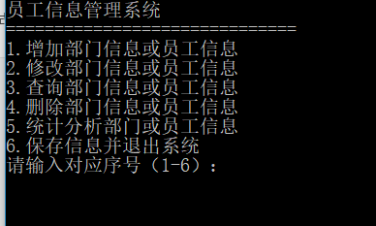

**4.2 添加信息模块运行界面**

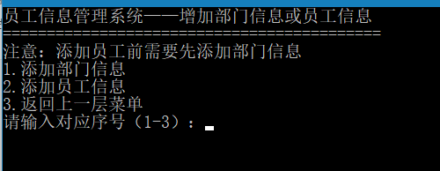

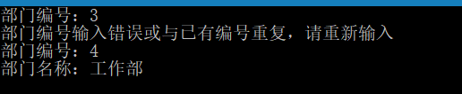

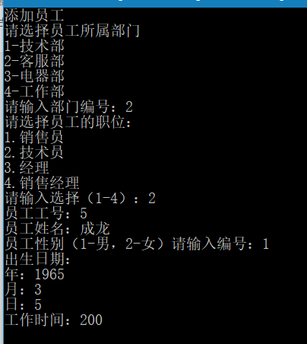

**4.3 修改信息模块运行界面**

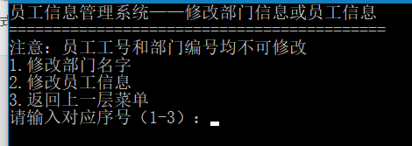

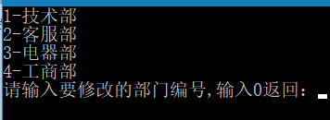

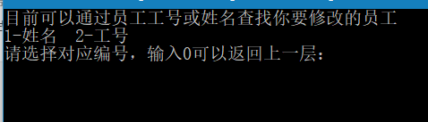

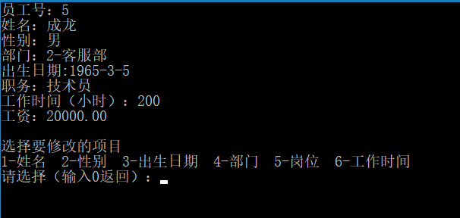

**4.4 查询信息模块运行界面**

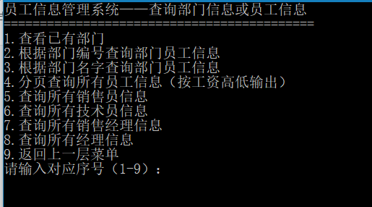

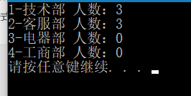

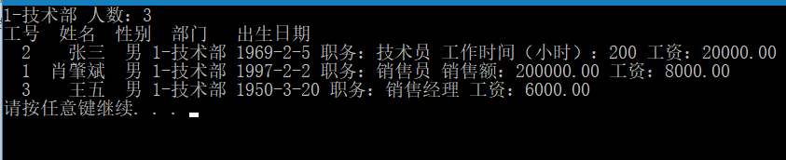

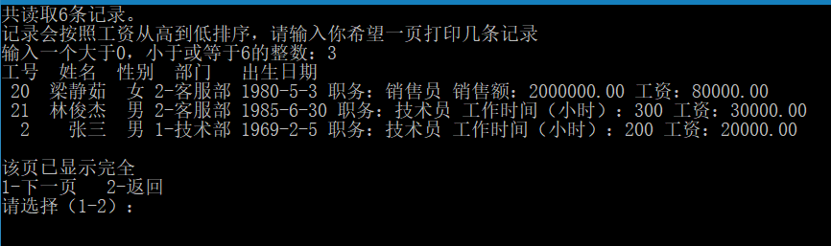

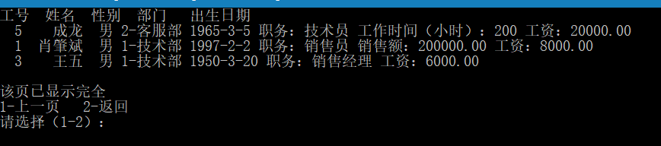

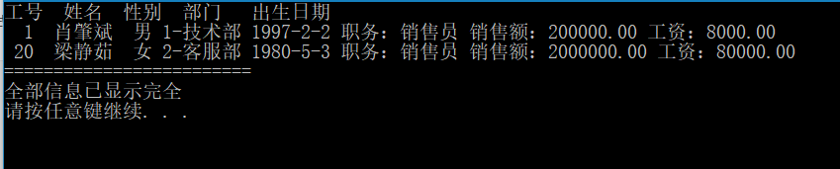

**4.5 删除信息模块运行界面**

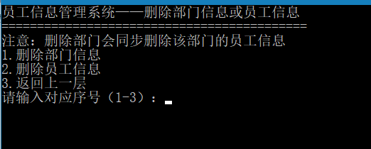

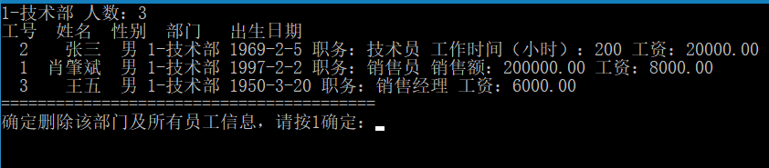

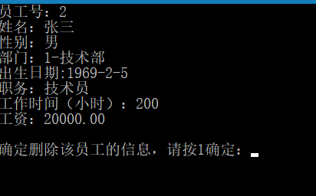

**4.6 分析模块运行界面**

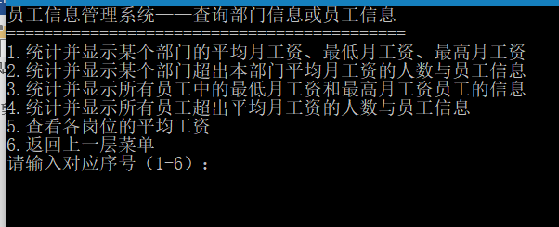

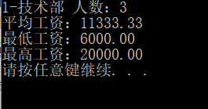

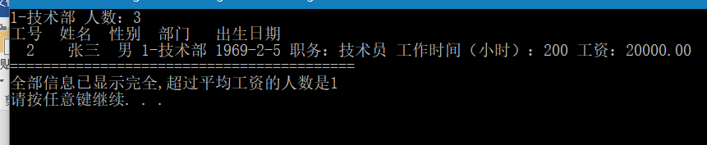

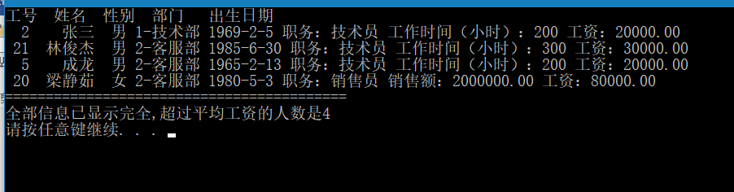

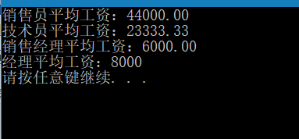

**4.7退出模块运行界面**

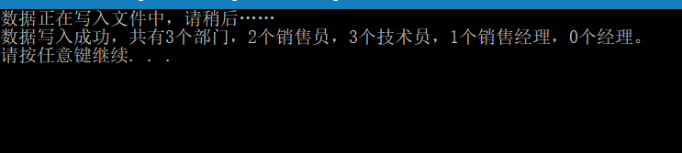

5．总结

**5．1 自我评价及收获**

**要求**：针对本人选择的课程设计题目，列出本人已经完成的项目，并对每项完成的任务进行自我评价，写出感想。在此基础上，还可对整个系统进行评价。（不小于200字）

这个C++的课程设计用了大概一周左右的时间完成，在一开始是毫无头绪地在瞎打。由于没有一个明确的思路，不像学期初那个C语言的项目有明确的思路。我采用了面向对象（姑且这么叫吧），把每个对象，就是每个员工，每个部门可以做什么，怎么做想出来，想到什么就打什么，因为从一开始的思路就是正确的，中间也没有出现什么巨大的改动，所以这个项目就这么打完了。由此我深深体会到面向对象编程的好处。这个项目说不上难，但也算是一次小小的尝试，希望可以把它做得更好。

**5．2 有待解决的问题及进一步完善的思路**

**要求**：针对本人选择的课程设计题目，列出尚未实现的部分，并作相应的文字说明，同时给出进一步完成的思路。在此基础上，还可对整个系统进行评价。（不小于200字）

其实这个项目一开始就打算给它弄个UI界面的，在中间看过一些什么MFC，什么duilib库，什么QT之类的，最后因为临近期末要复习其他科了，决定先放一放，然后就在控制台把它打完了。除此之外，由于当时分开多个头文件，发生了相互包含的问题，当时好像才写了300多行，瞬间爆了300多个错误，最后发现是相互include的问题，但是我并没有很好的解决方法，只能先把它们放在同一个头文件里面，确保只变异一次，这才解决了这个问题，其实也不能说是解决吧，毕竟如果对于大型点的项目，这样的方法本身就不安全，是不该被采用的。在没有更好的方法之前，只能表示“我也很绝望”。