­­­

A website to introduce people to the sport and study of Historical European Martial Arts

HEMA

Milestone 2

Prabhvir Saran, Bhagwan Virdi, Jaisreet Khaira, Tony Pacheco, and Liam MacIntyre

**Table of Contents**

Milestone 2: Site Map and Page Design 2

Sitemap 2

Site map explained 2

Wireframe Page Layouts 3

Print Layouts 5

Page Design / Colour Scheme 7

Appendix 1 8

Introduction 8

About the website 8

Functional Requirements 8

Work Plan 9

Milestone 3: Skeleton site with layout, tables and forms

## Url of the prototype website

## List of all the items completed

1. Organized all the files in the main folder called G2. All pages except index have their own folder so their content can be put inside along with them. The main css file called base is in the style folder.
2. A prototype page has been created for every single page.
3. The base css file is used to style all the pages.
4. All the content in the header and footer will have the font …. And all the content in the body will have the font ….
5. The main navigation bar is configured with an unordered list
6. The content on the about us page is organized with a table
7. The login/signup page forms are using the action attribute to push the data to the website provided.

## A/B Testing

Site a compared to site b

## Deviations from Milestone 1 and 2

There were some changes made. The contact and the meet the team pages were combined in to a single page. The layout on the About HEMA page, Style page and HEMA in BC page were changed to have a simpler design that can applied easily using a single css file.

Documentation of Work

No additional work

# Appendix 2

# **Milestone 2: Site Map and Page Design**

## Sitemap

Home

HEMA

About us

Login/Signup

About Hema

Styles

HEMA in BC

Contact

Meet the team

### Site map explained

Home

* The home page would have a picture representing HEMA, a quick introduction and some facts about HEMA.

HEMA (drop down menu, not an actual page)

* About HEMA
  + Brief overview of the history of modern HEMA and how it relates to historical arts
  + How Hema relates to and contrasts with Eastern Martial Arts as well as with Modern Martial Arts
* Styles
  + Describes various disciplines using a div whose content changes based on user’s selection from a list, by default gives a brief overview of the different styles
* HEMA in BC
  + A short list of local HEMA clubs, groups, schools etc.

About us (drop down menu, not an actual page)

* Contact (comments)
* Meet the team

Login/Signup

* The two buttons the top right hand corner will take the user to the Login / Signup page. This page will be divided in to two sections, the left site to login and the right side to signup.

## Wireframe Page Layouts

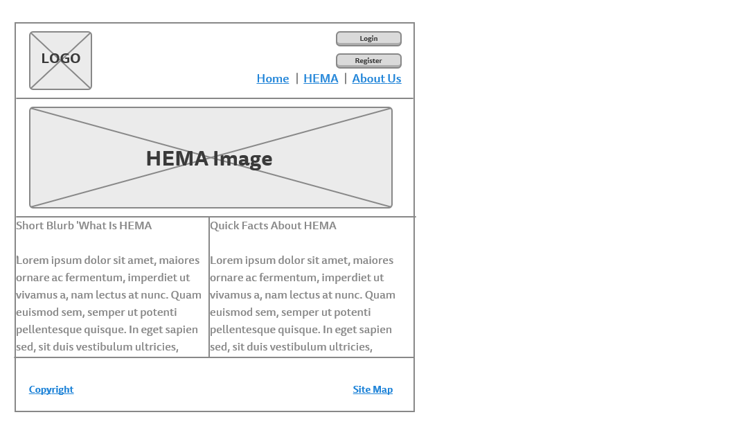

Home Page

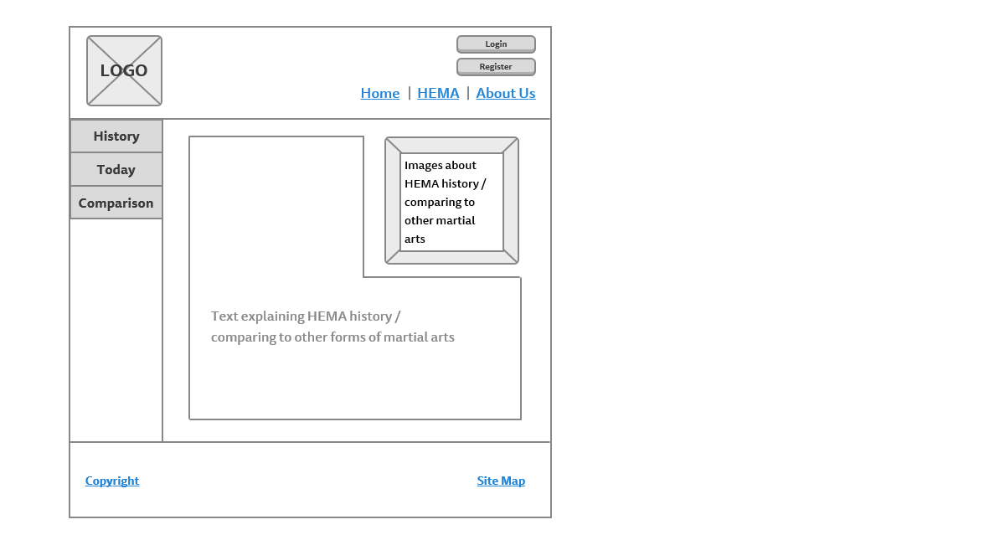

About HEMA Page

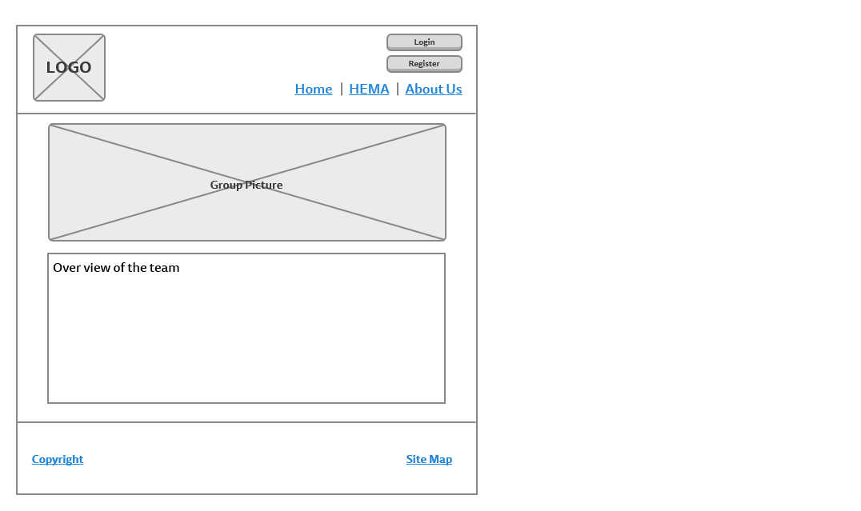

Meet the team Page

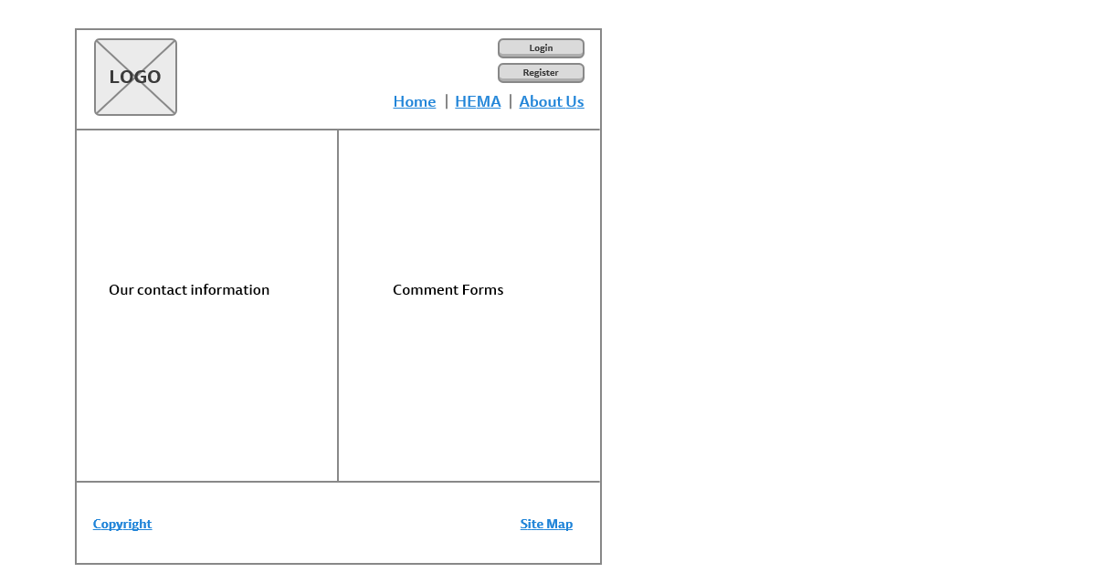

Contact Page

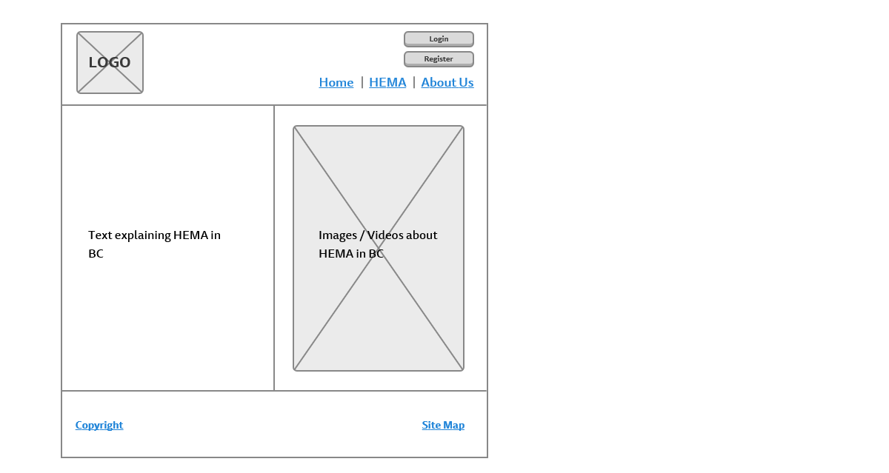

HEMA in BC Page

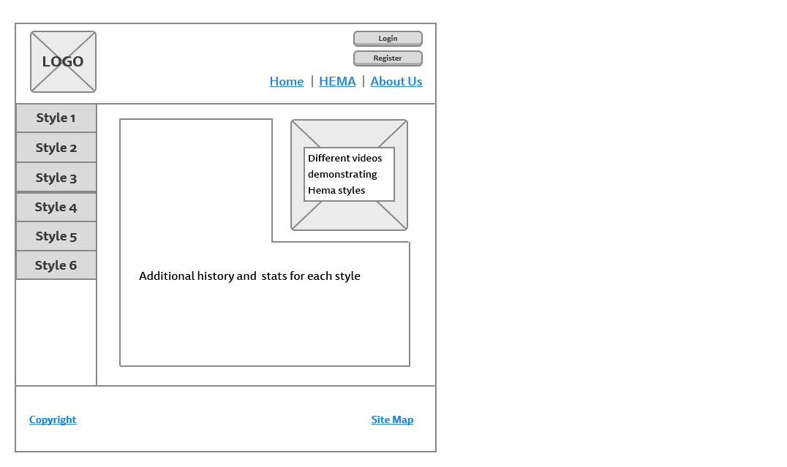

Styles Page

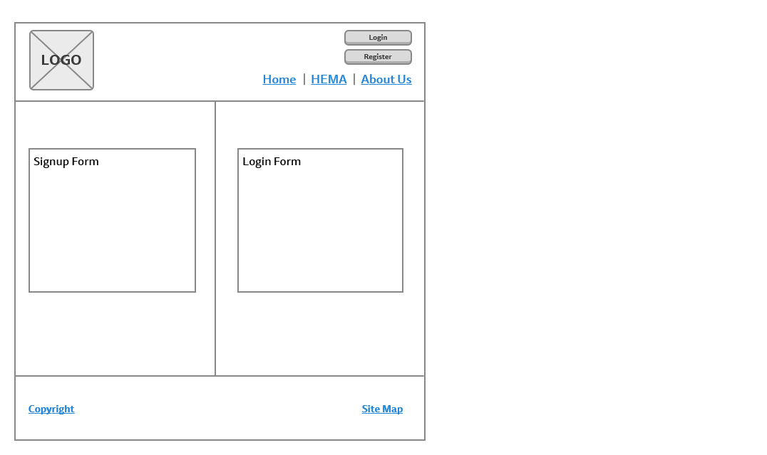

Signup / Login Page

## Print Layouts

There are three types of print layouts. Print layout 1 would be used for the home page. Print layout 2 is for pages using the div that changes the content based on user selection. Finally print layout 3 is for pages that use the two-column layout.

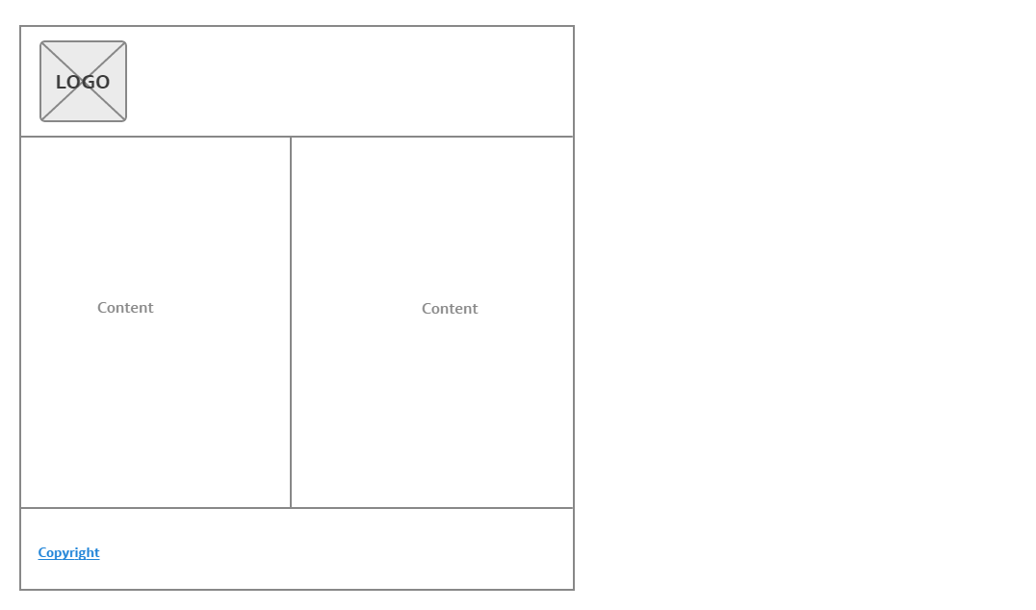

Print Layout 3

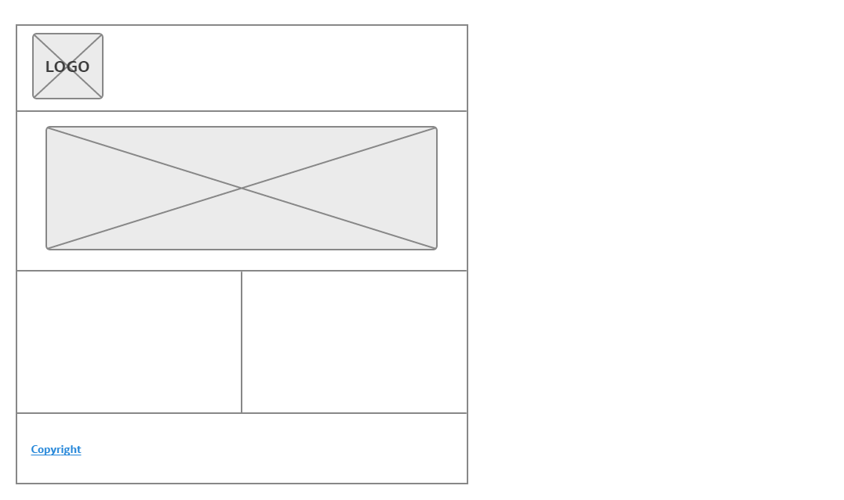

Print layout 1

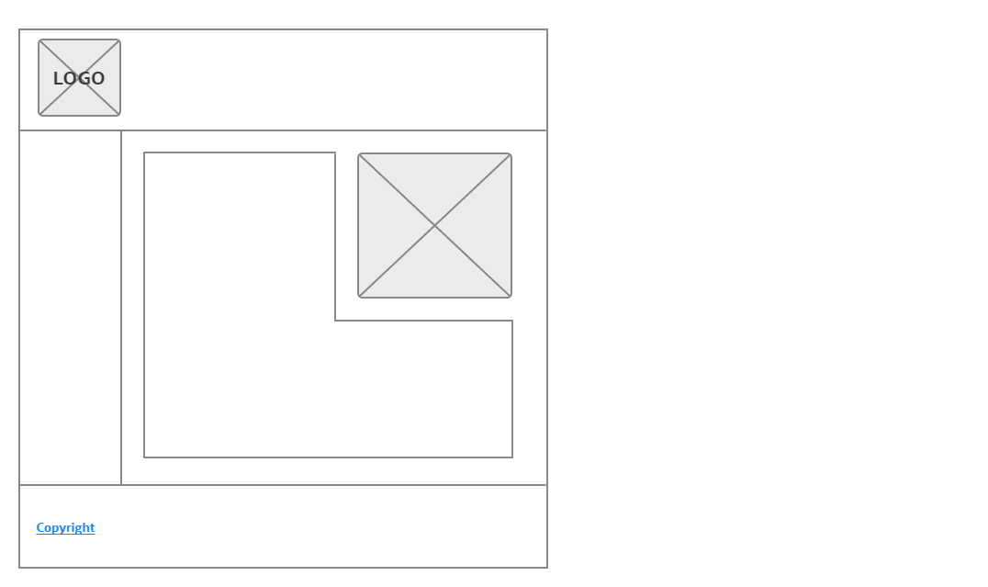

Print layout 2

## Page Design / Colour Scheme

The layout will be fluid to be more user friendly. For simple and intuitive navigation, we chose to use a drop down navigation bar in the header, which is a very common element of popular websites. On the About HEMA page and the Styles page, the left side navigation bar will have buttons which change the content in the main pane to match what the user wants to see. This will help user quickly find the content they want to see without having to sit through pages of links. Our color scheme (below) we chose because it has a historical feel to it, in line with the content of the website, but it also has a bold red, which captures the aggression of combat sports. The colours all fit within a complementary colour set.



| 000000 | 450001 | A50C0E | 2E3323 | FFFEBB

# Appendix 1

## Introduction

Historical European Martial Arts (HEMA) is a set of combat arts with their origins in Europe. Disciplines range from the earliest known axe & sword fighting manuals (circa 1400) to late Victorian era boxing and self-defense systems. Unlike most Eastern martial arts, European martial arts lost their teaching traditions and schools, so the focus of HEMA is the rediscovery and revival of these ‘dead’ arts.

## About the website

Because HEMA is a relatively young sport (the modern revival only started in the 80’s) it is not very well known; the goal of this website will be to introduce new people to the sport and hopefully speed the growth of its revival.

In addition to introducing new people to HEMA, we would also like for the website to serve as a portal to further learning on the subject. We can achieve this by including a glossary of terms commonly used in the HEMA community, having small articles on the different disciplines and weapons and a media gallery.

Not very many websites dedicated to HEMA exist now. The most popular forum for the discussion of HEMA are a Facebook group with just under 10,000 members, but a proper website dedicated to teaching people about HEMA (that doesn’t have a club or association affiliated with it) doesn’t seem to exist

<http://hroarr.com/> is a popular website which is mostly dedicated to sharing news articles and blog posts related to HEMA, but it has a heavy bias towards certain disciplines, and towards German styles as opposed to the style from other countries. Our website will aim to show no bias towards any one discipline, and will not be focused on news but rather general information.

<https://www.hemaalliance.com/> covers a little of everything in HEMA, but doesn’t get too in depth on anything technical. It serves mostly as a portal to other websites, with little original content. Our website will focus more on creative content.

## Functional Requirements

Users will be able register and login to the website. Once a user logs in, he/she can comment and share his/her views on HEMA and also can provide suggestions to request some content and can also suggest for the betterment of the website. The pages describing the styles of HEMA and nearby locations will include a form where users can comment on styles they prefer, or which locations they prefer or train at. The information in these two pages will be displayed in a list.

## Work Plan

We are planning on meeting as group to discuss the project at least three times a week right after classes. Devising an effective plan to keep us all working towards the completion of the project was difficult considering that we have different schedules and little free time; but tasks will be decided by all of us as a group and divided evenly among us. To this end, we have a few of assets that will help us stay organized and work effectively as a group.

* Slack is going to be the tool which keeps our group members in contact and allow us to schedule meeting up
* Trello will keep our team up to date on which tasks need to be worked on, when they are due, and which members of the groups are responsible for their completion
* GitHub will allow us to upload our main html code to a server online, which all of us will have access to and can change and reupload at anytime
* Google Drive/ Google Docs will allow us to share our non-code work and contribute as group to the writing of our project documents as well as keeping our other content and assets all saved in one location.