­­­

A website to introduce people to the sport and study of Historical European Martial Arts

HEMA

Milestone 2

Prabhvir Saran, Bhagwan Virdi, Jaisreet Khaira, Tony Pacheco, and Liam MacIntyre

**Table of Contents**

Milestone 3: Skeleton site with layout, tables and forms 2

Url of the prototype website 2

List of all the items completed 2

Additional work/Issues/Changes 2

Documentation of Work 2

A/B Testing 4

Test 1 4

Test 2 5

Appendix 2 7

Milestone 2: Site Map and Page Design 7

Sitemap 7

Site map explained 7

Wireframe Page Layouts 9

Print Layouts 11

Appendix 1 13

Introduction 13

About the website 13

Functional Requirements 13

Work Plan 14

# **Milestone 3: Skeleton site with layout, tables and forms**

## Url of the prototype website

http://students.bcitdev.com/A00980505/G2/

## List of all the items completed

1. Organized all the files in the main folder called G2. All pages except index have their own folder so their content can be put inside along with them. The main CSS file called base is in the style folder.
2. A prototype page has been created for every single page.
3. A single CSS file is used to style all the pages.
4. All the content in the header will have the Cinzel and all the content in the body and footer will have the font Titillium web. Both fonts are linked from google fonts.
5. The main navigation bar is configured with an unordered list.
6. A table is used the content on the About Us page.
7. The Login/signup page forms are using the action attribute to push the data to the website provided.

**PLZ CHECK THIS WITH THE INSTRUCTIONS IN MILESTONE 3**

## Additional work/Issues/Changes

The only additional work was that the Styles page is already using JavaScript to change the content of the page. We did encounter a major issue. Since we were all working on the same CSS file, while merging it using Git, it broke the code every time and we had to keep going back to fix it. There were some changes made to the website. The contact and the meet the team pages were combined in to a single page called the aboutus page. **WHY ?** The layout on the About HEMA page, Style page and HEMA in BC page was changed slightly. Now the images/videos are on top with text underneath to better match the homepage. **CHECK THE WEBSITE TO MAKE SURE WE DIDN’T MISS ANTHING HERE**

## Documentation of Work

Below are three screenshots of the front page, the about us page with a table and the login/signup page with the required form.

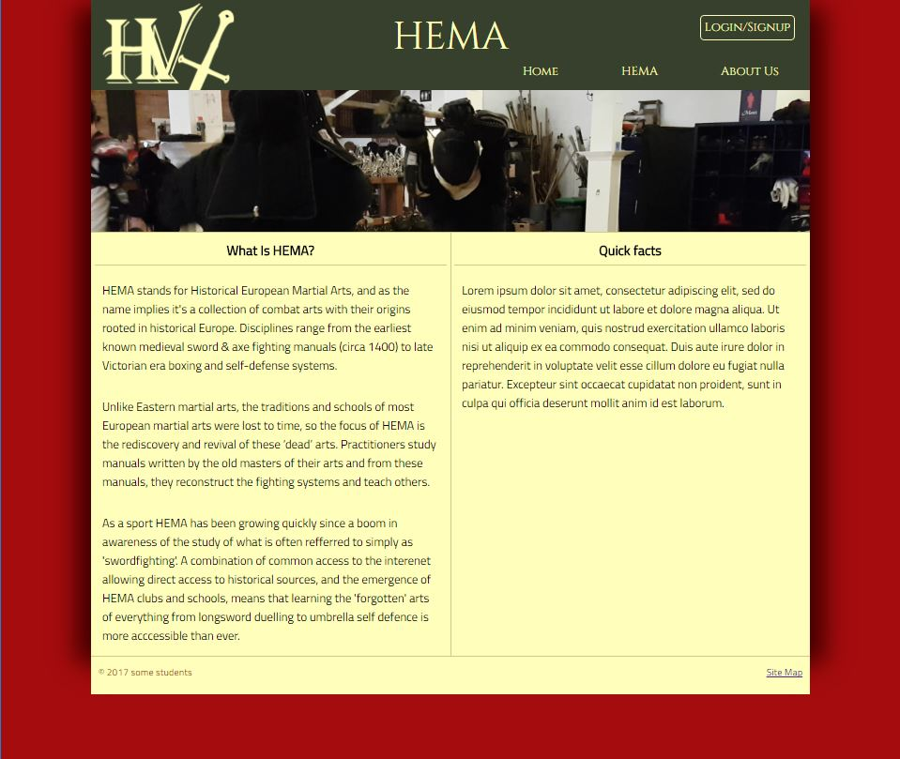

Front page

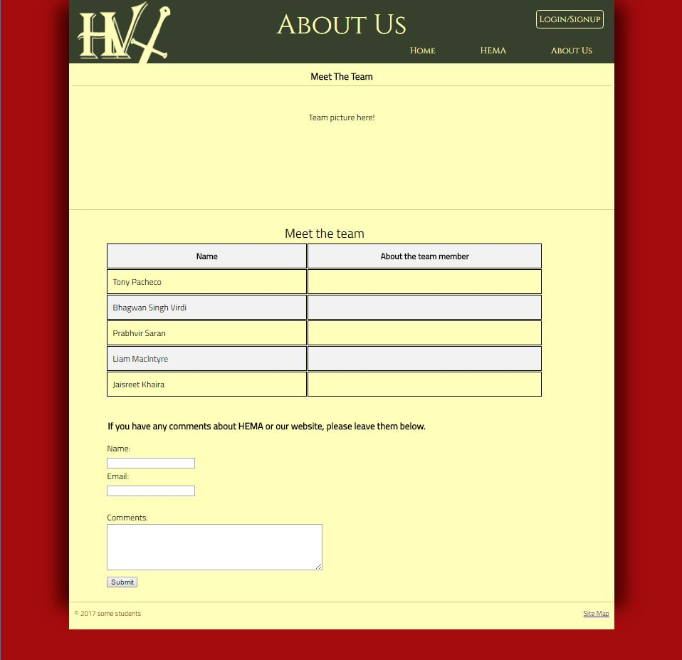

Aboutus page with the table

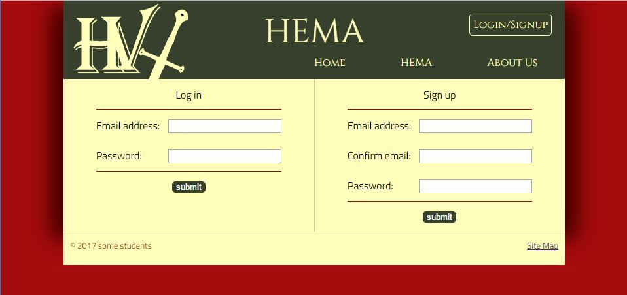

Login/Signup page with form

## A/B Testing

### Test 1

Two tests were conducted using a/b testing. The first test was done using two different fonts sets. The following two pictures display the difference. In the picture on, Tinos was user for header and Dosis for the main body vs. and Cinzel for the header and Titillium Web for the main in the second picture.

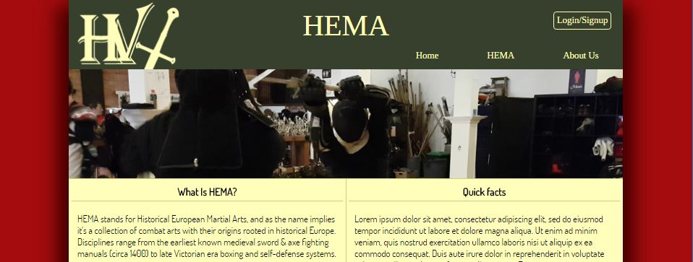

Picutre one (Tinos and Dosis font)

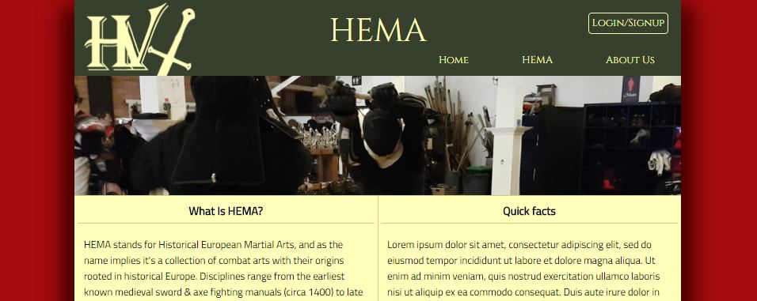

Picture two (Cinzel and Titillium Web font)

The test was conducted on five family members. Three out of five preferred the second font set (Cinzel and Titillium Web) and their main reason was that it has more of a historical feel to it than Tinos and Dosis font.

### Test 2

The navigation bar was used to conduct the second test. The login/sign up button was made part of the navigation list rather than a separate button on the top right corner. The following two images show the difference.

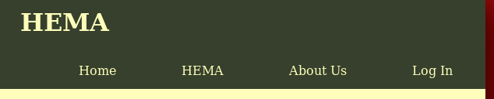

Login aligned with the nav bar



Login/Signup button in the top right corner

The same people were used for this test. Everyone preferred having the login/sign up button distinct and separate from the navigation bar as its purpose is quite different. The distinct location and border will help users to quickly sign in when they come to the site.

# Appendix 2

## **Milestone 2: Site Map and Page Design**

## Sitemap

Home

HEMA

About us

Sitemap

About HEMA

HEMA Styles

HEMA in BC

Login/Signup

### Site map explained

Home

* The home page would have a picture representing HEMA, a quick introduction and some facts about HEMA.

HEMA (drop down menu, not an actual page)

* About HEMA
  + Brief overview of the history of modern HEMA and how it relates to historical arts
  + How Hema relates to and contrasts with Eastern Martial Arts as well as with Modern Martial Arts
* HEMA Styles
  + Describes various disciplines using a div whose content changes based on user’s selection from a list, by default gives a brief overview of the different styles
* HEMA in BC
  + A short list of local HEMA clubs, groups, schools etc.

About us

* This page will have information about the team members and a comment forum for the users to provide feedback.

Login/Signup

* The button on the top right hand corner will take the user to the Login / Signup page. This page will be divided in to two sections, the left site to login and the right side to signup.

Sitemap

* This page will contain a link to all the pages in a list.

## Wireframe Page Layouts

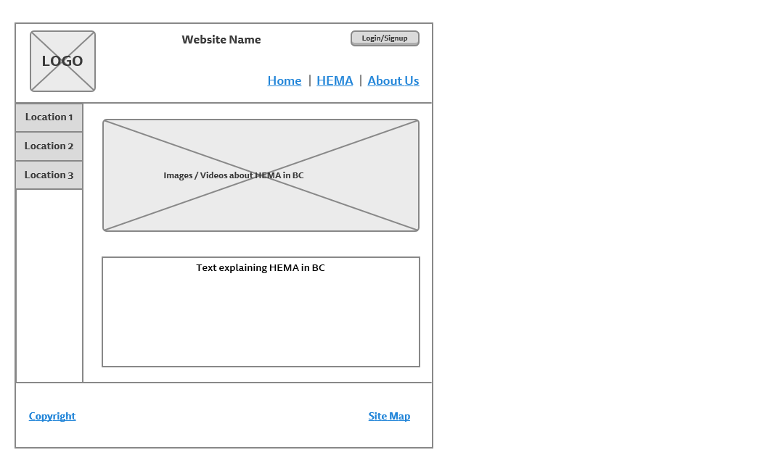

HEMA in BC page

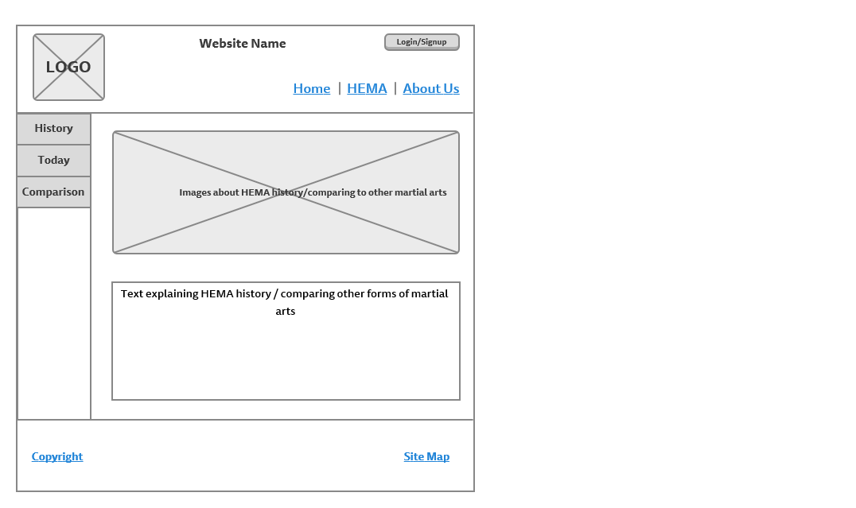

About HEMA page

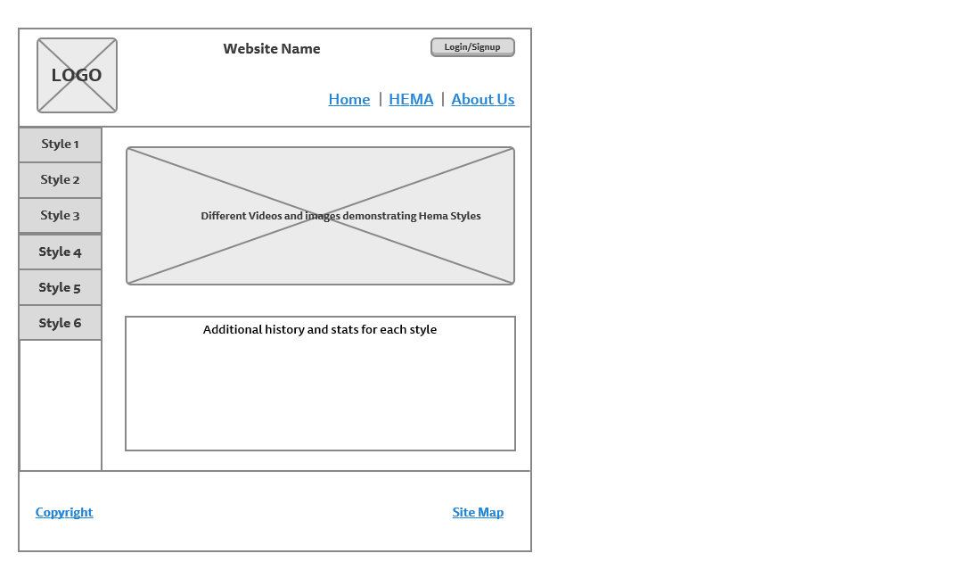

HEMA Styles page

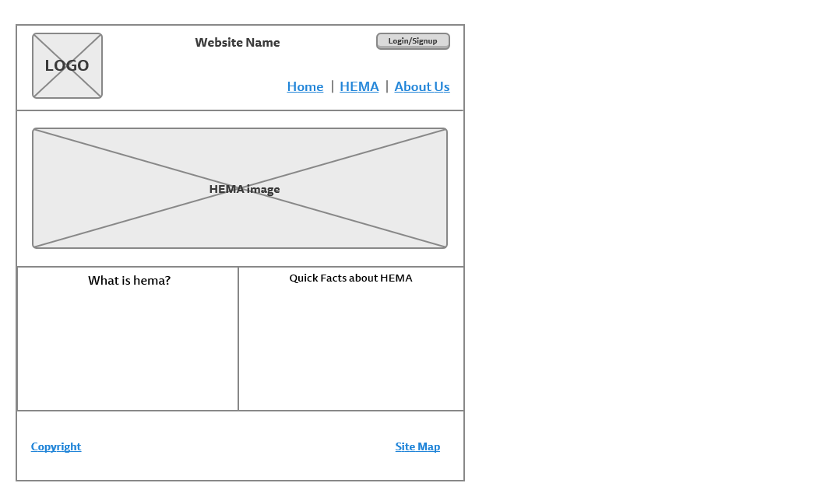

Home page

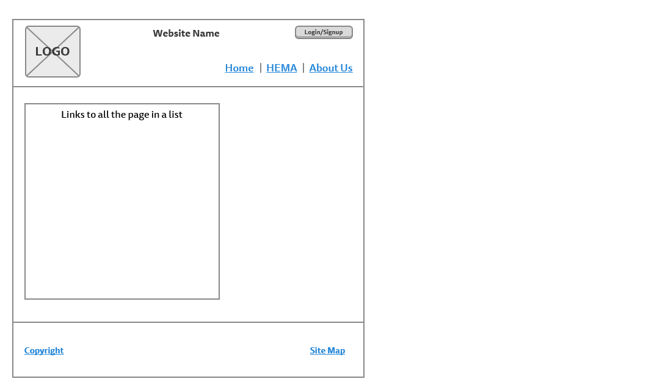

Sitemap page

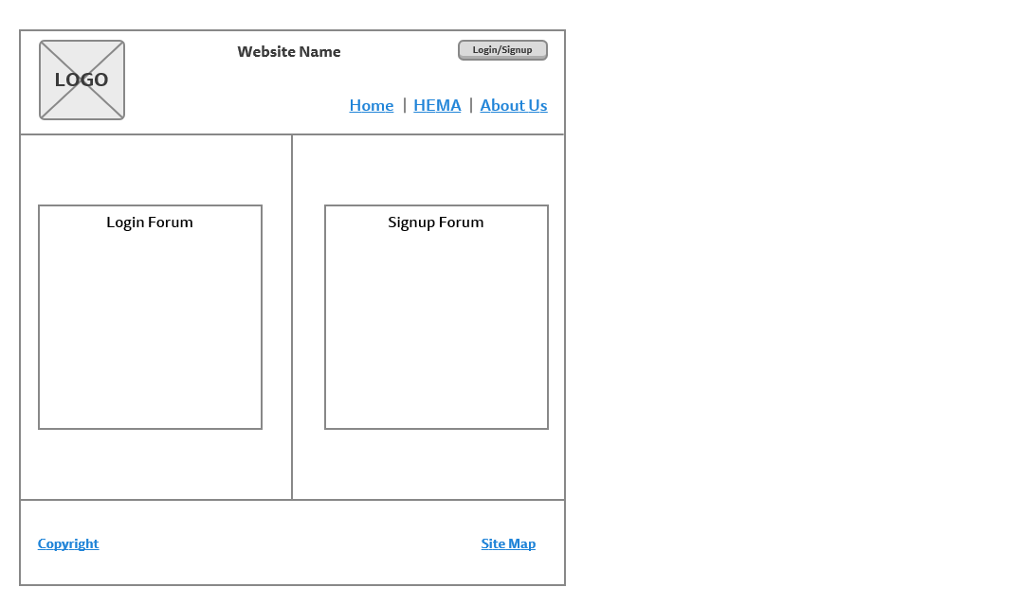

Login/Signup page

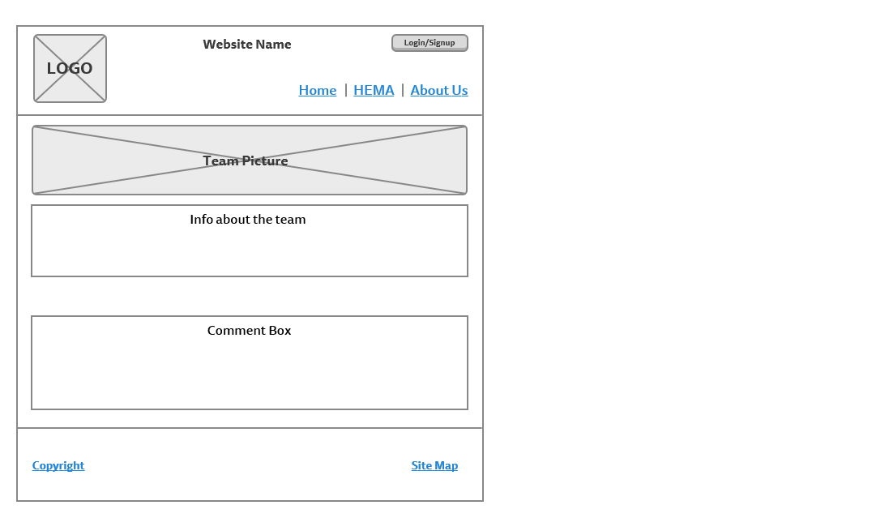

About Us page

## Print Layouts

There are four types of print layouts. Print layout 1 would be used for the home page. Print layout 2 is for pages using the div that changes the content based on user selection. Print layout 3 is for the login/signup page and finally print payout 4 is for the aboutus page.

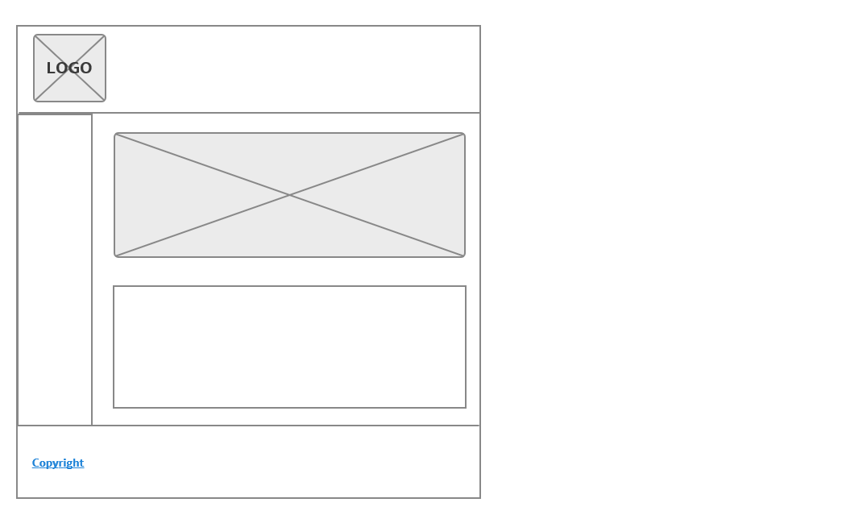

Print Layout 2

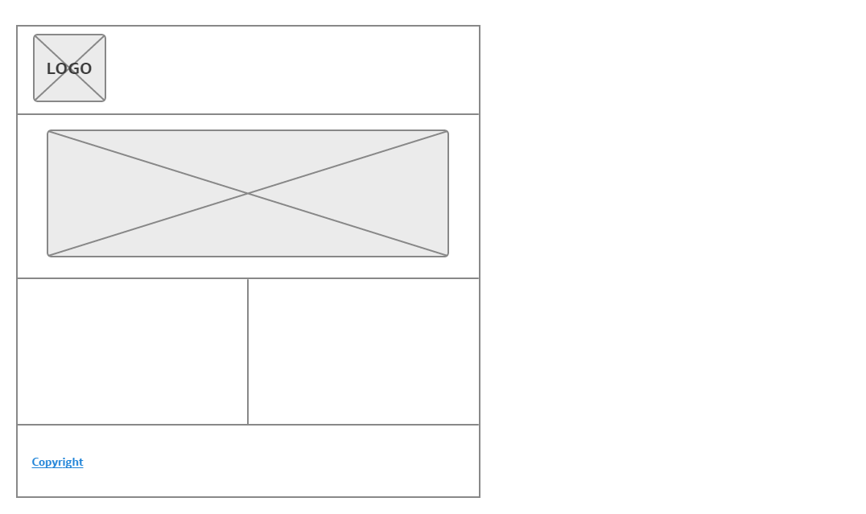

Print layout 1

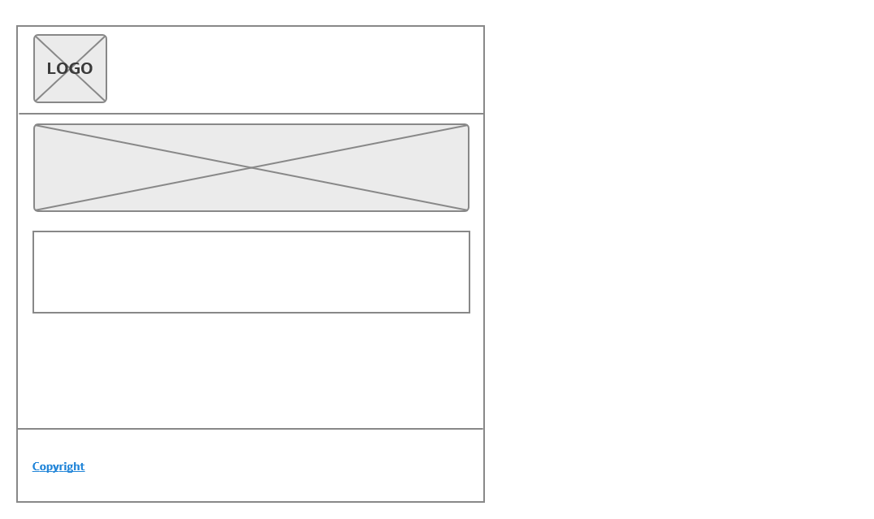

Print Layout 4

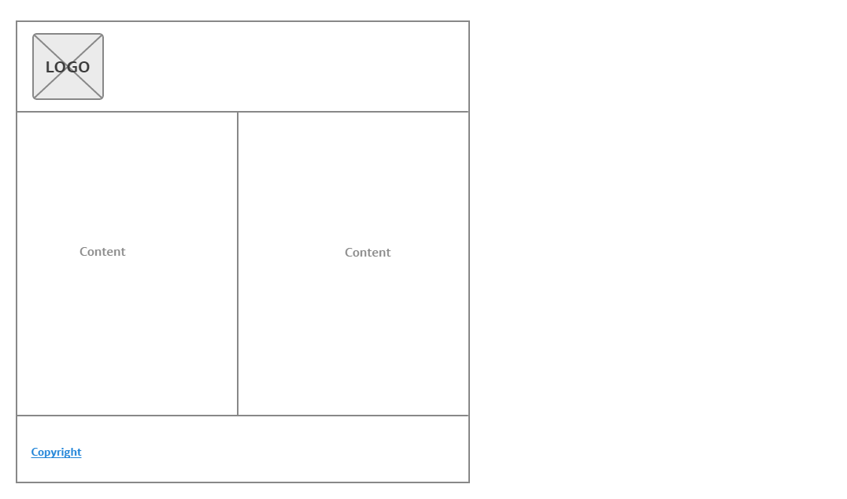

Print Layout 3

Page Design / Colour Scheme

The layout will be fluid to be more user friendly. For simple and intuitive navigation, we chose to use a drop down navigation bar in the header, which is a very common element of popular websites. On the About HEMA page and the Styles page, the left side navigation bar will have buttons which change the content in the main pane to match what the user wants to see. This will help user quickly find the content they want to see without having to sit through pages of links. Our color scheme (below) we chose because it has a historical feel to it, in line with the content of the website, but it also has a bold red, which captures the aggression of combat sports. The colours all fit within a complementary colour set.



| 000000 | 450001 | A50C0E | 2E3323 | FFFEBB

# Appendix 1

## Introduction

Historical European Martial Arts (HEMA) is a set of combat arts with their origins in Europe. Disciplines range from the earliest known axe & sword fighting manuals (circa 1400) to late Victorian era boxing and self-defense systems. Unlike most Eastern martial arts, European martial arts lost their teaching traditions and schools, so the focus of HEMA is the rediscovery and revival of these ‘dead’ arts.

## About the website

Because HEMA is a relatively young sport (the modern revival only started in the 80’s) it is not very well known; the goal of this website will be to introduce new people to the sport and hopefully speed the growth of its revival.

In addition to introducing new people to HEMA, we would also like for the website to serve as a portal to further learning on the subject. We can achieve this by including a glossary of terms commonly used in the HEMA community, having small articles on the different disciplines and weapons and a media gallery.

Not very many websites dedicated to HEMA exist now. The most popular forum for the discussion of HEMA are a Facebook group with just under 10,000 members, but a proper website dedicated to teaching people about HEMA (that doesn’t have a club or association affiliated with it) doesn’t seem to exist

<http://hroarr.com/> is a popular website which is mostly dedicated to sharing news articles and blog posts related to HEMA, but it has a heavy bias towards certain disciplines, and towards German styles as opposed to the style from other countries. Our website will aim to show no bias towards any one discipline, and will not be focused on news but rather general information.

<https://www.hemaalliance.com/> covers a little of everything in HEMA, but doesn’t get too in depth on anything technical. It serves mostly as a portal to other websites, with little original content. Our website will focus more on creative content.

## Functional Requirements

Users will be able register and login to the website. Once a user logs in, he/she can comment and share his/her views on HEMA and also can provide suggestions to request some content and can also suggest for the betterment of the website. The pages describing the styles of HEMA and nearby locations will include a form where users can comment on styles they prefer, or which locations they prefer or train at. The information in these two pages will be displayed in a list.

## Work Plan

We are planning on meeting as group to discuss the project at least three times a week right after classes. Devising an effective plan to keep us all working towards the completion of the project was difficult considering that we have different schedules and little free time; but tasks will be decided by all of us as a group and divided evenly among us. To this end, we have a few of assets that will help us stay organized and work effectively as a group.

* Slack is going to be the tool which keeps our group members in contact and allow us to schedule meeting up
* Trello will keep our team up to date on which tasks need to be worked on, when they are due, and which members of the groups are responsible for their completion
* GitHub will allow us to upload our main html code to a server online, which all of us will have access to and can change and reupload at anytime
* Google Drive/ Google Docs will allow us to share our non-code work and contribute as group to the writing of our project documents as well as keeping our other content and assets all saved in one location.