What were the drivers of the level of COVID-19 vaccination in Poland?

Sebastian Chmielewski

Zofia Danek

Antoni Martinek

Tymoteusz Strojny

Antoni Szostak

**Introduction**

In December of 2019, the whole world was gripped by the rapid spread of news concerning a mysterious virus, unlike anything seen before. Humanity stopped for a moment to understand and prepare our species for the incoming months. Thanks to our ability to adapt, people quickly started to find solutions and accommodate their daily routine to this new reality. As with any new situation, this one also required many difficult decisions. One of the most challenging ones was to answer the question: ‘Should I get vaccinated?’. Due to the fact that the global pandemic was such a new crisis, there was a lack of authority and research that would give an unequivocal answer to this question. That is why people used a variety of criteria to make the best decision for their health and safety.

Central to our investigation is the hypothesis that discernible correlation exists between vaccination rates and factors such as place of residence and political affiliations. We will focus on how the vaccination process looked like in Poland which is an intriguing example due to its history and political situation. We strongly believe that through rigorous analysis and empirical evidence with powerful quantitative methods we will be able to prove that such correlation exists.

**Significance of size**

One of the crucial factors in terms of viruses and their counter measures might be the sizes of municipalities. Poland is currently not only the ninth largest country in Europe regarding the area but also the sixth by number of inhabitants. First, it is obligatory to define what are we taking into consideration when we mention “the size”. In our analysis we came up with 3 various approaches: area, population and their combination which is population density.

The first factor is the area, measured in square kilometres. Poland consists of approximately 312705 square kilometres of inland territory and 9870 square kilometres of territorial waters. In that area, there are 2477 municipalities which will be the objects of our research.  We sorted the elements in descending order and using the David V. Huntsberger suggestion divided them into the 12 intervals. They were grouped equally except the last one, which consisted of the smallest observations by territory. The first eleven intervals had 207 observations while the last one had 200. For each interval we determined the average value of fully vaccinated inhabitants in Poland.

*Average percent of fully vaccinated inhabitants against covid-19 grouped in intervals by area in Poland, 2021*

The first interval had an outstanding average value of 60.19% inhabitants that decided to fully vaccinate. What is worth noticing, since the intervals were grouped in descending order, the group number one had the largest territory. It consisted of 65075 square kilometres which is 20.81% of Poland’s total landmass. The lowest value observed was in interval number 7, where only 49.75% inhabitants were fully vaccinated. This group occupies 7.07% of country. If we combine intervals number 1, 2, 3 and 4 we get an area of 174636 square kilometres which is 55.85% of total area, the average value of people who decided to fully vaccinate in this group is 55.4%. When we add up the rest of the intervals, which consists of 44.15% of Poland’s territory we get the average of fully vaccinated inhabitants equal to 50.57%. This indicates that indeed, size of municipalities matter. On average 9.55% more inhabitants are fully vaccinated in first four intervals.

The second factor is population. As of 2021, Poland has 38 088 564 inhabitants. We decided to make the same approach as the one with area, by using intervals division, we created 12 different groups. First eleven of them had 207 observations while the last one, with the smallest number of inhabitants had 200 observations. People distribution in Poland turned out to be much more urban than we expected, 48.34% of inhabitants live in first group, which consists of 207 biggest municipalities in terms of population, that is approximately 18 412 623 people. We observed that the average percent of fully vaccinated citizens in this group was equal to 60.19%.

Average percent of fully vaccinated inhabitants against covid-19 grouped in intervals by population in Poland, 2021

The border observation of first Interval was for municipality of Nowy Dwór Mazowiecki, which is a domicile for 28705 citizens. The remaining groups are more inhabited. However, the relevance of these areas is crucial to understand behaviour of polish citizens during pandemic. When we sum up intervals from 2 to 12, we get 19 601 197 inhabitants, which account for 51.66% of absolute population. While for the first group the average amount of fully vaccinated inhabitants is 60.19%, for the remaining accumulated it is only 51.45%. That indicates that 16.99% more people decide to fully vaccinate in 207 most populous municipalities than in the remaining 2270. As we can observe, the size of population per municipality is even more relevant to percent of people vaccinated.

The third approach to the problem connected both area per square kilometres and population. The factor we decided to analyse was density of population. To measure the municipality’s density, we simply must divide the number of inhabitants by its territory. As we observed in the last paragraph, the citizens distribution was strongly asymmetric, to this level that almost half of the country lives in the 207 municipalities. The density factor is a good solution for such asymmetry, since some of the areas are bigger while having much smaller population and the others are small but have a massive number of citizens.

In this situation, we decided to make slightly different approach. Instead of dividing groups equally, we have appointed 7 intervals based on the intensity of density. The distribution and numerical ranges we came up with are listed below on the chart.

*Quantity of observations in groups per density in Poland, 2021*

As it is easy to observe, most of polish municipalities have a density of less than hundred inhabitants per square kilometre. The most populous areas are located mainly in the well urbanized metropolises. As of 2021, according to Central Statistical Office (pol. Główny Urząd Statystyczny) there are eleven metropolitan areas in Poland.

After carefully conducting calculations of average vaccination rate in all ranges of municipalities, this is what we received.

*Average Covid-19 vaccination rate in all intervals in Poland, 2021*

The first group, which held municipalities with density over 1500 inhabitants per square kilometer had an average full vaccination rate against Covid-19 at the level of 61,44%. Next interval, which contained 82 observations where density was between 1500 and 1001 people per square kilometer, had an average valueat 58,84%. The trend is well described by “Least Squares” model, where the coefficient of determination is 90,75%. The linear function is decreasing, reaching the rate of vaccination at average of 50,45% for the last interval, where municipalities had density of 50 or less inhabitants per square kilometre. When we confront the values of the most populous areas with the least dense territories, we can clearly see the distinction. 21,78% more citizens are fully vaccinated against Covid-19 in the first interval than in the last one. This asymmetry may be even more shocking when we compare the population of these areas. The first interval is a domicile for 11 098 696 citizens, 29,14% of total population. While the seventh interval has only 4 935 319 inhabitants.

The conducted analysis shows that size does matter when it comes to vaccination against Covid-19 in Poland. The popularity of vaccine is much more visible in dense areas, mostly in metropolises. Meanwhile, citizens from rural municipalities tend to vaccinate less often. Scientific regularities are best seen when analysing the density instead of areas or population which may be deceiving.

**What makes us best in class?**

The distinction in vaccination rates when comparing urban (63.6%) and rural areas (55,2%) is clear but the question we pose if what makes the urban/rural area have the highest vaccination rate compared to other urban/rural areas. Our research proves that certain factors have substantially bigger impact than others.

Firstly, we divided the municipalities by the type of area (rural/mixed/urban) by taking the last digit of their municipal code. Further, we conducted study with each group separately. The results show that in each of the groups the revenue of municipality budget from personal income tax (PIT) is characterized by the highest or second-highest correlation to a percent of vaccinated. In rural areas revenues from PIT have 0.55 mark (Pearsons's correlation), whereas in mixed areas it is 0.49 and in urban areas 0.50 result. Additionally, in mixed areas number of entities registered per 10 thousand inhabitants seem to have effect on vaccination rates. Those results lead us to believe that the income of private entities is key to higher vaccination rates and the wealthier the municipality is the higher the rate of vaccine intake is. In addition, the other factors that may play a role are total area of forest (the higher the area the lower the vaccination rate), number of people per apartment (same as with the forests area). Furthermore, we can observe that higher unemployment rates especially in male group has negative impact on vaccinations rate. The conclusion of this part of the study is that the wealthier and professionally active the inhabitants are the higher the level of vaccination is.

**Vaccination rate differences among western and eastern Poland**

Variety of scientific studies dedicated to data analysis on many topics show significant differences in results between eastern and western Poland. We aimed to confirm if this is also true when it comes to vaccination rates. Firstly, our research was focused on verifying if the historical partition of Poland could be the factor in this case.

Vaccination rates in different partition areas

After taking the percent of vaccinated in each of the municipalities and multiplying it by the total population of each municipality and further calculating the rate in each of the partition areas we found significant difference in the area of Austrian partition compared to the other two. However, the difference in Prussian and Russian area is marginable.

We speculate that this distinction may be caused by history-influenced factors. Moreover, the similarity of vaccination rates in the other two partition areas lead us to believe that this choice of country division is not the right direction where we should look for intel.  Nevertheless, we propose another approach to the division of Poland. If we take into account, the Vistula River and divide the country along the course of the river the distinction in vaccination rates seems to be clearer.

Difference in vaccination rates with Vistula River division

Eastern part has notably lower rate compared to the Western part. We postulate that socioeconomical differences which grew over the decades may influence the emerged difference. This observation proves that one of the drivers of vaccination rates is localization based.

**Vaccination rates among different age groups**

COVID-19 puts older people at greatest risk, especially those over 60 years of age and those with existing medical conditions such as heart disease, diabetes, hypertension, obesity and a weakened immune system. People in these age groups and at these risk groups are more likely to experience serious COVID-19 symptoms, including pneumonia, respiratory failure and death.

Consequently, older people, due to their higher risk of complications and severity of COVID-19, tend to be more likely to opt for vaccination against the disease. Furthermore, many countries initially prioritised older age groups in the vaccination process.  Our analysis confirms this. We normalised the data on the population in the different age groups in the municipality. We sorted the data by vaccination rate and extracted 2 smaller datasets being the 10% best and worst performers in terms of vaccination rate. We produced 2 demographic graphs and overlaid them to find out how the demographics differed in well and poorly vaccinated municipalities.  The graph shows that the municipalities with the best vaccination rate have a significantly higher proportion of people in the 35-49 and 60-74 age brackets than the other group. While in the least vaccinated municipalities, the proportion of younger age groups prevails. Interestingly, the oldest age group 75-84 has a higher percentage in the least vaccinated group. This may be related to the phenomenon of young people leaving less urbanised areas, which tend to have worse vaccination rates.

Share of people who completed the initial COVID-19 vaccination protocol by age, Poland 2021

Demographic chart for the 10% of the best and worst municipalities in terms of vaccination rate

**Vaccination rate and political views**

The 2023 Polish parliamentary election is for us the best current indicator in the matter of the overall political landscape in Poland. The latest 2024 Polish local election, like other local elections, is more focused on local issues than on the broader political sentiment, so it's not relevant to our analysis. There were more than a dozen electoral committees registered, but we focused on the committees that were registered in all constituencies. For the purpose of better understanding name of the parties we used short names of the parties, in order of registration number mentioned below:

* Third Way (pol. Trzecia Droga, full name: 'KKW Trzecia Droga Polska 2050 Szymona Hołowni – Polskie Stronnictwo Ludowe’
* New Left (pol. Nowa Lewica)
* Law and Justice (pol. Prawo i Sprawiedliwość)
* Confederation Liberty and Independence (pol. Konfederacja, full name: ‘Konfederacja Wolność i Niepodległość’
* Civic Coalition (pol. Koalicja Obywatelska, full name: ‘KKW Koalicja Obywatelska PO .N iPL Zieloni ‘

To avoid any mismatches due to cultural differences in meaning, only the Polish names will be used in further analysis.

The 2023 Polish parliamentary election results

Depending on the political vision of the party or the conditions of the voters, vaccination rates may vary. We compared vaccination rate data from all municipalities in Poland with the results of the 2023 Polish parliamentary elections. After collecting the vote data for each party in each municipality, we calculated the percentage result for each party across all municipalities. These regions were then divided into 5 intervals based on vaccination rates. Since only percentage values were compared, absolute conclusions should not be drawn. However, an overall trend can still be observed.

Relationship between the percentage of Trzecia Droga voters in the municipality and the percentage of vaccinated people

Trzecia Droga is a party with a centrist ideology. Although there is a positive trend between the percentage of vaccinated individuals and the percentage of votes, it is not as pronounced as in other parties. This is because Trzecia Droga tends to position itself as an alternative to the government, attracting voters with diverse views.

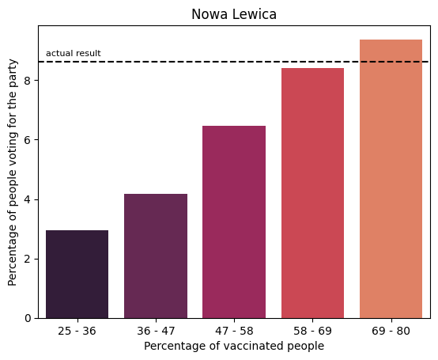

Relationship between the percentage of Nowa Lewica voters in the municipality and the percentage of vaccinated people

In the most vaccinated group (69-80%), the left-wing party Lewica tended to receive an average of above 9% of votes. In the 25-36% vaccinated group, Lewica only received about 3% of votes. The sentiment difference is unsurprisingly significant, because of party declarations about proposals to introduce mandatory COVID-19 vaccinations

Relationship between the percentage of Konfederacja voters in the municipality and the percentage of vaccinated people

In the least vaccinated group (25-36%), Konfederacja tended to receive an average of almost 10% of votes. This fact, considering that Konfederacja is a far-right party that opposed lockdowns, compulsory mask-wearing, and vaccinations, serves as a strong confirmation of the negative trend observed in the graph.

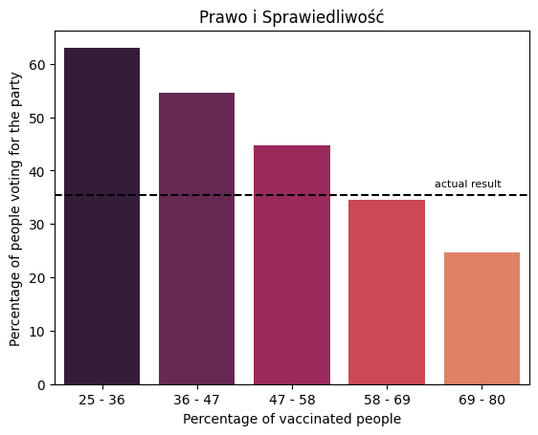

Relationship between the percentage of PiS voters in the municipality and the percentage of vaccinated people

The most distinctive negative trend concerned PiS, the right-wing populist party which held the majority in both the Sejm and the Senate during the Covid-19 pandemic. In municipalities with a relatively low percentage of vaccinated people, PiS tended to receive up to 60% of votes on average. Such differences may have occurred due to other factors such as education, residence, and others.

Relationship between the percentage of KO voters in the municipality and the percentage of vaccinated people

Koalicja Obywatelska, the big tent party, tended to receive relatively more votes as the percentage of vaccinated people increased in the municipality. Surprisingly, they only received about 9% on average in the least vaccinated group.

It is important not to approach charts with a black-and-white attitude, but rather to take into account other factors. Overall, our analysis confirms a strong link between vaccination rates and political views. It turns out that voters for right-wing parties are less likely to vaccinate. This relationship is particularly well illustrated in the chart describing the results for PiS.

**The neighbourhood effect**

The neighbourhood effect is an economic and social science concept that assumes that neighbourhoods have either a direct or indirect effect on individual behaviours. That is why one may posit the propensity to vaccinate is almost as contagious as the coronavirus itself. If we take a closer look at the municipalities map connected with the vaccination percentage data, we can predict that similar values cluster together.

Percentage of inhabitants fully vaccinated against COVID-19 in 2021

We managed to prove that by analysing the overall clustering of the spatial data using a statistical measure - Moran’s I. The Global Moran’s I turned out to equal approximately 0.71 which indicates that the spatial autocorrelation is in fact present in this dataset. Moreover, the Local Moran's I also showed that the spatial autocorrelation is positive. It turns out that 941 out of 2477 municipalities present significant spatial data patterns at a significance level of p = 0.05.

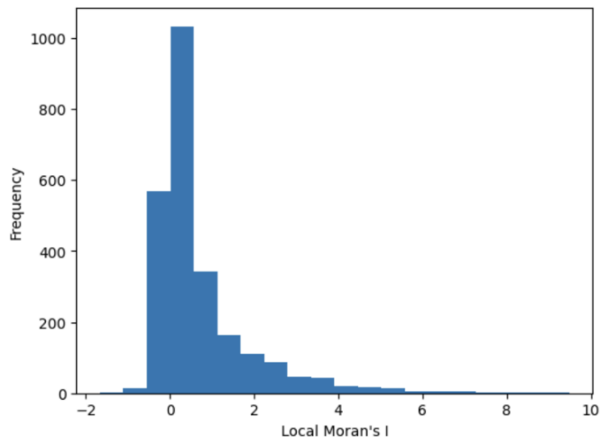

Local Moran’s I in municipalities

Creating a LISA (Local Indicators of Spatial Association) cluster map allowed us to distinctly show that propensity to vaccinate is in fact contagious. It seems really clear that the western part of Poland was definitely more enthusiastic about the vaccines than the eastern part. We can also clearly observe that the natural border happens to run closely to the Vistula River. Poland’s longest river divides the country between the municipalities classified as HH (High-High - municipalities with high percentage of inhabitants fully vaccinated against COVID - 19 surrounded by other municipalities with high rate) and the LL (Low-Low - municipalities with low percentage of inhabitants fully vaccinated against COVID-19 surrounded by other municipalities with low rate).

LISA cluster map with the course of Vistula

Moreover, we can look at the scatterplot that also emphasises the clustering of similar levels of inhabitants fully vaccinated against COVID-19.

Local Moran’s I Scatterplot

**Conclusion**

Looking at the drivers of the Covid-19 vaccinations we can observe many emerging patterns. Larger and more populated municipalities tend to have higher number of fully vaccinated inhabitants. Furthermore, Eastern Poland seem to have lower levels of vaccination in comparison to the western part. The variation in vaccination rates among different age groups is notable. We dove deep to research what may factor when comparing municipalities of the same type which provided us with the knowledge that wealth of the inhabitants and several other factors impact vaccination rates.  Moreover, political views of individuals and the party of choice are profoundly connected with their vaccination commitment. Apart from that we took the neighbourhood effect into consideration and came up with conclusion that it is greatly visible in this case. This research allowed us to understand the drivers of Covid-19 vaccination in Poland deeper and the insight gained during the study extends the knowledge about this vast and bottomless topic.

**Sources**

https://ourworldindata.org/covid-vaccinations#share-that-have-completed-the-initial-protocol-by-age

https://www.money.pl/

https://sejmsenat2023.pkw.gov.pl/sejmsenat2023/en

data files provided by contest Organizer