AwesomeEnterpriseApp – concept introduction/project proposal

Our application is thought to be a Web solution/service aimed specifically at tourists visiting New York and restaurant/cafe owners in New York.
We want application to help tourists/users find famous film spots across the city of New York and enjoy a nice/famous meal in the area (perhaps even looking at the spot and playing a part of their favorite movie character ? :)).
Tourists/users will be using a directory listing of spots (alphabetical e.g.) or searchbox to find their spot.
Application will offer an on-line menu selection for each restaurant signing up to use the application. User/tourist will not have to log in, but rather express an interest in a particular dish.
The restaurant will have an access to the application Web service through an API or RSS feed giving a detailed information (better idea for each industrial kitchen as to amount of food that has to be supplied) about the reservations, anonymous though. This very same information could be accessed on the profile page of the restaurant after logging in.
It will also use Yahoo or Google maps to facilitate finding the chosen movie spot.

Below is a quick overview of the information system that the application implements:

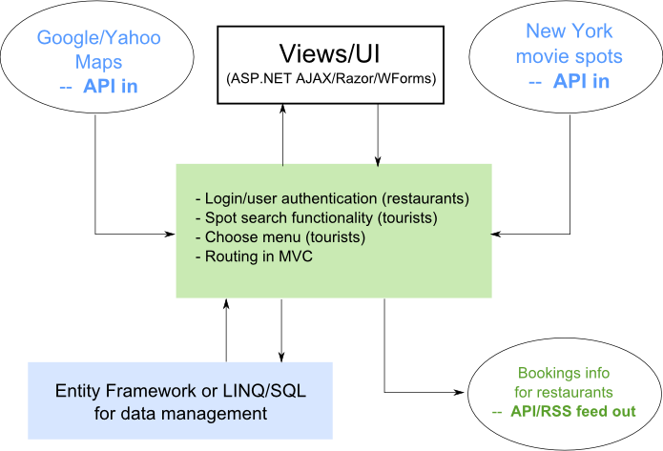

User authentication implementation

The authentication system for AwesomeEnterpriseApp will follow a rather standard pattern:

>>> user (restaurant manager for that matter) connects to the application
>>> if a profile already exists page with restaurant profile is loaded
>>> if a profile does not exist it user will be prompted to create it
>>> after creating the profile it will be loaded and page with the profile rendered
Either Web forms-based authentication will be used (cookies only) or the one that is offered by ASP.NET MVC (sessions and cookies used in the process).

