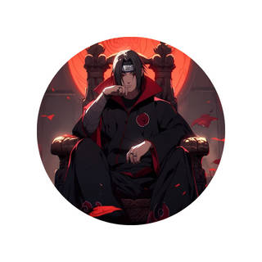

itachi uchiha | 00000000 | uchihaitachi@gmail.com

# About me

I am the god of uchiha. I kiled my whole clan for the sake of my village except my little brother. I love my brother .

# University

**Konoha anbu black ops ,**  *born- died*I became evil to protect konoha.

# Skills

Sharingan

* Susano'o
* Genjutsu