基于多种优化算法的烟雾弹投放策略探究
摘要
本文建立了基于运动学和几何学的数学模型，系统地讨论了无人机投放烟幕干扰弹对导弹实施干扰的策略优化问题。问题的核心在于通过无人机精确投放烟幕干扰弹，在来袭导弹与保护目标之间形成有效遮蔽，最大化对真目标的保护时间，关键挑战包括多维度参数优化（飞行方向、速度、投放时刻、引爆时刻）、物理约束处理（重力作用、烟雾下沉、时间窗口限制）以及多目标协调优化。
针对此问题，本文构建了包含导弹、无人机、烟雾弹的完整数学模型，采用42个标记点模拟对真目标的遮蔽效果，建立了考虑惯性运动、重力作用和烟雾沉降的烟雾弹运动方程，并设计了基于线段-球体相交算法的遮蔽判定机制。在求解方法上，采用分层优化策略，针对不同问题规模选择适配的优化算法：问题一基于已知参数直接进行计算，得到$FY1$对$M1$的有效遮蔽时长为$1.42$秒；问题二采用BasinHopping算法进行全局优化，获得最大遮蔽时间为$4.49$秒；问题三运用差分进化算法处理多约束优化问题，通过投放三枚烟雾弹实现对$M1$总计$6.29$秒的有效遮蔽，显著提升了防护效果；问题四扩展至多无人机协调的组合优化，三架无人机协同对$M1$形成最大$11.15$秒的有效遮蔽时间。
本文建立的模型全面考虑了重力、惯性等物理因素；采用了适应性强的优化算法组合，有效处理了多层次约束条件和大规模参数空间搜索；构建了可扩展的多目标协调框架，支持从单一目标到复杂多威胁场景的全面分析；提供了部分三维图示，清晰地展现了建立的模型。
关键词：BasinHopping算法，差分进化算法，空间几何，多目标优化，约束优化

一、问题概述
1.1 问题背景
烟幕干扰弹通过化学燃烧或爆炸形成烟幕或气溶胶云团，在目标前方空域形成遮蔽，干扰敌方导弹。无人机可挂载烟幕干扰弹，通过精确投放和起爆控制，在来袭导弹和保护目标之间生成烟幕，以延长对目标的有效遮蔽时间。烟幕云团以$3m/s$匀速下沉，起爆后$20$秒内，中心$10m$范围内浓度可提供有效遮蔽。来袭导弹（$M1$、$M2$、$M3$）速度$300m/s$，直指假目标（原点）。无人机受领任务后可瞬时调整航向和速度（$70\sim 140m/s$），但确定后不再改变。每架无人机投放两枚干扰弹需间隔至少$1$秒。可通过调整无人机飞行方向、烟雾弹释放时机、烟雾弹引爆时机等以达到有效遮蔽的最大化。

1.2 基本问题
本问题主要涉及对于无人机、导弹、干扰弹的运动轨迹建模，需计算烟幕云团与导弹路径的时空交集，并优化投放和起爆参数以最大化累积有效遮蔽时间。

二、模型假设
1. 不考虑导弹和无人机受到的风速、空气乱流等干扰因素；
2. 假设烟雾弹离开无人机后做平抛运动，不考虑风速等干扰因素；
3. 将导弹坐标近似视为其主导引头的坐标，不考虑导弹的飞行姿态与主导引头的大小；
4. 导弹的主导引头只受到烟雾弹的遮蔽，不考虑探测距离、弹体遮挡等其它遮蔽因素；
5. 不考虑假目标的大小，将其坐标视为$（0,0,0）$；
6. 不考虑烟雾弹从无人机释放后离开飞机的时间，不考虑烟雾弹引爆后爆炸的时间；
7. 假设所有位置处重力加速度的大小均相同。

三、符号说明
本节将对文中使用的符号进行说明。
符号 | 含义 | 单位 | 备注
$$g$$ | 重力加速度 | $$m⋅s^{-2}$$ | 此处看作标量
$$M_{t}^{j}$$ | 导弹$M_{j}$在$t$时刻的位置 | $$\left(m,m,m\right)$$ | 三维向量
$$D_{t}^{i,\left(x,y\right)}$$ | 朝向$（x,y,0）$的无人机$D_{i}$在$t$时刻的位置 | $$\left(m,m,m\right)$$ | 三维向量
$$S_{t}^{i,k}$$ | 从无人机$D_{i}$上发射的第$k$枚烟雾弹$S_{i,k}$在$t$时刻的位置 | $$\left(m,m,m\right)$$ | 三维向量
$$G_{t}^{i,k}$$ | 烟雾弹$S_{i,k}$爆炸后产生的气团中心$G_{i,k}$在$t$时刻的位置 | $$\left(m,m,m\right)$$ | 三维向量
$$d_{G,M}^{i,k,j}$$ | 烟雾弹$S_{i,k}$爆炸后产生的气团中心$G_{i,k}$对导弹$M_{j}$是否形成有效遮蔽的判定距离 | $$m$$
$$（ξ,η,h）$$ | 真目标上的一个标记点坐标 | $$\left(m,m,m\right)$$ | 三维向量
$$τ_{drop}^{i,k}$$ | 来自无人机$D_{i}$的第$k$枚烟雾弹的投掷时刻 | $$s$$ | 时刻
$$τ_{delay}^{i,k}$$ | 来自无人机$D_{i}$的第$k$枚烟雾弹的引爆时刻 | $$s$$ | 时刻
$$T^{i,k,j}$$ | 来自无人机$D_{i}$的第$k$枚烟雾弹对导弹$M_{j}$的有效遮蔽区间 |  | 时间段
$$\left|T\right|$$ | 区间$T$的宽度 |  | 右端点减左端点
$$\tilde{{}_{\left(ξ,η\right)}^{h}A}$$ | 坐标$A$相对${}_{\left(ξ,η\right)}^{h}T$的坐标
$$v_{O}$$ | 物体$O$的移动速度向量 | $$m⋅s^{-1}$$ | 三位列向量
$$x_{A}$$ | 坐标$A$的$x$方向分量 | $$m$$ | $y$、$z$方向同理
注：
① 上标$i$表示无人机的编号，上标$j$表示导弹的编号，上标$k$表示在相应无人机上烟雾弹和气团中心的编号；
② 下标$M$代表导弹，下标$D$代表无人机，下标$S$代表烟雾弹，下标$G$代表气团中心。

四、问题一的建模与求解
由题目中的假设，现明确有效遮蔽的定义如下：云团中心到导弹飞行路径的投影距离不超过$10m$，且时间上距离起爆不超过$20s$，则认为是有效遮蔽。
对于问题一到问题五中对有效遮蔽的判断，总体思路是通过距离判据$d_{G,M}^{i,k,j}$与$10$的大小关系来判定，将时间距离起爆不超过$20s$作为约束条件用于验证。
由于烟雾弹离开无人机后做平抛运动，只受重力作用，其在地面的投影坐标与对应的无人机在地面的投影坐标相同，即：
$$\left\{\begin{aligned}x_{D_{t}^{i,\left(x,y\right)}}=x_{S_{t}^{i,k}} \\ y_{D_{t}^{i,\left(x,y\right)}}=y_{S_{t}^{i,k}}\end{aligned}\right.$$
本问题中，由于导弹与无人机的飞行目标均为假目标$\left(0,0,0\right)$，故将$D_{t}^{i,\left(x,y\right)}$简记为$D_{t}^{i}$。另外，由于本问题中只涉及一架无人机和一枚导弹，且烟雾弹与无人机一一对应，故省略所有上标$i$、$j$、$k$。

现呈现对问题一的分析计算过程如下：
根据题目中给出的信息给出建模如下图所示：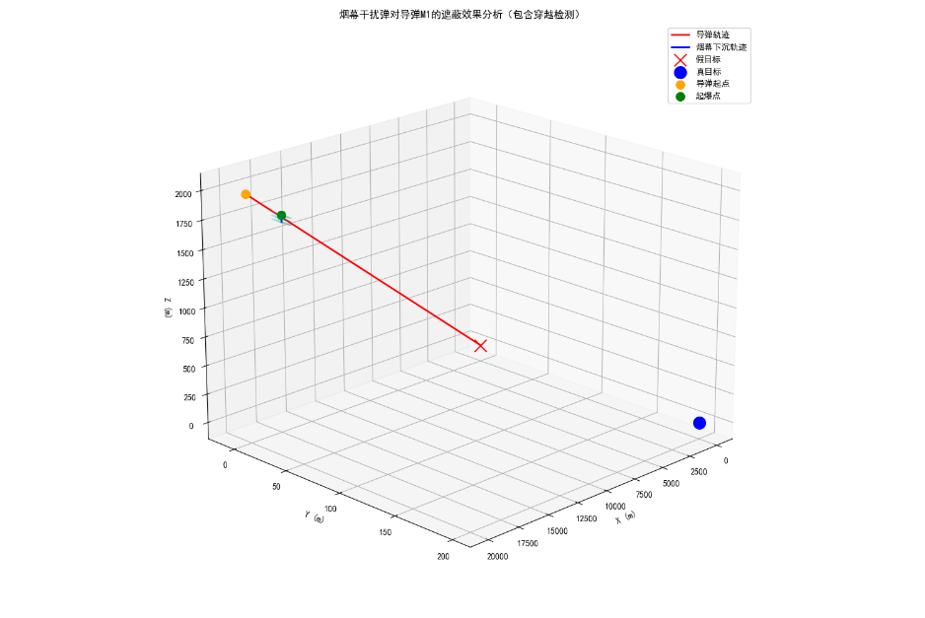 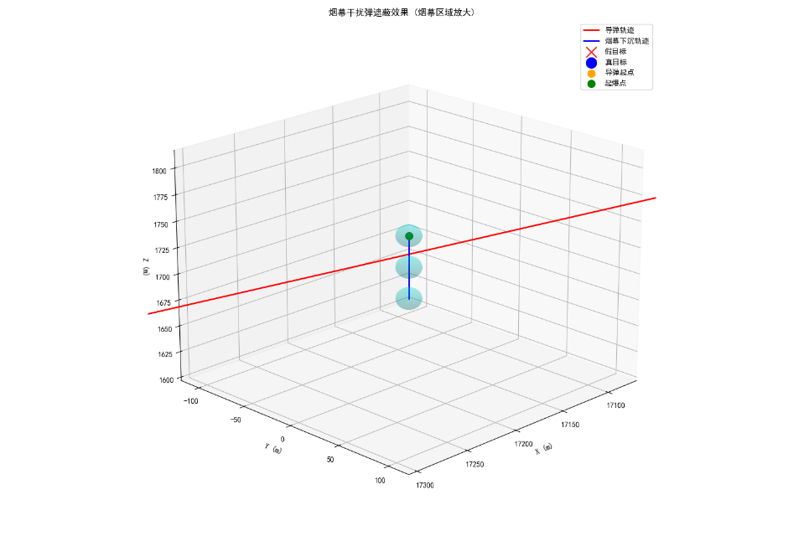
整体建模 烟幕区域放大
根据题设中给出的信息计算有关的初始位置与速度：
$$M_{0}=\left(20000,0,2000\right)$$
$$D_{0}=\left(17800,0,1800\right)$$
$$\left\{\begin{aligned}v_{M}∕∕M_{0} \\ \left\|v_{M}\right\|=300\end{aligned}\right.⟹ v_{M}=\left(-298.511157,0,-29.851116\right)$$
$$\left\|v_{G}\right\|=3⟹ v_{G}=\left(0,0,-3\right)$$
$$\left\|v_{D}\right\|=120⟹ v_{D}=\left(-120,0,0\right)$$
由此可计算在某些特定时刻导弹和无人机的位置：
$$D_{1.5}=D_{0}+1.5v_{D}=\left(17620,0,1800\right)$$
$$D_{5.1}=D_{0}+5.1v_{D}=\left(17188,0,1800\right)$$
$$M_{t}=\left(20000+x_{v_{M}}⋅t,0,2000+z_{v_{M}}⋅t\right)$$
对于从无人机释放后的烟雾弹，只需考虑$z$方向的坐标变化：
$$z_{S_{t+∆t}}=z_{S_{t}}+\frac{1}{2}g{\left(∆t\right)}^{2}$$
$$z_{S_{1.5}}=z_{D_{0}}=1800$$
$$z_{S_{1.5+3.6}}=1736.496$$
$$S_{5.1}=\left(17188,0,1736.496\right)$$
$5.1$秒时，烟雾弹被引爆，气团中心做竖直向下的匀速直线运动：
$$G_{t}=\left(17188,0,1736.496-3\left(t-5.1\right)\right)$$
将坐标原点修正为真目标上的标记点，即减去真目标上标记点的位置向量：
$$\tilde{{}_{\left(ξ,η\right)}^{h}{M_{t}}}=（20000-298.511157t-ξ,-η,2000-29.851116t-h）$$
$$\tilde{{}_{\left(ξ,η\right)}^{h}{G_{t}}}=\left(17188-ξ,-η,1751.796-3t-h\right)$$
定义气团中心$G$对导弹$M$是否形成有效遮蔽的判定距离$d_{G,M}$：气团中心$G$到导弹$M$飞行路径所在直线的投影距离。
接下来计算对应的$d_{G,M}$如下：
$$d_{G,M}=\frac{\left\|\tilde{{}_{\left(ξ,η\right)}^{h}{G_{t}}}×\tilde{{}_{\left(ξ,η\right)}^{h}{M_{t}}}\right\|}{\left\|\tilde{{}_{\left(ξ,η\right)}^{h}{M_{t}}}\right\|}$$
在问题一中，由于导弹轨迹、无人机位置距离真目标较远（远大于真目标的体积），因此可忽略真目标的大小，即规定$ξ=0$，$η=200$，$h=0$。在此近似下，$d_{G,M}$的表达式可简化为：
$$d_{G,M}=\frac{\left\|\tilde{{}_{\left(0,200\right)}^{0}{G_{t}}}×\tilde{{}_{\left(0,200\right)}^{0}{M_{t}}}\right\|}{\left\|\tilde{{}_{\left(0,200\right)}^{0}{M_{t}}}\right\|}$$
其中：
$$\tilde{{}_{\left(0,200\right)}^{0}{G_{t}}}=（17188,-200,1751.796-3t）$$
$$\tilde{{}_{\left(0,200\right)}^{0}{M_{t}}}=（20000-298.511157t,-200,2000-29.851116t）$$
接下来使用计算机程序完成如上的计算步骤，记录下$d_{G,M}$先后两次等于$10$时所对应的$t$值$t_{1}$和$t_{2}$（程序见附录一：计算有效遮蔽时间的程序），$\left|T\right|=\left|t_{1}-t_{2}\right|$即为有效遮蔽的时长。得出结论：
$$t_{1}=8.0425$$
$$t_{2}=9.4485$$
$$\left|t_{1}-t_{2}\right|=1.406$$
经检验，此处$t_{1}$、$t_{2}$均落在爆炸后$20$秒的范围内，即在时间上也满足有效遮蔽的要求。因此，这一结果符合该问题的要求。

综上所述，对于问题一得出结论：
烟雾弹对于导弹$M_{1}$的有效遮蔽时间约为$1.406$秒。

五、问题二的建模与求解
5.1 有效遮蔽判定距离的计算
问题二采用与问题一类似的建模方法，区别在于引入了更多参数。问题一中已知的常量$τ_{drop}^{i,k}$，$τ_{delay}^{i,k}$和$v_{D_{t}^{i,\left(x,y\right)}}$在问题二中成为了变量，需要进行参数优化。由于问题二中仍然只涉及一架无人机和一枚导弹，且烟雾弹与无人机一一对应，故仍省略所有上标$i$、$j$、$k$。
将问题一中的部分常数用对应的变量代替，可以类似地得到一系列基本的计算结果如下：
$$M_{0}=\left(20000,0,2000\right)$$
$$D_{0}=\left(17800,0,1800\right)$$
$$v_{M}=\left(-298.511157,0,-29.851116\right)$$
$$M_{t}=\left(20000+x_{v_{M}}⋅t,0,2000+z_{v_{M}}⋅t\right)$$
$$v_{G}=\left(0,0,-3\right)$$
以上数据同问题一。考虑到无人机只能水平飞行，即$z_{v_{D}}=0$，有：
$$v_{D}=\left(x_{v_{D}},y_{v_{D}},0\right)$$
$$D_{τ_{drop}}=D_{0}+τ_{drop}v_{D}=\left(17800+τ_{drop}x_{v_{D}},τ_{drop}y_{v_{D}},1800\right)$$
$$D_{τ_{delay}}=D_{0}+τ_{delay}v_{D}=\left(17800+τ_{delay}x_{v_{D}},τ_{delay}y_{v_{D}},1800\right)$$
考虑烟雾弹与爆炸后气团中心的高度：
$$z_{S_{t+∆t}}=z_{S_{t}}+\frac{1}{2}g{\left(∆t\right)}^{2}$$
$$z_{S_{τ_{drop}}}=z_{D_{0}}=1800$$
$$z_{S_{τ_{delay}}}=z_{S_{τ_{drop}}}+\frac{1}{2}g{\left(τ_{delay}-τ_{drop}\right)}^{2}$$
$$S_{τ_{delay}}=\left(17800+τ_{delay}x_{v_{D}},τ_{delay}y_{v_{D}},1800+\frac{g}{2}{\left(τ_{delay}-τ_{drop}\right)}^{2}\right)$$
$$G_{t}=\left(17800+τ_{delay}x_{v_{D}},τ_{delay}y_{v_{D}},1800+\frac{g}{2}{\left(τ_{delay}-τ_{drop}\right)}^{2}-3\left(t-τ_{delay}\right)\right)$$
将坐标原点修正为真目标上的标记点：
$$\tilde{{}_{\left(ξ,η\right)}^{h}{M_{t}}}=（20000-298.511157t-ξ,-η,2000-29.851116t-h）$$
$$\tilde{{}_{\left(ξ,η\right)}^{h}{G_{t}}}=\left(17800+τ_{delay}x_{v_{D}}-ξ,τ_{delay}y_{v_{D}}-η,1800+\frac{g}{2}{\left(τ_{delay}-τ_{drop}\right)}^{2}+3τ_{delay}-3t-h\right)$$
同样地，可由以下公式计算$d_{G,M}$：
$$d_{G,M}=\frac{\left\|\tilde{{}_{\left(ξ,η\right)}^{h}{G_{t}}}×\tilde{{}_{\left(ξ,η\right)}^{h}{M_{t}}}\right\|}{\left\|\tilde{{}_{\left(ξ,η\right)}^{h}{M_{t}}}\right\|}$$
由该方式计算得到的$d_{G,M}$是关于$t$的一元函数。在标记点$（ξ,η,h）$选定的情况下，具有参数$τ_{drop}$、$τ_{delay}$和$v_{D}$。
建立方程：
$$d_{G,M}\left(t\right)=10$$
该方程的两根$t_{1}$（有效遮蔽开始的时刻）和$t_{2}$（有效遮蔽结束的时刻）即为有效遮蔽区间$T$的两个端点。$\left|T\right|=\left|t_{1}-t_{2}\right|$是关于上述参数的函数。
约束条件：
$$\left\{\begin{aligned}t_{1}-τ_{delay}<20 \\ t_{2}-τ_{delay}<20\end{aligned}\right.$$
接下来问题转化为对于目标函数$\left|T\right|$进行约束优化。在优化的过程中，将目标函数看作分别选定一系列标记点$（ξ,η,h）$后得到的有效遮蔽区间的交集宽度，即可模拟对于整个真目标的最大有效覆盖时间。

5.2 约束优化
本小节将对目标函数$\left|T\right|$进行约束优化，并具体讨论对于某个给定的标记点$（ξ,η,h）$，对函数$\left|T\right|$进行约束优化的过程。
由于参数$v_{D}$本质上是一个三维向量，由$x_{v_{D}}$和$y_{v_{D}}$两个标量参数决定，故引入新的参数$V$和$θ$，其中$V$表示无人机飞行的速度大小，$θ$表示无人机飞行方向与$x$轴正半轴的夹角，$V∈\left[70,140\right]$，$θ∈\left[0,2π\right]$。从而有：
$$v_{D}=\left(x_{v_{D}},y_{v_{D}},0\right)=（V\cos{θ},V\sin{θ},0）$$
需要优化的参数转化为四个标量$τ_{drop}$、$τ_{delay}$、$V$、$θ$。用如下列向量表示优化参数：
$$X=\left[\begin{matrix}θ \\ V \\ τ_{drop} \\ τ_{delay}\end{matrix}\right]$$
问题转化为目标函数$\left|T\right|\left(X\right)$中对于向量值参数$X$的约束优化。注意此处目标函数是取一系列的标记点后得出的最终结果。
约束条件：
$$\left\{\begin{aligned}t_{1}-τ_{delay}<20 \\ t_{2}-τ_{delay}<20 \\ V∈\left[70,140\right] \\ θ∈\left[0,2π\right] \\ τ_{drop}>0 \\ τ_{delay}>τ_{drop}>0\end{aligned}\right.$$
对于部分约束条件进行简化。对于$τ_{drop}$，由于导弹从初始位置飞行至假目标约耗时$66s$，故给定范围$τ_{drop}∈\left[0,70\right]$作为优化的约束条件。对于$τ_{delay}$，由于从$1800m$高处做平抛运动的烟雾弹在$20s$内即会落地，故给定范围$τ_{delay}∈\left[0,20\right]$作为优化的约束条件。对于$θ$，由于无人机总体上要往导弹飞行的方向靠近，故给定较小的夹角范围$θ∈\left[\frac{7π}{8},\frac{9π}{8}\right]$作为优化的约束条件。于是，最终的约束条件为：
$$\left\{\begin{aligned}θ∈\left[\frac{7π}{8},\frac{9π}{8}\right] \\ V∈\left[70,140\right] \\ τ_{drop}∈\left[0,70\right] \\ τ_{delay}∈\left[0,20\right]\end{aligned}\right.$$
记$Ω=\left[\frac{7π}{8},\frac{9π}{8}\right]×\left[70,140\right]×\left[0,70\right]×\left[0,20\right]$，有$∀X∈Ω$。
由于这是一个非线性、非凸、可能多峰的约束优化问题，故采用BasinHopping算法进行优化。（具体程序见附录二：利用BasinHopping算法优化有效遮蔽时间函数的程序）
对于目标函数$\left|T\right|\left(X\right)$，BasinHopping算法的迭代过程为：
① 外层优化：
$$X_{s+1}=X_{s}+δ_{s}$$
$$X_{s}^{*}=\underset{X}{argmin}\left|T\right|\left(X\right), starting from X_{s+1}$$
$$X_{s+1}=\left\{\begin{aligned}X_{s}, P_{accept}>U\left(0,1\right) \\ X_{s}^{*}, otherwise\end{aligned}\right.$$
其中，$δ_{s}\sim N（0,σ^{2}I）$为随机跳跃向量，$I$为某随机单位向量；$P_{accept}$为接受概率；$U\left(0,1\right)$为均匀分布的随机数。
② 内层优化：
采用L-BFGS-B算法处理内层优化问题（即$X_{s}^{*}=\underset{X}{argmin}\left|T\right|\left(X\right)$）：
L-BFGS-B算法的迭代公式为：
$$X_{s+1}=X_{s}-α_{s}H_{s}^{-1}∇\left|T\right|(X_{s})$$
其中$H_{s}$是基于有限内存的BFGS近似Hessian矩阵：
$$H_{s}=H_{0}+\sum_{p=1}^{m}{\frac{{ s}_{p}{ s}_{p}^{T}}{{ s}_{p}^{T}y_{p}}}-\sum_{p=1}^{m}{\frac{H_{0}y_{p}y_{p}^{T}H_{0}}{y_{p}^{T}H_{0}y_{p}}}$$
整体算法的执行流程如下图所示：
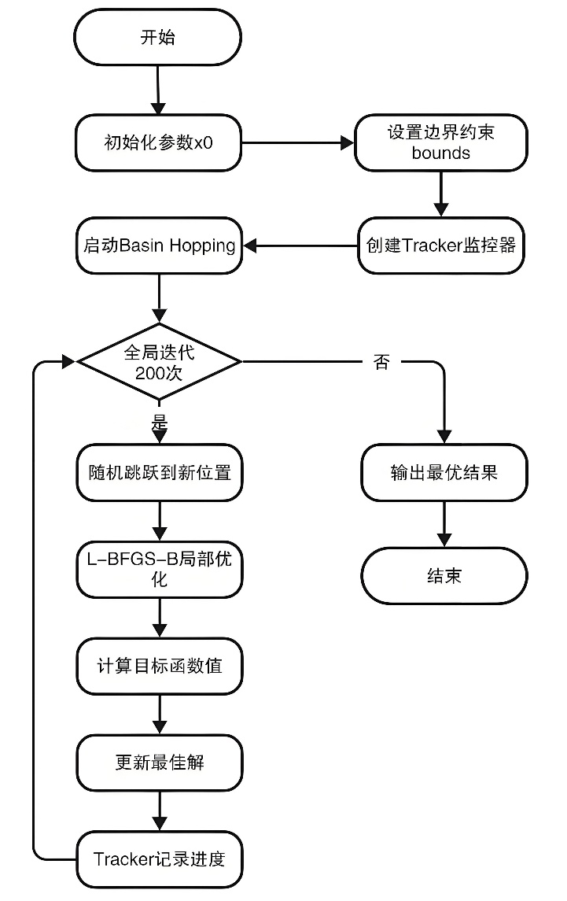
经过计算机程序200次迭代，最终得出最优结果如下（最优的参数用上标$*$表示）：
$$X^{*}=\left[\begin{matrix}θ^{*} \\ V^{*} \\ {τ_{drop}}^{*} \\ {τ_{delay}}^{*}\end{matrix}\right]=\left[\begin{matrix}3.1264 \\ 119.5245 \\ 0.6958 \\ 4.2995\end{matrix}\right]$$
$${τ_{delay}}^{*}-{τ_{drop}}^{*}=3.6037$$
$$\max_{Ω}\left|T\right|（X）=4.49$$
最优情况下的示意图如下：
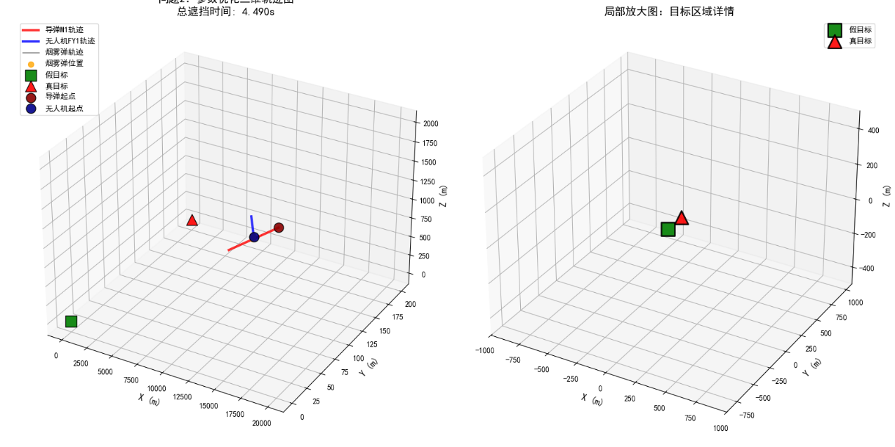

综上所述，对于问题二得出结论：
当：无人机飞行方向与$x$轴正半轴夹角$3.1264 rad$，
飞行速度为$119.5245 m/s$，
第$0.6958$秒时投掷烟雾弹，$3.6037$秒后引爆烟雾弹
时，对于导弹$M_{1}$的有效遮蔽时间最长，达到$4.49 s$。

六、问题三的建模与求解
6.1 有效遮蔽判定距离的计算
问题三采用与问题二类似的建模方法，区别在于需要同时考虑三枚烟幕弹，包括不同的投掷时刻和引爆时刻。在此问题中，由于只涉及一架无人机和一枚导弹，故上标$i$、$j$均可省略，仅保留单一上标$k$表示烟雾弹的编号。
由题意，有约束条件：
$$\left\{\begin{aligned}τ_{drop}^{2}-τ_{drop}^{1}≥1 \\ τ_{drop}^{3}-τ_{drop}^{2}≥1\end{aligned}\right.$$
大量与问题一、二中重复的数据不再列出。
采用与前文类似的方法可得一系列计算结果如下：$k=1,2,3$
$$D_{τ_{drop}^{k}}=D_{0}+τ_{drop}^{k}v_{D}=\left(17800+τ_{drop}^{k}x_{v_{D}},τ_{drop}^{k}y_{v_{D}},1800\right)$$
$$D_{τ_{delay}^{k}}=D_{0}+τ_{delay}^{k}v_{D}=\left(17800+τ_{delay}^{k}x_{v_{D}},τ_{delay}^{k}y_{v_{D}},1800\right)$$
$$G_{t}^{k}=\left(17800+τ_{drop}^{k}x_{v_{D}},τ_{delay}^{k}y_{v_{D}},1800+\frac{g}{2}{\left(τ_{delay}^{k}-τ_{drop}^{k}\right)}^{2}-3\left(t-τ_{delay}^{k}\right)\right)$$
$$\tilde{{}_{\left(ξ,η\right)}^{h}{G_{t}^{k}}}=\left(17800+τ_{drop}^{k}x_{v_{D}}-ξ,τ_{delay}^{k}y_{v_{D}}-η,1800+\frac{g}{2}{\left(τ_{delay}^{k}-τ_{drop}^{k}\right)}^{2}+3τ_{delay}^{k}-3t-h\right)$$
$$d_{G,M}^{k}=\frac{\left\|\tilde{{}_{\left(ξ,η\right)}^{h}{G_{t}^{k}}}×\tilde{{}_{\left(ξ,η\right)}^{h}{M_{t}}}\right\|}{\left\|\tilde{{}_{\left(ξ,η\right)}^{h}{M_{t}}}\right\|}$$
对于每枚烟雾弹分别进行判定，得出其有效遮蔽区间$T^{k}$，从而总的有效遮蔽区间$T^{total}$可表达为：
$$T^{total}=T^{1}∪T^{2}∪T^{3}$$
由容斥原理，有：
$$\left|T^{total}\right|=\left|T^{1}\right|+\left|T^{2}\right|+\left|T^{3}\right|-\left|T^{1}∩T^{2}\right|-\left|T^{2}∩T^{3}\right|-\left|T^{3}∩T^{1}\right|+\left|T^{1}∩T^{2}∩T^{3}\right|$$
接下来问题转化为对函数$\left|T^{total}\right|$进行约束优化。在优化的过程中，将每一个$\left|T^{k}\right|$看作分别选定一系列标记点$（ξ,η,h）$后得到的有效遮蔽区间的交集宽度，进而获得目标函数，即可模拟对于整个真目标的最大有效覆盖时间。

6.2 约束优化
优化变量：$v_{D}$（$V$、$θ$）、$τ_{drop}^{1}$、$τ_{drop}^{2}$、$τ_{drop}^{3}$、$τ_{delay}^{1}$、$τ_{delay}^{2}$、$τ_{delay}^{3}$
用列向量$X$表示优化变量，有：
$$X=\left[\begin{matrix}θ \\ V \\ τ_{drop}^{1} \\ τ_{drop}^{2} \\ τ_{drop}^{3} \\ τ_{delay}^{1} \\ τ_{delay}^{2} \\ τ_{delay}^{3}\end{matrix}\right]$$
目标函数：$\left|T^{total}\right|（X）, X∈Ω$
与问题二类似，约束条件：
$$\left\{\begin{aligned}θ∈\left[\frac{7π}{8},\frac{9π}{8}\right] \\ V∈\left[70,140\right] \\ τ_{drop}^{k}∈\left[0,20\right] ,k=1,2,3 \\ τ_{delay}^{1}∈\left[0,10\right] , k=1,2,3\end{aligned}\right.$$
对于这个约束优化问题，采用差分进化算法。具体实现细节详见附录三：基于差分进化算法优化遮蔽时间函数的程序。优化结果如下（最优的参数用上标$*$表示）：
$$X^{*}=\left[\begin{matrix}θ^{*} \\ V^{*} \\ {τ_{drop}^{1}}^{*} \\ {τ_{drop}^{2}}^{*} \\ {τ_{drop}^{3}}^{*} \\ {τ_{delay}^{1}}^{*} \\ {τ_{delay}^{2}}^{*} \\ {τ_{delay}^{3}}^{*}\end{matrix}\right]=\left[\begin{matrix}3.13393916480562 \\ 138.273404091497 \\ 0.70344561563089 \\ 3.5078237246063 \\ 13.2397185007457 \\ {τ_{drop}^{1}}^{*}+4.1842156894336 \\ {τ_{drop}^{2}}^{*}+5.1832776222144 \\ {τ_{drop}^{3}}^{*}+4.7528076945069\end{matrix}\right]$$
在此参数下，有效遮蔽时间达到最大值$6.29 s$。
结论详见result1.xlsx。

七、问题四的建模与求解
问题四采用与问题二类似的建模方法，区别在于需要同时考虑三架无人机，包括不同的速度向量、烟雾弹投掷时刻和引爆时刻。在此问题中，由于只涉及一枚导弹且烟雾弹与无人机一一对应，故上标$j$、$k$均可省略，仅保留单一上标$i$表示无人机的编号。
有关目标函数的计算过程如下：$i=1,2,3$
$$v_{D}^{i}=\left(x_{v_{D}^{i}},y_{v_{D}^{i}},0\right)=（V^{i}\cos{θ^{i}},V^{i}\sin{θ^{i}},0）$$
$$D_{τ_{drop}^{i}}=D_{0}+τ_{drop}^{i}v_{D}^{i}=\left(17800+τ_{drop}^{i}x_{v_{D}^{i}},τ_{drop}^{i}y_{v_{D}^{i}},1800\right)$$
$$D_{τ_{delay}^{i}}=D_{0}+τ_{delay}^{i}v_{D}^{i}=\left(17800+τ_{delay}^{i}x_{v_{D}^{i}},τ_{delay}^{i}y_{v_{D}^{i}},1800\right)$$
$$G_{t}^{i}=\left(17800+τ_{drop}^{i}x_{v_{D}^{i}},τ_{delay}^{i}y_{v_{D}^{i}},1800+\frac{g}{2}{\left(τ_{delay}^{i}-τ_{drop}^{i}\right)}^{2}-3\left(t-τ_{delay}^{i}\right)\right)$$
$$\tilde{{}_{\left(ξ,η\right)}^{h}{G_{t}^{i}}}=\left(17800+τ_{drop}^{i}x_{v_{D}^{i}}-ξ,τ_{delay}^{i}y_{v_{D}^{i}}-η,1800+\frac{g}{2}{\left(τ_{delay}^{i}-τ_{drop}^{i}\right)}^{2}+3τ_{delay}^{i}-3t-h\right)$$
$$d_{G,M}^{i}=\frac{\left\|\tilde{{}_{\left(ξ,η\right)}^{h}{G_{t}^{i}}}×\tilde{{}_{\left(ξ,η\right)}^{h}{M_{t}}}\right\|}{\left\|\tilde{{}_{\left(ξ,η\right)}^{h}{M_{t}}}\right\|}$$
对于每架无人机分别进行判定，得出其有效遮蔽区间$T^{i}$，从而总的有效遮蔽区间$T^{total}$可表达为：
$$T^{total}=T^{1}∪T^{2}∪T^{3}$$
利用与问题三类似的差分进化算法，优化$T^{total}$的取值。具体参数见附录四（注：此程序借助AI工具完成）。优化得到的$X^{*}$如下：
$$X^{*}=\left[\begin{matrix}{θ^{1}}^{*} \\ {V^{1}}^{*} \\ {θ^{2}}^{*} \\ {V^{2}}^{*} \\ {θ^{3}}^{*} \\ {V^{3}}^{*} \\ {τ_{drop}^{1}}^{*} \\ {τ_{drop}^{2}}^{*} \\ {τ_{drop}^{3}}^{*} \\ {τ_{delay}^{1}}^{*} \\ {τ_{delay}^{2}}^{*} \\ {τ_{delay}^{3}}^{*}\end{matrix}\right]=\left[\begin{matrix}0.0974 \\ 89.35 \\ 4.2155 \\ 84.58 \\ 1.6904 \\ 117.81 \\ 0.76 \\ 10.93 \\ 21.38 \\ {τ_{drop}^{1}}^{*}+0.33 \\ {τ_{drop}^{2}}^{*}+7.37 \\ {τ_{drop}^{3}}^{*}+5.12\end{matrix}\right]$$
在此参数下，得到的最大有效遮蔽时间为$11.15s$。
结论详见result2.xlsx。

八、问题五的建模
问题五延续之前问题二和问题四的建模方式。
对于三枚导弹、五架无人机示意图如下：
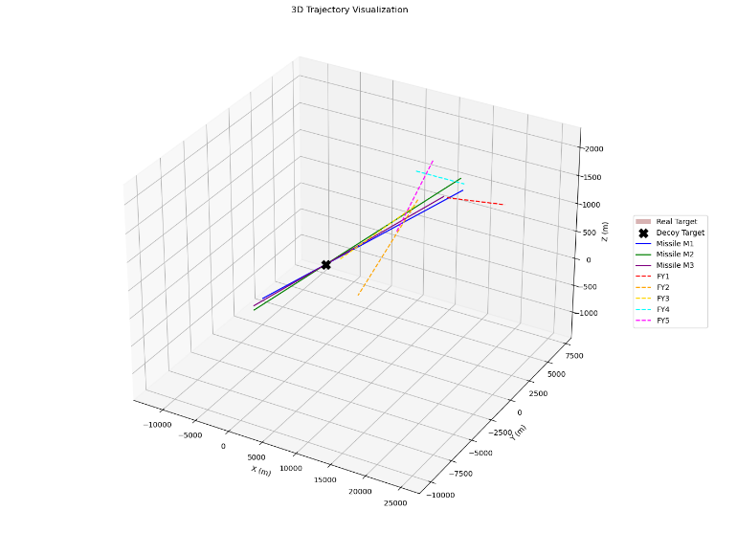
类似地，可以获得如下计算结果：
分别计算三枚导弹的位置及速度：
$$M_{0}^{1}=\left(20000,0,2000\right)$$
$$v_{M^{1}}=\left(-298.511157,0,-29.851116\right)$$
$$M_{t}^{1}=\left(20000+x_{v_{M^{1}}}t,0,2000+z_{v_{M^{1}}}t\right)$$
$$M_{0}^{2}=\left(19000,600,2100\right)$$
$$v_{M^{2}}=\left(-298.037433,-9.4117084,-32.9409795\right)$$
$$M_{t}^{2}=\left(19000+x_{v_{M^{2}}}t,600+y_{v_{M^{2}}}t,2100+z_{v_{M^{2}}}t\right)$$
$$M_{0}^{3}=\left(18000,-600,1900\right)$$
$$v_{M^{3}}=\left(-298.178757,9.9392919,-31.4733243\right)$$
$$M_{t}^{3}=\left(18000+x_{v_{M^{3}}}t,-600+y_{v_{M^{3}}}t,2000+z_{v_{M^{3}}}t\right)$$
从而：
$$\tilde{{}_{\left(ξ,η\right)}^{h}{M_{t}^{1}}}=（20000-298.511157t-ξ,-η,2000-29.851116t-h）$$
$$\tilde{{}_{\left(ξ,η\right)}^{h}{M_{t}^{2}}}=（19000-298.037433t-ξ,600-9.4117084t-η,2100-32.9409795t-h）$$
$$\tilde{{}_{\left(ξ,η\right)}^{h}{M_{t}^{3}}}=（18000-298.178757t-ξ,-600+9.9392919t-η,1900-29.851116t-h）$$
计算无人机及气团中心在$t$时刻的位置：$i=1,2,3,4,5$
$$D_{0}^{1}=\left(17800,0,1800\right)$$
$$D_{0}^{2}=\left(12000,1400,1400\right)$$
$$D_{0}^{3}=\left(6000,-3000,700\right)$$
$$D_{0}^{4}=\left(11000,2000,1800\right)$$
$$D_{0}^{5}=\left(13000,-2000,1300\right)$$
$$D_{t}^{i}=\left(x_{D_{t}^{i}},y_{D_{t}^{i}},z_{D_{t}^{i}}\right)$$
$$v_{D}^{i}=\left(x_{v_{D}^{i}},y_{v_{D}^{i}},0\right)=（V^{i}\cos{θ^{i}},V^{i}\sin{θ^{i}},0）$$
$$D_{τ_{drop}^{i,k}}^{i}=D_{0}^{i}+τ_{drop}^{i,k}v_{D}^{i}=\left(x_{D_{t}^{i}},+τ_{drop}^{i,k}x_{v_{D}^{i}},y_{D_{t}^{i}}+τ_{drop}^{i,k}y_{v_{D}^{i}},z_{D_{t}^{i}}\right)$$
$$D_{τ_{delay}^{i,k}}^{i}=D_{0}^{i}+τ_{delay}^{i,k}v_{D}^{i}=\left(x_{D_{t}^{i}},+τ_{delay}^{i,k}x_{v_{D}^{i}},y_{D_{t}^{i}}+τ_{drop}^{i,k}y_{v_{D}^{i}},z_{D_{t}^{i}}\right)$$
$$G_{t}^{i,k}=\left(x_{D_{t}^{i}}+τ_{drop}^{i,k}x_{v_{D}^{i}},y_{D_{t}^{i}}+τ_{delay}^{i,k}y_{v_{D}^{i}},z_{D_{t}^{i}}+\frac{g}{2}{\left(τ_{delay}^{i,k}-τ_{drop}^{i,k}\right)}^{2}-3\left(t-τ_{delay}^{i,k}\right)\right)$$
$$\tilde{{}_{\left(ξ,η\right)}^{h}{G_{t}^{i,k}}}=\left(x_{D_{t}^{i}}+τ_{drop}^{i,k}x_{v_{D}^{i}}-ξ,y_{D_{t}^{i}}+τ_{delay}^{i,k}y_{v_{D}^{i}}-η,z_{D_{t}^{i}}+\frac{g}{2}{\left(τ_{delay}^{i,k}-τ_{drop}^{i,k}\right)}^{2}+3τ_{delay}^{i,k}-3t-h\right)$$
计算$d_{G,M}^{i,k,j}$：
$$d_{G,M}^{i,k,j}=\frac{\left\|\tilde{{}_{\left(ξ,η\right)}^{h}{G_{t}^{i,k}}}×\tilde{{}_{\left(ξ,η\right)}^{h}{M_{t}^{j}}}\right\|}{\left\|\tilde{{}_{\left(ξ,η\right)}^{h}{M_{t}^{j}}}\right\|}$$
对于每架无人机、每枚烟雾弹和每枚导弹分别进行判定，得出其有效遮蔽区间$T^{i,k,j}$，综合这些区间得到目标函数$\left|T^{total}\right|（X）$，其中$X$为参数。
对该问题的参数$X$的优化由于时间与能力有限，暂时未能完成。该问题有待后续研究。

附录一：计算有效遮蔽时间的程序
from typing import List
import math

import numpy as np

FAKE_TARGET = np.array([0.0, 0.0, 0.0])
REAL_TARGET = np.array([0.0, 200.0, 0.0])

MISSILE_ORIGINAL = np.array((
(0.0, 0.0, 0.0),
(20000.0, 0.0, 2000.0),
(19000.0, 600.0, 2100.0),
(18000.0, -600.0, 1900.0)
))

DRONE_ORIGINAL = np.array((
(0.0, 0.0, 0.0),
(17800.0, 0.0, 1800.0),
(12000.0, 1400.0, 1400.0),
(6000.0, -3000.0, 700.0),
(11000.0, 2000.0, 1800.0),
(13000.0, -2000.0, 1300.0)
))

MISSILE_SPEED = 300.0
DRONE_MIN_SPEED = 70.0
DRONE_MAX_SPEED = 140.0
SMOKE_SINK_SPEED = 3.0
LEAST_MASKING_DIS = 10.0
MASKING_TIME = 20.0

GRAV = 9.81

class Aircraft(object):
'''飞行物类，包括导弹和无人机。
'''
def __init__(self, pos, target_pos, speed, debug = False):
self.pos_original = pos
self.target_pos = target_pos
self.speed = speed

vec_move = self.target_pos - self.pos_original
self.dis = np.linalg.norm(vec_move)
self.time = self.dis / self.speed
if self.dis != 0:
self.orient = vec_move / self.dis
else:
self.orient = np.array([0, 0, 0])

def get_pos(self, time_spent):
'''获取某时刻飞行物的所在位置。

Args
-------------
time_spent : float
需要获取位置的当前时刻
'''
if self.time == 0:
return self.pos_original
ratio = time_spent / self.time
pos_new = (self.pos_original * (1.0 - ratio)) + (self.target_pos * ratio)
return pos_new

class Missile(Aircraft):
'''
导弹类。
'''
def __init__(self, pos, target_pos = FAKE_TARGET, speed = MISSILE_SPEED,
debug = False):
if debug:
print(f"target_pos = {target_pos}")
super().__init__(pos, target_pos, speed, debug)

class Drone(Aircraft):
'''
无人机类。

无人机的起始位置与目标位置的高度应当相同，速度应当介于 70 和 140 之间。
'''
def __init__(self, pos, target_pos, speed, debug = False):
if pos[2] != target_pos[2]:
if debug:
print(f"Unexpected value on Z axis: pos {pos[2]} not equal to {target_pos[2]}")
else:
raise ValueError(f"Unexpected value on Z axis: pos {pos[2]} not equal to {target_pos[2]}")
if speed < DRONE_MIN_SPEED or speed > DRONE_MAX_SPEED:
if debug:
print(f"Unexpected speed: expected 70-140, get {speed}")
else:
raise ValueError(f"Unexpected speed: expected 70-140, get {speed}")

super().__init__(pos, target_pos, speed, debug)

class Smoke(object):
'''烟雾弹类。
'''
def __init__(self, drone: Drone, time_drop, time_delay, debug = False):
'''
Args
--------------
drone : Drone
投放烟雾弹的无人机
time_drop : float
投放烟雾弹的**全局时间**
time_delay : float
投放烟雾弹后的起爆延迟时间
'''
if time_delay < 0:
raise ValueError(f"Unexpected timeWaiting: expected >=0, get {time_delay}")

self.pos_original = drone.get_pos(time_drop)
self.time_drop = time_drop
self.time_delay = time_delay
self.orient = drone.orient # 有惯性时的横向运动方向向量
# 无惯性时取[0, 0, 0]
self.speed = drone.speed

def get_valid_time(self):
'''
返回烟雾弹的有效遮蔽时间。
'''
return (
self.time_drop + self.time_delay,
self.time_drop + self.time_delay + MASKING_TIME
)

def get_pos_global(self, time_spent, inertia = True, debug = False):
'''
通过 **总时间** 确定烟雾弹的位置。

Args
-----------
time_spent : float
全局时间
inertia : bool
是否有惯性，默认True

Returns
-------------
pos : Tuple[float, float, float]
表示烟雾弹的位置
valid : bool
True表示此时烟雾弹有效，False表示烟雾弹无效
'''
if time_spent < self.time_drop:
return self.pos_original - self.orient * self.speed * (self.time_drop - time_spent),False
else:
return self.get_pos_by_delay(time_spent - self.time_drop, inertia, debug)

def get_pos_by_delay(self, time_delay, inertia = True, debug = False):
'''
通过 **投放后时间** 确定烟雾弹的位置。

Args
-----------
time_spent : float
投放后时间
inertia : bool
是否有惯性，默认True

Returns
-------------
pos : Tuple[float, float, float]
表示烟雾弹的位置
valid : bool
True表示此时烟雾弹有效，False表示烟雾弹无效
'''
if time_delay < 0:
raise Warning(f"Unexpected delay: expected >=0, get {time_delay}")

if inertia:
if time_delay < self.time_delay:
pos = self.pos_original + self.orient * time_delay * self.speed
pos[2] -= GRAV * (time_delay ** 2) / 2
return pos, False
else:
pos = self.pos_original + self.orient * self.time_delay * self.speed
pos[2] -= GRAV * (self.time_delay ** 2) / 2
pos[2] -= SMOKE_SINK_SPEED * (time_delay - self.time_delay)
if time_delay < self.time_delay + MASKING_TIME:
return pos, True
else:
return pos, False
else:
if time_delay < self.time_delay:
pos = self.pos_original
pos[2] -= GRAV * (time_delay ** 2) / 2
return pos, False
else:
pos = self.pos_original
pos[2] -= GRAV * (self.time_delay ** 2) / 2
pos[2] -= 3 * (time_delay - self.time_delay)
if time_delay < self.time_delay + MASKING_TIME:
return pos, True
else:
return pos, False

def get_critical_points(pos, debug = False):
'''
获取某一位置上看到的真目标的一组"关键点"，共42个。
真目标是一个半径为7m、高10m的圆柱形固定目标，下底面的圆心为(0,200,0)。
'''
center_bottom = np.array([0, 200, 0])
center_top = np.array([0, 200, 10])
critical_points = []

diff = center_bottom - pos
angle_start = math.acos((diff[0]) / (math.sqrt((diff[0] ** 2) + (diff[1] ** 2))))
angles = np.linspace(angle_start, angle_start + 2 * np.pi, num = 8, endpoint = False)

angles = np.linspace(0, 2*np.pi, num = 9, endpoint = True)
heights = [0, 2.5, 5, 7.5, 10]
for angle in angles:
x = 7 * np.cos(angle)
y = 200 + 7 * np.sin(angle)
for z in heights:
critical_points.append(np.array([x, y, z]))

critical_points.append(center_bottom)
critical_points.append(center_top)

if debug:
print(f"POS = {pos}")
print(critical_points)
return critical_points

def judge_cover(missile: Missile, smokes: List[Smoke], time_spent: float,
accurate = True, debug = False):
'''
计算某一时刻导弹是否被有效遮盖。
'''
missile_pos = missile.get_pos(time_spent)
if debug:
print(f"TIME = {time_spent}")
print(f"missile_pos = {missile_pos}")

for smoke in smokes:
smoke_pos, valid = smoke.get_pos_global(time_spent)
if debug:
print(f"smoke_pos = {smoke_pos}, valid = {valid}")

if valid and np.linalg.norm(missile_pos - smoke_pos) <= LEAST_MASKING_DIS:
if debug:
print("SUCCESS!")
return True

if accurate:
critical_points = get_critical_points(missile_pos)
else:
critical_points = [np.array([0, 200, 0])]
all_covered = True

for point in critical_points:
point_covered = False

for smoke in smokes:
smoke_pos, valid = smoke.get_pos_global(time_spent)
if not valid:
continue

line_vec = point - missile_pos
smoke_vec = smoke_pos - missile_pos

t = np.dot(smoke_vec, line_vec) / np.dot(line_vec, line_vec)
if debug:
print(f"line_vec = {line_vec}, smoke_vec = {smoke_vec}")
print(f"t = {t}")
if t < 0 or t > 1:
continue

perpendicular_point = missile_pos + t * line_vec # 垂足位置
dis = np.linalg.norm(smoke_pos - perpendicular_point)
if debug:
print(f"perpendicular_point = {perpendicular_point}, dis = {dis}")
if dis <= 10:
point_covered = True
if debug:
print("SUCCESS!")
break

if not point_covered:
all_covered = False
break

return all_covered

def calc_cover_time(missile: Missile, smokes: List[Smoke], start_time_point,
end_time_point, interval = 0.01, accurate = True,
debug = False):
'''
计算若干枚烟雾弹对一枚导弹的有效遮蔽时长。

Args
----------
start_time_point : float
开始的全局时间
end_time_point : float
结束的全局时间
interval : float
计算的最小时间间隔
accurate : bool
计算真目标时使用关键点组而非单点，默认为True

Returns
----------
cover_intervals : List[Tuple[float, float]]
表示有效遮盖的所有时间段
'''
time_points = np.arange(start_time_point, end_time_point, interval)
cover_status = [judge_cover(missile, smokes, t, accurate, debug) for t in time_points]

cover_intervals = []
start_time = None

for i, covered in enumerate(cover_status):
if covered and (start_time is None):
start_time = time_points[i] - interval / 2
elif (not covered) and (start_time is not None):
end_time = time_points[i] - interval / 2
cover_intervals.append((start_time, end_time))
start_time = None

# 别忘了最后一个区间
if start_time is not None:
end_time = missile.time
cover_intervals.append((start_time, end_time))

return cover_intervals

def main():
missile1 = Missile(
MISSILE_ORIGINAL[1],
)

drone1_target = np.array([0, 0, 1800])
drone1 = Drone(
DRONE_ORIGINAL[1],
drone1_target,
speed=120
)
smoke1 = Smoke(
drone1,
1.5,
3.6
)

# 计算覆盖时间
cover_intervals = calc_cover_time(
missile1,
[smoke1],
start_time_point=8,
end_time_point=10,
interval=0.001,
accurate=True
)
total_cover_time = sum(end - start for start, end in cover_intervals)

print(f"烟雾弹对M1的有效遮蔽时长为: {total_cover_time} 秒")
print(f"覆盖时间段: {cover_intervals}")

if __name__ == '__main__':
main()

附录二：利用Basinhopping算法优化有效遮蔽时间函数的程序
from typing import Tuple, List
import math
import sys

import numpy as np
from scipy.optimize import basinhopping, dual_annealing, direct, shgo

from problem1 import Missile, Drone, Smoke, calc_cover_time

FAKE_TARGET = np.array([0, 0, 0])
REAL_TARGET = np.array([0, 200, 0])

MISSILE_ORIGINAL = np.array((
(0.0, 0.0, 0.0),
(20000.0, 0.0, 2000.0),
(19000.0, 600.0, 2100.0),
(18000.0, -600.0, 1900.0)
))

DRONE_ORIGINAL = np.array((
(0.0, 0.0, 0.0),
(17800.0, 0.0, 1800.0),
(12000.0, 1400.0, 1400.0),
(6000.0, -3000.0, 700.0),
(11000.0, 2000.0, 1800.0),
(13000.0, -2000.0, 1300.0)
))

MISSILE_SPEED = 300
DRONE_MIN_SPEED = 70
DRONE_MAX_SPEED = 140
SMOKE_SINK_SPEED = 3
LEAST_MASKING_DIS = 10
MASKING_TIME = 20

GRAV = 9.81

def objective(params):
orient_angle, speed, time_drop, time_delay = params
speed = speed * 10
time_drop = time_drop * 10
target_pos = DRONE_ORIGINAL[1].copy()

target_pos[0] = target_pos[0] + math.cos(orient_angle)
target_pos[1] = target_pos[1] + math.sin(orient_angle)

missile1 = Missile(MISSILE_ORIGINAL[1])
drone1 = Drone(DRONE_ORIGINAL[1], target_pos, speed)
smoke1 = Smoke(drone1, time_drop, time_delay)

cover_intervals = calc_cover_time(
missile1,
[smoke1],
0,
15,
0.01,
accurate=True
)

masking_time = sum(end - start for start, end in cover_intervals)
""" if masking_time == 0:
return np.linalg.norm(missile1.get_pos(time_drop) - smoke1.get_pos_by_delay(0)[0]) """
return -masking_time

class Tracker:
def __init__(self):
self.cnt = 0
self.masking_time_max = 0.00
self.params_at_max = []

def __call__(self, x, f, accept):
self.cnt += 1
if -f > self.masking_time_max:
self.masking_time_max = -f
self.params_at_max = x.copy()

if self.cnt % 10 == 0:
print(f"第{self.cnt}次尝试：结果{-f:.4f}，当前最佳{self.masking_time_max:.4f}")
print(f"本次策略：angle={x[0]:.4f}, speed={x[1] * 10:.4f}, drop time={x[2] * 10:.4f}, delay time: {x[3]:.4f}")

def run_basin_hopping():
"""运行basin hopping算法找最优解。

x0 : array_like
变量的初始猜测，依次为orient_angle, speed, time_drop, time_delay
args : Tuple[float, float, float, bool]
传给calc_cover_time()的参数，依次为start_time_point, end_time_point, interval, accurate
niter : int
迭代的次数
stepsize : float
随即位移的最大步长
"""

x0 = np.array([3.1254, 11.9538, 0.07406, 3.6])

bounds = [(7 * np.pi / 8, 9 * np.pi / 8), (7, 14), (0, 7), (0, 20)]

minimizer_kwargs = {
"method": "L-BFGS-B",
"bounds": bounds,
"options": {"maxiter": 100}
}

tracker = Tracker()

result = basinhopping(
objective,
x0,
niter=200,
minimizer_kwargs=minimizer_kwargs,
stepsize=0.001,
accept_test=None,
callback=tracker
)

params = result.x
print(f"Result: best value = {-result.fun}")
print(f"Best angle: {params[0]:.4f}")
print(f"Best speed: {params[1] * 10:.4f}")
print(f"Best drop time: {params[2] * 10:.4f}")
print(f"Best delay time: {params[3]:.4f}")

def main():
run_basin_hopping()

if __name__ == "__main__":
main()

附录三：基于差分进化算法优化遮蔽时间函数的程序
import numpy as np
from scipy.optimize import differential_evolution
from problem1 import Missile, Drone, Smoke, calc_cover_time, MISSILE_ORIGINAL, DRONE_ORIGINAL

bounds = [
(70, 140), # 无人机速度 (m/s)
(7 * np.pi / 8, 9 * np.pi / 8), # 无人机航向角 (弧度)
(0, 20), # 投放时间1 (s)
(0, 20), # 投放时间2 (s)
(0, 20), # 投放时间3 (s)
(0, 10), # 起爆延迟1 (s)
(0, 10), # 起爆延迟2 (s)
(0, 10) # 起爆延迟3 (s)
]

def objective_function(x):
"""
目标函数：计算总遮蔽时间的负值（因为DE是最小化算法）
变量x: [速度, 角度, 投放时间1, 投放时间2, 投放时间3, 起爆延迟1, 起爆延迟2, 起爆延迟3]
"""

speed, angle, drop1, drop2, drop3, delay1, delay2, delay3 = x

drop_times = sorted([drop1, drop2, drop3])
diff1 = drop_times[1] - drop_times[0]
diff2 = drop_times[2] - drop_times[1]
diff = 0
if diff1 < 1:
diff += diff1
if diff2 < 1:
diff += diff2
if diff > 1e-6:
return 1e6 + diff * 1e6

if delay1 < 0 or delay2 < 0 or delay3 < 0:
return 1e7

orient = np.array([np.cos(angle), np.sin(angle), 0])

drone_pos = DRONE_ORIGINAL[1]
target_pos = drone_pos + orient * 100000
drone = Drone(drone_pos, target_pos, speed)

smokes = [
Smoke(drone, drop1, delay1),
Smoke(drone, drop2, delay2),
Smoke(drone, drop3, delay3)
]

missile = Missile(MISSILE_ORIGINAL[1])

start_time = min(drop1, drop2, drop3)
end_time = missile.time

cover_intervals = calc_cover_time(
missile, smokes, start_time, end_time,
interval=0.1, accurate=False
)

total_cover_time = sum(end - start for start, end in cover_intervals)
return -total_cover_time

def constraint_function(x):
"""
约束函数：处理投放时间间隔约束
返回值为非负表示满足约束
"""
_, _, drop1, drop2, drop3, _, _, _ = x
drop_times = sorted([drop1, drop2, drop3])

violation1 = max(0, 1 - (drop_times[1] - drop_times[0])) # 间隔至少1秒
violation2 = max(0, 1 - (drop_times[2] - drop_times[1])) # 间隔至少1秒

return [violation1, violation2]

def main():

# 运行差分进化算法
result = differential_evolution(
objective_function,
bounds,
strategy='best1bin',
maxiter=100,
popsize=30,
tol=0.01,
mutation=(0.5, 1.0),
recombination=0.7,
disp=True
)

# 输出结果
print("\n优化结果:")
print(f"成功: {result.success}")
print(f"消息: {result.message}")
print(f"最优解: {result.x}")
print(f"最优值 (负遮蔽时间): {result.fun}")
print(f"实际遮蔽时间: {-result.fun}")
print(f"迭代次数: {result.nit}")
print(f"函数评估次数: {result.nfev}")

# 解析最优解
speed, angle, drop1, drop2, drop3, delay1, delay2, delay3 = result.x
print(f"\n最优策略:")
print(f"无人机速度: {speed} m/s")
print(f"无人机航向角: {angle} rad ({np.degrees(angle)}°)")
print(f"投放时间: {drop1}, {drop2}, {drop3} s")
print(f"起爆延迟: {delay1}, {delay2}, {delay3} s")

print("验证最终结果...")

orient = np.array([np.cos(angle), np.sin(angle), 0])

drone_pos = DRONE_ORIGINAL[1]
target_pos = drone_pos + orient * 100000
drone = Drone(drone_pos, target_pos, speed)

smokes = [
Smoke(drone, drop1, delay1),
Smoke(drone, drop2, delay2),
Smoke(drone, drop3, delay3)
]

missile = Missile(MISSILE_ORIGINAL[1])

start_time = min(drop1, drop2, drop3)
end_time = missile.time

cover_intervals = calc_cover_time(
missile, smokes, start_time, end_time,
interval=0.01, accurate=True
)

total_cover_time = sum(end - start for start, end in cover_intervals)
print(f"准确模式下的总遮蔽时间: {total_cover_time} s")
print(f"覆盖时间段: {cover_intervals}")

# 保存结果到Excel（这里需要根据提供的模板格式实现）
# 假设模板有特定格式，这里简单示例
results = {
'无人机速度(m/s)': speed,
'无人机航向角(弧度)': angle,
'投放时间1(s)': drop1,
'投放时间2(s)': drop2,
'投放时间3(s)': drop3,
'起爆延迟1(s)': delay1,
'起爆延迟2(s)': delay2,
'起爆延迟3(s)': delay3,
'总遮蔽时间(s)': total_cover_time
}

print("\n保存到Excel的结果:")
for key, value in results.items():
print(f"{key}: {value}")

return result

if __name__ == "__main__":
result = main()

附录四：
注：此程序借助AI工具完成
import numpy as np
import matplotlib.pyplot as plt
import pandas as pd
from scipy.optimize import differential_evolution
from dataclasses import dataclass, field

# =============================================================================
# 1. Configuration & Data Classes
# =============================================================================

@dataclass
class SimulationConfig:
"""Holds all physical and simulation constants."""
G: float = 9.8 # Gravitational acceleration, m/s^2
V_MISSILE: float = 300 # Missile speed, m/s
R_CLOUD: float = 10 # Smoke cloud radius, m
V_SINK: float = 3 # Smoke cloud sinking speed, m/s
CLOUD_LIFETIME: float = 20 # Smoke cloud effective lifetime, s

# Simulation time parameters
T_START: float = 0
T_END: float = 100
DT: float = 0.05

# Initial positions
R_M1_0: np.ndarray = field(default_factory=lambda: np.array([20000, 0, 2000]))
R_FY_0S: list = field(default_factory=lambda: [
np.array([17800, 0, 1800]),
np.array([12000, 1400, 1400]),
np.array([6000, -3000, 700])
])
DECOY_TARGET: np.ndarray = field(default_factory=lambda: np.array([0, 0, 0]))

@dataclass
class Target:
"""Represents the target cylinder to be protected."""
base_center: np.ndarray
radius: float
height: float
key_points: np.ndarray = field(init=False)

def __post_init__(self):
"""Generate key points on the cylinder surface after initialization."""
self.key_points = self._generate_key_points()

def _generate_key_points(self, n_points_circle: int = 8) -> np.ndarray:
"""Generates a set of points representing the target's volume."""
points = []
# Center points of top and bottom circles
points.append(self.base_center)
points.append(self.base_center + np.array([0, 0, self.height]))

# Points on the circumference of top and bottom circles
for h in [0, self.height]:
for i in range(n_points_circle):
angle = 2 * np.pi * i / n_points_circle
offset = self.radius * np.array([np.cos(angle), np.sin(angle), 0])
points.append(self.base_center + offset + np.array([0, 0, h]))
return np.array(points)

# =============================================================================
# 2. Core Physics and Geometry Functions
# =============================================================================

def is_segment_sphere_intersect(p1: np.ndarray, p2: np.ndarray, center: np.ndarray, radius: float) -> bool:
"""
Checks if a line segment [p1, p2] intersects with a sphere using a vectorized geometric approach.
Args:
p1 (np.ndarray): Start point of the segment(s), shape (3,) or (N, 3).
p2 (np.ndarray): End point of the segment, shape (3,).
center (np.ndarray): Center of the sphere, shape (3,).
radius (float): Radius of the sphere.
Returns:
bool or np.ndarray: True if intersection occurs.
"""
# Vector from line start to sphere center and line direction vector
segment_vec = p2 - p1
center_vec = center - p1

# Project center_vec onto segment_vec to find the closest point on the line
# The parameter t represents the projection length relative to the segment length
segment_len_sq = np.sum(segment_vec**2, axis=-1)

# Avoid division by zero for zero-length segments
segment_len_sq[segment_len_sq == 0] = 1e-9

t = np.sum(center_vec * segment_vec, axis=-1) / segment_len_sq
t_clamped = np.clip(t, 0, 1) # Clamp t to be on the segment

# Find the closest point on the segment and calculate its distance to the sphere center
closest_point_on_segment = p1 + t_clamped[..., np.newaxis] * segment_vec
dist_sq = np.sum((closest_point_on_segment - center)**2, axis=-1)

return dist_sq <= radius**2

# =============================================================================
# 3. Scenario Simulation Class
# =============================================================================

class Scenario:
"""Manages the entire simulation, including objects and shielding calculation."""
def __init__(self, config: SimulationConfig, target: Target):
self.config = config
self.target = target
self.time_range = np.arange(config.T_START, config.T_END, config.DT)

# Pre-calculate missile trajectory
self.e_M1 = (config.DECOY_TARGET - config.R_M1_0) / np.linalg.norm(config.DECOY_TARGET - config.R_M1_0)
self.missile_positions = config.R_M1_0 + self.time_range[:, np.newaxis] * config.V_MISSILE * self.e_M1

def _get_scenario_details(self, decision_vars: np.ndarray):
"""Calculates positions and states for UAVs and clouds based on decision variables."""
params = decision_vars.reshape(3, 4)
angles, speeds, t_releases, t_delays = params.T

t_explosions = t_releases + t_delays
e_FYs = np.array([np.cos(angles), np.sin(angles), np.zeros(3)]).T

r_FY_releases = self.config.R_FY_0S + speeds * t_releases[:, np.newaxis] * e_FYs
r_S_explosions = r_FY_releases + speeds * t_delays[:, np.newaxis] * e_FYs - 0.5 * self.config.G * t_delays[:, np.newaxis]**2 * np.array([0, 0, 1])

return t_explosions, r_S_explosions

def calculate_shielding_time(self, decision_vars: np.ndarray) -> float:
"""
Fitness function for optimization. Calculates the total effective shielding time.
This function is vectorized for performance.
"""
t_explosions, r_S_explosions = self._get_scenario_details(decision_vars)

is_shielded_overall = np.ones_like(self.time_range, dtype=bool)

for kp in self.target.key_points:
# For a given key point, is it ever un-obscured?
is_kp_obscured_by_any_cloud = np.zeros_like(self.time_range, dtype=bool)

for i in range(3): # For each of the three clouds
# Check which time points this cloud is active
is_cloud_active = (self.time_range >= t_explosions[i]) & \
(self.time_range <= t_explosions[i] + self.config.CLOUD_LIFETIME)

if not np.any(is_cloud_active):
continue

# Calculate centers for all active time points at once
active_times = self.time_range[is_cloud_active]
time_since_explosion = active_times - t_explosions[i]
cloud_centers = r_S_explosions[i] - self.config.V_SINK * time_since_explosion[:, np.newaxis] * np.array([0, 0, 1])

# Check for intersection for all active time points
missile_pos_active = self.missile_positions[is_cloud_active]
is_intersect = is_segment_sphere_intersect(missile_pos_active, kp, cloud_centers, self.config.R_CLOUD)

# Update the timeline: the key point is obscured if this cloud intersects
is_kp_obscured_by_any_cloud[is_cloud_active] |= is_intersect

# Shielding is only effective if ALL key points are obscured.
# So, if we find even one key point that is NOT obscured, the overall shielding fails.
is_shielded_overall &= is_kp_obscured_by_any_cloud

total_effective_time = np.sum(is_shielded_overall) * self.config.DT
return -total_effective_time # Negative for minimization

# =============================================================================
# 4. Analysis and Visualization
# =============================================================================

def analyze_and_plot_results(scenario: Scenario, optimal_vars: np.ndarray):
"""Processes the optimal results and generates outputs and plots."""
config = scenario.config
optimal_params = optimal_vars.reshape(3, 4)
angles_rad, speeds, release_times, delay_times = optimal_params.T
explosion_times = release_times + delay_times
e_FYs = np.array([np.cos(angles_rad), np.sin(angles_rad), np.zeros(3)]).T

release_pos = config.R_FY_0S + speeds * release_times[:, np.newaxis] * e_FYs
explosion_pos = release_pos + speeds * delay_times[:, np.newaxis] * e_FYs - 0.5 * config.G * delay_times[:, np.newaxis]**2 * np.array([0, 0, 1])

# --- Print and Save Results ---
max_shielding_time = -scenario.calculate_shielding_time(optimal_vars)
print('\n--- Optimal Strategy ---')
print(f'Total Effective Shielding Time: {max_shielding_time:.2f} seconds')

results_data = []
for i in range(3):
print(f'\n--- UAV FY{i+1} ---')
print(f' Flight Angle: {np.rad2deg(angles_rad[i]):.2f} deg')
print(f' Flight Speed: {speeds[i]:.2f} m/s')
print(f' Release Time: {release_times[i]:.2f} s | Detonation Time: {explosion_times[i]:.2f} s')
print(f' Release Position: {release_pos[i]} m')
print(f' Explosion Position: {explosion_pos[i]} m')
results_data.append([
i+1, f"{np.rad2deg(angles_rad[i]):.2f}", f"{speeds[i]:.2f}", release_times[i], delay_times[i],
*release_pos[i], *explosion_pos[i]
])

df = pd.DataFrame(results_data, columns=[
'UAV_ID', 'Angle_deg', 'Speed_ms', 'Release_Time_s', 'Delay_Time_s',
'Release_X', 'Release_Y', 'Release_Z', 'Explosion_X', 'Explosion_Y', 'Explosion_Z'
])
df['Total_Shielding_Time_s'] = f"{max_shielding_time:.2f}"
df.to_excel('multi_uav_strategy_refactored.xlsx', index=False)
print("\nOptimal strategy saved to 'multi_uav_strategy_refactored.xlsx'")

# --- 3D Trajectory Plot ---
fig = plt.figure(figsize=(14, 10))
ax = fig.add_subplot(111, projection='3d')
ax.plot(scenario.missile_positions[:, 0], scenario.missile_positions[:, 1], scenario.missile_positions[:, 2], label='Missile Trajectory', color='b', lw=2)

uav_colors = ['g', 'm', 'c']
for i in range(3):
t_max_traj = release_times[i] + 2
traj_range = np.arange(0, t_max_traj, config.DT)
r_FY_traj = config.R_FY_0S[i] + speeds[i] * traj_range[:, np.newaxis] * e_FYs[i]
ax.plot(r_FY_traj[:, 0], r_FY_traj[:, 1], r_FY_traj[:, 2], label=f'UAV {i+1} Trajectory', color=uav_colors[i], lw=2)
ax.scatter(*release_pos[i], c=uav_colors[i], marker='o', s=100, label=f'Release {i+1}')
ax.scatter(*explosion_pos[i], c=uav_colors[i], marker='*', s=200, label=f'Explosion {i+1}')

# Target Cylinder
u, v = np.mgrid[0:2*np.pi:30j, 0:scenario.target.height:3j]
x = scenario.target.radius * np.cos(u) + scenario.target.base_center[0]
y = scenario.target.radius * np.sin(u) + scenario.target.base_center[1]
z = v + scenario.target.base_center[2]
ax.plot_surface(x, y, z, color='r', alpha=0.3, label='Real Target')

ax.set_xlabel('X (m)'), ax.set_ylabel('Y (m)'), ax.set_zlabel('Z (m)')
ax.set_title('3D Visualization of Coordinated UAV Strategy')
ax.legend()
plt.savefig('3d_trajectory_refactored.png', dpi=300)
plt.show()

# =============================================================================
# 5. Main Execution
# =============================================================================

def main():
"""Main function to set up and run the optimization problem."""
# --- 1. Setup Configuration ---
config = SimulationConfig()
target = Target(base_center=np.array([0, 200, 0]), radius=7, height=10)
scenario = Scenario(config, target)

# --- 2. Define Optimization Bounds ---
# Bounds for [angle, speed, release_time, delay_time] for each of the 3 UAVs
bounds = [(0.05, 0.15), (80, 120), (0.5, 1.0), (0.3, 0.6), # UAV 1
(4.0, 4.5), (70, 90), (10, 15), (5.0, 9.0), # UAV 2
(1.6, 2.2), (80, 120), (20, 30), (5.0, 8.0)] # UAV 3

# --- 3. Run Optimization ---
print("Starting optimization...")
result = differential_evolution(
func=scenario.calculate_shielding_time,
bounds=bounds,
strategy='best1bin',
maxiter=150,
popsize=20,
tol=0.01,
mutation=(0.5, 1),
recombination=0.7,
disp=True,
workers=-1)

# --- 4. Process and Display Results ---
if result.success:
analyze_and_plot_results(scenario, result.x)
else:
print("\nOptimization failed to find a solution.")

if __name__ == "__main__":
main()

