|  |
| --- |
| abc |

# **Links**

|  |  |
| --- | --- |
| Document | <https://angular.io/docs> |
| Online IDE for 1st App | <https://stackblitz.com/angular/odpeknvxnlq?file=src%2Fapp%2Fapp.component.ts> |
| Search API | <https://angular.io/api?type=pipe> |
| Template syntax | [https://angular.io/guide/template-syntax](https://angular.io/guide/template-syntax#the-pipe-operator-) |
| Directive | Attribute Directives: <https://angular.io/guide/attribute-directives>  <input [(ngModel)]="hero.name">  <a [title]="product.name + ' details'"> |
| Structural Directives: <https://angular.io/guide/structural-directives>  *ngFor  *ngIf  *ngSwitch: <https://angular.io/guide/template-syntax#ngSwitch>  *ngStyle: <https://angular.io/guide/template-syntax#ngStyle>  *ngClass: <https://angular.io/guide/template-syntax#ngClass> |
| Service / Dependency Injection  (share data) | <https://angular.io/guide/dependency-injection> |
| Glossary (bảng thuật ngữ) | <https://angular.io/guide/glossary> |
| CLI – Command Line Interface | <https://angular.io/cli> |
| Lifecycle hooks | <https://angular.io/guide/lifecycle-hooks> |
| Observe API response  Subcribe data | <https://angular.io/guide/http>  <https://angular.io/tutorial/toh-pt4#observable-data>  <https://rxjs-dev.firebaseapp.com/guide/overview> |
| {{ interpolation binding }} | <https://angular.io/guide/template-syntax#interpolation> |

# **CLI commands**

<https://angular.io/cli>

|  |  |
| --- | --- |
| **npm install -g @angular/cli** | install the Angular CLI globally |
| **ng new** my-project-name | Create a new Angular CLI workspace project  & initial application |
| cd my-project-name  **ng build –prod** | build project |
| **ng serve –open**  ng serve –o | Run the application  <http://localhost:4200/> |
|  |  |
| **ng generate component** heroes  **ng generate component** heroes **-t** | generate a new ”heroes” **component**  inlineTemplate=true (generate template without html file – inline template) |
| **ng generate service** hero | generate a new ”hero” **service** |
| **ng generate module** app-routing **--flat --module=app** | generate a new ”app-routing” **module**  **--flat** puts the file in src/app instead of its own folder.  **--module=app** tells the CLI to register it in the imports array of the AppModule. |

# **Data binding**

<https://angular.io/guide/template-syntax#binding-syntax-an-overview>

|  |  |  |
| --- | --- | --- |
| C:\Users\phitr\OneDrive\Desktop\data binding.PNG | | |
| **Source 🡪 View** | **Source 🡨🡪 View** | **View 🡪 Source** |
| {{expression}}  [target]="expression"  bind-target="expression" | [(target)]="expression"  bindon-target="expression" | (target)="statement"  on-target="statement" |
| Interpolation  Property  Attribute  Class  Style | Two-way  [NgModules](https://angular.io/api/forms/DefaultValueAccessor)  [[(ngModel)]](https://angular.io/guide/template-syntax#ngmodel-two-way-binding)  [DemoForm](https://stackblitz.com/angular/bbjgpkqgpog?file=src%2Fapp%2Fapp.component.html)  [DemoFontSize](https://stackblitz.com/angular/xleymovoeld?file=src%2Fapp%2Fsizer%2Fsizer.component.html) | Event |
| HTML attribute vs. DOM property:  The distinction between an HTML attribute and a DOM property is key to understanding how Angular binding works. **Attributes are defined by HTML. Properties are accessed from DOM (Document Object Model) nodes.**   * A few HTML attributes have 1:1 mapping to properties; for example, id. * Some HTML attributes don't have corresponding properties; for example, aria-*. * Some DOM properties don't have corresponding attributes; for example, textContent.   Template binding works with **properties** and **events**, not **attributes**.  **Property values can change; attribute values can't:** <https://stackblitz.com/angular/gxqmxolavag?file=src%2Fapp%2Fapp.component.ts>  HTML attributes is to initialize element and directive state | | |

|  |  |  |
| --- | --- | --- |
| [**Binding types & targets**](https://angular.io/guide/template-syntax#binding-types-and-targets) | | |
| **Type** | **Target** | **Examples** |
| Property | Element property  Component property  Directive property | <img [src]="heroImageUrl">  <app-hero-detail [hero]="currentHero"></app-hero-detail>  <div [[ngClass](https://angular.io/api/common/NgClass)]="{'special': isSpecial}"></div> |
| Event | Element event  Component event  Directive event | <button (click)="onSave()">Save</button>  <app-hero-detail (deleteRequest)="deleteHero()"></app-hero-detail>  <div (myClick)="clicked=$event" clickable>click me</div> |
| Two-way | Event and property | <input [([ngModel](https://angular.io/api/forms/NgModel))]="name"> |
| Attribute | Attribute (the exception) | <https://angular.io/guide/template-syntax#attribute-binding>  <button [attr.aria-label]="help">help</button>  <tr><td [attr.colspan]="1 + 1">Three-Four</td></tr>  <tr><td [colSpan]="1 + 1">Three-Four</td></tr> |
| Class | class property | <https://angular.io/guide/template-syntax#class-binding>  Object format with class names as the keys & truthy/falsy expressions as the values  <div [class.special]="isSpecial">Special</div>  <div [class]="className className">Special</div>  <div [class]="['className', 'className']">Special</div> // array  <div [class]="{className: true, className: false}">Special</div> // object  <https://angular.io/guide/template-syntax#ngclass>  <div [[ngClass](https://angular.io/api/common/NgClass)]="isSpecial ? 'special' : ''">This div is special</div>  (NgClass no longer provides significant value, and might eventually be removed in the future)  <div [ngClass]="currentClasses">This div is initially saveable, unchanged, and special.</div>    currentClasses: {};    setCurrentClasses() {      // CSS classes: added/removed per current state of component properties      this.currentClasses =  {        'saveable': this.canSave,        'modified': !this.isUnchanged,        'special':  this.isSpecial      };    } |
| Style | style property | <https://angular.io/guide/template-syntax#style-binding>  <https://angular.io/api/animations/style>  <button [style.color]="isSpecial ? 'red' : 'green'">  <button [style]="width: 100px; height: 100px;">  <button [style]=" ['width', '100px']"> // array  <button [style]="{width: '100px', height: '100px'}"> // object  <https://angular.io/guide/template-syntax#ngstyle>  <div [[ngStyle](https://angular.io/api/common/NgStyle)]="currentStyles">  (NgStyle no longer provides significant value, and might eventually be removed in the future)  <div [ngStyle]="currentStyles">    currentStyles: {};    setCurrentStyles() {      // CSS styles: set per current state of component properties      this.currentStyles = {        'font-style':  this.canSave      ? 'italic' : 'normal',        'font-weight': !this.isUnchanged ? 'bold'   : 'normal',        'font-size':   this.isSpecial    ? '24px'   : '12px'      };    } |

|  |  |  |  |
| --- | --- | --- | --- |
|  | <https://angular.io/guide/template-syntax#styling-precedence>  **Styling Precedence** | | |
|  | **Property binding ⇨** | **Map binding ⇨** | **Static value** |
| **Template**  **⇩** | <div [class.foo]="hasFoo">  <div [style.color]="color"> | <div [class]="classExpr">  <div [style]="styleExpr"> | <div class="foo">  <div style="color: blue"> |
| **Directive**  **⇩** | host: {'[class.foo]': 'hasFoo'}  host: {'[style.color]': 'color'} | host: {'[class]': 'classExpr'}  {'[style]': 'styleExpr'} | host: {'class': 'foo'}  host: {'style': 'color: blue'} |
| **Component** | host: {'[class.foo]': 'hasFoo'}  host: {'[style.color]': 'color'} | host: {'[class]': 'classExpr'}  host: {'[style]': 'styleExpr'} | host: {'class': 'foo'}  host: {'style': 'color: blue'} |
| <!-- The `class.special` binding will override any value for the `special` class in `classExpr`. -->  <div [class.special]="isSpecial" [class]="classExpr">Some text.</div>  <!-- The `style.color` binding will override any value for the `color` property in `styleExpr`. -->  <div [style.color]="color" [[style](https://angular.io/api/animations/style)]="styleExpr">Some text.</div> | | | |
| <!-- The `class.special` template binding will override any host binding to the `special` class set by `dirWithClassBinding` or `comp-with-host-binding`.-->  <comp-with-host-binding [class.special]="isSpecial" dirWithClassBinding>Some text.</comp-with-host-binding>  <!-- The `style.color` template binding will override any host binding to the `color` property set by `dirWithStyleBinding` or `comp-with-host-binding`. -->  <comp-with-host-binding [style.color]="color" dirWithStyleBinding>Some text.</comp-with-host-binding> | | | |
| <!-- If `classExpr` has a value for the `special` class, this value will override the `class="special"` below -->  <div class="special" [class]="classExpr">Some text.</div>  <!-- If `styleExpr` has a value for the `color` property, this value will override the `[style](https://angular.io/api/animations/style)="color: blue"` below -->  <div [style](https://angular.io/api/animations/style)="color: blue" [[style](https://angular.io/api/animations/style)]="styleExpr">Some text.</div> | | | |
| **null** 🡪 value will be removed entirely  **undefined** 🡪 lower priority value | | | |

|  |  |
| --- | --- |
| **property binding** (for setting an element property to a non-string data value) | **interpolation** |
| <p><img [src]="itemImageUrl"> is the <i>property bound</i> image.</p> | <p><img src="{{itemImageUrl}}"> is the <i>interpolated</i> image.</p> |
| <p>"<span [innerHTML]="propertyTitle"></span>" is the <i>property bound</i> title.</p> | <p><span>"{{interpolationTitle}}" is the <i>interpolated</i> title.</span></p> |

# **Syntax**

|  |  |  |
| --- | --- | --- |
| Property binding [ ] |  | <https://angular.io/guide/template-syntax#property-binding-property> |
| <a [title]="product.name + ' details'">  {{ product.name }}  </a> | <a title="Phone XL details">  Phone XL  </a> |
| <a [routerLink]="['/products', productId]">  {{ product.name }}  </a> | <a href="/products/8">  Phone XL  </a>  <https://angular.io/api/router/RouterLink> |
| [pipe](https://angular.io/guide/pipes) | <b>{{ product.price | currency }}</b> | uses the currency pipe to transform product.price from a number to a currency string.  A pipe is a way you can transform data in your HTML template  <https://angular.io/guide/template-syntax#the-pipe-operator->  <https://angular.io/api?type=pipe>  <https://angular.io/api/common/CurrencyPipe>  <https://angular.io/api/common/DatePipe> |
| <div *ngFor="let shipping of shippingCosts | async"> | returns the latest value from a stream of data & continues to do so for the life of a given component.  When Angular destroys that component, the async pipe automatically stops  <https://angular.io/api/common/AsyncPipe> |
| input | <input #customerInput>  inputed value: {{customerInput.value}} |  |
| ngModel  (data binding) | <input [(ngModel)]="hero.name"> | two-way data binding syntax  app.module.ts  import { [FormsModule](https://angular.io/api/forms/FormsModule) } from '@angular/forms';  imports: [  [BrowserModule](https://angular.io/api/platform-browser/BrowserModule),  [FormsModule](https://angular.io/api/forms/FormsModule)  ], |
| Class binding | [class.some-css-class]="some-condition"  [class.selected]="hero === selectedHero" | <https://angular.io/guide/template-syntax#class-binding> |
| onchange  (on typing) | <input #searchBox id="search-box" (input)="search(searchBox.value)" /> | Every time the user types in the textbox, the binding calls search() with the textbox value |
| disabled | <input [disabled]="true">  <input [attr.disabled]="false">  <input [disabled]="condition ? true : false">  <input [disabled]="condition ? 'disabled' : null"> | <button disabled>Save</button>  Notice that the binding is to the disabled property of the button's DOM element, not the attribute. This applies to data-binding in general. Data-binding works with properties of DOM elements, components, and directives, not HTML attributes. |

|  |  |  |
| --- | --- | --- |
| ngFor |  | <li *ngFor="let product of products">  {{ product.name }}  </li> |
| ngFor  &  index |  | <div *ngFor="let product of products; index as productId">  <a [title]="product.name + ' details'" [routerLink]="['/products', productId]">  {{ product.name }}  </a>  </div> |
| ngfor  with trackby |  | <https://angular.io/guide/template-syntax#ngfor-with-trackby> |
| ngIf |  | <p *ngIf="product.description">  {{ product.description }}  </p>  <https://angular.io/guide/template-syntax#ngIf>  <https://angular.io/api/common/NgIf> |
| click | Event binding ( )  <https://angular.io/guide/template-syntax#event-binding> | <button (click)="share()">  Share  </button> |

|  |  |
| --- | --- |
| [interpolation](https://angular.io/api/core/Component#interpolation) | <https://angular.io/guide/template-syntax#interpolation->  <p>Current customer: {{ currentCustomer }}</p>  <img src="{{itemImageUrl}}">  <p>The sum of 1 + 1 is not {{1 + 1 + functionName()}}</p>  <input #customerInput>  Inputed value: {{customerInput.value}} |
| Template statements  (event binding) | <https://angular.io/guide/template-syntax#template-statements>  <button (click)="deleteHero()">Delete hero</button>  <button (click)="onSave($event)">Save</button>  <button *[ngFor](https://angular.io/api/common/NgForOf)="let hero of heroes" (click)="deleteHero(hero)">{{hero.name}}</button>  <form #heroForm (ngSubmit)="onSubmit(heroForm)"> ... </form> |

|  |
| --- |
| **Two-way binding syntax w same result** |
|  |
| <label for="example-ngModel">[([ngModel](https://angular.io/api/forms/NgModel))]:</label>  <input [([ngModel](https://angular.io/api/forms/NgModel))]="currentItem.name" id="example-ngModel"> |
| <label for="example-change">(ngModelChange)="...name=$event":</label>  <input [[ngModel](https://angular.io/api/forms/NgModel)]="currentItem.name" (ngModelChange)="currentItem.name=$event" id="example-change"> |
| <label for="without">without [NgModel](https://angular.io/api/forms/NgModel):</label>  <input [value]="currentItem.name" (input)="currentItem.name=$event.target.value" id="without"> |

# **Import**

Input & Output demo: <https://stackblitz.com/angular/xleymovoeld?file=src%2Fapp%2Fsizer%2Fsizer.component.ts>

* Input (data fr parent)

[Getting Started / Your First App # Input](https://angular.io/start#input)

<https://angular.io/guide/template-syntax#how-to-use-input>

<https://angular.io/guide/template-syntax#input-and-output-properties>

The @[Input](https://angular.io/api/core/Input)() decorator indicates that the property value passes in from the component's parent

|  |
| --- |
| src/app/product-alerts/product-alerts.component.ts  import { [Input](https://angular.io/api/core/Input) } from '@angular/core';  @[Input](https://angular.io/api/core/Input)() product;  src/app/product-alerts/product-alerts.component.html  <p *[ngIf](https://angular.io/api/common/NgIf)="product.price > 700"> <button>Notify Me</button> </p>  src/app/product-list/product-list.component.html  <app-product-alerts [product]="product"> </app-product-alerts> |

* Output (emit event to parent)

[Getting Started / Your First App # Output](https://angular.io/start#output)

<https://angular.io/guide/template-syntax#how-to-use-output>

<https://angular.io/guide/template-syntax#input-and-output-properties>

Output(emit) an event

|  |
| --- |
| src/app/product-alerts/product-alerts.component.ts  import { [Output](https://angular.io/api/core/Output), [EventEmitter](https://angular.io/api/core/EventEmitter) } from '@angular/core';  @[Output](https://angular.io/api/core/Output)() notify = new [EventEmitter](https://angular.io/api/core/EventEmitter)();  src/app/product-alerts/product-alerts.component.html  <button (click)="notify.emit()">Notify Me</button>  src/app/product-list/product-list.component.ts  onNotify() {  window.alert('You will be notified when the product goes on sale');  }  src/app/product-list/product-list.component.html  <app-product-alerts [product]="product" (notify)="onNotify()"> </app-product-alerts> |

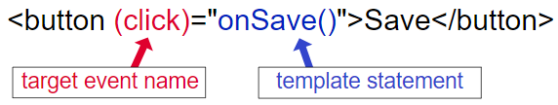

<https://angular.io/guide/template-syntax#event-binding-event>

Demo: <https://stackblitz.com/angular/gjvajkplmqoe?file=src%2Fapp%2Fapp.component.html>

Event types: <https://developer.mozilla.org/en-US/docs/Web/Events>

<https://angular.io/api/core/EventEmitter>

|  |  |
| --- | --- |
| <button (myClick)="clickMessage=$event" clickable>click with myClick</button> {{clickMessage}} | {{clickMessage}} = click |
| <input  [value]="currentItem.name"  (input)="currentItem.name=$event.target.value" >  without [NgModel](https://angular.io/api/forms/NgModel) | init value  onChange event |

🡺 Routing (URL params)

[Getting Started / Routing](https://angular.io/start/start-routing)

<https://angular.io/api/router/RouterModule>

<https://angular.io/api/router/RouterOutlet>

URL parameters

|  |
| --- |
| src/app/app.module.ts  @NgModule({  imports: [  BrowserModule,  ReactiveFormsModule,  RouterModule.forRoot([  { path: '', component: ProductListComponent },  { path: 'products/:productId', component: ProductDetailsComponent },  ])  ],  src/app/product-list/product-list.component.html  <a [routerLink]="['/products', productId]">  {{ product.name }}  </a>  src/app/product-details/product-details.component.ts  import { [ActivatedRoute](https://angular.io/api/router/ActivatedRoute) } from '@angular/router';  constructor( private route: [ActivatedRoute](https://angular.io/api/router/ActivatedRoute), ) { }  src/app/product-details/product-details.component.ts  ngOnInit() {  this.route.paramMap.subscribe(params => {  this.product = products[+params.get('productId')];  });  } |

* Services (share data)

[Getting Started / Managing Data #Services](https://angular.io/start/start-data#services)

<https://angular.io/guide/providers>

To share data across components

When you provide the service at the root level, Angular creates a single, shared instance of HeroService and injects into any class that asks for it. Registering the provider in the @Injectable metadata also allows Angular to optimize an app by removing the service if it turns out not to be used after all.

|  |
| --- |
| src/app/cart.service.ts  import { [Injectable](https://angular.io/api/core/Injectable) } from '@angular/core';  @Injectable({  providedIn: 'root'  })  export class CartService {  items = [];  addToCart(product) {  this.items.push(product);  }  getItems() {  return this.items;  }  }  src/app/product-details/product-details.component.ts import { CartService } from '../cart.service';  export class ProductDetailsComponent implements OnInit {  constructor(  private cartService: CartService  ) { }  addToCart(product) {  this.cartService.addToCart(product);  window.alert('Your product has been added to the cart!');  }  }  src/app/product-details/product-details.component.html  <button (click)="addToCart(product)">Buy</button>  src/app/cart/cart.component.ts  import { CartService } from '../cart.service';  export class CartComponent implements OnInit {  items;  constructor(  private cartService: CartService  ) { }  ngOnInit() {  this.items = this.cartService.getItems();  }  }  src/app/cart/cart.component.html  <div class="cart-item" *ngFor="let item of items">  <span>{{ item.name }}</span>  <span>{{ item.price | currency }}</span>  </div> |

* HttpClient (API JSON)

[Getting Started / Managing Data #HttpClient](https://angular.io/start/start-data#services)

<https://angular.io/guide/http>

<https://angular.io/api/common/http/HttpClient>

Your app can fetch data and interact with external APIs and resources like JSON

|  |
| --- |
| src/assets/shipping.json  [  {  "type": "Overnight",  "price": 25.99  },  {  "type": "2-Day",  "price": 9.99  },  {  "type": "Postal",  "price": 2.99  }  ]  src/app/app.module.ts  import { [HttpClientModule](https://angular.io/api/common/http/HttpClientModule) } from '@angular/common/[http](https://angular.io/api/common/http)';  (at the top of the file with the other imports)  @NgModule({  imports: [  BrowserModule,  HttpClientModule,  ReactiveFormsModule,  RouterModule.forRoot([  { path: '', component: ProductListComponent },  { path: 'products/:productId', component: ProductDetailsComponent },  { path: 'cart', component: CartComponent },  ])  ]  })  src/app/cart.service.ts  import { [HttpClient](https://angular.io/api/common/http/HttpClient) } from '@angular/common/[http](https://angular.io/api/common/http)';  constructor( private [http](https://angular.io/api/common/http): [HttpClient](https://angular.io/api/common/http/HttpClient) ) {}  getShippingPrices() {  return this.http.get('/assets/shipping.json');  }  src/app/shipping/shipping.component.ts  import { CartService } from '../cart.service';  export class ShippingComponent implements OnInit {  shippingCosts;  constructor(  private cartService: CartService  ) {  }  ngOnInit() {  this.shippingCosts = this.cartService.getShippingPrices();  }  }  src/app/shipping/shipping.component.html  <div class="shipping-item" *ngFor="let shipping of shippingCosts | async">  <span>{{ shipping.type }}</span>  <span>{{ shipping.price | currency }}</span>  </div> |

* Form

[Getting Started / Forms](https://angular.io/start/start-forms#define-the-checkout-form-model)

Create custom form controls and easy validation experiences

<https://angular.io/guide/forms>

<https://angular.io/api/forms/FormsModule>

<https://angular.io/api/forms/FormBuilder>

<https://angular.io/api/forms/ReactiveFormsModule>

[(ngModel)]: <https://angular.io/guide/template-syntax#ngmodel-two-way-binding>

Demo: <https://stackblitz.com/angular/bbjgpkqgpog?file=src%2Fapp%2Fapp.component.html>

|  |
| --- |
| src/app/cart/cart.component.ts  import { [FormBuilder](https://angular.io/api/forms/FormBuilder) } from '@angular/forms';  export class CartComponent implements OnInit {  items;  checkoutForm;  constructor(  private cartService: CartService,  private formBuilder: FormBuilder,  ) {  this.checkoutForm = this.formBuilder.group({  name: '',  address: ''  });  }  onSubmit(customerData) {  // Process checkout data here  this.items = this.cartService.clearCart();  this.checkoutForm.reset();  console.warn('Your order has been submitted', customerData);  }  }  src/app/cart.service.ts  clearCart() {  this.items = [];  return this.items;  }  src/app/cart/cart.component.html  <form [formGroup]="checkoutForm" (ngSubmit)="onSubmit(checkoutForm.value)">  <div>  <label for="name">  Name  </label>  <input id="name" type="text" formControlName="name">  </div>  <div>  <label for="address">  Address  </label>  <input id="address" type="text" formControlName="address">  </div>  <button class="button" type="submit">Purchase</button>  </form> |

* XXX

Getting Started / XXX

UseForXXX

|  |
| --- |
| XXX |

# **Definition**

* Object

objectName {

id: number;

name: string;

}

* Array

arrayName[]

* Attribute

defined by HTML, **value cannot change**

<button disabled>Save</button>

* Property

accessed from DOM (Document Object Model) nodes, **value can change**

<button [disabled]="isUnchanged">Save</button>

* Component

XXX

<app-hero-detail></app-hero-detail>

* Directive

XXX

@Input()

@NgModule

NgClass

* Module

XXX

* XXX

XXX

* XXX

XXX

* XXX

XXX

* XXX

XXX

* XXX

XXX

* XXX

XXX

* XXX

XXX

* XXX

XXX

# **NOTE**

* model-view-controller (MVC) or model-view-viewmodel (MVVM)
* <script> & <html>, <body>, <base> are ignore in *.html file
* Reserve the constructor() for simple initialization such as wiring constructor parameters to properties. The constructor shouldn't *do anything*. It certainly shouldn't call a function that makes HTTP requests to a remote server as a *real* data service would.
  + **Constructor()** for **variables**
  + **ngOnInit**() for **functions**
* Instead, call getHeroes() inside the *[ngOnInit lifecycle hook](https://angular.io/guide/lifecycle-hooks)* and let Angular call ngOnInit() at an appropriate time *after* constructing a HeroesComponent instance.
* Angular only binds to **public** component properties
* Angular uses **capitalization conventions** to distinguish the names of various types, as described in the [naming guidelines section](https://angular.io/guide/styleguide#02-01) of the Style Guide. Here's a summary of the case types:
  + camelCase : Symbols, **properties**, **methods**, **pipe** names, non-component directive selectors, constants. Standard or lower camel case uses lowercase on the first letter of the item. For example, "selectedHero".
  + UpperCamelCase (or PascalCase): **Class** names, including classes that define components, **interfaces**, **NgModules**, **directives**, and **pipes**, Upper camel case uses uppercase on the first letter of the item. For example, "HeroListComponent".
  + dash-case (or "kebab-case"): Descriptive part of **file** names, component **selectors**. For example, "app-hero-list".
  + underscore_case (or "snake_case"): Not typically used in Angular. Snake case uses words connected with underscores. For example, "convert_link_mode".
  + UPPER_UNDERSCORE_CASE (or UPPER_SNAKE_CASE, or SCREAMING_SNAKE_CASE): Traditional for **constants** (acceptable, but prefer camelCase). Upper snake case uses words in all capital letters connected with underscores. For example, "FIX_ME".
* Many NgModules such as the [RouterModule](https://angular.io/guide/router" \o "Routing and Navigation) and the [FormsModule](https://angular.io/guide/forms" \o "Forms) define their own attribute directives. The most common attribute directives are as follows:
  + [NgClass](https://angular.io/guide/template-syntax#ngClass)—adds and removes a set of CSS classes.
  + [NgStyle](https://angular.io/guide/template-syntax#ngStyle)—adds and removes a set of HTML styles.
  + [NgModel](https://angular.io/guide/template-syntax#ngModel)—adds two-way data binding to an HTML form element.
* Return a string if the target property expects a string, a number if it expects a number, an object if it expects an object, and so on

|  |  |
| --- | --- |
| string | src/app/app.component.html  <app-item-detail [childItem]="parentItem"></app-item-detail>  src/app/item-detail/item-detail.component.ts  @[Input](https://angular.io/api/core/Input)() childItem: string;  src/app/app.component.ts  parentItem = 'lamp'; |
| array | src/app/app.component.html  <app-item-list [items]="currentItems"></app-item-list>  src/app/item-list.component.ts  @[Input](https://angular.io/api/core/Input)() items: Item[];  src/app/item.ts  export interface Item { id: number; name: string; }  src/app.component.ts  currentItems = [{ id: 21, name: 'phone' }]; |

# **Tour of Heros App**

* Links

<https://angular.io/tutorial>

<https://stackblitz.com/angular/bbykkemeqor?file=src%2Fapp%2Fhero.service.ts>

* Visual Layout

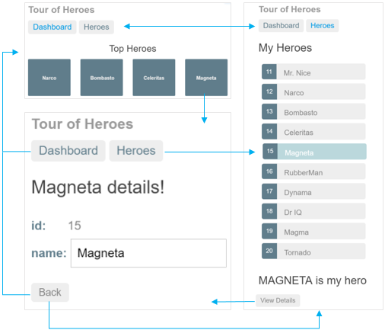

* interface

|  |
| --- |
| export interface Hero {      id: number;      name: string;  } |

* Mock data

<https://angular.io/tutorial/toh-pt2#create-mock-heroes>

|  |
| --- |
| import { Hero } from '../hero';    hero: Hero = {      id: 1,      name: 'Windstorm'    };  export const HEROES: Hero[] = [    { id: 11, name: 'Dr Nice' },    { id: 12, name: 'Narco' },    { id: 13, name: 'Bombasto' },    { id: 14, name: 'Celeritas' },    { id: 15, name: 'Magneta' },    { id: 16, name: 'RubberMan' },    { id: 17, name: 'Dynama' },    { id: 18, name: 'Dr IQ' },    { id: 19, name: 'Magma' },    { id: 20, name: 'Tornado' },  ];  export class HeroesComponent implements OnInit {    selectedHero: Hero;    onSelect(hero: Hero): void {      this.selectedHero = hero;    }  } |
| src/app/hero.ts  export class Hero {      constructor(          public id: number,          public name: string) { }  }  src/app/app.component.ts  heroes = [      new Hero(1, 'Windstorm'),      new Hero(13, 'Bombasto'),      new Hero(15, 'Magneta'),      new Hero(20, 'Tornado')  ];  myHero = this.heroes[0]; |

* Routing config

<https://angular.io/tutorial/toh-pt5#routes>

|  |
| --- |
| const routes: Routes = [    { path: '', redirectTo: '/dashboard', pathMatch: 'full' }, // auto navigate to dashboard & change '/' path to '/dashboard'    { path: 'dashboard', component: DashboardComponent },    { path: 'heroes', component: HeroesComponent }, // tells the router to match that URL to path: 'heroes' and display the HeroesComponent when the URL is something like localhost:4200/heroes    { path: 'detail/:id', component: HeroDetailComponent }, // :id is a placeholder for a specific hero id  ]; |

* Get id From URL

<https://angular.io/tutorial/toh-pt5#routable-herodetailcomponent>

|  |
| --- |
| import { ActivatedRoute } from '@angular/router';    constructor(      private route: ActivatedRoute, // holds parameter information of URL    ) { }      const id = +this.route.snapshot.paramMap.get('id');      // route parameters are always strings      // (+) operator converts the string to a number (which is what a hero id should be)      // route.snapshot is a static image of the route information shortly after the component was created      // paramMap is a dictionary of route parameter values extracted from the URL. The "id" key returns the id of the hero to fetch |

* goBack()

<https://angular.io/tutorial/toh-pt5#find-the-way-back>

|  |
| --- |
| import { Location } from '@angular/common';    constructor(      private location: Location, // service for interacting with the browser; to navigate back to the view that navigated here    ) { }    goBack(): void {      this.location.back();    } |

* Observable data (by RxJS library)

<https://angular.io/tutorial/toh-pt4#observable-data>

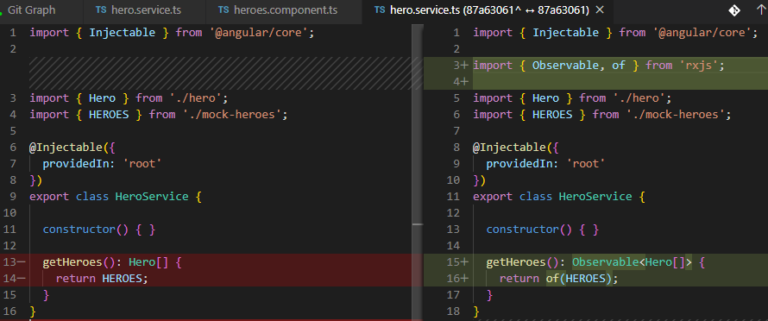

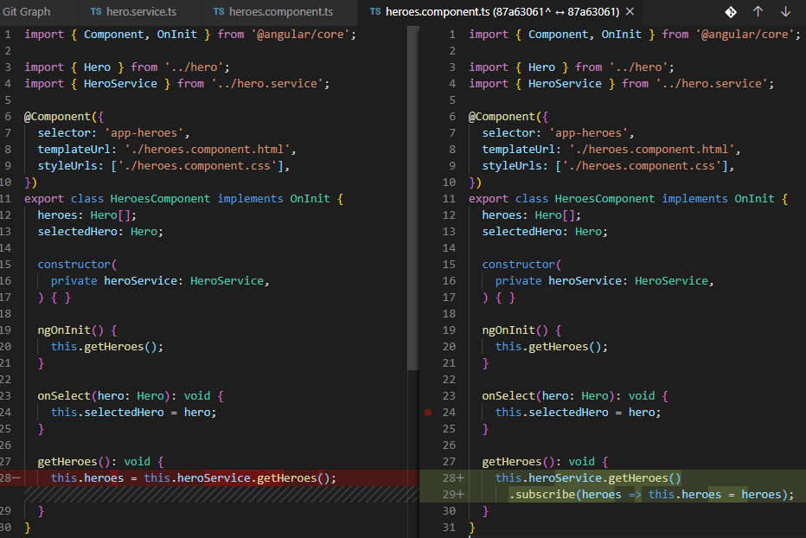

* Get data from server (by In-memory Web API module)
  + Get Heroes List

<https://angular.io/tutorial/toh-pt6#heroes-and-http>

* + Log message by RxJS tap()

<https://angular.io/tutorial/toh-pt6#handleerror>

<https://github.com/TonyTran0209/angular-tour-of-heroes/commit/2b4743a2fbcf505a92e78dbc285640d06193f2f2?diff=split>

|  |
| --- |
| import { catchError, map, tap } from 'rxjs/operators';    // After reporting the error to the console,    // the handler constructs a user friendly message    // and returns a safe value to the app so the app can keep working.    /**     * Handle Http operation that failed.     * Let the app continue.     * @param operation - name of the operation that failed     * @param result - optional value to return as the observable result     */    private handleError<T>(operation = 'operation', result?: T) {      return (error: any): Observable<T> => {        // TODO: send the error to remote logging infrastructure        console.error(error); // log to console instead        // TODO: better job of transforming error for user consumption        this.log(`${operation} failed: ${error.message}`);        // Let the app keep running by returning an empty result.        return of(result as T);      };    }    /** Log a HeroService message with the MessageService */    private log(message: string) {      this.messageService.add(`HeroService: ${message}`);    } |

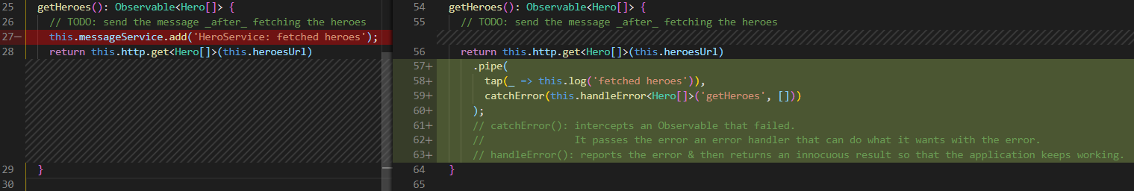

|  |
| --- |
| getHeroes(): Observable<Hero[]> {      // TODO: send the message _after_ fetching the heroes      return this.http.get<Hero[]>(this.heroesUrl)        .pipe(          tap(_ => this.log('fetched heroes')),          catchError(this.handleError<Hero[]>('getHeroes', []))        );        // catchError(): intercepts an Observable that failed. It passes the error an error handler that can do what it wants with the error.        // handleError(): reports the error & then returns an innocuous result so that the application keeps working.    } |

* + Get hero by id

<https://angular.io/tutorial/toh-pt6#get-hero-by-id>

<https://github.com/TonyTran0209/angular-tour-of-heroes/commit/5cc71262f82d5bdc83cd485e0fda335895ab476e>

|  |
| --- |
| // GET hero by id. Will 404 if id not found    getHero(id: number): Observable<Hero> {      // TODO: send the message _after_ fetching the hero      const url = `${this.heroesUrl}/${id}`;      return this.http.get<Hero>(url)        .pipe(          tap(_ => this.log(`fetched hero id=${id}`)),          catchError(this.handleError<Hero>(`getHero id=${id}`))        );    } |

* + Update hero by id

<https://angular.io/tutorial/toh-pt6#update-heroes>

<https://github.com/TonyTran0209/angular-tour-of-heroes/commit/245aef04aeb463fb837e1b084f0975f26e6a4923?diff=split>

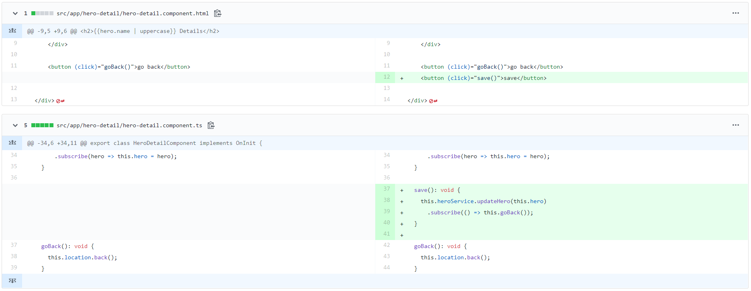

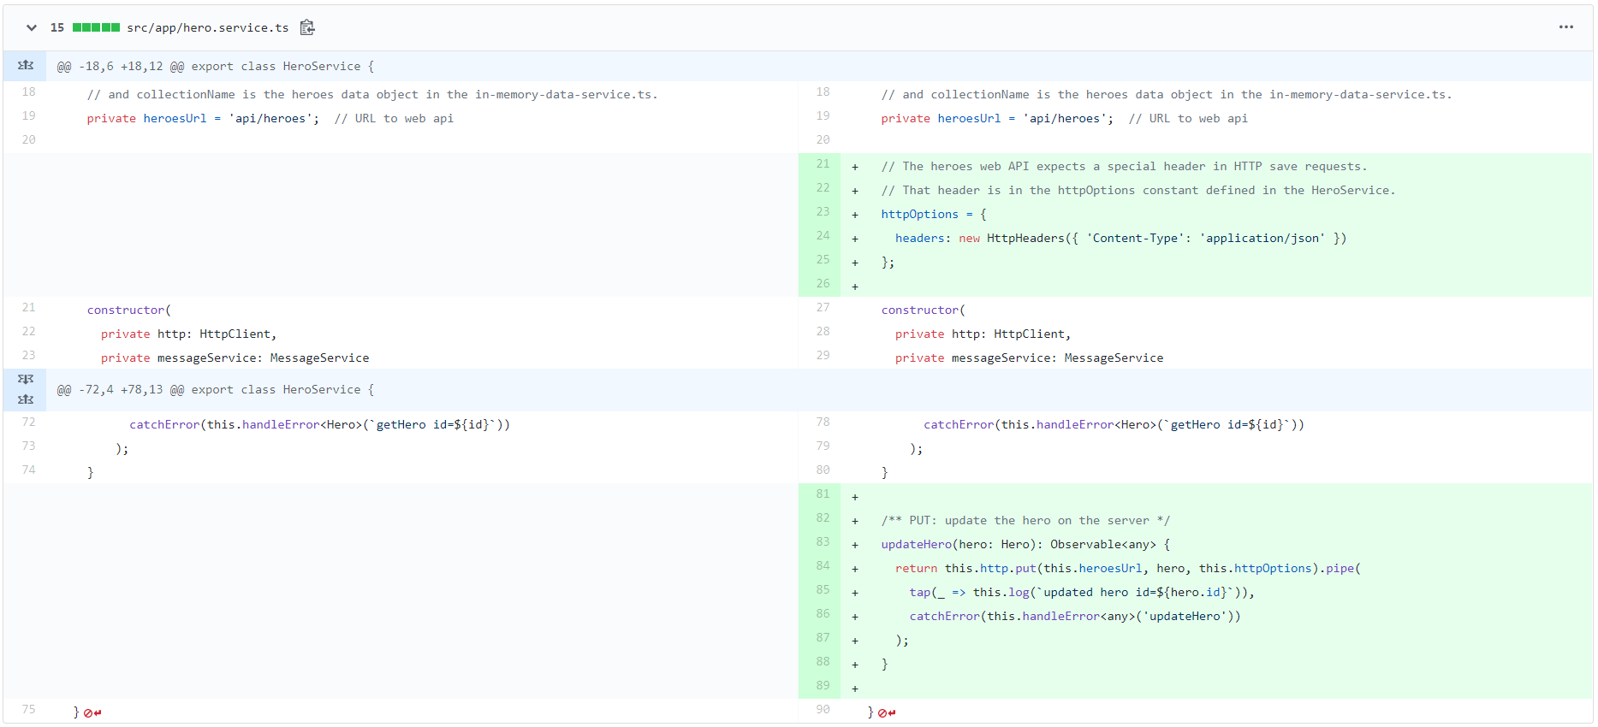

* + Add a new hero

<https://angular.io/tutorial/toh-pt6#add-a-new-hero>

<https://github.com/TonyTran0209/angular-tour-of-heroes/commit/3d10a4dda7078c17f97b5b1fde2269242d7a2cbb?diff=split>

|  |
| --- |
| src/app/heroes/heroes.component.html  <div>    <label>Hero name:      <input #heroName />    </label>    <!-- (click) passes input value to add() & then clears the input -->    <button (click)="add(heroName.value); heroName.value=''">      add    </button>  </div>  src/app/heroes/heroes.component.ts    add(name: string): void {      name = name.trim();      if (!name) { return; }      this.heroService.addHero({ name } as Hero)        .subscribe(hero => {          this.heroes.push(hero);        });    }  src/app/hero.service.ts    /** POST: add a new hero to the server */    addHero(hero: Hero): Observable<Hero> {      return this.http.post<Hero>(this.heroesUrl, hero, this.httpOptions).pipe(        tap((newHero: Hero) => this.log(`added hero w/ id=${newHero.id}`)),        catchError(this.handleError<Hero>('addHero'))      );    } |

* + Delete hero by id

<https://angular.io/tutorial/toh-pt6#delete-a-hero>

<https://github.com/TonyTran0209/angular-tour-of-heroes/commit/7640e720f3e9b06286b694f837d65e1cb1e18cf4?diff=split>

|  |
| --- |
| src/app/heroes/heroes.component.ts    delete(hero: Hero): void {      this.heroes = this.heroes.filter(h => h !== hero);      this.heroService.deleteHero(hero).subscribe();      // There's nothing for the component to do with the Observable returned by heroService.delete() but it must subscribe() anyway.      // If you don't use subscribe(), the service will not send the delete request to the server.      // As a rule, an Observable does nothing until something subscribes.    }  src/app/hero.service.ts    /** DELETE: delete the hero from the server */    deleteHero(hero: Hero | number): Observable<Hero> {      const id = typeof hero === 'number' ? hero : hero.id;      const url = `${this.heroesUrl}/${id}`;      return this.http.delete<Hero>(url, this.httpOptions).pipe(        tap(_ => this.log(`deleted hero id=${id}`)),        catchError(this.handleError<Hero>('deleteHero'))      );    } |

* + Search Hero by name

<https://angular.io/tutorial/toh-pt6#search-by-name>

<https://github.com/TonyTran0209/angular-tour-of-heroes/commit/80e937938ecefc6889cd8054aa86ba4b9ffd25d9?diff=split>

<https://www.learnrxjs.io/learn-rxjs/operators/transformation/switchmap>

|  |
| --- |
| src/app/hero-search/hero-search.component.html  <div id="search-component">    <h4><label for="search-box">Hero Search</label></h4>    <!-- As the user types in the search box, an input event binding calls the component's search() method with the new search box value. -->    <!-- Every time the user types in the textbox, the binding calls search() with the textbox value, a "search term".    The searchTerms becomes an Observable emitting a steady stream of search terms. -->    <input #searchBox id="search-box" (input)="search(searchBox.value)" />    <ul class="search-result">      <!-- The $ is a convention that indicates heroes$ is an Observable, not an array -->      <!-- async pipe identifies Angular's AsyncPipe & subscribes to an Observable automatically, so you won't have to do so in the component class -->      <li *ngFor="let hero of heroes$ | async">        <a routerLink="/detail/{{ hero.id }}">          {{ hero.name }}        </a>      </li>    </ul>  </div>  src/app/hero-search/hero-search.component.ts  import { Component, OnInit } from '@angular/core';  import { Observable, Subject } from 'rxjs';  import {     debounceTime, distinctUntilChanged, switchMap   } from 'rxjs/operators';  import { Hero } from '../hero';  import { HeroService } from '../hero.service';  @Component({    selector: 'app-hero-search',    templateUrl: './hero-search.component.html',    styleUrls: ['./hero-search.component.css']  })  export class HeroSearchComponent implements OnInit {    heroes$: Observable<Hero[]>; // The $ is a convention that indicates heroes$ is an Observable, not an array    private searchTerms = new Subject<string>(); // is an RxJS Subject    constructor(private heroService: HeroService) {}    // Push a search term into the observable stream.    /* A Subject is both a source of observable values & an Observable itself.    You can subscribe to a Subject as you would any Observable.    You can also push values into that Observable by calling its next(value) method as the search() method does. */    search(term: string): void {      this.searchTerms.next(term);    }    ngOnInit(): void {      this.heroes$ = this.searchTerms.pipe(        // wait until the flow of new string events pauses for 300ms before passing along the latest string        // You'll never make requests more frequently than 300ms        debounceTime(300),        // ensures that a request is sent only if the filter text changed        distinctUntilChanged(),        /* switchMap() calls the search service for each search term that makes it through debounce() and distinctUntilChanged().        It cancels & discards previous search observables,        returning only the latest search service observable */        // https://www.learnrxjs.io/learn-rxjs/operators/transformation/switchmap        switchMap((term: string) => this.heroService.searchHeroes(term)),      );    }    }  src/app/hero.service.ts    /* GET heroes whose name contains search term */    searchHeroes(term: string): Observable<Hero[]> {      if (!term.trim()) {        // if not search term, return empty hero array.        return of([]);      }      return this.http.get<Hero[]>(`${this.heroesUrl}/?name=${term}`).pipe(        tap(x => x.length ?          this.log(`found heroes matching "${term}"`) :          this.log(`no heroes matching "${term}"`)),        catchError(this.handleError<Hero[]>('searchHeroes', []))      );    } |

* XXX

|  |
| --- |
| abc |