**实验三：****管理SQL Server表数据**

**一、实验目的和要求**

1．熟悉数据表结构及使用特点；

2．熟悉使用Management Stuio界面方式管理数据表数据；

3．熟悉使用T-SQL语句管理数据表数据。

**二、实验环境**

1．已安装SQL Server 2008企业版的计算机（60台）；

2．具有局域网网络环境，有固定ip地址。

**三、实验学时**

4学时

**四、实验内容及步骤**

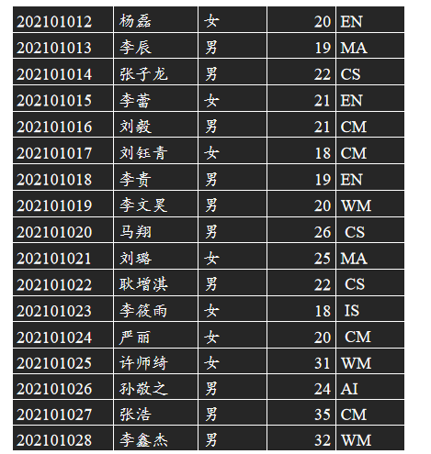1. 向各个数据表中插入如下记录：

学生信息表（Student）

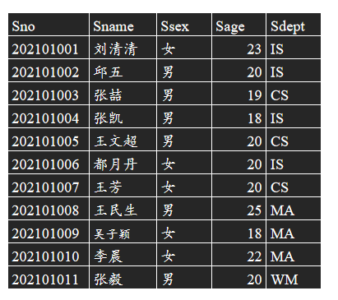

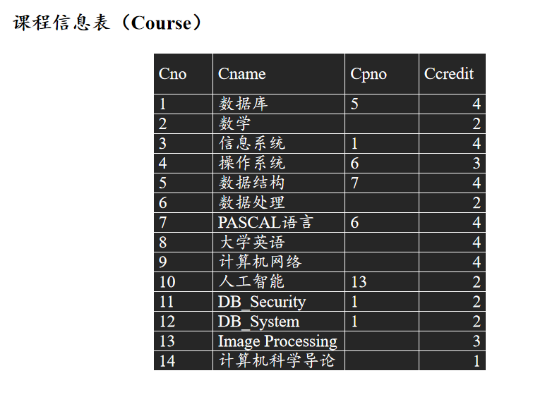

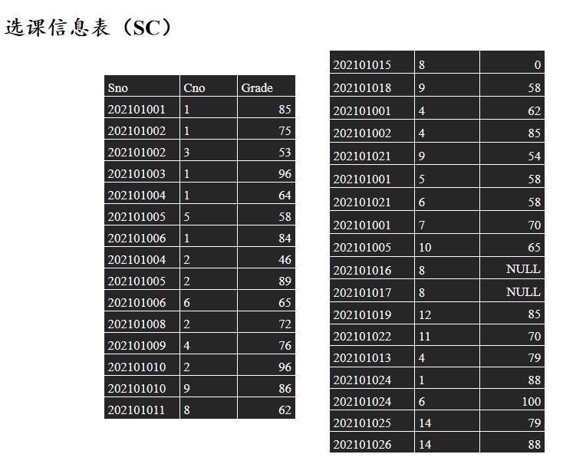

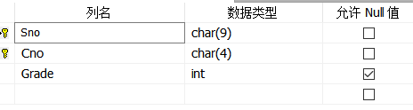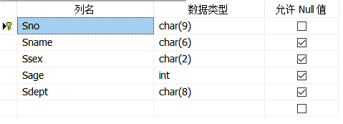

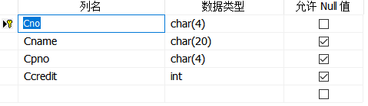

USE EX3

GO

INSERT INTO Student VALUES

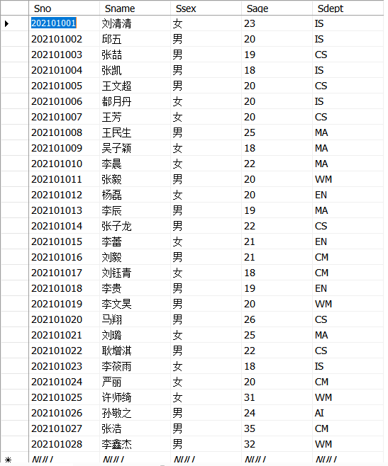 ('202101001','刘清清','女',23,'IS'),

('202101002','邱五','男',20,'IS'),

('202101003','张喆','男',19,'CS'),

('202101004','张凯','男',18,'IS'),

('202101005','王文超','男',20,'CS'),

('202101006','都月丹','女',20,'IS'),

('202101007','王芳','女',20,'CS'),

('202101008','王民生','男',25,'MA'),

('202101009','吴子颖','女',18,'MA'),

('202101010','李晨','女',22,'MA'),

('202101011','张毅','男',20,'WM'),

('202101012','杨磊','女',20,'EN'),

('202101013','李辰','男',19,'MA'),

('202101014','张子龙','男',22,'CS'),

('202101015','李蕾','女',21,'EN'),

('202101016','刘毅','男',21,'CM'),

('202101017','刘钰青','女',18,'CM'),

('202101018','李贵','男',19,'EN'),

('202101019','李文昊','男',20,'WM'),

('202101020','马翔','男',26,'CS'),

('202101021','刘璐','女',25,'MA'),

('202101022','耿增淇','男',22,'CS'),

('202101023','李筱雨','女',18,'IS'),

('202101024','严丽','女',20,'CM'),

('202101025','许师绮','女',31,'WM'),

('202101026','孙敬之','男',24,'AI'),

('202101027','张浩','男',35,'CM'),

('202101028','李鑫杰','男',32,'WM')

GO

use EX3

go

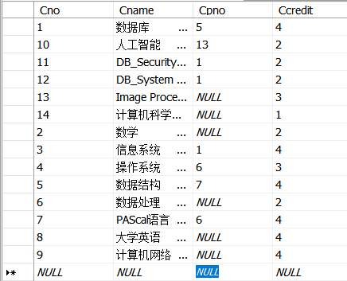insert into Course values

('1','数据库','5',4),

('2','数学',null,2),

('3','信息系统','1',4),

('4','操作系统','6',3),

('5','数据结构','7',4),

('6','数据处理',null,2),

('7','PAScal语言','6',4),

('8','大学英语',null,4),

('9','计算机网络',null,4),

('10','人工智能','13',2),

('11','DB_Security','1',2),

('12','DB_System','1',2),

('13','Image Processing',null,3),

('14','计算机科学导论',null,1);

go

USE EX3

GO

INSERT INTO SC VALUES

('202101001','1',85),

('202101002','1',75),

('202101002','3',53),

('202101003','1',96),

('202101004','1',64),

('202101005','5',58),

('202101006','1',84),

('202101004','2',46),

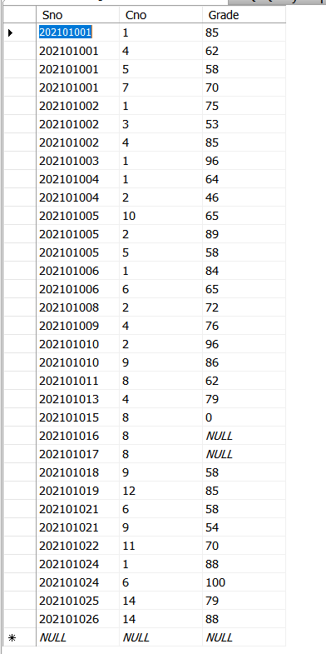 ('202101005','2',89),

('202101006','6',65),

('202101008','2',72),

('202101009','4',76),

('202101010','2',96),

('202101010','9',86),

('202101011','8',62),

('202101015','8',0),

('202101018','9',58),

('202101001','4',62),

('202101002','4',85),

('202101021','9',54),

('202101001','5',58),

('202101021','6',58),

('202101001','7',70),

('202101005','10',65),

('202101016','8',null),

('202101017','8',null),

('202101019','12',85),

('202101022','11',70),

('202101013','4',79),

('202101024','1',88),

('202101024','6',100),

('202101025','14',79),

('202101026','14',88)

Go

1. 修改IS系姓名为“邱五”的学生姓名为“邱武”；

UPDATE Student

SET Sname = '邱武'

WHERE Sname = '邱五' and Sdept = 'IS'

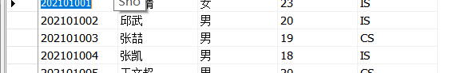

1. 修改课程“操作系统”的学分为4学分；

UPDATE Course

SET Ccredit = 4

WHERE Cname = '操作系统'



1. 将选修课程“2”的同学成绩减10分；

UPDATE SC

SET Grade = Grade-10

WHERE Cno = '2'

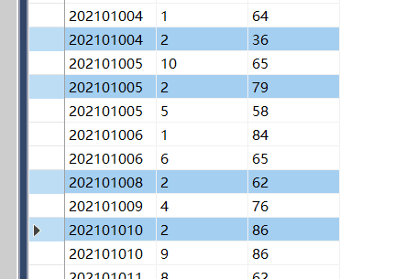

1. 将选修课程“数据库”和“计算机网络”的同学成绩加5分；

UPDATE SC

SET Grade = Grade+5

WHERE Cno IN

(SELECT Cno

FROM Course

WHERE Cname='数据库' OR Cname='计算机网络')

GO

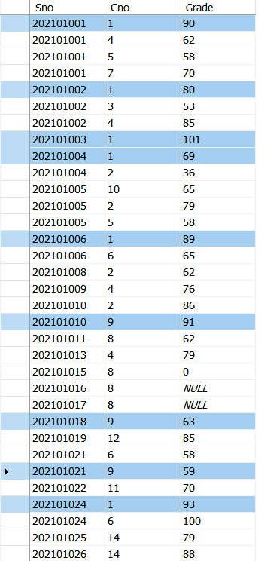

1. 将学号为“202101012”的学生信息重新设置为“申恩娟、女、20、MA”；

use EX3

go

UPDATE Student

SET Sname = '申恩娟',

Ssex = '女',

Sage = 20,

Sdept = 'MA'

WHERE Sno = '202101012'

GO



1. 删除数据表Student中AI系的学生记录；

USE EX3

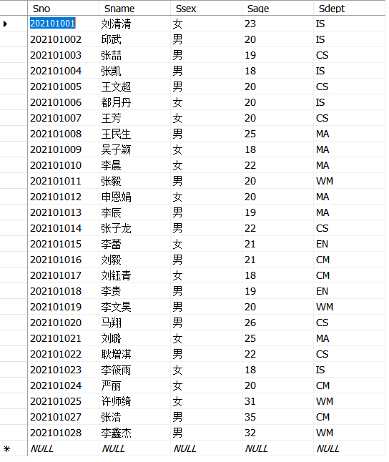GO

DELETE

FROM SC

WHERE Sno in(

select Sno

from Student

where Sdept='AI'

)

GO

DELETE

from Student

where Sdept='AI'

GO

1. 删除数据表Student中WM系年龄大于30的男同学的记录；

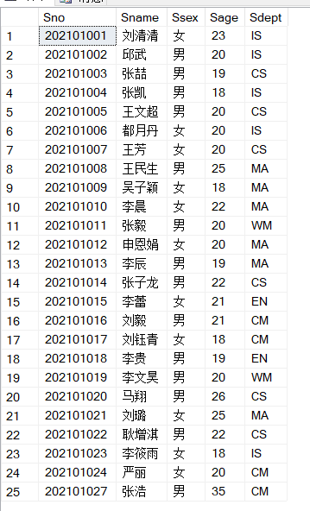USE EX3

GO

DELETE

FROM SC

WHERE Sno in(

select Sno

from Student

where Sdept='WM' AND Sage>30 AND Sage='男'

)

GO

DELETE

from Student

where Sdept='WM' AND Sage>30 AND Sage='男'

GO

1. 删除数据表Course中学分低于2学分的课程信息；

USE EX3

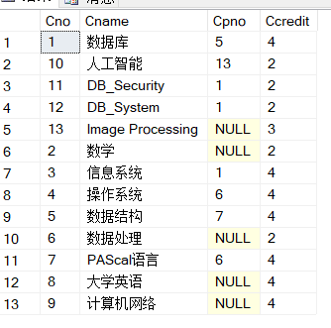GO

DELETE

FROM SC

WHERE Cno in(

select Cno

from Course

where Ccredit<2

)

GO

DELETE

from Course

where Ccredit<2

GO

1. 删除成绩为NULL的所有女生的选课记录；

USE EX3

GO

DELETE

FROM SC

WHERE Sno in(

select Sno

from Student

where Ssex='女'

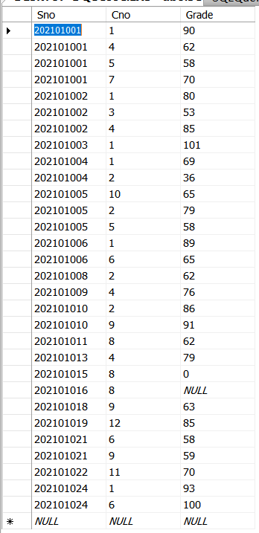)AND Grade is null

GO

1. 删除选修“计算机科学导论”所有男生的选课信息。

USE EX3

GO

DELETE

FROM SC

WHERE Cno IN (SELECT Cno

FROM Course

WHERE Cname ='计算机科学导论')

AND

Sno IN( SELECT Sno

FROM Student

WHERE Ssex = '男')

GO

**五、出现的问题及解决办法**

1．主要的问题就是在建表的时候加了外码，使我以后的删除增加了一些难度，但是我跟同学对比了删除后的数据，都是一样的，于是就用着带外码的做，也想提升一下能力

2．建表的时间太长了。